ELEC3609/9609 · ASSIGNMENT 1

StudyCrew System & Database Design
  - Functional requirements, physical data model and complete interface wireframes
A design for visible work, earlier intervention and fairer team conversations.
Team | ELEC3609-Fri13-16-G02
Version | 1.0 · 20 August 2026
Submission | Final system design report
Product | StudyCrew

Document control
Version | Date | Status | Scope
0.1 | 20 Aug 2026 | Draft | Concept and requirement baseline
0.7 | 20 Aug 2026 | Reviewed | ERD, wireframes and traceability
1.0 | 20 Aug 2026 | Submission candidate | Integrated report

Contents
Section | Evidence delivered
1. Product definition | Problem, users, value and design boundary
2. Functional requirements | 18 measurable IEEE 830-style requirements
3. Data model | 13-table 3NF model, Crow's Foot ERDs and constraints
4. Wireframes | 11 generic views covering every requirement
5. Traceability | Requirement-to-table-to-view-to-MVP matrix
6. Quality and feasibility | Normalisation, security, accessibility and risks

Executive summary
StudyCrew gives university project teams one private place to plan tasks, coordinate meetings and review factual contribution evidence. Its differentiator is not another task board: every meaningful collaboration action produces an immutable, inspectable event. The resulting dashboard supports earlier workload conversations without converting activity into an automated grade.
Design thesis Make work visible early enough to act, while keeping contribution evidence transparent, contextual and non-judgemental.

1. Product definition

1.1 Problem and opportunity
Small student teams often split coordination across chat, calendars and task lists. Status becomes stale, meeting attendance is hard to reconstruct and contribution concerns surface close to submission. StudyCrew unifies planning and evidence so the team can see blocked work, upcoming commitments and activity history before delivery risk becomes critical.

1.2 Primary users and outcomes
Actor | Need | Successful outcome
Project member | Know what to do and where discussion belongs | Find assigned work, update status and collaborate without losing context
Project owner | Coordinate access and respond to delivery risk | Invite members, manage roles and identify blocked or overdue work
Whole team | Discuss contribution using shared facts | Reconcile activity totals with underlying events without a black-box score

1.3 Scope boundary
In scope: authenticated project collaboration, task workflow, comments, meetings, RSVP, activity evidence, in-app notifications, search/filter and evidence export. Out of scope: grading, sentiment analysis, peer scoring, LMS synchronisation, external email delivery, real-time chat and native mobile applications.

1.4 Assumptions
Assumption | Design response
A user may belong to multiple projects | Membership is a junction table; every project query is membership-scoped
One active owner must remain | A partial unique index permits one active owner and application logic prevents sole-owner removal
Evidence must survive ordinary edits | Source records use soft retention where needed and activity events are append-only
Users may be in different time zones | All instants use timestamptz/UTC and profiles store an IANA time zone

2. Functional requirements
The specification follows the assignment's IEEE 830-1998 Section 5.3.2 expectation. Each requirement is uniquely identified, uses mandatory shall language and defines inputs, processing, outputs, failure behaviour and a measurable acceptance condition. Sixteen of the eighteen functions are available only to authenticated users.
MVP rule The proposed MVP contains 15 requirements. FR-SEARCH-01 and FR-EXPORT-01 are designed extensions and are implemented only after the core quality gates pass.

FR-AUTH-01 · Register an account
Element | Specification
Shall statement | The system shall create a user account when a visitor submits a unique, syntactically valid email address, a display name of 2-80 characters and a password of at least 12 characters.
Input/trigger | visitor submits the registration form.
Processing | normalise the email to lowercase, reject an existing email, hash the password with the configured one-way password algorithm, create one user and one profile in a transaction, and start an authenticated session.
Success output | redirect to the empty project dashboard within 2 seconds under normal test load and display a registration confirmation.
Failure output | preserve non-secret form fields and identify each invalid field without revealing whether a different account is active.
Acceptance | valid input creates exactly one `users` row and one `profiles` row; duplicate email or invalid input creates neither row.
Trace | Tables: users; profiles | Views: WF-01 | MVP: Yes

FR-AUTH-02 · Sign in and sign out
Element | Specification
Shall statement | The system shall authenticate a registered user from an email and password and shall terminate that user's current session on sign-out.
Input/trigger | sign-in or sign-out submission.
Processing | compare the password using the configured hash verifier, rotate the session identifier after successful sign-in, and invalidate the server-side session on sign-out.
Success output | show the project dashboard after sign-in and the public sign-in view after sign-out.
Failure output | return one generic credential error and create no session.
Acceptance | an invalid password cannot access an authenticated route; a signed-out session cannot be reused to access one.
Trace | Tables: users | Views: WF-01 | MVP: Yes

FR-PROF-01 · Maintain a profile
Element | Specification
Shall statement | The system shall allow an authenticated user to view and update their display name, course, time zone, biography and avatar URL.
Input/trigger | user submits profile fields.
Processing | validate lengths, permit only a recognised IANA time zone and update only the profile associated with the authenticated user.
Success output | show the saved profile values on refresh.
Failure output | identify invalid fields and leave stored values unchanged.
Acceptance | a user can update their own profile but cannot update another profile by changing a URL or request identifier.
Trace | Tables: profiles | Views: WF-10 | MVP: Yes

FR-PROJ-01 · Create a project
Element | Specification
Shall statement | The system shall allow an authenticated user to create a project with a name of 3-100 characters, optional description and due date.
Input/trigger | user submits the new-project form.
Processing | create the project and an `owner` membership for the creator in one transaction.
Success output | open the new project overview showing the creator as owner.
Failure output | show validation errors and create no partial project.
Acceptance | successful creation produces exactly one project and one owner membership; the project is absent from non-members' dashboards.
Trace | Tables: projects; project_members | Views: WF-02; WF-03 | MVP: Yes

FR-PROJ-02 · Invite and join members
Element | Specification
Shall statement | The system shall allow a project owner to invite an email address and shall allow the matching authenticated user to accept or decline the invitation before its expiry.
Input/trigger | owner sends an invitation; invitee accepts or declines.
Processing | prevent duplicate pending invitations and existing-member invitations, expire invitations after 7 days, and create membership only on a valid acceptance.
Success output | show the pending invitation to both parties and, after acceptance, show the new member in the roster.
Failure output | reject expired, cancelled, duplicate or unauthorised use.
Acceptance | one accepted invitation creates one membership and cannot be accepted a second time.
Trace | Tables: project_invitations; project_members | Views: WF-02; WF-06 | MVP: Yes

FR-PROJ-03 · Administer project membership
Element | Specification
Shall statement | The system shall allow the project owner to change a member between `member` and `facilitator` roles or remove that member, but shall not allow removal or demotion of the sole owner.
Input/trigger | owner submits a role change or removal.
Processing | verify current ownership and target membership, then update or soft-remove the membership with an audit event.
Success output | refresh the roster and permission-dependent controls.
Failure output | return a permission or sole-owner constraint message.
Acceptance | a regular member receives HTTP 403 for the same operation; a removed member immediately loses project access.
Trace | Tables: project_members; activity_events | Views: WF-06 | MVP: Yes

FR-TASK-01 · Manage tasks
Element | Specification
Shall statement | The system shall allow a current project member to create, view, edit and archive a task with title, description, priority and optional due date.
Input/trigger | member submits a task create, update or archive action.
Processing | validate title length (3-120), priority (`low`, `medium`, `high`, `urgent`) and project membership; retain archived tasks for evidence.
Success output | update the project board without a full page reload and display the task's latest values.
Failure output | reject invalid or unauthorised changes without partial data.
Acceptance | valid create/edit/archive actions are visible after refresh; archived tasks are excluded from the default board and remain exportable.
Trace | Tables: tasks; activity_events | Views: WF-03; WF-04; WF-05 | MVP: Yes

FR-TASK-02 · Assign task responsibility
Element | Specification
Shall statement | The system shall allow a current project member to assign zero or more current project members to a task and to remove assignees.
Input/trigger | member submits the assignee selector.
Processing | reject users outside the task's project, avoid duplicate assignments and apply additions/removals atomically.
Success output | show the same assignees on the board and task detail view.
Failure output | identify an ineligible assignee and preserve prior state.
Acceptance | assigning two eligible users creates two unique junction rows; resubmitting the same selection creates no duplicates.
Trace | Tables: task_assignees; project_members; notifications | Views: WF-04; WF-05 | MVP: Yes

FR-TASK-03 · Progress a task
Element | Specification
Shall statement | The system shall allow an assignee or project owner to move a task among `todo`, `in_progress`, `blocked` and `done` states.
Input/trigger | authorised user selects or drags a task to a state.
Processing | require a blocker note of 3-500 characters for `blocked`, set `completed_at` only for `done`, and record the actor and transition.
Success output | move the task to the selected board column and announce the change in an accessible live region.
Failure output | return the task to its prior state with a reason.
Acceptance | blocked without a note is rejected; moving to done sets one completion timestamp; reopening clears it.
Trace | Tables: tasks; activity_events | Views: WF-04; WF-05 | MVP: Yes

FR-COLL-01 · Discuss a task
Element | Specification
Shall statement | The system shall allow a current project member to add a plain- text comment of 1-2000 characters to a task and edit or delete their own comment.
Input/trigger | member submits a comment action.
Processing | escape active content, retain created/edited timestamps and permit project owners to moderate with an audit event.
Success output | append or update the comment thread in chronological order.
Failure output | reject blank, oversized or unauthorised modifications.
Acceptance | scripts render as text, not executable markup; a non-author, non-owner cannot modify the comment.
Trace | Tables: task_comments; activity_events; notifications | Views: WF-05 | MVP: Yes

FR-MEET-01 · Schedule a meeting
Element | Specification
Shall statement | The system shall allow a current project member to create, update or cancel a meeting with title, start time, end time, location/link and agenda.
Input/trigger | member submits the meeting form.
Processing | require the end after the start, store UTC, retain organiser, and mark cancellation rather than deleting attendance evidence.
Success output | show the meeting in chronological project and calendar views.
Failure output | identify invalid times or fields and preserve stored data.
Acceptance | the same UTC meeting renders correctly in two test time zones; an end time equal to the start time is rejected.
Trace | Tables: meetings; activity_events; notifications | Views: WF-03; WF-07 | MVP: Yes

FR-MEET-02 · Respond to a meeting
Element | Specification
Shall statement | The system shall allow each current project member to set one response (`pending`, `accepted`, `declined`) and an optional availability note for a non-cancelled meeting.
Input/trigger | member submits an RSVP.
Processing | upsert one response for the meeting/member pair and timestamp it.
Success output | update attendee counts and the member's displayed response.
Failure output | reject non-members and responses to cancelled meetings.
Acceptance | repeated changes update one row rather than creating duplicates; displayed counts equal the underlying response rows.
Trace | Tables: meeting_attendees; activity_events | Views: WF-07 | MVP: Yes

FR-CONTR-01 · Record contribution evidence
Element | Specification
Shall statement | The system shall append an immutable activity event when an authenticated member creates, updates or completes a task, comments, schedules a meeting, responds to a meeting or changes membership.
Input/trigger | successful completion of an audited action.
Processing | record actor, project, event type, relevant entity reference and UTC timestamp in the same transaction as the source action.
Success output | make the event available to the project activity feed.
Failure output | roll back the source action if its required event cannot be recorded; never expose secret or deleted comment content in metadata.
Acceptance | each audited source action creates exactly one matching event; application roles cannot update or delete event rows.
Trace | Tables: activity_events | Views: WF-03; WF-07; WF-08 | MVP: Yes

FR-CONTR-02 · View contribution insights
Element | Specification
Shall statement | The system shall allow a current project member to view per- member activity counts, completed tasks, comments and meeting participation for a selected project and date range of no more than 366 days.
Input/trigger | member selects date range and optional activity type.
Processing | aggregate immutable events and current task/attendance records; do not calculate a grade or qualitative score.
Success output | render summary totals, an accessible table and drill-down event list within 3 seconds under the seeded test dataset.
Failure output | identify invalid ranges and return no data for non-members.
Acceptance | dashboard totals reconcile exactly with a reference SQL query; zero-activity members remain visible with zero values.
Trace | Tables: activity_events; tasks; task_comments; meeting_attendees | Views: WF-08; WF-11 | MVP: Yes

FR-NOTIF-01 · Manage in-app notifications
Element | Specification
Shall statement | The system shall notify an authenticated user in-app when they are invited, assigned a task, mentioned in a comment, or affected by a meeting change, and shall allow each notification to be marked read.
Input/trigger | a qualifying source event or mark-read action.
Processing | create at most one notification per recipient/source event, suppress self-notification, and set `read_at` for the recipient only.
Success output | update unread count and link to the authorised source view.
Failure output | omit links to resources the recipient can no longer access.
Acceptance | duplicate event handling creates one notification; one user cannot mark another user's notification as read.
Trace | Tables: notifications; activity_events | Views: WF-05; WF-07; WF-09 | MVP: Yes

FR-SEARCH-01 · Search and filter project work
Element | Specification
Shall statement | The system shall allow a current project member to search task titles/descriptions and filter by status, priority, assignee and due-date state.
Input/trigger | member enters a query or changes a filter.
Processing | combine filters with logical AND, use case-insensitive text matching and return only tasks in the selected authorised project.
Success output | update results and report result count within 1 second after a 300 ms input debounce under the seeded test dataset.
Failure output | show a clear empty state rather than stale results.
Acceptance | test fixtures return the documented result set for each filter and no cross-project task is returned.
Trace | Tables: tasks; task_assignees | Views: WF-04 | MVP: No

FR-EXPORT-01 · Export contribution evidence
Element | Specification
Shall statement | The system shall allow a current project member to request a PDF or CSV evidence export for an authorised project and date range.
Input/trigger | member selects format and valid date range.
Processing | create an export job, generate a snapshot containing project, range, generation time, member totals and underlying event rows, and expire the download after 24 hours.
Success output | show job status and provide an authorised download when ready.
Failure output | mark the job failed with a retry option and no partial file.
Acceptance | exported totals match FR-CONTR-02 for the same inputs; expired or non-member download requests are denied.
Trace | Tables: export_jobs; activity_events | Views: WF-08; WF-11 | MVP: No

FR-SEC-01 · Enforce project authorisation
Element | Specification
Shall statement | The system shall verify authentication and current project membership on every server-side read or mutation of project-scoped data.
Input/trigger | any request containing or resolving to a project identifier.
Processing | derive user identity only from the validated session and apply role checks before querying or mutating protected records.
Success output | allow the request only when the stated permission holds.
Failure output | return HTTP 401 when unauthenticated and HTTP 403 when authenticated but unauthorised, without returning protected record content.
Acceptance | an automated access-control matrix test covers every protected route with visitor, non-member, member and owner identities.
Trace | Tables: all project-scoped tables | Views: WF-02 to WF-11 | MVP: Yes

3. Data model

3.1 Modelling decisions
The physical model targets PostgreSQL 16. UUID keys are used for externally visible entities; bigint identity keys support high-volume immutable events and notifications. All instants use timestamptz. Enumerated states are represented by constrained varchar values so the allowed domain is explicit in the schema and ERD.
Required association | Implementation | Integrity evidence
One-to-one | users to profiles | profiles.user_id is both PK and FK; a profile cannot exist without one user
One-to-many | projects to tasks | tasks.project_id is NOT NULL; each task belongs to exactly one project
Many-to-many | users to projects | project_members has composite PK (project_id, user_id)
Many-to-many | users to tasks | task_assignees has composite PK (task_id, user_id)
Many-to-many | users to meetings | meeting_attendees has composite PK (meeting_id, user_id)

3.2 Table catalogue
Table | Purpose | Primary key | Principal relationships / constraints
users | Account identity and credential state | user_id | profiles, projects, memberships and authored records
profiles | One profile per account | user_id (PK/FK) | Exactly one-to-one with users
projects | Private team workspace | project_id | Created by user; owns memberships, tasks, meetings and events
project_members | User-project junction and role | project_id + user_id | Many-to-many users/projects; one active owner per project
project_invitations | Time-limited invitation lifecycle | invitation_id | Belongs to project; invited by user; unique pending email
tasks | Project work item and workflow state | task_id | Belongs to project; created by user; owns assignees/comments
task_assignees | Task-user assignment junction | task_id + user_id | Many-to-many tasks/users; no duplicate assignment
task_comments | Sanitised task discussion | comment_id | Belongs to task; authored/moderated by users
meetings | Scheduled or cancelled project meeting | meeting_id | Belongs to project; organised by user; owns attendance
meeting_attendees | One RSVP per meeting/member | meeting_id + user_id | Many-to-many meetings/users
activity_events | Append-only contribution evidence | event_id | Belongs to project/actor; optional single source target
notifications | Recipient-specific in-app alert | notification_id | Unique recipient/source-event pair
export_jobs | Asynchronous evidence export | export_job_id | Belongs to project/requester; bounded range and expiry

3.3 Normalisation
The schema satisfies third normal form. Repeating memberships, assignments and attendance are isolated in junction tables; non-key attributes describe only their table key; profile data is separated from credentials; derived contribution totals are calculated from events rather than stored; and notification/export lifecycle state is isolated from source collaboration records. JSONB is restricted to non-authoritative event metadata, while all reportable identities and relationships remain typed foreign keys.

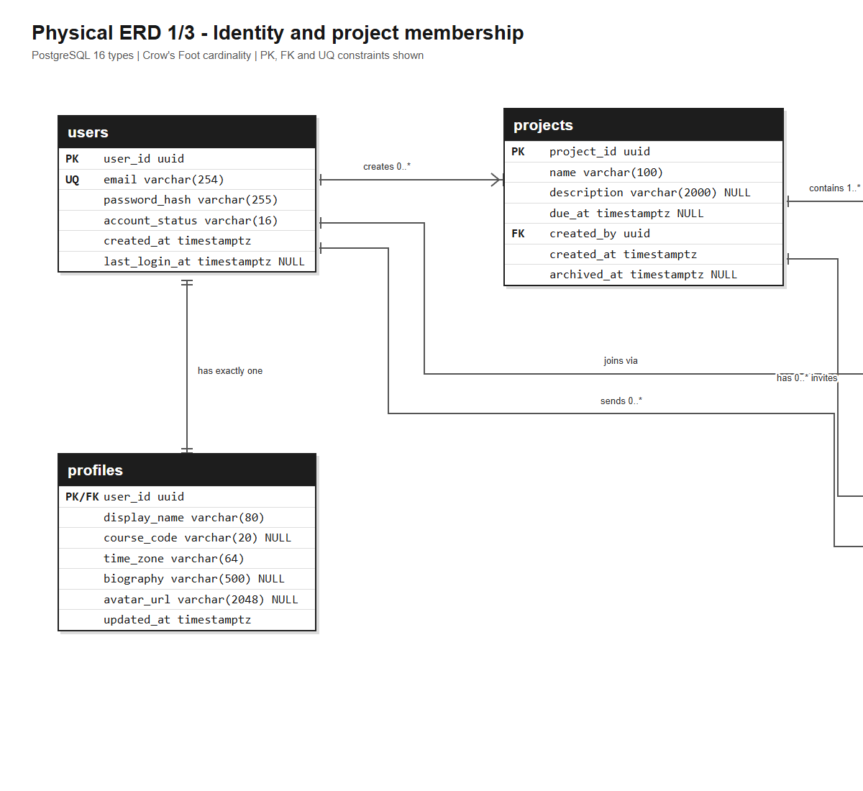
Figure 1A. Physical ERD 1/3 (left/centre view) in Crow's Foot notation. The deliberate overlap preserves relationship context; the complete landscape diagram is included in the repository.

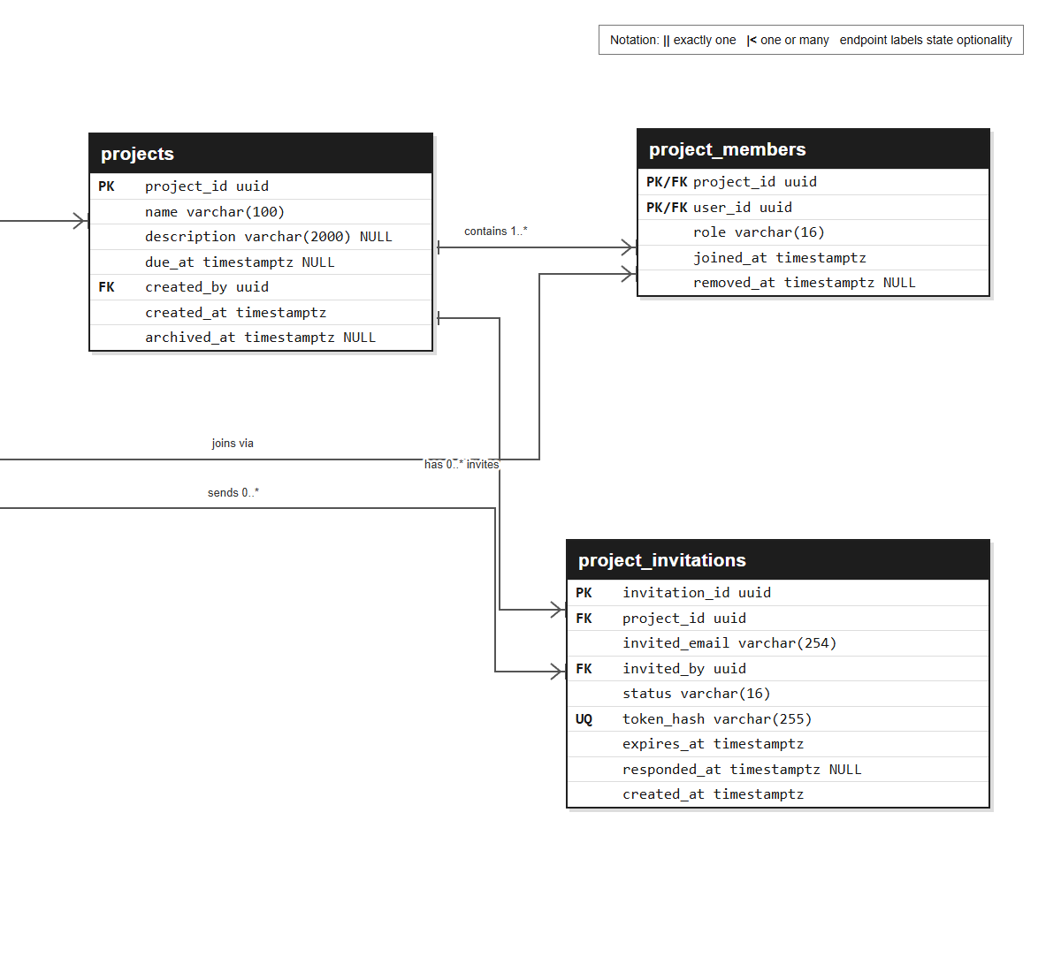
Figure 1B. Physical ERD 1/3 (centre/right view) in Crow's Foot notation. The deliberate overlap preserves relationship context; the complete landscape diagram is included in the repository.

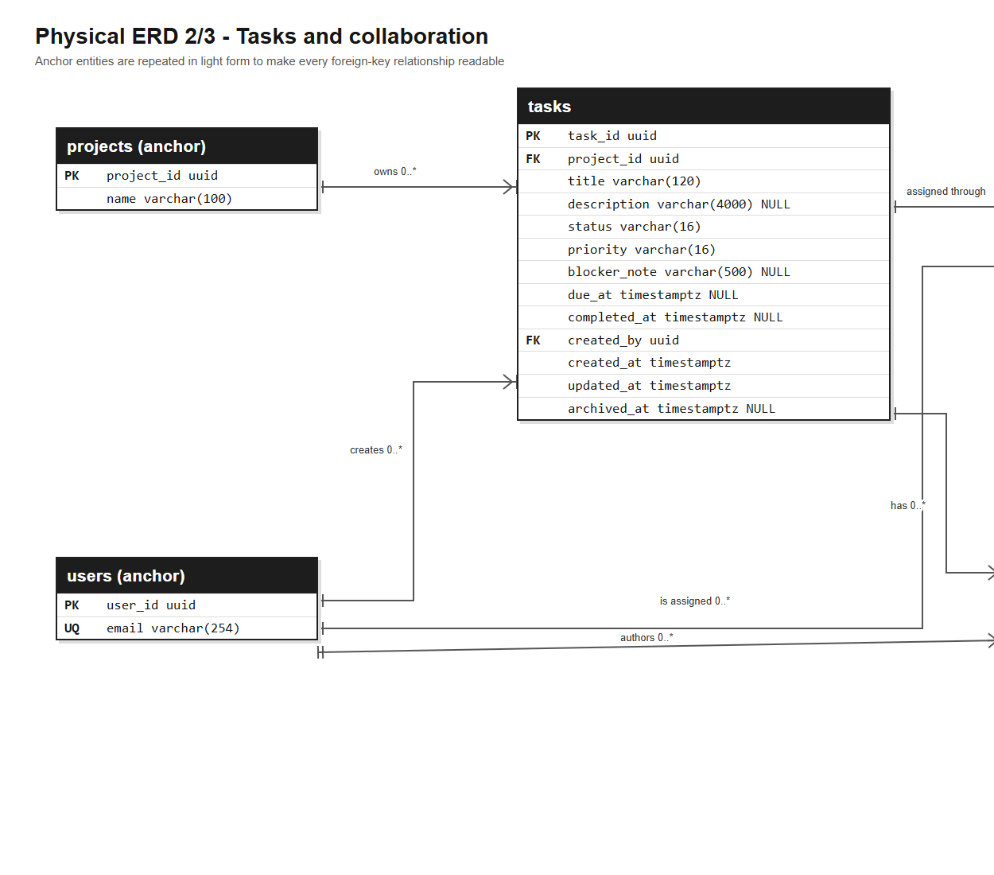
Figure 2A. Physical ERD 2/3 (left/centre view) in Crow's Foot notation. The deliberate overlap preserves relationship context; the complete landscape diagram is included in the repository.

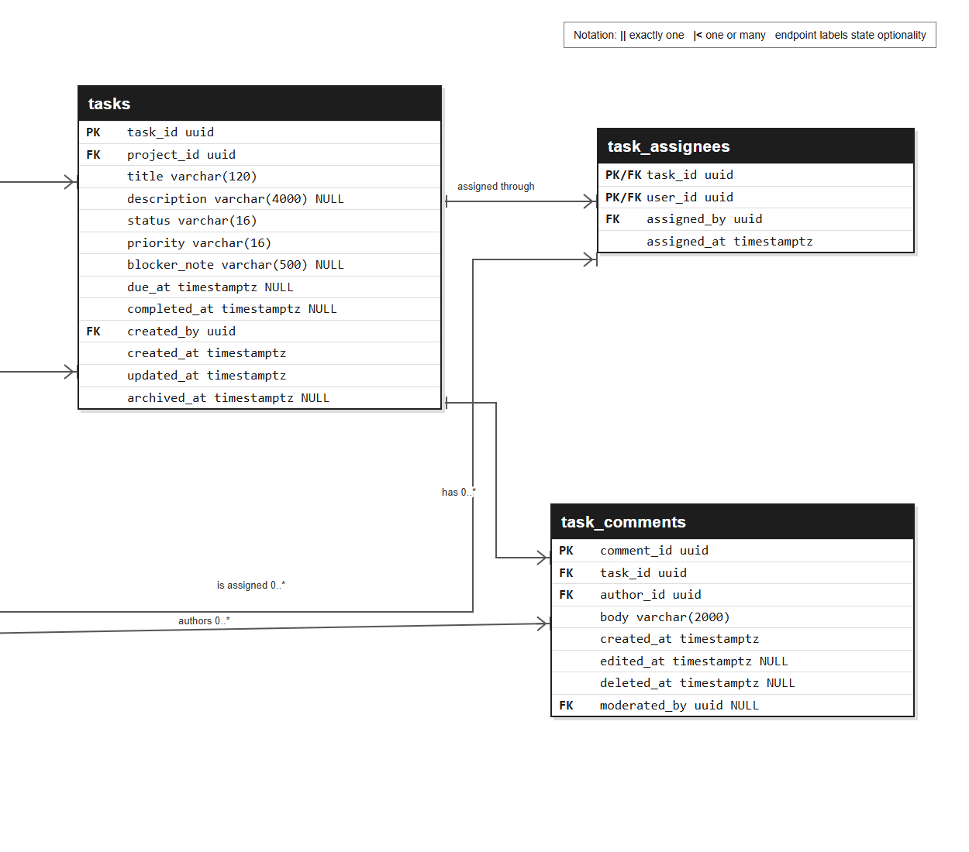
Figure 2B. Physical ERD 2/3 (centre/right view) in Crow's Foot notation. The deliberate overlap preserves relationship context; the complete landscape diagram is included in the repository.

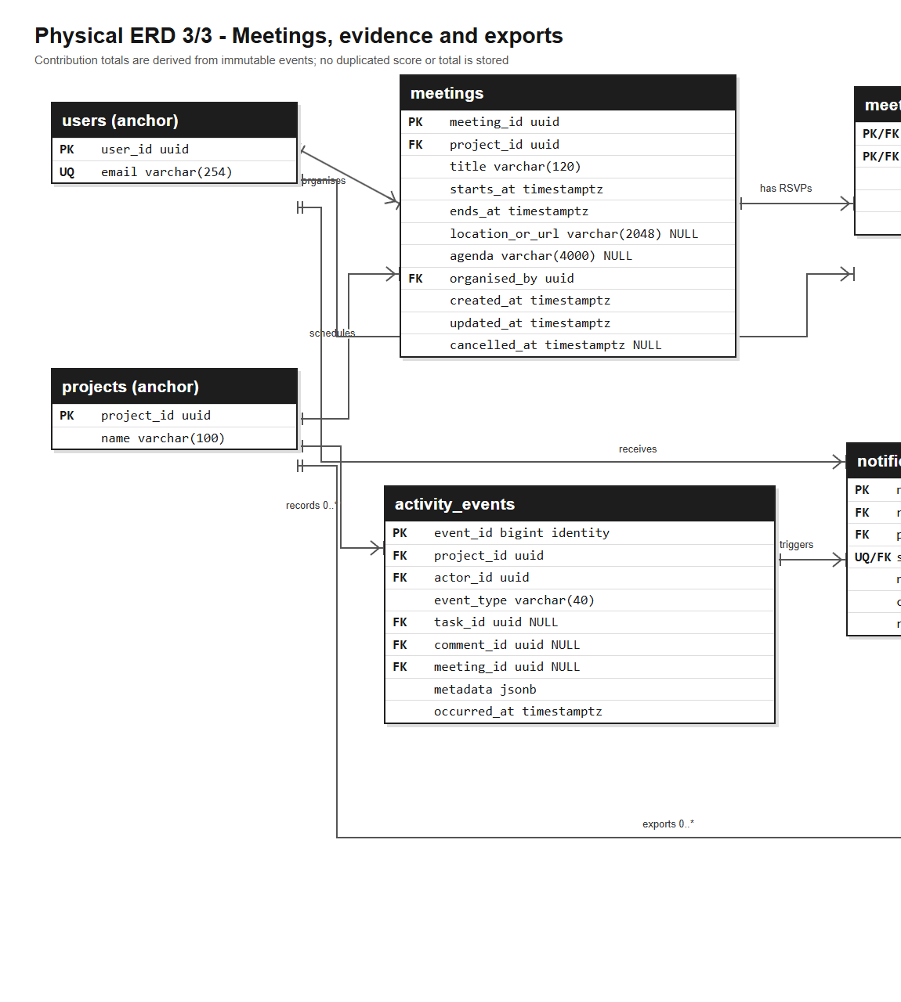
Figure 3A. Physical ERD 3/3 (left/centre view) in Crow's Foot notation. The deliberate overlap preserves relationship context; the complete landscape diagram is included in the repository.

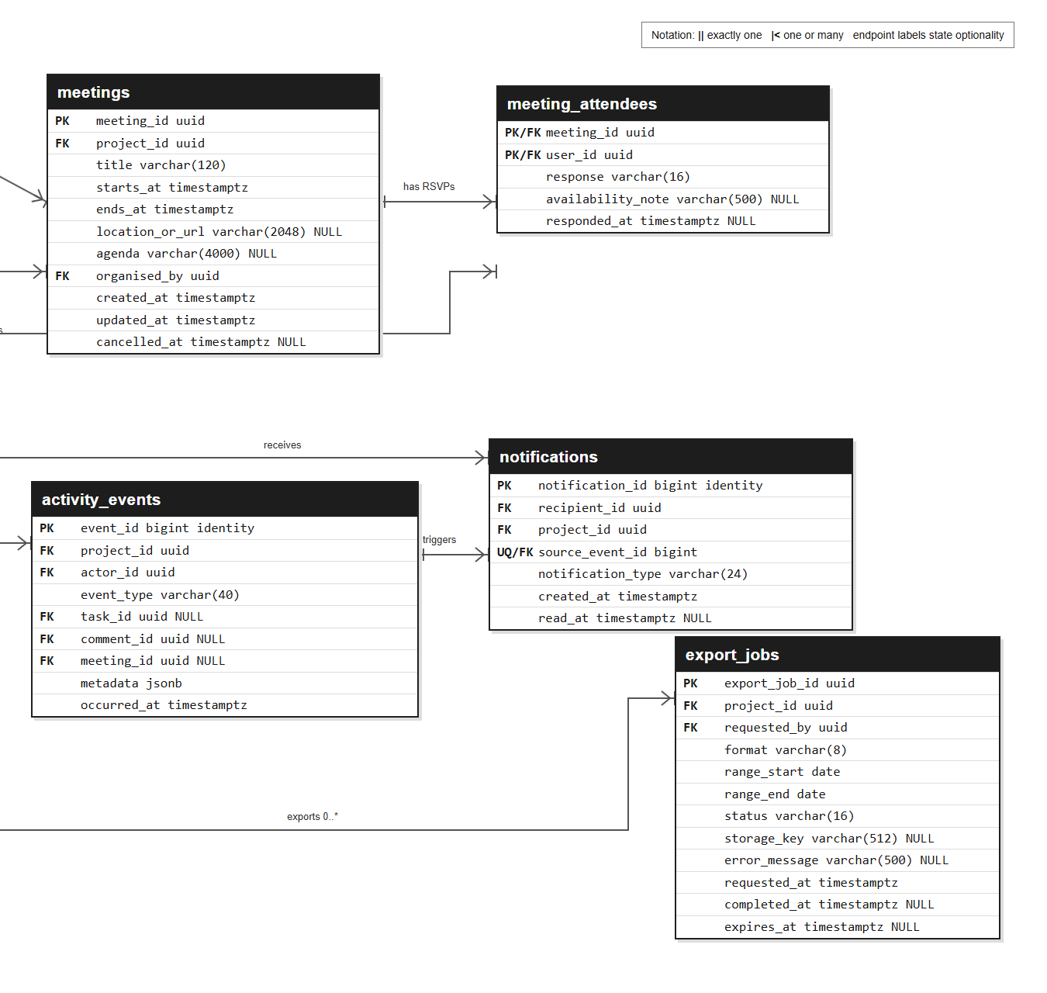
Figure 3B. Physical ERD 3/3 (centre/right view) in Crow's Foot notation. The deliberate overlap preserves relationship context; the complete landscape diagram is included in the repository.

3.4 Integrity and performance controls
Concern | Control
Duplicate identity | Lowercase email check plus unique users.email
Multiple active owners | Partial unique index on active owner membership
Duplicate invitations / notifications | Partial and composite unique indexes
Invalid workflow state | CHECK domains for task, meeting, invitation, export and notification state
Inconsistent completion | Task completion timestamp constraint tied to done status
Slow board and evidence queries | Composite indexes on project/status/priority and project/occurred_at
Evidence tampering | Append-only activity policy; application roles receive no UPDATE/DELETE grant

4. Wireframes
The wireframes intentionally omit colour and theming. They define information hierarchy, user controls, error/empty-state intent and cross-view flow. Requirement tags embedded in each frame make coverage directly inspectable.

WF-01 · Authentication
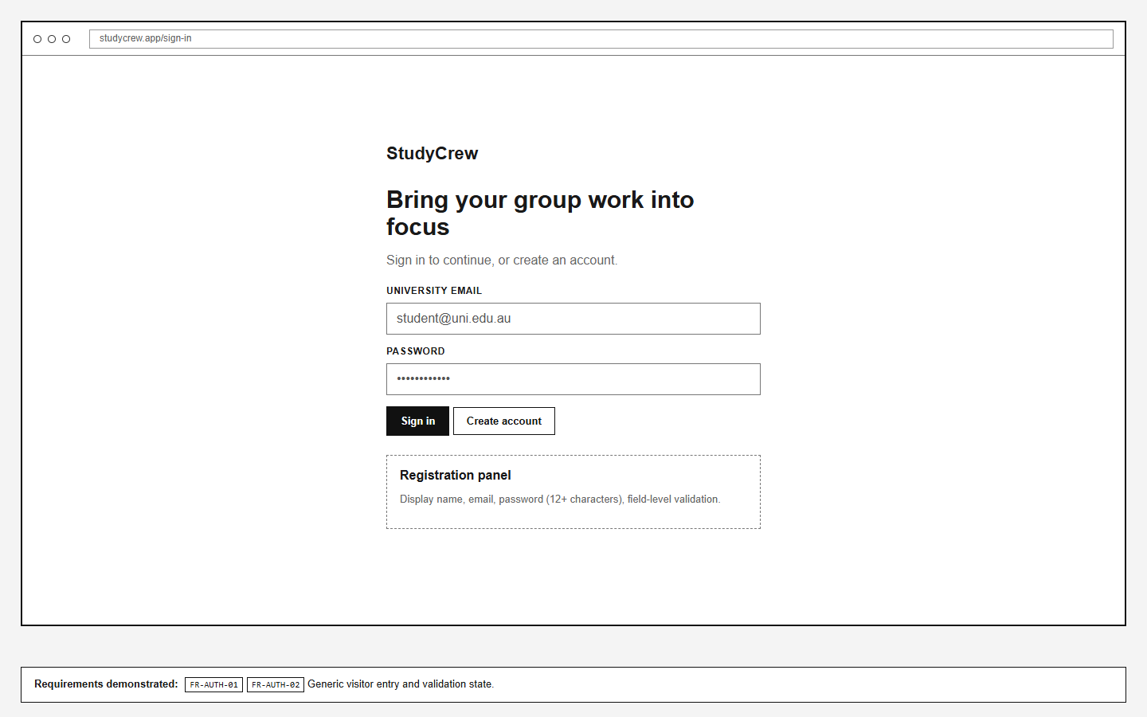
Figure 4. WF-01 Authentication. Coverage: FR-AUTH-01, FR-AUTH-02.

WF-02 · Project dashboard
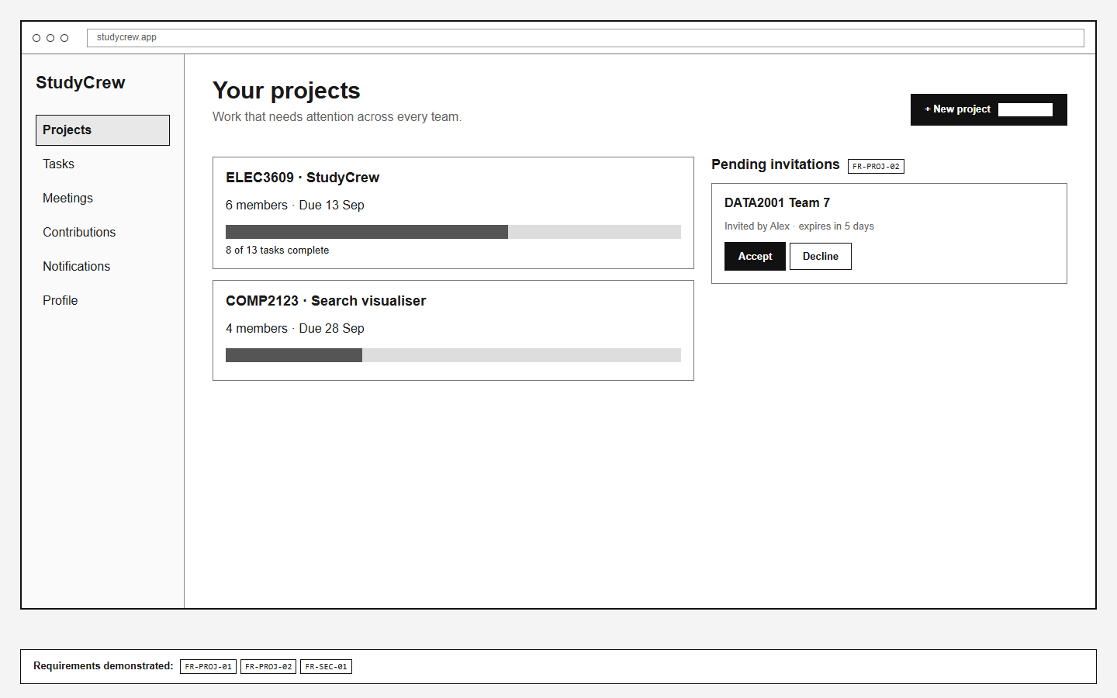
Figure 5. WF-02 Project dashboard. Coverage: FR-PROJ-01, FR-PROJ-02, FR-SEC-01.

WF-03 · Project overview
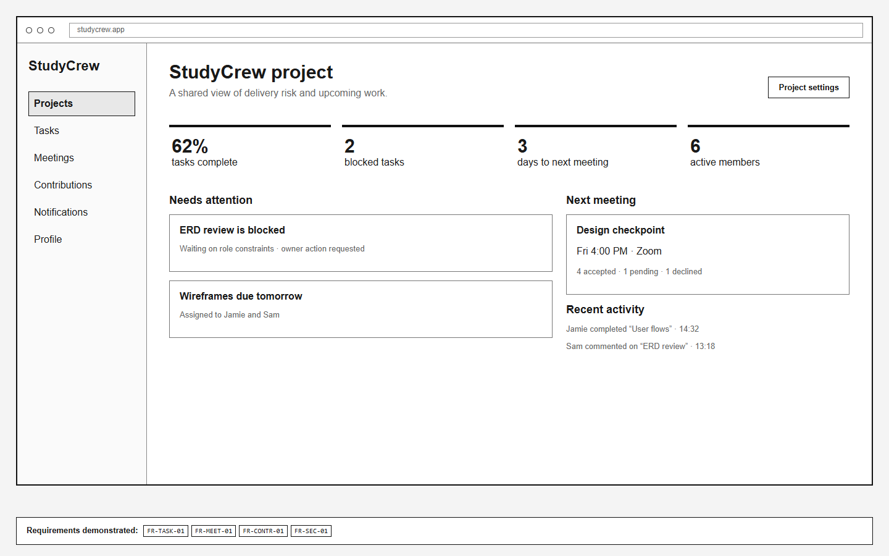
Figure 6. WF-03 Project overview. Coverage: FR-PROJ-01, FR-TASK-01, FR-MEET-01, FR-CONTR-01, FR-SEC-01.

WF-04 · Task board
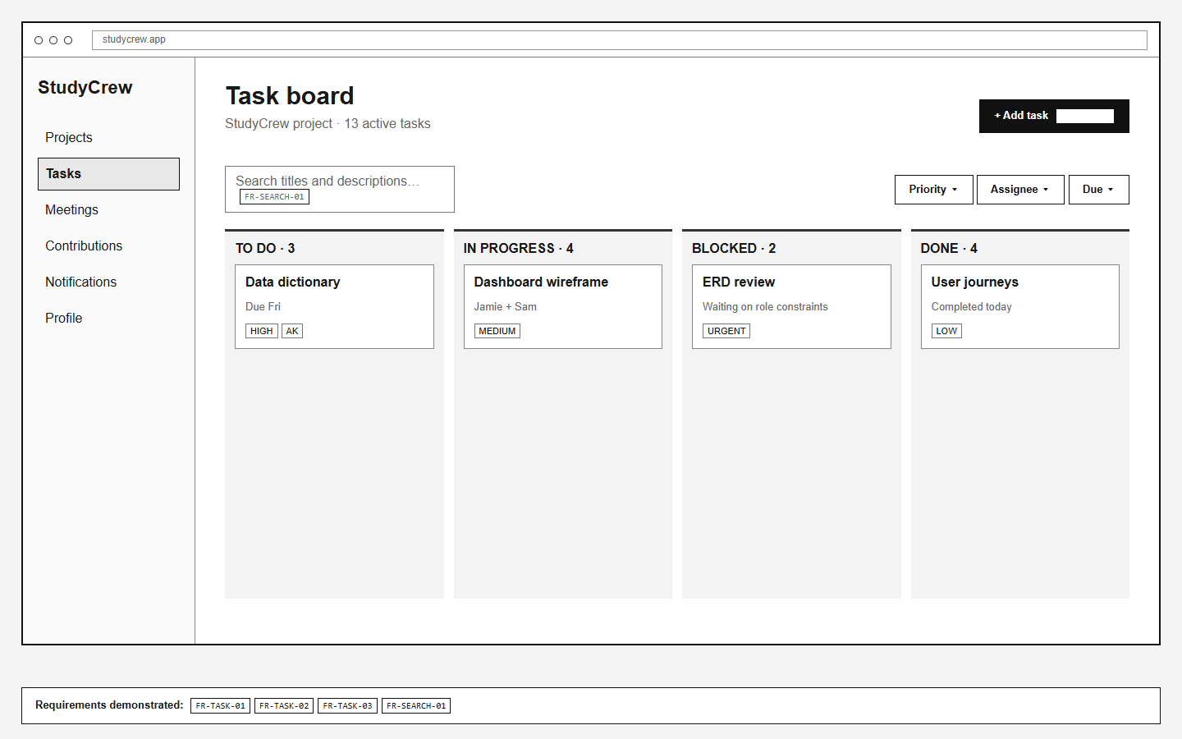
Figure 7. WF-04 Task board. Coverage: FR-TASK-01, FR-TASK-02, FR-TASK-03, FR-SEARCH-01, FR-SEC-01.

WF-05 · Task detail and discussion
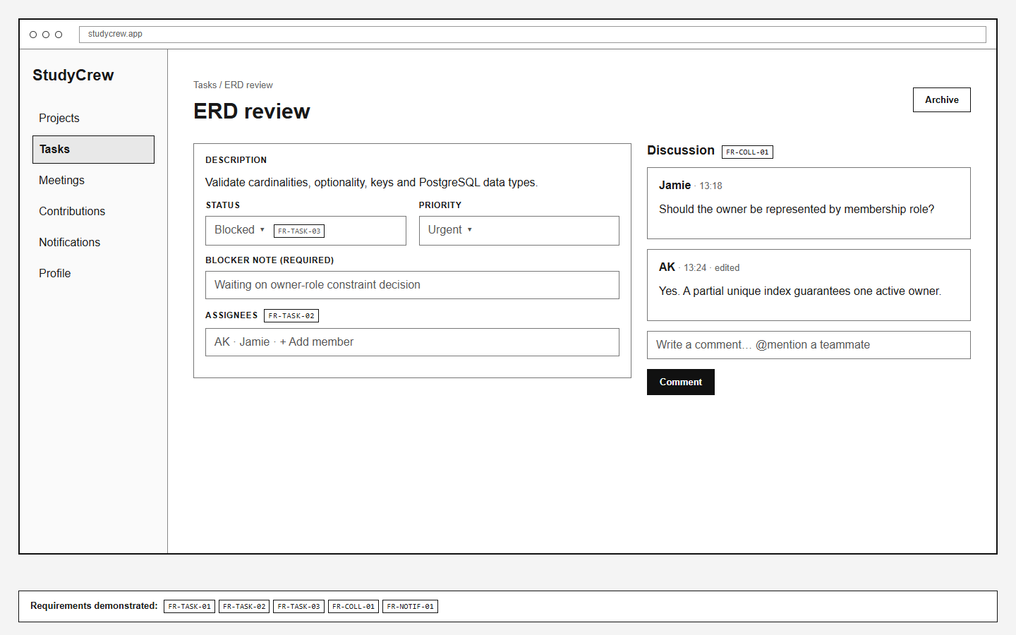
Figure 8. WF-05 Task detail and discussion. Coverage: FR-TASK-01, FR-TASK-02, FR-TASK-03, FR-COLL-01, FR-NOTIF-01, FR-SEC-01.

WF-06 · Members and invitations
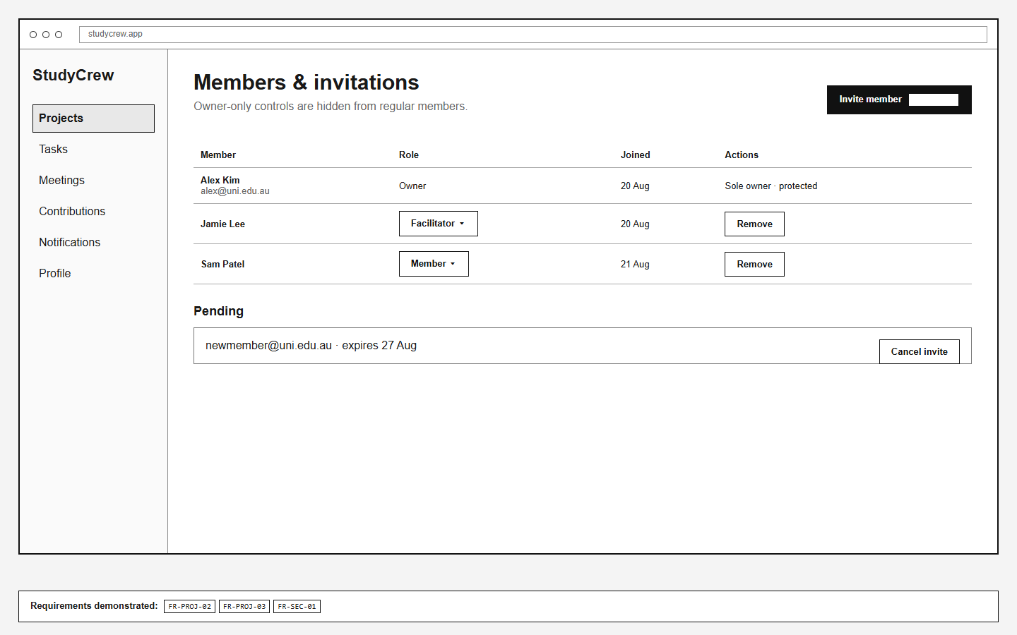
Figure 9. WF-06 Members and invitations. Coverage: FR-PROJ-02, FR-PROJ-03, FR-SEC-01.

WF-07 · Meetings and RSVP
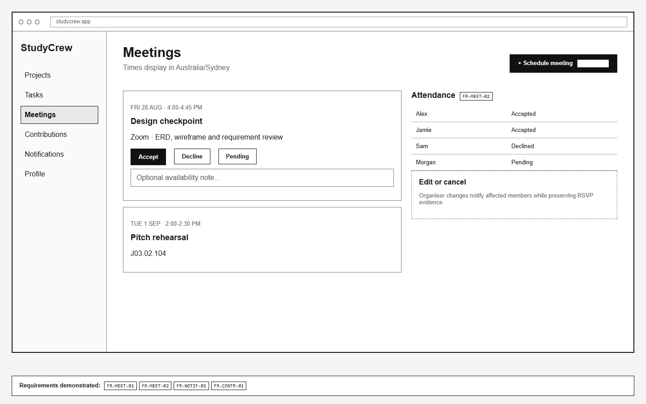
Figure 10. WF-07 Meetings and RSVP. Coverage: FR-MEET-01, FR-MEET-02, FR-CONTR-01, FR-NOTIF-01, FR-SEC-01.

WF-08 · Contribution evidence
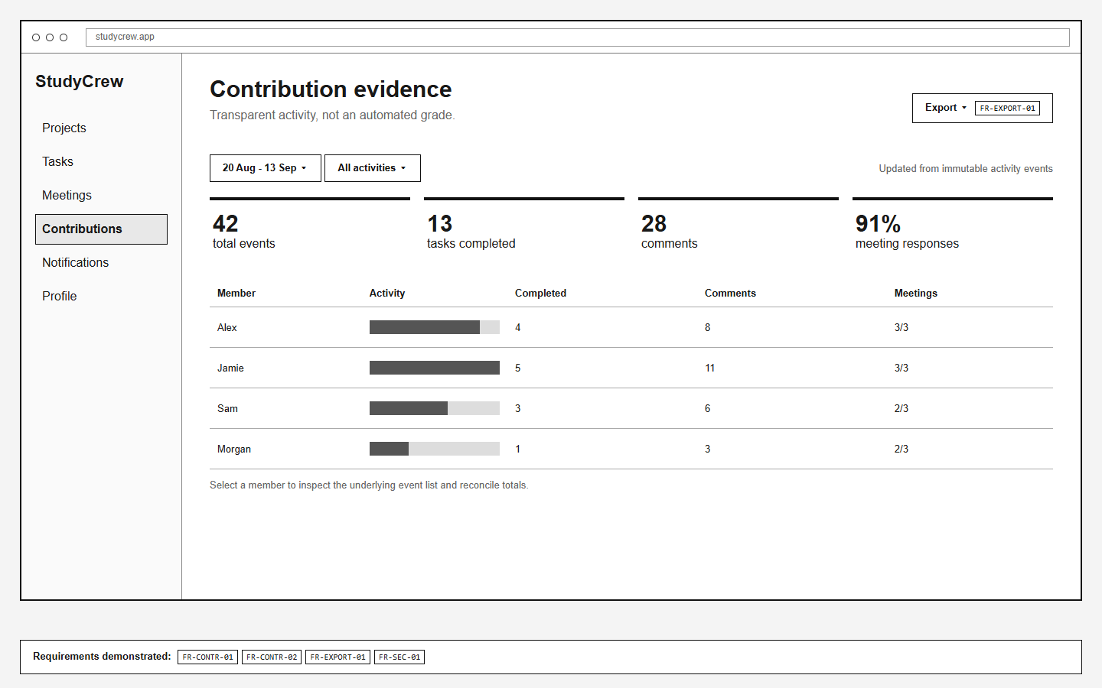
Figure 11. WF-08 Contribution evidence. Coverage: FR-CONTR-01, FR-CONTR-02, FR-EXPORT-01, FR-SEC-01.

WF-09 · Notifications
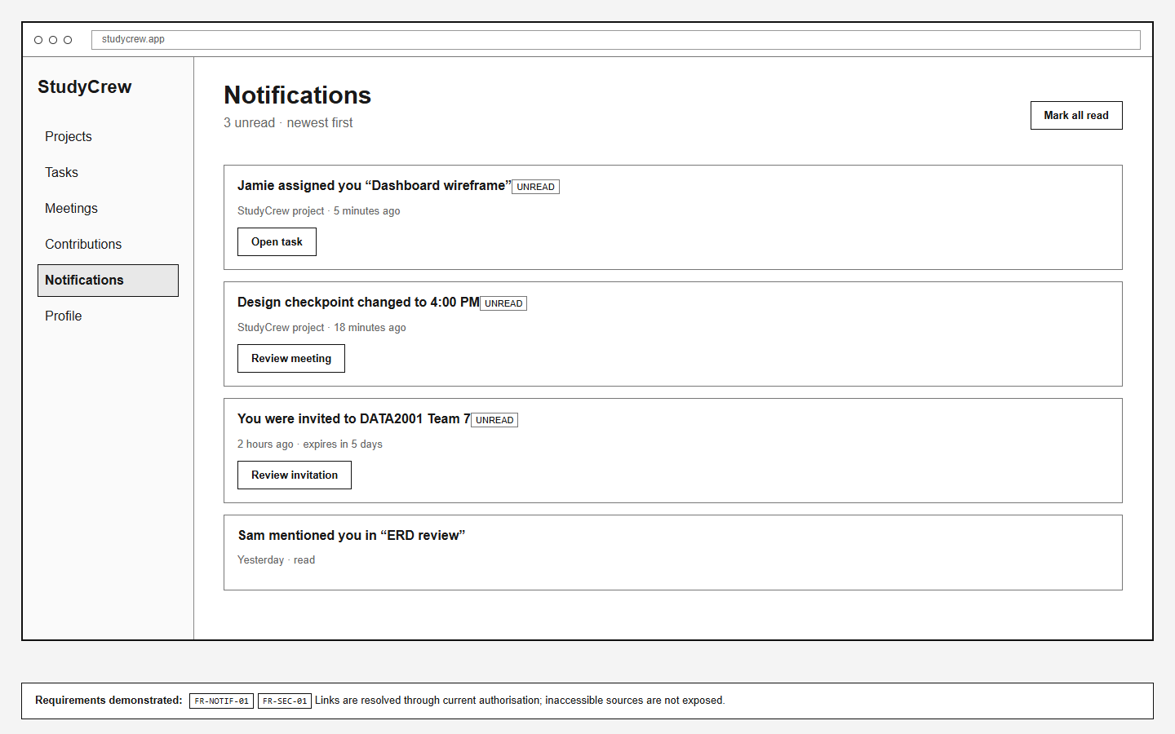
Figure 12. WF-09 Notifications. Coverage: FR-NOTIF-01, FR-SEC-01.

WF-10 · Profile
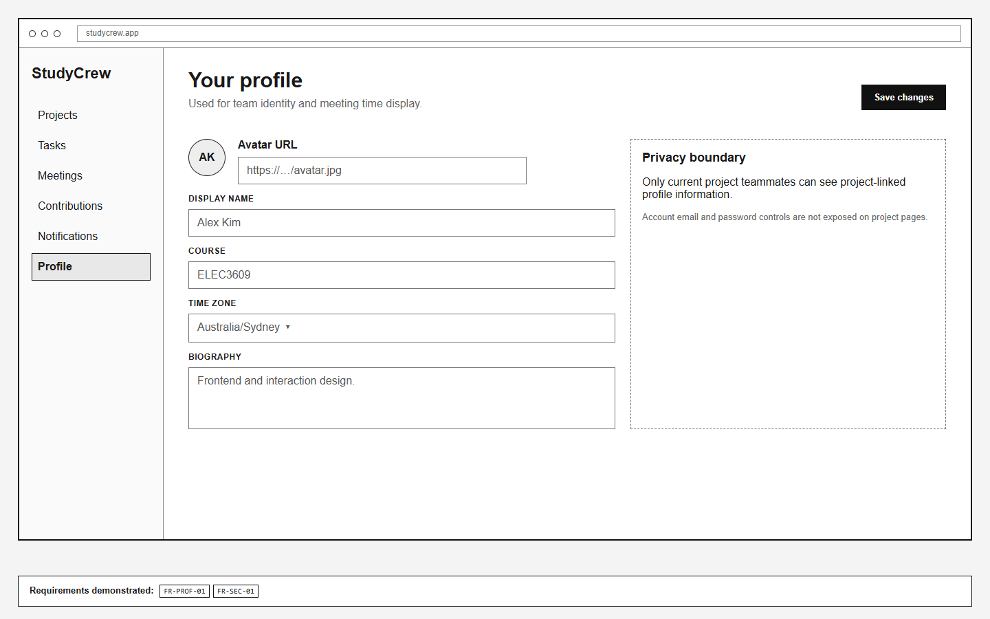
Figure 13. WF-10 Profile. Coverage: FR-PROF-01, FR-SEC-01.

WF-11 · Evidence export
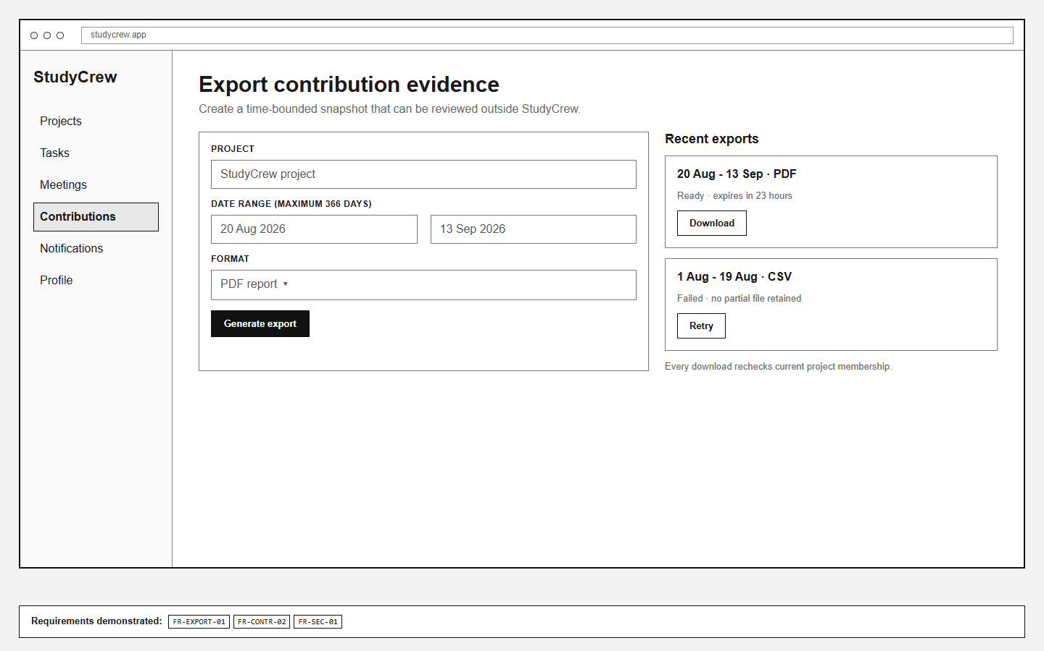
Figure 14. WF-11 Evidence export. Coverage: FR-CONTR-02, FR-EXPORT-01, FR-SEC-01.

4.1 End-to-end user flows
Flow | Views | Completion evidence
Start a team | WF-01 → WF-02 → WF-06 → WF-03 | Owner account, project and accepted membership exist
Deliver a task | WF-04 → WF-05 → WF-04 | Task assigned, discussed and moved to done with event record
Coordinate a meeting | WF-07 → WF-09 | Valid UTC meeting, one RSVP per member and change notification
Review contribution | WF-08 → event drill-down → WF-11 | Totals reconcile to immutable events and authorised export

5. Traceability matrix
Requirement | Primary tables | Wireframes | MVP
FR-AUTH-01 | users; profiles | WF-01 | Yes
FR-AUTH-02 | users | WF-01 | Yes
FR-PROF-01 | profiles | WF-10 | Yes
FR-PROJ-01 | projects; project_members | WF-02; WF-03 | Yes
FR-PROJ-02 | project_invitations; project_members | WF-02; WF-06 | Yes
FR-PROJ-03 | project_members; activity_events | WF-06 | Yes
FR-TASK-01 | tasks; activity_events | WF-03; WF-04; WF-05 | Yes
FR-TASK-02 | task_assignees; project_members; notifications | WF-04; WF-05 | Yes
FR-TASK-03 | tasks; activity_events | WF-04; WF-05 | Yes
FR-COLL-01 | task_comments; activity_events; notifications | WF-05 | Yes
FR-MEET-01 | meetings; activity_events; notifications | WF-03; WF-07 | Yes
FR-MEET-02 | meeting_attendees; activity_events | WF-07 | Yes
FR-CONTR-01 | activity_events | WF-03; WF-07; WF-08 | Yes
FR-CONTR-02 | activity_events; tasks; task_comments; meeting_attendees | WF-08; WF-11 | Yes
FR-NOTIF-01 | notifications; activity_events | WF-05; WF-07; WF-09 | Yes
FR-SEARCH-01 | tasks; task_assignees | WF-04 | No
FR-EXPORT-01 | export_jobs; activity_events | WF-08; WF-11 | No
FR-SEC-01 | all project-scoped tables | WF-02 to WF-11 | Yes
Coverage audit: 18/18 requirements map to at least one table and one wireframe. All 13 tables appear in the ERDs. The 15 MVP requirements map to concrete acceptance conditions; the two post-MVP features remain designed and traceable.

6. Quality, feasibility and risk

6.1 Security and privacy
Server-side authorisation derives identity from the session and checks current membership before every project-scoped query or mutation. Password hashes, invitation token hashes and account emails never enter activity metadata or exports. Soft removal immediately revokes project access. Exports expire after 24 hours and each download rechecks membership.

6.2 Accessibility and responsive behaviour
Interactive controls use visible labels and keyboard focus; task status changes are announced in an accessible live region; charts have equivalent tables; errors identify fields in text; and colour is never the sole state indicator. At narrow widths, the sidebar becomes a menu, board columns scroll horizontally with labelled regions and forms collapse to one column without changing function.

6.3 Feasibility
Layer | Proposed dependency | Reason
Client | React + accessible component primitives | Responsive views and predictable state-driven interactions
API | Node.js + Express | Small-team familiarity and testable REST boundary
Data | PostgreSQL + Prisma | Relational integrity, transactions and explicit migrations
Testing | Vitest + Playwright | Unit, integration, access-control and end-to-end journeys
Delivery | GitHub Actions + Docker | Repeatable checks and environment parity

6.4 Principal risks
Risk | Likelihood / impact | Mitigation and trigger
Activity counts interpreted as grades | Medium / High | No score; show definitions and event drill-down; revise language if users infer quality
Scope expansion | High / Medium | Freeze approved MVP; search/export remain post-MVP until quality gates pass
Authorisation leak | Low / High | Central policy middleware and route-by-role matrix in CI
Late integration | Medium / High | Vertical slices from week 7; seeded journeys pass at each milestone

References
[1] IEEE Computer Society, IEEE Std 830-1998, IEEE Recommended Practice for Software Requirements Specifications, 1998. Superseded standard; used because the assignment explicitly requires Section 5.3.2.
[2] ELEC3609/9609 Group Project, Assignment 1: System & Database Design, 2026.
Schema source: database/schema.sql. Requirement source: docs/requirements.md. Traceability source: docs/traceability.csv.

