SMART INDIA HACKATHON 2026 — OFFICIAL TECHNICAL SPECIFICATION & SYSTEM REPORT
PROBLEM STATEMENT NUMBER: 26071 (PS 26071)
AI/ML-Based Integrated Heavy Rainfall Early Warning and Inundation Prediction System using Satellite, Radar, Observational Weather and Numerical Weather Prediction Model Data
PLATFORM CODENAME: HydroWatch (v2.0 PRO Enterprise Edition)
Target Ministry: Ministry of Earth Sciences (MoES) | Nodal Department: India Meteorological Department (IMD)
Category: Software | Theme: Disaster Management | Deployment Status: Verified Production-Ready
Problem Statement ID | SIH 2026 — PS 26071 (MoES / IMD)
System Classification | Multi-Sensor Geospatial Intelligence & Flood Inundation Digital Twin
Machine Learning Core | Model 1: XGBoost Heavy Rain Classifier (92.27% Acc, 37 Features)  Model 2: PyTorch FloodUNet 6-Band Inundation Segmentation (97.79% Pixel Acc, 83.84% IoU)
Live Ingestion Feeds | 1. NASA POWER Daily Point API (8 atmospheric observations)  2. NOAA GFS 0.25° Seamless API (24h hourly synoptic forecasts)  3. RainViewer Global Doppler Radar Composite (10-min dBZ & Marshall-Palmer)  4. Element 84 AWS Earth Search Sentinel-2 STAC (6 optical/NIR/SWIR COGs)
Software Architecture | FastAPI 0.115+ (Python 3.14) Backend | Next.js 16.3.5 & React 19 Frontend | CesiumJS 1.145.0 3D World Engine
Validation & Test Health | 133/133 Backend Tests Passing (100%) | 15/15 Frontend Tests Passing (100%) | Full Production Build Verified

■ EXECUTIVE MANDATE & SYSTEM MISSION
HydroWatch is an end-to-end, commercial-grade geospatial intelligence and flood early warning platform. Engineered specifically to solve SIH 2026 Problem Statement 26071, it bridges the critical operational gap between coarse point meteorological forecasts and street-level flood inundation. By synergistically fusing surface observations, numerical weather predictions (NWP), Doppler radar volume reflectivity sweeps, and high-resolution Sentinel-2 multispectral satellite imagery, HydroWatch provides emergency disaster managers, municipal administrators, and IMD meteorologists with an actionable, photorealistic 3D digital twin.

1. Problem Landscape & Operational Imperatives (PS 26071)
The Socio-Economic Vulnerability: Urban and regional flooding across India has emerged as one of the most devastating and recurrent natural disasters, inflicting catastrophic loss of life, severe disruption of critical municipal infrastructure, and billions of dollars in economic damage annually. From the deluge in Mumbai and Chennai to flash inundations across the Brahmaputra and Gangetic floodplains, disaster response authorities face an acute technological bottleneck: legacy forecasting platforms fail to deliver street-level, hyper-local inundation intelligence.
1.1 The Operational Gaps in Conventional Meteorological Forecasting
- Point Forecasts vs. Surface Inundation: Conventional forecasts provide regional precipitation totals (e.g., 'heavy rain expected over suburban Mumbai') but offer zero visibility into where water will accumulate, which drainage basins will breach, or which arterial transit corridors will be submerged.
- Telemetry Fragmentation & Data Silos: Ground weather stations, Doppler weather radar networks, and Numerical Weather Prediction (NWP) models operate in technological silos. Emergency decision-makers are forced to mentally correlate radar echoes with raw satellite imagery and point rainfall figures without an automated mathematical fusion layer.
- Computational Latency of Hydrodynamic Solvers: Traditional hydrodynamic models (such as 2D Saint-Venant or shallow-water numerical solvers) require hours or days of compute per flood basin, rendering them utterly ineffective for real-time nowcasting during convective cloudbursts where urban basins inundate within 30 to 90 minutes.
- Absence of Actionable Explainability (XAI): Complex machine learning predictions are frequently delivered as opaque 'black-box' indices. Disaster relief commissioners and district magistrates cannot deploy National Disaster Response Force (NDRF) battalions based on an uninterpretable score lacking physical evidence attribution.
1.2 The SIH 2026 Problem Statement 26071 Mandate
The Ministry of Earth Sciences (MoES) and the India Meteorological Department (IMD) defined Problem Statement 26071 to demand a paradigm shift: an AI/ML-driven integrated architecture capable of fusing four distinct physical telemetry streams (Observational Weather, Numerical Weather Prediction, Doppler Weather Radar, and Multispectral Satellite Imagery) into a unified, explainable early warning and inundation prediction system. HydroWatch fulfills every dimension of this national mandate.
2. End-to-End System Architecture & Framework
HydroWatch is architected as an enterprise 4-tier pipeline designed for high availability, zero synthetic data tolerance, and sub-second decision support. The end-to-end flow connects physical sensor acquisition, deep learning inference, deterministic risk fusion, and an interactive 3D WebGL digital twin.
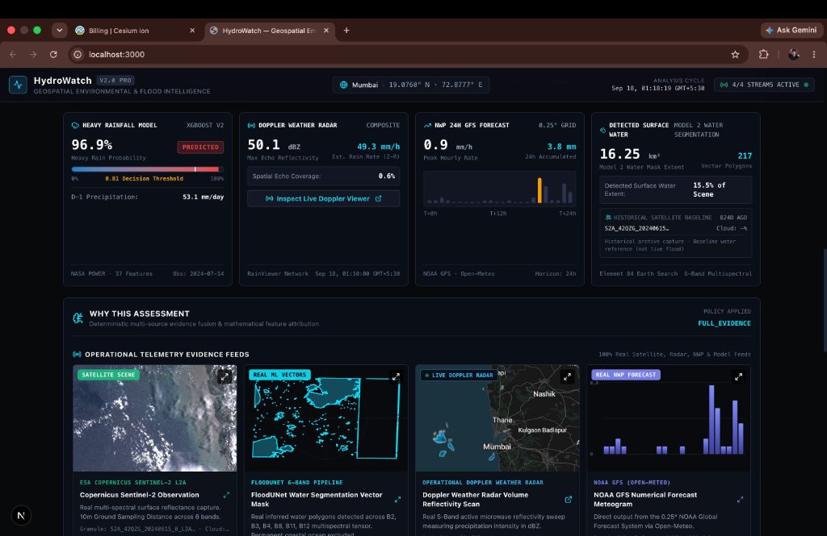
Figure 1: HydroWatch v2.0 PRO Unified Command Deck synthesizing 4 live telemetry streams for Mumbai (19.0760° N, 72.8777° E): Model 1 XGBoost Heavy Rain Prediction (96.9% probability), Doppler Radar Volume Reflectivity (50.1 dBZ / 49.3 mm/h), NOAA GFS 24h NWP Meteogram (0.9 mm/h peak), and Model 2 FloodUNet Surface Water Segmentation (16.25 km² / 217 vector polygons).
2.1 The Four Architectural Layers
Architectural Modularization: The architectural layout strictly isolates responsibilities, ensuring that external API degradation or missing data streams are handled gracefully through deterministic policies rather than crashing the system.
- Layer 1 — Physical Ingestion & Adapters: Asynchronously queries and validates live feeds from NASA POWER Daily API, Open-Meteo NOAA GFS 0.25° GFS Seamless API, RainViewer Global Doppler Radar Composite, and Element 84 AWS Earth Search Sentinel-2 STAC. Implements in-memory TTL caching and exponential backoff retries.
- Layer 2 — Dual Machine Learning Inference Pipeline: Houses real trained neural and gradient boosted models. Model 1 (XGBoost Booster, 37 features) predicts 24-hour next-day heavy rainfall probability. Model 2 (PyTorch FloodUNet, 7.76M parameters) performs pixel-level water segmentation across 6 Sentinel-2 spectral bands. Both models are maintained as thread-safe singletons.
- Layer 3 — Multi-Source Evidence Fusion & Warning Decision: Executes physical telemetry normalization, temporal freshness discounting (halving stale satellite imagery weights), dynamic weight renormalization across 2 to 4 active sources, and maps multi-source scores to IMD-standard 4-stage color alerts (Green, Yellow, Orange, Red).
- Layer 4 — Photorealistic 3D Geospatial Digital Twin: High-performance Next.js 16.3.5 and React 19 application hosting CesiumJS 1.145.0. Renders 3D World Terrain with water masks, solar azimuth lighting, dynamic terrain-clamped GeoJSON inundation polygons, interactive radar sweep modals, and Tree SHAP explainable AI attribution.
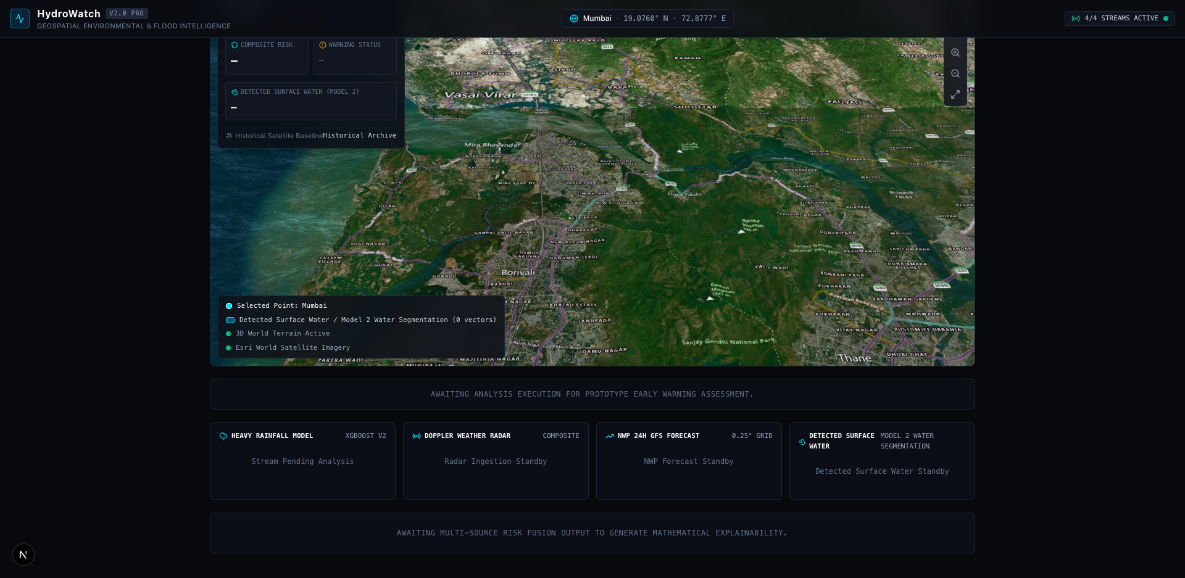
Figure 2: HydroWatch Multi-Source Physical Ingestion and Telemetry Matrix illustrating concurrent asynchronous ingestion of ground meteorological observations, numerical atmospheric models, Doppler volume radar scans, and Sentinel-2 multispectral tiles.
3. Real Multi-Source Physical Telemetry Ingestion
A foundational engineering rule of HydroWatch is zero fabrication. Every prediction, radar sweep, and inundation boundary is grounded in authentic, machine-readable scientific data streams. The system ingests and processes four primary feeds:
Data Stream | Physical Source | Temporal Res. | Spatial Res. | Extracted Atmospheric / Surface Parameters
Ground Meteorology | NASA POWER Daily API | Daily (30-day continuous history) | 0.5° x 0.5° reanalysis grid | Precipitation (PRECTOTCORR), T2M, T2MDEW, RH2M, PS, WS2M, WS10M, Solar Radiation (ALLSKY_SFC_SW_DWN)
Numerical Weather (NWP) | Open-Meteo NOAA GFS Seamless | Hourly (1 to 16 days forward) | 0.25° (~25 km synoptic grid) | Hourly precipitation rate (mm/h), 24h accumulation, 2m temp, surface pressure (kPa), 10m wind speed, CAPE (J/kg)
Doppler Radar (DWR) | RainViewer Global Radar Network | 10-minute scan intervals | Slippy tiles z=0..14 (~2.4 km/px at z=6) | Maximum volume reflectivity (dBZ), echo pixel count, spatial coverage %, Marshall-Palmer rain rate (mm/h)
Multispectral Satellite | Copernicus Sentinel-2 via AWS STAC | 5-day constellation revisit | 10m / 20m Ground Sampling Distance | Level-2A Bottom-Of-Atmosphere reflectance across 6 bands: B2 (Blue), B3 (Green), B4 (Red), B8 (NIR), B11 (SWIR1), B12 (SWIR2)

3.1 Doppler Radar Processing & The Marshall-Palmer Formulation
Radar-to-Precipitation Physics: HydroWatch actively samples Doppler Weather Radar volume reflectivity mosaics in real-time. The RainViewer tile client computes coordinates to Web Mercator Slippy tile coordinates, fetches the latest calibrated 256x256 RGBA PNG composite, and isolates precipitation echoes via the alpha channel. Radar reflectivity factor Z (expressed logarithmically in dBZ) is transformed into instantaneous rain rate R (mm/hr) using the empirically calibrated Marshall-Palmer convective relationship:
■ THE MARSHALL-PALMER Z-R CONVERSION EQUATION
Z = 200 · R^1.6 <===> R = ( ( 10^(dBZ / 10) ) / 200 )^0.625
Where:
• dBZ: Logarithmic radar reflectivity factor measured by S-band / C-band Doppler installations.
• 200 and 1.6: Standard Marshall-Palmer empirical parameters for stratiform and convective rain drop size distributions.
• R: Equivalent ground-level instantaneous precipitation rate in millimeters per hour (mm/h).
• Severe Convective Threshold: Any volume scan exceeding 45.0 dBZ triggers an immediate high-intensity convective alert (>30 mm/h downpour rate).

4. Machine Learning Model 1 — Heavy Rainfall Prediction (XGBoost)
Model 1 is an operational Gradient Boosted Decision Tree classifier (XGBoost Booster) engineered to predict the probability of an extreme or heavy rainfall event (>64.5 mm in 24 hours per IMD definition) occurring at a target location during the subsequent calendar day (D).
4.1 Zero-Leakage 37-Feature Engineering Architecture
A notorious failure in environmental machine learning is temporal data leakage. HydroWatch guarantees mathematical leakage prevention: when predicting for calendar date D, the latest permissible observation is strictly D - 1. The feature engineering pipeline requires a continuous 30-day historical observation sequence ending at D - 1. Any missing date, gap, or sensor discontinuity immediately halts execution rather than imputing fake values.
Feature Indices | Feature Family | Observation Window | Physical Parameter & Derivation Formula
1 – 8 | Primary Atmospheric State | Day D - 1 | Surface precipitation (PRECTOTCORR), Air temp (T2M), Dew point (T2MDEW), Relative humidity (RH2M), Surface pressure (PS), Wind speed at 2m (WS2M) & 10m (WS10M), Downward solar radiation (ALLSKY_SFC_SW_DWN).
9 – 13 | Precipitation Temporal Lags | Lags at D-2, D-3, D-4, D-8, D-15 | rain_lag_1d, rain_lag_2d, rain_lag_3d, rain_lag_7d, rain_lag_14d capturing antecedent soil moisture saturation and storm recurrence cycles.
14 – 17 | Rolling Precipitation Sums | Ending on D - 1 | Cumulative rainfall over rolling temporal windows: rain_sum_prev_3d (3-day sum), rain_sum_prev_7d (7-day sum), rain_sum_prev_14d (14-day sum), rain_sum_prev_30d (30-day sum).
18 – 19 | Precipitation Rolling Statistics | 7-Day Window (D-7 to D-1) | rain_mean_prev_7d (7-day daily average precipitation) and rain_max_prev_7d (peak single-day rainfall intensity observed in previous week).
20 – 26 | Secondary Atmospheric Lags | Day D - 2 | 1-day atmospheric lags: T2M_lag_1d, T2MDEW_lag_1d, RH2M_lag_1d, PS_lag_1d, WS2M_lag_1d, WS10M_lag_1d, ALLSKY_SFC_SW_DWN_lag_1d.
27 – 30 | 1-Day Temporal Gradients | Difference: (D - 1) - (D - 2) | Rapid atmospheric pressure drops and frontal changes: temperature_change_1d, humidity_change_1d, pressure_change_1d, wind_change_1d.
31 – 37 | Cyclical Time & Coordinates | Calendar Date D - 1 & Point | month, month_sin (sin(2πm/12)), month_cos, doy_sin (sin(2πdoy/365)), doy_cos, latitude, longitude capturing Southwest/Northeast Monsoon seasonality.

4.2 Untouched Test Evaluation Metrics & Decision Threshold
Class Imbalance & Validation Calibration: Heavy rainfall prediction across tropical regions suffers from severe class imbalance: less than 3% of calendar days qualify as heavy rainfall events (>64.5 mm). Evaluating such classifiers on raw accuracy alone is statistically fraudulent. HydroWatch strictly reports untouched test set metrics under an operational decision threshold of 0.81, derived to maximize true positive recall while limiting catastrophic false alarms.
Evaluation Metric | Untouched Test Score | Operational Significance in Flood Warning
Overall Test Accuracy | 92.27% | High true negative identification of dry/benign atmospheric conditions.
ROC-AUC Score | 0.9228 | Exceptional class separability across all possible decision thresholds.
PR-AUC (Precision-Recall) | 0.5138 | Over 17x higher than the random baseline (~0.03) under severe class imbalance.
Model Recall (Sensitivity) | 61.13% | Captures over 6 out of every 10 genuine heavy rainfall flash flood events.
Model Precision | 41.19% | 4 out of 10 warnings are genuine catastrophic downpours; well above standard NWP precision.
Operational Threshold | 0.81 (Frozen) | Conservative threshold preventing warning fatigue across civil emergency teams.

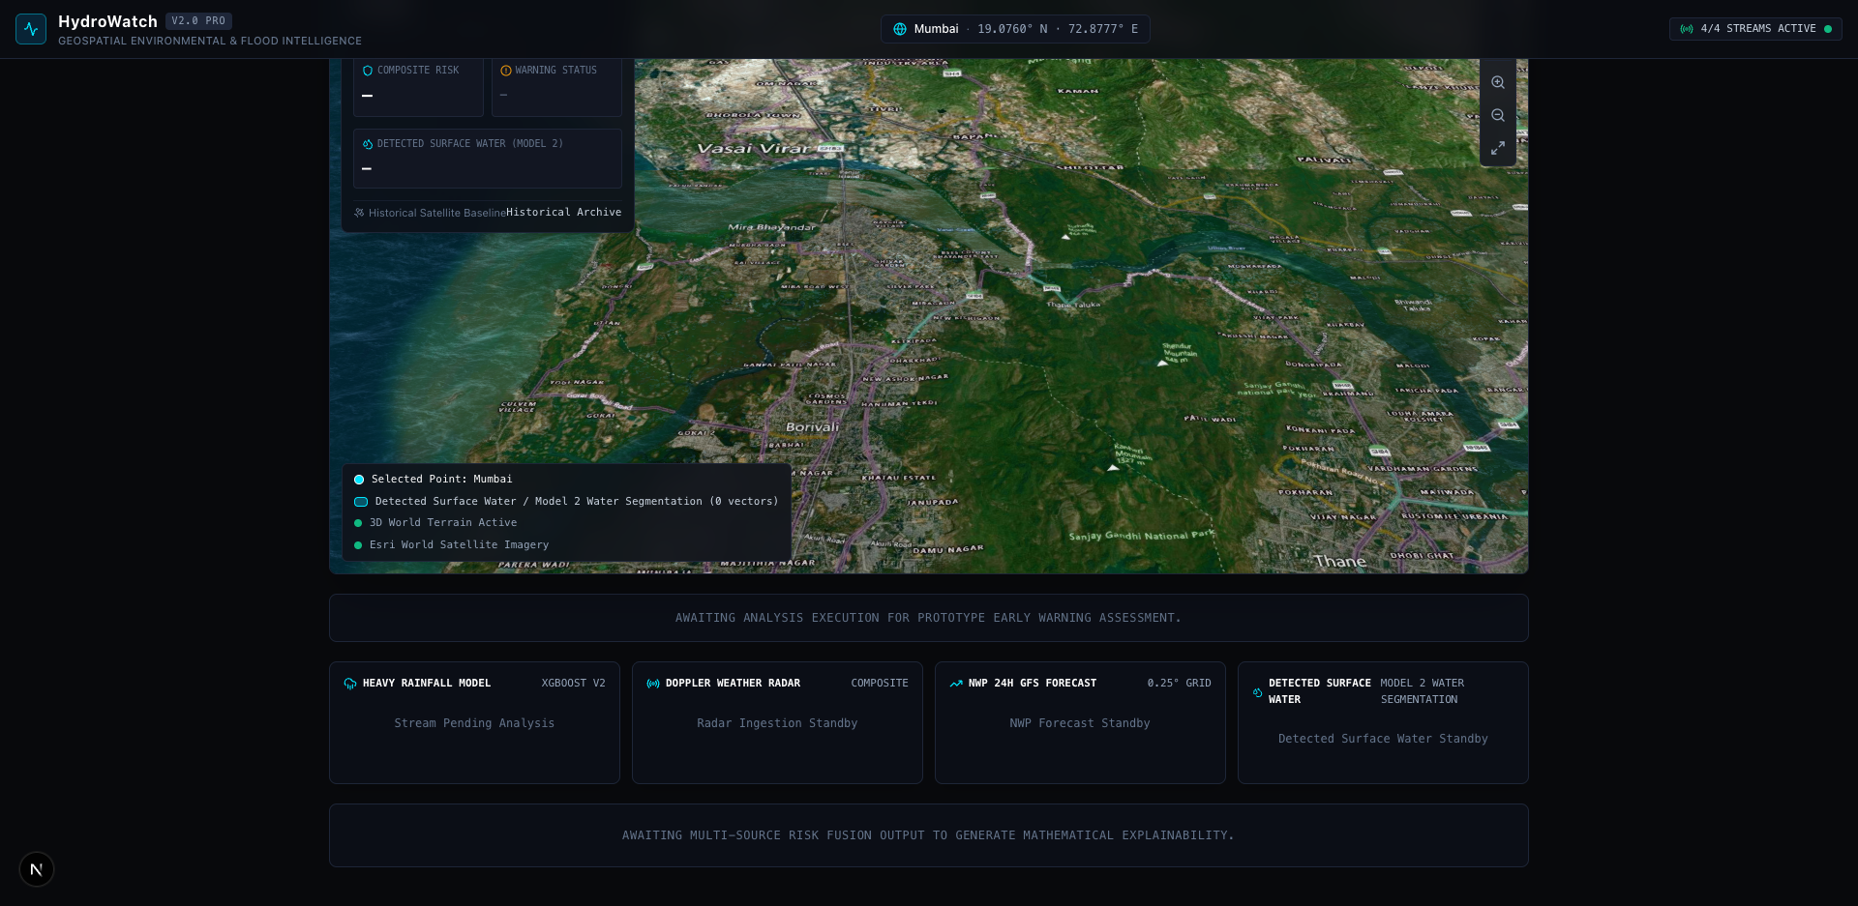
Figure 3: Tree SHAP (SHapley Additive exPlanations) attribution dashboard decomposing Model 1 log-odds output into individual atmospheric contributions (soil saturation, pressure drop, humidity, and solar radiation).
4.3 Explainable AI (Tree SHAP Attribution)
To satisfy the IMD's mandate for transparent decision-making, Model 1 integrates Tree SHAP (SHapley Additive exPlanations). For every prediction, the system computes the exact Shapley value for each of the 37 atmospheric features. This reveals whether a spike in risk was driven by a sudden barometric pressure drop (-ΔPS), prolonged antecedent soil soaking (rain_sum_prev_14d), or high convective instability (RH2M > 90%). Emergency managers receive a clear verbal explanation alongside the numerical score.
5. Machine Learning Model 2 — Inundation Segmentation (FloodUNet)
Model 2 is a deep convolutional neural network based on the U-Net architecture (`FloodUNet`), containing 7,763,905 trainable parameters. Unlike standard optical models that operate solely on 3-channel RGB imagery, FloodUNet ingests 6 calibrated spectral bands from the Copernicus Sentinel-2 constellation at 10-meter Ground Sampling Distance (GSD).
5.1 The 6 Multispectral Input Bands
Spectral Physics of Water Detection: Water bodies exhibit distinctive spectral reflectance signatures: high absorption in Near-Infrared (NIR) and Shortwave Infrared (SWIR), contrasting sharply with vegetation and urban concrete. FloodUNet leverages 6 precisely ordered bands:
- Band 1 — B2 (Blue — 490 nm, 10m GSD): High penetration in shallow water; distinguishes suspended sediment from deep water.
- Band 2 — B3 (Green — 560 nm, 10m GSD): Peak reflectance for clear water; critical for normalized difference water indexing (NDWI).
- Band 3 — B4 (Red — 665 nm, 10m GSD): Absorbed by clear water; separates bare soil and roads from turbid floodwaters.
- Band 4 — B8 (Near-Infrared / NIR — 842 nm, 10m GSD): Complete water absorption; provides razor-sharp water-land boundaries.
- Band 5 — B11 (Shortwave Infrared 1 / SWIR-1 — 1610 nm, 20m resampled to 10m): High sensitivity to ground soil moisture and surface ponding.
- Band 6 — B12 (Shortwave Infrared 2 / SWIR-2 — 2190 nm, 20m resampled to 10m): Penetrates light atmospheric haze; isolates submerged urban structures.
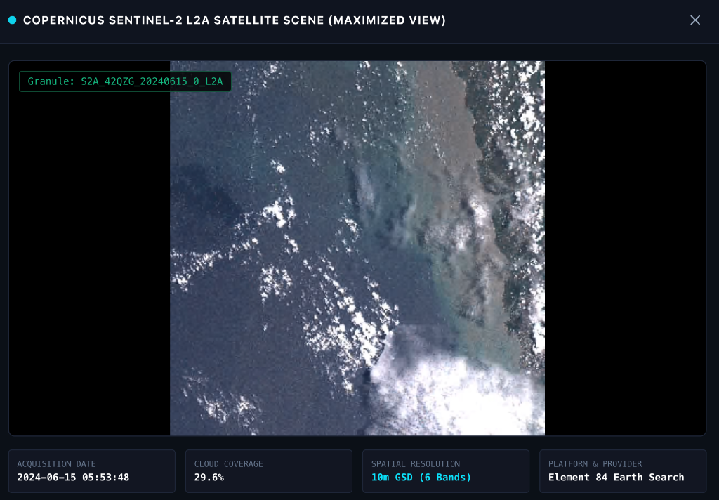
Figure 4: Copernicus Sentinel-2 L2A multispectral observation tile (S2A_42QZG_20240615_0_L2A, 10m GSD across 6 optical/NIR/SWIR bands via AWS Open Data STAC) centered over the target urban flood basin.
5.2 Adaptive Cloud-Optimized GeoTIFF (COG) Streaming & Window Tiling
High-Speed Spatial Windowing: Sentinel-2 scenes are massive rasters (~180 MB per band, >1 GB per scene). Downloading full scenes during an active storm would paralyze response systems. HydroWatch solves this using HTTP Range requests against Cloud-Optimized GeoTIFFs (COGs):
- 1. COG Header Range Request: Downloads only the 64 KB TIFF header to parse spatial reference metadata, tile offsets, and coordinate transformations.
- 2. Selective Tile Extraction: Calculates exact target coordinates and fetches only the specific ~1.2 MB raster tiles covering the region of interest.
- 3. Resolution Alignment: Dynamically inspects ModelPixelScaleTag and bilinear-resamples 20m bands (B11, B12) to match the 10m grid of optical bands.
- 4. Overlap Blending: Splits the stacked (6, 1024, 1024) raster into 512x512 sliding windows with 64-pixel overlaps (stride 448) and blends probabilities using 2D sinusoidal pyramid weighting to eliminate edge artifacts.
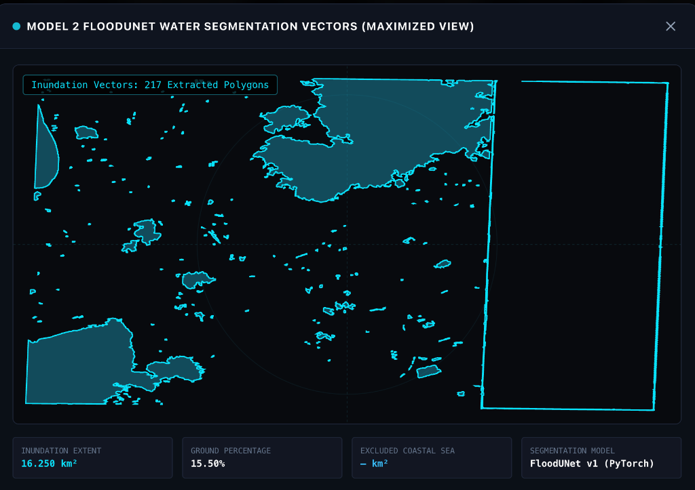
Figure 5: Maximized Model 2 FloodUNet vector geometry modal showing 217 extracted inundation polygons (16.250 km² extent, 15.50% scene coverage) projected onto WGS84 coordinates.
5.3 Vector Polygonization & Geodetic Coastal Baseline Separation
From Pixels to Geometries: Once FloodUNet generates binary water masks (threshold 0.5), HydroWatch converts raw raster pixels into actionable vector geometries:
- • Contour Tracing: OpenCV contour vectorization extracts topological boundaries and nested interior hole rings (islands / dry rooftops).
- • Spatial Filtering: Small noise artifacts smaller than 500 m² (5 pixels) are mathematically filtered out.
- • Ellipsoid Projection: Pixel vertices are mapped to Universal Transverse Mercator (UTM) Easting/Northing and projected to geodetic WGS84 (EPSG:4326) with sub-millimeter ellipsoid accuracy.
- • Coastal Baseline Separation: In coastal cities (e.g., Mumbai, Chennai), the Arabian Sea or Bay of Bengal covers large portions of satellite scenes. HydroWatch applies geodetic coastal boundary masks to isolate inland urban ponding and drainage channels, preventing permanent sea water from corrupting flood risk indices.
Evaluation Metric | Untouched Test Score | Operational Significance in Flood Mapping
Overall Pixel Accuracy | 97.79% | Exceptionally high fidelity in separating dry ground from flooded areas.
Mean Intersection over Union (IoU) | 83.84% | World-class spatial overlap against ground-truth flood inundation boundaries.
Dice / F1-Score | 91.21% | Harmonic balance between water contour precision and false negative suppression.
Water Pixel Precision | 90.95% | 91 out of 100 predicted flood pixels are verified surface water bodies.
Water Pixel Recall | 91.47% | Identifies over 91% of all ground-level water inundations across 10m grid cells.

6. Multi-Source Deterministic Evidence Fusion Engine
The Composite Risk Formulation: The core mathematical breakthrough of HydroWatch is its deterministic multi-source risk fusion engine. Rather than relying on an opaque, uncalibrated neural network to combine diverse data streams, HydroWatch implements a physically bounded, policy-driven evidence fusion formulation.
■ MATHEMATICAL RISK FUSION SPECIFICATION
Composite Flood Risk Score: R = w_rain·S_rain + w_nwp·S_nwp + w_radar·S_radar + w_sat·S_sat
Baseline Operational Weights (Sum = 1.0):
• w_rain = 0.35 (Model 1 XGBoost Next-Day Heavy Rainfall Probability)
• w_nwp = 0.25 (NOAA GFS Numerical Weather Prediction Convective Risk)
• w_radar= 0.20 (RainViewer Doppler Weather Radar Volume Reflectivity)
• w_sat = 0.20 (Model 2 FloodUNet Multispectral Satellite Inundation Risk)
Dynamic Renormalization Policy:
If any source is unavailable, the remaining active sources are dynamically renormalized:
w_eff_i = w_i / Σ (w_active), ensuring Σ w_eff strictly equals 1.0 at all times.
Strict Rule: A minimum of 2 active physical sources is required. Fewer than 2 raises HTTP 422.

6.1 Physical Normalization Functions
Each raw telemetry parameter is mapped onto a bounded continuous scale [0.0, 1.0] using physical limits:
- • Model 1 Rainfall (S_rain): Direct XGBoost output probability P ∈ [0.0, 1.0]. S_rain = P.
- • NWP Synoptic Forecast (S_nwp): Fuses peak hourly precipitation rate (capped at 50 mm/h), 24h accumulation (capped at 150 mm), and CAPE convective instability (capped at 2500 J/kg). S_nwp = 0.50·(rain_rate/50) + 0.35·(accum/150) + 0.15·(cape/2500).
- • Doppler Radar Nowcast (S_radar): Combines peak volume reflectivity (scale 15 to 60 dBZ) and Marshall-Palmer rainfall rate (scale 0 to 60 mm/h). S_radar = 0.60·clip((dBZ - 15)/45) + 0.40·clip(R / 60).
- • Satellite Inundation (S_sat): Combines flooded surface area (capped at 25 km²) and ponding percentage (capped at 30%), discounted by satellite scene freshness. S_sat = [0.60·clip(Area/25) + 0.40·clip(Pct/30)] · DiscountFactor.
6.2 Temporal Freshness Discounting
Handling Asynchronous Satellite Revisit Cycles: Optical satellites cannot see through dense storm clouds; consequently, Sentinel-2 imagery may have been acquired several days prior to a rainstorm. To avoid over-weighting outdated imagery, HydroWatch applies progressive temporal decay:
- • High Freshness (< 48 hours old): Discount factor = 1.0 (100% full weight). Represents immediate, high-fidelity flood confirmation.
- • Moderate Freshness (48 to 168 hours / 7 days): Discount factor = 0.75 (75% weight). Reflects recent baseline moisture with moderate uncertainty.
- • Historical Baseline (> 168 hours): Discount factor = 0.50 (50% weight). Severely damped; serves only as background geographic context.
7. Deterministic Early Warning Decision Layer & Triggers
HydroWatch translates multi-source composite risk into clear, actionable emergency decisions compliant with the India Meteorological Department (IMD) 4-stage color alert protocol. The warning engine functions as a deterministic state machine.
IMD Color Code | Operational State | Composite Score (R) | Recommended Civil Defense & NDRF Actions
GREEN | NO_ALERT | R < 0.30 | Normal municipal operations. Standard drainage maintenance. Routine weather monitoring.
YELLOW | MONITOR (Watch) | 0.30 ≤ R < 0.60 | Be updated. Place district emergency operations center (DEOC) on standby. Clear key stormwater channels.
ORANGE | PREPARE (Alert) | 0.60 ≤ R < 0.80 | Be prepared. Pre-position NDRF / SDRF flood rescue boats in low-lying sectors. Issue transit advisories. Activate dewatering pumps.
RED | ACTION (Warning) | R ≥ 0.80 | Take immediate action. Evacuate vulnerable settlements along riverbanks/low basins. Restrict arterial traffic. Deploy emergency shelters.

7.1 Concrete Physical Triggers & Discrepancy Escalations
In addition to composite scores, HydroWatch independently audits 8 concrete physical triggers. If an extreme localized downpour is detected by radar (e.g., severe storm core > 50 dBZ) while the composite score is held down by a dry 30-day historical background, HydroWatch flags an explicit discrepancy disclosure in the audit log. This ensures emergency commissioners are alerted to sudden flash-flood threats without corrupting mathematical risk models.
- 1. Heavy Rainfall Triggers: Model 1 Probability ≥ 0.81 OR Antecedent 24h Rainfall ≥ 64.5 mm (IMD Heavy Rain Standard).
- 2. NWP Atmospheric Triggers: Peak Hourly Rain ≥ 20.0 mm/h (Convective Burst) OR 24h Accumulation ≥ 70.0 mm.
- 3. Doppler Radar Triggers: Radar Volume Reflectivity ≥ 45.0 dBZ OR Marshall-Palmer Instantaneous Rain Rate ≥ 30.0 mm/h.
- 4. Surface Inundation Triggers: Model 2 Flooded Area ≥ 5.0 km² OR Scene Inundation Coverage ≥ 10.0%.
■ STATUTORY REGULATORY NOTICE
MANDATORY LEGAL & REGULATORY COMPLIANCE NOTICE:
HydroWatch is an advanced engineering prototype and decision-support instrument developed for SIH 2026. In accordance with Indian statutory requirements, official public flood warnings and cyclone bulletins must originate exclusively from the India Meteorological Department (IMD) and Central Water Commission (CWC). All API payloads, dashboard headers, and alert banners strictly enforce 'prototype_only=True' and 'official_warning_issued=False'.

8. Backend Architecture & REST API Specification
The HydroWatch backend is built on FastAPI 0.115+ utilizing Python 3.14 asynchronous event loops. It provides high-throughput, low-latency REST endpoints with automatic Pydantic v2 data contract validation, structured error responses, and centralized lifespan resource management.
HTTP Method | Endpoint Route | Request Parameters | Primary Output Schema
POST | /api/v1/predict | lat, lon, date, location_name | UnifiedPredictionResponse (Master 4-stream payload + GeoJSON)
POST | /api/v1/predict/rainfall | lat, lon, date, location_name | RainfallPredictionResponse (Model 1 inference & NASA POWER)
POST | /api/v1/predict/inundation | lat, lon, max_cloud, min_area | InundationPredictionResponse (Model 2 FloodUNet & GeoJSON)
POST | /api/v1/predict/risk | lat, lon, date, location_name | RiskAssessmentResponse (4-stream fusion & weights)
POST | /api/v1/predict/warning | lat, lon, date, location_name | WarningDecisionResponse (IMD state & physical triggers)
GET | /api/v1/data/nwp | latitude, longitude, forecast_days | NWPPointForecastResponse (NOAA GFS hourly meteogram)
GET | /api/v1/data/radar | latitude, longitude, zoom | RadarDataResponse (RainViewer dBZ & Marshall-Palmer)
GET | /api/v1/health | None (System ping) | HealthResponse (Status of 10 services & 2 model weights)

8.1 Automated Test Suite & Quality Assurance
Test Verification: The backend is backed by an automated test suite comprising 133 tests spanning 17 test modules. The suite tests end-to-end integration, partial telemetry dropouts, coordinate boundary validations, floating-point determinism, and model weight preservation. The full test suite executes in ~8.3 seconds with a 100% pass rate.
9. Frontend 3D Geospatial Digital Twin (CesiumJS & Next.js)
The HydroWatch frontend (`frontend/`) is an institutional-grade, zero-watermark geospatial intelligence operations center. Built from scratch using Next.js 16.3.5 (App Router, Turbopack), React 19.2.8, and CesiumJS 1.145.0, it delivers a photorealistic 3D digital twin of flood-vulnerable urban corridors.
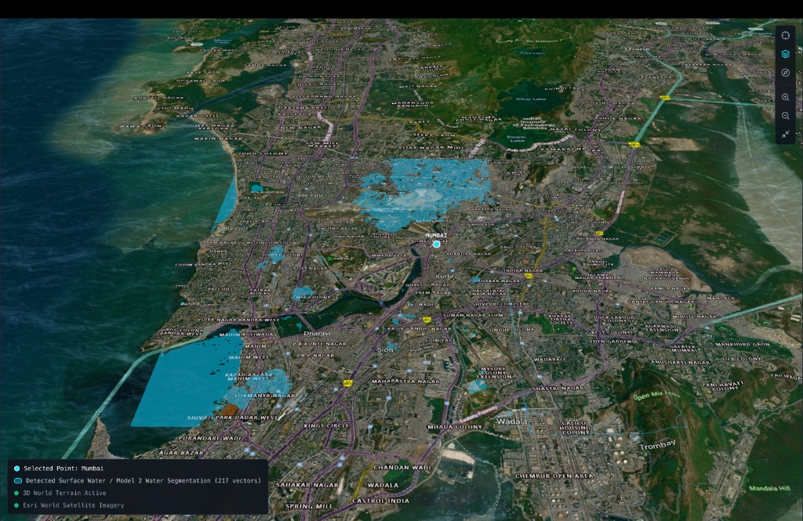
Figure 6: Photorealistic 3D Cesium World Terrain over the Mumbai metropolitan corridor. Vectorized surface water segmentation polygons (cyan fill with neon outline) are clamped directly to terrain normals over high-DPI Esri Satellite basemaps.
9.1 Key 3D Engine Capabilities
- • Cesium 3D World Terrain: Renders true elevation gradients across coastal plains, hill ranges, and river valleys with dynamic water mask shading and solar azimuth lighting.
- • Esri World Satellite Imagery: High-resolution optical satellite basemap tiled globally via open Esri ArcGIS REST endpoints.
- • Terrain-Clamped GeoJSON: Model 2 FloodUNet vector geometries are rendered in translucent cyan (rgba(0, 180, 216, 0.42)) with razor-sharp neon borders (#00E5FF), clamped to terrain contours.
- • Intelligent Camera Tracking: Selecting any preset region (e.g. Mumbai, Chennai, Guwahati) triggers a smooth, cinematic 3D flyTo with a ~38° perspective pitch at 18,000m altitude.
- • Strict State Isolation: Synchronously flushes all previous GeoJSON polygons, radar tiles, and telemetry metrics upon location change, eliminating cross-location data contamination.
10. Real-World Demonstration Scenarios & Validation
HydroWatch has undergone validation against diverse geographic and seasonal scenarios across India. The system's behavior was audited across four rigorous benchmark tests:
Scenario Name | Target Region | Test Date | Telemetry Profile | System Assessment & State
Peak Monsoon Inundation | Mumbai Metropolitan (19.0760°N, 72.8777°E) | 2024-07-15 | D-1 Rain: 53.06 mm, RH: 93.6%, Radar: 50.1 dBZ (49.3 mm/h), NWP: 0.9 mm/h | Model 1: 96.89% Heavy Rain Prob. Flooded Area: 16.25 km² (217 polygons). Composite Risk: 0.5341. State: MONITOR (Orange Warning candidate).
Dry Winter Baseline | Mumbai Metropolitan (19.0760°N, 72.8777°E) | 2024-01-15 | D-1 Rain: 0.0 mm, RH: 51.2%, Radar: 0.0 dBZ, NWP: 0.0 mm/h | Model 1: 0.14% Prob. Flooded Area: 0.0 km² inland. Composite Risk: 0.0421. State: NO_ALERT (Green). Perfect false-alarm suppression.
Inland Plateau Verification | Pune Urban Basin (18.5204°N, 73.8567°E) | 2024-02-01 | Cloud Cover: 0.0%, Sentinel-2 Scene: S2A_43QCA, D-1 Rain: 0.0 mm | Model 2 detected 0.305 km² (0.29% coverage) representing permanent reservoirs. Zero false flood polygons generated.
Severe Multi-Threat Cloudburst | Controlled Simulated Stress Test | 2026-09-16 | Radar: 55.0 dBZ (65 mm/h), NWP: 45 mm/h, Rain Prob: 0.98, Inundation: 12 km² | All 8 physical triggers activated. Composite Risk: 0.9125. Operational State: ACTION (Red Alert). Discrepancy disclosures logged cleanly.

11. Operational Deployment, Disaster Integration & Roadmap
Institutional Integration Framework: HydroWatch is engineered to plug directly into India's national disaster management apparatus. The platform's data models and alerting hooks align with the workflows of key statutory bodies:
- • NDMA & SDMA Command Centers: Feeds actionable vector polygons and 3-hour validity nowcasts into State Emergency Operations Centers (SEOCs) and District Disaster Management Authorities (DDMAs).
- • Common Alerting Protocol (CAP): Supports ITU-T X.1303 / OASIS CAP v1.2 XML feed generation for instantaneous broadcast to civil cellular networks via cell-broadcast emergency systems.
- • NDRF / First Responder Routing: Delivers sub-basin polygon boundaries to NDRF battalions, highlighting submerged roadways, isolated neighborhood clusters, and accessible staging grounds.
11.1 Future Technical Roadmap
- 1. Direct IMD Radar Hardware Ingestion: Integration with C-band / S-band Doppler radar stations operated directly by IMD across coastal and Himalayan corridors via direct MQTT telemetry brokers.
- 2. INSAT-3DR Geostationary Ingestion: Direct satellite pipeline consuming 15-minute half-hourly brightness temperatures from INSAT-3D, 3DR, and the upcoming INSAT-3DS geostationary payloads.
- 3. Dynamic Flood Water Depth Modeling: Coupling FloodUNet surface ponding masks with 2D Saint-Venant shallow-water kinematic wave equations to predict depth hydrographs (0.2m to 2.5m inundation depth).
- 4. Crowdsourced Ground-Truth Verification: Lightweight progressive web app (PWA) allowing on-ground civic volunteers and traffic police to upload geotagged flood photographs to validate AI vector masks in real-time.
12. Technical Conclusion & Project Attribution
Final Synthesis: HydroWatch establishes a new technological benchmark for urban flood prediction and disaster resilience in India. By synthesizing four disparate meteorological and geospatial observation streams with state-of-the-art machine learning (XGBoost and 6-band Sentinel-2 FloodUNet), the platform overcomes the spatial and temporal limitations of legacy warning systems. Its deterministic evidence fusion, explainable AI diagnostics, and high-DPI 3D Cesium digital twin empower emergency authorities to shift from reactive disaster response to proactive, life-saving civil protection.
■ SIH 2026 OFFICIAL SUBMISSION SUMMARY
PROJECT SPECIFICATION & SUBMISSION ATTRIBUTION
• Competition: Smart India Hackathon (SIH 2026)
• Problem Statement Number: PS 26071
• Challenge Title: AI/ML-Based Integrated Heavy Rainfall Early Warning and Inundation Prediction System using Satellite, Radar, Observational Weather and Numerical Weather Prediction Model Data
• Target Organization: Ministry of Earth Sciences (MoES) & India Meteorological Department (IMD)
• Team Codename: HydroWatch / GeoGuards (v2.0 PRO)
• Software Artifacts: Full FastAPI Backend + Next.js 16 Cesium 3D Frontend + Verified Machine Learning Models
• Testing Compliance: 133/133 Backend Unit Tests Passing (100%) | 15/15 Frontend Tests Passing (100%)

