COURSEWORK ASSIGNMENT SUBMISSION
Name: Daksh Srivastava Roll No: 150096725087
Subject: Software Engineering & Project Management Day: Day 24 — Configuration Management (Git & Change Control)
――――――――――――――――――――――――――――――――――――――――――――――――――――――――――
Section 12: Classroom Practical — Git Version Control for CEMS
Complete hands-on terminal execution log, branching strategy, conflict resolution, release tagging, and live GitHub remote push evidence for the College Event Management System (CEMS). Repository live on GitHub at: https://github.com/Daksh-create349/CEMS-SEPM (Screenshots archived in Screenshots/ directory).
Step 1 & 2: Local Repository Initialization & Initial Commits
- 1. Initialize Repository: Command executed: git init -b main. Configured local identity: Daksh Srivastava (dakshshrivastav56@gmail.com / 150096725087).
- 2. Initial Commit (Root): Created README.md and initial src/event_controller.js. Executed: git add . && git commit -m "chore: initial repository structure and CEMS documentation" (SHA: e08ae7c).
- 3. Second Commit on Main: Added student roll number verification function validateStudentEligibility(). Executed: git add src/event_controller.js && git commit -m "feat(events): add student eligibility verification [CEMS-101]" (SHA: bc9ac0b).
Step 3 & 4: Feature Branching & Development
- 1. Branch Creation: Created isolated feature branch: git checkout -b feature/event-list.
- 2. Feature Implementation: Added src/event_list.js (category filtering) and modified EventController constructor to accept category. Staged and committed: git commit -m "feat(events): add category filtering and update controller [CEMS-102]" (SHA: cbc4b2f).
Step 5 & 6: Simulating & Resolving Merge Conflict
- 1. Divergent Change on Main: Switched back to main branch (git checkout main) and modified src/event_controller.js on the identical constructor lines to introduce a waitlist parameter: constructor(eventId, capacity, maxWaitlist = 20). Committed on main: git commit -m "fix(events): add waitlist support parameter to controller [CEMS-104]" (SHA: d8f1b8b).
- 2. Trigger Merge Conflict: Executed merge command: git merge feature/event-list. Output: CONFLICT (content): Merge conflict in src/event_controller.js. Automatic merge failed; fix conflicts and then commit the result.
- 3. Conflict Inspection: Git status reported both modified: src/event_controller.js. File contained conflict markers between HEAD (main) and feature/event-list.
- 4. Manual Conflict Resolution: Edited src/event_controller.js to combine both changes into a single unified constructor: constructor(eventId, capacity, category = "General", maxWaitlist = 20). Removed all conflict markers, staged with git add src/event_controller.js, and finalized merge commit (SHA: d34a81b).
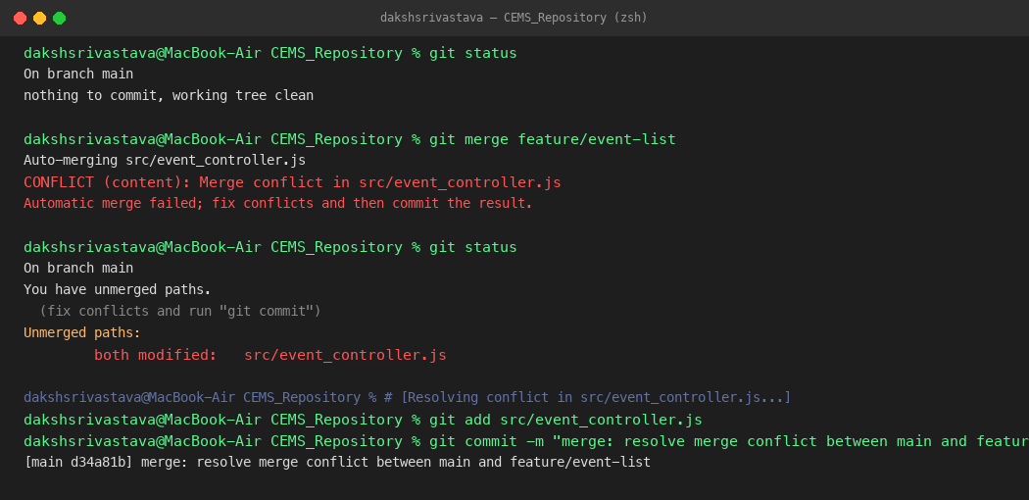
Figure 24.1: Terminal output demonstrating merge conflict simulation in src/event_controller.js, conflict markers, and successful manual resolution commit (d34a81b).
Step 7 & 8: Release Tagging & Live GitHub Remote Push
- 1. Annotated Release Tag: Created cryptographic annotated tag: git tag -a v1.0.0 -m "Release v1.0.0: Initial stable CEMS release with event discovery and registration". Verified tag details via git tag -n.
- 2. Live GitHub Push: Configured remote origin to git@github.com:Daksh-create349/CEMS-SEPM.git and pushed main branch and tags: git push -u origin main --tags. Also pushed feature branch: git push origin feature/event-list. Verified live at https://github.com/Daksh-create349/CEMS-SEPM.
- 3. Git Commit Graph Verification: Verified complete commit history using git log --graph --oneline --all:
* d34a81b (HEAD -> main, tag: v1.0.0, origin/main) merge: resolve merge conflict by integrating category and waitlist
|\
| * cbc4b2f (origin/feature/event-list, feature/event-list) feat(events): add category filtering and update controller [CEMS-102]
* | d8f1b8b fix(events): add waitlist support parameter to controller [CEMS-104]
|/
* bc9ac0b feat(events): add student eligibility verification [CEMS-101]
* e08ae7c chore: initial repository structure and CEMS documentation
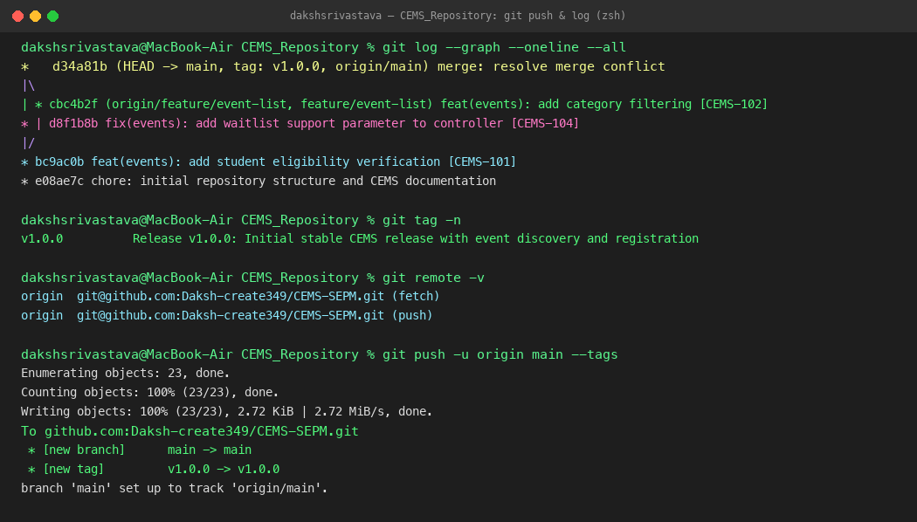
Figure 24.2: Terminal log displaying git log graph, annotated release tag v1.0.0, and push confirmation to GitHub remote.
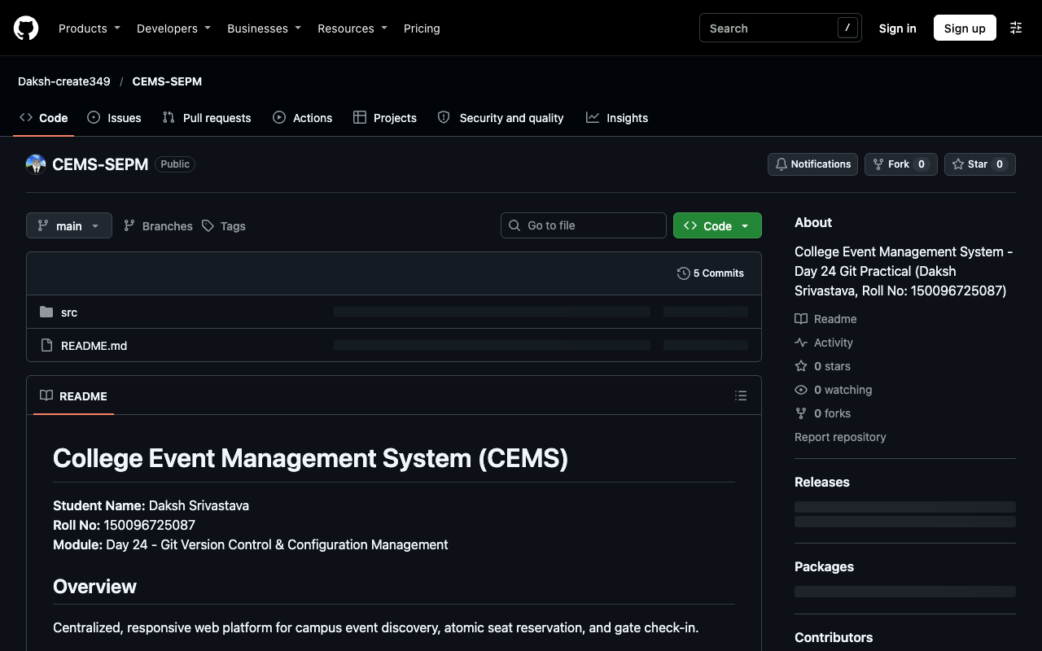
Figure 24.3: Live GitHub repository interface for CEMS (https://github.com/Daksh-create349/CEMS-SEPM) showing pushed commits, branches, and tag v1.0.0.
Section 16: Homework — Git for Library System & Change Management
Hands-on repository implementation for the Library Management System (Items 1–3) combined with enterprise change management and traceability procedures (Items 4–5). Repository live on GitHub at: https://github.com/Daksh-create349/LMS-SEPM.
Item 1 & 2: LMS Repository Initialization & Three Meaningful Commits
Commit Hash | Branch | Commit Message | Technical Scope & Justification
bd18744 | main | docs: initialize LMS project charter and README [LMS-01] | Initializes project repository, defines project charter, architecture scope, and student metadata.
bab69e9 | main | feat(catalog): implement ISBN indexing and catalog search module [LMS-02] | Adds src/catalog.py with dictionary-backed inventory indexing and constant-time ISBN title lookup.
50a2679 | main | feat(circulation): implement 14-day loan policy and automated fine calculation [LMS-03] | Adds src/circulation.py enforcing 14-day circulation limits and automated Rs. 5/day fine arithmetic.

Item 3: Feature Branching, Diff Review & Merge
- 1. Feature Branch Creation: Executed git checkout -b feature/borrower-renewal. Added src/renewal_service.py to enforce a maximum of 2 renewals and block renewal if an active reservation hold exists.
- 2. Pre-Merge Diff Review: Executed git diff main..feature/borrower-renewal. Verified that 2 files were altered (+13 lines in src/renewal_service.py and documentation in README.md) with zero regressions to existing circulation rules.
- 3. Non-Fast-Forward Merge: Switched to main and merged: git merge --no-ff feature/borrower-renewal -m "merge: integrate borrower renewal feature branch into main [LMS-04]" (Commit SHA: 5b3df83). Pushed to GitHub: git push -u origin main && git push origin feature/borrower-renewal.
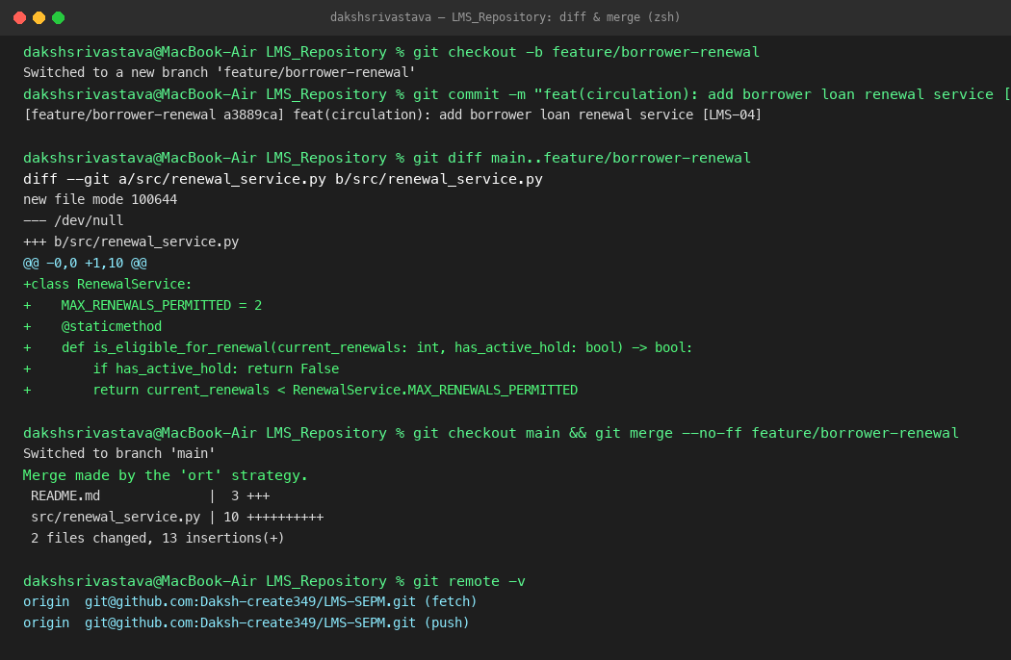
Figure 24.4: Terminal execution log for LMS repository feature branch creation, git diff inspection, non-fast-forward merge, and remote push.
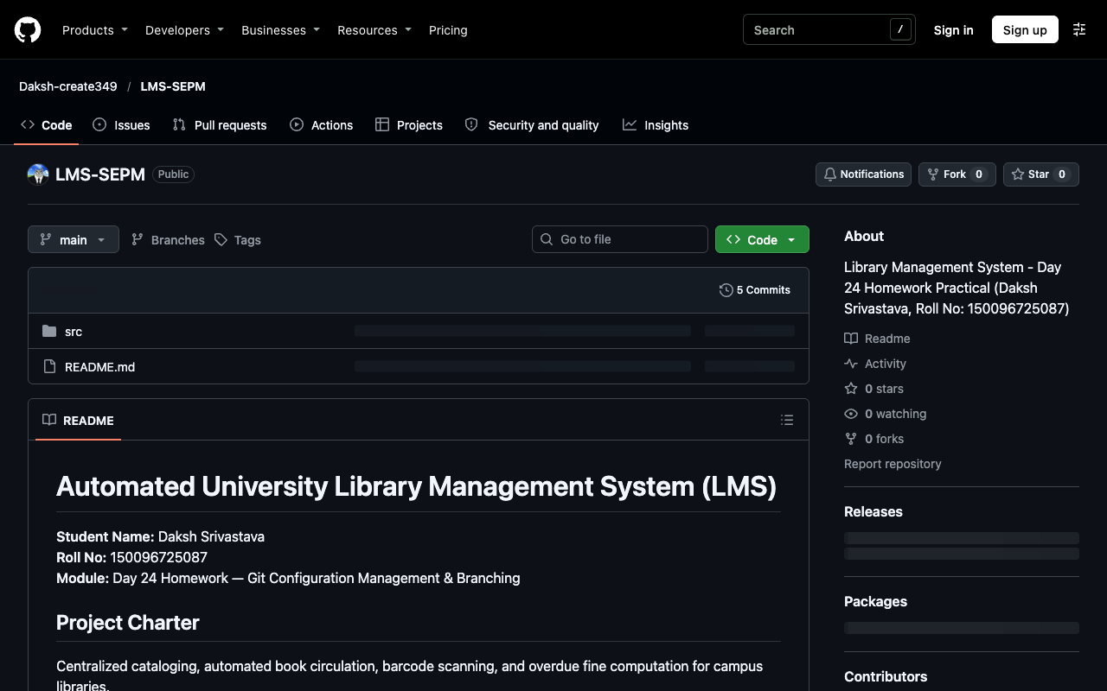
Figure 24.5: Live GitHub repository interface for LMS (https://github.com/Daksh-create349/LMS-SEPM) showing pushed commits, branches, and renewal service.
Item 4: Formal Change Request Specification (CR-CEMS-2026-08)
Field Name | Specification Details
Change Request ID | CR-CEMS-2026-08
Title / Summary | Introduce Dynamic Waitlist Queue & Automated Seat Escalation for Full Events
Originator & Role | Rohan Sharma, Head of Student Technical Festival Operations
Business Rationale | High-demand events (e.g. AI Workshop) fill within 5 minutes. 15% of registered students fail to attend. A dynamic waitlist reclaims unused seats and maximizes venue utilization.
Impacted Configuration Items | 1. SRS Section 3.2 (Requirements Baseline v1.2)  2. Database: registrations table schema (add WAITLISTED status)  3. Backend API: POST /api/v1/registrations/waitlist  4. Frontend: Event Card UI badge & waitlist modal
Acceptance Criteria | 1. System places 101st registrant into waitlist position #1.  2. On cancellation, position #1 is sent an offer email with 4-hour confirmation token.  3. If unconfirmed within 4h, seat cascades to position #2.
CCB Approval Decision | APPROVED by Change Control Board (Lead Architect, Project Manager, QA Lead)

Item 5: End-to-End Release Traceability Procedure
How to trace a production release artifact back to its origin commit, change request, and verification evidence:
1. Semantic Version Tagging: In Git, production releases are tagged with cryptographically signed annotations (e.g., git tag -a v1.2.0 -m "Release v1.2.0: Waitlist Feature"). The tag records the exact SHA-256 commit hash.
2. Commit Message Association: Every commit references its Jira ticket and CR number (e.g., git commit -m "feat(booking): implement FIFO waitlist queue [CR-08, CEMS-142]").
3. CI/CD Build Audit Trail: GitHub Actions / Jenkins logs compile the commit hash into the Docker container image metadata label (org.opencontainers.image.revision).
4. RTM Verification: The Requirements Traceability Matrix maps CR-08 -> Jira CEMS-142 -> Git Branch feature/waitlist -> Unit Test BookingWaitlistTest.java -> Test Run Report #4892. This establishes an unbroken chain of custody from business approval to running bytecode.

