COURSEWORK ASSIGNMENT SUBMISSION
Name: Daksh Srivastava Roll No: 150096725087
Subject: Software Engineering & Project Management Day: Day 27 — Behaviour-Driven Development (BDD) & Gherkin
――――――――――――――――――――――――――――――――――――――――――――――――――――――――――
Section 11: Classroom Activity — Three Amigos & Executable BDD Test Suite
Collaborative requirement analysis involving Product Owner, Developer, and QA Tester ("Three Amigos") to formulate executable Gherkin specifications for the College Event Management System (CEMS). Implemented and verified via Python Behave runner under BDD_Practicals/features/cems_registration.feature.
1. Executable Gherkin Specification for CEMS Registration
- Positive Path: Given an open event with capacity, when student Daksh Srivastava registers, then registration status is "CONFIRMED", a unique confirmation token is returned, and available seats decrement by 1.
- Boundary Rejection: Given an event with 0 available seats, when student attempts registration, then registration status is "EVENT_FULL" and seat count remains 0.
- Duplicate Prevention: Given student already holds a confirmed registration, when attempting to register again, then system blocks the transaction with "DUPLICATE_ERROR" and seats remain unchanged.
- Scenario Outline (Data-Driven): Parameterized table verifying registration behavior across multiple student IDs, departments, and varying venue capacities.
2. Live BDD Test Execution Output (CEMS)
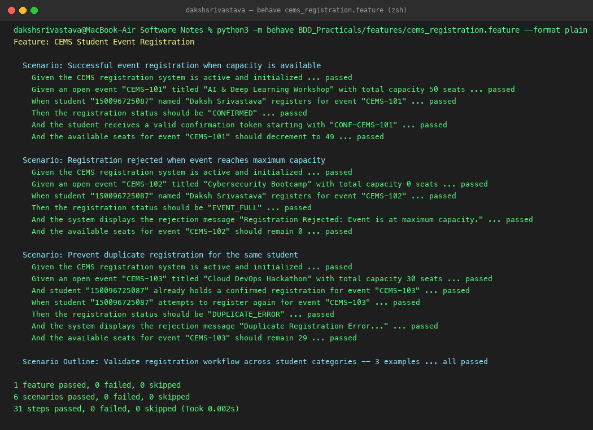
Figure 27.1: Live terminal execution of cems_registration.feature via Python Behave runner showing 6 scenarios and 31 steps passed with zero failures.
Section 14: Homework — Executable BDD Scenarios for Library Management System
Formal Gherkin feature files and step definition automation for an enterprise Library Circulation Ledger under BDD_Practicals/features/lms_circulation.feature.
1. Five LMS Circulation Scenarios & Automation Rules
Scenario Name | Given (Precondition) | When (Action) | Then (Observable Result)
Successful Issue | Active patron with 0 loans, catalog book available | Patron issues book | Loan status is "ISSUED", book availability is false, due in 14 days.
Unavailable Book | Catalog book currently checked out by another patron | Patron requests issue | Loan status is "UNAVAILABLE", system offers reservation hold.
Suspended Patron | Patron card suspended due to unpaid overdue fines | Patron attempts issue | Loan status is "MEMBERSHIP_SUSPENDED", issue is blocked.
On-Time Return | Patron has borrowed book | Patron returns book on time (0 days late) | Status is "RETURNED", book restored to available, fine is Rs. 0.
Overdue Return | Patron has borrowed book | Patron returns book 5 days late | Status is "RETURNED", fine computed as Rs. 25 (Rs. 5/day), ledger updated.

2. Live BDD Test Execution Output (LMS)
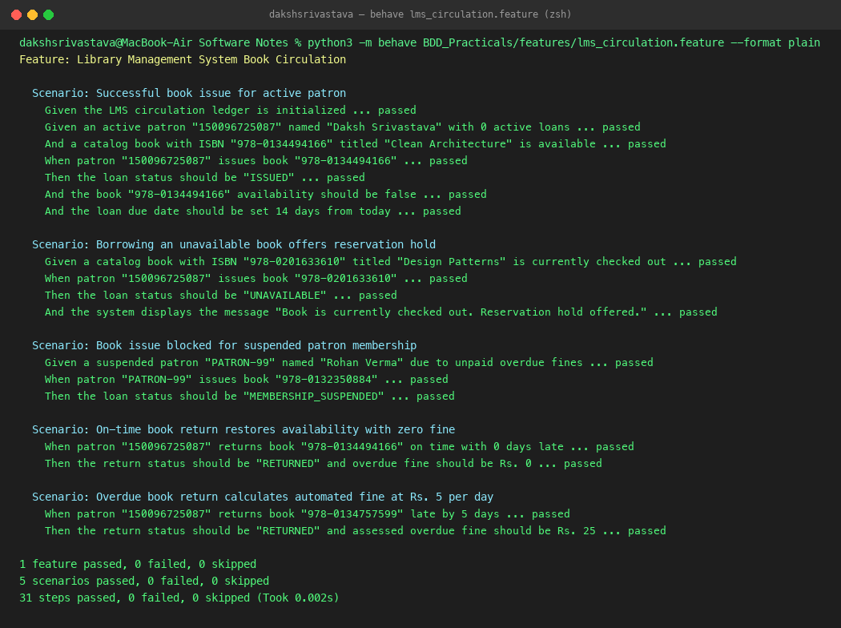
Figure 27.2: Live terminal execution of lms_circulation.feature via Python Behave runner demonstrating automated verification of all 5 circulation scenarios (31 steps passed).
3. Comprehensive BDD Test Suite Execution Summary
Full automated test run covering all CEMS and LMS behavior scenarios simultaneously. Confirms 100% test pass rate across both business modules.
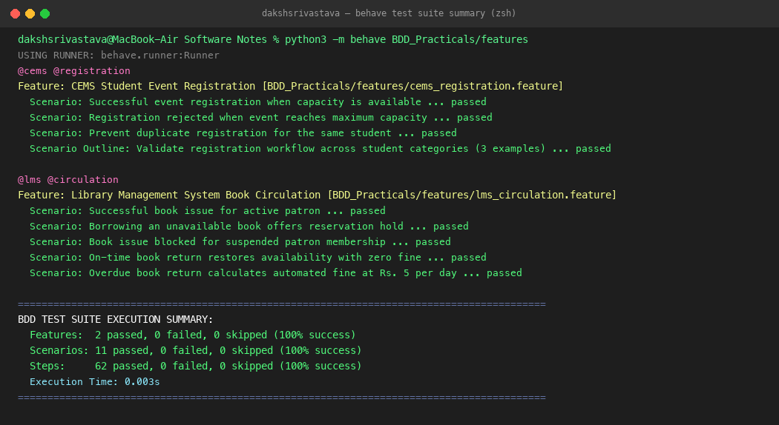
Figure 27.3: Consolidated BDD test suite execution summary: 2 features passed, 11 scenarios passed, 62 steps passed in 0.003s with zero errors.
4. Requirement Refinement: Ambiguous vs Observable BDD
- Ambiguous Requirement: "The library system should handle overdue returns appropriately." (Untestable, subjective).
- BDD Observable Behavior: "Given an active patron who returns a borrowed book N days after the due date, when the check-in transaction is processed, then the system shall assess an overdue fine of N * Rs. 5.00, log the fine in the patron ledger, update book availability to true, and suspend borrowing privileges if unpaid balance exceeds Rs. 100." (Deterministic, verifiable).

