SESSION – 1
- Install MySQL Workbench on your computer, connect to the local MySQL server, and take a screenshot of the default databases shown in the Schemas panel.
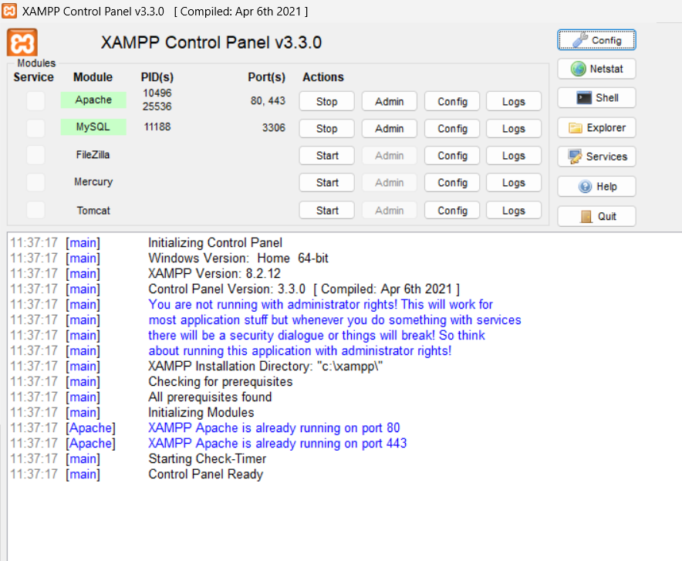

- Create a new database called InstaClone in MySQL Workbench, then create a table named Users with columns: user_id (INT, primary key), username (VARCHAR), email (VARCHAR), and followers_count (INT).

- CREATE DATABASE INSTACLONE :-

CREATE TABLE Users(

user_id INT PRIMARY KEY AUTO_INCREMENT,

username VARCHAR(255),

email VARCHAR(255),

followers_count INT

)

- Insert 3 sample users into the Users table you created, using realistic Instagram-style usernames and follower counts.

- INSERT INTO Users(user_id,username,email,follower_count)

VALUES (1,”daksh_patel”,”daksh@gmail.com”,”2050”),

(2,”mahir_patel”,”mahir@gmail.com”,”1500”),

(3,”prince_123”,”prince@gmail.com”,”850”);

- Create another table in the InstaClone database called Posts with columns: post_id (INT, primary key), user_id (INT), caption (VARCHAR), and post_date (DATE). Add a foreign key from Posts.user_id to Users.user_id to establish a relationship.

- CREATE TABLE Posts(

Post_id INT PRIMARY KEY AUTO_INCREMENT,

User_id INT(5),

Caption VARCHAR(255),

Post_date DATE,

FOREIGN KEY (user_id) REFERENCES Users(user_id)

)

- Write a short comparison (3-4 lines each) of MySQL, PostgreSQL, Oracle, and SQLite, focusing on where each one is commonly used (for example: web apps, mobile apps, enterprise systems, etc.).

- MySQL: Common in web applications and content-management systems. Often used for sites and services that need a widely supported relational database.
- PostgreSQL: Popular for web apps, analytics, and systems with complex queries or data types. Often chosen when standards support and extensibility matter.
- Oracle Database: Common in large enterprises, banks, and government systems. It supports demanding workloads and extensive enterprise management needs.
- SQLite: Common in mobile apps, desktop software, and embedded devices. It stores a database in a single local file, so it works well without a separate server.

