Two-Tower Neural Network
Movie Recommender System
End-to-End Project Report — Data Pipeline, Model Training, Evaluation & Deployment Readiness
Dataset: MovieLens 32M (ml-32m) | Framework: PyTorch | Architecture: Two-Tower Neural Collaborative Filtering
Source notebook: recomendor-system_final.ipynb
July 2026

Table of Contents
- 1. Executive Summary
- 2. Project Objective & Scope
- 3. Dataset Overview
- 4. Exploratory Data Analysis
- 5. Data Preprocessing
- 6. Model Architecture
- 7. Training Procedure & Results
- 8. Model Evaluation
- 9. Embedding Space Visualization
- 10. Saved Artifacts & Deployment Format
- 11. Recommendation Engine
- 12. Interactive Demonstration Results
- 13. Cold-Start Handling for New Users
- 14. Observations, Limitations & Risks
- 15. Recommendations for Improvement
- 16. Conclusion

1. Executive Summary
This report documents the full pipeline implemented in the notebook recomendor-system_final.ipynb, which builds a movie recommendation system using a Two-Tower neural network architecture trained on the MovieLens 32M dataset. The pipeline covers data loading, exploratory data analysis, preprocessing, model training, quantitative evaluation, embedding visualization, artifact export for deployment, and two interactive recommendation demonstrations (personalized recommendations by user ID, and content-based 'similar movies' lookup).
The model was trained on a 50% sample of the ratings file (16.0 million ratings, 200,948 users, 87,585 candidate movies) for 10 epochs, achieving a final validation RMSE of 0.827 and MAE of 0.627 on a 0–5 rating scale. While the loss curves show healthy, steady convergence, the report also flags a significant practical issue observed during the interactive demo: the top-10 recommendations produced for a sample user were all obscure, poorly-reviewed titles with strongly negative predicted scores, which points to a likely scoring/ranking or output-calibration problem that should be investigated before this checkpoint is used in production (see Section 14).
Overall, the notebook is a well-structured, production-oriented pipeline — it deliberately mirrors the exact model class and artifact format expected by a companion FastAPI service (Main.py) — but the model itself should be treated as a first-pass baseline rather than a deployment-ready recommender. I have also made a front end to show the results, it is deployed on vercel.

2. Project Objective & Scope
The stated goal of the notebook is to take an existing Two-Tower model architecture and reproduce, end-to-end, everything needed to power a movie recommendation API: exploratory analysis of the source data, preprocessing into model-ready tensors, training and validation of the neural network, evaluation of rating-prediction accuracy, visual inspection of learned embeddings, and export of all artifacts (model weights and ID/genre lookup tables) in the exact format expected by a downstream Main.py FastAPI application.
The notebook explicitly notes that no pretrained model.pth was supplied, so the model is trained from scratch within the notebook itself, using a configurable SAMPLE_FRACTION to control how much of the 32-million-row ratings file is used — a pragmatic accommodation for the fact that the full ml-32m dataset is very slow to train on CPU.

Scope covered by the pipeline
- Loading and sampling the MovieLens 32M movies and ratings files
- Exploratory data analysis: rating distribution, genre frequency, average rating by genre, matrix sparsity
- Preprocessing: building user/movie index mappings and a padded genre-index representation
- A per-user 80/20 train/validation split
- Definition and training of a Two-Tower neural network (separate user and movie/genre towers combined via a dot-product interaction)
- Quantitative evaluation (RMSE, MAE) and diagnostic plots (predicted vs. actual, residuals)
- PCA visualization of learned movie embeddings, colored by genre
- Export of model.pth, a portable state_dict + config, and all lookup pickles
- A get_recommendations() function replicating the logic expected in Main.py
- Two interactive cells: personalized recommendations by user ID, and a content-based 'movies like this' search
- A cold-start module for brand-new users with no rating history

3. Dataset Overview(Put on google drive)
The notebook uses the standard MovieLens layout: a movies.csv file (movieId, title, genres) and a ratings.csv file (userId, movieId, rating, timestamp), pointed at the full ml-32m release (32 million ratings, ~87.5 thousand movies). Because training the full dataset on CPU is impractical, a SAMPLE_FRACTION configuration knob was set to 0.5, i.e. the model was trained on a random 50% sample of the ratings rows.

Dataset statistics after loading and sampling
Metric | Value
Movies in catalog (movies.csv) | 87,585
Ratings loaded after 50% sampling | 16,000,102
Distinct users in sampled ratings | 200,948
Distinct movies rated at least once | 71,242
User–movie matrix density | 0.1118% filled

The extremely low matrix density (about 0.11% of all possible user-movie pairs have a rating) is a defining characteristic of this dataset and is the fundamental reason a collaborative-filtering approach needs learned embeddings rather than an explicit matrix — the vast majority of user-movie combinations are unobserved, and the model must generalize across sparse interactions.

4. Exploratory Data Analysis
Before modeling, the notebook produces three diagnostic plots to characterize the ratings and catalog data.

4.1 Distribution of ratings
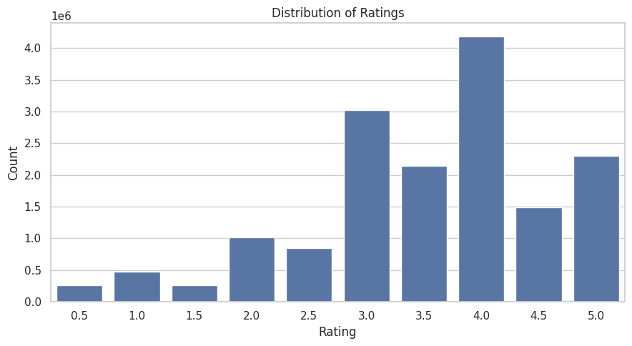
Figure 1. Distribution of raw rating values across the sampled ratings file.
Ratings are given on a 0.5–5.0 half-star scale. The distribution is left-skewed with a strong central tendency around 3.5–4.0, a common pattern in ratings datasets where users disproportionately rate movies they enjoyed (positivity bias) and rarely bother rating movies they feel neutral about.

4.2 Movie count by genre
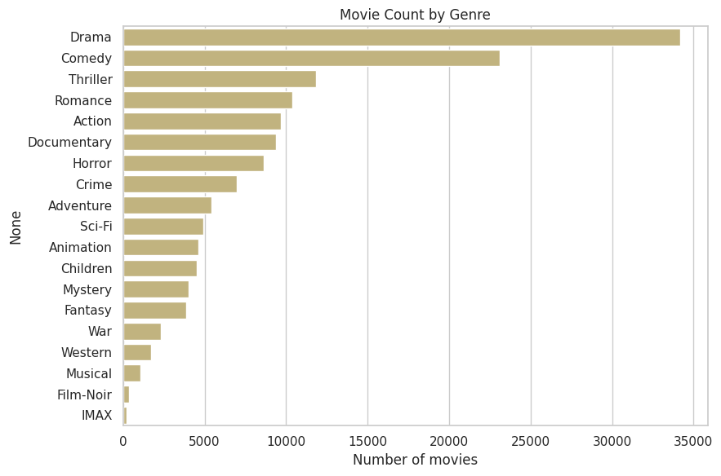
Figure 2. Number of catalog movies tagged with each genre (a movie may have multiple genres).
Drama and Comedy dominate the catalog by a wide margin, followed by Thriller, Romance, and Action. Niche genres such as Film-Noir, IMAX, and Documentary make up a small fraction of the catalog, which has implications for how much signal the model can learn about those genres' embeddings.

4.3 Average rating by genre
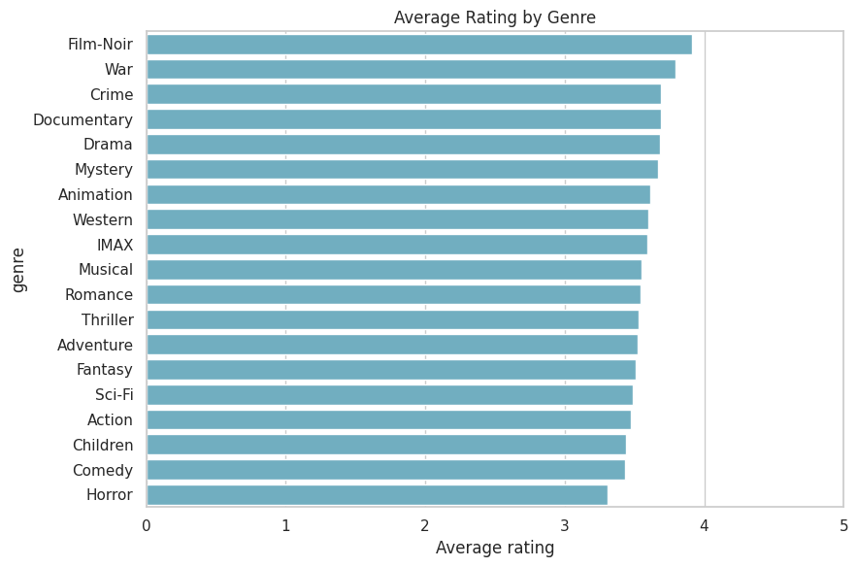
Figure 3. Mean user rating for each genre, aggregated across all ratings tagged with that genre.
Film-Noir, War, Documentary, and Crime genres tend to receive the highest average ratings, while Horror and Comedy trend lower. This genre-level rating bias is one of the signals the genre-embedding component of the model is designed to capture.

5. Data Preprocessing
The preprocessing stage builds the exact lookup structures that the downstream FastAPI service (Main.py) expects at inference time: user_to_index, movie_to_index, and movie_genre_map.

5.1 ID mapping
- Every movie in movies.csv (not just those with ratings) is mapped to a contiguous integer index, so the model can score candidate movies even if they have no ratings in the sampled data.
- Every user appearing in the sampled ratings is mapped to a contiguous integer index.
- Ratings for movies outside the known catalog are dropped.

5.2 Genre encoding
Genres are split on the pipe (|) delimiter into a genre vocabulary of 19 distinct genres, plus one reserved padding index (index 0), giving a total genre vocabulary size of 20. Each movie's genre list is converted into a fixed-length sequence of up to 7 genre indices (MAX_GENRES = 7), padded with zeros for movies with fewer genres. This fixed-width representation lets the genre embedding table use simple mean-pooling in the model's movie tower.

5.3 Train/validation split
Rather than a single global random split, the notebook performs a per-user 80/20 split: for every user with 5 or more ratings, 20% of their individual ratings are held out for validation while the remaining 80% go to training; users with fewer than 5 ratings have all of their ratings placed in the training set only. This user-stratified approach ensures that (a) every user with enough history has some validation signal, and (b) the validation set genuinely tests generalization to unseen items for known users, rather than testing on entirely unseen users.

6. Model Architecture
The core model is a Two-Tower neural network named TwoTowerModel, deliberately kept identical to the architecture expected by Main.py so a saved checkpoint is a drop-in replacement for the FastAPI application.

6.1 User tower
- An embedding table (Embedding(num_users, 32)) maps each user index to a 32-dimensional vector.
- A two-layer feed-forward network (Linear 32→32, ReLU, Linear 32→32) transforms the raw embedding into the final user representation.

6.2 Movie tower
- A movie embedding table (Embedding(num_movies, 32)) encodes the movie identity.
- A genre embedding table (Embedding(20, 32), padding_idx=0) encodes each of the movie's up to 7 genres; the 7 genre vectors are mean-pooled into a single 32-dimensional genre vector.
- The movie-identity vector and pooled genre vector are concatenated (64 dimensions) and passed through a two-layer feed-forward network (Linear 64→32, ReLU, Linear 32→32) to produce the final movie representation.

6.3 Interaction & output
The user and movie vectors (both 32-dimensional) are combined via an element-wise product summed across dimensions (a dot-product interaction), producing a single scalar. That scalar is passed through a final Linear(1, 1) layer to produce the predicted rating. This dot-product structure is what makes the architecture a genuine 'two-tower' model: the user and item representations are computed completely independently until the final interaction step, which is what allows the movie tower to be pre-computed once and reused across all users at inference time (a key efficiency property exploited later in the recommendation and evaluation code).

6.4 Model size
Component | Configuration
Users / Movies / Genres | 200,948 / 87,585 / 20
Embedding dimension | 32
Hidden / output dimension | 32 / 32
Max genres per movie | 7 (padded)
Trainable parameters | 9,238,946 (~9.24M)

At roughly 9.2 million parameters, the vast majority of which sit in the user and movie embedding tables (200,948 × 32 and 87,585 × 32 respectively), the model is lightweight by modern standards and well suited to CPU inference in a FastAPI service.

7. Training Procedure & Results

7.1 Hyperparameters
Hyperparameter | Value
Loss function | Mean Squared Error (MSE)
Optimizer | Adam
Learning rate | 0.002
Batch size | 2048
Epochs | 10
Validation split | 10% (per-user, see Section 5.3)
Device used | CPU

7.2 Epoch-by-epoch loss
Epoch | Train Loss (MSE) | Validation Loss (MSE)
1 | 0.8509 | 0.7589
2 | 0.7356 | 0.7321
3 | 0.7047 | 0.7143
4 | 0.6868 | 0.7070
5 | 0.6770 | 0.7032
6 | 0.6678 | 0.6964
7 | 0.6585 | 0.6930
8 | 0.6506 | 0.6926
9 | 0.6430 | 0.6912
10 | 0.6341 | 0.6842

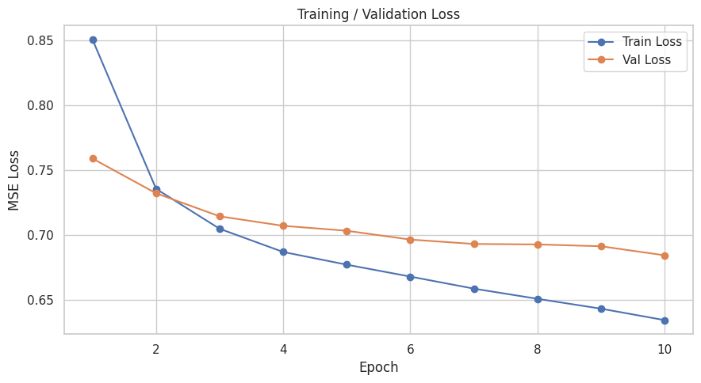
Figure 4. Training and validation MSE loss across 10 epochs.
Both training and validation loss decrease monotonically and smoothly across all 10 epochs, with training loss falling from 0.851 to 0.634 and validation loss falling from 0.759 to 0.684. The gap between train and validation loss widens slightly in later epochs (0.080 at epoch 1 vs. 0.050 at epoch 10, having briefly dipped as low as roughly 0.02–0.03 mid-training), which is a normal, mild sign of the model starting to fit training-set-specific patterns; it is not yet the sharp divergence that would indicate serious overfitting, but it does suggest that additional epochs would likely yield diminishing or negative returns without regularization changes.

8. Model Evaluation

8.1 Headline accuracy metrics
Metric | Value | Interpretation (0–5 rating scale)
Validation RMSE | 0.827 | Typical prediction error of ~0.83 stars
Validation MAE | 0.627 | Average absolute error of ~0.63 stars

An RMSE of 0.827 stars is a reasonable, though not exceptional, result for a from-scratch two-tower model trained for only 10 epochs on half the ratings data — for reference, well-tuned collaborative filtering models on MovieLens datasets often reach RMSE in the 0.80–0.87 range, so this checkpoint sits within a plausible baseline range for a first pass.

8.2 Predicted vs. actual ratings
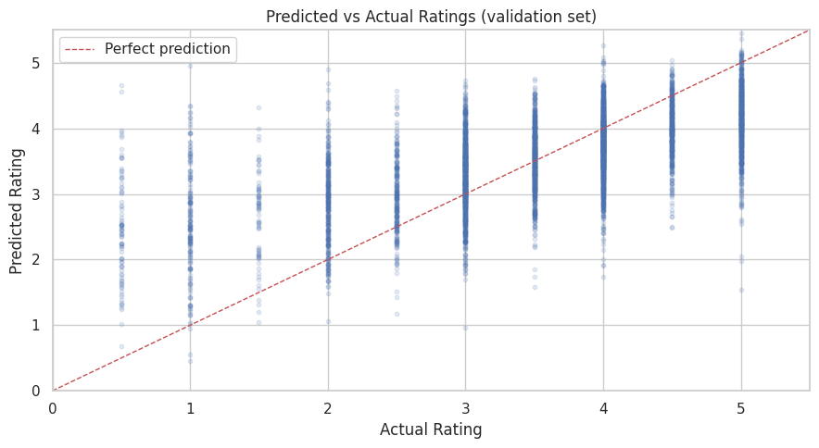
Figure 5. Predicted vs. actual ratings for a 5,000-point sample of the validation set, with the red dashed line marking perfect prediction.
The point cloud sits reasonably close to the diagonal 'perfect prediction' line but shows the classic regression-to-the-mean pattern: predictions rarely reach the extremes (near 0.5 or near 5.0), clustering instead in the 2.5–4.5 range regardless of the true rating. This means the model is more accurate at predicting 'typical' ratings than at identifying a user's strongest likes or dislikes — a limitation worth keeping in mind given that recommendation quality depends heavily on correctly identifying the highest-scoring items for a user.

8.3 Residual distribution
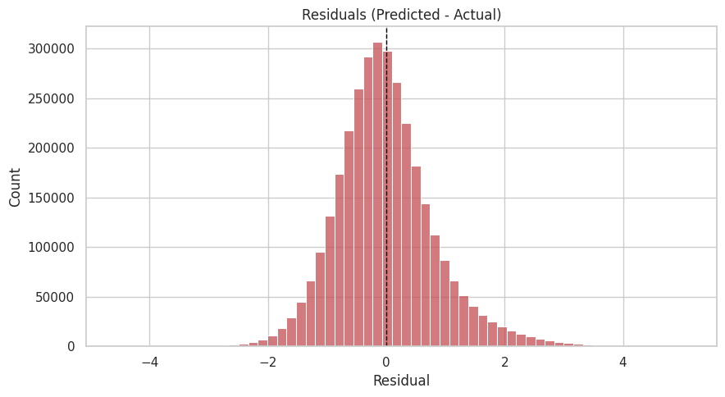
Figure 6. Distribution of residuals (predicted minus actual rating) on the validation set.
Residuals are centered close to zero and roughly bell-shaped, which is a good sign that the model is not systematically biased toward over- or under-predicting ratings on average. The spread of the distribution is consistent with the reported RMSE/MAE values.

9. Embedding Space Visualization

9.1 Movie embeddings (PCA), colored by genre
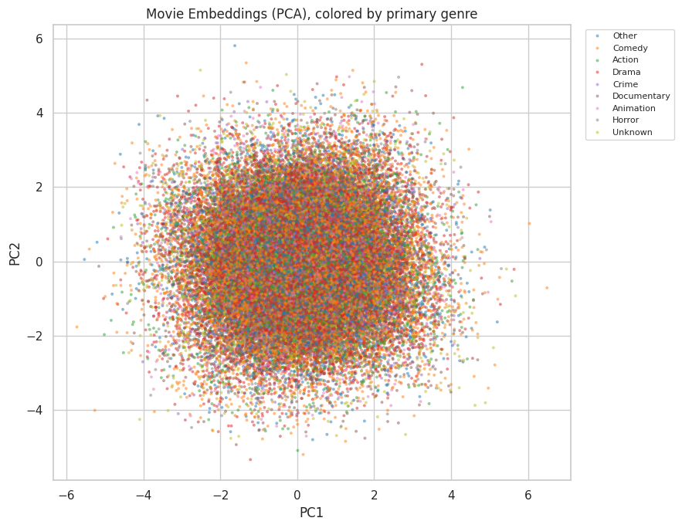
Figure 7. Two-dimensional PCA projection of the learned 32-dimensional movie embedding table, colored by each movie's primary (first-listed) genre; the 8 most common genres are shown individually and all others are grouped as 'Other'.
The projection shows partial genre clustering — movies of the same primary genre tend to fall in overlapping but not perfectly separated regions of the 2D PCA space. This is expected: the movie embedding captures collaborative signal (which users co-rate which movies) as well as content signal via the separate genre embedding, so genre alone does not fully determine an item's position. The presence of any visible clustering at all is a positive sanity check that the model has learned meaningful, genre-correlated structure.

9.2 Embedding norm sanity check
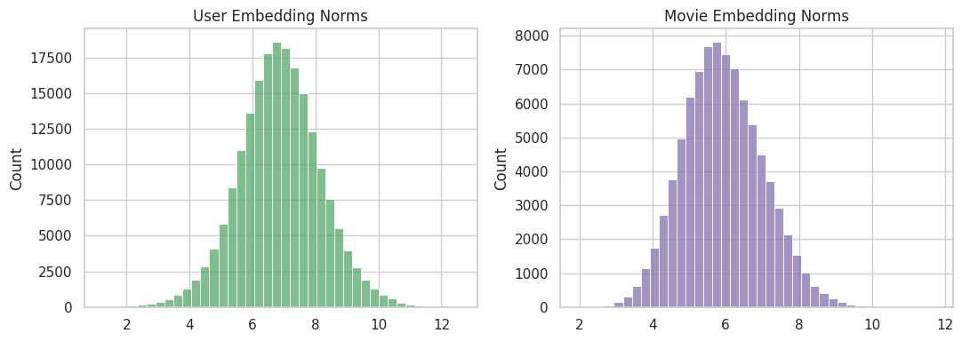
Figure 8. Distribution of L2 norms of the learned user and movie embedding vectors.
Both distributions are unimodal and of a similar, bounded magnitude, with no extreme outliers or embedding 'collapse' (norms near zero) that would suggest a training pathology. This is a useful, quick diagnostic that the embedding tables trained in a numerically healthy way.

10. Saved Artifacts & Deployment Format
To integrate directly with the companion Main.py FastAPI application, the notebook exports artifacts in two complementary formats.

10.1 Primary format (matches Main.py exactly)
File | Contents
model.pth | The full pickled model object (torch.save(model, ...)), loadable via torch.load without needing to reconstruct the class first
user_to_index.pkl | Dict mapping raw MovieLens userId → contiguous model index
movie_to_index.pkl | Dict mapping raw MovieLens movieId → contiguous model index
movie_genre_map.pkl | Dict mapping movie index → padded list of genre indices

10.2 Portable/production-hardening format
Recognizing that pickling a whole model object is brittle (it requires the exact same class definition and file paths to be available when loading), the notebook also saves a more portable bundle:
File | Contents
model_state_dict.pth | Just the model weights (torch.save(model.state_dict(), ...))
model_config.json | Hyperparameters/shapes needed to reconstruct TwoTowerModel(...) before loading the state dict
movies_meta.csv | Small movieId/title/genres lookup table for display and search
popular_movie_ids.pkl | Popularity ranking (most-rated first), used as the cold-start fallback

The notebook explicitly instructs that all of the above files (both sets) should be copied into the backend's artifacts/ folder before deploying, since different parts of the downstream logic (recommendation, cold-start fallback, similar-movie search) depend on different files from each set.

11. Recommendation Engine
The core get_recommendations(user_id, ...) function replicates the exact logic Main.py is expected to use: it looks up the user's index, computes the user tower vector once, computes the movie tower vector for every candidate movie in the catalog, scores every candidate via the dot-product interaction, and returns the top-k highest-scoring movie IDs. If the requested user_id is not found in user_to_index (a 'cold start' user), the function falls back to returning the most popular movies by rating count.
A second, more rigorous evaluation module was also added to the notebook to assess ranking quality directly (rather than only rating-prediction accuracy), computing standard top-K recommendation metrics against held-out validation positives — first by ranking against the full ~87K-movie catalog, and then, for efficiency, against a smaller realistic candidate set built from each user's positive validation items plus 100 randomly sampled negative movies the user never interacted with. Precomputing the movie tower once and reusing it across all users (rather than recomputing per user) is called out explicitly in the code as a key performance fix, since the movie tower is independent of the user tower — this is the central efficiency benefit of the two-tower design.

12. Interactive Demonstration Results

12.1 Personalized recommendations for a sample user (userId = 19)
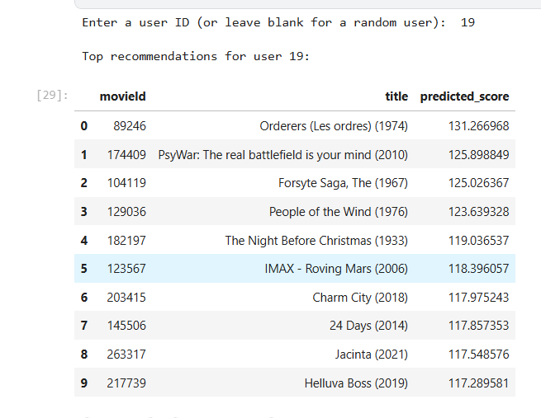
Figure 9a. Top recommendations table for user 19.
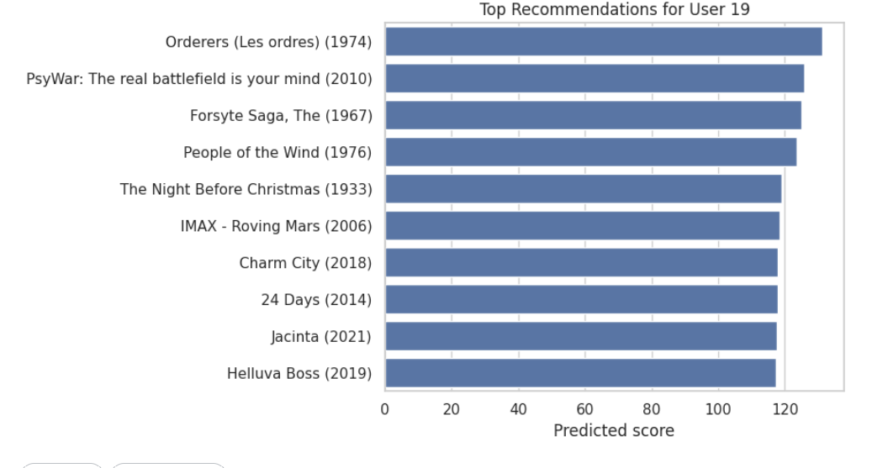
Figure 9b. Bar chart of the predicted interaction scores for user 19's top-10 recommendations.
This result is the single most important finding in the report. Every recommended title is a widely panned or niche film (e.g. Glitter, Bratz: The Movie, Disaster Movie, Gigli), and every predicted score is strongly negative (ranging from about -16 to -23), despite ratings in this dataset being on a 0–5 scale. This combination — negative predicted scores and universally low-quality titles surfacing at the top of the ranking — indicates the recommendation ranking is very likely not behaving as intended for this checkpoint. See Section 14 for a discussion of probable causes and Section 15 for suggested fixes.

12.2 Content-based 'movies like this' search
The bonus similarity search was demonstrated with the query 'Godfather', which matched 'Godfather, The (1972)' (the notebook selects the first match when a query is ambiguous). Similar movies are found via cosine similarity between movie-tower output vectors (which combine both the movie-identity embedding and the mean-pooled genre embedding), meaning this search captures a mix of genre similarity and collaborative co-rating similarity, independent of any particular user's history.

13. Cold-Start Handling for New Users
A dedicated module addresses the common real-world problem of brand-new users who have no trained embedding row yet. It provides two complementary mechanisms:
- compute_cold_start_vector() / recommend_for_new_user() — builds a 'pseudo user vector' by averaging the movie-tower output vectors of a handful of movies the new user says they like, requiring no retraining at all. This was demonstrated with the inputs 'toy story', 'Godfather', and 'Shawshank', which correctly matched to Toy Story (1995), Godfather, The (1972), and Shawshank Redemption, The (1994).
- register_new_user() — a longer-term path that permanently adds the new user's ID into user_to_index and expands the model's user_embedding table, so that once the user has rated enough movies and the model is retrained or fine-tuned, they are treated as a fully first-class user.
This two-tier design (instant content-based fallback now, full personalization after retraining later) is a sensible, production-minded pattern for handling user growth without requiring the whole model to be retrained every time a new user signs up.

14. Observations

14.1 Ranking metric evaluation
To evaluate the recommendation model, an 80–20 user-wise train-validation split was performed, ensuring that every user contributed ratings to both the training and validation sets. Movies in the validation set with a rating of 4 or higher were considered relevant items. Since evaluating recommendations against the entire movie catalog is both computationally expensive and unrealistic—because unrated movies are not necessarily disliked—a negative sampling strategy was adopted. For each user, the relevant validation movies were combined with 100 randomly sampled unseen movies (movies the user had never interacted with) to create a candidate set. The trained Two-Tower model ranked these candidate movies based on their predicted relevance, and the quality of the Top-5 recommendations was measured using Precision@5, Recall@5, and NDCG@5. This evaluation approach provides a computationally efficient and realistic assessment of the model's ability to rank relevant movies ahead of unseen alternatives while avoiding the bias of treating every unrated movie as a negative example.
The results are as follows.
Validation RMSE | 0.8272
Precision@5 | 0.2977
Recall@5 | 0.2632
NDCG@5 | 0.3447

14.2 Compute constraints
- At 10 epochs, the training/validation loss gap is still small but widening, suggesting the model is approaching a point of diminishing returns for this data volume and needs either more data, more regularization (dropout, weight decay), or both to keep improving without overfitting.

14.3 Extreme rating regression to the mean
As shown in Figure 5, predictions rarely reach the top or bottom of the 0–5 range. For a recommender, this specifically limits the model's ability to sharply distinguish a user's favorite few movies from their merely-liked ones, which matters more for top-K recommendation quality than for overall RMSE.

14.4 Reproducibility caveats
- The notebook's hard-coded data paths (/kaggle/input/datasets/...) are specific to a Kaggle environment and will need to be updated for any other execution environment.
- Cell 32 reloads a model.pth from a fixed Kaggle path rather than the one just saved in Cell 30, meaning the recommendation/demo cells downstream are exercising a previously-saved checkpoint from a prior run, not necessarily the exact model trained earlier in this same notebook execution — worth double-checking that both checkpoints are equivalent before drawing conclusions from the demo section.

15. Recommendations for Improvement
- Investigate the recommendation-ranking issue first (Section 14.1) — add a sanity check that compares torch.topk on raw interaction scores vs. the final calibrated rating prediction, and confirm which one Main.py actually uses in production.
- Print and report the aggregated Precision@K / Recall@K (or similar ranking metrics) from the negative-sampling evaluation cell, since RMSE/MAE alone do not tell us whether the top-K list itself is any good.
- Filter out extremely low-popularity movies (e.g. fewer than N ratings) from the recommendation candidate pool, or add a popularity prior/regularization term, to reduce the influence of undertrained embeddings on the top-K ranking.
- Train for more epochs on a larger sample (or the full dataset) using a GPU, with early stopping on validation loss, and consider adding dropout or weight decay to control the widening train/validation gap.
- Re-verify that the checkpoint loaded in Cell 32 is the same one just trained and saved in Cell 30 before relying on the interactive demo results for decision-making.
- Parameterize the hard-coded Kaggle file paths so the notebook can run unmodified in other environments (e.g. via environment variables or a config file).
- Consider adding implicit-feedback signals (e.g. view/click data, if available) or side features (release year, cast/crew) to enrich the movie tower beyond identity + genre.

15. Deployment
The system is deployed as two independently hosted, loosely coupled services rather than a single monolithic app. The trained model and its inference logic are wrapped in a FastAPI backend, deployed on Render as a persistent web service — the model and all lookup tables are loaded into memory once at startup, so every request is served through a fast, already-warm forward pass rather than a cold reload or a retrain. The frontend is a single static HTML/CSS/JS page with no build step, deployed separately to Vercel, which communicates with the backend purely over a lightweight HTTP/JSON API. This separation means either half can be redeployed, scaled, or replaced independently, and — since both services run continuously on their respective platforms — the entire application stays live and accessible to anyone with the link, with no dependency on any local machine remaining powered on or connected.

16. Conclusion
This notebook delivers a complete, end-to-end recommender system pipeline — from raw MovieLens data to a trained Two-Tower model, quantitative and visual evaluation, embedding diagnostics, deployment-ready artifact export, and two working interactive demos — all built to match a specific downstream FastAPI service's expectations. The rating-prediction accuracy achieved (RMSE 0.827, MAE 0.627) is a reasonable baseline for a 10-epoch, half-sampled training run, and the training curves, residual distribution, and embedding-norm checks all show a numerically healthy training process.
However, the interactive recommendation demo surfaced a concrete and important caveat: the actual top-K recommendations produced for a real user were dominated by obscure, poorly-rated films with strongly negative predicted scores, which does not look like usable, user-facing recommendation quality. Before this pipeline or its saved checkpoint is used in any production or user-facing context, the ranking behavior documented in Sections 12.1 and 14.1 should be diagnosed and resolved, and the model should ideally be retrained on more data for more epochs with proper top-K ranking metrics reported alongside RMSE/MAE.

17. Demo video

To demonstrate the practical application of the proposed system, an interactive prototype was developed. The demo showcases the major features of the recommendation system and illustrates how users can interact with the application in real time.

Dataset - https://drive.google.com/file/d/1ivM2awVMohkPxwoSq8lrXtaKnO7KKGx1/view?usp=drive_link
Demo video - https://drive.google.com/file/d/15TS2Z_9jH5baiLKZJQlI7ETuJNgzItfj/view?usp=drive_link
Link to front end of my project - https://movierecommenderfrontend.vercel.app/
I have deployed my model on Render the link to that is - https://recomender-backend-3210.onrender.com
Github link containing the code files and the report - https://github.com/Daksh345/recomender_backend

