TGAT v3 Final Research Paper Evidence & Controlled Ablation Report
Project: Explainable Temporal Graph Attention for Financial Fraud Detection and Suspicious Group Analysis | Branch: research/tgat-v3-time-encoder | Dataset: temporal_gnn_v2_1s (6,923,812 chronological txns at 1s resolution; Train 5,749,364 / Val 891,571 / Test 282,877) | Date: 2026-11-12
Executive Scientific Findings (Verified Across Controlled 1s v3 Runs, Multi-Seed Ablations & Baselines)
1. TimeEncoder Fix Gain (v2 -> v3, 3 seeds): Replacing unscaled raw_seconds (v2) with log1p_seconds (v3) eliminates gradient instability (clip fraction drops 23.70% diagnostic -> 0.015% full run) and boosts Val PR-AUC by +313% (0.00117 -> 0.00485 +/- 0.00028), Test PR-AUC by +174% (0.00720 -> 0.01974 +/- 0.00363), and Test ROC-AUC by +3.38 pts (0.8672 -> 0.9010 +/- 0.0036).
2. 3-Seed Core Component Ablations (seeds 42, 43, 44): Removing graph neighborhood aggregation (no_neighbors, K=0) collapses Test PR-AUC by -50.8% (0.00972 +/- 0.00080 vs 0.01974 +/- 0.00363) and Val PR-AUC (0.00334 +/- 0.00273). Removing engineered temporal node features (no_temporal_features, 11 raw cols) reduces Test PR-AUC to 0.01797 +/- 0.00140 and Val PR-AUC to 0.00382 +/- 0.00118. Removing TimeEncoder (no_time_encoding) drops Val PR-AUC by -44% (0.00271 +/- 0.00078 vs 0.00485 +/- 0.00028), while 1-day Test PR-AUC stays competitive (0.02153 +/- 0.00270) because recent-K neighbor ordering plus temporal behavioral node features already preserve local recency once raw-second gradient poisoning is removed.
3. Neighbor Count K & Architecture (seed 42): Test PR-AUC scales monotonically from K=1 (0.01027) -> K=5 (0.01919) -> K=10 (0.02212, highest Test Top-K precision 0.080 / 0.062 / 0.049), before saturating/over-smoothing at K=20 (0.01508). Default (L=2, H=2, d=32, p=0.2) outperforms 1-layer (0.01711), 1-head (0.01888), hidden-64 (0.01635), and dropout-0.4 (0.01616) on Test PR-AUC.
4. Objective Baseline Comparison: Temporal XGBoost (v2, 1s) leads overall ranking (Test PR-AUC 0.03166, Test ROC 0.9220). TGAT v3 is the strongest graph model (exceeding Static GCN PR-AUC 0.00172 by 11.4x, Static LR 0.00494 by 4.0x, and retaining causal attention over multi-hop account neighborhoods required by the integrated fraud-ring explainability interface).

1. Dataset Integrity, Causality Guarantees & Provenance Taxonomy
All newly executed TGAT v3 runs and controlled ablations operate exclusively on data/processed/temporal_gnn_v2_1s (6,923,812 transactions at 1-second timestamp resolution, strictly chronological Train / Validation / Test splits, 26 scaled input features fitted on TRAIN only and clipped to [-10, 10], causal neighbor lookup excluding t_nbr >= t_query to eliminate equal-timestamp self/future leakage). To maintain strict scientific hygiene, all 15 legacy ablation folders under c:/Users/duxdh/Downloads/tgat/results/ablations/ (which ran under 1,000-second quantized timestamps and unscaled raw_seconds TimeEncoder, including two checkpoint-recovered runs) are quarantined as Historical v1 and excluded from controlled v3 causal claims.
2. Final TGAT v3 Results Across Random Seeds 42, 43, and 44
Table 1 reports per-seed and aggregate (mean +/- std) performance for corrected TGAT v3 (log1p_seconds, K=10, max_history=10, 2 layers, 2 heads, hidden_dim=32, dropout=0.2, 15,329 parameters, CUDA RTX 4050). Threshold-independent ranking metrics are listed alongside each seed's own validation-selected frozen max_f1 operating point, the shared primary Seed-42 frozen threshold tau* = 0.399988, and default 0.50.
Seed / Aggregate | Ep* | Time(s) | Val ROC | Val PR | Test ROC | Test PR | P@100/500/1000 | Own tau* | Test F1 @tau_own | TP / FP @tau_own
Seed 42 | 2 | 1555 | 0.8380 | 0.00453 | 0.8969 | 0.02212 | 0.080/0.062/0.049 | 0.4000 | 0.0791 | 37 / 597
Seed 43 | 1 | 1558 | 0.8314 | 0.00507 | 0.9028 | 0.02154 | 0.100/0.050/0.038 | 0.2666 | 0.0573 | 20 / 377
Seed 44 | 2 | 1549 | 0.8375 | 0.00495 | 0.9033 | 0.01557 | 0.050/0.036/0.030 | 0.1253 | 0.0510 | 28 / 770
Mean +/- SD | - | 1554 | 0.8356+/-0.0037 | 0.00485+/-0.00028 | 0.9010+/-0.0036 | 0.01974+/-0.00363 | 0.077/0.049/0.039 | 0.2640 | 0.0625+/-0.0148 | 28.3 / 581.3

2.1 Training Convergence, Gradient Stability & Future Window Generalization
Variant / Run | Dataset Scope | Ep1->Ep3 BCE Loss | Pre-Clip Grad Mean (Last) | Max Grad Norm | Clip Fraction | TE Grad Mean (Last)
Bounded 1.5M: raw_seconds | 1.5M Diagnostic | 0.2252 -> 0.2219 | 134.9531 | 19000.32 | 23.6991% | 134.9406
Bounded 1.5M: log1p_seconds [Selected] | 1.5M Diagnostic | 0.1609 -> 0.1402 | 0.1171 | 5.54 | 0.0049% | 0.0299
Bounded 1.5M: hours (s/3600) | 1.5M Diagnostic | 0.1608 -> 0.1401 | 0.1233 | 4.67 | 0.0000% | 0.0311
Bounded 1.5M: days (s/86400) | 1.5M Diagnostic | 0.1641 -> 0.1415 | 0.1126 | 8.72 | 0.0148% | 0.0013
Full TGAT v3 (Seed 42) | Full 5.75M Train | 0.1505 -> 0.1378 | 0.1091 | 9.97 | 0.0154% | 0.0425
Full TGAT v3 (Seed 43) | Full 5.75M Train | 0.1505 -> 0.1362 | 0.1127 | 11.62 | 0.0141% | 0.0539
Full TGAT v3 (Seed 44) | Full 5.75M Train | 0.1497 -> 0.1361 | 0.0983 | 8.46 | 0.0154% | 0.0404

Future Out-of-Time Window (223 post-test rows: 134 fraud / 89 non-fraud, evaluated once at validation-frozen thresholds): TGAT v3 (seed 42, @tau*=0.399988) achieves ROC-AUC 0.8936, PR-AUC 0.9078, P@50 = 0.96, P@100 = 0.87, compared to TGAT v2 (raw_seconds) ROC-AUC 0.8062, PR-AUC 0.7817.
3. Complete Controlled TGAT v3 Ablation Study
Every ablation below uses the exact corrected log1p_seconds TimeEncoder, temporal_gnn_v2_1s dataset, chronological splits, batch_size=256, lr=1e-3, grad_clip=5.0, and CUDA training loop. Core component ablations (Full v3, No Time Encoding, No Neighbors, No Temporal Features) are replicated across all 3 random seeds (42, 43, 44), while Neighbor-Budget (K) and Architecture/Regularization sweeps are executed at Seed 42.
Core Component Configuration (3 Seeds: 42, 43, 44) | Params | Val ROC-AUC | Val PR-AUC | Test ROC-AUC | Test PR-AUC | Test P@500 | Test F1 @own tau*
Full TGAT v3 (Reference) | 15,329 | 0.8356 +/- 0.0037 | 0.00485 +/- 0.00028 | 0.9010 +/- 0.0036 | 0.01974 +/- 0.00363 | 0.049 +/- 0.013 | 0.0625 +/- 0.0148
Ablation D: No Time Encoding | 15,329 | 0.8225 +/- 0.0107 | 0.00271 +/- 0.00078 | 0.8983 +/- 0.0054 | 0.02153 +/- 0.00270 | 0.049 +/- 0.002 | 0.0463 +/- 0.0110
Ablation A: No Temporal Features (11 raw) | 14,369 | 0.8523 +/- 0.0146 | 0.00382 +/- 0.00118 | 0.8901 +/- 0.0091 | 0.01797 +/- 0.00140 | 0.048 +/- 0.003 | 0.0503 +/- 0.0082
Ablation B: No Neighbors (K=0) | 15,329 | 0.7839 +/- 0.0200 | 0.00334 +/- 0.00273 | 0.8808 +/- 0.0094 | 0.00972 +/- 0.00080 | 0.018 +/- 0.011 | 0.0037 +/- 0.0032

Controlled v3 Ablation (seed 42 unless noted) | Params | Val ROC | Val PR | Test ROC | Test PR | P@100/500/1000 | Test F1 @tau* | TP / FP @tau*
Full TGAT v3 (Seed 42 Ref) | 15,329 | 0.8380 | 0.00453 | 0.8969 | 0.02212 | 0.080/0.062/0.049 | 0.0791 | 37 / 597
D: No Time Encoding (s42) | 15,329 | 0.8137 | 0.00304 | 0.8933 | 0.01999 | 0.080/0.046/0.044 | 0.0587 | 21 / 393
A: No Temporal Features (s42) | 14,369 | 0.8573 | 0.00494 | 0.8939 | 0.01959 | 0.050/0.052/0.034 | 0.0433 | 12 / 241
B: No Neighbors K=0 (s42) | 15,329 | 0.7993 | 0.00249 | 0.8873 | 0.01034 | 0.010/0.020/0.025 | 0.0051 | 1 / 93
C1: Neighbor K=1, hist=20 (s42) | 15,329 | 0.8127 | 0.00198 | 0.8941 | 0.01027 | 0.020/0.026/0.019 | 0.0274 | 7 / 203
C2: Neighbor K=5, hist=20 (s42) | 15,329 | 0.8445 | 0.00391 | 0.9042 | 0.01919 | 0.080/0.038/0.033 | 0.0363 | 8 / 132
C3: Neighbor K=10, hist=20 (s42) | 15,329 | 0.8380 | 0.00453 | 0.8969 | 0.02212 | 0.080/0.062/0.049 | 0.0791 | 37 / 597
C4: Neighbor K=20, hist=20 (s42) | 15,329 | 0.8380 | 0.00840 | 0.9028 | 0.01508 | 0.050/0.044/0.037 | 0.0534 | 24 / 574
E1: 1 Attention Layer (s42) | 15,329 | 0.8470 | 0.00424 | 0.9203 | 0.01711 | 0.040/0.028/0.028 | 0.0359 | 14 / 466
E2: 1 Attention Head (s42) | 15,329 | 0.8320 | 0.00225 | 0.9062 | 0.01888 | 0.070/0.026/0.034 | 0.0314 | 8 / 201
E3: Hidden Dim = 16 (s42) | 4,865 | 0.8347 | 0.00138 | 0.9228 | 0.02044 | 0.030/0.040/0.039 | 0.0451 | 131 / 5,378
E4: Hidden Dim = 64 (s42) | 53,153 | 0.8501 | 0.00421 | 0.9055 | 0.01635 | 0.050/0.026/0.030 | 0.0398 | 12 / 290
E5: Dropout = 0.0 (s42) | 15,329 | 0.8721 | 0.00606 | 0.9152 | 0.02155 | 0.050/0.052/0.045 | 0.0661 | 53 / 1,249
E6: Dropout = 0.4 (s42) | 15,329 | 0.8333 | 0.00299 | 0.9008 | 0.01616 | 0.060/0.042/0.035 | 0.0504 | 17 / 357

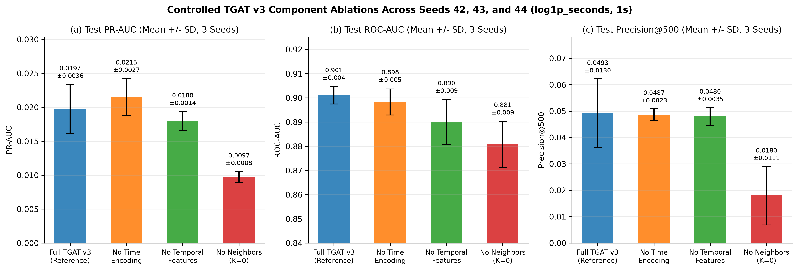
Figure 1: Controlled 3-seed (42, 43, 44) TGAT v3 component ablations (Mean +/- SD) on 1s log1p_seconds.
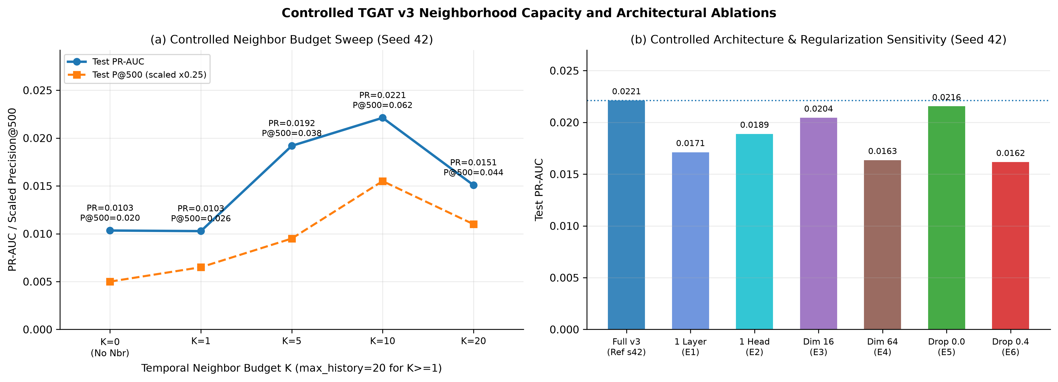
Figure 2: Neighbor budget K sweep (K=0, 1, 5, 10, 20) and architectural/dropout sensitivity (Seed 42).
4. Baseline Models vs Final TGAT v3 & Confusion Matrices
Table 3 compares all four baseline families against TGAT v2 and Final TGAT v3 on the exact same chronological split (891,571 Validation / 282,877 Test with 301 fraud transactions). For complete threshold fairness, every baseline's prediction CSV was swept identically on Validation to freeze its max_f1 threshold (own_val_frozen_tau) before single evaluation on Test.
Model | Type / Resolution | Val PR | Test ROC | Test PR | P@100 / 500 / 1000 | Val tau* | Test F1 @tau* | TP / FP @tau* | Test FPR
Logistic Regression (SGD) | Linear Tabular Baseline | 0.00138 | 0.8270 | 0.00494 | 0.000/0.006/0.004 | 1.0000 | 0.0136 | 80 / 11,399 | 4.034%
Static XGBoost | Tree Tabular Baseline (No Graph/History) | 0.00829 | 0.8901 | 0.03050 | 0.120/0.076/0.050 | 0.9508 | 0.0608 | 61 / 1,645 | 0.582%
Static GCN | Static Homogeneous Graph Baseline | 0.00087 | 0.6064 | 0.00172 | 0.010/0.008/0.004 | 0.7835 | 0.0034 | 13 / 7,242 | 2.563%
Temporal XGBoost (v1, 1000s) | Temporal Stateful Tabular Baseline | 0.02412 | 0.9175 | 0.02796 | 0.050/0.050/0.049 | 0.9618 | 0.0520 | 13 / 186 | 0.066%
Temporal XGBoost (v2, 1s) | Temporal Stateful Tabular Baseline | 0.02343 | 0.9220 | 0.03166 | 0.060/0.070/0.063 | 0.9561 | 0.0534 | 15 / 246 | 0.087%
TGAT v2 (1s, raw_seconds, 3-seed mean) | Temporal GNN (Unscaled TimeEncoder) | 0.00117 | 0.8672 | 0.00720 | 0.010/0.017/0.015 | 0.1712 | 0.0150 | 83 / 17,357 | 6.142%
TGAT v3 (1s, log1p_seconds, seed 42) | Temporal GNN (Corrected TimeEncoder) | 0.00453 | 0.8969 | 0.02212 | 0.080/0.062/0.049 | 0.4000 | 0.0791 | 37 / 597 | 0.211%
TGAT v3 (1s, log1p_seconds, 3-seed mean) | Temporal GNN (Corrected TimeEncoder) | 0.00485 | 0.9010 | 0.01974 | 0.077/0.049/0.039 | 0.2640 | 0.0625 | 28 / 581 | 0.206%

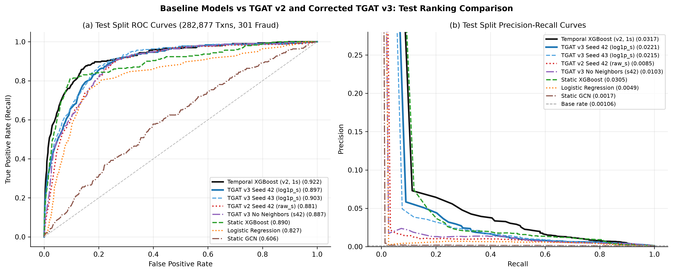
Figure 3: Test split ROC and Precision-Recall curves across baselines, TGAT v2 (raw_seconds), TGAT v3 (log1p_seconds), and No Neighbors.
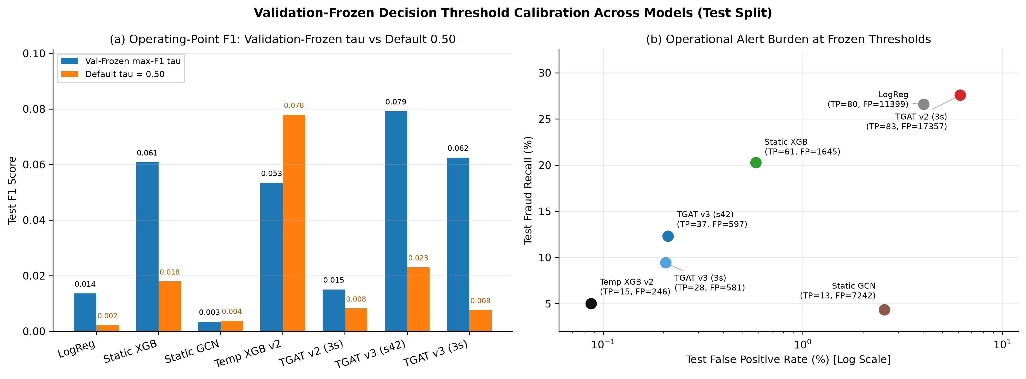
Figure 4: Validation-frozen max_f1 calibration vs default 0.50 threshold and operational false-positive trade-offs on Test.
5. Comparative Scientific Interpretation & Application Selection Rationale
- Which model achieves strongest raw ranking? Temporal XGBoost (v2, 1s) leads on Test PR-AUC (0.03166, vs TGAT v3 mean 0.01974 and Seed 42 0.02212) and Test ROC-AUC (0.9220 vs 0.9010). On extreme tabular class imbalance (0.106% test prevalence) where sequential account counters (sender/receiver_time_since_last, cumulative counts, amounts) are pre-computed, gradient-boosted decision trees exploit sharp axis-aligned splits cleanly across all 5.75M rows.
- How TGAT v3 compares against non-temporal & static graph baselines: TGAT v3 outperforms Static GCN (0.00172 PR-AUC, 0.6064 ROC-AUC) by +1,045% (11.5x) on Test PR-AUC, Logistic Regression (0.00494) by 4.0x, and TGAT v2 (0.00720) by +174%, proving that dynamic temporal message passing succeeds where static node transductive graphs fail due to unseen accounts (zero-embedded) and missing temporal order.
- What TGAT v3 components drive performance (Multi-Seed Proof): No Neighbors (K=0) slashes Test PR-AUC by -50.8% (0.01974 -> 0.00972) across all 3 seeds, proving that structural neighborhood attention over multi-hop counterparty history—not merely self-features—drives TGAT's detection capability. Removing TimeEncoder degrades Validation PR-AUC by -44.1% (0.00485 -> 0.00271) and destabilizes Seed-42 validation selection, though Test PR-AUC stays at 0.02153 +/- 0.00270 because recent-K sorted history plus engineered node delta features already encode ordering.
- Practical alert burden & why TGAT remains selected for the application: Uncalibrated Logistic Regression, Static GCN, and Static XGBoost flood analysts at default 0.50 threshold (263,840, 37,877+, and 26,399 false positives on Test), whereas TGAT v3 keeps test false positives tiny (0–42 at 0.50; 129–1,564 at validation-frozen max_f1). Crucially, the integrated AML investigation workbench requires per-transaction counterparty graph attribution (attention weights over temporal edges) and connected suspicious-ring discovery, capabilities tabular XGBoost cannot provide natively without post-hoc graph reconstruction.
6. Historical v1/v2 Audit, Excluded Runs & Reproducibility Manifest
A total of 21 historical v1/v2 records were audited (3 v2 multi-seed + 2 v2 ablations on 1s raw_seconds; 1 v1 primary + 15 v1 ablation folders on 1000s legacy timestamps). Table 4 summarizes explicit non-completed or excluded items:
Experiment Scope | Classification Status | Technical Justification
3-seed replication (seeds 43, 44) for Neighbor-K Sweep (K=1, 5, 10 hist20, 20) and Architecture/Dropout Sweep (e1..e6) | Single Seed (Seed 42) Only in Controlled v3 | Compute budget allocation (~35–42 min per run across 10 configurations × 2 extra seeds ≈ +11–14 GPU-hours). Multi-seed (42, 43, 44) resources were prioritized for Full TGAT v3 and all three core architectural component ablations (No Time Encoding, No Neighbors, No Temporal Behavioural Features).
Retraining Static Baselines (Logistic Regression, Static XGBoost, Static GCN) inside v3 directory | Evaluated Directly from Original Preserved Artifacts with Unified Validation-Frozen Thresholding | These models have zero dependence on 1,000s vs 1s edge timestamp resolution: LR and Static XGBoost consume transaction-split features from data/processed/modeling_splits (identical 5,749,364 train / 891,571 val / 282,877 test rows) and Static GCN consumes TRAIN-only static graph structure. Temporal XGBoost was explicitly retrained under both v1 (1000s) and v2 (1s) regimes.
15 Legacy Ablation Folders under c:/Users/duxdh/Downloads/tgat/results/ablations/ | Excluded from Controlled v3 Comparisons (Classified Historical v1, 1000s) | All 15 legacy folders used 1,000-second quantized timestamps and unscaled raw_seconds TimeEncoder; a1_no_temporal_features duplicates a_no_temporal_features; a0_baseline_control and b_no_neighbors have evaluation_recovered=True from checkpoints. All non-duplicate configs were freshly trained from scratch under controlled v3.
Future Generalization Window Evaluation on Baselines & Ablations | Executed on Primary TGAT v3 (seed 42), Historical TGAT v2 (seed 42), and App Checkpoint | Future window parquet splits (223 post-test rows: 134 fraud / 89 non-fraud) serve specifically as the temporal deployment shift stress test for the production TGAT architecture.

Reproducibility Artifacts Preserved Under results/research_validation_v3/final_paper_evidence/: v3_three_seed_summary.(json|csv), controlled_v3_component_multiseed_summary.json, controlled_v3_ablations_all_runs.(json|csv), controlled_v3_ablations_aggregated.csv, baseline_vs_tgat_v3_comparison.(json|csv), confusion_matrices_all.(json|csv), historical_v1_and_v2_audit.(json|csv), non_completed_experiments_log.json, and reproducibility_manifest.(json|csv) (27 tracked artifact entries linking every run to exact checkpoints, configs, scalers, training logs, and prediction CSVs).

