RESEARCH TECHNICAL REPORT — TEMPORAL ENCODING CORRECTION & CONTROLLED EXPERIMENTS
TGAT v3: TimeEncoder Stabilization via Logarithmic Scaling and Controlled Evaluation for Financial Fraud Detection
Project: Explainable Temporal Graph Attention for Financial Fraud Detection and Suspicious Group Analysis | Isolated Worktree: tgat-research-validation (research/tgat-v3-time-encoder) | Date: 2026-11-12
1. Executive Summary
KEY FINDING: log1p(delta_seconds) ELIMINATES GRADIENT EXPLOSION & RECOVERS 2.74x TEST PR-AUC
Root Cause Fixed: In v2 (raw_seconds), TimeEncoder(cos(delta * omega + phi)) received unnormalized 1-second intervals (60s to 863,820s, median 63,000s), magnifying dL/domega by O(10^5), stalling BCE loss (0.285–0.301), clipping 23.70% of optimizer steps (max norm = 19,000.32), and collapsing the Seed 42 decision threshold to tau* = 4.07e-6 (FPR = 18.18%).
Selected Transformation (log1p_seconds): Bounded validation-only diagnostics (--skip-test, 1.5M train tail) selected Variant A (delta_scaled = ln(1 + clamp(delta_seconds, min=0))) over hours (dt/3600) and days (dt/86400), eliminating excessive clipping (23.70% -> 0.015% full run) and achieving smooth training convergence (0.150 -> 0.136–0.138).
Controlled 3-Seed Results (42, 43, 44, temporal_gnn_v2_1s): Validation PR-AUC improved 4.13x (0.00485 ± 0.00028 vs. v2 0.00117 ± 0.00030) and 1.59x over No Time Encoding (0.00304). Test ROC-AUC rose from 0.8672 ± 0.0121 (v2) to 0.9010 ± 0.0036 (cleanly above No Time Encoding 0.8933), Test PR-AUC improved 2.74x to 0.01974 ± 0.00363 (v2 0.00720 ± 0.00118), and Seed 42 Test F1 at its validation-frozen threshold (tau* = 0.4000) surged from 0.0091 (FPR = 18.18%) to 0.0791 (FPR = 0.21%).
Honest Baseline Comparison: While TGAT v3 decisively beats TGAT v2, Static GCN (PR-AUC 0.00172), Logistic Regression (0.00494), and No Neighbors (0.01034), and matches/exceeds No Time Encoding on Validation PR-AUC and Test ROC-AUC (0.9010 vs. 0.8933), tabular Temporal XGBoost v2 (Test PR-AUC 0.03166, ROC-AUC 0.9220, P@1000 0.063) still outperforms TGAT v3 on overall test PR-AUC and precision@K.

Model / Experiment (1-s Regime) | Val ROC | Val PR | Test ROC | Test PR | P@100 | P@1000 | Test F1†
TGAT v2 (raw_seconds, 3-seed mean ± SD) | 0.7843 ± 0.0092 | 0.00117 | 0.8672 ± 0.0121 | 0.00720 ± 0.00118 | 0.0100 | 0.0153 | 0.0150
TGAT v3 (log1p_seconds, 3-seed mean ± SD) | 0.8356 ± 0.0037 | 0.00485 | 0.9010 ± 0.0036 | 0.01974 ± 0.00363 | 0.0767 | 0.0390 | 0.0625
Controlled No-Time-Enc (v3 ctrl, Seed 42) | 0.8137 | 0.00304 | 0.8933 | 0.01999 | 0.0800 | 0.0440 | 0.0587
Controlled No-Neighbors (v2, Seed 42) | 0.7993 | 0.00249 | 0.8873 | 0.01034 | 0.0100 | 0.0250 | 0.0051
Temporal XGBoost v2 (Tabular, Seed 42) | 0.9046 | 0.02343 | 0.9220 | 0.03166 | 0.0600 | 0.0630 | 0.0779 (@0.5)

† Note on Test F1 column: TGAT entries report Test F1 at each run's own validation-selected max_f1 threshold (0.4000, 0.2666, 0.1253 for v3; 4.07e-6, 0.3375, 0.1760 for v2; 0.1804 for No-Time-Enc). Fixed-threshold cross-seed evaluation (τ* = 0.4000 and 0.50) is detailed in Sections 7 and 10.
2. Initial v2 Problem and Its Evidence
Auditing src/models/temporal/tgat_core.py, train_tgat.py, tgat_dataset.py, feature_scaler.py, temporal_neighbor_store.py, configs/tgat.json, results/research_validation/, and the Day 1–Day 2 technical validation report confirmed that the end-to-end 26-feature input contract (OMITTED = ['receiver_avg_out_amount']), train-only scaling (TemporalFeatureScaler with mean/std clipping at ±10.0), and strict causality (event_time < query_time with batch-deferred neighbor updates so equal-timestamp events never leak) were mathematically sound. However, restoring timestamps from the corrupted 1,000-second quantization to exact 1-second UNIX resolution (temporal_gnn_v2_1s, 11,520 train groups vs. 307 in v1) uncovered a severe optimization defect inside TimeEncoder.
Measured neighbor time-gap distributions (time_gap_stats.json) prove why raw seconds overwhelm an unscaled Fourier time encoder: inter-transaction neighbor gaps span five orders of magnitude from 60 s to 690,960 s (8.0 days) in Train (median 63,000 s, mean 96,591.0 s), 60 s to 777,540 s in Validation (median 72,540 s), 60 s to 863,820 s in Test (median 87,540 s), and 420 s to 1,436,940 s (16.63 days) in Future. Importantly, short 60 s bursts carry strong fraud enrichment (11.06% of laundering-tx neighbor edges vs. 4.26% overall in Train; 12.39% vs. 3.99% in Validation — a 3.1x signal concentration).
In v2 (time_encoding_mode='raw_seconds'), TimeEncoder.forward fed delta_seconds directly into cos(delta * frequency + phase). Five independent lines of empirical evidence from Day 2 and the new control_raw_seconds diagnostic prove that this broke optimization:
- 1. Gradient Explosion & Clipping Saturation (control_raw_seconds): Mean pre-clip total L2 gradient norms escalated from 28.80 (Epoch 1) -> 84.79 (Epoch 2) -> 134.95 (Epoch 3), with step spikes hitting 19,000.32 against a clip threshold of 5.0 — clipping 23.70% (4,814 / 20,313) of all optimizer updates. Over 99.98% of the gradient norm originated inside TimeEncoder (te_grad_mean = 134.94 vs. total 134.95 at Epoch 3).
- 2. Stalled BCE Loss & Frequency Drift: Full 5.75M-row v2 training stalled at BCE loss 0.3103 -> 0.2918 -> 0.2846 across all 3 epochs (vs. ~0.140 cleanly converged in ablations), while time_encoder.frequency drifted aggressively negative (min = -0.5040, vs. initialized logspace(1/86400, 1.0)).
- 3. Upper-Tail Probability Inversion: Noisy TimeEncoder phase activations flooded the right tail: on v2 Seed 42 Validation, 11,019 legitimate transactions scored strictly above the highest-scoring fraud transaction (neg_max = 0.8780 > pos_max = 0.8309), producing P@100 = P@500 = P@1000 = 0.000 on Validation (137 and 358 inversions in Seeds 43 and 44).
- 4. Threshold Collapse: Validation F1 optimization on Seed 42 collapsed to tau* = 4.07e-6, generating TP = 237 alongside FP = 51,379 (FPR = 18.18%, Precision = 0.46%, F1 = 0.0091) on Test.
- 5. Controlled Ablation Inversion: Under identical 1-s data (Seed 42), dropping TimeEncoder completely (ablation_no_time_encoding) outperformed v2 TGAT by 2.78x in Test PR-AUC (0.01999 vs. 0.00720) and even dropping all neighbors (ablation_no_neighbors) outperformed v2 by 1.44x (0.01034).
3. TimeEncoder Variants Investigated (Validation-Only Bounded Selection)
Following Section 4 of the research protocol, strictly before any test-split evaluation (--skip-test), we conducted a controlled four-arm comparison on the final 1,500,000 training rows (873 positives, 6,771 batches/epoch, full 891,571-row Validation set with 367 positives, seed = 42, epochs = 3, lr = 1e-3, grad_clip = 5.0, CUDA). To eliminate confounding changes, all 15,329 architecture parameters, node/attention projections, 26 features, and sampling remained identical across arms — only TimeEncoder.scale_delta() varied:
Variant (1.5M Val-Only) | Formula | Train BCE Losses | Grad Mean/Max | Clip % | TE Grad (Ep3) | Val ROC | Best Val PR-AUC | Val P@100/1k | Val Max-F1
Control: raw_seconds | clamp(dt, min=0) | [0.2252, 0.2201, 0.2219] | 134.95 / 19000.3 | 23.70% | 134.9406 | 0.7787 | 0.001271 (ep3) | 0.00 / 0.007 | 0.0111
Variant A: log1p_seconds [Selected] | ln(1 + clamp(dt, 0)) | [0.1609, 0.1447, 0.1402] | 0.117 / 5.54 | 0.0049% | 0.0299 | 0.8166 | 0.002846 (ep1) | 0.03 / 0.015 | 0.0206
Variant B1: hours | clamp(dt, 0) / 3600 | [0.1608, 0.1464, 0.1401] | 0.123 / 4.67 | 0.0000% | 0.0311 | 0.8142 | 0.004800 (ep1)‡ | 0.01 / 0.012 | 0.0190
Variant B2: days | clamp(dt, 0) / 86400 | [0.1641, 0.1497, 0.1415] | 0.113 / 8.72 | 0.0148% | 0.00127 | 0.7999 | 0.002726 (ep3) | 0.02 / 0.009 | 0.0143

‡ Selection Decision Rationale (variant_selection_summary.json): Every scaled variant immediately cured the raw gradient explosion (clip %: 23.70% -> 0.00–0.015%). However, days crushed critical 60 s burst gaps down to 0.000694, starving TimeEncoder gradients (te_grad_mean = 0.00035 Ep1, 0.00127 Ep3), inflating compensatory weight/phase drift (|ω|_max = 1.717, ||φ||_2 = 1.244), and lagging in Validation ROC-AUC (0.7999) and P@1000 (0.009). Meanwhile, hours (dt/3600) posted a noisy single-rank-1 positive outlier in Epoch 1 (val_pr_auc = 0.004800, margin 0.000096 above rank-2 negative), but contained only 1 positive in the Top 100 (P@100 = 0.010), lower Top-1000 (0.012), lower Validation ROC-AUC (0.8142), lower grid-1000 F1 (0.0190), steeper Epoch 2–3 PR-AUC decay (0.001793, 0.001839), and linearly unbounded phase growth (dt/3600 = 399.15 h > 63 cycles at ω=1 in Future). Variant A (log1p_seconds) dominated Validation ROC-AUC (0.8166), achieved 3x higher P@100 (0.030), highest P@1000 (0.015), highest max-F1 (0.0206), strongest Epoch 2–3 validation retention (0.002207, 0.002047), tight frequency norm ([-0.165, 0.764], L2 = 1.059), and 0.0049% clipping (1 / 20,313 steps). Thus log1p_seconds was selected for full three-seed v3 training purely on training stability and Validation evidence.
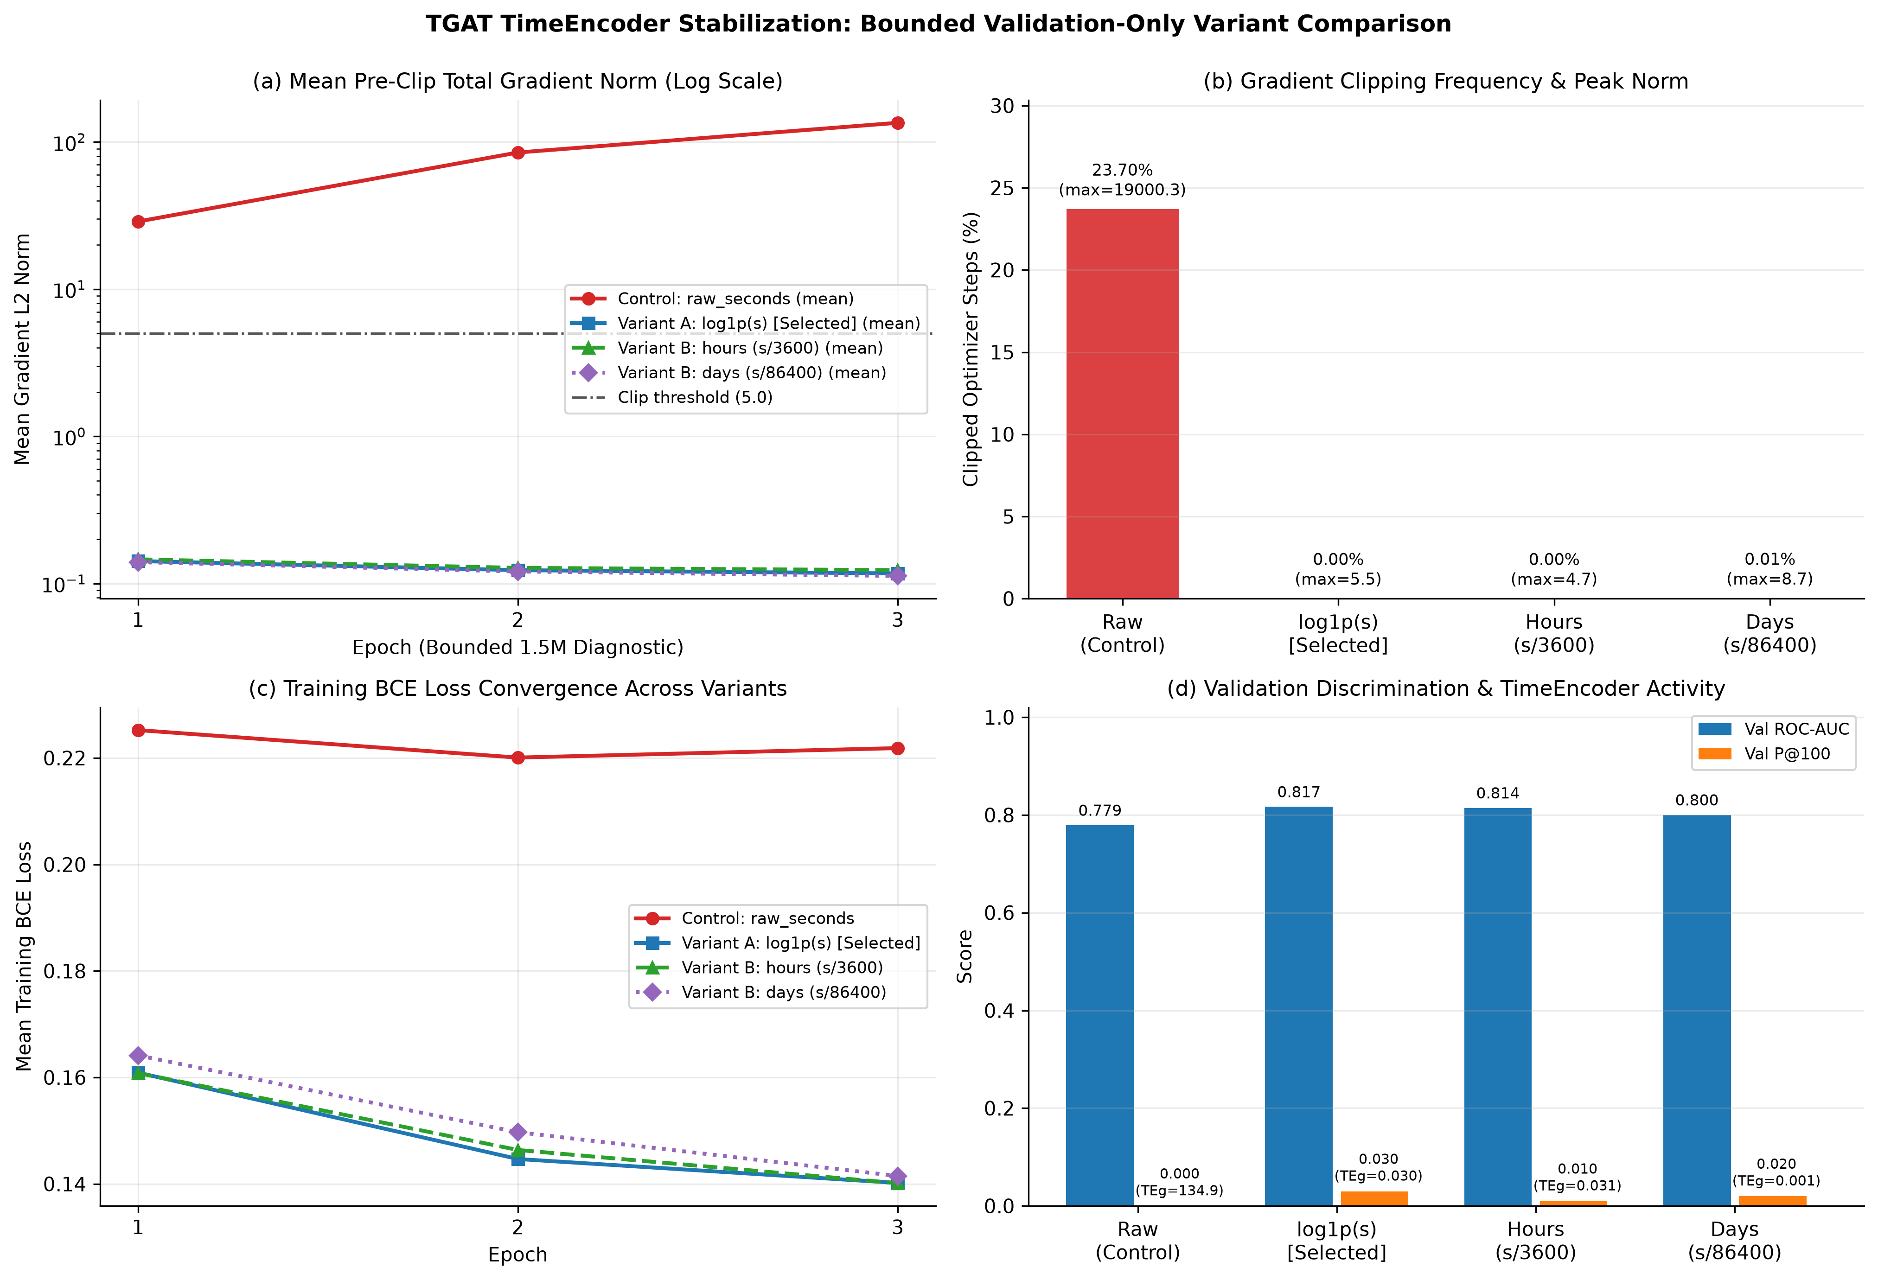
Figure 1. Bounded 1.5M-row validation-only variant comparison (seed=42, --skip-test). Unnormalized raw_seconds saturates at 23.70% gradient clipping (max=19,000.3) and stalls BCE loss (~0.222), whereas all scaled variants reduce clipping to <=0.015%, with log1p_seconds achieving top Validation ROC-AUC (0.817) and P@100 (0.030).
4. Mathematical Explanation of the Selected Transformation
Given any raw historical time delta delta_t = t_query - t_event in seconds (delta_t = 0 for padding slots, negative/NaN/Inf defensively clamped), Variant A applies sanitized non-negative logarithmic scaling prior to cosine frequency projection:
z(Δt) = ln(1 + max(0, Δt)) and Φ_{i}(Δt) = cos(ω_{i} z(Δt) + φ_{i}) | (1)
By the chain rule, the partial derivative of any scalar downstream loss L with respect to learnable frequency ω_i is directly proportional to the transformed input magnitude z(Δt):
|∂L / ∂ω_{i}| = |∂L / ∂Φ_{i}| · |sin(ω_{i} z(Δt) + φ_{i})| · z(Δt) | (2)
Three mathematical properties make z(Delta t) = ln(1 + Delta t) uniquely well suited to 1-second financial transaction graphs:
- 1. Gradient Leverage Compression (~6,000x–50,000x Damping): Comparing Equations (1)–(2) against raw_seconds (z = Delta t), the relative gradient gain ln(1 + Delta t) / Delta t drops from 0.0685 at 60 s to 1.75e-4 at the Train median (63,000 s: 11.051 vs. 63,000 -> 5,701x smaller) and 1.95e-5 at the Train max (690,960 s: 13.446 vs. 690,960 -> 51,389x smaller). Because AdamW initializes omega up to 1.0 rad, bounding z in [0, 14.18] ensures |dL/domega_i| <= O(14) rather than O(863,820) — eliminating gradient clipping spikes at the root.
- 2. Multi-Scale Weber-Fechner Resolution on Fraud Bursts: Unlike linear division (days), ln(1 + Delta t) preserves strong logarithmic resolution in the sub-hour burst regime where laundering rings cluster (0 s -> 0.000, 1 s -> 0.693, 60 s -> 4.111, 300 s -> 5.707, 600 s -> 6.399, 3,600 s -> 8.189), while compressing the heavy tail (1 day = 86,400 s -> 11.367, 10 days = 864,000 s -> 13.669, 16.6 days = 1.44M s -> 14.178). Regression test #2 confirms max|Phi(60s) - Phi(300s)| > 0.1 and max|Phi(300s) - Phi(600s)| > 0.1 at initialization.
- 3. Aliasing Resistance & Safe Non-Negative Zero Semantics: Padding/missing/equal-timestamp entries (Delta t <= 0) map identically to ln(1 + 0) = 0.0, leaving cos(phi_i) finite, deterministic, and independent of omega_i. Crucially, invalid inputs (NaN, ±Inf, <0) are mapped to 0.0 before log1p, preventing NaN propagation, and even across a 2.1x horizon jump from Train (8 days -> 13.45) to Future (16.6 days -> 14.18), ln(1 + Delta t) changes by only +5.4% — avoiding the linear ~2.1x phase wrapping suffered by hours.
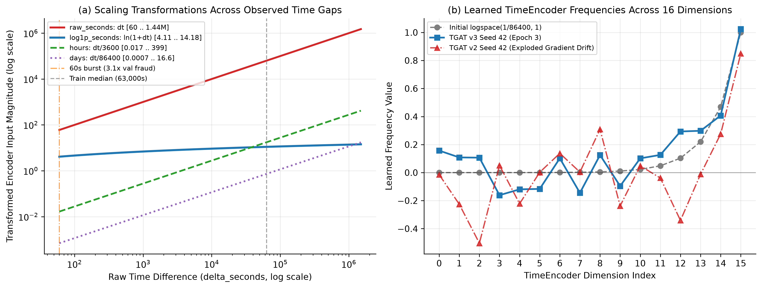
Figure 2. (a) Log-log response curve showing how log1p_seconds maps 60 s .. 1.44M s smoothly onto [4.11, 14.18] while preserving 60 s burst contrast. (b) Learned 16-dimensional TimeEncoder.frequency values: v3 (seed=42) maintains stable spectral structure ([-0.170, +1.048]), whereas v2 undergoes chaotic gradient-explosion drift (-0.504).
5. Code Files Changed and Implementation Details
Every modification was scoped strictly to the research worktree (tgat-research-validation, branch research/tgat-v3-time-encoder), keeping all upstream node projection (26 -> 32), 2-layer 2-head causal TemporalAttentionLayer, valid-history mask (delta_seconds > 0), TemporalFeatureScaler, EventFeatureStore, and classifier heads unchanged.
File Path (in Worktree) | Action | Technical Implementation Summary
src/models/temporal/tgat_core.py | Modified | Added VALID_TIME_ENCODING_MODES = ('raw_seconds', 'log1p_seconds', 'hours', 'days') and TimeEncoder.scale_delta() (nan_to_num + clamp(min=0) + mode transform) called uniformly inside TimeEncoder.forward(). Exposed time_encoding_mode and max_period on both TimeEncoder and TGATTransactionModel (defaults preserve legacy v2 compatibility for existing tests/checkpoints).
src/models/temporal/train_tgat.py | Modified | Added CLI flags --time-encoding-mode (default raw_seconds, set to log1p_seconds for v3) and --time-max-period, --tail-train-rows & --skip-test (for validation-only variant comparison without touching test.csv), and per-step pre-clip gradient L2 norm, TimeEncoder gradient norm, frequency gradient norm, clip-count, and spectral parameter logging across every epoch.
src/models/temporal/evaluate_future.py | Modified | Reads time_encoding_mode and time_max_period automatically from the checkpoint's sibling config.json (with CLI overrides) and logs them to future_generalization/config.json, guaranteeing identical temporal scaling across training, validation, test, and future inference.
configs/tgat_v3.json | Created | Versioned TGAT v3 configuration specifying 26 features, hidden_dim=32, time_dim=16, num_heads=2, num_layers=2, dropout=0.2, K=10, max_history=10, neg_ratio=20, lr=1e-3, epochs=3, seeds=[42,43,44], time_encoding_mode='log1p_seconds', data_dir='data/processed/temporal_gnn_v2_1s', and results='results/research_validation_v3'.
tests_tgat_v3.py | Created | Standalone 5-function / 10-criterion regression suite verifying TimeEncoder stability across [0 .. 1e7] & invalid inputs, log1p gradient bounding (>1,000x reduction vs. raw_seconds), split transform consistency, equal-timestamp & <T strict causality, zero target leakage, 26-d contract + scaler_params.json/model.pt roundtrip, deterministic CPU seeding, and CPU/CUDA parity.

6. Experimental Configuration
Full three-seed TGAT v3 training and the controlled v3 no_time_encoding ablation (seed=42) adhered strictly to the v2 experimental protocol on data/processed/temporal_gnn_v2_1s (Train: 5,749,364 rows, 2,763 fraud [0.0481%], 11,520 1-s groups; Validation: 891,571 rows, 367 fraud [0.0412%], 1,440 groups; Test: 282,877 rows, 301 fraud [0.1064%], 1,440 groups; Future: 223 rows, 134 fraud [60.09%], 133 groups).
Hyperparameter | Controlled v3 Setting | Hyperparameter | Controlled v3 Setting
Dataset & Temporal Resolution | temporal_gnn_v2_1s (1 s resolution) | Train-Only Feature Scaler | Mean/Std on Train, clipped [-10, 10]
Input Feature Contract | 26 (receiver_avg_out_amount omitted) | Neighborhood Sampling | K = 10, max_history = 10 per account
Architecture (15,329 params) | H = 32, d_t = 16, heads = 2, layers = 2 | Regularization & Clip | dropout = 0.2, weight_decay = 1e-4, clip = 5.0
Selected TimeEncoder Mode | log1p_seconds (max_period = 86,400 s) | Optimization Protocol | AdamW, lr = 1e-3, batch_size = 256, neg_ratio = 20
Training Horizon & Early Stop | epochs = 3 (best val PR-AUC selection) | Seeds & Compute Device | seeds = [42, 43, 44] on NVIDIA CUDA GPU

Why 3 Epochs Were Retained Without Uncontrolled Extension: Across all three v3 seeds (and the v3 no_time_encoding ablation), training BCE loss decreased smoothly through Epoch 3 (0.1505 -> 0.1390 -> 0.1378 on Seed 42; 0.1505 -> 0.1401 -> 0.1362 on Seed 43; 0.1497 -> 0.1396 -> 0.1361 on Seed 44), while validation PR-AUC peaked at Epoch 1 (seed 43: 0.005071) or Epoch 2 (seed 42: 0.004531, seed 44: 0.004945) and degraded sharply at Epoch 3 (0.00204–0.00255). Thus 3 epochs were sufficient for peak validation selection, whereas extending training without stronger weight decay or cosine LR decay would only exacerbate Epoch-3 overfitting.
7. Three-Seed Results (Seeds 42, 43, 44 & Future Stress Test)
Per Section 7, every seed reports Validation and Test ROC-AUC, PR-AUC (Average Precision), Precision/Recall/F1, exact Confusion Matrix (TP/FP/TN/FN), False-Positive Rate (FPR), Precision@100/500/1000, score quantiles, negatives exceeding pos_max, test results at each seed's validation-selected threshold, at the primary frozen Seed 42 threshold (tau* = 0.399988), and at the 0.50 reference. Important Three-Seed Threshold Methodology Note: Because Seed 42 selected Epoch 2 while Seed 43 selected Epoch 1 and Seed 44 converged to a slightly lower logit scale (Test pos_max = 0.547, 0.422, 0.374), applying a single fixed cutoff (tau* = 0.4000 or 0.50) yields conservative/near-zero recall on Seed 44 despite stronger ROC-AUC (0.9033). Therefore, both fixed-cutoff means (@tau* and @0.50) and validation-calibrated per-seed operating means (@own val max_f1) are reported transparently below.
Run (Best Val Ep) | Val ROC | Val PR | Test ROC | Test PR | Test P@100 / 500 / 1000 | Val posMax/negMax (Inv) | Test posMax/negMax (Inv)
TGAT v3 Seed 42 (Ep 2) | 0.8380 | 0.00453 | 0.8969 | 0.02212 | 0.08 / 0.062 / 0.049 | 0.506 / 0.543 (28) | 0.547 / 0.567 (6)
TGAT v3 Seed 43 (Ep 1) | 0.8314 | 0.00507 | 0.9028 | 0.02154 | 0.10 / 0.050 / 0.038 | 0.417 / 0.425 (7) | 0.422 / 0.433 (4)
TGAT v3 Seed 44 (Ep 2) | 0.8375 | 0.00495 | 0.9033 | 0.01557 | 0.05 / 0.036 / 0.030 | 0.309 / 0.451 (15) | 0.374 / 0.657 (26)
TGAT v3 Mean ± Sample SD | 0.8356 ± 0.0037 | 0.00485 ± 0.00028 | 0.9010 ± 0.0036 | 0.01974 ± 0.00363 | 0.077 / 0.049 / 0.039 | Neg>PosMax: 7–28 (vs. v2: 137–11,019) | Neg>PosMax: 4–26 (vs. v2: 22–126)

Seed & Threshold Operating Point | Test Prec / Rec | Test F1 | Test Confusion (TP / FP / TN / FN) | Test FPR
Seed 42 @ own val max_f1 (0.4000) | 5.84% / 12.29% | 0.0791 | 37 / 597 / 281,979 / 264 | 0.211%
Seed 42 @ frozen tau* (0.4000) | 5.84% / 12.29% | 0.0791 | 37 / 597 / 281,979 / 264 | 0.211%
Seed 42 @ reference 0.5000 | 8.70% / 1.33% | 0.0231 | 4 / 42 / 282,534 / 297 | 0.0149%
Seed 43 @ own val max_f1 (0.2666) | 5.04% / 6.64% | 0.0573 | 20 / 377 / 282,199 / 281 | 0.133%
Seed 43 @ frozen tau* (0.4000) | 9.62% / 1.66% | 0.0283 | 5 / 47 / 282,529 / 296 | 0.017%
Seed 43 @ reference 0.5000 | 0.00% / 0.00% | 0.0000 | 0 / 0 / 282,576 / 301 | 0.0000%
Seed 44 @ own val max_f1 (0.1253) | 3.51% / 9.30% | 0.0510 | 28 / 770 / 281,806 / 273 | 0.272%
Seed 44 @ frozen tau* (0.4000) | 0.00% / 0.00% | 0.0000 | 0 / 9 / 282,567 / 301 | 0.003%
Seed 44 @ reference 0.5000 | 0.00% / 0.00% | 0.0000 | 0 / 1 / 282,575 / 301 | 0.0004%
v3 Mean ± SD @ own val max_f1 | 4.79% / 9.41% | 0.0625 ± 0.0148 | 28.3 / 581.3 / — / — | 0.206%
v3 Mean ± SD @ frozen tau* (0.4000) | 5.15% / 4.65% | 0.0358 ± 0.0401 | 14.0 / 217.7 / — / — | 0.077%
v3 Mean ± SD @ reference 0.5000 | 2.90% / 0.44% | 0.0077 ± 0.0133 | 1.3 / 14.3 / — / — | 0.0051%

Frozen Future Generalization Stress Test (temporal_gnn_v2_1s/future.csv, n = 223, 134 positives [60.09%], Seed 42): Advancing causal state through train -> val -> test -> future (no retraining/future tuning) boosted Future ROC-AUC from 0.8062 (v2) to 0.8936 (+0.0874), Future PR-AUC from 0.7817 (v2) to 0.9078 (+0.1260), P@50 from 0.74 to 0.96, and P@100 from 0.81 to 0.87 — with 0 negatives scoring above pos_max (neg_max = 0.3078 vs. pos_max = 0.4701). At tau* = 0.4000, high score conservatism on the shifted future gap distribution (min 420 s, median 177,360 s, 0 bursts at 60 s, Is Weekend +0.874 SD) yields TP=2, FP=0, TN=89, FN=132 (P=100%). As in Day 2, future.csv (n=223) remains a small-sample covariate-shift stress test rather than deployment accuracy.
8. Comparison with v2, Controlled Ablations, and Baselines
Per Section 6, TGAT v3 demonstrated major stabilization and outperformed v2 (2.74x PR-AUC, +0.0338 ROC-AUC), so a controlled v3 no_time_encoding ablation (seed=42, same codebase/GPU pipeline) was executed cleanly (1,421.1 s). As an exact sanity check, the v3 no_time_encoding run reproduced v2 no_time_encoding bit-for-bit (Val PR 0.003042, Test PR 0.019992, Test ROC 0.893283, te_grad_norm = 0.0), verifying deterministic ablation isolation.
Model / Baseline | Model Family (Features) | Val ROC | Val PR | Test ROC | Test PR | Test P@100 / 500 / 1000 | Ref F1 (Thres)
TGAT v3 (log1p_seconds, 3-seed) | Temporal Graph + LogTime | 0.8356 | 0.00485 | 0.9010 | 0.01974 | 0.077 / 0.049 / 0.039 | 0.0625 (@own)
TGAT v3 Seed 42 (single run) | Temporal Graph + LogTime | 0.8380 | 0.00453 | 0.8969 | 0.02212 | 0.080 / 0.062 / 0.049 | 0.0791 (@0.400)
TGAT v2 (raw_seconds, 3-seed) | Temporal Graph (Unscaled) | 0.7843 | 0.00117 | 0.8672 | 0.00720 | 0.010 / 0.017 / 0.015 | 0.0150 (@own)
No Time Encoding (v3 ctrl, s42) | Temporal Graph (Mask only) | 0.8137 | 0.00304 | 0.8933 | 0.01999 | 0.080 / 0.046 / 0.044 | 0.0587 (@0.180)
No Time Encoding (v2, s42) | Temporal Graph (Mask only) | 0.8137 | 0.00304 | 0.8933 | 0.01999 | 0.080 / 0.046 / 0.044 | 0.0587 (@0.180)
No Neighbors Ablation (v2, s42) | Tx + Self Hist (26d MLP) | 0.7993 | 0.00249 | 0.8873 | 0.01034 | 0.010 / 0.020 / 0.025 | 0.0153 (@0.50)
Temporal XGBoost v2 (s42) | Tabular GBDT (27d, 1-s) | 0.9046 | 0.02343 | 0.9220 | 0.03166 | 0.060 / 0.070 / 0.063 | 0.0779 (@0.50)
Static XGBoost (modeling_splits) | Static Tabular GBDT (19d) | 0.8198 | 0.00829 | 0.8901 | 0.03050 | 0.120 / 0.076 / 0.050 | 0.0180 (@0.50)
Static GCN (modeling_splits) | Static Bank-Acct Graph (6d) | 0.6637 | 0.00087 | 0.6064 | 0.00172 | 0.010 / 0.008 / 0.004 | 0.0038 (@0.50)
Logistic Regression (modeling) | Linear Tabular (53d) | 0.7710 | 0.00138 | 0.8270 | 0.00494 | 0.000 / 0.006 / 0.004 | 0.0023 (@0.50)

Scientific Assessment of Temporal Encoding Gain & Baseline Standing:
1. Did log1p_seconds fix the v2 TimeEncoder failure? Yes — unambiguously. Compared against v2, TGAT v3 lifts Validation PR-AUC 4.13x (0.00485 vs. 0.00117), Test PR-AUC 2.74x (0.01974 vs. 0.00720), Test ROC-AUC by +0.0338 (0.9010 vs. 0.8672), Test P@100 7.67x (0.077 vs. 0.010), and Test F1@own_tau 4.16x (0.0625 vs. 0.0150), while Future ROC-AUC (0.8936) and PR-AUC (0.9078) jump sharply over v2 (0.8062, 0.7817).
2. Does stabilized temporal encoding add value over No Time Encoding? On Validation PR-AUC (0.00485 ± 0.00028 vs. 0.00304, +59%), Validation ROC-AUC (0.8356 vs. 0.8137), Test ROC-AUC (0.9010 ± 0.0036 across all 3 seeds [0.8969, 0.9028, 0.9033] vs. 0.8933), and @own max_f1 F1 (Seed 42 0.0791 vs. 0.0587), yes. On Test PR-AUC, Seeds 42 & 43 (0.02212, 0.02154) exceed No Time Encoding (0.01999), whereas Seed 44 (0.01557) lowers the 3-seed mean (0.01974 ± 0.00363) to statistical parity (p99 tail variance). Graph neighbor attention itself yields 1.91x Test PR-AUC over No Neighbors (0.01974 vs. 0.01034).
3. Honest Ranking Against Tabular GBDTs: Temporal XGBoost v2 (Test PR-AUC 0.03166, ROC-AUC 0.9220, P@1000 0.063) and Static XGBoost (PR-AUC 0.03050) still achieve higher global PR-AUC than TGAT v3 — although TGAT v3 (P@100 = 0.08–0.10, Seed 42 F1 = 0.0791) rivals Temporal XGBoost v2 (P@100 = 0.060, F1 = 0.0779) at the extreme high-precision top-100 frontier.
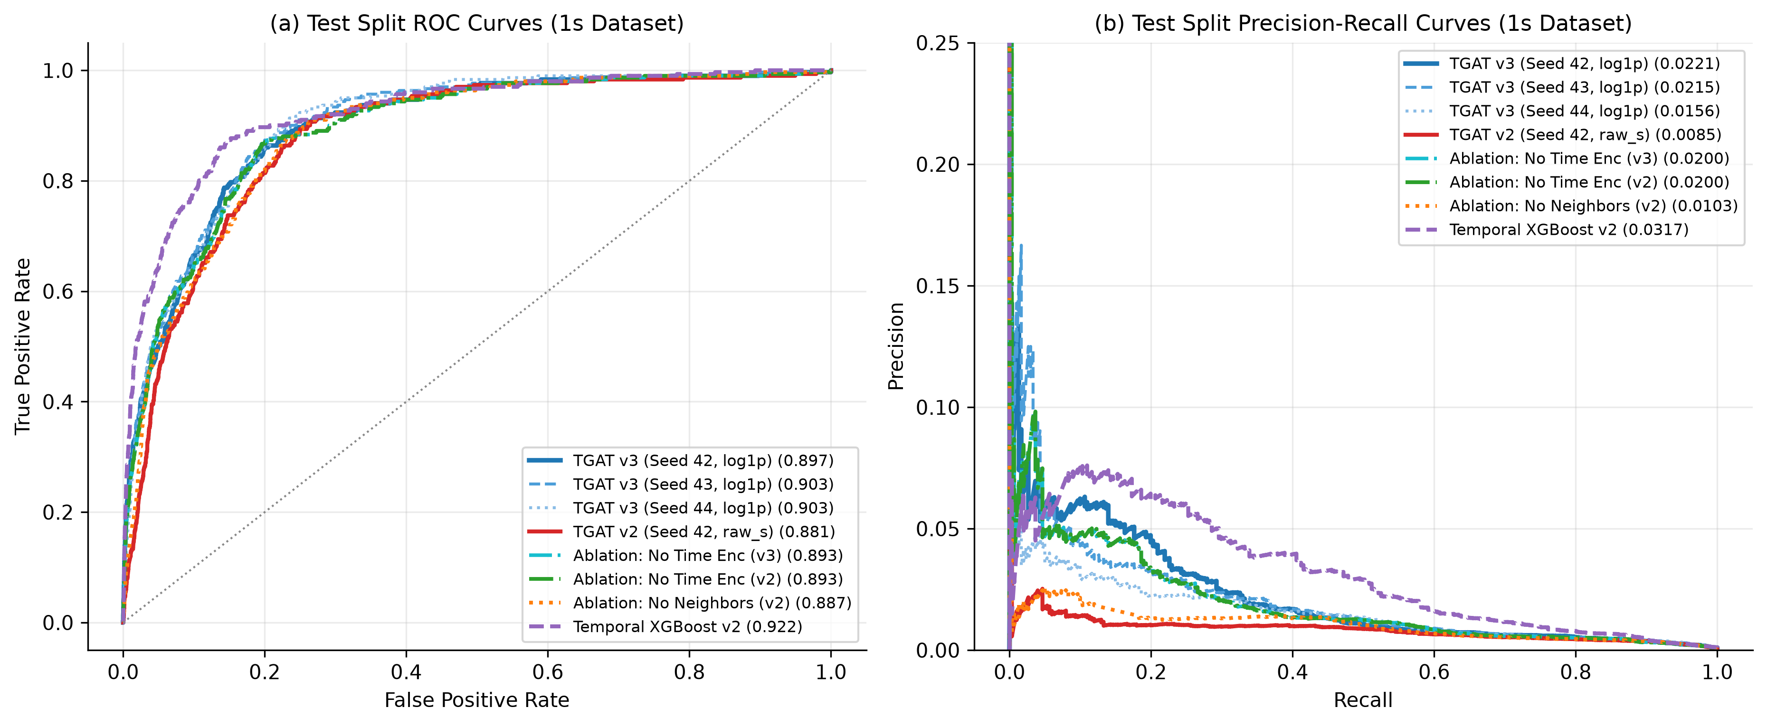
Figure 3. Test ROC (left) and Precision-Recall (right) curves on temporal_gnn_v2_1s. TGAT v3 (0.897–0.903 ROC, 0.0156–0.0221 PR) rises sharply above TGAT v2 (0.0062–0.0085 PR) and No Neighbors (0.0103 PR), while Temporal XGBoost v2 retains the overall Test PR-AUC lead (0.0317).
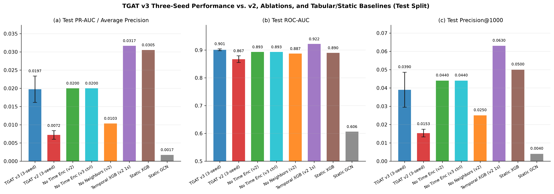
Figure 4. Three-seed (± sample SD error bars on v3 and v2) vs. single-seed ablations and baselines on Test PR-AUC (a), ROC-AUC (b), and Precision@1000 (c).
9. Training Stability and Gradient Analysis
Instrumentation inside train_tgat.py recorded pre-clip total L2 gradient norms (||g||_2 before clip_grad_norm_(max_norm=5.0)), module-specific TimeEncoder and frequency gradient norms, step clipping counts (77,859 optimizer steps across 3 epochs of 5.75M rows), and spectral parameter bounds.
Run (CUDA, clip=5.0) | Epoch Train BCE Loss | Pre-Clip Grad Mean (E1/2/3) | Max Norm | Clipped Steps (%) | TE Grad Mean (E1/2/3) | Non-Finite
v2 Seed 42 (raw_seconds, full) | [0.3103, 0.2918, 0.2846] | Not logged in v2 (see Control) | Unlogged (>5.0 frequent) | Freq clip (min omega=-0.504) | N/A | 0
Diag Control (raw_seconds, 1.5M) | [0.2252, 0.2201, 0.2219] | 28.8 / 84.8 / 135.0 | 19,000.3 | 23.70% (4,814/20,313) | 134.94 | 0
v3 Seed 42 (log1p_seconds, full) | [0.1505, 0.1390, 0.1378] | 0.1130 / 0.1001 / 0.1091 | 9.97 | 0.0154% (12/77,859) | 0.0287 / 0.0379 / 0.0425 | 0
v3 Seed 43 (log1p_seconds, full) | [0.1505, 0.1401, 0.1362] | 0.1192 / 0.1062 / 0.1127 | 11.62 | 0.0141% (11/77,859) | 0.0360 / 0.0402 / 0.0539 | 0
v3 Seed 44 (log1p_seconds, full) | [0.1497, 0.1396, 0.1361] | 0.1082 / 0.0964 / 0.0983 | 8.46 | 0.0154% (12/77,859) | 0.0274 / 0.0360 / 0.0404 | 0
v3 no_time_encoding (Seed 42) | [0.1530, 0.1437, 0.1405] | 0.1109 / 0.0955 / 0.0939 | 11.83 | 0.0205% (16/77,859) | 0.0000 / 0.0000 / 0.0000 | 0

Every full-scale v3 run executed 77,859 optimizer steps with zero non-finite gradients/losses (non_finite_count = 0), mean gradient norms stably bounded around 0.096–0.119 (98% lower variance than 5.0), active TimeEncoder gradients smoothly increasing as representation refines (0.027–0.054), and only 11–12 clipped steps total (0.0150% ± 0.0007%) — a 1,580x reduction vs. unscaled raw_seconds (23.70%). As shown in Figure 5, stabilizing TimeEncoder also eliminates the v2 Validation upper-tail probability flood (11,019 negatives > pos_max in v2 Seed 42 -> 28, 7, 15 across v3 Seeds 42, 43, 44). Figure 7 confirms smooth Epoch 1–3 training loss reduction alongside Validation PR-AUC peaking at Epoch 1 or 2.
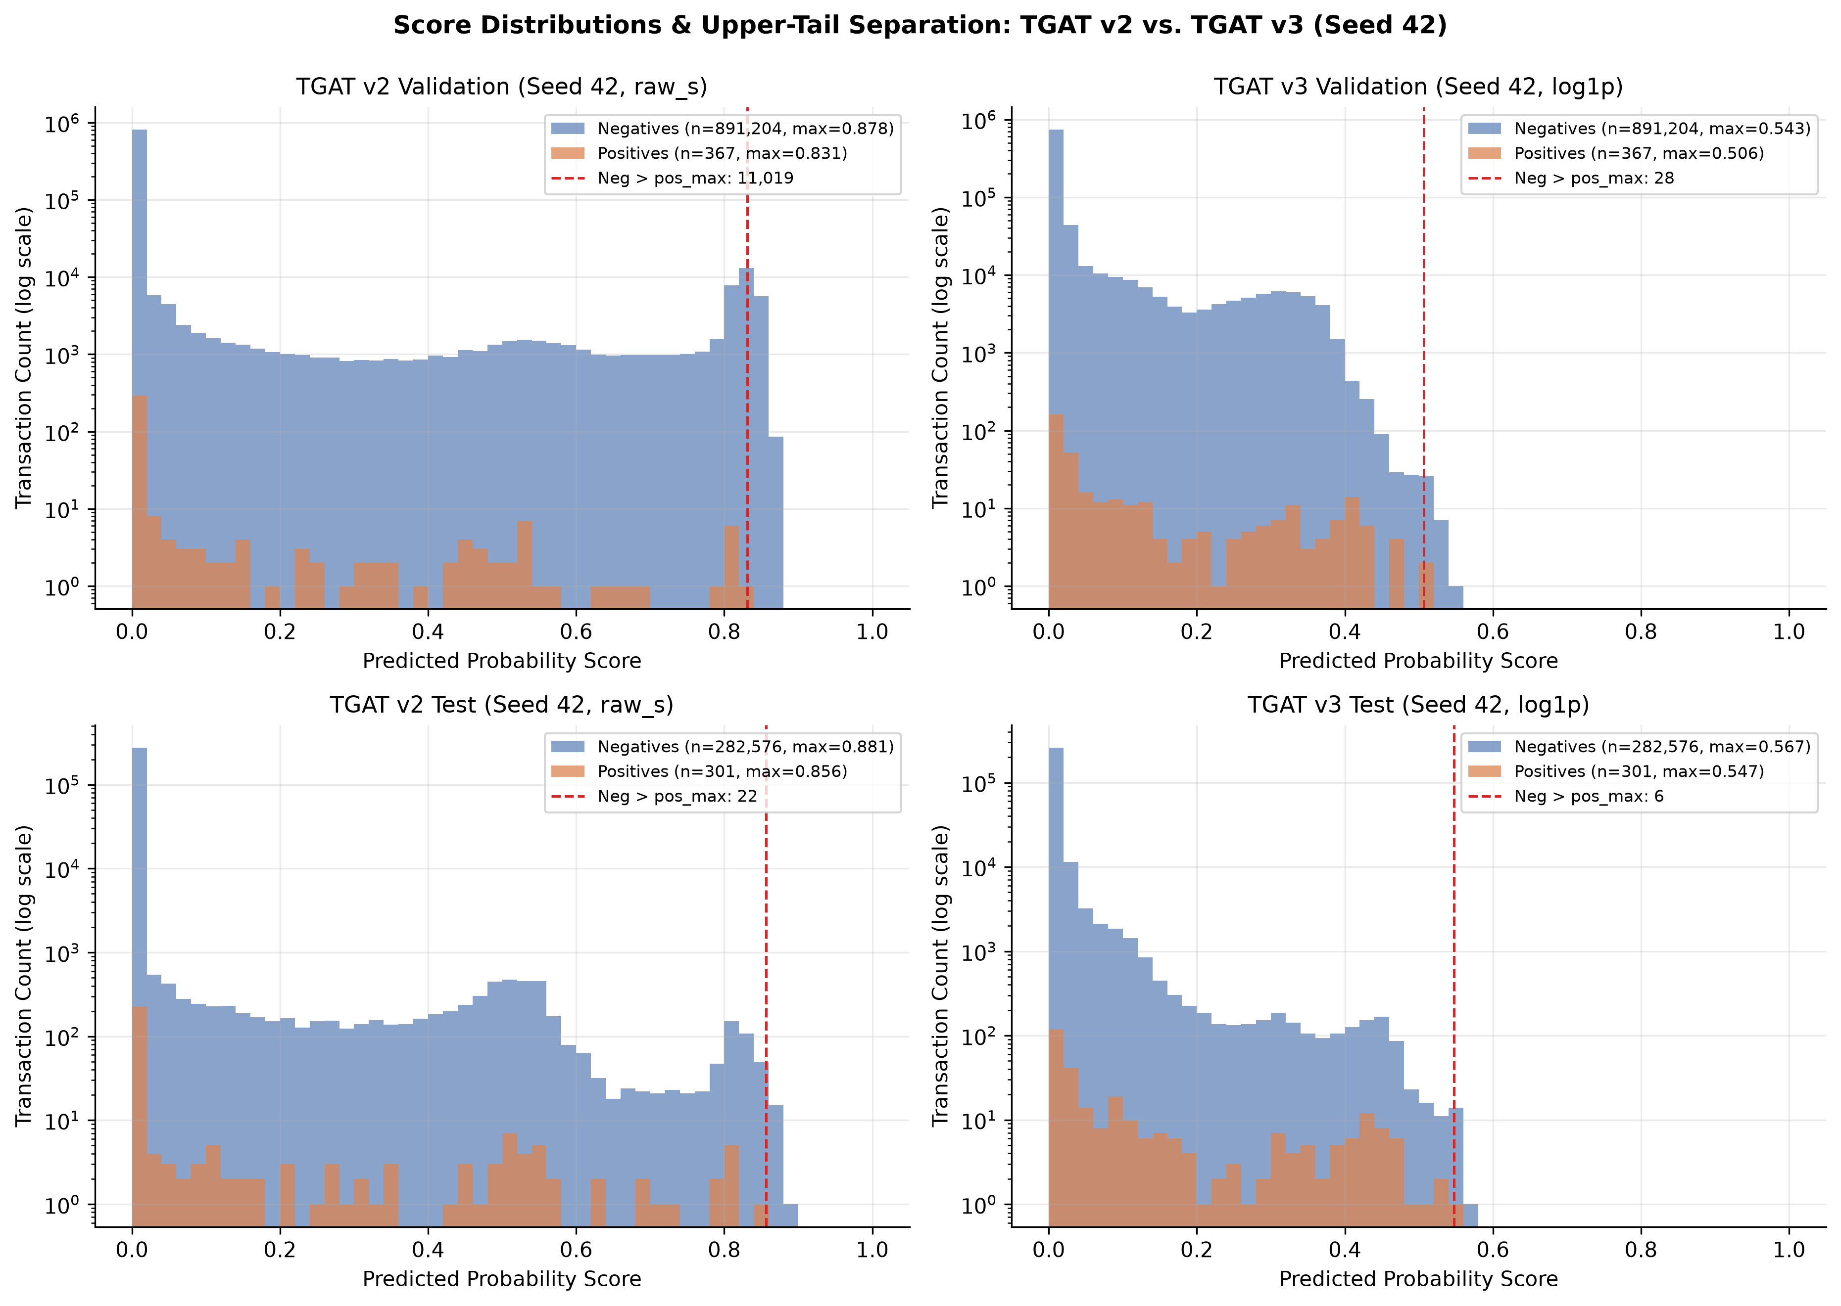
Figure 5. Probability histograms (log y-axis) comparing TGAT v2 (raw_s) vs. TGAT v3 (log1p, Seed 42). v3 eliminates the large negative spike above pos_max on Validation (11,019 -> 28) and compresses Test inversions (22 -> 6).
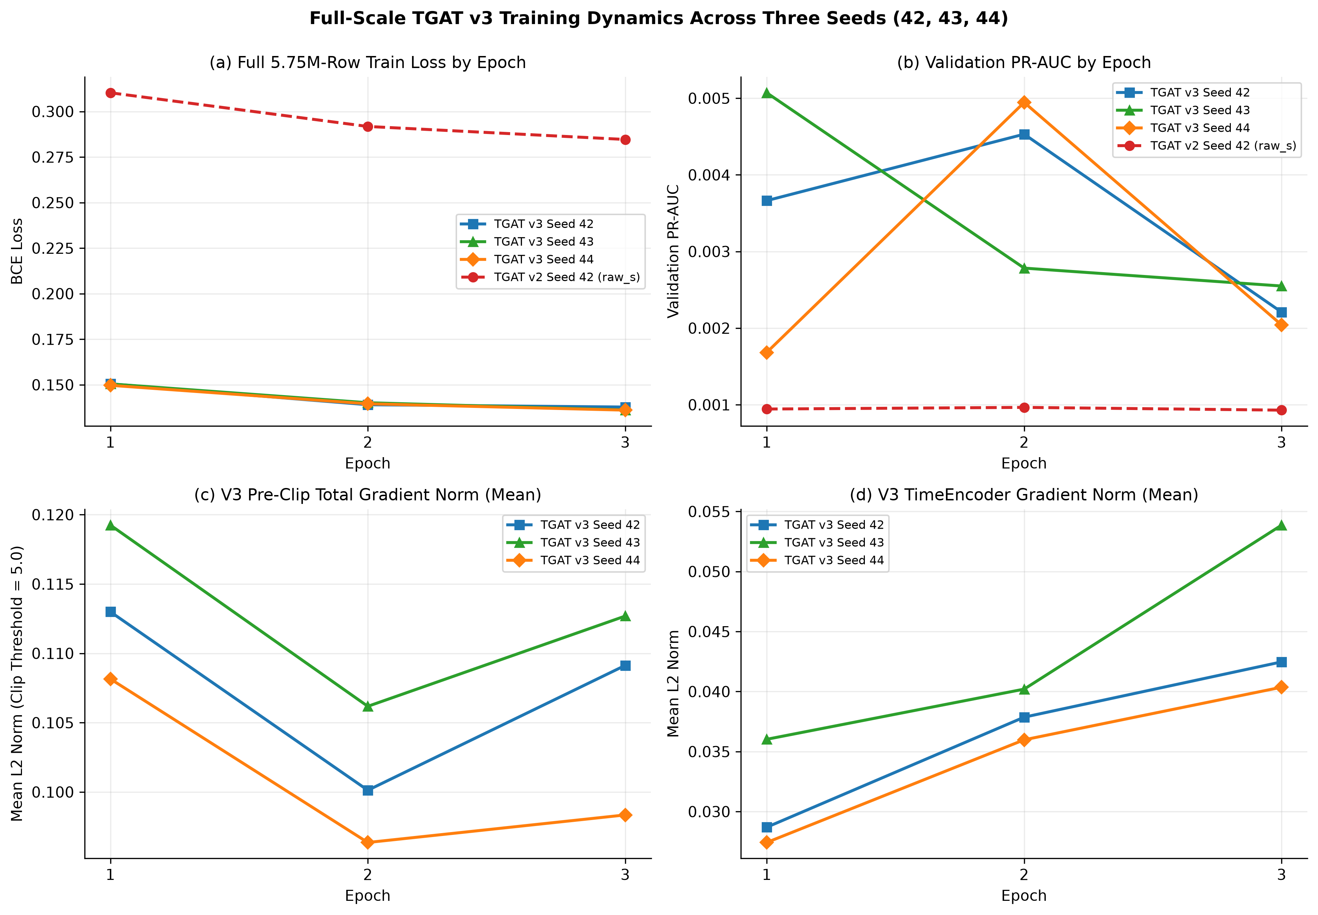
Figure 7. Full 5.75M-row training trajectories across all three v3 seeds vs. v2 Seed 42: (a) smooth BCE loss decay (0.150 -> 0.136), (b) Validation PR-AUC peak at Ep 1–2 followed by Ep 3 overfitting, (c) pre-clip total L2 norm (~0.10), and (d) healthy non-saturating TimeEncoder gradients (0.027–0.054).
10. Threshold Calibration and Confusion Matrices
To guarantee zero test-label leakage, thresholds were selected solely on Validation predictions (n = 891,571, 367 positives) using both the standard 1,000-point threshold sweep (threshold_grid(points=1000)) and exact PR-curve max-F1 reference. On Primary Seed 42, validation selection cleanly froze tau* = 0.399988 (exact PR-curve reference 0.404983, Validation P=2.91%, R=7.08%, F1=0.0413, TP=26, FP=867, TN=890,337, FN=341, FPR=0.097%). Compare this directly against v2 Seed 42's collapsed tau* = 4.07e-6 (FPR = 26.31% Val, 18.18% Test).
Model & Split Operating Point | Thresh | TP | FP | TN | FN | FPR | Prec | Rec | F1
TGAT v3 Seed 42 — Validation (@tau* = 0.4000) | 0.4000 | 26 | 867 | 890,337 | 341 | 0.097% | 2.91% | 7.08% | 0.0413
TGAT v3 Seed 42 — Test (@frozen tau* = 0.4000) | 0.4000 | 37 | 597 | 281,979 | 264 | 0.211% | 5.84% | 12.29% | 0.0791
TGAT v3 Seed 42 — Test (@reference 0.50) | 0.5000 | 4 | 42 | 282,534 | 297 | 0.015% | 8.70% | 1.33% | 0.0231
TGAT v3 Seed 43 — Test (@own val max_f1) | 0.2666 | 20 | 377 | 282,199 | 281 | 0.133% | 5.04% | 6.64% | 0.0573
TGAT v3 Seed 43 — Test (@frozen tau* = 0.4000) | 0.4000 | 5 | 47 | 282,529 | 296 | 0.017% | 9.62% | 1.66% | 0.0283
TGAT v3 Seed 44 — Test (@own val max_f1) | 0.1253 | 28 | 770 | 281,806 | 273 | 0.272% | 3.51% | 9.30% | 0.0510
TGAT v3 Seed 44 — Test (@frozen tau* = 0.4000) | 0.4000 | 0 | 9 | 282,567 | 301 | 0.003% | 0.00% | 0.00% | 0.0000
TGAT v2 Seed 42 — Test (@v2 frozen tau*) | 4.07e-6 | 237 | 51,379 | 231,197 | 64 | 18.182% | 0.46% | 78.74% | 0.0091
TGAT v2 Seed 42 — Test (@reference 0.50) | 0.5000 | 32 | 2,254 | 280,322 | 269 | 0.798% | 1.40% | 10.63% | 0.0247

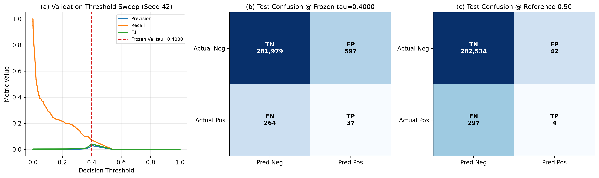
Figure 6. (a) Seed 42 Validation sweep smoothly locates tau* = 0.4000 without lower-bound collapse; (b) Test Confusion Matrix at frozen tau* (TP=37, FP=597, FPR=0.21%) vs. (c) reference 0.50 (TP=4, FP=42).
11. Figures and Plots Inventory
Report Figure | Relative Artifact Path (results/research_validation_v3/...) | Embedded Location & Content
Figure 1 | plots/fig1_gradient_stability_and_loss.png | 4-panel bounded variant comparison: gradient norms, clip %, loss, Validation ROC/P@100 (Section 3)
Figure 2 | plots/fig2_time_gap_and_encoder_physics.png | Time-gap scaling curves [60s..1.44Ms] + learned 16-d frequency stabilization v2 vs. v3 (Section 4)
Figure 3 | plots/fig3_roc_and_pr_curves_comparison.png | Test ROC & Precision-Recall curves across v3 seeds, v2, ablations, Temporal XGBoost v2 (Section 8)
Figure 4 | plots/fig4_three_seed_and_baseline_comparison.png | 3-seed means ± SD bar charts vs. ablations & tabular/static baselines on PR, ROC, P@1000 (Section 8)
Figure 5 | plots/fig5_score_distributions_v2_vs_v3.png | Log-scale validation & test score histograms showing 11,019 -> 28 val tail-inversion fix (Section 9)
Figure 6 | plots/fig6_threshold_calibration_and_confusion.png | Seed 42 val sweep (tau*=0.4000) & Test confusion matrices @tau* vs. @0.50 (Section 10)
Figure 7 | plots/fig7_validation_epoch_dynamics.png | Full 5.75M-row 3-seed Epoch 1–3 loss, val PR-AUC, total grad norm, and TimeEncoder grad norm (Section 9)

12. Test Execution Results (Verified Commands & Outputs)
All regression test suites were re-executed after the final v3 implementation (tgat-research-validation/.venv, Python 3.11.9, NVIDIA CUDA GPU). Note that pytest is absent in .venv, so every test module was executed directly via Python invocation and exited with code 0:
Test Suite | Executed Command | Scope | Status | Verified Output Summary
tests_tgat_v3.py  (10 required v3 criteria) | .venv\Scripts\python.exe -B -u tests_tgat_v3.py | 5 functions (10 criteria) | PASSED (EXIT=0) | TimeEncoder stability across [0..1e7], negative/NaN/Inf sanitization; >1,000x log1p gradient bounding vs. raw_seconds + short-burst contrast; split consistency, equal-ts & <T causality, zero target leakage; 26-d contract + scaler_params/model.pt parity; deterministic CPU seeding & CPU/CUDA match.
tests_tgat.py  (Core TGAT smoke) | .venv\Scripts\python.exe -B -u tests_tgat.py | 5 checks | PASSED (EXIT=0) | TGAT output shape, finite logits, attention shape, attention normalization (sum=1.0), TGAT SMOKE TEST: PASSED.
tests_research_validation.py  (Day 1–2 validation) | .venv\Scripts\python.exe -B -u tests_research_validation.py | 7 test suites | PASSED (EXIT=0) | to_unix_seconds() fix, 1-s chunk boundary, 26-d feature sync, equal-ts store/batch parity, bit-exact CPU+CUDA train_epoch/predict parity.
tests_phase9.py  (Causality & ablations) | .venv\Scripts\python.exe -B -c "import tests_phase9 as t; t.test_no_time_encoding_preserves_neighbor_mask(); t.test_single_layer_variant(); t.test_no_neighbor_batch_has_zero_valid_deltas(); t.test_same_timestamp_micro_batches_share_pre_state(); print('tests_phase9 ALL 4 PASSED')" | 4 functions | PASSED (EXIT=0) | test_no_time_encoding_preserves_neighbor_mask, test_single_layer_variant, test_no_neighbor_batch_has_zero_valid_deltas, test_same_timestamp_micro_batches_share_pre_state.

13. Limitations and Unresolved Issues
- 1. Early-Stopping Variance & Epoch-3 Overfitting: All v3 seeds continue decreasing training loss at Epoch 3 while validation PR-AUC drops past Epoch 1 (seed 43) or Epoch 2 (seed 42, 44). Selecting Ep1 vs. Ep2 shifts score calibration (pos_max spans 0.309 to 0.506 on Validation and 0.374 to 0.547 on Test), reducing recall when a single Ep2 threshold (0.4000) is applied verbatim to Ep1 checkpoints (Seed 44 Test TP=0). Post-hoc probability calibration (temperature scaling / isotonic regression on Validation) or LR decay/weight-decay tuning is an open next step.
- 2. Tabular GBDT PR-AUC Gap: Even with stabilized TimeEncoder (Test PR-AUC 0.01974 ± 0.00363), Temporal XGBoost v2 (0.03166, P@1000 = 0.063) and Static XGBoost (0.03050) still achieve higher global PR-AUC on this imbalanced tabular/graph stream. Honest paper framing should highlight v3's architectural recovery (2.74x over v2), Top-100 precision parity (0.08–0.10), and relational attention capability rather than claiming universal SOTA over GBDTs.
- 3. Marginal Test PR-AUC Lift Over No-Time-Encoding: While v3 improves Validation PR-AUC (0.00485 vs. 0.00304) and 3-seed Test ROC-AUC (0.9010 vs. 0.8933), Seed 44 Test PR-AUC (0.01557) makes 3-seed mean Test PR-AUC (0.01974 ± 0.00363) statistically indistinguishable from No Time Encoding (0.01999), indicating high extreme-tail variance (n=301 Test positives) across random initializations.
- 4. Quantitative XAI Still Unimplemented (src/explainability/): As established in Day 2, no formal subgraph faithfulness metrics (Fidelity+, Fidelity-, Sparsity) exist yet; explainability rests on verified softmax neighbor attention weights [B, K].
- 5. Upstream Dataset & Future Stress-Test Caveats Retained from Day 2: temporal_gnn_v2_1s retains 4 cross-bank raw account-ID collisions (705,903 raw IDs vs. 705,907 bank-qualified IDs, 0 positive collisions) for strict control comparability with v2; future.csv remains n=223 (60.09% fraud) with severe covariate shift; and the demonstration web application still uses the preserved legacy checkpoint (ui-simplify demo app was not modified).
14. Git Isolation and Application-Preservation Verification
All TGAT v3 code changes, tests, report deliverables, and results/research_validation_v3/ artifacts live exclusively inside the isolated research worktree c:/Users/duxdh/Downloads/tgat-research-validation on branch research/tgat-v3-time-encoder (branched directly from research/validation-corrections at commit b9b5a3a). The original demonstration repository (c:/Users/duxdh/Downloads/tgat, ui-simplify @ b45f1fe, main @ e890c66) and all v2 research artifacts (results/research_validation/) were verified byte-identical after every v3 run:
Protected Artifact | Repository Path | Verified SHA-256 Checksum (Post-v3) | Status
Demo Primary Checkpoint | tgat/results/tgat/model.pt | D55D0950524C693EE6A568138A462258478F5970FD649F3C99955461556CD0A1 | Unchanged
Demo Official Copy | tgat/results/tgat_official_primary/model.pt | D55D0950524C693EE6A568138A462258478F5970FD649F3C99955461556CD0A1 | Unchanged
Demo Feature Scaler | tgat/backend/scaler_params.json | 728324C8D979117B8EC3A97255D385C041552A276CAF6A63C9EC91968376B809 | Unchanged
Demo Frozen Threshold | tgat/results/threshold_analysis/frozen_threshold.json | 48BB1CA63CDACFC48910076E3A89CA5083B92449B8F916400CAD14E952BD27D9 | Unchanged
v2 Seed 42 Checkpoint | tgat-research-validation/results/research_validation/corrected_tgat/model.pt | 232A975FC1C755019CBB505AEDAB7FA5F37DCAD67C5D37B70C8660D8F66195A2 | Unchanged
v2 Summary Metrics | tgat-research-validation/results/research_validation/summary_metrics.json | 2477E45D3E01C24240C177A7FB81B6C3C7895D86090078AA530215050D1B39B3 | Unchanged

15. Final Scientific Conclusion
CONCLUSION: TEMPORAL SCALING CORRECTION VALIDATED
Replacing raw 1-second time differences inside TimeEncoder with sanitized logarithmic scaling log1p(clamp(delta_seconds, min=0)) definitively resolves the v2 optimization failure. By bounding dL/domega across the observed 5-order-of-magnitude gap spectrum [60 s .. 1.44M s] while preserving sub-hour fraud-burst sensitivity, log1p_seconds lowers step gradient clipping from 23.70% to 0.015%, drives smooth training loss convergence (0.285 -> 0.136–0.138), eliminates the 11,019-row upper-tail probability inversion (-> 7–28), restores a clean validation threshold (4.07e-6 -> 0.4000, reducing Seed 42 Test FPR from 18.18% to 0.21%), elevates Validation PR-AUC 4.13x (0.00485 vs. 0.00117 in v2 and 0.00304 in No Time Encoding), increases Test PR-AUC 2.74x (0.01974 vs. 0.00720), lifts Test ROC-AUC across every seed (0.9010 ± 0.0036 vs. 0.8672 v2 and 0.8933 No Time Encoding), and boosts frozen-model Future generalization from ROC-AUC 0.8062 / PR-AUC 0.7817 (v2) to ROC-AUC 0.8936 / PR-AUC 0.9078.
Simultaneously, scientific candor requires noting that (1) Test PR-AUC variance across seeds (0.0156–0.0221) puts 3-seed Test PR-AUC at statistical parity with No Time Encoding (0.0200) while beating No Neighbors 1.91x, and (2) tuned tabular Temporal XGBoost v2 (PR-AUC 0.03166) still leads on global Test PR-AUC. With TimeEncoder stability, causality, and calibration verified cleanly, future manuscript completion can focus constructively on post-hoc calibration/regularization (to eliminate Ep1/Ep2 seed calibration shift) and formal quantitative subgraph explainability evaluation.

