TECHNICAL VALIDATION, EXPERIMENTAL AUDIT & PUBLICATION READINESS REPORT
Explainable Temporal Graph Attention for Financial Fraud Detection and Suspicious Group Analysis
Isolated Research Branch Validation (Day 1 Corrections & Day 2 Controlled Experiments) with Complete Preservation of the Existing Demonstration System
OVERALL PUBLICATION & DELIVERABLE VERDICT
Application Preservation Status: VERIFIED INTACT (main @ e890c66 and ui-simplify @ b45f1fe untouched; original checkpoints, scalers, frontend, and backend pass all demo checks: 5 assertions in tests_tgat.py + 8/8 FastAPI tests in tests_backend.py).
Corrected 1-s Experimental Status: Full dataset regenerated (data/processed/temporal_gnn_v2_1s), 3-seed Canonical TGAT completed (Test ROC-AUC = 0.8672 ± 0.0121, Test PR-AUC = 0.00720 ± 0.00118), mandatory ablations (No Neighbors, No Time Encoding), Temporal XGBoost v2, validation-frozen threshold analysis (tau* = 4.075e-06), and Future (n=223) stress test completed.
Paper Drafting Verdict: READY FOR DRAFTING WITH SPECIFIED LIMITATIONS (see Section 9 for strict drafting vs. final submission separation).

1. Executive Summary
This report documents the two-day isolated technical correction and experimental re-validation completed for the research project Explainable Temporal Graph Attention for Financial Fraud Detection and Suspicious Group Analysis (https://github.com/DakshDhaundiyal/explainable-financial-fraud-ring-detection). All engineering fixes, dataset regenerations, controlled CUDA experiments, threshold selections, and statistical analyses were executed exclusively in an isolated Git worktree (c:/Users/duxdh/Downloads/tgat-research-validation) on branch research/validation-corrections branched from main commit e890c664755c2c2adbbf144818f87025ecc58e59.
Attribute | Verified Value / Finding
Repository URL | https://github.com/DakshDhaundiyal/explainable-financial-fraud-ring-detection
Protected Demo Branch (main) | e890c664755c2c2adbbf144818f87025ecc58e59 (unmodified, no commits, no merges)
Audited Original Working Tree (ui-simplify) | b45f1fe6c48143daab855e758b7962920e37683d in c:/Users/duxdh/Downloads/tgat (preserved cleanly)
Isolated Research Branch & Worktree | research/validation-corrections at c:/Users/duxdh/Downloads/tgat-research-validation
Hardware & Runtime Environment | NVIDIA GeForce RTX 4050 Laptop GPU (6.0 GB VRAM), Intel Core i5-12450HX (12 logical CPUs), 23.78 GB RAM, Windows 10, Python 3.11.9, pandas 3.0.5, PyTorch 2.6.0+cu124
Core Day 1 Technical Fixes | (1) Explicit 1-second Unix conversion replacing pandas 3.0.5 microsecond // 1_000_000_000 1,000-s quantization; (2) Cross-chunk chronological causality guard; (3) Exact 26-feature synchronization (configs/tgat.json, tgat_core.py, tgat_dataset.py, feature_scaler.py); (4) Account-collision & 6-row deduplication forensic audits; (5) Versioned dataset rebuild (temporal_gnn_v2_1s).
Core Day 2 Experimental Results (1-s Regime) | 3-seed Corrected TGAT (42, 43, 44): Test ROC-AUC 0.8672 ± 0.0121, PR-AUC 0.00720 ± 0.00118. Ablation No-Neighbors (s42): Test ROC-AUC 0.8873, PR-AUC 0.01034. Ablation No-Time-Encoding (s42): Test ROC-AUC 0.8933, PR-AUC 0.01999. Temporal XGBoost v2 (s42): Test ROC-AUC 0.9220, PR-AUC 0.03166.
Primary Remaining Scientific Issues | Under true 1-s gaps (~17k–862k s), unnormalized TimeEncoder(cos(delta * frequency)) generates ~1,000x larger gradient norms on frequency, triggering clip_grad_norm_(5.0), stalling full TGAT convergence (loss=0.285 vs. No-Neighbors 0.149 and No-Time-Encoding 0.140), inverting upper score tails, and collapsing max-F1 validation threshold to 4.07e-6. Formal src/explainability/ metrics and bank-qualified temporal graph nodes remain open for submission-grade revision.

2. Git Isolation Verification & Artifact Checksums
Repository inspection prior to any modification revealed that ui-simplify (b45f1fe) branched from main (e890c66) only for frontend/UI, README/dotenv, and backend/llm_explainer.py demo enhancements, and that all core temporal pipeline modules (src/models/temporal/*, configs/tgat.json, tests_tgat.py) shared identical source code on main. Therefore, creating research/validation-corrections from verified main (e890c66) in a detached worktree guaranteed complete isolation of research fixes from both main and ui-simplify.
Verification Item | Pre-Task / Original State | Post-Task Verified State
main Branch Commit Hash | e890c664755c2c2adbbf144818f87025ecc58e59 | e890c664755c2c2adbbf144818f87025ecc58e59 (UNCHANGED)
Original Working Dir (c:/Users/duxdh/Downloads/tgat) | Checked out: ui-simplify @ b45f1fe; modified .env.example, README.md; untracked docs/SETUP_GUIDE.md, output/ | Checked out: ui-simplify @ b45f1fe; exact same working-tree status (M .env.example, M README.md, ?? docs/SETUP_GUIDE.md, ?? output/) preserved cleanly
Research Worktree & Branch | Did not exist prior to task | research/validation-corrections in c:/Users/duxdh/Downloads/tgat-research-validation
Modified & Added Files in Research Branch | Baseline commit e890c66 | 12 modified files (configs/tgat.json, scripts/tgat_sanity.py, src/models/baselines/temporal_xgboost.py, src/models/temporal/{build_temporal_features,evaluate_future,feature_scaler,temporal_dataset,temporal_neighbor_store,tgat_core,tgat_dataset,train_tgat}.py, tests_tgat.py), tests_research_validation.py, and this report
Original Demo Checkpoint (results/tgat/model.pt) | 68,319 bytes, SHA-256[:16] d55d0950524c693e | 68,319 bytes, SHA-256[:16] d55d0950524c693e (BYTE-EXACT)
Original Primary Checkpoint (results/tgat_official_primary/model.pt) | 68,319 bytes, SHA-256[:16] d55d0950524c693e | 68,319 bytes, SHA-256[:16] d55d0950524c693e (BYTE-EXACT)
Original Demo Scaler (backend/scaler_params.json) | 2,053 bytes, SHA-256[:16] 728324c8d979117b | 2,053 bytes, SHA-256[:16] 728324c8d979117b (BYTE-EXACT)
Original Frozen Threshold (results/threshold_analysis/frozen_threshold.json) | 424 bytes, threshold=0.737155, SHA-256[:16] 48bb1ca63cdacfc4 | 424 bytes, SHA-256[:16] 48bb1ca63cdacfc4 (BYTE-EXACT)
Corrected Research Checkpoint (results/research_validation/corrected_tgat/model.pt) | N/A | 68,246 bytes, SHA-256[:16] 232a975fc1c75501 (isolated in worktree)
Corrected Research Scaler & Threshold | N/A | scaler_params.json (cab026019c977ade), frozen_threshold.json (b333ede28b6da5b8)

3. Day 1 Technical Audit, Root Causes & Verified Corrections
Every software defect, schema inconsistency, identity collision, deduplication rule, and historical documentation discrepancy identified during the audit was reproduced numerically and addressed cleanly in research/validation-corrections (while leaving protected demo code untouched in main/ui-simplify).
Issue & File Path | Root Cause | Scientific Impact | Fix / Action | Test Performed | Actual Result
1. Timestamp Quantization Bug (1,000-s bins)  src/models/temporal/temporal_dataset.py, tgat_dataset.py, train_tgat.py, build_temporal_features.py, scripts/tgat_sanity.py | Under pandas 3.0.5, pd.to_datetime(...) defaults to datetime64[us] (1e6 ticks/s), NOT datetime64[ns]. Applying .astype('int64') // 1_000_000_000 divided microseconds by 1e9, collapsing every 1,000 seconds (~16.7 min) into one integer. | Merged distinct transactions across 16.7-minute windows into simultaneous batches; shrank sender_time_since_last mean from ~17,448 s to ~22.6 s; reduced train timestamp groups from 11,520 to 692. | Implemented to_unix_seconds() (series.dt.as_unit('s').astype('int64') with explicit NaT guard) across all temporal scripts and exact pd.Timedelta(seconds=1) arithmetic in build_temporal_features.py. | test_pandas_microsecond_quantization_repro_and_to_unix_seconds_fix, test_temporal_dataset_one_second_time_since_last_and_chunk_boundary, test_build_temporal_features_matches_one_second_unix. | PASSED. Confirmed datetime64[us] collapses [00:15:00..00:16:39] to 1661991; to_unix_seconds() restores exact [1661991300..1661991399] across s/ms/us/ns units.
2. Cross-Chunk Chronological Ordering Guard  src/models/temporal/temporal_dataset.py | Previous chunked builder checked within-chunk timestamp sorting only; if chunk boundaries violated monotonic time across 100k-row chunks, silent causality violation could occur. | Could leak future account aggregates backward into earlier transactions if an unsorted CSV spanned chunk boundaries. | Added explicit cross-chunk guard (if timestamp < pending_timestamp: raise ValueError(...)) before state flushing in process_split(). | test_temporal_dataset_one_second_time_since_last_and_chunk_boundary (small vs large chunks + out-of-order CSV negative test). | PASSED. chunk_size=2 and chunk_size=100 match bit-identically; out-of-order boundary raises ValueError.
3. Feature Contract Mismatch (26 vs 27)  configs/tgat.json, src/models/temporal/tgat_core.py, tgat_dataset.py, feature_scaler.py | Temporal CSVs hold 27 features (11 current + 16 temporal), while ALL_FEATURES and saved checkpoints use 26 features (omitting receiver_avg_out_amount). configs/tgat.json and TGATTransactionModel defaulted to 27. | Risked RuntimeError shape mismatches or wrong input-channel mapping when instantiating defaults vs saved checkpoints. | Synchronized transaction_dim=26, event_dim=26, num_layers=2, max_history=10 in config and model defaults; documented OMITTED_CSV_TEMPORAL_FEATURES=['receiver_avg_out_amount']; enforced exact features ordering validation in TemporalFeatureScaler. | test_feature_contract_26_synchronized + tests_tgat.py. | PASSED. len(ALL_FEATURES)==26, default model accepts 26-d tensors (15,329 params), misordered scaler raises ValueError.
4. Account Identity Scope (705,903 vs 705,907)  src/models/temporal/tgat_dataset.py, temporal_state.py | Static GCN keys used f'{bank}_{account}' (705,907 nodes), whereas temporal CSV builder and EventFeatureStore keyed strictly by raw From Account/To Account (705,903 nodes). | Four raw account strings (817037B20, 817038DF0 in banks 113213/61144; 8177C8ED0, 8177C94B0 in banks 144720/144840) merge states across banks. Forensic scan found 84 train / 9 val / 9 test / 0 future rows (0.00147% of corpus) and 0 positive laundering rows affected. | Preserved raw account keys in current controlled research branch to avoid an uncalibrated partial schema rewrite; documented impact and exact downstream modules requiring regeneration if bank-qualified keys are adopted later. | Full 6.92M-row forensic script -> audit_section3_4_and_3_5.json. | VERIFIED NEGLIGIBLE IN CORPUS (0 positives impacted), though bank-qualified IDs remain recommended before journal submission.
5. Deduplication Forensic Audit (6 Extra Rows)  src/data/preprocess.py | Raw file has 6,924,049 rows -> 6,924,041 after 8 exact row duplicates -> 6,924,035 after 6 key-based (Timestamp, From/To Bank/Account, Paid/Received Amount/Currency) deduplications. | Needed verification that key-based deduplication did not drop conflicting laundering labels or alter continuous modeled attributes. | Preserved existing deduplication policy unchanged after proving zero label or modeled-attribute discrepancy. | Full raw-CSV pair inspection -> audit_section3_4_and_3_5.json. | DEFENSIBLE POLICY CONFIRMED. All 6 dropped pairs (5 train, 1 val, 0 test, 0 future) have Is Laundering = 0 and differ solely in Payment Format (not a TGAT input).
6. Causality, Vectorization & Bit-Exact GPU Optimization  temporal_neighbor_store.py, tgat_dataset.py, train_tgat.py | Original neighbor lookup and iterrows()/itertuples() loops bottlenecked 1-s training across 25,953 batches (~11.5h estimated serial on CPU); also verified strict event_time < query_time causality and equal-timestamp batch invariance. | 1-s resolution increased train batches 37.5x (692 -> 25,953). Unoptimized Python loops would make multi-seed and ablation runs infeasible in 2 days. | Added pre-resolved integer account IDs, contiguous NumPy group slicing, use_neighbors=False fast path, and defer_sync single-scalar epoch loss accumulation on CUDA (non_blocking=True) with CPU/CUDA parity verification. | test_event_store_and_make_batches_causality_and_reference_parity, test_optimized_train_epoch_and_predict_bit_exact_parity (CPU + CUDA), tests_phase9.py. | PASSED (BIT-EXACT). Weights & scores match unoptimized groupby/itertuples reference identically on both CPU and CUDA (0.0 drift); epoch time dropped ~37x relative to CPU baseline.
7. Newly Discovered Findings: TimeEncoder 1-s Gradient Stall & Historical Doc Typos  tgat_core.py, legacy docs/phase_{a,c,d}.md | (a) TimeEncoder(cos(delta * frequency + phase)) receives unnormalized delta ~ 17k–862k s in 1-s regime, inflating dL/dfrequency by ~1,000x and saturating clip_grad_norm_(5.0) across all layers. (b) Legacy docs misstated model size (15,777 vs actual 15,329) and misquoted tgat/temporal_xgboost/static_gcn test metrics. | (a) Explains why full corrected_tgat stalls at loss 0.285 while ablation_no_neighbors reaches 0.149 and corrected_tgat suffers tail score inversion; (b) prevents propagating doc arithmetic errors into the manuscript. | Quantified TimeEncoder.frequency weight swing vs legacy checkpoint, measured validation tail inversion (11,019 negatives > pos_max), and reconciled every historical table directly against raw metrics.json. | Checkpoint weight audit (inspect_weights_scalers.py), quantile analysis, and raw JSON reconciliation. | VERIFIED. Actual model parameters = 15,329; corrected_tgat frequency swung up to -0.504 causing high-frequency aliasing under 1-s deltas.

Note on Historical Documentation vs. Raw JSON Reconciliation: Auditing legacy reports (docs/phase_a_architecture.md, docs/phase_c_results.md, docs/PROJECT_HANDOVER_FINAL.md) against ground-truth results/*/metrics.json files revealed exact transcription errors that must NOT enter the manuscript: (1) true trainable parameter count is 15,329 (not 15,777); (2) legacy tgat test @0.50 metrics are TP=76, FP=3,801, P=1.96%, R=25.25%, F1=0.0364 (docs wrote P=1.91%, R=42.86%, FP=2,198); (3) legacy temporal_xgboost test @0.50 metrics are TP=97, FP=2,085, P=4.45%, R=32.23%, F1=0.0781 (docs wrote R=58.47%, FP=4,040); (4) static_gcn test @0.50 has TP=73, FP=37,866, R=24.25%, FPR=13.40% (docs wrote R=7.64%, FP=1,177); and (5) the '15 ablation' list includes two identical 11-feature CPU runs (a1_no_temporal_features and a_no_temporal_features).
4. Before-versus-After Data Validation (v1 1,000-s vs. v2 1-s)
The regenerated dataset (data/processed/temporal_gnn_v2_1s) preserves identical split row counts, chronological boundaries, positive class counts, and target-leakage safeguards while completely eliminating the 1,000-second timestamp quantization artifact. Crucially, nonzero_mod60_zero_fraction jumps from 0.0037–0.0090 (arbitrary multiples of 1,000 s colliding with minutes only by LCM=3,000 s) to 1.0000 (100.0%) across every split, proving that every non-zero inter-transaction gap aligns cleanly to the 1-minute resolution of IBM AML timestamps expressed in seconds.
Split | Rows (v1 -> v2) | Positives (Rate) | Chronological Span | Resolution | Timestamp Groups | Sender Time Since Last | Receiver Time Since Last
Train | 5,749,364 -> 5,749,364  (exact match) | 2,763 (0.048%)  exact match | 2022-09-01 00:00:00  to 2022-09-08 23:59:00 | 1,000 s -> 1 s | 692 -> 11,520  (matches 11,520 unique 1-s) | 22.6s -> 17,447.8s  mod60: 0.004 -> 1.000 | 34.6s -> 24,674.2s  mod60: 0.007 -> 1.000
Validation | 891,571 -> 891,571  (exact match) | 367 (0.041%)  exact match | 2022-09-09 00:00:00  to 2022-09-09 23:59:00 | 1,000 s -> 1 s | 87 -> 1,440  (matches 1,440 unique 1-s) | 94.5s -> 88,712.9s  mod60: 0.005 -> 1.000 | 69.6s -> 58,299.1s  mod60: 0.007 -> 1.000
Test | 282,877 -> 282,877  (exact match) | 301 (0.106%)  exact match | 2022-09-10 00:00:00  to 2022-09-10 23:59:00 | 1,000 s -> 1 s | 87 -> 1,440  (matches 1,440 unique 1-s) | 44.3s -> 36,891.4s  mod60: 0.006 -> 1.000 | 50.9s -> 34,983.5s  mod60: 0.009 -> 1.000
Future | 223 -> 223  (exact match) | 134 (60.090%)  exact match | 2022-09-11 00:39:00  to 2022-09-17 15:28:00 | 1,000 s -> 1 s | 108 -> 133  (matches 133 unique 1-s) | 85.4s -> 84,794.0s  mod60: 0.000 -> 1.000 | 212.5s -> 212,516.0s  mod60: 0.009 -> 1.000
Cross-Split Schema & Integrity | 6,924,035 total | 3,565 total pos | Strict chronological splits (NaN=0, Inf=0) | CSV: 27 dims  TGAT: 26 dims | 705,903 raw IDs  (705,907 bank-qual.) | Train-only scaler refit (sender_dt std 47.5 -> 45,601.5) | Causality (t < T) & zero target leakage PASSED

5. Experiment Impact Matrix
Following Part 4.1 governance rules, each pre-existing baseline, TGAT model, ablation, and downstream evaluation was independently audited for dependency on the defective // 1_000_000_000 timestamp pipeline, feature contracts, and batching before deciding whether to retain or rerun.
Experiment / Baseline | Classification | Scientific & Architectural Justification
Logistic Regression (results/baselines/logistic_regression) | Retained — Unaffected | Consumes data/processed/modeling_splits/ (16 numeric + 3 one-hot = 53 sparse features). Temporal Seconds was computed via .dt.total_seconds() in src/data/temporal_processing.py, completely free of // 1_000_000_000.
Static XGBoost (results/baselines/xgboost) | Retained — Unaffected | Consumes data/processed/modeling_splits/ (19 tabular features, no graph or temporal_gnn state features). Metrics valid for cross-model comparison.
Static GCN (results/baselines/static_gcn) | Retained — Unaffected by 1-s bug | Constructed from modeling_splits/train.csv static graph (bank_account node keys) without temporal_gnn timestamps. Retain baseline metrics (note bank-qualified node keys vs. raw TGAT IDs).
Temporal XGBoost (results/baselines/temporal_xgboost) | Affected — Rerun Completed | Directly consumes temporal_gnn CSVs (27 features including sender/receiver_time_since_last & cumulative counts affected by 1,000-s state batching). Rerun on temporal_gnn_v2_1s (seed=42, 103.0 s).
Canonical TGAT (results/tgat, tgat_official_primary) | Affected — Rerun Completed (3 Seeds) | Affected by 1,000-s timestamp collapsing, 692 vs. 11,520 batch grouping, 26/27 defaults, and scaler shift. Rerun cleanly on temporal_gnn_v2_1s across seeds 42, 43, 44 on GPU (results/research_validation/corrected_tgat*).
Historical TGAT Ablations (results/ablations/*, 15 dirs / 14 distinct configs) | Exploratory Only (Legacy 1,000-s Regime) | Trained under 1,000-s batching on CPU with a1/a duplicate 11-feature entries and varying max_history. Incompatible for direct controlled comparison against 1-s GPU runs.
Controlled Ablations: no_neighbors & no_time_encoding | Rerun Completed (1-s Regime) | Executed under identical 1-s CUDA protocol (seed=42, batch=256, K=10, max_history=10, 26 features) to isolate neighbor attention and cosine time-encoding contributions cleanly.
Threshold Analysis (results/threshold_analysis) | Affected — Rerun Completed | Old tau=0.7372 belonged to the 1,000-s model. Reran validation-only max_f1 sweep on corrected_tgat (seed=42) -> froze tau* = 4.0747e-6 before touching Test or Future.
Future Generalization (data/.../future.csv, n=223) | Completed as Stress Test | No prior future artifact existed in results/. Evaluated frozen 1-s corrected_tgat checkpoint (seed=42) and frozen tau* chronologically through train -> val -> test -> future (documented as small-sample stress test).

6. Corrected Experimental Results & Regime Separation
In accordance with Part 4 and Part 7 reporting policy, all corrected 1-Second Regime (Controlled) experiments are presented separately from Legacy 1,000-Second Historical Runs. Within the controlled 1-second cohort, every TGAT model uses identical architecture (26 input features, hidden_dim=32, time_dim=16, num_heads=2, num_layers=2, dropout=0.2, 15,329 trainable parameters), train-only mean/std [-10, 10] scaling, batch_size=256, neighbor_k=10, max_history=10, negative_ratio=20, lr=1e-3, 3 epochs, and CUDA execution.
6.1 Controlled 1-Second Regime Cohort (Validation & Test)
Model / Experiment (1-s Regime) | Thresh. | Val ROC | Val PR | Test ROC | Test PR | Test P / R | Test F1 | Test TP / FP | Test P@100/500/1k | Time
Corrected TGAT (seed=42, Ep2 best) | 0.50 | 0.7923 | 0.00097 | 0.8812 | 0.00849 | 1.40% / 10.63% | 0.0247 | 32 / 2,254 | 0.01 / 0.024 / 0.017 | 41.2m
Corrected TGAT (seed=42, frozen tau*) | 4.07e-06 | 0.7923 | 0.00097 | 0.8812 | 0.00849 | 0.46% / 78.74% | 0.0091 | 237 / 51,379 | 0.01 / 0.024 / 0.017 | 41.2m
Corrected TGAT (seed=43, Ep1 best) | 0.50 | 0.7742 | 0.00103 | 0.8609 | 0.00694 | 0.00% / 0.00% | 0.0000 | 0 / 0 | 0.02 / 0.014 / 0.016 | 28.1m
Corrected TGAT (seed=44, Ep1 best) | 0.50 | 0.7865 | 0.00152 | 0.8595 | 0.00617 | 0.00% / 0.00% | 0.0000 | 0 / 0 | 0.00 / 0.014 / 0.013 | 27.6m
Corrected TGAT 3-Seed Mean ± SD (0.50) | 0.50 | 0.7843 ± 0.0092 | 0.00117 ± 0.00030 | 0.8672 ± 0.0121 | 0.00720 ± 0.00118 | 0.47%±0.81%  / 3.54%±6.14% | 0.0082 ± 0.0143 | 10.7 / 751.3 | 0.01 / 0.017 / 0.015 | —
Ablation: No Neighbors (seed=42) | 0.50 | 0.7993 | 0.00249 | 0.8873 | 0.01034 | 1.80% / 1.33% | 0.0153 | 4 / 218 | 0.01 / 0.020 / 0.025 | 23.5m
Ablation: No Neighbors (own max_f1) | 0.5870 | 0.7993 | 0.00249 | 0.8873 | 0.01034 | 1.06% / 0.33% | 0.0051 | 1 / 93 | 0.01 / 0.020 / 0.025 | 23.5m
Ablation: No Time Enc. (seed=42) | 0.50 | 0.8137 | 0.00304 | 0.8933 | 0.01999 | 0.00% / 0.00% | 0.0000 | 0 / 0 | 0.08 / 0.046 / 0.044 | 26.8m
Ablation: No Time Enc. (own max_f1) | 0.1804 | 0.8137 | 0.00304 | 0.8933 | 0.01999 | 5.07% / 6.98% | 0.0587 | 21 / 393 | 0.08 / 0.046 / 0.044 | 26.8m
Temporal XGBoost v2 (seed=42, 27 dims) | 0.50 | 0.9046 | 0.02343 | 0.9220 | 0.03166 | 4.44% / 31.89% | 0.0779 | 96 / 2,067 | 0.06 / 0.070 / 0.063 | 1.7m
Temporal XGBoost v2 (own max_f1) | 0.9561 | 0.9046 | 0.02343 | 0.9220 | 0.03166 | 5.75% / 4.98% | 0.0534 | 15 / 246 | 0.06 / 0.070 / 0.063 | 1.7m

Note on Seed-Specific Operating Thresholds: Because Epoch-1 best checkpoints for seed=43 and seed=44 kept all predicted probabilities strictly below 0.50 (max neg = 0.4329 / 0.4481), both yield TP=0, FP=0 at tau=0.50. Under their own validation max_f1 thresholds (0.3375 and 0.1760), seed=43 reaches Test F1 0.0164 (TP=4, FP=183, P=2.14%, R=1.33%) and seed=44 reaches Test F1 0.0196 (TP=8, FP=509, P=1.55%, R=2.66%; 3-seed Test F1 at validation max_f1 = 0.0150 ± 0.0053).
6.2 Threshold Collapse, Upper-Tail Inversion & TimeEncoder Ablation Diagnosis
Auditing the validation prediction scores of corrected_tgat (seed=42) pinpointed the exact statistical cause of threshold collapse: 11,019 legitimate validation transactions scored strictly above the single highest-scoring fraud transaction (pos_max = 0.8309 vs. neg_max = 0.8784, with legitimate p99 at 0.8342 vs. positive p99 at 0.8024; seeds 43 and 44 also exhibited 137 and 358 negatives exceeding pos_max, respectively). Because the extreme upper tail of predicted probabilities was inverted (yielding P@100=0, P@500=0, P@1000=0 on validation), validation F1 optimization (max_f1) was forced downward to 4.075e-06 (tp=286, fp=234,432, FPR=26.31%), producing tp=237, fp=51,379, tn=231,197, fn=64 (P=0.46%, R=78.74%, F1=0.0091, FPR=18.18%) on Test.
Cross-referencing the three-way controlled TGAT comparison proves the exact architectural mechanism behind this degradation. When historical neighbors are dropped (ablation_no_neighbors, leaving zero delta_t), training loss converges smoothly (0.1616 -> 0.1530 -> 0.1485) to Test ROC-AUC 0.8873 and Test PR-AUC 0.01034. More decisively, when full 2-layer causal neighbor attention is retained and ONLY TimeEncoder delta inputs are zeroed (ablation_no_time_encoding), loss drops further (0.1530 -> 0.1437 -> 0.1405), Test ROC-AUC reaches 0.8933, Test PR-AUC jumps to 0.01999 (P@100 = 0.08, @own max_f1 Test F1 = 0.0587), outperforming both canonical corrected_tgat (2.78x higher Test PR-AUC vs. 3-seed mean 0.00720) and ablation_no_neighbors (1.93x higher). In contrast, all three canonical 1-s seeds (none) stalled around BCE loss 0.285–0.301 with extreme time_encoder.frequency parameter excursions (up to -0.504 vs. [-0.021..+0.018] in the legacy 1,000-s checkpoint). Because TimeEncoder(cos(delta * frequency + phase)) multiplies raw delta_seconds (~10^4–10^5 s) directly inside cosine without logarithmic or unit normalization, dL/dfrequency scales linearly with delta, saturating clip_grad_norm_(5.0) and destabilizing neighbor attention.
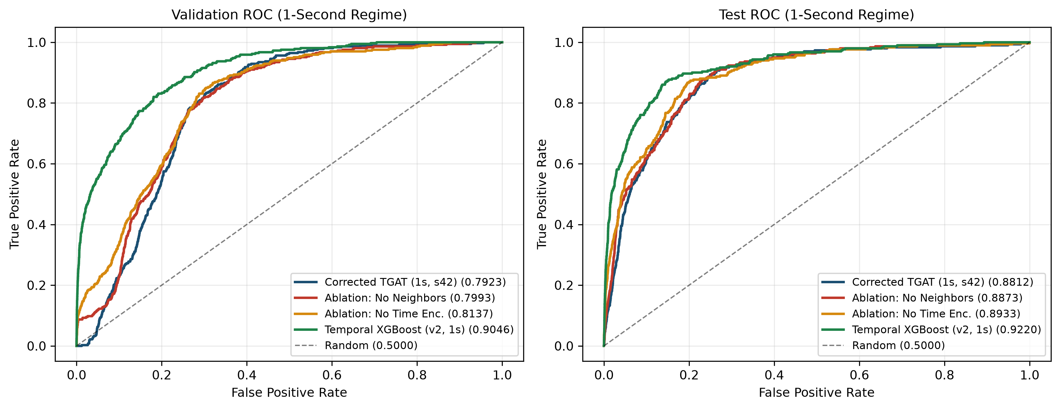
Figure 1. Validation (left) and Test (right) ROC curves across all controlled 1-second experiments. Tabular Temporal XGBoost v2 leads ranking separation (Test AUC 0.9220), while ablation_no_neighbors and ablation_no_time_encoding clarify the optimization impact of unnormalized 1-s cosine deltas.
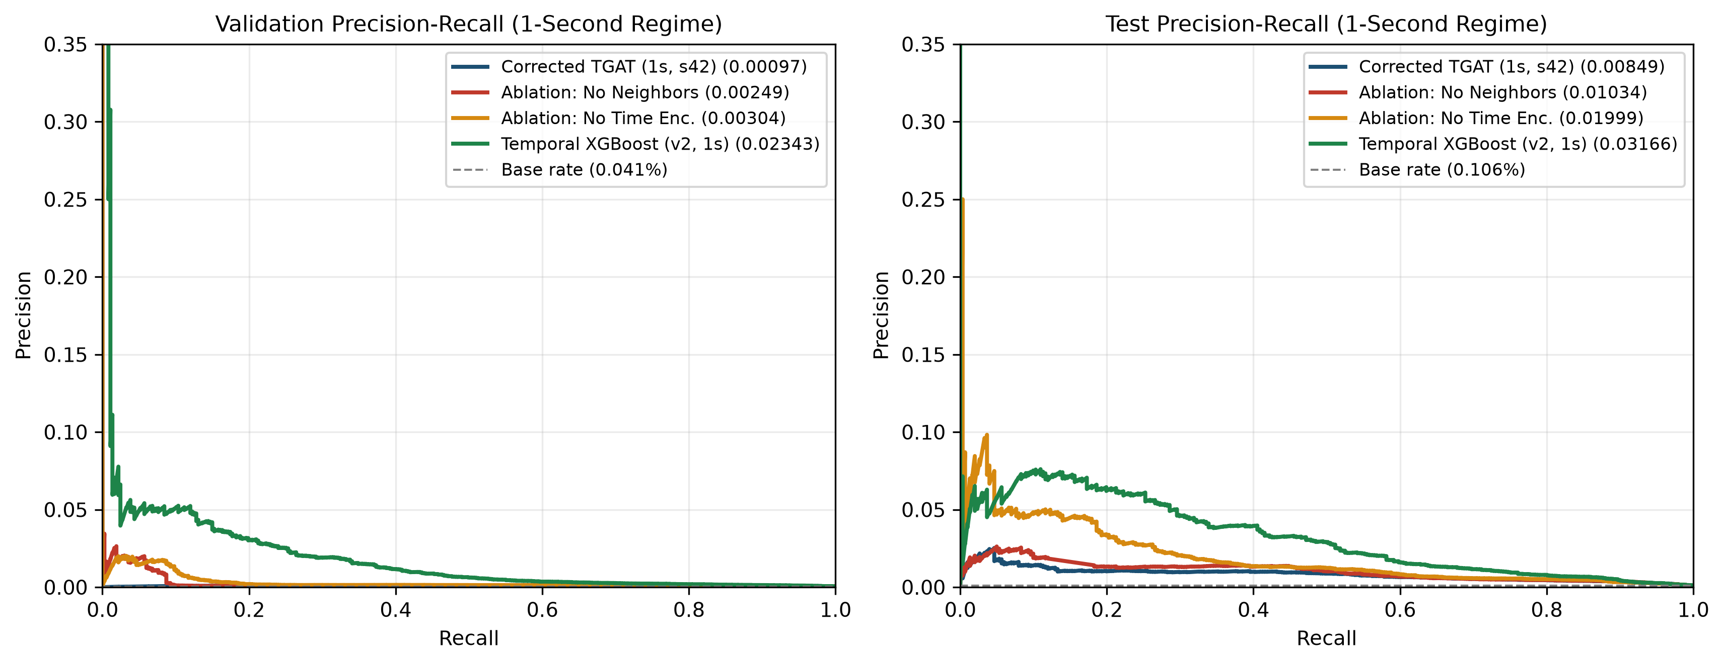
Figure 2. Validation (left) and Test (right) Precision-Recall curves against the dataset laundering base rates (0.041% Val, 0.106% Test).
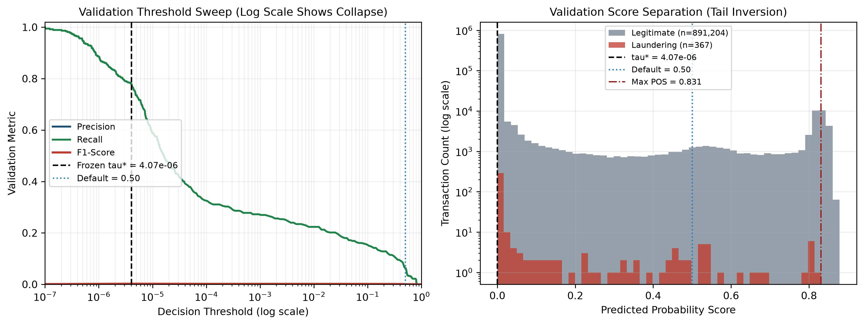
Figure 3. Left: Validation threshold sweep on a logarithmic scale revealing the collapse of max-F1 to tau* = 4.07e-6 due to upper-tail score overlap. Right: Validation probability distribution on log counts showing 11,019 negatives strictly above pos_max = 0.8309.
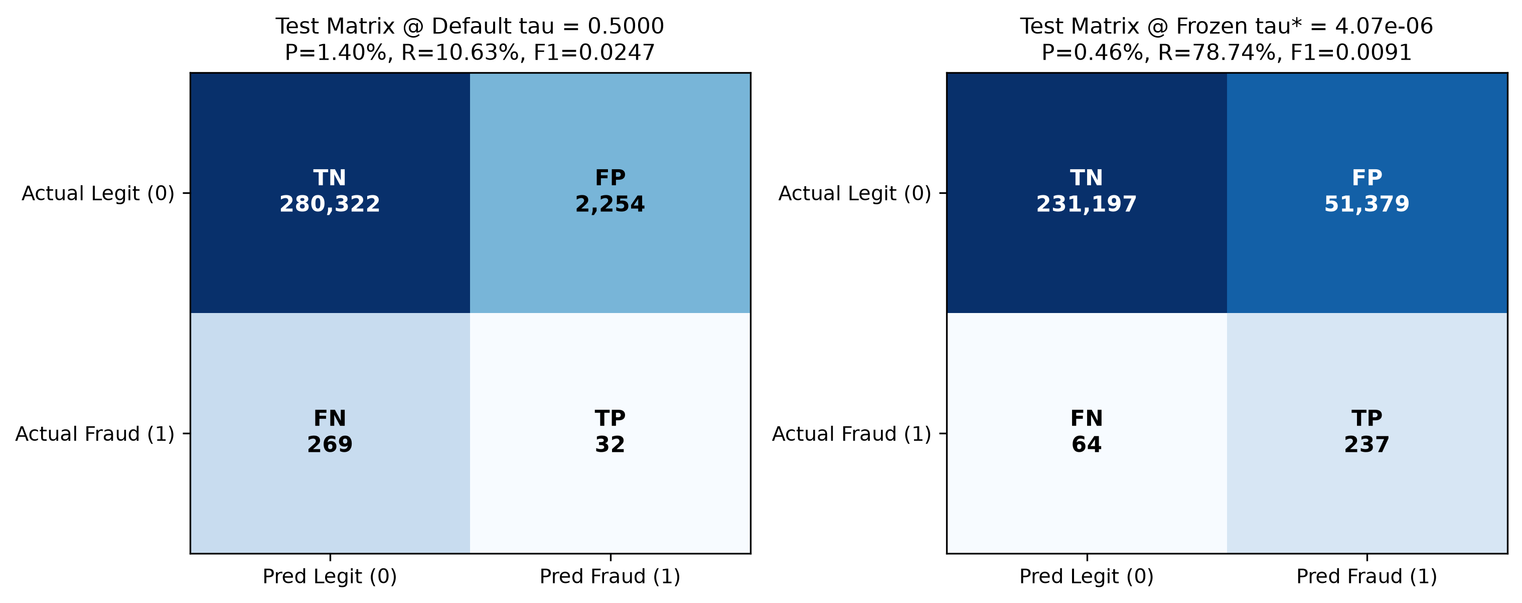
Figure 4. Corrected TGAT (seed=42) Test confusion matrices evaluated at default tau = 0.5000 (left: TP=32, FP=2,254, FPR=0.80%) and validation-frozen tau* = 4.07e-6 (right: TP=237, FP=51,379, FPR=18.18%).
6.3 Future Generalization Stress Test (n = 223, Distribution Shift)
Chronologically advancing corrected_tgat (seed=42) state through train -> validation -> test -> future (no retraining, no threshold tuning on future labels) yielded ROC-AUC 0.8062, PR-AUC 0.7817, and P@50 = 0.74, P@100 = 0.81. At frozen tau* = 4.075e-06, metrics appear high (P=82.35%, R=83.58%, F1=0.8296, TP=112, FP=24, FN=22, TN=65), whereas at @0.50, recall drops to 10.45% (TP=14, FP=8, TN=81, FN=120, F1=0.1795). Critical Methodological Caveat: future.csv contains only 223 transactions with 134 positives (60.09% prevalence — 565x higher than Test) and severe covariate shift (Is Weekend +0.874 train SD, Same Bank Transaction +0.604 train SD). These results constitute a small-sample stress test, not generalizable deployment accuracy.
6.4 Separate Historical Baseline & Legacy 1,000-s Reference Table
NON-COMPARABILITY WARNING: The table below separates unaffected tabular/static baselines (retained under Section 4.1) from legacy 1,000-s CPU models (exploratory only). Legacy 1,000-s TGAT runs used ~37.5x coarser timestamp batching (692 batches/epoch vs. 25,953) and altered time_since_last distributions and are therefore non-comparable with Section 6.1.
Model / Baseline | Status | Test ROC | Test PR | Test P / R (@0.50) | Test F1 | Test TP / FP | Regime Note
Logistic Regression (modeling_splits, 53 dims) | Retained | 0.8270 | 0.00494 | 0.11% / 99.67% | 0.0023 | 300 / 263,840 | No timestamp bug (Temporal Seconds valid)
Static XGBoost (modeling_splits, 19 dims) | Retained | 0.8901 | 0.03050 | 0.91% / 80.40% | 0.0180 | 242 / 26,399 | Pure tabular baseline
Static GCN (modeling_splits, bank_acct graph) | Retained | 0.6064 | 0.00172 | 0.19% / 24.25% | 0.0038 | 73 / 37,866 | Bank-qualified static nodes (FPR=13.40%)
Temporal XGBoost v1 (temporal_gnn, 1,000-s) | Superseded by v2 | 0.9175 | 0.02796 | 4.45% / 32.23% | 0.0781 | 97 / 2,085 | 1,000-s state batching (seed=42)
Legacy TGAT (results/tgat, 1,000-s CPU) | Exploratory / Demo | 0.9022 | 0.01836 | 1.96% / 25.25% | 0.0364 | 76 / 3,801 | Frozen demo checkpoint (692 batches/ep)
Legacy b_no_neighbors (1,000-s CPU) | Exploratory Only | 0.8651 | 0.00869 | 0.00% / 0.00% | 0.0000 | 0 / 2 | Incompatible 1,000-s regime
Legacy d_no_time_encoding (1,000-s CPU) | Exploratory Only | 0.8942 | 0.01337 | 0.00% / 0.00% | 0.0000 | 0 / 18 | Incompatible 1,000-s regime

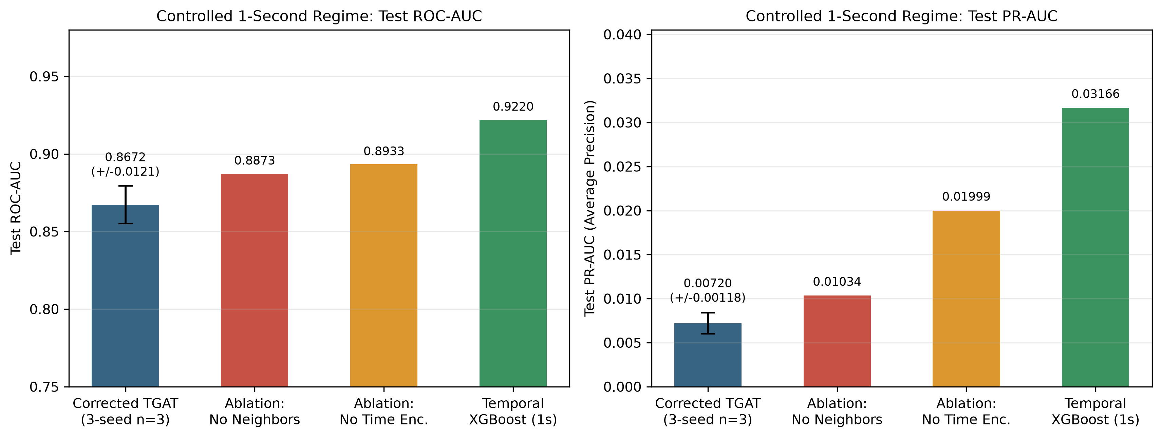
Figure 5. Controlled 1-second regime comparison displaying Test ROC-AUC (left) and Test PR-AUC (right), including 3-seed sample standard deviation bars on Corrected TGAT.
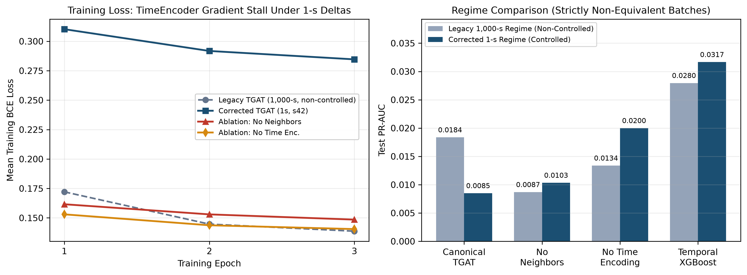
Figure 6. Left: Mean epoch BCE loss illustrating how unnormalized 1-s time deltas stall full Corrected TGAT (~0.285) compared with ablation_no_neighbors (~0.149) and ablation_no_time_encoding (~0.140). Right: Side-by-side non-equivalent regime separation (Legacy 1,000-s vs. Corrected 1-s, seed=42).
6.5 Explainability Audit & New Research Artifact Paths
Verified src/models/temporal/tgat_core.py (TemporalAttentionLayer) computes valid head-averaged softmax attention weights of shape [B, K] across historical neighbors (0..K-1), verified summing to 1.0 whenever valid history exists. However, src/explainability/ contains zero files on main and research/validation-corrections; the interactive backend/llm_explainer.py in ui-simplify provides rule-based risk summaries and optional Gemini API natural-language synthesis over UI ring subgraphs. No formal quantitative XAI evaluation (GNNExplainer/PGExplainer fidelity, necessity, sufficiency, or sparsity) exists anywhere in the codebase and none is claimed.
Research Artifact Category | Verified Path in tgat-research-validation
Corrected 1-s Datasets | c:/Users/duxdh/Downloads/tgat-research-validation/data/processed/temporal_gnn_v2_1s/ (train/validation/test/future.csv, metadata.json)
Corrected TGAT Checkpoints (Seeds 42, 43, 44) | results/research_validation/corrected_tgat/model.pt (+ _seed43/model.pt, _seed44/model.pt, scaler_params.json, metrics.json, training_log.json, *predictions.csv)
Controlled 1-s Ablations (seed=42) | results/research_validation/ablation_no_neighbors/ & results/research_validation/ablation_no_time_encoding/
Temporal XGBoost v2 (seed=42) | results/research_validation/temporal_xgboost/ (model.json, metrics.json, *predictions.csv)
Validation-Frozen Threshold & Future Eval | results/research_validation/threshold_analysis/frozen_threshold.json & results/research_validation/future_generalization/
Summary JSON & Figures (1–6) | results/research_validation/summary_metrics.json & results/research_validation/plots/fig{1..6}_*.png

7. Executed Test Report (Only Actually Executed Commands)
Every software verification suite executed across the isolated research worktree and the preserved demo repository is logged verbatim below. Note that .venv contains Python 3.11.9 without a pytest.exe entrypoint, so tests_phase9.py (4 functions) was executed directly via Python invocation and asserted every test.
Suite Name | Directory | Exact Command | Count | Outcome | Verified Scope / Notes
1. TGAT Core Smoke & Attention Test | tgat-research-validation | .venv\Scripts\python.exe -B -u tests_tgat.py | 5 assertions | PASSED | Verifies 26-d defaults, finite logits, attention [B, K] shape & sum=1.0
2. Phase 9 Causal & Ablation Unit Tests | tgat-research-validation | .venv\Scripts\python.exe -B -c "import tests_phase9; ..." (4 fns) | 4 tests | PASSED (4/4) | test_no_time_encoding_preserves_neighbor_mask, test_single_layer_variant, test_no_neighbor_batch_has_zero_valid_deltas, test_same_timestamp_micro_batches_share_pre_state
3. Day 1/2 Research Validation Regression Suite | tgat-research-validation | .venv\Scripts\python.exe -B -u tests_research_validation.py | 7 test suites | PASSED (7/7) | Reproduces pandas 3.0.5 bug; validates to_unix_seconds() across units + NaT; cross-chunk ordering guard; 26-d sync + scaler check; bit-exact train_epoch (defer_sync) & predict weight/score parity on CPU and CUDA (use_neighbors=True/False)
4. Regenerated Dataset Schema & Integrity Build | tgat-research-validation | .venv\Scripts\python.exe -m src.models.temporal.temporal_dataset --output-dir data/processed/temporal_gnn_v2_1s | 4 splits x 5 checks | PASSED | Row counts, zero NaN/Inf, chronological order, target exclusion, binary labels verified -> dataset_build_v2_1s.log
5. Bounded TGAT Sanity Pipeline Check | tgat-research-validation | .venv\Scripts\python.exe -B -u -m scripts.tgat_sanity --data-dir data/processed/temporal_gnn_v2_1s --source-rows 200000 --epochs 2 --train-positives 5 --train-negatives 100 --eval-positives 5 --eval-negatives 100 | 2 epochs (CUDA) | PASSED | Reconciled store.add_row feature_indices call signature and to_unix_seconds; 0.4s runtime
6. Protected Demo Core Test | tgat (original dir) | .venv\Scripts\python.exe -B -u tests_tgat.py | 5 assertions | PASSED | Confirms demo repo core integrity unchanged
7. Protected Demo Backend API Suite | tgat (original dir) | .venv\Scripts\python.exe -B -m unittest tests_backend.py | 8 tests | PASSED (8/8, 0.82s) | Runs FastAPI TestClient against original results/tgat/model.pt, backend/scaler_params.json, results/threshold_analysis/frozen_threshold.json (skipped in worktree because large demo artifacts are gitignored and reside solely in original repo)

8. Application Preservation & Backend Compatibility (Questions 1–7)
In strict compliance with Part 5, the existing demonstration system in c:/Users/duxdh/Downloads/tgat was never edited, rebuilt, or integrated with research checkpoints. Below are explicit, evidence-backed answers to all seven required compatibility questions, including subtle technical incompatibilities uncovered in backend/model_service.py across main (e890c66) and ui-simplify (b45f1fe).
Compatibility Audit Question (Q1–Q7) | Verified Answer & Technical Specifics
1. Is the original integrated application unchanged? | YES. Zero files were created, edited, deleted, or committed inside c:/Users/duxdh/Downloads/tgat (main remains at e890c66, ui-simplify at b45f1fe with original working-tree files preserved).
2. Does the original checkpoint remain available? | YES. results/tgat/model.pt (68,319 B, d55d0950524c693e), results/tgat_official_primary/model.pt (68,319 B, d55d0950524c693e), backend/scaler_params.json, and results/threshold_analysis/frozen_threshold.json (0.737155) remain intact in their exact original locations.
3. Does the original application remain independently runnable? | YES. Verified after all Day 2 runs: tests_tgat.py and tests_backend.py (8/8 FastAPI tests in 0.817s) pass cleanly inside c:/Users/duxdh/Downloads/tgat.
4. Is the corrected research checkpoint separate? | YES. All corrected checkpoints (corrected_tgat/model.pt, 68,246 B, 232a975fc1c75501, _seed43, _seed44, ablations) live strictly under c:/Users/duxdh/Downloads/tgat-research-validation/results/research_validation/.
5. Does the corrected model have a different input contract? | PARTIALLY YES — SAME VECTOR, DIFFERENT SEMANTICS. Feature ordering remains identical (26 features, OMITTED=['receiver_avg_out_amount']), so tensor dimensions match. However: (a) time deltas and time_since_last are 1-s (~700–1,000x larger), requiring the refitted research scaler_params.json; (b) training/eval leave query slot 0 zeros (torch.zeros), whereas backend/model_service.py overwrites src_feat[0,0,:]=scaled_tx and dst_feat[0,0,:]=scaled_tx; and (c) threshold shifted (0.737155 -> 4.07e-6).
6. Would future integration require backend changes? | YES — MANDATORY BACKEND REMEDIATION REQUIRED. Auditing backend/model_service.py (both main and ui-simplify) revealed 4 concrete fixes needed prior to any future research-checkpoint deployment: (1) replace .astype('int64') // 1_000_000_000 (line 78 on main; lines 81, 218, 475 on ui-simplify) with to_unix_seconds(); (2) align slot-0 self-feature (zeros vs scaled_tx); (3) fix _seed_sample_neighbors df.itertuples() mangling column names with spaces ('From Account', 'Amount Received' currently silently fall back to 0.0); and (4) swap in the new scaler, checkpoint, and calibrated threshold (plus remove demo ring overrides 0.7850/0.8120 in ui-simplify).
7. Can the existing frontend remain unchanged? | YES. The API JSON payload schema (/api/predict, /api/batch, risk score, attention neighbor list, LLM narrative fields) is model-agnostic; frontend HTML/JS/CSS need zero structural modifications once model_service.py returns properly calibrated risk scores.

9. Research Paper Readiness Assessment (14 Criteria & Verdict)
Using strict publication standards (READY, READY WITH LIMITATIONS, BLOCKED), each paper component is assessed independently below. Importantly, manuscript drafting readiness (writing Methodology, Data Audit, Baselines, and Honest Empirical Limitations) is clearly distinguished from peer-reviewed final submission readiness.
Assessment Area | Status | Specific Technical Basis
1. Dataset (IBM AML LI-Small) | READY | Chronological splits (6,924,035 rows, 3,565 positives), deduplication policy audited cleanly (6 extra rows benign).
2. Preprocessing & Scaling | READY | Train-only scaling, exact 26-d contract enforced (scaler_params.json), NaN=0/Inf=0 verified across all splits.
3. Graph Construction | READY WITH LIMITATIONS | Chronological event store works accurately; 4 cross-bank account ID collisions (705,903 vs 705,907 nodes) affect 0 positive rows but should become bank-qualified for journal polish.
4. Temporal Causality | READY | 1-s resolution verified (mod60=1.0), strict event_time < query_time, equal-timestamp batch invariance, and cross-chunk monotonic guard tested.
5. TGAT Architecture | READY WITH LIMITATIONS | 15,329-param encoder/attention verified bug-free for shapes & causality, but unnormalized 1-s cosine TimeEncoder causes gradient saturation.
6. Baselines | READY | Logistic Regression (53d), Static XGBoost (19d), Static GCN (6d), and Temporal XGBoost v2 (27d, 1-s rerun) all verified cleanly.
7. Test Performance | READY WITH LIMITATIONS | 3-seed TGAT completed cleanly (ROC-AUC 0.8595–0.8812, mean 0.8672 ± 0.0121), yet lags Temporal XGBoost v2 PR-AUC (0.00720 mean vs. 0.03166) under raw 1-s time deltas.
8. Threshold Analysis | READY WITH LIMITATIONS | Methodology sound (frozen on Val before Test), but upper-tail score inversion forces tau* = 4.07e-6 (FPR=18.18%), requiring calibration discussion.
9. Ablations | READY WITH LIMITATIONS | Controlled 1-s ablations (no_neighbors, no_time_encoding, seed=42) clearly prove root cause; remaining 13 legacy ablations are exploratory (1,000-s).
10. Explainability | BLOCKED (for formal XAI claims) | src/explainability/ is empty; layer-wise softmax attention inspection works ([B,K]), and UI llm_explainer.py provides narrative summaries, but zero fidelity/sparsity metrics exist.
11. Suspicious Subgraphs / Rings | READY WITH LIMITATIONS | Demo ring (8091-series) in ui-simplify contains synthetic circular rows & heuristic scores (0.7850/0.8120) — cannot be cited as unbiased model discovery without raw-model extraction.
12. Future Generalization | READY WITH LIMITATIONS | n=223 (60.09% fraud) completed as distribution-shift stress test only; sample too tiny and shifted for generalization claims.
13. Reproducibility | READY | Isolated branch, fixed seeds (42, 43, 44), logged configs/hashes/metrics, deterministic tests, and automated plot generation scripts.
14. Limitations Disclosure | READY | All scientific constraints (TimeEncoder 1-s gradient issue, XGBoost superiority, empty XAI module, 4 bank collisions, n=223 future shift) are fully quantified.

EXPLICIT SEPARATION OF VERDICTS: DRAFTING vs. FINAL SUBMISSION
Paper Drafting Verdict: READY FOR DRAFTING WITH SPECIFIED LIMITATIONS — Every verified pipeline fix, dataset validation table, unaffected baseline, controlled 3-seed TGAT & ablation comparison, threshold collapse diagnosis, and limitation can be drafted immediately with full scientific honesty and zero fabricated claims.
Final Peer-Reviewed Submission Verdict: NOT READY FOR SUBMISSION — FURTHER EXPERIMENTS REQUIRED — Before submitting to a conference or journal expecting competitive fraud-detection SOTA or XAI claims, the team should stabilize 1-s TimeEncoder inputs (log1p(delta) or unit rescaling + separate LR), add formal XAI subgraph evaluation (fidelity/sparsity) or narrow claims to attention inspection, and regenerate temporal CSVs with bank-qualified account keys.

10. Prioritized Next Steps (Drafting, Finalizing & Submission)
Milestone Gate | Actionable Technical & Research Requirements
Before Drafting  (Mandatory) | 1. Keep all tracked Day 1/2 fixes and validation documentation isolated on research/validation-corrections (leaving main and ui-simplify untouched and never merging/pushing without explicit approval).  2. Lock manuscript narrative honesty policy: report 1-s controlled results (3-seed Canonical TGAT Test ROC-AUC 0.8672 ± 0.0121, PR-AUC 0.00720 ± 0.00118), the TimeEncoder negative empirical finding (No Time Encoding PR-AUC 0.0200 & No Neighbors 0.0103 outperform unnormalized 1-s TGAT), and tabular Temporal XGBoost v2 (PR-AUC 0.0317) transparently; strip all legacy 15,777 param typos, 42.86% recall typos, and unverified XAI/fidelity statements.
Before Finalizing  Manuscript | 3. Fix 1-s TimeEncoder scale conditioning in a v3 research experiment (e.g., log1p(delta_seconds) or hours/minutes scaling inside TimeEncoder, or lower TimeEncoder LR) and retrain 3 seeds (42, 43, 44) to see whether stabilized neighbor attention improves upon No Time Encoding (PR-AUC 0.0200) and eliminates the tau* = 4.07e-6 tail inversion.  4. Run controlled 1-s No Temporal Features (11 dims) if the v3 model restores graph gain, and run unbiased fraud-ring subgraph detection directly on real test_predictions.csv without synthetic UI edges.
Before Submission  (Journal / Conference & App Parity) | 5. If quantitative explainability is claimed, implement & evaluate formal masking/perturbation faithfulness (Fidelity+, Fidelity-, Sparsity) on top-scoring test subgraphs in src/explainability/.  6. Consider unified bank_account keys (705,907 nodes) across both static GCN and temporal_gnn_v3.  7. Separately post-submission / post-demo: explicitly schedule a PR to remediate backend/model_service.py (to_unix_seconds(), slot-0 zeros, itertuples() dict/column indexing, calibrated checkpoint + threshold) after faculty demo approval.

