***SQL Queries***

1. **Find list of all patient who is treated by the doctor whose did is 'E4404' in the year 2015.**

    Select p.PID,P_Name,DOB,GENDER,DID from

    Patient as p join Treated_by as t on

    (p.PID=t.PID) where t.DID = 'E4404'

     and p.In_date>=Date '2015-01-01' and

     p.Out_date<= Date '2015-12-31';

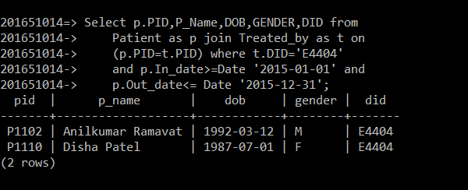

1. **Find the appointment date, contact and eid of the doctor who is appointed to meet with appointment_no 3301**

Select appointment_date, contactno, eid from appointment_with as a join employee as e

on(a.did=e.eid) join appointment as p on(a.appointment_no=p.appointment_no) where

a.appointment_no='A2206';

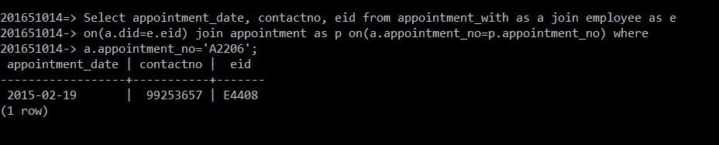

1. **Give the details of Visitor=’Ishan Raju’ and Patient to meet.**

select visitorid, visitor_name, stay_from, stay_to, p_name

from visitor as v join meet as m

on(v.visitorid=m.visitor_id) natural join patient as p

where visitor_name = 'Ishan Raju';

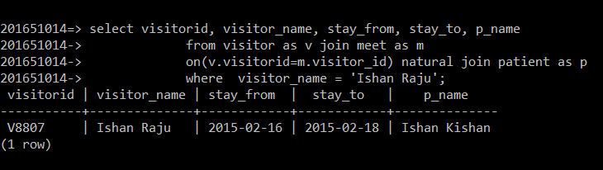

1. **Find all details of patient reports with total medicine Quantity him/her owns order by medicine quantity in ascending order**

Select p.pid, p.p_name, p.DOB, r.test_list_id, r.report_date,

r.remarks, sum (medicine_quantity) as

total_medicine_quantity from patient as p

natural join test_list as t natural join report as r join

medicine_list as m on(m.pid=p.pid)

where p.in_date >= Date'2015-01-01' and

p.out_date<= Date'2015-12-31' group by p.pid, r.test_list_id

order by sum(medicine_quantity) asc;

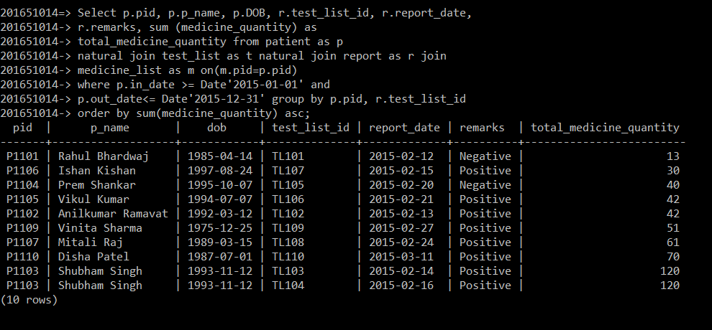

1. **Find Total medicine amount of each patient order by pid**

select m.pid, p.p_name, sum(medicine_amount)

as Total_Medicine_Amount from medicine_list as m join

patient as p on(m.pid=p.pid)

group by m.pid,p.p_name order by m.pid;

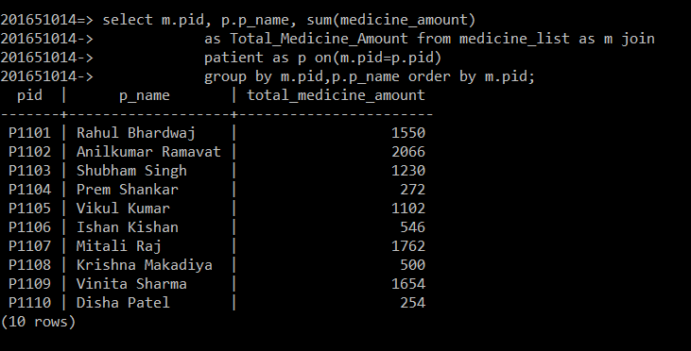

1. **List of all the medicines to patient ‘P1103’ by Doctor ‘E4404’**

Select * from Medicine_List where

DID = 'E4404' and PID = 'P1103';

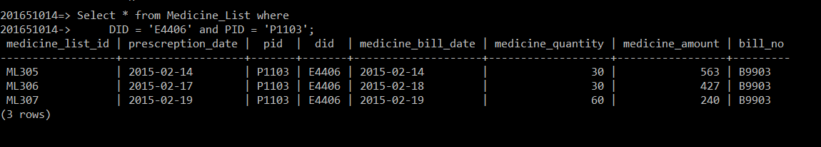

1. **Find list of EID,E_name,DOB,DOJ,Salary,Gender of employee doctors with salary>=90,000**

Select e.EID, ename, DOB, DOJ, Salary, Gender from

(Employee as e Join Doctor as d on e.EID=d.DID)

where e.Salary>=90000;

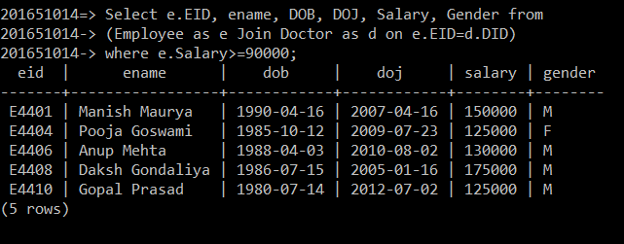

1. **Give all the details about test reports of patients treated by Doctor ‘E4404’ or ‘E4406’**

Select Test_List_ID, Report_date, Remarks, DID

From (Report natural join Test_List)

where DID='E4404' or DID='E4406';

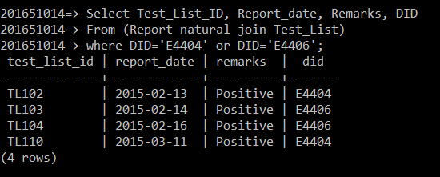

1. **Find visitorID, Visitor_Name who were coming to meet PID='P1103' or 'P1104'**

Select VisitorID,Visitor_Name,PID

from (Visitor as v join meet as m

on v.VisitorID=m.Visitor_ID)

where PID='P1103' or PID='P1104';

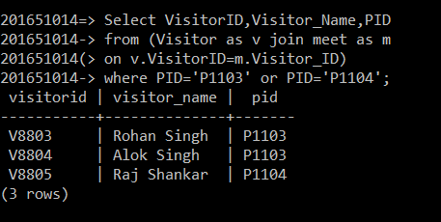

**10.List all the types of doctors and the count of each type.**

Select Type, count(*) from doctor group by Type;

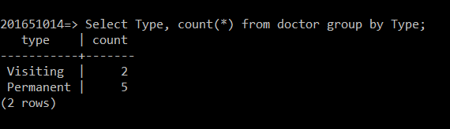

**11.Find name of patient(s) who is/are treated by doctor whose**

**employee id is ‘E4404’**

Select p.pid, P_name, dob, gender, DID from patient as p join treated_by as t on (p.pid=t.pid) where t.did=(select did from doctor as d join employee as e on (d.did=e.eid) where d.did='E4404');

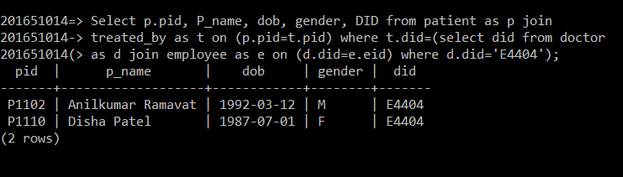

**12.List all patients in ward number W2001 sorted by ascending**

**order.**

SELECT P_Name,DOB FROM

(Patient as p join ward_list as w on p.PID=w.PID)

WHERE Ward_no='W2001' ORDER BY DOB ASC;

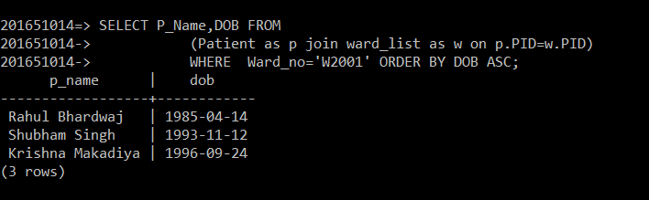

**13. Give the count of number of Operations performed by**

**Doctor E4406 on Patient P1103.**

SELECT count(*) from(Operation_List natural join performs)

where PID='P1103' and DID='E4406';

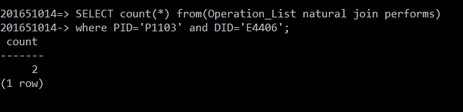

14. **Find list of Doctor who performs more than 1 operations**

select e.ename, p.did, count(operation_list_id) as

no_of_operation from performs as p join employee as e

on(p.did=e.eid) group by p.did,e.ename

having count(operation_list_id) >1;

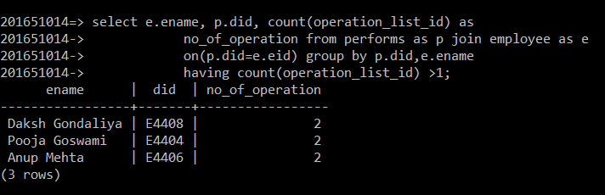

15. **List of employee whom category=’Doctor’ and**

**qualification=’MBBS’**

select eid, ename, gender from employee

where qualification='MBBS'

intersect select eid, ename, gender from employee

where category='Doctor';

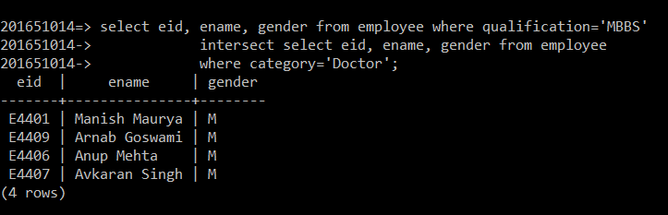

**16**. **Determine the Test_List which have more than 1 test**

Select test_list_id, count(test_id) as no_of_test_id

from have group by test_list_id  having count(test_id)>1;

