



Department of Computer Engineering
--Instructed By--
Dr. Aashka Raval
--Team--
24BCP240-Daksh Shah
24BCP261-Mahir Shah

DBMS Project Report: MovieRec Recommendation System

1. Introduction
This project details the design and implementation of MovieRec, a database-driven movie recommendation system. The primary objective was to create a robust and scalable backend database using MySQL capable of efficiently storing and managing information related to users, movies, and their interactions.
The core of the project is a MySQL database, movie_rec_db, which was designed to serve as the central repository for all application data and to execute complex queries. The system is architected to support user authentication, movie browsing and searching, and the submission of ratings and reviews. The database's primary function is to generate several types of recommendations—including popularity-based, content-based, and collaborative filtering—to provide users with personalized movie suggestions.
While a simple web interface was developed to interact with the database, this report focuses exclusively on the database management aspects, including the conceptual and logical design, the SQL implementation, and the advanced queries that power the system's features.

2. Requirements Analysis
The database was designed to meet the following functional and data requirements.
Data Storage Requirements
The system must persist the following data entities:
- User Data: User credentials (username, email, password) and account creation timestamps.
- Movie Data: Detailed movie information, including title, release year, synopsis, and duration.
- Personnel Data: Information pertaining to actors and directors, such as names and birthdates.
- Taxonomy Data: A master list of all available movie genres.
- User Interaction Data:
  - Ratings: Storage for user-submitted ratings (on a scale of 1-5) for specific movies.
  - Reviews: Storage for user-written textual reviews for movies.
  - Watchlists: Mechanisms to allow users to create and manage lists of movies for future viewing.
- Relational (Link) Data:
  - Linkages between movies and their associated genres.
  - Linkages between movies and their cast, including the specific role name.
  - Linkages between movies and their directors.

Functional Requirements (Database-Centric)
The database must support operations to:
- User Management: Securely create new user accounts (enforcing username uniqueness) and authenticate existing users.
- Data Population: Efficiently handle large-scale data insertion. A Python script (data_generator.py) was developed to populate the database with over 26,000 records to simulate a real-world environment.
- Movie Browsing: Retrieve lists of movies with support for filtering by title (search) and genre (JOIN).
- Rating Management: Atomically handle user rating submissions. The system utilizes an INSERT ... ON DUPLICATE KEY UPDATE command to allow a user to either create a new rating or update an existing one in a single transaction.
- Watchlist Management: Allow users to add a movie to, or remove a movie from, their personal watchlist.
- Recommendation Generation:
  - Popularity-Based: Calculate and return the top-10 movies based on a weighted average rating formula.
  - Content-Based: Given a specific movie, identify and return similar movies based on shared genres and directors.
  - Collaborative-Based: Given a specific movie, identify other movies frequently liked by users who also liked the given movie.
  - Personalized: Generate recommendations for a specific user based on their historical rating data.
- Admin Functions: Provide an interface to execute arbitrary (read-only) SELECT queries and to insert new data into any table.

3. Conceptual Design (ER Diagram)
A textual description of the database's conceptual design is provided below.
Entities:
- users: Stores user account information.
- movies: The central entity, storing all movie details.
- genres: A lookup table for all possible movie genres.
- actors: Stores information about individual actors.
- directors: Stores information about individual directors.
- reviews: Stores text reviews written by users for movies.
- watchlists: Stores watchlist containers created by users (e.g., "My Favorites").
Relationships & Junction Tables:
- A user can provide many ratings and write many reviews.
- A movie can receive many ratings and many reviews.
- The ratings table links users and movies in a many-to-many relationship, storing the rating attribute.
- A user can possess many watchlists (One-to-Many).
- A watchlist can contain many movies, and a movie can exist on many watchlists. This many-to-many relationship is managed by the watchlist_items junction table.
- A movie can be associated with many genres. This many-to-many relationship is managed by the movie_genres junction table.
- A movie can feature many actors. This many-to-many relationship is managed by the movie_actors junction table, which also includes a role_name attribute.
- A movie can have many directors. This many-to-many relationship is managed by the movie_directors junction table.
This design results in 12 tables (relations) in total, satisfying the project requirement (>= 5 * N, where N=2, requiring >= 10 relations).

4. Relational Schema (Logical Design)
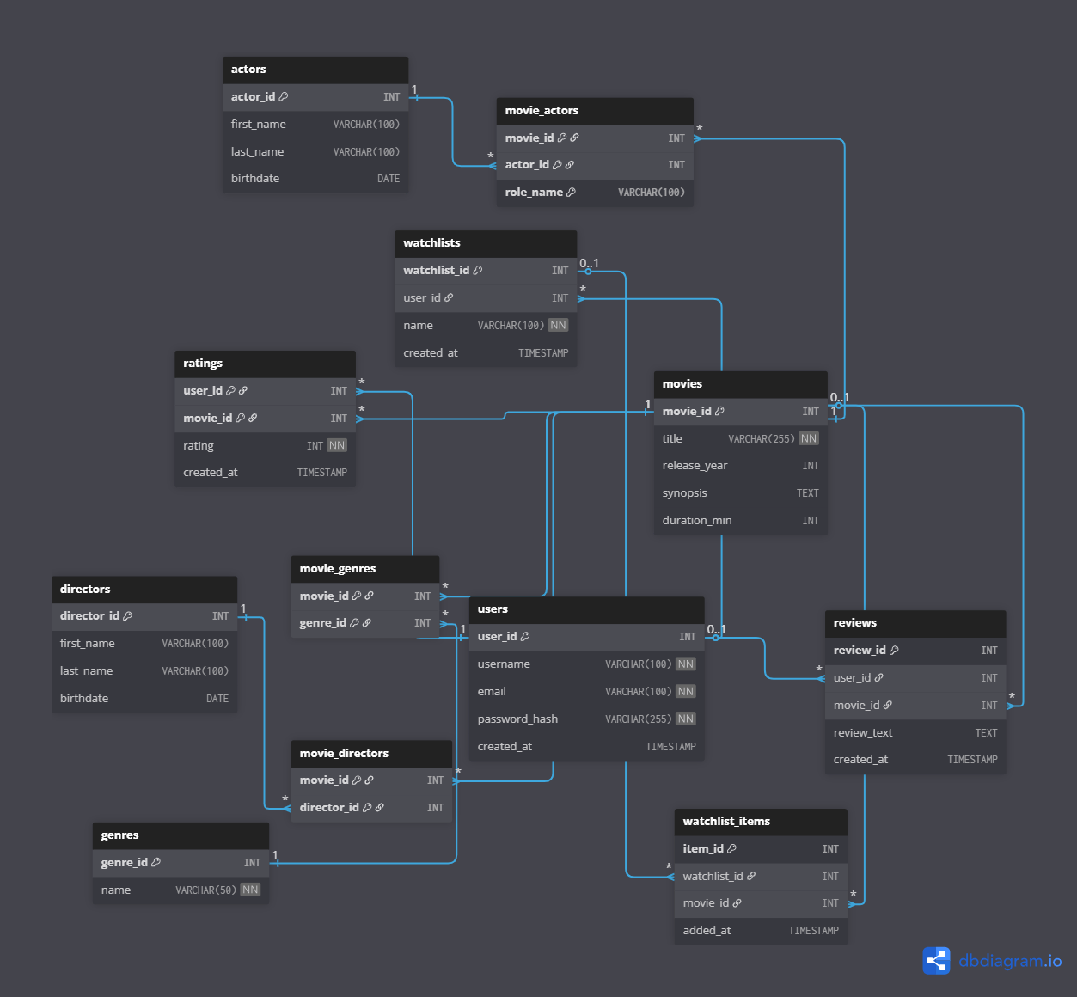

5. SQL Implementation
Table Creation (DDL)
The following SQL Data Definition Language (DDL) scripts were executed to generate the database schema in MySQL.
-- Creates the users table
CREATE TABLE users (
user_id INT AUTO_INCREMENT PRIMARY KEY,
username VARCHAR(100) NOT NULL UNIQUE,
email VARCHAR(100) NOT NULL UNIQUE,
password_hash VARCHAR(255) NOT NULL,
created_at TIMESTAMP DEFAULT CURRENT_TIMESTAMP
);

-- Creates the movies table
CREATE TABLE movies (
movie_id INT AUTO_INCREMENT PRIMARY KEY,
title VARCHAR(255) NOT NULL,
release_year INT,
synopsis TEXT,
duration_min INT
);

-- Creates the genres table
CREATE TABLE genres (
genre_id INT AUTO_INCREMENT PRIMARY KEY,
name VARCHAR(50) NOT NULL UNIQUE
);

-- Creates the actors table
CREATE TABLE actors (
actor_id INT AUTO_INCREMENT PRIMARY KEY,
first_name VARCHAR(100),
last_name VARCHAR(100),
birthdate DATE
);

-- Creates the directors table
CREATE TABLE directors (
director_id INT AUTO_INCREMENT PRIMARY KEY,
first_name VARCHAR(100),
last_name VARCHAR(100),
birthdate DATE
);

-- Creates the ratings table with a composite primary key
CREATE TABLE ratings (
user_id INT,
movie_id INT,
rating INT NOT NULL,
created_at TIMESTAMP DEFAULT CURRENT_TIMESTAMP,
PRIMARY KEY (user_id, movie_id),
FOREIGN KEY (user_id) REFERENCES users(user_id) ON DELETE CASCADE,
FOREIGN KEY (movie_id) REFERENCES movies(movie_id) ON DELETE CASCADE
);

-- Creates the reviews table
CREATE TABLE reviews (
review_id INT AUTO_INCREMENT PRIMARY KEY,
user_id INT,
movie_id INT,
review_text TEXT,
created_at TIMESTAMP DEFAULT CURRENT_TIMESTAMP,
FOREIGN KEY (user_id) REFERENCES users(user_id) ON DELETE SET NULL,
FOREIGN KEY (movie_id) REFERENCES movies(movie_id) ON DELETE CASCADE
);

-- Creates the watchlists table
CREATE TABLE watchlists (
watchlist_id INT AUTO_INCREMENT PRIMARY KEY,
user_id INT,
name VARCHAR(100) NOT NULL,
created_at TIMESTAMP DEFAULT CURRENT_TIMESTAMP,
FOREIGN KEY (user_id) REFERENCES users(user_id) ON DELETE CASCADE
);

-- Creates the watchlist_items table
CREATE TABLE watchlist_items (
item_id INT AUTO_INCREMENT PRIMARY KEY,
watchlist_id INT,
movie_id INT,
added_at TIMESTAMP DEFAULT CURRENT_TIMESTAMP,
FOREIGN KEY (watchlist_id) REFERENCES watchlists(watchlist_id) ON DELETE CASCADE,
FOREIGN KEY (movie_id) REFERENCES movies(movie_id) ON DELETE CASCADE,
UNIQUE KEY (watchlist_id, movie_id)
);

-- Creates the movie_genres junction table
CREATE TABLE movie_genres (
movie_id INT,
genre_id INT,
PRIMARY KEY (movie_id, genre_id),
FOREIGN KEY (movie_id) REFERENCES movies(movie_id) ON DELETE CASCADE,
FOREIGN KEY (genre_id) REFERENCES genres(genre_id) ON DELETE CASCADE
);

-- Creates the movie_actors junction table
CREATE TABLE movie_actors (
movie_id INT,
actor_id INT,
role_name VARCHAR(100),
PRIMARY KEY (movie_id, actor_id, role_name),
FOREIGN KEY (movie_id) REFERENCES movies(movie_id) ON DELETE CASCADE,
FOREIGN KEY (actor_id) REFERENCES actors(actor_id) ON DELETE CASCADE
);

-- Creates the movie_directors junction table
CREATE TABLE movie_directors (
movie_id INT,
director_id INT,
PRIMARY KEY (movie_id, director_id),
FOREIGN KEY (movie_id) REFERENCES movies(movie_id) ON DELETE CASCADE,
FOREIGN KEY (director_id) REFERENCES directors(director_id) ON DELETE CASCADE
);

Data Population Scripts (DML)
A separate Python script (data_generator.py) was created to populate the database with a large, realistic dataset utilizing the Faker library. This script generated and inserted the following record counts:
- NUM_USERS: 200
- NUM_MOVIES: 1,000
- NUM_GENRES: 20
- NUM_ACTORS: 500
- NUM_DIRECTORS: 100
- NUM_RATINGS: 10,000
- NUM_REVIEWS: 500
- NUM_WATCHLISTS: 300
- NUM_WATCHLIST_ITEMS: 5,000
- MOVIE_GENRES_LINKS: 3,000
- MOVIE_ACTORS_LINKS: 4,000
- MOVIE_DIRECTORS_LINKS: 1,500
Total Records: 26,120. This volume significantly exceeds the project requirement (>= 3000 * N, where N=2, requiring >= 6,000 records) and provides a sufficiently large dataset for testing query performance.

6. Core Query Examples
The following queries represent the core business logic of the application, executed by the Python-based backend.

Query 1: Atomic Rating Update (INSERT... ON DUPLICATE KEY)
This query atomically handles rating submissions. If the user-movie pair does not exist, it inserts a new row. If it does exist, it updates the existing row's rating.
Query:
INSERT INTO ratings (user_id, movie_id, rating)
VALUES (%s, %s, %s)
ON DUPLICATE KEY UPDATE rating = VALUES(rating);

Parameters: (user_id, movie_id, rating_value)
Result: A new row is inserted, or an existing row is updated. This is a key unique feature that ensures data integrity and simplifies application logic, avoiding a separate "check-then-insert/update" transaction.

Query 2: Dynamic Movie Search
This query retrieves a list of movies, dynamically adding JOIN and WHERE clauses based on user-provided input for search terms and genre filters.
Query (Example with all filters active):
SELECT
m.movie_id, m.title, m.release_year,
COALESCE(AVG(r.rating), 0) AS average_rating
FROM movies m
LEFT JOIN ratings r ON m.movie_id = r.movie_id
JOIN movie_genres mg ON m.movie_id = mg.movie_id
WHERE mg.genre_id = %s AND m.title LIKE %s
GROUP BY m.movie_id, m.title, m.release_year
ORDER BY m.title ASC
LIMIT 50;

Parameters: (genre_id_value, '%search_term%')
Result: Returns a list of movies (up to 50) that match the search criteria, along with their calculated average rating.

Query 3: Aggregated Movie Details Retrieval
This operation consists of several queries executed in sequence to aggregate all necessary data for a single movie's detail page. This includes actors, directors, recent reviews (with usernames), and the current user's specific rating.
Query (Conceptual Sequence):
-- 1. Get Movie Info & Avg Rating
SELECT m.movie_id, m.title, m.release_year, m.synopsis, m.duration_min,
COALESCE(AVG(r.rating), 0) AS average_rating, COUNT(r.rating) AS total_ratings
FROM movies m LEFT JOIN ratings r ON m.movie_id = r.movie_id
WHERE m.movie_id = %s GROUP BY m.movie_id;

-- 2. Get Actors
SELECT a.first_name, a.last_name, ma.role_name
FROM actors a JOIN movie_actors ma ON a.actor_id = ma.actor_id
WHERE ma.movie_id = %s;

-- 3. Get Directors
SELECT d.first_name, d.last_name
FROM directors d JOIN movie_directors md ON d.director_id = md.director_id
WHERE md.movie_id = %s;

-- 4. Get Reviews
SELECT r.review_text, r.created_at, u.username
FROM reviews r JOIN users u ON r.user_id = u.user_id
WHERE r.movie_id = %s ORDER BY r.created_at DESC LIMIT 10;

-- 5. Get User's Rating
SELECT rating FROM ratings WHERE movie_id = %s AND user_id = %s;

Parameters: (movie_id, user_id)
Result: Returns all data components necessary to construct the movie details page.

Query 4: Popularity-Based Recommendation (Weighted Rating)
This query calculates a weighted rating for all movies (based on the IMDB formula) to determine the most popular items, filtering out movies with an insufficient number of ratings.
Query:
-- C = Global average rating (calculated first)
-- MIN_RATINGS = 5
SELECT
m.movie_id, m.title, m.release_year,
COUNT(r.rating) AS v, AVG(r.rating) AS R,
( (COUNT(r.rating) / (COUNT(r.rating) + %s)) * AVG(r.rating) + ( %s / (COUNT(r.rating) + %s)) * %s ) AS weighted_rating
FROM movies m
LEFT JOIN ratings r ON m.movie_id = r.movie_id
GROUP BY m.movie_id, m.title, m.release_year
HAVING v >= %s
ORDER BY weighted_rating DESC
LIMIT 10;

Parameters: (MIN_RATINGS, C)
Result: Returns the top 10 most popular movies based on the weighted score.

Query 5: Personalized Content-Based Recommendation
This query identifies movies to recommend to a specific user based on the genres of movies they have previously rated highly. It utilizes Common Table Expressions (CTEs) to define the user's favorite genres and movies they have already rated, then excludes those from the final suggestion list.
Query:
WITH UserFavoriteGenres AS (
SELECT DISTINCT mg.genre_id
FROM ratings r
JOIN movie_genres mg ON r.movie_id = mg.movie_id
WHERE r.user_id = %s AND r.rating >= 4
),
UserRatedMovies AS (
SELECT DISTINCT movie_id FROM ratings WHERE user_id = %s
)
SELECT
m.movie_id, m.title, m.release_year,
COUNT(DISTINCT mg.genre_id) AS genre_matches,
COALESCE(AVG(r.rating), 0) AS average_rating
FROM movies m
JOIN movie_genres mg ON m.movie_id = mg.movie_id
LEFT JOIN ratings r ON m.movie_id = r.movie_id
WHERE
mg.genre_id IN (SELECT genre_id FROM UserFavoriteGenres)
AND m.movie_id NOT IN (SELECT movie_id FROM UserRatedMovies)
GROUP BY m.movie_id, m.title, m.release_year
ORDER BY genre_matches DESC, average_rating DESC
LIMIT 10;

Parameters: (user_id, user_id)
Result: Returns the top 10 movies the user has not seen, which best match their inferred genre preferences.

Query 6: Personalized Collaborative Recommendation
This complex query generates recommendations by identifying "similar users." It first identifies the target user's highly-rated movies. It then finds other users who also rated those same movies highly. Finally, it recommends movies that those similar users liked but the target user has not yet rated.
Query:
WITH TargetUserRatings AS (
SELECT movie_id FROM ratings WHERE user_id = %s AND rating >= 4
),
SimilarUsers AS (
SELECT r.user_id, COUNT(r.movie_id) AS shared_likes
FROM ratings r
WHERE r.movie_id IN (SELECT movie_id FROM TargetUserRatings)
AND r.user_id != %s AND r.rating >= 4
GROUP BY r.user_id
HAVING shared_likes >= 3
),
RecommendedMovies AS (
SELECT r.movie_id, COUNT(DISTINCT r.user_id) AS similar_user_likes
FROM ratings r
WHERE r.user_id IN (SELECT user_id FROM SimilarUsers)
AND r.rating >= 4
AND r.movie_id NOT IN (SELECT movie_id FROM TargetUserRatings)
GROUP BY r.movie_id
)
SELECT
m.movie_id, m.title, m.release_year,
rm.similar_user_likes,
COALESCE(AVG(r_all.rating), 0) AS average_rating
FROM RecommendedMovies rm
JOIN movies m ON rm.movie_id = m.movie_id
LEFT JOIN ratings r_all ON m.movie_id = r_all.movie_id
GROUP BY m.movie_id, m.title, m.release_year, rm.similar_user_likes
ORDER BY rm.similar_user_likes DESC, average_rating DESC
LIMIT 10;

Parameters: (user_id, user_id)
Result: Returns the top 10 movies liked by "similar users," providing personalized collaborative filtering.

7. Testing and Evaluation
The database was validated through a combination of direct SQL testing and application-level functional testing.
- Data Integrity Testing:
  - UNIQUE Constraints: An attempt to insert a new user with an existing username was made. The database correctly rejected the INSERT operation, preventing duplicate user entries.
  - FOREIGN KEY Constraints: An attempt to insert a rating with a non-existent user_id was made. The operation failed as expected, ensuring referential integrity.
  - Rating Atomicity: The INSERT ... ON DUPLICATE KEY UPDATE query was tested by submitting a rating for the same movie twice. The first query created a new row, and the second query successfully updated the rating column of that specific row, confirming the intended logic.
- Data Population Testing:
  - The data_generator.py script was executed, and its output was monitored for errors.
  - SELECT COUNT(*) queries were executed on all 12 tables to verify that the correct number of records (26,120 in total) was inserted, meeting the project's data volume requirements.
- Query Correctness Testing:
  - Recommendation Queries: The complex recommendation queries (Popular, Content, Collaborative) were executed manually in a MySQL client. The results were analyzed to ensure they were logical (e.g., content-based recommendations shared genres, popular recommendations had high ratings).
  - Dynamic Search: The application was used to search by title and filter by genre. The MySQL query log was monitored to confirm that the WHERE and JOIN clauses were being constructed and executed correctly.
- Application-Level Testing:
  - All features of the web application (Login, Register, Rate, Add to Watchlist) were used systematically.
  - This testing verified that the correct data was being sent from the application and that the database queries were correctly processing the data and returning the expected results to the frontend.

8. Conclusion
This project successfully demonstrates the design, implementation, and querying of a comprehensive MySQL database for a movie recommendation system. The 12-table schema effectively normalizes the data, preventing redundancy and ensuring a high degree of data integrity.
The primary challenge was the development of the complex, multi-level SQL queries required for the recommendation engines. This was overcome by leveraging Common Table Expressions (CTEs), which allowed for the logical separation of complex logic into manageable steps (e.g., finding similar users, then finding their liked movies, then filtering). The implementation of INSERT ... ON DUPLICATE KEY UPDATE for ratings and the dynamic generation of search queries were also key technical successes.
Future work could involve database-level optimizations, such as adding indexes to frequently queried columns (movies.title, ratings.movie_id) to improve the performance of searches and joins.

