Aim:

Design a system with two buttons such that a. Red light when any button is pressed during day. b. Green light when both buttons are pressed during day.

Apparatus:

Connecting Wires, Resistances, Arduino, LED's,pushbutton,LDR.

Circuit Diagram:

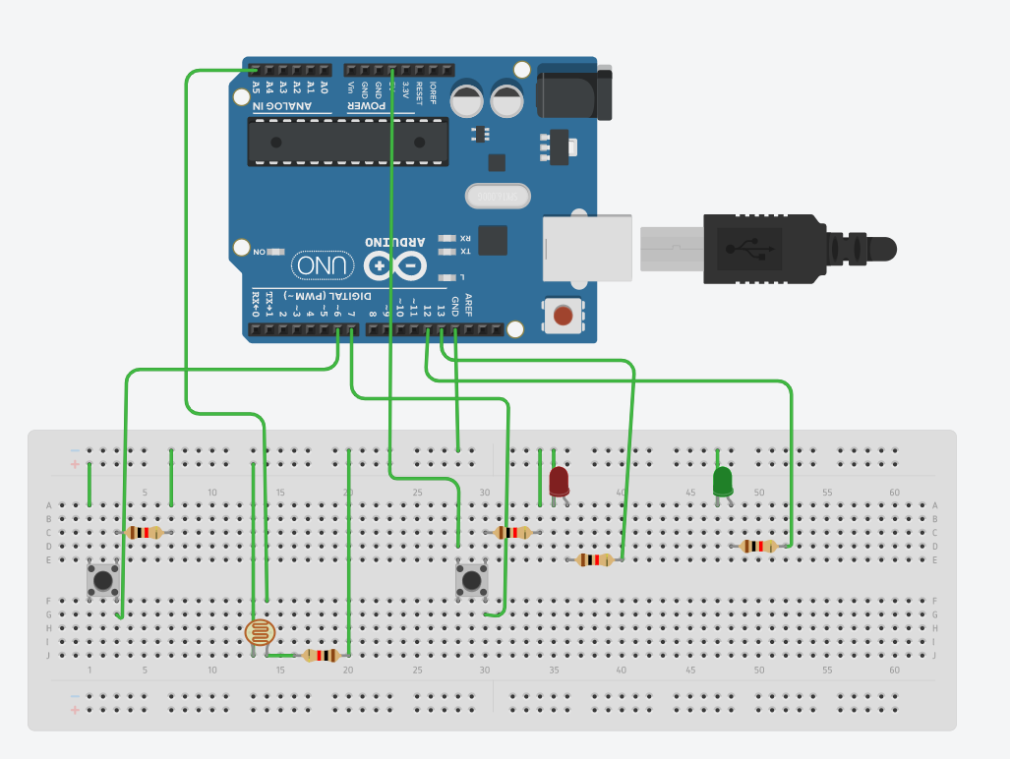

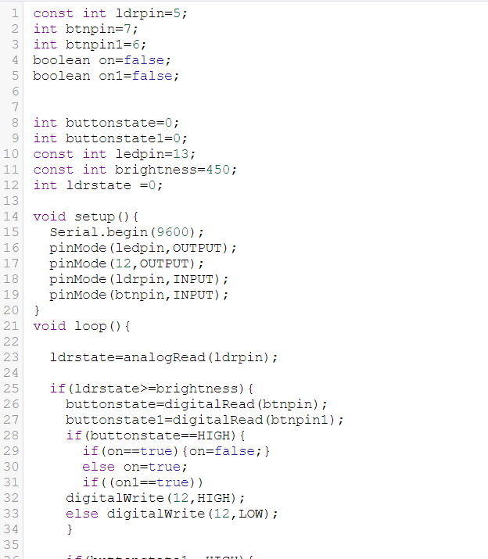

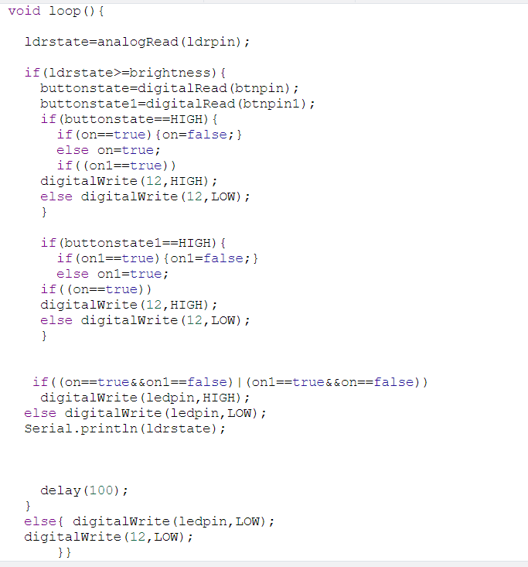

Theory :

LED is a light emmiting diode that gives light as a output. It is a semiconductor. They require very less power to get lighted and work very efficiently.

Arduino:
An Arduino UNO is a device that is equipped with digital and analog input/output slots. It has 14 Input/Output slots, 5 Analog slots and can work between 7 to 20 volts.It has 3 ground pins. It works when user inputs code into arduino.
Concept Used :

One leg of LED is inserted into the input/output pin of the arduino. Other leg is connected to the resistance and the resistance is connected to the ground slot of the arduino .One leg of pushbutton is connected to 5V ,second to the input/output pin and third leg to the ground.One leg of LDR is connected to 5V and second is connected to analog pin and second is also connected to resistor which is connected to ground.

Observation :
When one button is pressed red led blinks and when both buttons are pressed then green led blinks.
Learning Outcomes:

- Learned how to make a LED on and off.
- Learned how to use pushbutton.
- Learned how to use LDR.

Problems :

- Connections of LED may not be connected properly.
- LED's may not be working.
- Code may be wrong
- Arduino is not working.

Troubleshooting:

- All connections should be checked properly.
- Arduino should be working.
- LED's that are in working conditions should be used.
- Right code must be used.

Precaution:

- Don't plug in an LED without a current limiting resistor.
- Don't supply more than 9V unless proper knowledge.
- Check all the connections.

