—— C - Programs ——

Name : Daksh Vegad
ID :25ce137
Batch : c2
Program 1:
#include<stdio.h>
int main(){
printf("hello World\n");
return 0;
}
Caption
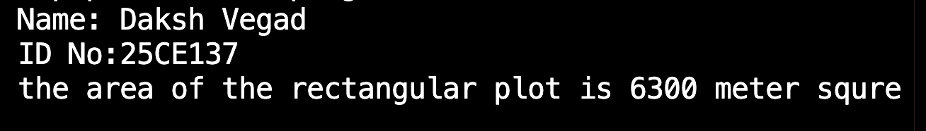
program 2:
Caption
#include<stdio.h>
int main()
{
printf("Name: Daksh Vegad\n");
printf("ID No:25CE137\n");
int length=70 ;
int breadth=90;

printf("the area of the rectangular plot is %d meter squre \n",length*breadth);
printf("the perameter of the rectangular plot is %d meters\n",2*(length+breadth));
return 0;
}
program 3:
#include<stdio.h>
int main()
{
printf("Name: Daksh Vegad\n");
printf("ID No:25CE137\n");
float height, weight, BMI;
printf("-----BMI Calculator-----\n");
printf("Enter your height in meters: ");
scanf("%f", &height);
if(height<=0)
{
printf("Note: The height Cannot Be a zero or nagative number");
return 0;
}

printf("Enter Your Weight in kg: ");
scanf("%f", &weight);
if(weight<=0)
{
printf("Note: The weight cannot be a zero Or negative number");
return 0;
}

BMI=weight/(height*height);
printf("Your Body Mass Index(BMI)is: %f\n",BMI);
if(BMI<18.5)
{
printf("You are underweight");
return 0;
}
else if(BMI>=18.5 && BMI<=24.9)
{
printf("you are in normal weight");
return 0;
}
else if(BMI>=25 && BMI<=29.9)
{
printf("you are Overweight");
return 0;
}
else if(BMI>=30)
{
printf("you are obses");
return 0;
}

}

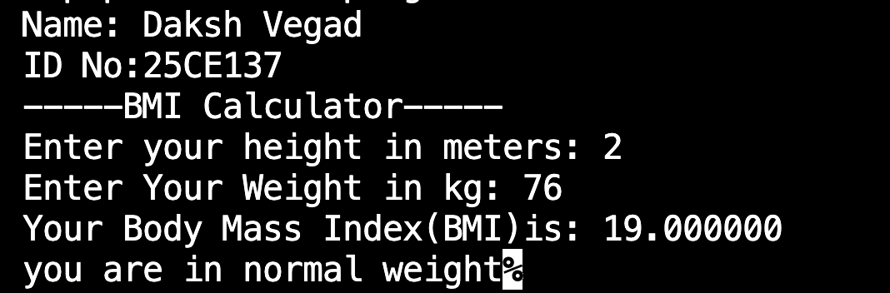
Caption

program 4:
#include <stdio.h>
#include <limits.h>
#include <float.h>

int main() {
printf("Name: Daksh Vegad\n");
printf("ID No:25CE137\n");
int choice;

while (1) {
printf("\n===== Data Type Info Menu =====\n");
printf("1. char\n");
printf("2. short\n");
printf("3. int\n");
printf("4. long\n");
printf("5. long long\n");
printf("6. float\n");
printf("7. double\n");
printf("8. long double\n");
printf("9. Exit\n");
printf("Enter your choice (1-9): ");
scanf("%d", &choice);

switch (choice) {
case 1:
printf("\n--- char ---\n");
printf("Size: %lu byte\n", sizeof(char));
printf("Signed Range: %d to %d\n", CHAR_MIN, CHAR_MAX);
printf("Unsigned Range: 0 to %u\n", UCHAR_MAX);
break;

case 2:
printf("\n--- short ---\n");
printf("Size: %lu bytes\n", sizeof(short));
printf("Signed Range: %d to %d\n", SHRT_MIN, SHRT_MAX);
printf("Unsigned Range: 0 to %u\n", USHRT_MAX);
break;

case 3:
printf("\n--- int ---\n");
printf("Size: %lu bytes\n", sizeof(int));
printf("Signed Range: %d to %d\n", INT_MIN, INT_MAX);
printf("Unsigned Range: 0 to %u\n", UINT_MAX);
break;

case 4:
printf("\n--- long ---\n");
printf("Size: %lu bytes\n", sizeof(long));
printf("Signed Range: %ld to %ld\n", LONG_MIN, LONG_MAX);
printf("Unsigned Range: 0 to %lu\n", ULONG_MAX);
break;

case 5:
printf("\n--- long long ---\n");
printf("Size: %lu bytes\n", sizeof(long long));
printf("Signed Range: %lld to %lld\n", LLONG_MIN, LLONG_MAX);
printf("Unsigned Range: 0 to %llu\n", ULLONG_MAX);
break;

case 6:
printf("\n--- float ---\n");
printf("Size: %lu bytes\n", sizeof(float));
printf("Range: %e to %e\n", FLT_MIN, FLT_MAX);
break;

case 7:
printf("\n--- double ---\n");
printf("Size: %lu bytes\n", sizeof(double));
printf("Range: %e to %e\n", DBL_MIN, DBL_MAX);
break;

case 8:
printf("\n--- long double ---\n");
printf("Size: %lu bytes\n", sizeof(long double));
printf("Range: %Le to %Le\n", LDBL_MIN, LDBL_MAX);
break;

case 9:
printf("Exiting program.\n");
return 0;

default:
printf("Invalid choice. Please select between 1 and 9.\n");
}
}

return 0;
}
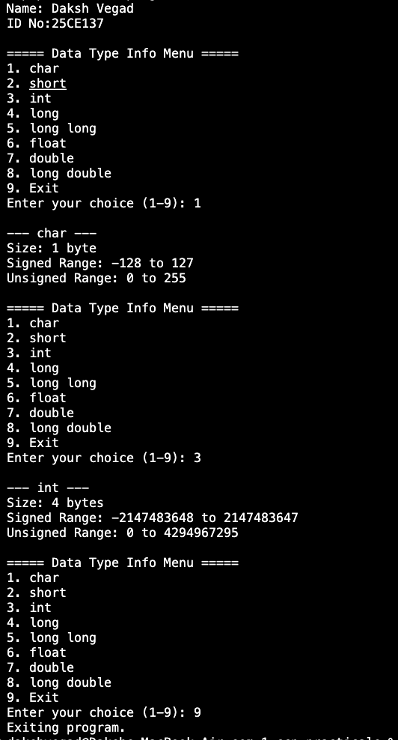
Caption

Program 5:
#include <stdio.h>

int main() {
printf("Name: Daksh Vegad\n");
printf("ID No:25CE137\n");
// Given data
long long total_population = 1441981744;
float percent_women = 48.4;
float literacy_rate_men = 80.95;
float literacy_rate_women = 62.84;

long long total_women = (long long)((percent_women / 100) * total_population);
long long total_men = total_population - total_women;

long long literate_women = (long long)((literacy_rate_women / 100) * total_women);
long long illiterate_women = total_women - literate_women;

long long literate_men = (long long)((literacy_rate_men / 100) * total_men);
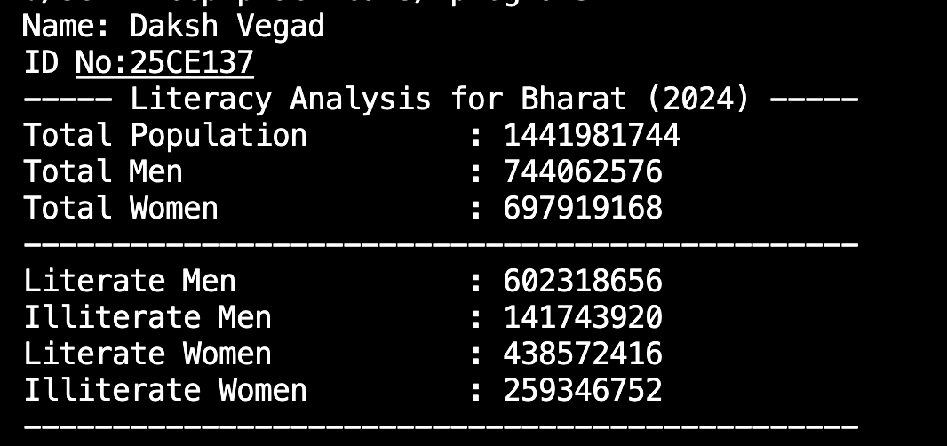
long long illiterate_men = total_men - literate_men;
Caption

printf("----- Literacy Analysis for Bharat (2024) -----\n");
printf("Total Population : %lld\n", total_population);
printf("Total Men : %lld\n", total_men);
printf("Total Women : %lld\n", total_women);
printf("-----------------------------------------------\n");
printf("Literate Men : %lld\n", literate_men);
printf("Illiterate Men : %lld\n", illiterate_men);
printf("Literate Women : %lld\n", literate_women);
printf("Illiterate Women : %lld\n", illiterate_women);
printf("-----------------------------------------------\n");

return 0;
}

program 6:
#include <stdio.h>

int main() {
printf("Name: Daksh Vegad\n");
printf("ID No:25CE137\n");
float celsius, fahrenheit;

// Example temperatures to convert
celsius = 0;
fahrenheit = (celsius * 9.0 / 5.0) + 32;
printf("Celsius: %.2f => Fahrenheit: %.2f\n", celsius, fahrenheit);

celsius = 100;
fahrenheit = (celsius * 9.0 / 5.0) + 32;
printf("Celsius: %.2f => Fahrenheit: %.2f\n", celsius, fahrenheit);

celsius = -40;
fahrenheit = (celsius * 9.0 / 5.0) + 32;
printf("Celsius: %.2f => Fahrenheit: %.2f\n", celsius, fahrenheit);

return 0;
}

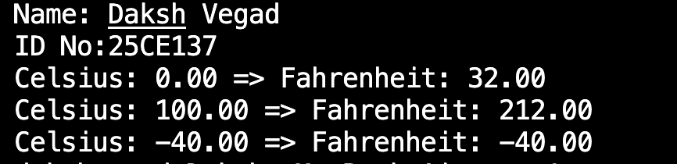
Caption

program 7:
#include <stdio.h>

int main() {
printf("Name: Daksh Vegad\n");
printf("ID No:25CE137\n");
int age;
float ticket_price = 0.0;
const float ADULT_TICKET_FARE = 25.0;
const int CHILD_AGE_CUTOFF = 12;
const int SENIOR_AGE_CUTOFF = 60;

printf("Enter visitor's age: ");
scanf("%d", &age);

if (age < 0 || age > 120) {
printf("Error: Age must be between 0 and 120.\n");
return 1; // Exit with an error code
}

if (age < CHILD_AGE_CUTOFF) {
ticket_price = 0.0;
printf("Free entry for children under %d years old!\n", CHILD_AGE_CUTOFF);
} else if (age >= SENIOR_AGE_CUTOFF) {
ticket_price = ADULT_TICKET_FARE * 0.5;
printf("Senior citizen discount applied! Ticket price: %.2f\n", ticket_price);
} else {
ticket_price = ADULT_TICKET_FARE;
printf("Adult ticket price: %.2f\n", ticket_price);
}

printf("Total amount payable: %.2f\n", ticket_price);

return 0;
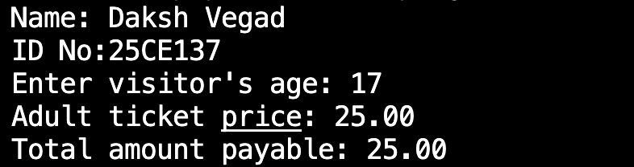
}
Caption
program 8:
#include<stdio.h>
int main()
{
printf("Name: Daksh Vegad\n");
printf("ID No:25CE137\n");
int age;
printf("----Eligibiliti Checker----\n");
printf("Enter Your Age: ");
scanf("%d",&age);

if(age<=0)
{
printf("Invalid age enterd! please enter valid age\n");
return 0;
}
else if(age>0 && age<18)
{
printf("You are not eligible\n");
return 0;
}
else if(age>=18 && age<=59)
{
printf("You are eligible for Regular savings account\n");
return 0;
}
else if(age>=60 )
{
printf("You are eligible for senior citizon Account\n");
return 0;
}
}
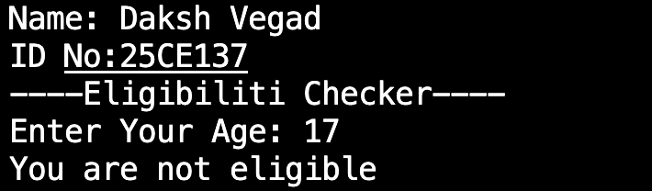
Caption

Program 9:
#include<stdio.h>
int main()
{
printf("Name: Daksh Vegad\n");
printf("ID No:25CE137\n");
float TA,DA,FA;
printf("-----ShopEase Online-----\n");
printf("Enter the total Ammount: ");
scanf("%f", &TA);

if(TA<1000)
{
printf("You Did not get any discount\n");
DA=TA;
}
else if(TA>=1000 && TA<5000)
{
printf("Hurray! you Got 10%% Discount\n");
DA=TA-(TA*0.1);
}
else if(TA>=5000)
{
printf("Hurray! you got 20%% Discount\n");
DA=TA-(TA*0.2);
}
printf("----bill summry----\n");
printf("your Discount ammount is %.2f Rupees\n",DA);
printf("5%% GST Applied\n");
FA=DA+(DA*0.05);
printf("Your Final Ammount Is:%.2f Rupees\n",FA);

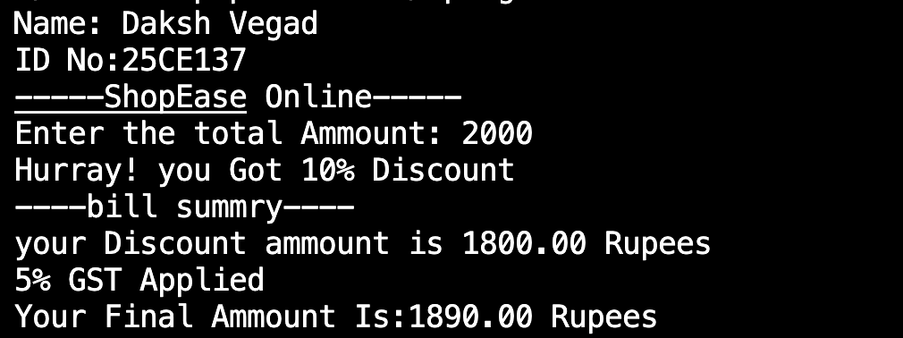
}

Program 10:
#include<stdio.h>
int main()
{
printf("Name: Daksh Vegad\n");
printf("ID No:25CE137\n");
int choice,q;
int total=0;
printf("-----Welcome to Foodies Restaurent-----\n");
printf("MENU\n");
printf("Enter 1 for Burger worth rupees 150\n ");
printf("Enter 2 for Pizza worth rupees 200\n ");
printf("Enter 3 for Pasta. worth rupees 120\n ");
printf("Enter 4 for Sandwitch worth rupees 100\n ");
printf("Enter 5 for French Fries worth rupees 80\n ");
printf("Enter 0 For finish order \n\n");

do{
printf("Enter Your Choice: ");
scanf("%d", &choice);

switch(choice)
{
case 1 :
printf("Enter Quantity Of Burgers: ");
scanf("%d", &q);
total= 150*q;
printf("%d Burgers Added(%d rupees)\n",q,150*q);
break;

case 2 :
printf("Enter Quantity Of Pizzas: ");
scanf("%d", &q);
total= 200*q;
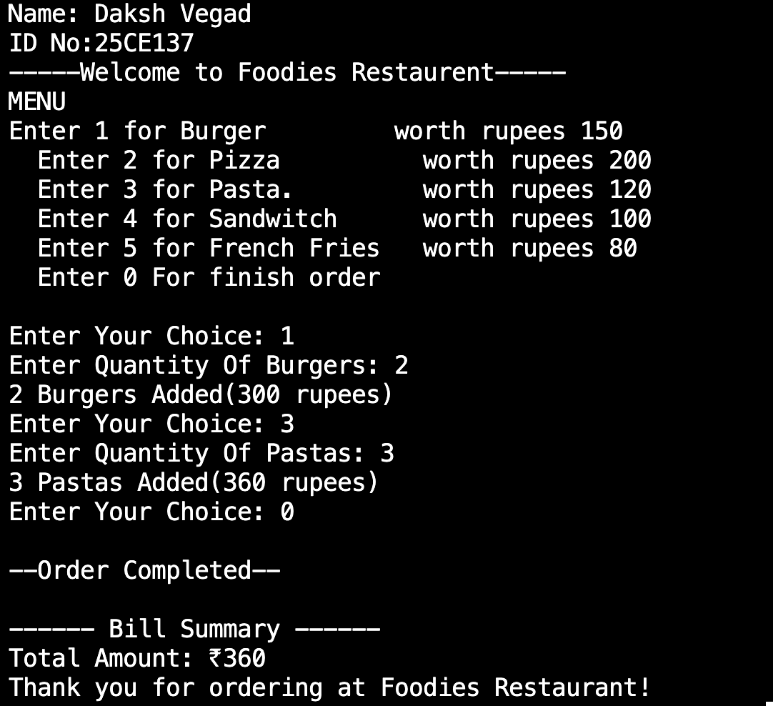
printf("%d Pizzas Added(%d rupees)\n",q,200*q);
Caption
break;

case 3:
printf("Enter Quantity Of Pastas: ");
scanf("%d", &q);
total= 120*q;
printf("%d Pastas Added(%d rupees)\n",q,120*q);
break;

case 4:
printf("Enter Quantity Of sandwitch: ");
scanf("%d", &q);
total= 100*q;
printf("%d sandwitch Added(%d rupees)\n",q,100*q);
break;

case 5:
printf("Enter Quantity Of french fries: ");
scanf("%d", &q);
total= 80*q;
printf("%d french fries Added(%d rupees)\n",q,80*q);
break;

case 0:
printf("\n--Order Completed--\n");
break;

default:
printf("Invalid choice! Please select from menu\n ");

}
}
while(choice != 0);

printf("\n------ Bill Summary ------\n");
printf("Total Amount: ₹%d\n", total);
printf("Thank you for ordering at Foodies Restaurant!\n");

return 0;
}
Program 11:
#include <stdio.h>

int main() {
printf("Name: Daksh Vegad\n");
printf("ID No:25CE137\n");
int marks;

printf("Enter student marks (0-100): ");
scanf("%d", &marks);

if (marks < 0 || marks > 100) {
printf("Invalid input! Marks must be between 0 and 100.\n");
}
else {
if (marks >= 90) {
printf("Marks: %d --> Grade: A\n", marks);
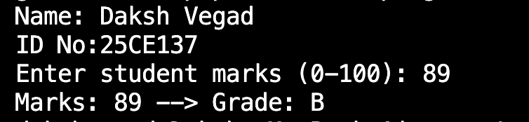
}
Caption
else if (marks >= 80) {
printf("Marks: %d --> Grade: B\n", marks);
}
else if (marks >= 70) {
printf("Marks: %d --> Grade: C\n", marks);
}
else if (marks >= 60) {
printf("Marks: %d --> Grade: D\n", marks);
}
else {
printf("Marks: %d --> Grade: F\n", marks);
}
}

return 0;
}

Program 12:
#include <stdio.h>

int main() {
printf("Name: Daksh Vegad\n");
printf("ID No:25CE137\n");
int i;

printf("------- Library Catalog -------\n\n");

// Loop from 1 to 50
for (i = 1; i <= 50; i++) {
if (i % 5 == 0) {
// Every 5th book
printf("Book ID: %d (Special Edition)\n", i);
} else {
printf("Book ID: %d\n", i);
}
}

return 0;
}
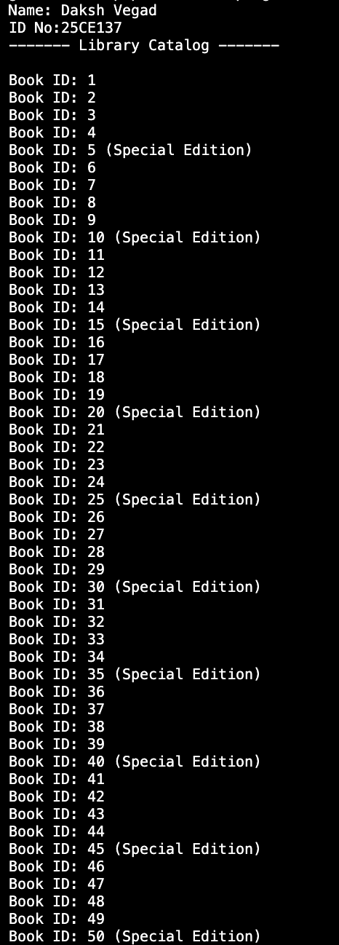
Caption
Program 13:
#include <stdio.h>

int main() {
printf("Name: Daksh Vegad\n");
printf("ID No:25CE137\n");
int tankLevel =0;
int maxCapacity = 100;
int refillRate = 10;

printf("---- Automatic Tank Refill Simulation ----\n\n");

// Loop until the tank reaches maximum capacity
while (tankLevel < maxCapacity) {
tankLevel += refillRate;
printf("Current water level: %d liters\n", tankLevel);
}

printf("Tank is full.\n");

return 0;
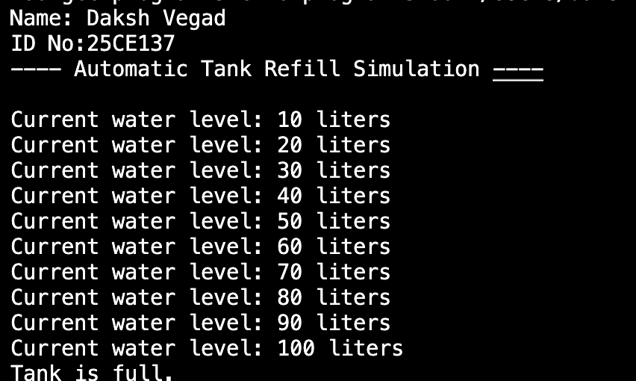
}
Caption

Program 14:
#include <stdio.h>

int main() {
printf("Name: Daksh Vegad\n");
printf("ID No:25CE137\n");
float balance = 5000.00;
float withdrawalAmount;
char continueTransaction = 'y';

printf("Welcome to the National Bank of Bharat ATM!\n");
printf("Your current balance is: ₹%.2f\n", balance);

while (continueTransaction == 'y' || continueTransaction == 'Y') {
printf("\nEnter the amount you wish to withdraw: ₹");
scanf("%f", &withdrawalAmount);

if (withdrawalAmount <= 0) {
printf("Invalid amount. Please enter a positive amount.\n");
continue;
}

if (withdrawalAmount > balance) {
printf("Insufficient balance. Your current balance is ₹%.2f\n", balance);
} else {

balance -= withdrawalAmount;
printf("Withdrawal successful!\n");
printf("Remaining balance: ₹%.2f\n", balance);
}

printf("\nDo you want to perform another transaction? (y/n): ");
scanf(" %c", &continueTransaction);
}

printf("\nThank you for using the National Bank of Bharat ATM. Goodbye!\n");
return 0;
}
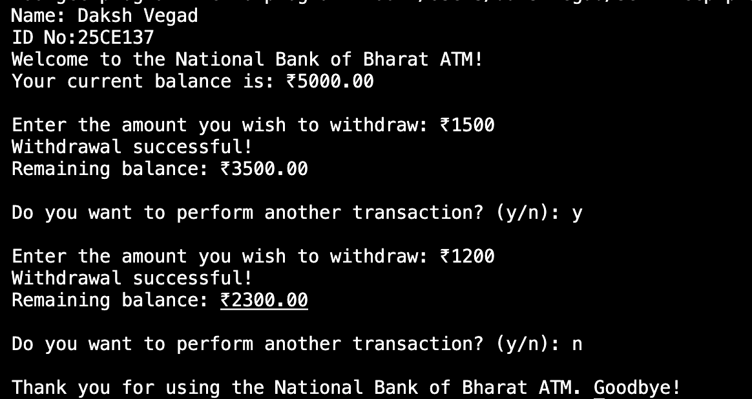
Caption
Program 15:
#include<stdio.h>
#include<unistd.h>
int main()
{
printf("Name: Daksh Vegad\n");
printf("ID No:25CE137\n");
int seconds;
printf("Enter the starting Number of seconds for countdown: ");
scanf("%d", &seconds);

if(seconds<0)
{
printf("ERROR: you Cannot enter Negative Number\n");
return 1;
}
printf("\nStarting Countdown....\n");

for(int i=seconds;i>0;i--)
{
printf("%d\n",i);
sleep(1);
}
printf("Countdown Completed!\n");
return 0;

}
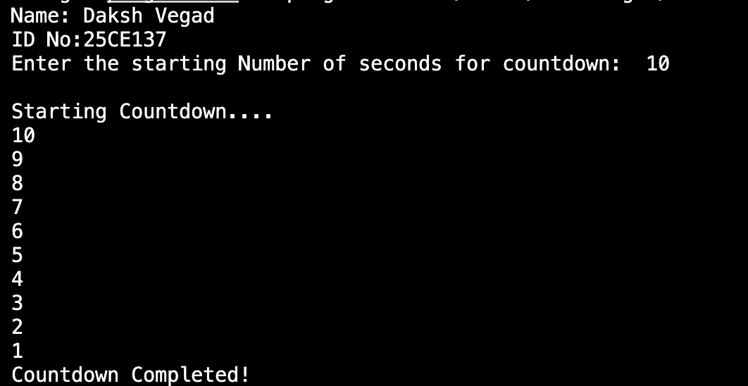
Caption
Program 16:
#include <stdio.h>

int main() {
printf("Name: Daksh Vegad\n");
printf("ID No:25CE137\n");
int matchsticks = 21, user_pick, computer_pick;

printf("Matchstick Game: There are 21 matchsticks.\n");
printf("You and the computer will take turns picking 1 to 4 matchsticks.\n");
printf("The one forced to pick the last matchstick loses!\n\n");

while (matchsticks > 1) {
// User's turn
printf("Matchsticks left: %d\n", matchsticks);
printf("Your turn! Pick 1, 2, 3, or 4 matchsticks: ");
scanf("%d", &user_pick);

if (user_pick < 1 || user_pick > 4) {
printf("Invalid choice! You must pick between 1 and 4 matchsticks.\n");
continue;
}

matchsticks -= user_pick;

if (matchsticks == 1) {
printf("\nOnly 1 matchstick left! You forced the computer to pick it.\n");
printf(" You WIN! Computer loses.\n");
break;
}

computer_pick = 5 - user_pick;
matchsticks -= computer_pick;

printf("Computer picks %d matchstick(s).\n", computer_pick);

if (matchsticks == 1) {
printf("\nOnly 1 matchstick left! You are forced to pick it next turn.\n");
printf("Computer WINS! You lose.\n");
break;
}
}

return 0;
}
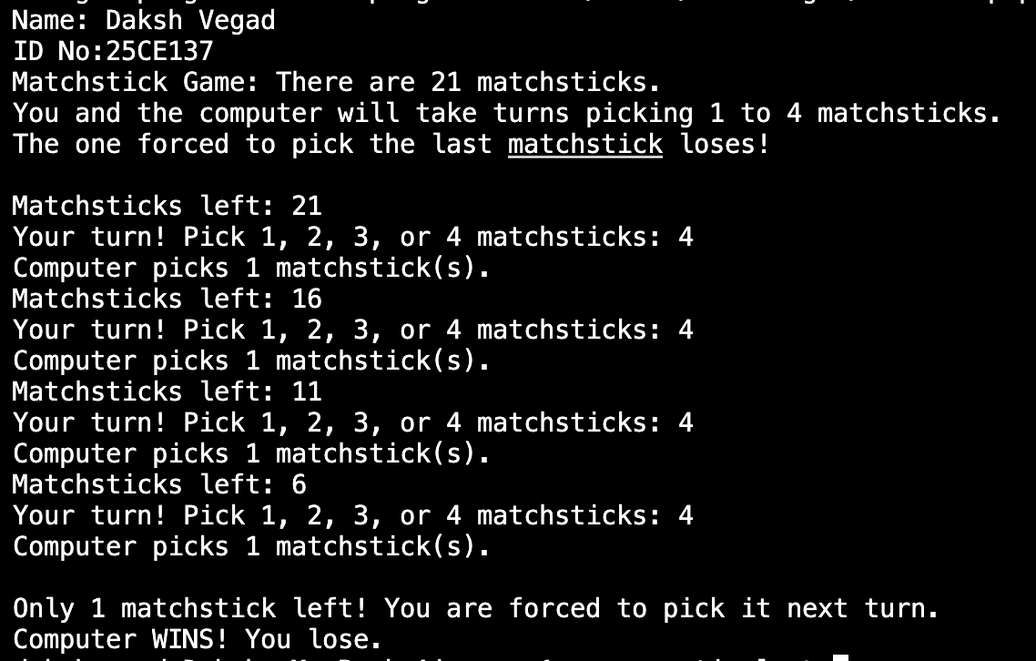
Caption
Program 17:
#include <stdio.h>
#include <unistd.h>

int main() {
printf("name: Daksh Vegad\n");
printf("ID No: 25CE137\n");
float totalDistance, distancePerMin;
float distance = 0.0;
int minute = 0;

printf("Enter marathon distance (e.g., 5 or 10 km): ");
scanf("%f", &totalDistance);

printf("Enter distance covered per minute (e.g., 0.5): ");
scanf("%f", &distancePerMin);

while (1) {
minute++;
distance += distancePerMin;

printf("Minute %d: Distance covered = %.2f km\n", minute, distance);

if (distance >= totalDistance) {
printf("\nMarathon complete in %d minutes!\n", minute);
break;
}

sleep(1);
}

return 0;
}
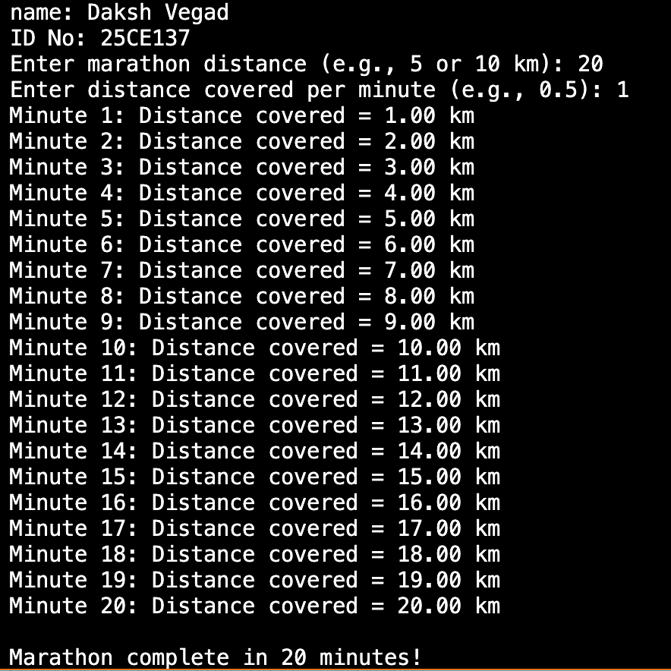
Caption
Program 18:
#include<stdio.h>
int main()
{
printf("Name: Daksh Vegad\n");
printf("ID No:25CE137\n");
int i,j;
int rows;
int cols;
printf("Enter the size of the table Vertically: ");
scanf("%d",&rows);
if(rows<=0)
{
printf("Please Enter Non-negetive or Non-zero number\n");

}
printf("Enter the size of the table Horizontally: ");
scanf("%d", &cols);
if(cols<=0)
{
printf("Please Enter Non-negetive or Non-zero number\n");

}
printf("\n Multification Table of(%d x &d)\n\n",rows,cols);
for( i=1;i<=rows;i++)
{
for( j=1;j<=cols;j++)
{
printf("%4d",i*j);
}
printf("\n");
}
return 0;
}
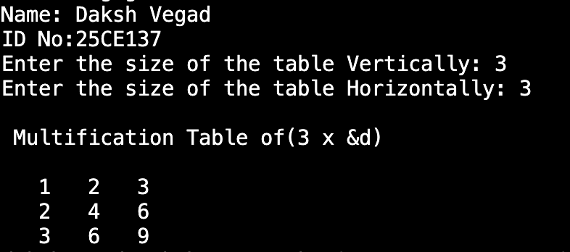
Caption
Program 19i:
#include<stdio.h>
int main()
{
printf("Name: Daksh Vegad\n");
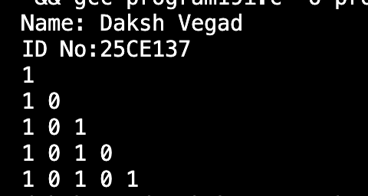
printf("ID No:25CE137\n");
Caption
int rows=5;
int i,j;
for(i=1;i<=rows;i++)
{
printf("1");
for(j=1;j<i;j++)
{
if(j%2 ==1)
{
printf(" 0");
}
else{
printf(" 1");
}
}
printf("\n");
}
return 0;
}

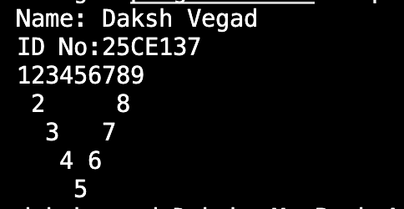
Caption
Program 19ii:

#include<stdio.h>
int main()
{
printf("Name: Daksh Vegad\n");
printf("ID No:25CE137\n");
int i,j;
int n=9;
for(i=1;i<=n;i++)
{
printf("%d",i);
}
printf("\n");
for(i=2;i<=(n+1)/2;i++)
{
for(j=1;j<i;j++)
{
printf(" ");
}
printf("%d",i);
for(j=1;j<=n-2*i;j++)
{
printf(" ");
}
if(i!=n-i+1)
{
printf("%d",n-i+1);
}
printf("\n");
}
return 0;
}

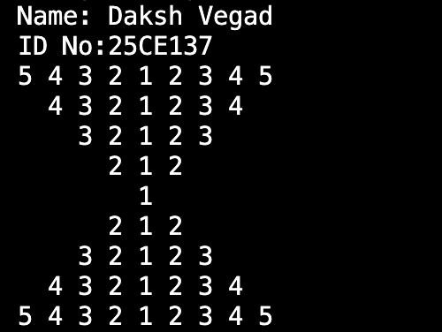
Program 19iii:
Caption

#include <stdio.h>

int main() {
printf("Name: Daksh Vegad\n");
printf("ID No:25CE137\n");
int num = 5;

for (int i = num; i >= 1; i--) {

for (int j = 0; j < num - i; j++) {
printf(" ");
}

for (int j = i; j >= 1; j--) {
printf("%d ", j);
}

for (int j = 2; j <= i; j++) {
printf("%d ", j);
}
printf("\n");
}

for (int i = 2; i <= num; i++) {

for (int j = 0; j < num - i; j++) {
printf(" ");
}

for (int j = i; j >= 1; j--) {
printf("%d ", j);
}

for (int j = 2; j <= i; j++) {
printf("%d ", j);
}
printf("\n");
}

return 0;
}
Program 19iv:
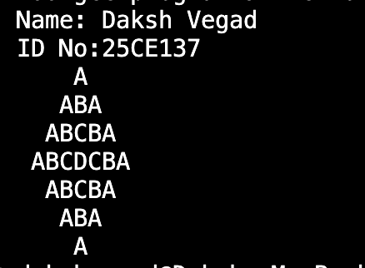
Caption
#include <stdio.h>

int main() {
printf("Name: Daksh Vegad\n");
printf("ID No:25CE137\n");
int num = 4;

for (int i = 0; i < num; i++) {

for (int j = 0; j < num - i; j++) {
printf(" ");
}

for (int j = 0; j <= i; j++) {
printf("%c", 'A' + j);
}

for (int j = i - 1; j >= 0; j--) {
printf("%c", 'A' + j);
}
printf("\n");
}

for (int i = num - 2; i >= 0; i--) {

for (int j = 0; j < num - i; j++) {
printf(" ");
}

for (int j = 0; j <= i; j++) {
printf("%c", 'A' + j);
}

for (int j = i - 1; j >= 0; j--) {
printf("%c", 'A' + j);
}
printf("\n");
}

return 0;
}
Program 20:
#include <stdio.h>

int main() {
printf("Name: Daksh Vegad\n");
printf("ID No:25CE137\n");
int n;
int num =1;
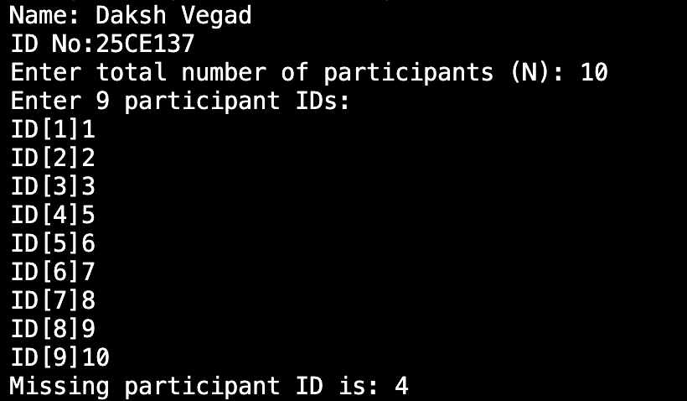
printf("Enter total number of participants (N): ");
Caption
scanf("%d", &n);

int ids[n-1];
int sum = 0;
int total = n * (n + 1) / 2;
printf("Enter %d participant IDs:\n", n - 1);
for (int i = 0; i < n - 1; i++) {
printf("ID[%d]",num++);
scanf("%d", &ids[i]);
sum += ids[i];
}

int missing = total - sum;
printf("Missing participant ID is: %d\n", missing);

return 0;
}
Program 21:
#include <stdio.h>

int main() {
printf("Name: Daksh Vegad\n");
printf("ID No:25CE137\n");
int numbers[25];
int i;
int positiveCount = 0, negativeCount = 0;
int evenCount = 0, oddCount = 0;

printf("Enter 25 integers:\n");

for (i = 0; i < 25; i++) {
printf("Enter number %d: ", i + 1);
scanf("%d", &numbers[i]);
}

for (i = 0; i < 25; i++) {
if (numbers[i] > 0) {
positiveCount++;
} else if (numbers[i] < 0) {
negativeCount++;
}

if (numbers[i] % 2 == 0) {
evenCount++;
} else {
oddCount++;
}
}

printf("\n--- Statistics ---\n");
printf("Total Positive Numbers: %d\n", positiveCount);
printf("Total Negative Numbers: %d\n", negativeCount);
printf("Total Even Numbers: %d\n", evenCount);
printf("Total Odd Numbers: %d\n", oddCount);

return 0;
}
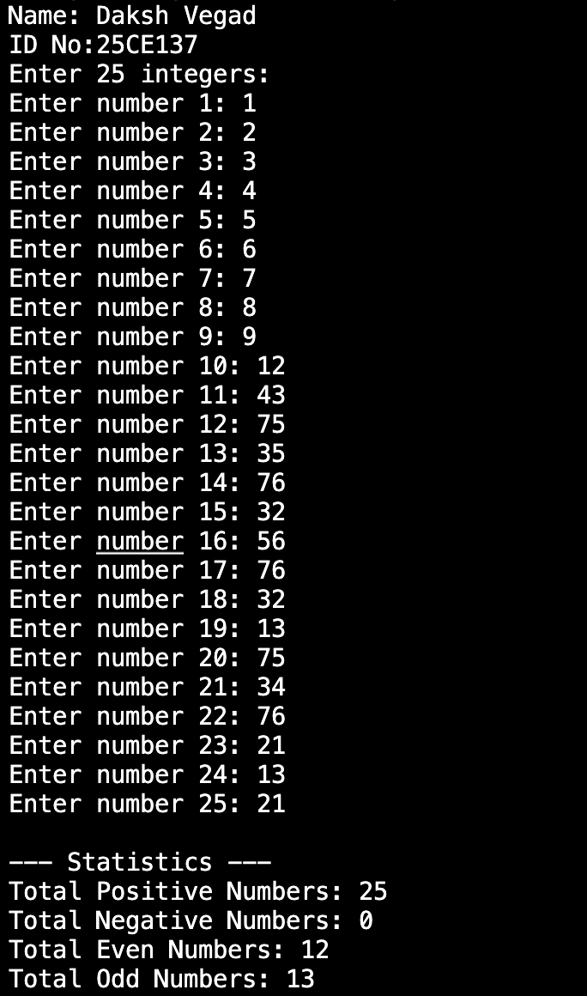
Caption
Program 22:
#include <stdio.h>

#define ROWS 5
#define COLS 10

int main() {
printf("Name: Daksh Vegad\n");
printf("ID No:25CE137\n");
char seats[ROWS][COLS];
int i, j, reserved, r, c;

for (i = 0; i < ROWS; i++) {
for (j = 0; j < COLS; j++)
{
seats[i][j] = '0';
}
}

printf("Enter the number of reserved seats: ");
scanf("%d", &reserved);

for (i = 0; i < reserved; i++) {
printf("Enter row and seat number for reserved seat %d (e.g., 2 5): ", i + 1);
scanf("%d %d", &r, &c);

// Validate input before marking
if (r < 1 || r > ROWS || c < 1 || c > COLS) {
printf("Invalid row or seat number. Skipping this entry.\n");
continue;
}

// Mark seat as reserved with 'X'
seats[r - 1][c - 1] = 'X';
}

// Display seating chart
printf("\nSeating Chart:\n");
for (i = 0; i < ROWS; i++) {
printf("Row %d: ", i + 1);
for (j = 0; j < COLS; j++) {
printf("%c ", seats[i][j]);
}
printf("\n");
}

return 0;
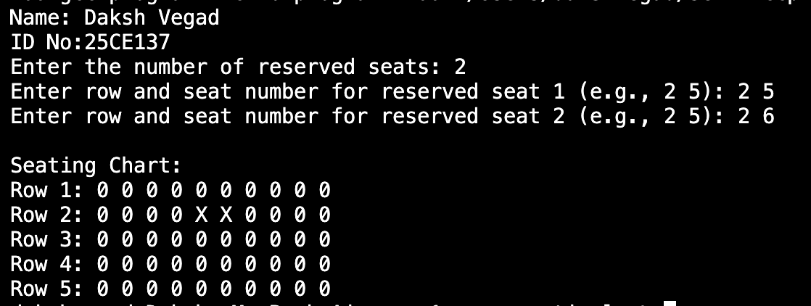
}
Caption

Program 23:
#include <stdio.h>

int main() {
printf("Name: Daksh Vegad\n");
printf("ID No:25CE137\n");
int n;
printf("Enter number of days: ");
scanf("%d", &n);

int prices[100];
printf("Enter prices for each day:\n");
for (int i = 0; i < n; i++) {
scanf("%d", &prices[i]);
}

int minPrice = prices[0];
int maxProfit = 0;

for (int i = 1; i < n; i++) {
int profit = prices[i] - minPrice;
if (profit > maxProfit) {
maxProfit = profit;
}
if (prices[i] < minPrice) {
minPrice = prices[i];
}
}

printf("Maximum Profit: %d\n", maxProfit);
return 0;
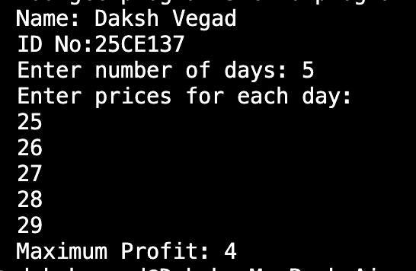
}
Caption
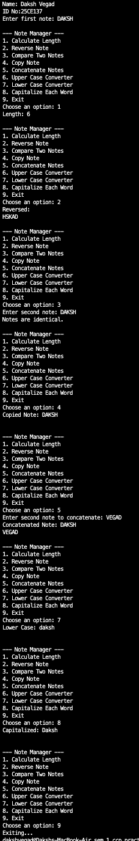
Program 24:
Caption
#include <stdio.h>
#include <ctype.h>

#define MAX 500

int noteLength(char s[]) {
int len = 0;
while (s[len] != '\0') len++;
return len;
}

void reverseNote(char s[], char rev[]) {
int len = noteLength(s);
for (int i = 0; i < len; i++)
rev[i] = s[len - 1 - i];
rev[len] = '\0';
}

int compareNotes(char a[], char b[]) {
int i = 0;
while (a[i] != '\0' && b[i] != '\0') {
if (a[i] != b[i]) return 0;
i++;
}
return (a[i] == '\0' && b[i] == '\0');
}

void copyNote(char src[], char dest[]) {
int i = 0;
while (src[i] != '\0') {
dest[i] = src[i];
i++;
}
dest[i] = '\0';
}

void concatNotes(char a[], char b[], char res[]) {
int i = 0, j = 0;
while (a[i] != '\0') {
res[i] = a[i];
i++;
}
while (b[j] != '\0') {
res[i + j] = b[j];
j++;
}
res[i + j] = '\0';
}

void toUpperCase(char s[]) {
for (int i = 0; s[i] != '\0'; i++)
if (s[i] >= 'a' && s[i] <= 'z')
s[i] = s[i] - 'a' + 'A';
}

void toLowerCase(char s[]) {
for (int i = 0; s[i] != '\0'; i++)
if (s[i] >= 'A' && s[i] <= 'Z')
s[i] = s[i] - 'A' + 'a';
}

void capitalizeWords(char s[]) {
int newWord = 1;
for (int i = 0; s[i] != '\0'; i++) {
if (s[i] == ' ' || s[i] == '\t' || s[i] == '\n') {
newWord = 1;
} else if (newWord && s[i] >= 'a' && s[i] <= 'z') {
s[i] = s[i] - 'a' + 'A';
newWord = 0;
} else {
newWord = 0;
}
}
}

int main() {
printf("Name: Daksh Vegad\n");
printf("ID No:25CE137\n");

char note1[MAX], note2[MAX], result[MAX];
int choice;

printf("Enter first note: ");
fgets(note1, MAX, stdin);

do {
printf("\n--- Note Manager ---\n");
printf("1. Calculate Length\n");
printf("2. Reverse Note\n");
printf("3. Compare Two Notes\n");
printf("4. Copy Note\n");
printf("5. Concatenate Notes\n");
printf("6. Upper Case Converter\n");
printf("7. Lower Case Converter\n");
printf("8. Capitalize Each Word\n");
printf("9. Exit\n");
printf("Choose an option: ");
scanf("%d", &choice);
getchar(); // consume newline after number

switch (choice) {
case 1:
printf("Length: %d\n", noteLength(note1));
break;
case 2:
reverseNote(note1, result);
printf("Reversed: %s\n", result);
break;
case 3:
printf("Enter second note: ");
fgets(note2, MAX, stdin);
if (compareNotes(note1, note2))
printf("Notes are identical.\n");
else
printf("Notes differ.\n");
break;
case 4:
copyNote(note1, result);
printf("Copied Note: %s\n", result);
break;
case 5:
printf("Enter second note to concatenate: ");
fgets(note2, MAX, stdin);
concatNotes(note1, note2, result);
printf("Concatenated Note: %s", result);
break;
case 6:
toUpperCase(note1);
printf("Upper Case: %s\n", note1);
break;
case 7:
toLowerCase(note1);
printf("Lower Case: %s\n", note1);
break;
case 8:
capitalizeWords(note1);
printf("Capitalized: %s\n", note1);
break;
case 9:
printf("Exiting...\n");
break;
default:
printf("Invalid choice.\n");
}
} while (choice != 9);

return 0;
}

Program 25:
#include <stdio.h>
#include <string.h>

#define MAX_BOOKS 5
#define MAX_NAME_LEN 50

// Book structure
typedef struct {
char name[MAX_NAME_LEN];
int available; // 1 = available, 0 = borrowed
} Book;

// Global library
Book library[MAX_BOOKS] = {
{"C Programming", 1},
{"Data Structures", 1},
{"Operating Systems", 1},
{"Database Systems", 1},
{"Computer Networks", 1}
};

// Function to display available books
void displayBooks() {
printf("\nAvailable Books:\n");
int found = 0;
for (int i = 0; i < MAX_BOOKS; i++) {
if (library[i].available) {
printf(" - %s\n", library[i].name);
found = 1;
}
}
if (!found) {
printf("No books available!\n");
}
}

// Function to get total number of available books
int getTotalBooks() {
int count = 0;
for (int i = 0; i < MAX_BOOKS; i++) {
if (library[i].available) {
count++;
}
}
return count;
}

// Function to borrow a book
void borrowBook(char *bookName) {
for (int i = 0; i < MAX_BOOKS; i++) {
if (strcmp(library[i].name, bookName) == 0) {
if (library[i].available) {
library[i].available = 0; // Mark as borrowed
printf("You borrowed: %s\n", library[i].name);
} else {
printf("Sorry, '%s' is already borrowed.\n", bookName);
}
return;
}
}
printf("Book '%s' not found in library.\n", bookName);
}

// Function to calculate fine
float calculateFine(int daysLate) {
float finePerDay = 2.0; // ₹2 per day
return daysLate * finePerDay;
}

// Main function
int main() {
printf("Name: Daksh Vegad\n");
printf("ID No:25CE137\n");
int choice, days;
char bookName[MAX_NAME_LEN];

do {
printf("\nLibrary Menu:\n");
printf("1. Display available books\n");
printf("2. Get total number of books\n");
printf("3. Borrow a book\n");
printf("4. Calculate fine\n");
printf("5. Exit\n");
printf("Enter your choice: ");
scanf("%d", &choice);
getchar(); // clear newline

switch (choice) {
case 1:
displayBooks();
break;
case 2:
printf("Total available books: %d\n", getTotalBooks());
break;
case 3:
printf("Enter book name to borrow: ");
fgets(bookName, sizeof(bookName), stdin);
bookName[strcspn(bookName, "\n")] = '\0'; // remove newline
borrowBook(bookName);
break;
case 4:
printf("Enter number of days late: ");
scanf("%d", &days);
printf("Fine amount = ₹%.2f\n", calculateFine(days));
break;
case 5:
printf("Exiting Library System...\n");
break;
default:
printf("Invalid choice! Try again.\n");
}
} while (choice != 5);

return 0;
}
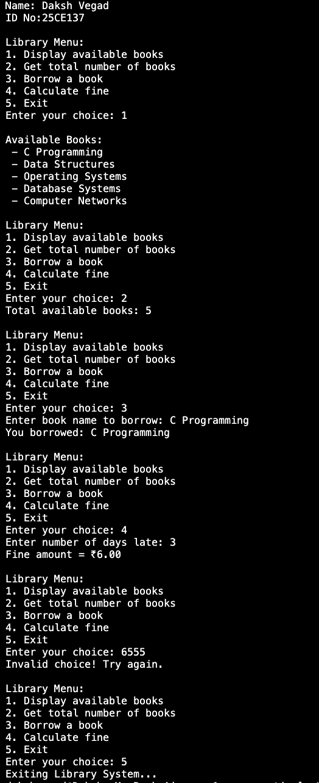
Caption
Program 26:
#include <stdio.h>
#include <math.h>

void inputSides(float *a, float *b, float *c) {
printf("Enter three sides of the triangle: ");
scanf("%f %f %f", a, b, c);
}

int isValidTriangle(float a, float b, float c) {
if (a <= 0 || b <= 0 || c <= 0) {
printf("Valid Triangle: No. Message: Side lengths must be positive numbers.\n");
return 0;
}
if ((a + b <= c) || (a + c <= b) || (b + c <= a)) {
printf("Valid Triangle: No\n Message: The given lengths do not form a valid triangle.\n");
return 0;
}
return 1;
}

float calculateArea(float a, float b, float c) {
float s = (a + b + c) / 2;
return sqrt(s * (s - a) * (s - b) * (s - c));
}

void displayResult(float a, float b, float c) {
if (isValidTriangle(a, b, c)) {
float area = calculateArea(a, b, c);
printf("Valid Triangle: Yes. Area = %.2f\n", area);
}
}

int main() {
printf("Name: Daksh Vegad\n");
printf("ID No:25CE137\n");
float a, b, c;
inputSides(&a, &b, &c);
displayResult(a, b, c);
return 0;
}
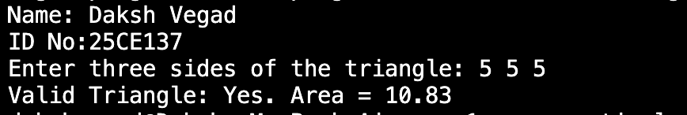
Caption
Program 27:
#include<stdio.h>
int main()
{
printf("Name: Daksh Vegad\n");
printf("ID No:25CE137\n");
int n;
printf("Enter Number of Months: ");
scanf("%d",&n);
if(n<1)
{
printf("Enter the number at least 1\n");
return 0;
}
long long a=1,b=1,next;
printf("\n----Savings Growth Pattern----\n");
for(int i=1;i<=n;i++){
if(i==1)
printf("Month %d: %lld\n",i,a);
else if(i==2)
printf("Month %d: %lld\n",i,b);
else{
next =a + b;
printf("Month %d: %lld\n",i,next);
a=b;
b=next;
}
}
return 0;

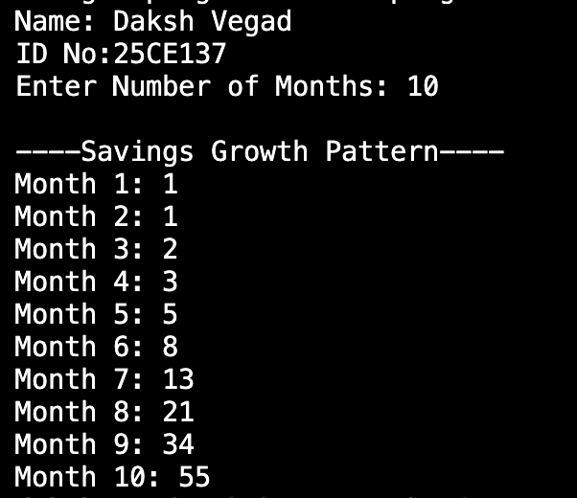
}
Caption
Program 28:
#include <stdio.h>
#include <string.h>

union BookDetails {
int accessionNumber;
char title[50];
char author[50];
float price;
int status;
};

struct Book {
int accessionNumber;
char title[50];
char author[50];
float price;
int status;
};

int main() {
printf("Name: Daksh Vegad\n");
printf("ID No:25CE137\n");
struct Book book;
union BookDetails detail;
int choice;

do {
printf("\n===== Library Management Menu =====\n");
printf("1. Enter Book Details\n");
printf("2. Display Book Details\n");
printf("3. Update Book Status\n");
printf("4. Exit\n");
printf("Enter your choice: ");
scanf("%d", &choice);

switch(choice) {
case 1:
printf("\n--- Enter Book Details ---\n");
printf("Enter Accession Number: ");
scanf("%d", &detail.accessionNumber);
book.accessionNumber = detail.accessionNumber;

printf("Enter Book Title: ");
scanf(" %[^\n]", detail.title);
strcpy(book.title, detail.title);

printf("Enter Author Name: ");
scanf(" %[^\n]", detail.author);
strcpy(book.author, detail.author);

printf("Enter Price (₹): ");
scanf("%f", &detail.price);
book.price = detail.price;

printf("Enter Book Status (1 = Issued, 0 = Available): ");
scanf("%d", &detail.status);
book.status = detail.status;

printf("Book details added successfully!\n");
break;

case 2:
printf("\n--- Displaying Book Details ---\n");
printf("Accession Number : %d\n", book.accessionNumber);
printf("Title : %s\n", book.title);
printf("Author : %s\n", book.author);
printf("Price (₹) : %.2f\n", book.price);
printf("Status : %s\n", (book.status == 1) ? "ISSUED" : "AVAILABLE");
break;

case 3:
printf("\n--- Update Book Status ---\n");
printf("Enter new status (1 = Issued, 0 = Available): ");
scanf("%d", &detail.status);
book.status = detail.status;
printf("Status updated successfully!\n");
break;

case 4:
printf("\nExiting program. Goodbye!\n");
break;

default:
printf("Invalid choice! Please try again.\n");
}

} while(choice != 4);

return 0;
}
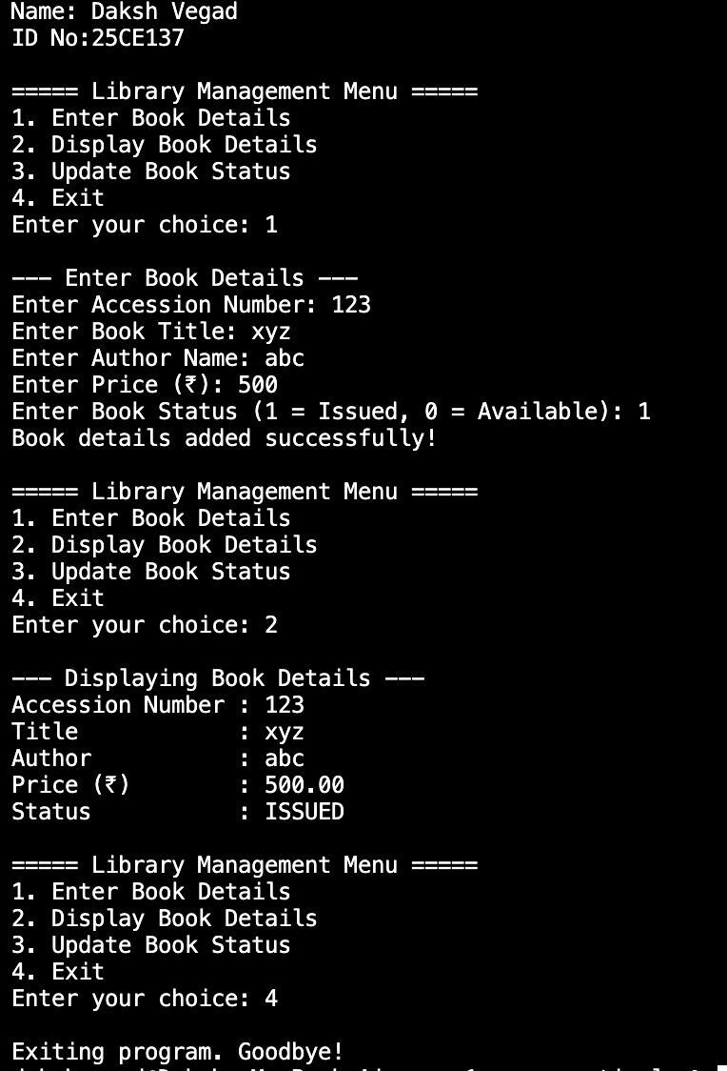
Caption
Program 29:
#include <stdio.h>
#include <string.h>

#define MAX_TEAMS 50

struct Coach {
char name[50];
int age;
int experience;
};

struct Team {
char teamName[50];
char sportType[30];
struct Coach coach;
};

int main() {
printf("Name: Daksh Vegad\n");
printf("ID No:25CE137\n");
struct Team teams[MAX_TEAMS];
int teamCount = 0;
int choice;
char searchName[50];

do {
printf("\n===== CHARUSAT Sports Team Management =====\n");
printf("1. Add New Team\n");
printf("2. Search Team by Name\n");
printf("3. Display All Teams\n");
printf("4. Exit\n");
printf("Enter your choice: ");
scanf("%d", &choice);

switch (choice) {
case 1: // Add new team
if (teamCount < MAX_TEAMS) {
printf("\n--- Enter Team Details ---\n");
printf("Enter Team Name: ");
scanf(" %[^\n]", teams[teamCount].teamName);

printf("Enter Sport Type: ");
scanf(" %[^\n]", teams[teamCount].sportType);

printf("\n--- Enter Coach Details ---\n");
printf("Enter Coach Name: ");
scanf(" %[^\n]", teams[teamCount].coach.name);

printf("Enter Coach Age: ");
scanf("%d", &teams[teamCount].coach.age);

printf("Enter Coach Experience (in years): ");
scanf("%d", &teams[teamCount].coach.experience);

teamCount++;
printf("Team added successfully!\n");
} else {
printf("Team list is full!\n");
}
break;

case 2: // Search team by name
printf("\nEnter Team Name to Search: ");
scanf(" %[^\n]", searchName);
int found = 0;

for (int i = 0; i < teamCount; i++) {
if (strcmp(teams[i].teamName, searchName) == 0) {
printf("\n--- Team Found ---\n");
printf("Team Name : %s\n", teams[i].teamName);
printf("Sport Type: %s\n", teams[i].sportType);
printf("Coach Name: %s\n", teams[i].coach.name);
printf("Coach Age : %d\n", teams[i].coach.age);
printf("Experience : %d years\n", teams[i].coach.experience);
found = 1;
break;
}
}
if (!found)
printf("Team not found!\n");
break;

case 3: // Display all teams
if (teamCount == 0) {
printf("\nNo teams to display.\n");
} else {
printf("\n--- All Teams and Coaches ---\n");
for (int i = 0; i < teamCount; i++) {
printf("\nTeam %d:\n", i + 1);
printf("Team Name : %s\n", teams[i].teamName);
printf("Sport Type: %s\n", teams[i].sportType);
printf("Coach Name: %s\n", teams[i].coach.name);
printf("Coach Age : %d\n", teams[i].coach.age);
printf("Experience: %d years\n", teams[i].coach.experience);
}
}
break;

case 4:
printf("\nExiting Program. Goodbye!\n");
break;

default:
printf("Invalid choice! Please try again.\n");
}

} while (choice != 4);

return 0;
}
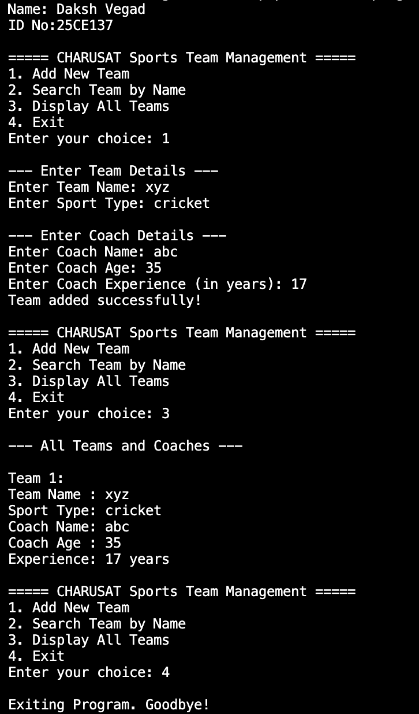
Caption
Program 30:
#include <stdio.h>

void sortPrices(float *ptr, int n) {
float temp;
for (int i = 0; i < n - 1; i++) {
for (int j = i + 1; j < n; j++) {
if (*(ptr + j) < *(ptr + i)) {
temp = *(ptr + i);
*(ptr + i) = *(ptr + j);
*(ptr + j) = temp;
}
}
}
}

int main() {
printf("Name: Daksh Vegad\n");
printf("ID No:25CE137\n");
int n;
float prices[100];

printf("Enter the number of items: ");
if (scanf("%d", &n) != 1 || n <= 0) {
printf("Error: No items to sort.\n");
return 0;
}

printf("Enter %d prices (in any order):\n", n);
for (int i = 0; i < n; i++) {
printf("Enter price[%d]: ",i+1);
if (scanf("%f", &prices[i]) != 1) {
printf("Error: Invalid input for price. Please enter numeric values only.\n");
return 0;
}
if (prices[i] < 0) {
printf("Error: Negative prices are not allowed.\n");
return 0;
}
}

sortPrices(prices, n);

printf("\nSorted Prices (Ascending Order):\n");
for (int i = 0; i < n; i++) {
printf("%.2f ", *(prices + i));
}
printf("\n");

return 0;
}
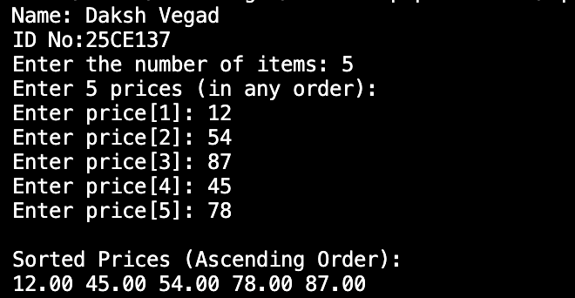
Caption
Program 31:
#include <stdio.h>
#include <stdlib.h>
#include <string.h>

int main() {
printf("Name:Daksh Vegad\n");
printf("ID no:25CE137\n");
char *summary;
int initialSize, newSize;

printf("Enter initial memory size for summary (in bytes): ");
scanf("%d", &initialSize);
getchar();

summary = (char *)calloc(initialSize, sizeof(char));

if (summary == NULL) {
printf("Memory allocation failed!\n");
return 1;
}

printf("\nEnter your initial article summary:\n");
fgets(summary, initialSize, stdin);

printf("\nCurrent Summary:\n%s", summary);
printf("\nEnter new size to expand memory (in bytes): ");
scanf("%d", &newSize);
getchar(); // clear newline

char *temp = realloc(summary, newSize);
if (temp == NULL) {
printf("Memory reallocation failed!\n");
free(summary);
return 1;
}
summary = temp;

printf("\nEnter the updated longer article summary:\n");
fgets(summary, newSize, stdin);

printf("\nUpdated Summary:\n%s", summary);

// free allocated memory
free(summary);

return 0;
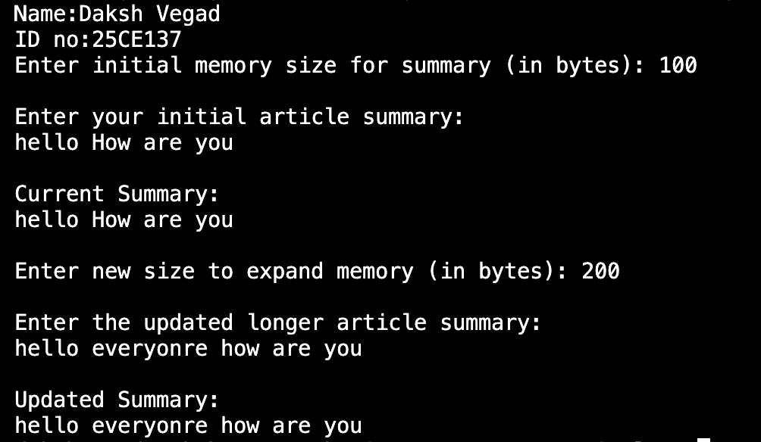
}
Caption
Program 32:
#include <stdio.h>
#include <string.h>
#include <ctype.h>

void reverseWord(char *start, char *end) {
while (start < end) {
char temp = *start;
*start = *end;
*end = temp;
start++;
end--;
}
}

int main() {
printf("Daksh Vegad\n");
printf("25CE137");
FILE *fp = fopen("Demo.txt", "r");
if (fp == NULL) {
printf("Error: File 'Demo.txt' does not exist or cannot be opened.\n");
return 1;
}

char ch;
char word[200];
int index = 0;

printf("\nReversed content:\n");

while ((ch = fgetc(fp)) != EOF) {
if (!isspace(ch)) {
if (index < sizeof(word) - 1) {
word[index++] = ch;
}
}

else {
if (index > 0) {
word[index] = '\0';
reverseWord(word, word + index - 1);
printf("%s", word);
index = 0;
}
printf("%c", ch);
}
}

if (index > 0) {
word[index] = '\0';
reverseWord(word, word + index - 1);
printf("%s", word);
}

fclose(fp);

return 0;
}
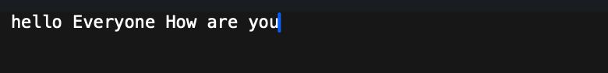
input
Caption
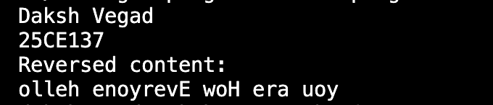
output
Caption

