Name: | Daksh Agarwal | Reg. No. /Acc. No./ UID: | 25LBCS4053
Laboratory: | Computer Eco-System | Code: | 25CSH-102
Programme/Discipline: | Btech CSE Data Science | Section: | One
Date of Experiment: |  | Date of Submission:
Experiment Title: | Design and implement a foundational project that introduces the core principles of cloud computing using online platforms.

Objective:
- Understand the fundamental concepts of cloud computing (e.g., IaaS, PaaS, SaaS).
- Set up and deploy a basic cloud application (e.g., a simple web app or file storage system) using an online cloud platform.
- Explore cloud services like virtual machines, object storage, and databases.
- Learn about scaling, security, and maintenance in a cloud environment.

Procedure / Algorithm

Step 1: Set Up Cloud Service Account
- Choose a cloud provider (AWS, Google Cloud, or Azure).
- Sign up for a free account (ensure it is eligible for free-tier services).
- Verify your account (email and identity).

Step 2: Create and Configure Virtual Machine (VM)
- Log in to the cloud console (AWS EC2, Google Compute Engine, or Azure Virtual Machines).
- Create a new VM instance with a basic OS (Ubuntu or Windows).
- Set up a static IP for the VM.
- Configure security groups or firewall rules to allow HTTP/HTTPS traffic.

Step 3: Deploy a Basic Web Application
- Install web server software on the VM (e.g., Apache, Nginx).
- Create a simple "Hello World" HTML page or use a simple framework (Flask for Python, Express for Node.js).
- Upload the code to the VM using SSH or through an SFTP client.
- Test the web application by accessing the VM's IP address in a browser.

Step 4: Set Up Object Storage
- Choose a cloud storage service (AWS S3, Google Cloud Storage, or Azure Blob Storage).
- Create a bucket/container to store files.
- Upload and manage files through the cloud console.
- Implement basic access control (e.g., public or private access to files).

Step 5: Use Database as a Service (DBaaS)
- Set up a managed database service (AWS RDS, Google Cloud SQL, or Azure SQL).
- Create a database (e.g., MySQL, PostgreSQL).
- Connect the database to your web application and store some data (e.g., user information, application data).

Step 6: Scaling and Load Balancing (Optional)
- Implement auto-scaling for your web application.
- Set up a load balancer to distribute traffic evenly between multiple instances of your application.
Resources uses –
• AWS cloud platform (EC2, S3, RDS services)
• Deployed a weather application using HTML, CSS, and JavaScript.

Step-1) Creating Account
1. Choose AWS free tier services.
2. Create account, sign in and log in to the “AWS Management Console.”

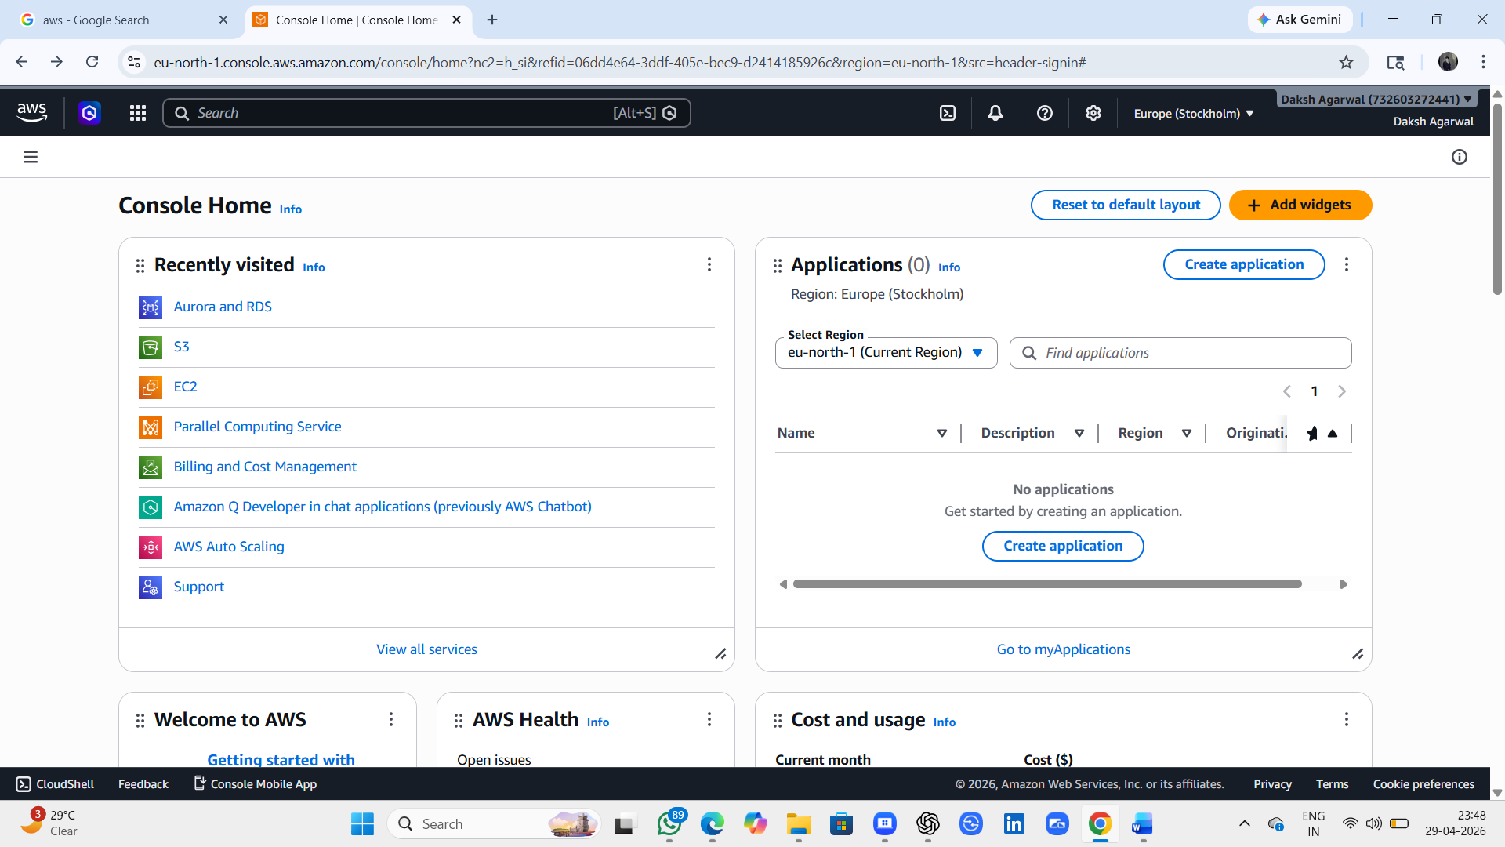

Step-2) Creation of EC2 instance –
1. Click on “EC2” – Select the “launch instance” - – Select the “launch Without walkthrough”
2. Type the name of the instance you want to create in the box “NAME AND TAGS” – example – My Web Server
3. Select “Web and OS Images”- Ubuntu or Windows
4. Select “Key pair login” – “Create new key pair”
5. Create “New Security groups”. – Check box – “Allow SSH traffic”, “Allow HTTPS traffic” “Allow HTTP traffic from the internet”
6. Click on “Launch Instance”
7. Click on EC2 at left corner and click on “Instances” (instance created can be seen).
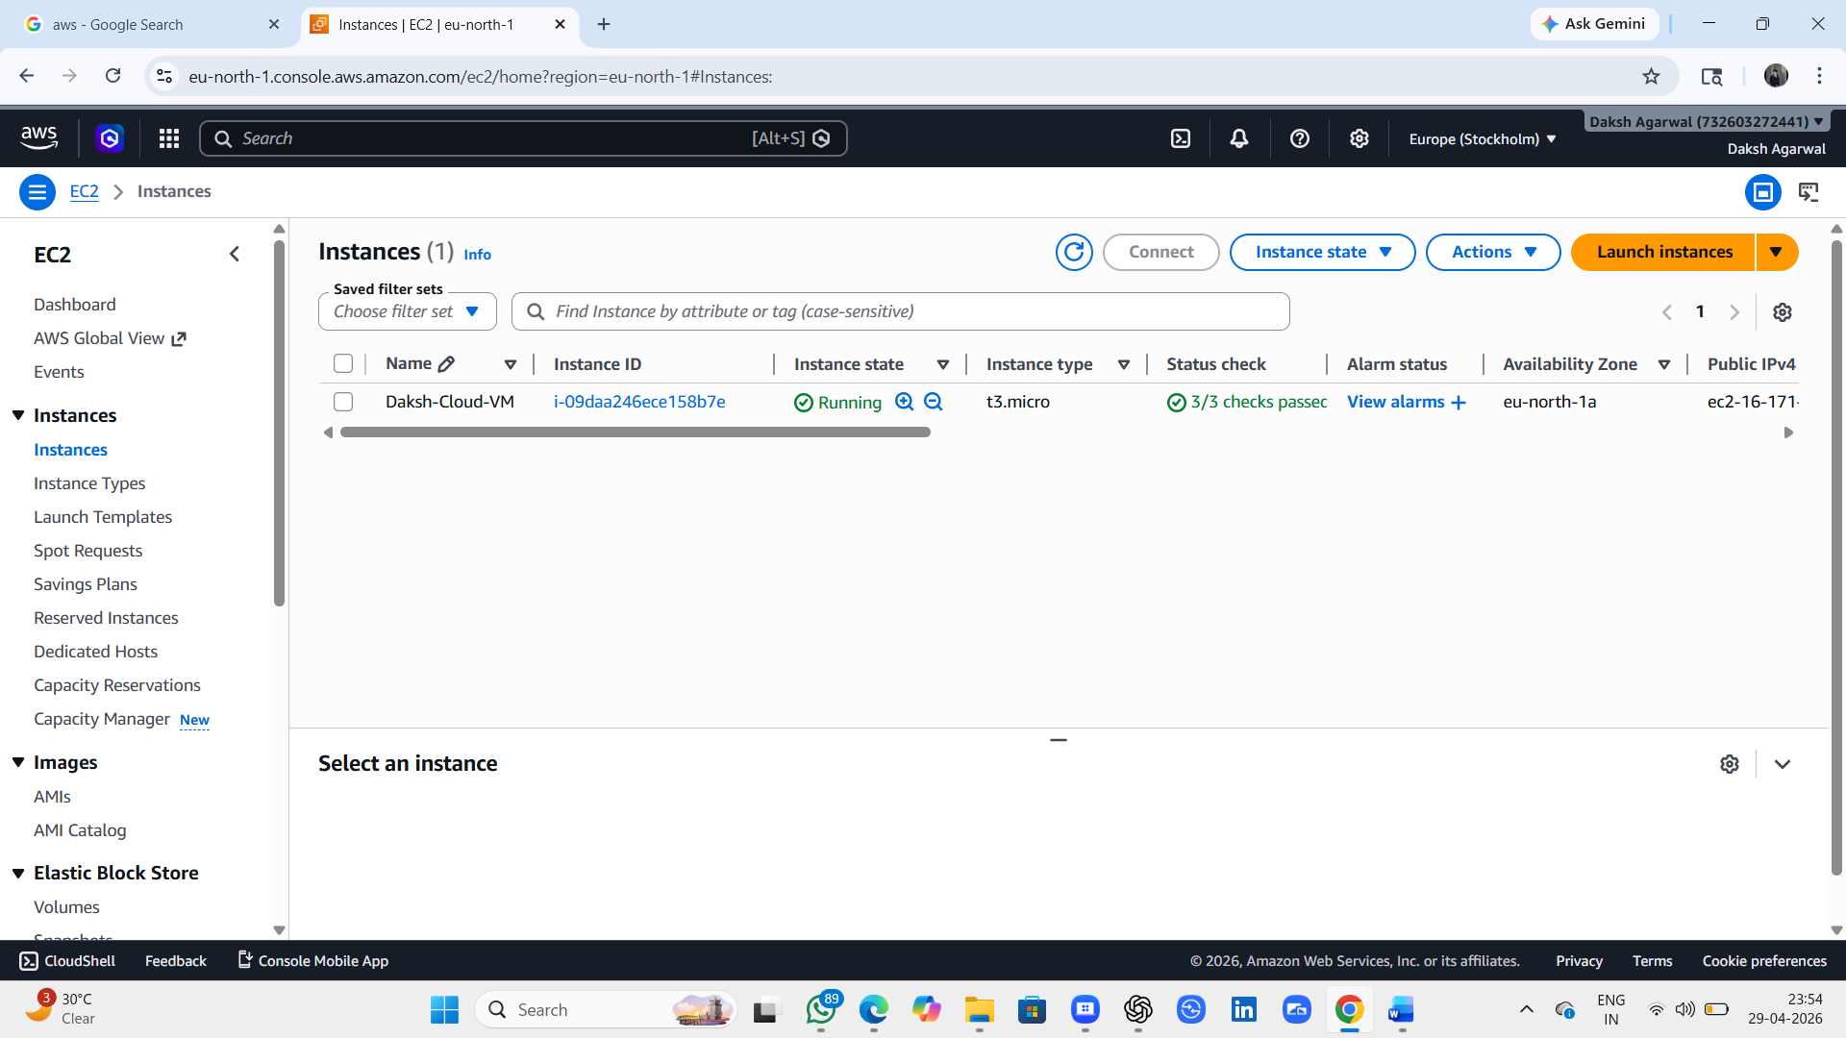

8. Click on “connect” – “Connect using a Public IP.” – “Connect”.
9. Cmd windows can be seen where we can write commands.
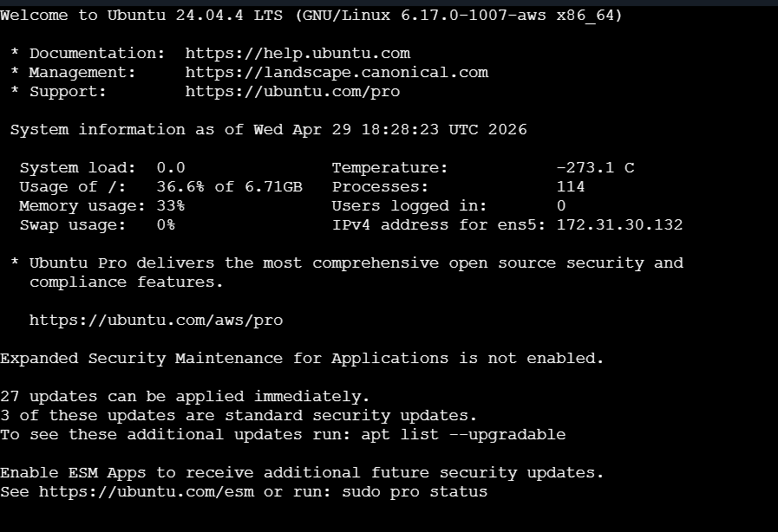

10. Commands to be written –

A. Install Apache server –
a. sudo apt install apache2 -y
b. sudo systemctl start apache2 (Start Apache Service)
c. sudo systemctl enable apache2 (Enable it to start automatically on boot)
d. sudo systemctl status apache2 (check running or not)

11. Check whether your server is running or not.
Browse the address on the browser URL bar - http://your-ec2-public-ip
Ubuntu Web page can be seen, that means server is perfectly installed.

12. Creating virtual environment to work on HTML,JS that is compatible to my project:
A. Connect EC2 and Install Web Server
- Connected EC2 using browser terminal
- Installed Apache server:
sudo apt update
sudo apt install apache2 -y
sudo systemctl start apache2
sudo systemctl enable apache2

3. Checked status:
sudo systemctl status apache2

13. Deploy Website:
- Opened HTML file:
sudo nano /var/www/html/index.html
- Created custom webpage (Cloud Website)
- Saved file
- Refreshed browser.

Result – Now your app is live on browser – Access it using the External URL given on the cmd window.

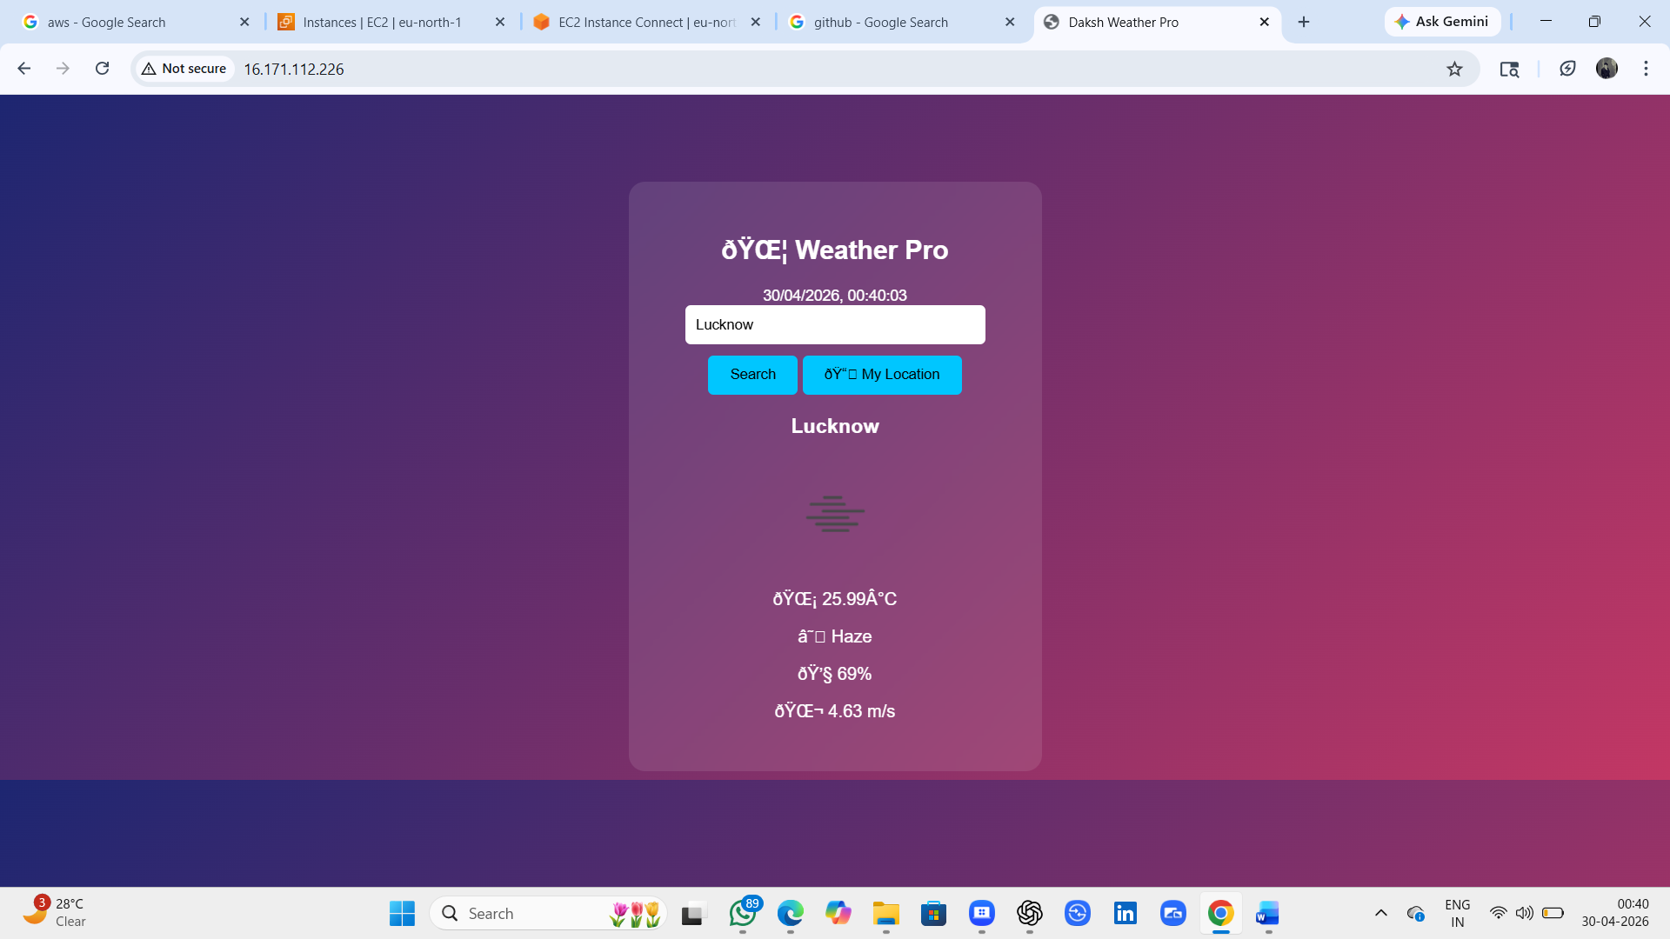

Step- 3) Use of S3 bucket –
1. Select “S3” – Click “Create bucket” – Enter “Bucket name” – Click “Create bucket.”
2. Click on “upload files” – click on “Add files or add folder” – click on “Upload files”

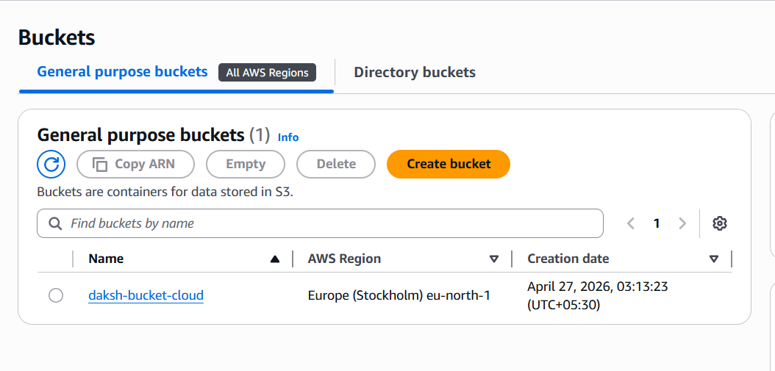
Step-4) Creation of RDS database –
1. Click on “Aurora and RDS”
2. Click in “Create” in right one.
3. Select database like MySQL, PostgreSQL
4. Enter “master password”, “Confirm master password.”
5. Click “Create database”
6. Click “Databases” in the left console.

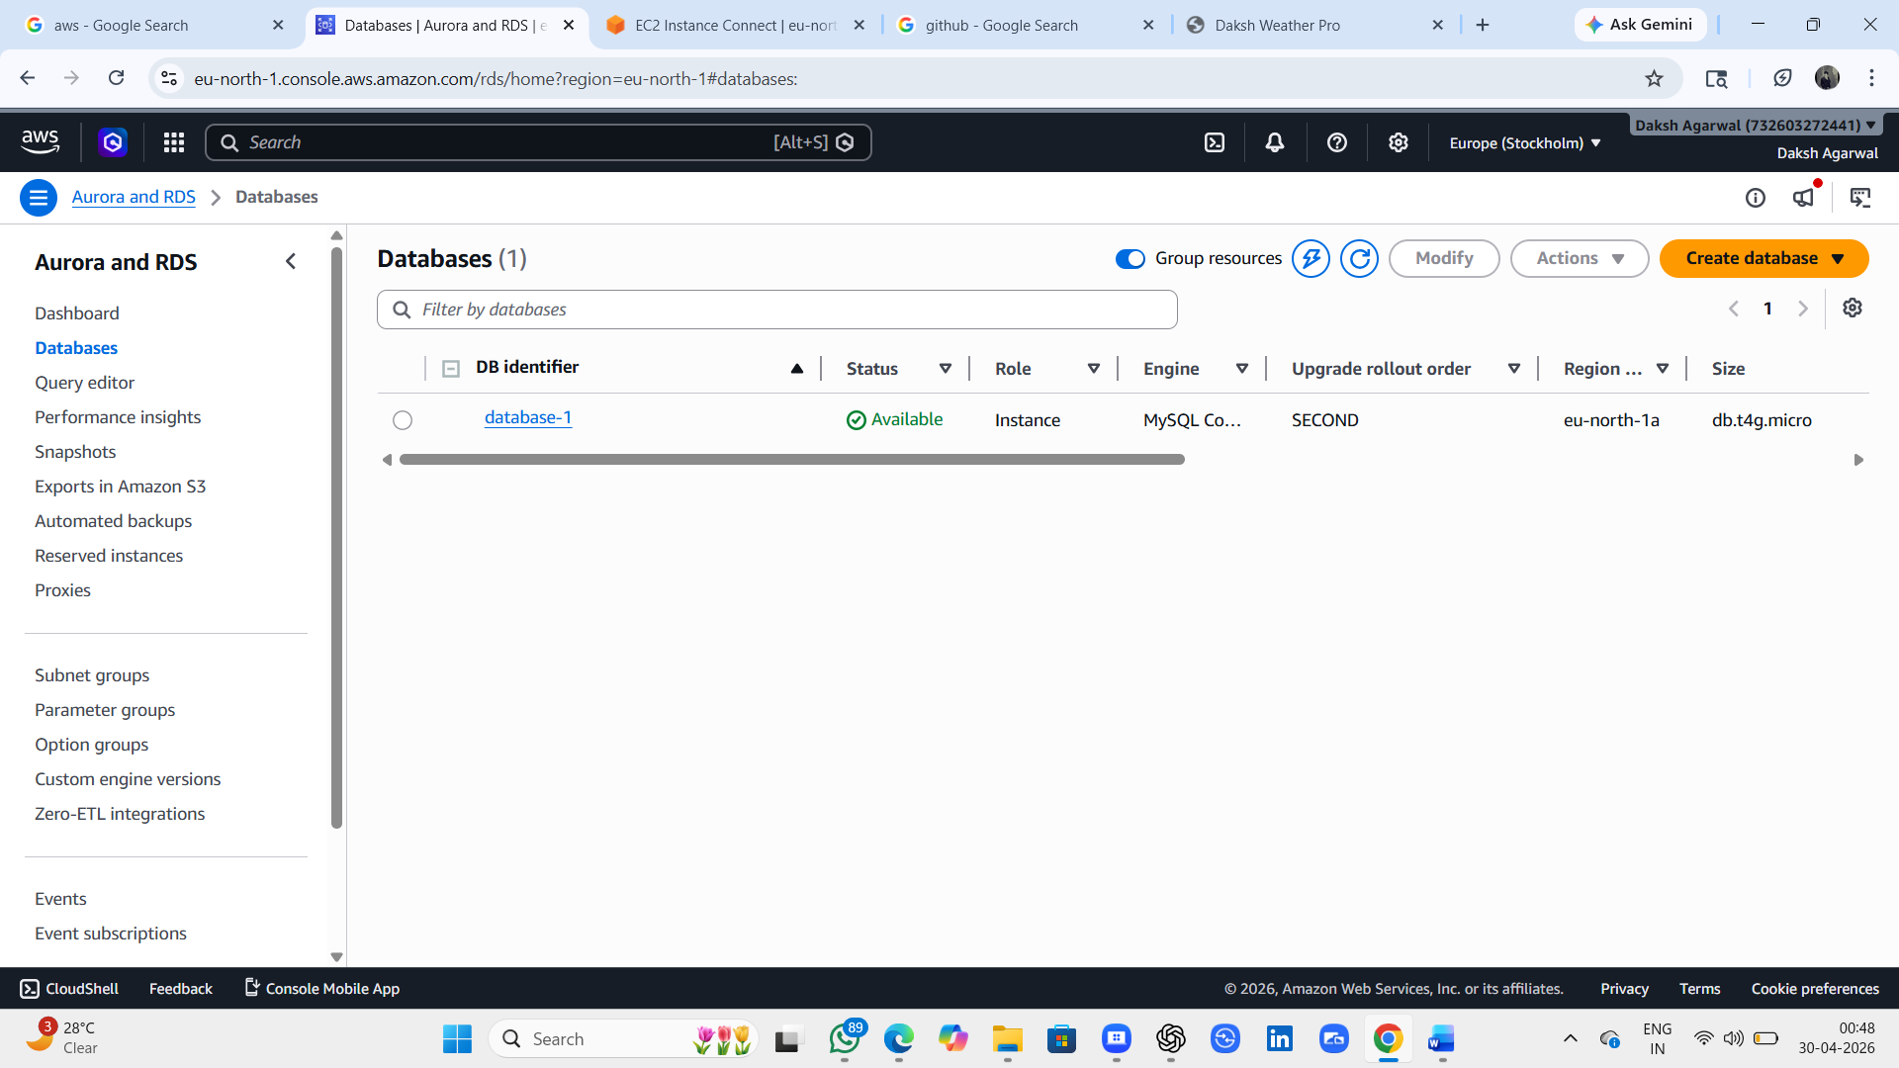

Result:
• Successfully created EC2 instance
• Hosted a website on cloud
• Stored files using S3
• Created database using RDS
👉 The cloud project was successfully implemented….

