Seeing More Ground, Using Two Cameras and a Mirror
A left/right camera setup built to widen ground coverage, not to watch the sky
Plain-language explanation with diagrams

1. Where the cameras physically sit
There are exactly two cameras, and both mount on the underside of the drone, at opposite ends — one on the left, one on the right. Both point straight down at the ground. Neither camera points at the sky or to the side on its own; the mirror is what extends the right-hand camera's reach outward, while still looking down.
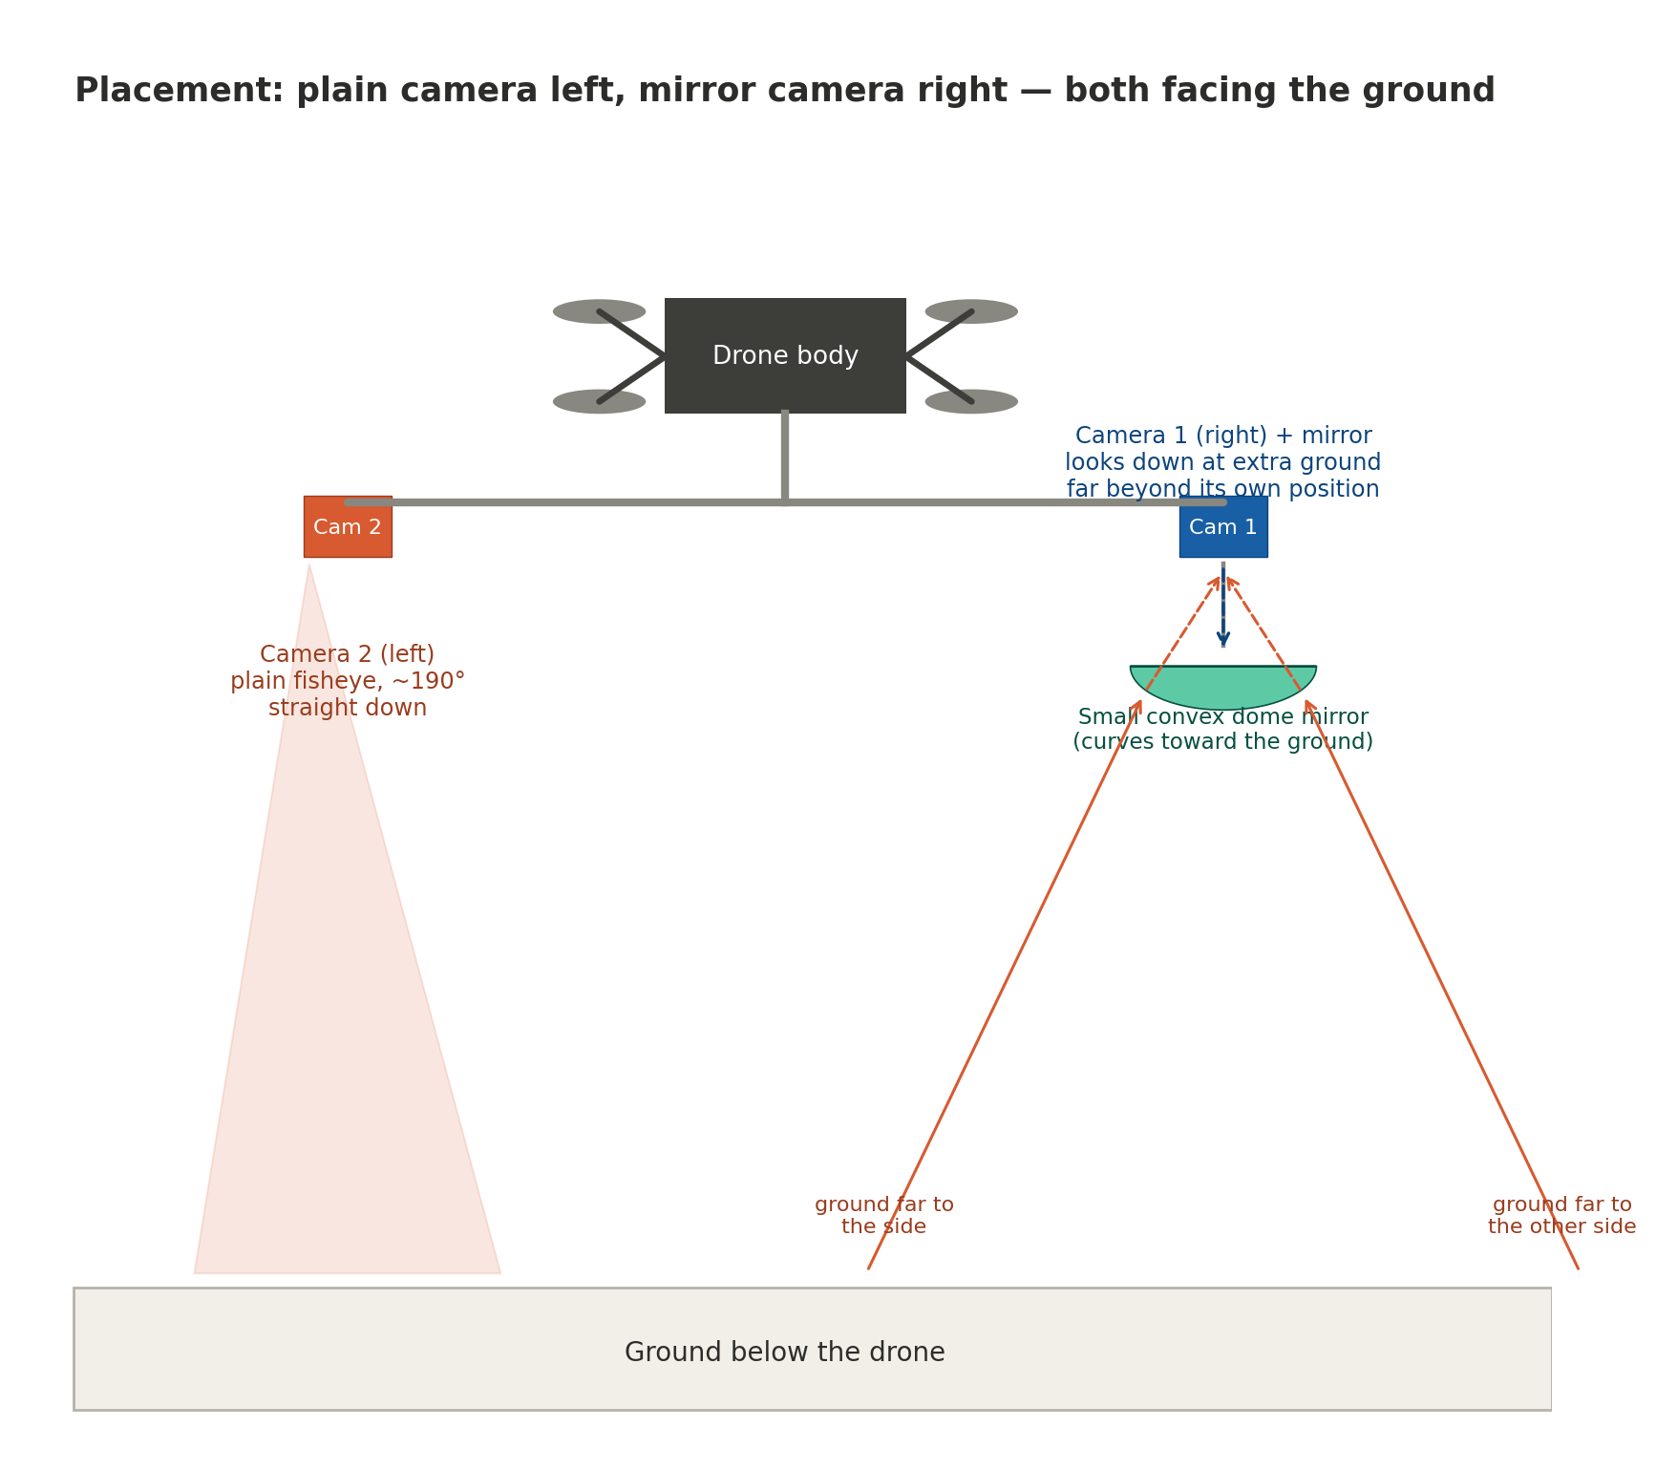
Figure 1: Camera 2 (left) is a plain fisheye pointed straight down. Camera 1 (right) is paired with a dome mirror, also facing down, which bends in extra ground views from far beyond where the camera itself sits.
- Camera 2 (left): mounted on the left side of the drone's underside, a plain fisheye lens (about 190°), facing straight down at the ground. It sees an ordinary circular patch of ground, nothing more.
- Camera 1 (right): mounted on the right side of the drone's underside, facing straight down at a small convex dome mirror positioned just below it. The mirror itself faces the ground.
- The dome mirror does not add a new viewing direction — both cameras are still only looking down. What it changes is how much ground a single downward-facing camera can pull into one shot.

2. How the mirror camera sees far more ground than it is pointed at
This is the part worth explaining carefully: Camera 1 is not looking at the ground directly — it is looking at the mirror, and the mirror is doing the looking. Because the mirror's surface is convex (curved outward), it can catch ground rays arriving from very shallow, wide angles — effectively ground that sits well beyond where a plain lens at that same spot could ever reach — and bend them upward into the camera above it.
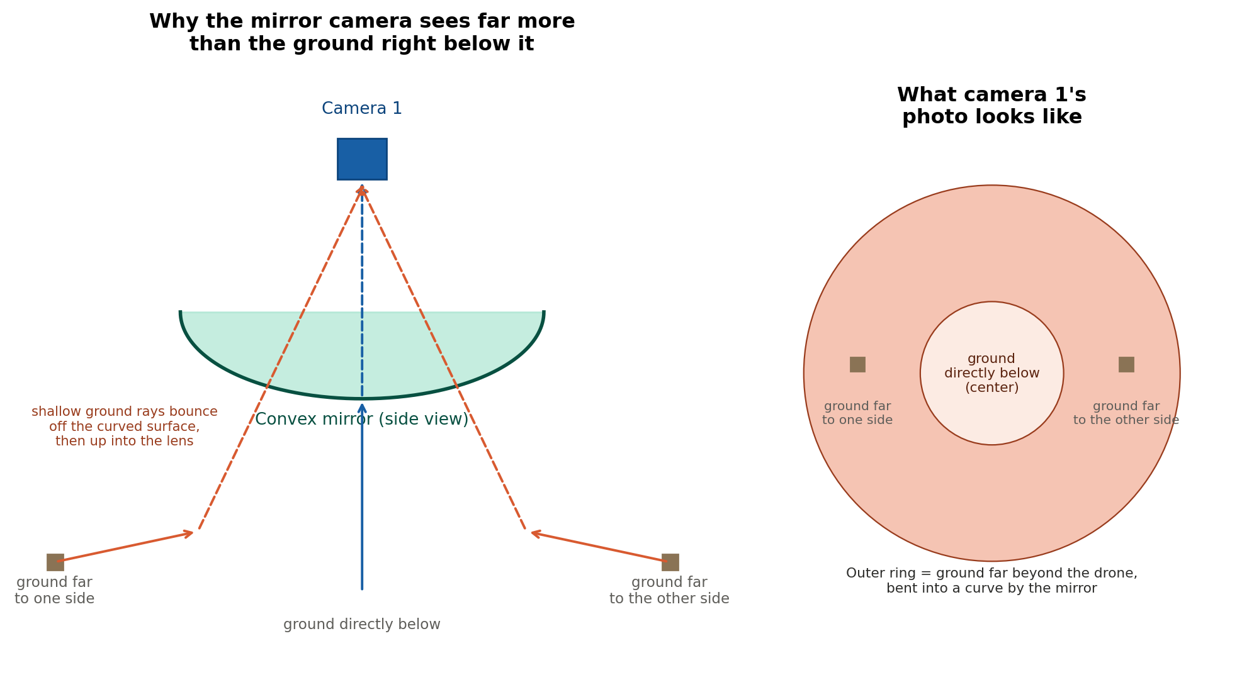
Figure 2: Left — the ground directly below reaches Camera 1 through the centre of the mirror; ground far to either side reaches it too, bounced in by the mirror's curve. Right — where each of those rays lands in the final photo.
Two different rays reach the same camera lens in two different ways:
- Ground directly below travels straight up, strikes the very centre of the mirror, and bounces straight back up into the lens — this becomes the small circle in the middle of the photo.
- Ground far to either side travels upward at a shallow, near-grazing angle, strikes the mirror off-centre, and is bent upward into the same lens — this becomes the outer ring of the photo, showing ground that is nowhere near directly beneath the drone.
The result is a single donut-shaped photo: a small centre showing the ground right below, surrounded by a ring showing ground stretching out much further than the camera's own position. Like any such image, that ring is curved and needs to be corrected (“unwarped”) before it reads as a normal, flat photo.

3. How much more ground this actually covers
This is the comparison that matters: Camera 2 alone photographs one ordinary patch of ground beneath it. Camera 1 alone, from the exact same kind of position, photographs a much wider stretch of ground — the same centre patch, plus a wide outer ring reaching well beyond it — because the mirror is doing work a plain lens cannot.
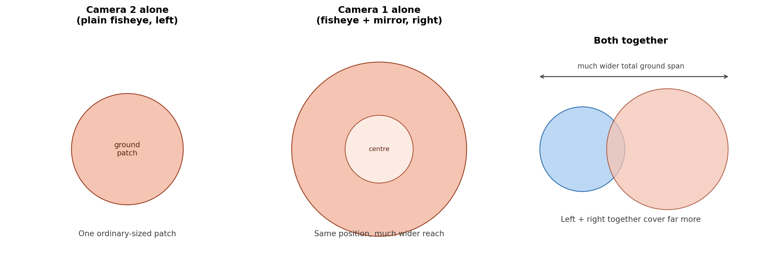
Figure 3: A plain camera covers one patch. The same spot fitted with a mirror covers a far larger stretch. Placed on opposite sides of the drone, the two together span an even wider strip of ground.
Placed on opposite sides of the drone as described, the two cameras' ground coverage does not just add up — the mirror camera's wide reach also fills in ground between the two positions, so together they cover a noticeably wider strip of ground in a single instant than two plain cameras in the same spots ever could.

4. Why this matters for landslides, earthquakes, and floods
During a search over a landslide, earthquake, or flood site, the amount of ground checked per pass directly decides how quickly the whole area can be covered. A wider strip of ground per glance means fewer flight passes are needed to search the same total area, which shortens the time before the whole site has been looked at.
- Landslides / earthquakes: a wider ground strip per pass means debris fields and collapsed structures across a larger stretch get photographed in the same flight time.
- Floods: a wider strip means more of a flooded area can be checked for stranded people per pass, without flying additional lines.
- Because the extra reach comes from a mirror rather than a second flight pass, this coverage gain costs no extra flight time — it comes for free from the optics already on board.

Summary
Two cameras, both facing straight down, mounted on opposite sides — left and right — of the drone's underside. The left camera is a plain ~190° fisheye, covering one ordinary patch of ground. The right camera is paired with a small convex dome mirror, also facing down, which bends in ground views from far beyond the camera's own position and produces one donut-shaped photo covering a much wider stretch of ground. Together, the two cameras cover a noticeably wider strip of ground per instant than either could alone — more ground checked per pass, with no extra flight time spent to get it.

