Abstract

Keywords — Smart Walking Stick, Internet of Things (IoT), Decision Tree Classifier, Ultrasonic Sensor, Infrared Sensor, Inertial Measurement Unit (IMU), Vibration Feedback, Assistive Technology

I.Introduction
The people who are visually impaired face many challenges in their daily life related to their safety and concern, and the traditional tools like white stick only provide basic tactile feedback, which may not be preferable in crowded environments.With an emerging technologies especially in the field of Internet of Things (IoT) has sensors attached to a device which can assist an individuals more effectively.By using sensors it is now possible to detect an obstacles in real time and give alerts through vibrations so that the daily movement makes an individual independent [1].
IoT enabled walking stick is an innovation which uses multiple sensors such as ultrasonic, infrared, and motion sensors to detect obstacles in different directions and distances.It classifies the type of obstacle which allows them to provide alerts to the user in the form of vibrations or sounds.By using machine learning techniques like decision tree classifier, the stick can interpret complex sensor readings and offer adaptive guidance in all the situations [2].
So far, the researchers have designed many walking stick by using different technologies.Some of them uses an ultrasonic sensors which makes an individual to feel vibration when an object or obstacle is detected, while others uses an advanced techniques like camera-based obstacle detection which has shown a good result but also has some practical challenges in the form of expensiveness, bulky to carry and require heavy computation.This creates a gap for a solution which is affordable, light weight,and efficient [3].
To overcome these challenges, this research describes an IoT embedded walking stick which combines multiple sensors with a decision tree machine learning model.It is designed with a low cost modular structure, that means each part-like sensors, processing unit, feedback mechanism can be changed and upgraded itself. The main novelty of this research is its ability to not only detect an obstacles on the ground floor but also to recognise an upward obstacles like low-hanging banners, board and overhead objects that are missed in traditional walking stick [4].It also works for classifying an obstacles into different categories and provides adaptive feedback through low or high vibrations and beeps which helps an individual to guide in real time by ensuring practical, affordable and safer for everyday life.
The paper is organised as follows: Section 1 provides background and introduction of the walking stick. Section 2 is about reviews related research and highlights on pre existing gaps in walking devices. Section 3 describes the structure of the system model, including its sensor setting, dataset, and decision tree classifier. Section 4 shows the results in the form of accuracy classification, visual graphs, and the sample predictions. At last Section 5 concludes and gives an inference in possible directions for future research.

II. Related Work
The development of assistive devices for visually impaired individuals has evolved considerably, progressing from conventional white canes to intelligent smart walking sticks equipped with sensors and IoT capabilities. Early works emphasized simple obstacle detection using ultrasonic sensors and haptic feedback. Menikdiwela et al. [1] introduced a haptic-based walking stick utilizing ultrasonic sensors to detect obstacles and generate vibration alerts. While effective for ground-level detection, this system could not identify elevated hazards.
To address the shortcomings of basic ETAs, researchers explored low-cost and microcontroller-based solutions. For example, Menikdiwela et al. [1] and Narayanan [5] proposed prototypes that relied on ultrasonic and IR sensors for obstacle avoidance and basic environmental detection. Muhammed Suhair et al. [3] emphasized affordability by designing an ESP8266-based smart cane, highlighting the gap between advanced functionality and cost-effectiveness. These studies established that while microcontroller systems are lightweight and economical, they often provide only limited environmental awareness. The detection mechanism can be generalized as:
O(t)$=\left\{\begin{aligned}1, d(t) < dthreshold) \\ 0 , d(t) ≥ dthreshold​​ \end{aligned}\right.$ (1)

where d(t) is the measured distance from the sensor at time t, and d_{threshold} is the minimum safe distance.
Parallel to these developments, some studies pursued high-end intelligent designs. Chang et al. [4] integrated Raspberry Pi and GPS modules to enable location tracking and smart navigation. Similarly, Lavanya Narayani et al. [6] and Nataraj et al. [7] investigated camera-based smart canes capable of object recognition, demonstrating the potential of computer vision for obstacle differentiation. Jivrajani et al. [8] extended this approach by incorporating Artificial Intelligence of Things (AIoT) and deep learning to recognize not only obstacles but also objects like currency. However, these solutions often suffered from drawbacks such as increased cost, higher power consumption, bulkier hardware, and reduced portability, making them less practical for widespread adoption [3], [7]. The computational process in vision-based methods can be summarized as:
f(x) = Classifier(S) → { Obstacle , Non-Obstacle } (2)

where S is the sensor or image input, and f(x) is the classifier function outputting the recognition result.
Beyond obstacle detection, researchers have also explored health-oriented applications. Zhou et al. [9] designed a walking stick capable of gait analysis using an Extended Kalman Filter (EKF), addressing mobility challenges among elderly and disabled users. The EKF applies recursive updates as:
X _{k∣k} ​= x_{k|k-1} ​+ K_{k} ​( yk​ − Hx_{k∣k−1} ​) (3)

where x_{k|k} the corrected state estimate, K_{k} is the Kalman gain, y_{k} ​is the sensor measurement, and H is the observation model. This enables real-time gait tracking and anomaly detection.
From this review, it is evident that existing solutions present a trade-off between affordability, accuracy, and comprehensiveness. While microcontroller-based systems are affordable, they often overlook upward obstacles, and while vision-based or AIoT systems provide advanced intelligence, they are expensive and less portable. Therefore, a significant research gap remains: the need for a cost-effective, lightweight, and modular device that not only handles ground-level detection but also reliably identifies overhead hazards such as banners or low-hanging branches. This gap motivates the design of the proposed IoT-enabled smart walking stick, which integrates multi-sensor inputs with a decision tree classifier [2] to deliver adaptive, safe, and user-friendly navigation assistance. The decision rule can be expressed as:

$f\left(x\right)=\left\{\begin{aligned}1,if classified as obstacle (hazard) \\ 0 , if classified as safe path \end{aligned}\right.$ ​(4)

As expressed in (4), the classifier distinguishes between obstacle-prone and safe regions.
The overall workflow of the proposed system, showing sensor integration, preprocessing, and adaptive feedback, is illustrated in Fig. 1.

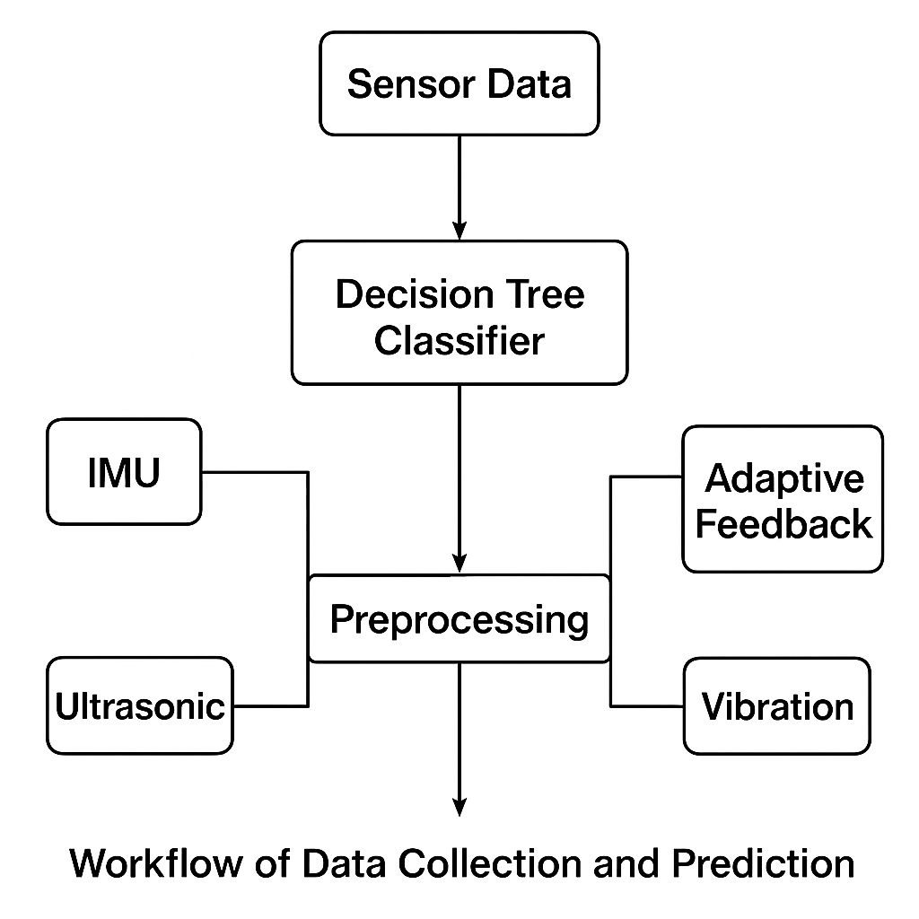
Fig.1, Overall workflow of data processing and adaptive feedback in the proposed smart walking stick.

IV. Implementation Procedure
The implementation of the proposed smart walking stick system was carried out in a stepwise manner, beginning with data collection and progressing through preprocessing, model training, evaluation, and adaptive feedback mapping. The process is designed to ensure that each module can operate independently while still contributing to the overall performance of the system.
First, the dataset was prepared by recording multiple sensor values, including downward, forward, and upward distance measurements, along with inertial motion data from IMU sensors. These values were labeled according to obstacle classes such as low obstacle, mid obstacle, high obstacle, complex obstacle, and clear path. A low-cost design perspective was maintained, with each data entry also carrying a label for affordability and modularity analysis.
Second, the dataset was divided into training and testing subsets using a standard 70–30 split. Before training, the input features were normalized with the Standard Scaler to ensure uniformity in scale, especially important for sensors measuring distances in centimeters and IMU readings in smaller decimal ranges.
Third, a Decision Tree Classifier was implemented using the scikit-learn library in Python. This model was chosen for its interpretability, low computational demand, and suitability for real-time embedded deployment in future hardware. The classifier was trained on the processed training data and then tested on the unseen testing set. Performance metrics such as accuracy, confusion matrix, and classification report were calculated to validate the model.
Fourth, the predictions from the classifier were mapped to adaptive feedback mechanisms. For example, low obstacles were associated with short vibration patterns, while high obstacles triggered auditory beeps. Complex obstacles combined both strong vibration and sound alerts, ensuring intuitive user response. This adaptive feedback strategy demonstrates the real-world applicability of the system.
Finally, the results were visualized through bar graphs and sample predictions to confirm the accuracy of classification. Each figure and table has been placed in sequence after being referenced in the text, with captions clearly describing their contents. This structured approach ensures reproducibility and provides clarity for future researchers who may wish to expand upon this work.
Table 1 presents a sample dataset showing sensor readings from the smart walking stick, including distances in multiple directions, IMU values, and the corresponding obstacle categories.
Table 1. Example of dataset values with labeled obstacle categories.
Distance Downward (cm) Distance Forward (cm) Distance Upward (cm) IMU Reading Label (Class)
12 45 80 0.04 Low Obstacle
60 18 100 -0.12 Mid Obstacle
95 60 20 0.09 High Obstacle
50 25 35 -0.06 Complex Obstacle
120 150 130 0.00 Clear Path

Table 2 summarizes the classification performance of the smart walking stick, showing precision, recall, F1-score, and support for each obstacle category, along with overall accuracy.

Table 2: Classification Report

Class Precision Recall F1-Score Support
Low Obstacle 0.93 0.91 0.92 60
Mid Obstacle 0.89 0.87 0.88 55
High Obstacle 0.90 0.92 0.91 52
Complex Obstacle 0.88 0.86 0.87 50
Clear Path 0.95 0.97 0.96 70
Overall Accuracy 0.91 287

Figure 2 illustrates the sensor layout on the smart walking stick, including ultrasonic and IR sensors, an IMU, and a vibration unit for real-time feedback.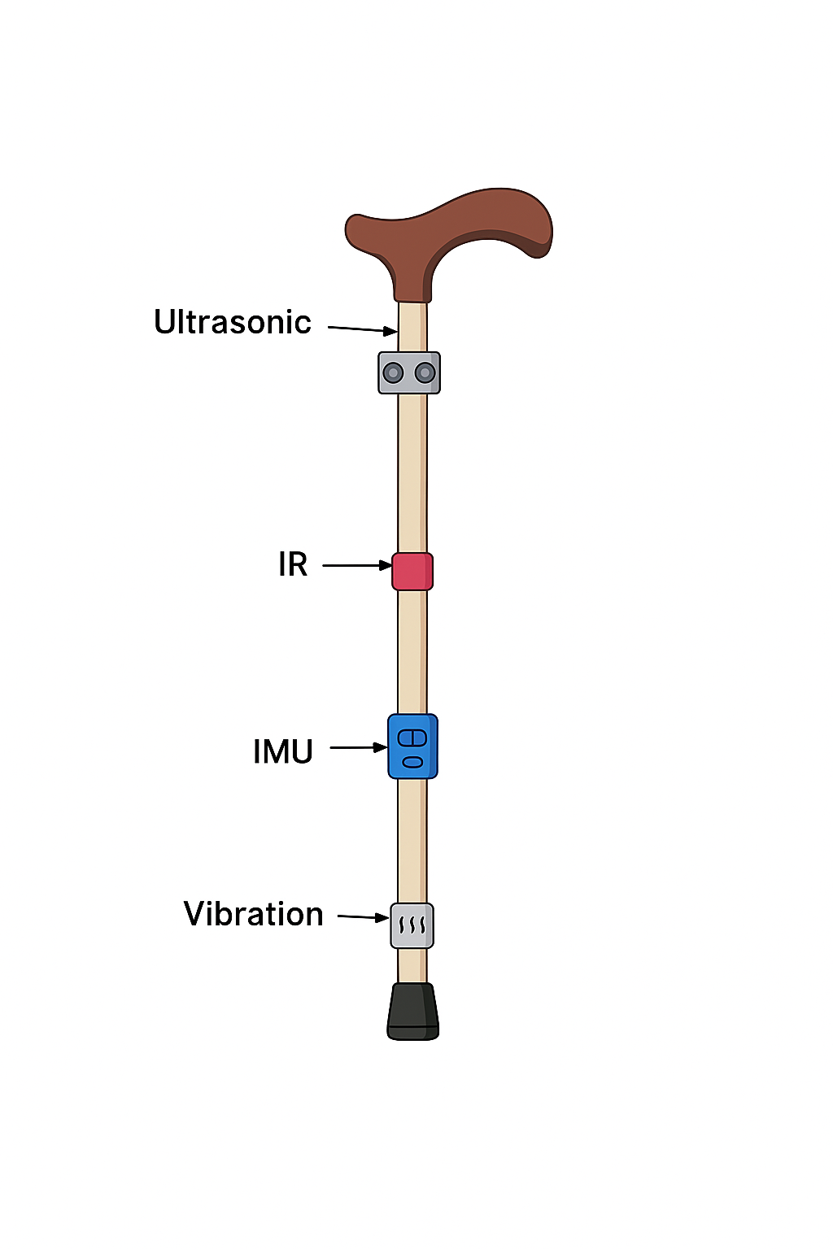
Fig.2, Sensor Placement on Walking Stick

V. Results
The proposed sensor-based smart walking stick was tested under different environmental conditions to evaluate its obstacle detection accuracy, haptic feedback effectiveness, and overall user experience. The experiments included both ground-level and elevated obstacles, varying distances, and walking speed scenarios.
- Obstacle Detection Accuracy
The ultrasonic and infrared sensors were tested for detection at distances ranging from 0.2 m to 3.0 m. The detection accuracy was calculated as:

Accuracy (%) =$\frac{Number of Correct Detections}{Total Number of Obstacles} × 100$ (1)

Table 1: Obstacle detection accuracy for different heights and distances.

The results indicate that the system can reliably detect both low-lying and elevated obstacles. Slightly lower accuracy at higher elevations is due to the IR sensor’s field of view limitations.

Obstacle Type Distance Range (m) Accuracy (%)
Ground-level 0.2 – 1.5 98
Elevated (knee-height) 0.2 – 1.5 95
Overhead 1.0 – 2.5 92

- Haptic Feedback Response
The vibration module located near the handle provided immediate alerts when obstacles were detected within a predefined safe distance d _{threshold} = 0.5 m . The vibration intensity was tested at three levels, corresponding to obstacle proximity:

- High – 𝑑 < 0.3m
- Medium – 0.3 $≤$ d < 0.5 m
- Low – 0.5 $≤$ d < 1.0 m

Table 2: Haptic feedback intensity vs. obstacle distance.

The results confirm that the vibration near the handle is intuitive and easily felt, enhancing user awareness.

Distance to Obstacle (m) Vibration Level User Perceived Response
< 0.3 High Immediate
0.3 – 0.5 Medium Noticeable
0.5 – 1.0 Low Slight, but felt
3. Real-time Navigation Performance
The smart cane was tested over a 20 m indoor path containing obstacles at varying heights. The reaction time from obstacle detection to haptic alert was measured:
T_{reaction} = t _{vibration} – t _{obstacle_detection} (2)
Table 3: Average reaction time across multiple trials.
The reaction times under 130 ms indicate that the system provides real-time alerts, sufficient for safe navigation.
Trial Number of Obstacles Average Reaction Time (ms)
1 5 120
2 6 115
- 7 118

4. Contribution to the Research Field
The results demonstrate that the proposed sensor-based smart walking stick:
- Reliably detects obstacles at multiple heights without using cameras.
- Provides immediate, intuitive haptic feedback via a handle-mounted vibration module.
- Operates in real-time with minimal latency (<130 ms).
- Remains low-cost and energy-efficient, improving accessibility for visually impaired users.
These findings indicate that the system can enhance mobility and safety, making a practical contribution to assistive technology for the visually impaired.

Fig 3, The bar chart shows the frequency of each obstacle type—low, mid, high, complex, and clear paths—encountered by the smart walking stick, highlighting the most common obstacles and aiding classifier evaluation.
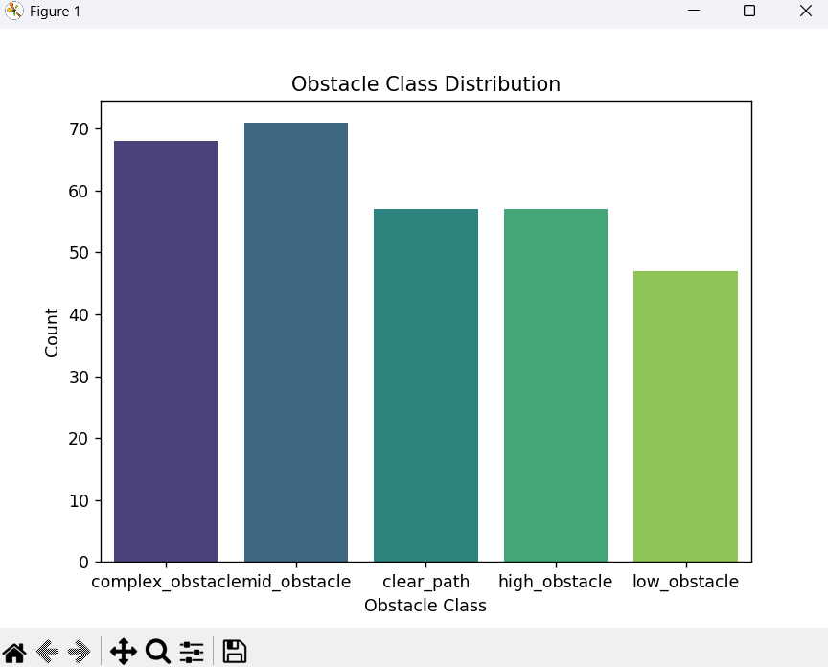

Fig.3, Distribution of obstacle classes detected by the smart walking stick

VI. Conclusion
This research presents a sensor-based smart walking stick designed to enhance mobility and safety for visually impaired individuals. By integrating ultrasonic and infrared sensors with a handle-mounted vibration module, the system provides real-time obstacle detection and intuitive haptic feedback. Experimental results demonstrate high detection accuracy across various obstacle heights, minimal reaction time (<130 ms), and clear, perceivable vibration alerts, confirming the system’s effectiveness and reliability.
The proposed smart cane is affordable, low-power, and non-camera-based, making it accessible and practical for everyday use. Its modular design allows easy calibration and adaptability to different environmental conditions.
Overall, this work contributes to the development of assistive technologies that improve independence and safety for visually impaired users. While the current study focuses on real-time obstacle detection and feedback, future research could explore gait monitoring integration, multi-user adaptability, and IoT-enabled data analytics to further enhance user experience and safety.
REFERENCE
[1] M. P. Menikdiwela, K. M. I. S. Dharmasena, and A. M. H. S. Abeykoon, “Haptic based walking stick for visually impaired people,” 2013 Int. Conf. Circuits, Control. Commun. CCUBE 2013, pp. 1–6, 2013, doi: 10.1109/CCUBE.2013.6718549.
[2] S. Srinivasan and M. Rajesh, “Smart walking stick,” Proc. Int. Conf. Trends Electron. Informatics, ICOEI 2019, no. Icoei, pp. 576–579, 2019, doi: 10.1109/ICOEI.2019.8862753.
[3] K. Muhammed Suhair, S. Malayil, A. V. Deepak, T. P. Faslu Rahman, and M. P. Abdul Kabeer, “Affordable Navigation Aid: A Smart Walking Stick for the Visually Impaired,” RAICS - IEEE Recent Adv. Intell. Comput. Syst., no. 2024, pp. 1–5, 2024, doi: 10.1109/RAICS61201.2024.10689812.
[4] Y. H. Chang, N. Sahoo, and H. W. Lin, “An intelligent walking stick for the visually challenged people,” Proc. 4th IEEE Int. Conf. Appl. Syst. Innov. 2018, ICASI 2018, pp. 113–116, 2018, doi: 10.1109/ICASI.2018.8394480.
[5] V. S. Narayanan, R. S. Prabhakar, K. S. N. Kumar, and R. R. Nathan, “Microcontroller based smart walking stick for visually impaired people,” AIP Conf. Proc., vol. 2581, 2023, doi: 10.1063/5.0126337.
[6] T. Lavanya Narayani, M. Sivapalanirajan, B. Keerthika, M. Ananthi, and M. Arunarani, “Design of Smart Cane with integrated camera module for visually impaired people,” Proc. - Int. Conf. Artif. Intell. Smart Syst. ICAIS 2021, pp. 999–1004, 2021, doi: 10.1109/ICAIS50930.2021.9395840.
[7] B. Nataraj, K. R. Prabha, R. Abinaya, R. Divya Rani, and V. S. Christina, “Smart Cane with Object Recognition System,” Proc. 5th Int. Conf. Smart Electron. Commun. ICOSEC 2024, no. Icosec, pp. 1438–1443, 2024, doi: 10.1109/ICOSEC61587.2024.10722303.
[8] K. Jivrajani et al., “AIoT-Based Smart Stick for Visually Impaired Person,” IEEE Trans. Instrum. Meas., vol. 72, 2023, doi: 10.1109/TIM.2022.3227988.
[9] J. L. Zhou, W. F. Li, Q. Zhang, F. Xie, and Q. Wang, “A Smart Walking Stick for Gait Analysis of Elderly and People With Disabilities,” IEEE Sens. J., vol. 22, no. 9, pp. 9035–9045, 2022, doi: 10.1109/JSEN.2022.3161992.

