ASSIGNMENT – 4

# **TASK-1**

**FIXED LOD (Level of Detail):** This expression computes values using the specified dimensions without reference to any other dimensions in the view. Fixed LOD functions are useful when users need to perform calculations at a specific level of detail, such as the customer or product level.

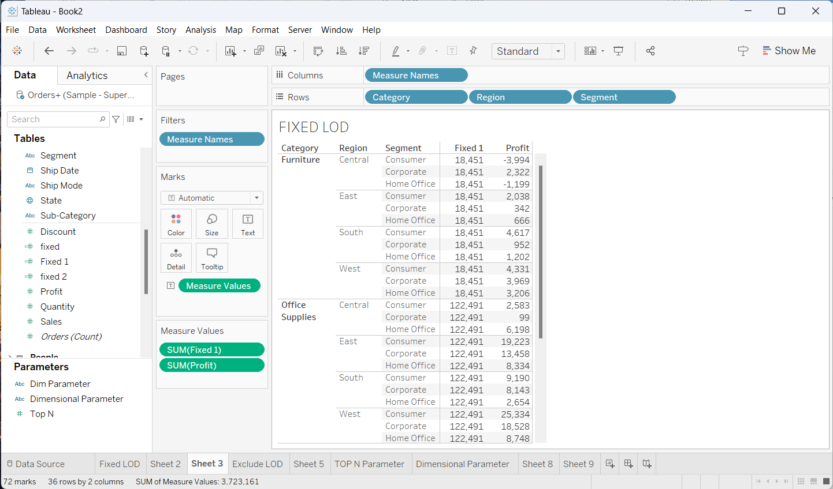

In the above visualization we can see that Measure Names value placed in Columns and different orders like Category, Region, Segment are placed in rows based on this row values we can observe the Fixed column with measured values are obtained.

**EXCLUDE LOD:** Exclude level of detail expressions prevent the calculation from using one or more of the dimensions present in the view. Exclude LOD functions are useful when users need to perform calculations that exclude specific fields but still need to preserve the level of detail in their view.

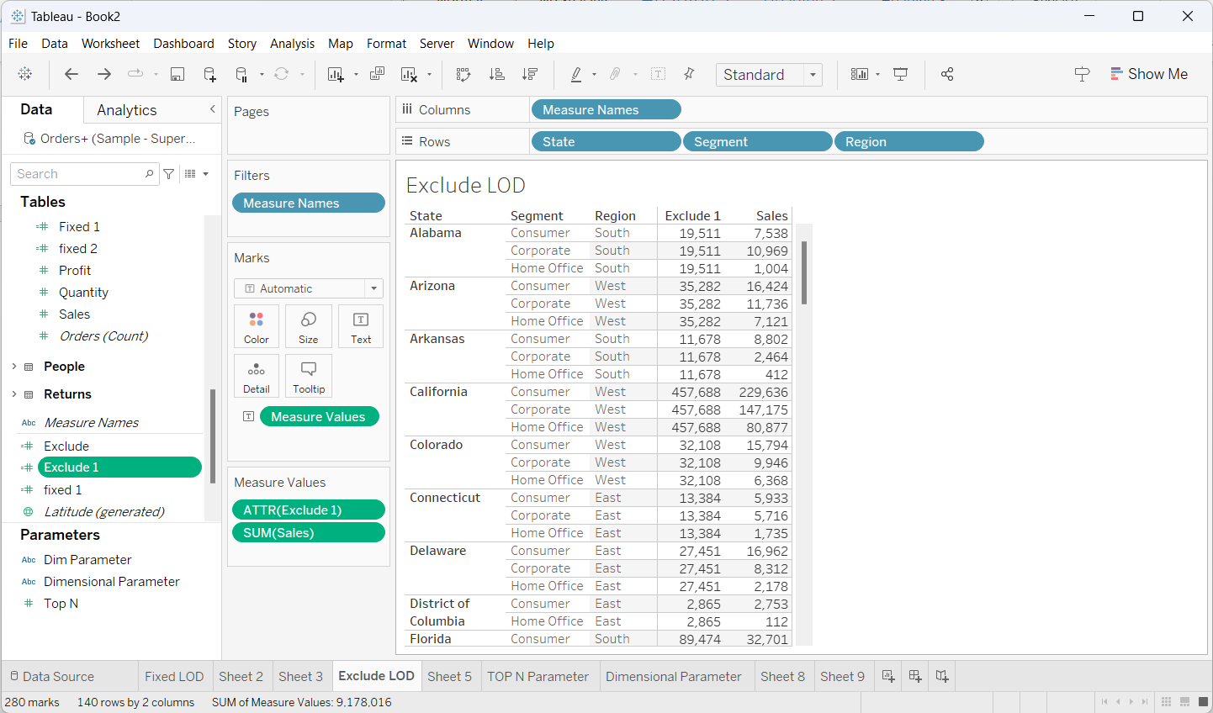

In the above visualization we observe that detailed expression of excluded values and detailed view of sales. We Excluded the segment so in exclude column it shows only the sum of sales value of the segment.

We use State, Segment and Region in Rows and as usual Measured names in columns.

# **Task – 2**

In Task 2 we created different map visualizations using Geographical data.

They are:

1. Filled map
2. Dual-axis map

**Filled Map:** Filled maps in Tableau are similar to symbol maps, but they include many more data points. With a filled map, you visualize divided geographical areas that are colored or shaded according to one numeric variable(measure).

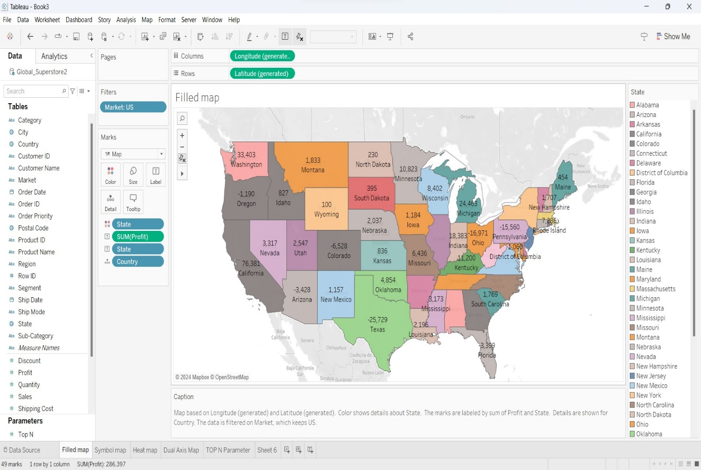

In the above visualization we can see that Filled Map in which longitude value is taken in column field and latitude value is taken in row field to get the resultant filled map. And here the colour variation shows about the profit of each area of US (United States).

**Dual-axis Map:** A dual-axis map is a map with two sets of geographic data overlaid on top of one another. There are three ways to create a dual-axis map in Tableau: By using Tableau Latitude(generated) and Longitude(generated) fields.

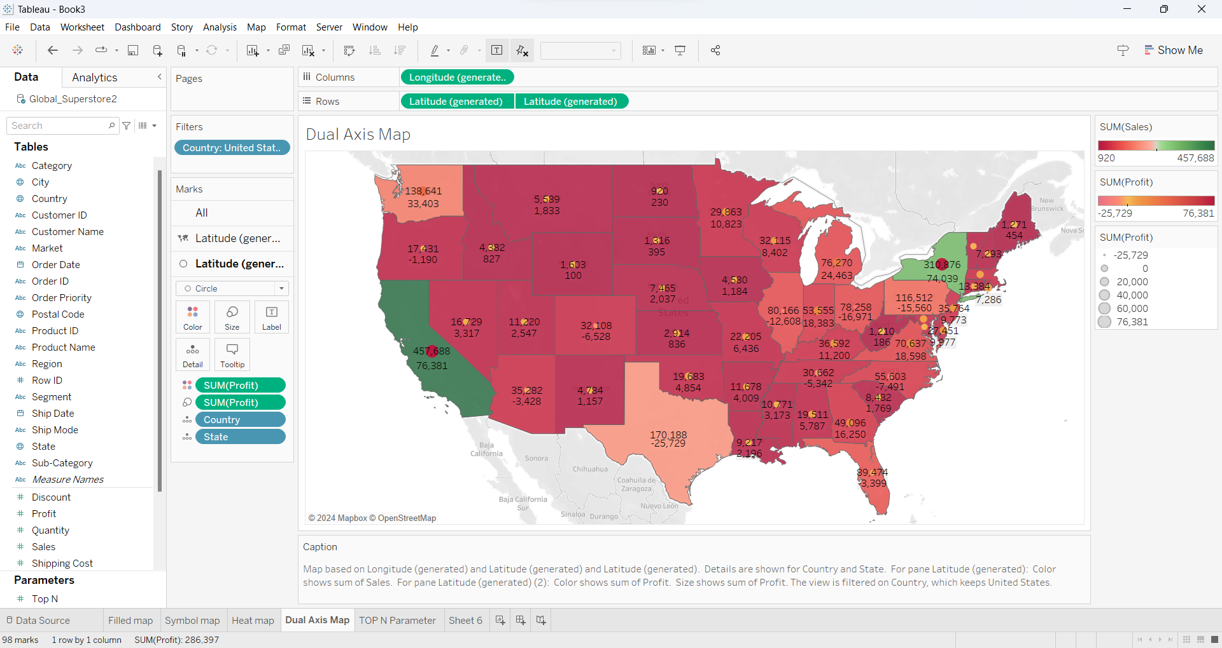

In the above visualization we can see that dual-axis map, to create that we use Longitude(generated) in column field and Latitude(generated) in row field. By using row field we created two maps one map is taken as filled map with the help of sales and the other one is taken as symbol map with the help of profit by using these two maps we created the Dual-axis Map.

# **Task – 3**

**Top N Parameter:** A Top N Parameter returns data according to a number you assign it hence the N is the name.

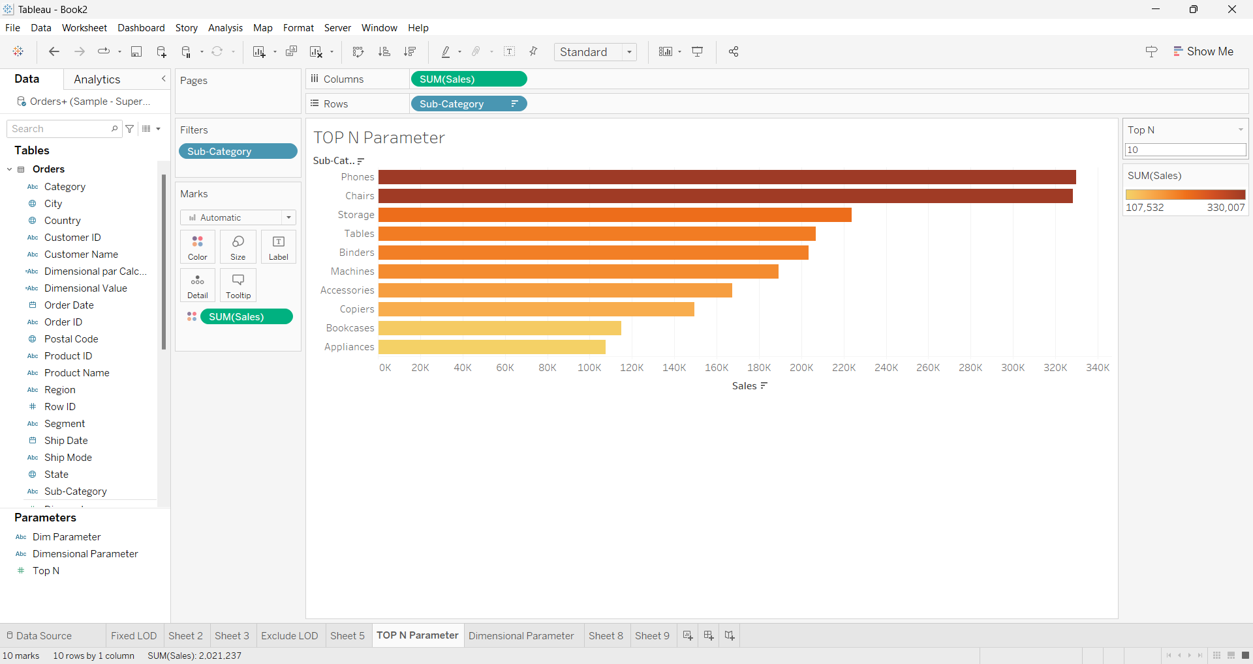

In the above visualization we can see that the Top N Parameter. Now, select sales from measures tab and drag it to column. Select Sub-Category from dimensions and drag it to rows then it automatically create a bar chart. Then we have to create a parameter named as Top N parameter. By overall sub-category it shows only top 10 sub-category because we use that top N parameter in our visualization.

**Dimensional Parameter**: Dimensions contains qualitative values (such as names, dates or geographical data).

We can use dimensions to categorize, segment and reveal the details in your data. Dimensions affect the level of detail in the view.

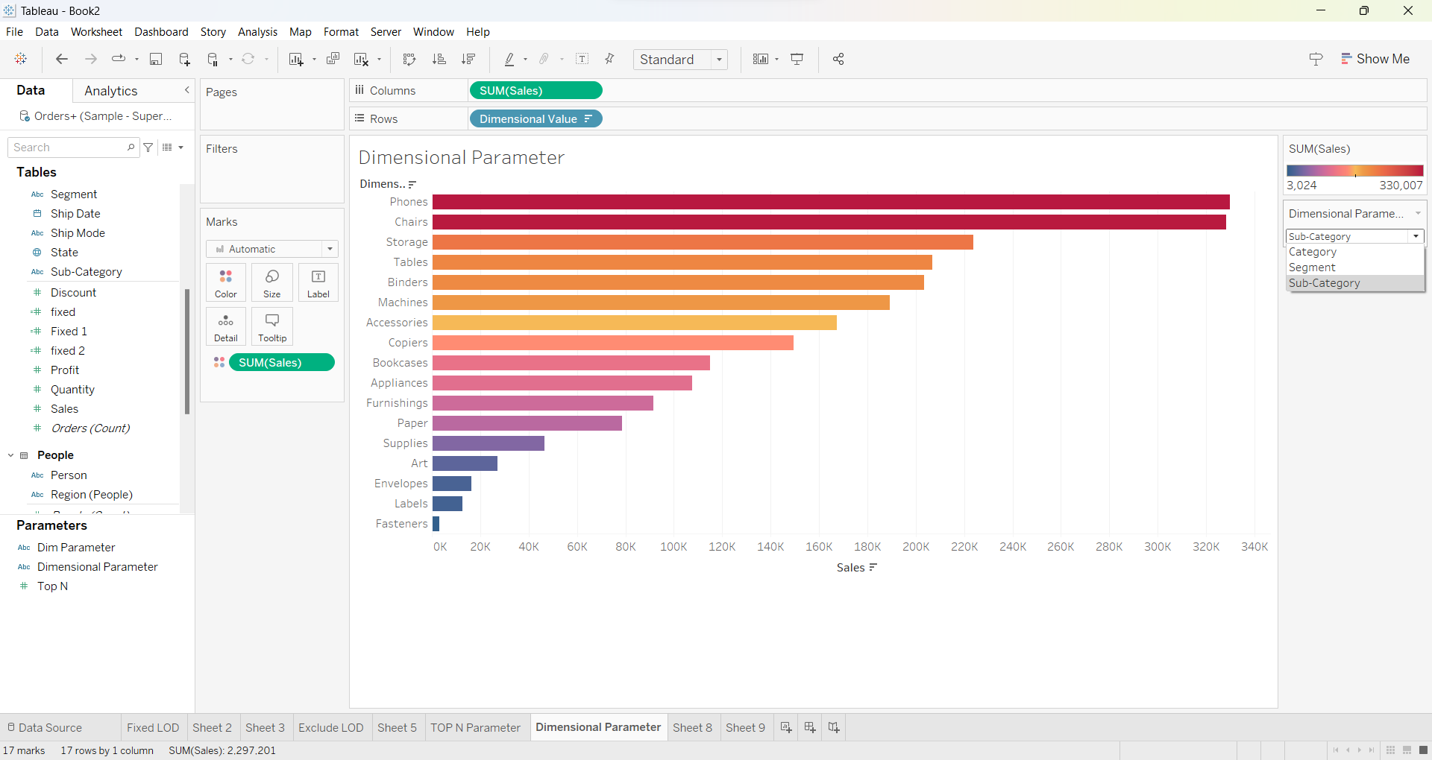

In the above visualization we can see that Dimensional Parameter. Now, select sum of sales from measures tab and drag it to the column field. Select dimensional value from dimensions and drag it to the row field. By selecting the dimensional parameter we get the resultant visualization by giving the dimensions to that parameter.