 | Title : Project Registration & Progress Review |  | FF No. 180
Department: CSAI |  | Academic Year: 2026-27
Semester : 1 |  | Group No. : TY-B-02
Project Title: Frequency-Aware Transformer for Robust EEG Emotion Recognition Using Multi-Band Brain Dynamics
Project Area: Artificial Intelligence, Deep Learning, Biomedical Signal Processing, Affective Computing
Group Members Details:

Sr. No. | Class & Div. | Roll No. | G.R.No. | Name of Student | Contact No. | Email ID
1 | CSAI-B | 8 | 12413720 | Sanskar Chitnis | 9175175688 | sanskar.chitnis241@vit.edu
2 | CSAI-B | 9 | 12411925 | Shlok Chorghe | 8237340805 | shlok.chorghe24@vit.edu
3 | CSAI-B | 12 | 12414733 | Daksh Bhardwaj | 9022682627 | daksh.bhardwaj24@vit.edu
4 | CSAI-B | 14 | 12411753 | Aryan Darekar | 8796018565 | aryan.darekar24@vit.edu

Name of Internal Guide: Prof. Dhananjay Bhagat
Contact No. & Email ID: 9503741306 dhananjay.bhagat@vit.edu

Project approved / Not approved

Guide Project Coordinator Head of Department

T
FF No 180

Project Synopsis
Problem Statement:
Emotion recognition from EEG signals is central to affective brain-computer interfaces, mental-health monitoring, and human-computer interaction. Existing deep learning approaches typically concatenate all EEG frequency bands (delta, theta, alpha, beta, gamma) into a single sequence and process it with a generic CNN, LSTM, or Transformer classifier. This early-fusion strategy ignores well-established neuroscientific evidence that different frequency bands carry distinct and interacting information about emotional state, and it produces "black-box" predictions that offer little insight into which bands or brain regions actually drive a decision. There is a need for an architecture that explicitly models each frequency band, learns how bands interact, and remains transparent enough to be trusted in real-world affective computing applications.
Objectives:
The project aims to achieve the following:
- Design a frequency-aware Transformer architecture that encodes each EEG frequency band (delta, theta, alpha, beta, gamma) separately before fusion, rather than concatenating them at the input stage.
- Introduce a cross-band attention mechanism that learns the interactions among frequency bands, capturing dependencies that early-concatenation models cannot represent.
- Benchmark the proposed architecture against standard CNN, LSTM, and vanilla Transformer baselines on public EEG emotion datasets.
- Validate the model on DEAP and SEED to demonstrate robustness across both continuous (valence/arousal) and discrete emotion-classification formulations, including subject-dependent and subject-independent evaluation settings.
Importance of the Project:
Neuroscientific grounding: By modeling frequency bands individually and their cross-band interactions explicitly, the architecture aligns with known EEG oscillatory correlates of emotion rather than treating the signal as an undifferentiated sequence. Generalization and robustness: Explicit band-wise encoding is expected to improve robustness under subject-independent evaluation, which is the setting where most existing EEG emotion models degrade sharply. Foundation for future work: This architecture forms the base model for two planned follow-up studies on explainable cross-band attention and brain-region/frequency-band neuroscientific analysis, making this project the anchor contribution of a coherent three-paper research line.
Methodology:
Raw EEG signals from DEAP and SEED are first pre-processed (artifact removal, filtering, epoching) and then passed through a bandpass filter bank that decomposes each channel into five canonical frequency bands: delta (0.5-4 Hz), theta (4-8 Hz), alpha (8-13 Hz), beta (13-30 Hz), and gamma (30-45 Hz). Each band is processed by its own lightweight feature encoder before being combined, so that band-specific temporal and spatial patterns are preserved rather than averaged away by early concatenation.
System Architecture:
- Band Decomposition: A bandpass filter bank splits the pre-processed EEG signal into delta, theta, alpha, beta, and gamma sub-signals per channel.
- Individual Feature Encoders: Each band is encoded independently using a shared-structure but separately-weighted encoder (e.g., 1D convolutional or linear projection layers), producing a per-band embedding sequence.
- Cross-Band Attention: A multi-head attention module operates across the five band embeddings, allowing the model to learn, for example, how gamma-band activity modulates alpha-band suppression during high-arousal states.
- Transformer Encoder: The fused, band-interaction-aware representation is passed through a standard Transformer encoder stack to model long-range temporal dependencies within the trial.
- Classification Head: A final fully connected / softmax layer maps the Transformer output to emotion classes (SEED: positive/neutral/negative) or to valence-arousal quadrants (DEAP).
Feature Development:
Band-wise Preprocessing Module: Implements the 5-band bandpass filter bank and per-channel epoching for both DEAP and SEED. Individual Band Encoders: Implements and trains separate encoder branches for delta, theta, alpha, beta, and gamma, avoiding early concatenation. Cross-Band Attention Module: Implements scaled dot-product multi-head attention across the five band-embedding streams, with attention weights logged for later interpretability work. Transformer Classification Backbone: Implements the sequence-level Transformer encoder and classification head, trained end-to-end with the band encoders and cross-band attention module. Baseline Suite: Re-implements CNN, LSTM, and a vanilla (non-band-aware) Transformer under identical preprocessing and evaluation protocols for fair comparison.
Impact:
Scientific Impact: Provides empirical evidence for whether explicit per-band modeling and cross-band attention outperform early-concatenation baselines, contributing a neuroscience-informed architectural pattern to the EEG emotion recognition literature. Practical Impact: A more robust, band-aware architecture is directly useful for downstream affective BCI and mental-health monitoring applications where subject-independent generalization matters. Research Continuity Impact: Establishes the base architecture and trained checkpoints that Papers 2 (Explainable Cross-Band Attention) and 3 (Brain Region and Frequency Band Analysis) will build upon, forming a coherent three-paper contribution rather than an isolated result.
Work Flow:
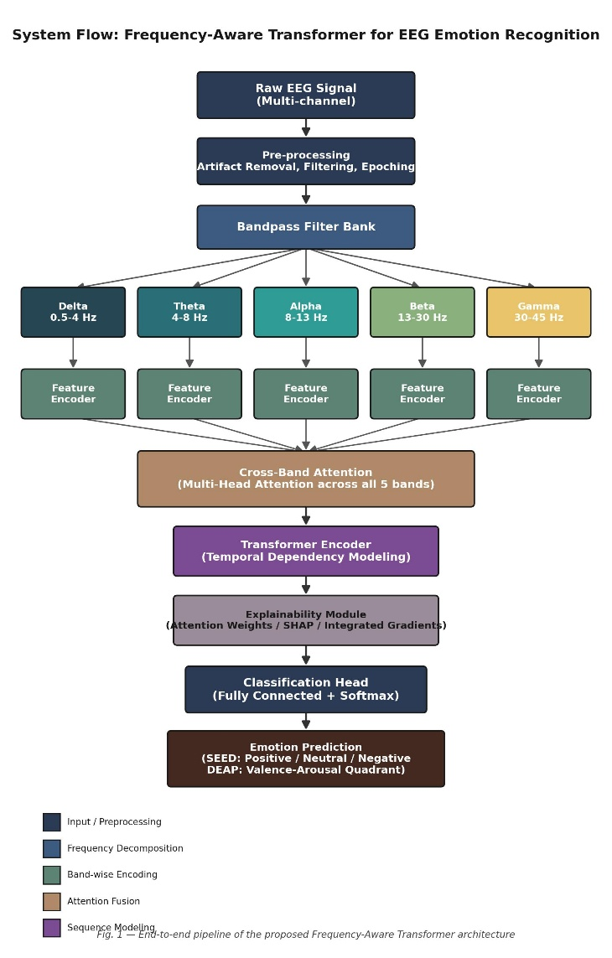
Conclusion:
This project proposes a Frequency-Aware Transformer that departs from the common practice of concatenating EEG bands into one undifferentiated sequence. By encoding delta, theta, alpha, beta, and gamma bands separately and explicitly modeling their interactions through cross-band attention before Transformer-based classification, the architecture is designed to be both more neuro -scientifically grounded and more robust than CNN, LSTM, and standard Transformer baselines. Validation on DEAP and SEED, under both subject-dependent and subject-independent protocols, will establish the empirical case for this design and lay the foundation for the explainability and neuroscientific-analysis studies that follow.

