PROCESS SIMULATION PROJECT REPORT
Distillation of Benzene and Toluene Mixture Using DWSIM
Simulation of binary distillation: thermodynamic modelling, vapour–liquid equilibrium, reflux ratio, product purity, and material and energy balances
Prepared by
Dakshin Kiran
Basis of study: 204 kmol/h feed, 60 mol% benzene / 40 mol% toluene
Software: DWSIM open-source chemical process simulator
Date: October 2026

Contents
Abstract
1. Introduction
2. Purpose and Objectives of the Study
3. Process Description and Design Basis
4. Theoretical Background
5. Thermodynamic Modelling and Vapour–Liquid Equilibrium
6. Simulation Methodology in DWSIM
7. Input Parameters
8. Material Balance
9. Shortcut Column Design (Fenske–Underwood–Gilliland)
10. Energy Balance
11. Effect of Reflux Ratio on Separation and Product Purity
12. Effect of Feed Stage Location and Number of Stages
13. Process Optimisation
14. Summary of Results and Comparison with the DWSIM Run
15. Discussion
16. Assumptions and Limitations
17. Conclusions
18. Recommendations and Future Work
References
Appendix A. Nomenclature
Appendix B. DWSIM Run Checklist

Abstract
Distillation remains the most widely used separation technology in the chemical and petrochemical industries, and the benzene–toluene pair is the classic teaching and benchmarking system for binary distillation because it is close to ideal and has a moderate relative volatility. This report documents a simulation study of the separation of a benzene–toluene mixture in a single binary distillation column using DWSIM, a free and open-source steady-state process simulator. The feed is a saturated liquid at atmospheric pressure with a flow rate of 204 kmol/h and a composition of 60 mol% benzene and 40 mol% toluene.
The study covers the full workflow of a distillation simulation: selection of a thermodynamic model, generation and checking of vapour–liquid equilibrium (VLE) data, specification of a column with a total condenser and a partial reboiler, closure of component material balances and an energy balance, and a parametric study of the reflux ratio, the number of stages and the feed stage location. A design basis of 95 mol% benzene in the distillate and 5 mol% benzene in the bottoms is used. For this basis the distillate rate is 124.67 kmol/h and the bottoms rate is 79.33 kmol/h, corresponding to a benzene recovery of 96.8%. The shortcut methods give a minimum reflux ratio of 0.855, a minimum of 6.46 stages, and about 14.9 theoretical stages at an operating reflux ratio of 1.111 (1.3 × R_{min}). The condenser and reboiler duties are about 2.26 MW and 2.42 MW respectively.
Increasing the reflux ratio raises product purity with strongly diminishing returns, while the vapour boil-up and therefore the energy demand rise almost linearly. A relative cost index that balances stages against energy has its minimum at roughly 1.2 to 1.5 times the minimum reflux ratio, which agrees with the usual design rule of thumb. The report also provides a step-by-step DWSIM procedure, a full parameter list, and a result-recording table so that the values obtained in the simulator can be compared with the reference calculations in this document.

1. Introduction
Separation processes account for a large share of capital cost and energy consumption in chemical plants, and distillation is by far the dominant technique among them. It exploits differences in volatility: when a liquid mixture is partially vaporised, the vapour is enriched in the more volatile component. Repeating this contact between rising vapour and descending liquid on many stages inside a column allows a nearly pure light product to be taken from the top and a nearly pure heavy product from the bottom.
Benzene (normal boiling point 80.1 °C) and toluene (110.6 °C) are neighbouring aromatic hydrocarbons that form an almost ideal liquid mixture. Their boiling points differ by about 30 °C and their relative volatility is roughly 2.4 to 2.6 at atmospheric pressure, so they can be separated in a conventional tray or packed column without any entrainer. Because the thermodynamics are simple and well characterised, the system is ideal for learning, for validating simulation tools, and for studying the trade-offs that govern distillation design.
Process simulators such as DWSIM allow an engineer to build a flowsheet, choose a thermodynamic model, and solve the rigorous stage-by-stage mass, equilibrium, summation and heat (MESH) equations in seconds. This makes it possible to run many what-if cases, for example different reflux ratios, and to see their effect on purity and energy use. This report describes such a study in detail.

2. Purpose and Objectives of the Study
The purpose of this project is to use DWSIM to simulate and analyse the separation of a benzene–toluene mixture by binary distillation, and to understand how thermodynamic modelling and operating parameters determine separation performance. It is intended as a chemical engineering exercise that links theory (VLE, McCabe–Thiele, shortcut design, balances) with a modern simulation tool, and that shows how a design is refined through sensitivity analysis and optimisation.
The specific objectives are:
- To select and justify a thermodynamic property model for the benzene–toluene system and to generate and verify the vapour–liquid equilibrium behaviour (T–x–y and x–y diagrams, relative volatility).
- To set up a distillation column in DWSIM for a feed of 204 kmol/h containing 60 mol% benzene and 40 mol% toluene, with a total condenser and a partial reboiler at atmospheric pressure.
- To close the overall and component material balances and to evaluate the condenser and reboiler duties through an energy balance.
- To determine the minimum reflux ratio, minimum number of stages, operating reflux ratio, number of theoretical stages and feed stage using shortcut methods, and to use these as the starting point of the rigorous simulation.
- To study the effect of reflux ratio, number of stages and feed stage location on distillate and bottoms purity and on benzene recovery.
- To identify an economically sensible operating reflux ratio by balancing capital-related effects (stages) against operating cost (energy).
- To document the method and all parameters so that the simulation can be reproduced by another user.

3. Process Description and Design Basis
The process consists of a single continuous distillation column fed with a binary liquid mixture. The feed enters the column at an intermediate stage. A total condenser at the top condenses all the overhead vapour; part of the condensate returns to the column as reflux and the rest leaves as the distillate (benzene-rich product). At the bottom, a partial reboiler vaporises part of the liquid to provide the vapour boil-up that flows up the column, and the remaining liquid leaves as the bottoms product (toluene-rich).
Table 1. Design basis and process specifications
Item | Value / specification
Feed flow rate | 204 kmol/h (56.67 mol/s)
Feed composition | 60 mol% benzene, 40 mol% toluene
Feed thermal condition | Saturated liquid (q = 1, vapour fraction = 0)
Feed pressure and temperature | 101.325 kPa (1 atm); bubble point 89.33 °C
Column operating pressure | 101.325 kPa at condenser and reboiler (pressure drop neglected)
Condenser type | Total condenser, saturated liquid distillate
Reboiler type | Partial reboiler (counted as an equilibrium stage)
Distillate specification | 95 mol% benzene (design basis)
Bottoms specification | 5 mol% benzene, i.e. 95 mol% toluene (design basis)
Operating reflux ratio | 1.3 × minimum reflux ratio (design basis)

The distillate and bottoms purities are not given in the problem statement; 95 mol% benzene overhead and 95 mol% toluene at the bottom are adopted here as a typical, commonly used design basis for this system. Any other purity pair can be examined with the same method and the same DWSIM flowsheet.

4. Theoretical Background

4.1 Vapour–liquid equilibrium
For a mixture that behaves ideally in both phases, the equilibrium relation is Raoult’s law. At equilibrium the partial pressure of each component in the vapour equals its mole fraction in the liquid multiplied by its vapour pressure at the system temperature:
y_{i} P = x_{i} P_{i}^{sat}(T) (1)
The vapour pressure is obtained from the Antoine equation, where P is in mmHg and T in °C:
log₁₀ P_{i}^{sat} = A_{i} − B_{i} / (T + C_{i}) (2)
The relative volatility of benzene (light component) with respect to toluene (heavy component) measures how easy the separation is. For an ideal system it is simply the ratio of vapour pressures, and for a constant value the equilibrium curve can be written explicitly:
α = (y_{Bz}/x_{Bz}) / (y_{Tol}/x_{Tol}) = P_{Bz}^{sat} / P_{Tol}^{sat} (3)
y = α x / [1 + (α − 1) x] (4)
The bubble-point temperature of a liquid of composition x is found by solving ΣxᵢPᵢ^{sat}(T) = P iteratively for T. This was done for every composition in this study to generate the T–x–y data.

4.2 Material balances
For a steady-state column with one feed and two products, the overall and light-component balances are:
F = D + B ; F z = D x_{D} + B x_{B} (5)
Solving the two equations gives the product rates directly:
D = F (z − x_{B}) / (x_{D} − x_{B}) ; B = F − D (6)
The internal flows follow from the reflux ratio R = L/D and the feed condition q. For a saturated-liquid feed (q = 1) and constant molar overflow:
L = R D ; V = (R + 1) D ; L′ = L + q F ; V′ = V − (1 − q) F (7)

4.3 McCabe–Thiele operating lines
With constant molar overflow, the compositions of passing streams in each section are related by straight operating lines:
Rectifying section: y = [R/(R + 1)] x + x_{D}/(R + 1) (8)
Stripping section: y = (L′/V′) x − B x_{B}/V′ (9)
The two lines intersect on the q-line, which is vertical at x = z when the feed is a saturated liquid. Theoretical stages are stepped off between the equilibrium curve and the operating lines.

4.4 Shortcut design equations
The minimum number of stages at total reflux is given by the Fenske equation, using a geometric-mean relative volatility:
N_{min} = ln{ [x_{D}/(1 − x_{D})] [(1 − x_{B})/x_{B}] } / ln α_{avg} (10)
For a saturated-liquid feed, the minimum reflux ratio occurs when the operating lines meet at the pinch on the equilibrium curve at the feed composition (Underwood result for a binary system):
R_{min} = (x_{D} − y*) / (y* − z) , y* = α z / [1 + (α − 1) z] (11)
The Gilliland correlation, in the Eduljee form, estimates the number of theoretical stages N at an operating reflux ratio R:
Y = (N − N_{min})/(N + 1) = 1 − exp{ [(1 + 54.4 X)/(11 + 117.2 X)] [(X − 1)/√X] } , X = (R − R_{min})/(R + 1) (12)
The feed location is estimated with the Kirkbride equation, which relates the number of stages above (N_{r}) and below (N_{s}) the feed:
N_{r}/N_{s} = { (z_{HK}/z_{LK}) (x_{B,LK}/x_{D,HK})² (B/D) }^{0.206} (13)

4.5 Energy balance
With a total condenser, the condenser duty equals the heat released in condensing the overhead vapour, and the reboiler duty is found from the vapour boil-up. The overall energy balance around the column must close:
Q_{C} = V λ_{D} ; Q_{R} = V′ λ_{B} ; F h_{F} + Q_{R} = D h_{D} + B h_{B} + Q_{C} (14)
where λ is the molar latent heat of the stream and h is the molar enthalpy.

5. Thermodynamic Modelling and Vapour–Liquid Equilibrium

5.1 Choice of property package
The property package determines the phase equilibrium, enthalpy and density calculations in DWSIM, so it is the most influential decision in a simulation. For benzene and toluene, which are non-polar, similar in molecular size, and chemically alike, activity-coefficient models are almost unnecessary, because the activity coefficients are very close to 1 over the whole composition range. Three suitable options were considered:
- Raoult’s Law: the simplest option and an excellent check for this near-ideal pair. It uses vapour pressures only.
- Peng–Robinson equation of state (recommended): a cubic equation of state that is accurate for hydrocarbons at atmospheric pressure, gives consistent liquid and vapour enthalpies, and remains valid if the pressure is later raised.
- NRTL or UNIQUAC (optional comparison): activity-coefficient models that can be used to confirm that non-ideality has no significant effect here.
The Peng–Robinson package is therefore used as the base case, and the Raoult’s Law package is used as an independent cross-check. The reference calculations in this report use Raoult’s law with Antoine vapour pressures, which is the ideal limit of these models. Close agreement between the two packages in DWSIM is itself a useful validation of the setup.
Table 2. Pure-component data used in the calculations
Property | Benzene | Toluene
Molar mass (kg/kmol) | 78.11 | 92.14
Normal boiling point at 101.325 kPa (°C) | 80.10 | 110.63
Antoine constant A (mmHg, °C) | 6.90565 | 6.95464
Antoine constant B | 1211.033 | 1344.800
Antoine constant C | 220.790 | 219.482
Approx. latent heat at boiling point (kJ/kmol) | 30 800 | 33 200
Approx. liquid heat capacity (kJ/kmol·K) | 136 | 157

5.2 VLE results
The bubble-point temperature and equilibrium vapour composition were calculated from Raoult’s law at 760 mmHg for compositions from 0 to 1. The values are listed below and plotted as a temperature–composition diagram and an x–y diagram.
Table 3. Vapour–liquid equilibrium data for benzene–toluene at 101.325 kPa
x (benzene, liquid) | y (benzene, vapour) | Bubble point T (°C) | Relative volatility α
0.0 | 0.0000 | 110.63 | –
0.1 | 0.2092 | 106.14 | 2.381
0.2 | 0.3761 | 102.10 | 2.411
0.3 | 0.5111 | 98.46 | 2.440
0.4 | 0.6218 | 95.14 | 2.467
0.5 | 0.7136 | 92.11 | 2.492
0.6 | 0.7905 | 89.33 | 2.516
0.7 | 0.8556 | 86.76 | 2.539
0.8 | 0.9110 | 84.38 | 2.560
0.9 | 0.9587 | 82.17 | 2.581
1.0 | 1.0000 | 80.10 | –

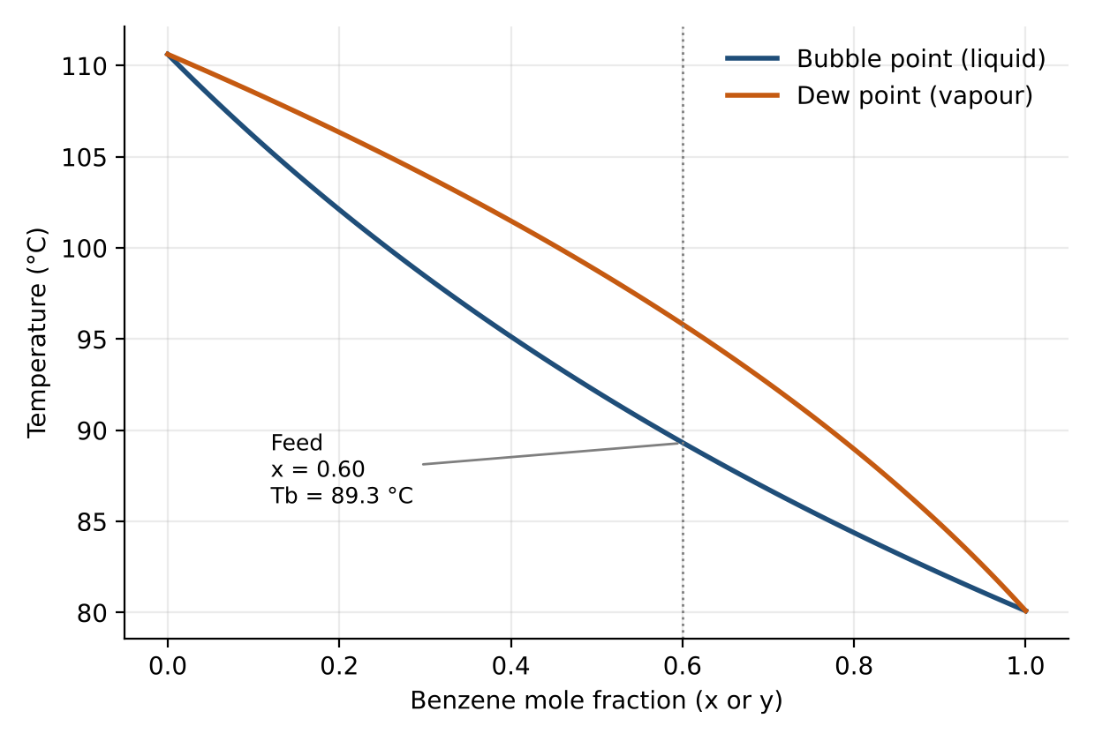
Figure 1. Temperature–composition (T–x–y) diagram for benzene–toluene at 101.325 kPa.
The relative volatility is 2.59 at the distillate end, 2.52 at the feed composition and 2.36 at the bottoms end, giving a geometric mean of 2.489. The variation is only about 10%, which confirms that a constant-volatility treatment is acceptable for shortcut calculations, while the stage-by-stage calculations used in the rest of this report use the full temperature-dependent VLE.

6. Simulation Methodology in DWSIM
The overall method has two parts. First, a reference design is produced by hand calculation and shortcut methods (Sections 8 to 10). Second, the same column is built in DWSIM, solved with the rigorous MESH equations, and the results are compared with the reference values and extended with sensitivity studies. The steps below describe the DWSIM procedure. Menu names may differ slightly between DWSIM versions, but the logic is the same.

6.1 Step-by-step procedure
- Create the simulation. Open DWSIM and create a new steady-state simulation. Save the file immediately with a descriptive name such as benzene_toluene_distillation.dwxmz.
- Select the unit system. Choose a system with temperature in °C, pressure in kPa, molar flow in kmol/h and energy in kW, so that the numbers match this report.
- Add compounds. From the compound database add Benzene and Toluene.
- Choose the property package. Select Peng–Robinson (PR) as the thermodynamic model for the base case. Create a second simulation or switch the package to Raoult’s Law for the comparison run.
- Add the feed stream. Insert a Material Stream named Feed. Specify pressure 101.325 kPa, vapour fraction 0 (saturated liquid), molar flow 204 kmol/h, and mole fractions of 0.60 benzene and 0.40 toluene. DWSIM then calculates the feed temperature, which should be close to 89.3 °C.
- Add the column. Insert a Distillation Column unit operation from the unit operations palette and open its editor.
- Set the number of stages. In DWSIM the condenser is counted as stage 1 and the reboiler as the last stage. For 15 theoretical stages including the reboiler plus a total condenser, enter 16 stages.
- Set the condenser. Choose a total condenser (liquid distillate only) at 101.325 kPa.
- Set the reboiler. Set the reboiler pressure to 101.325 kPa (no pressure drop for the base case).
- Connect the feed. Connect the Feed stream to the feed stage. Using the numbering of the previous step, the Kirkbride estimate of stage 7 from the top of the 15-stage column corresponds to stage 8 in DWSIM.
- Define the specifications. Specify the reflux ratio as 1.11 and the distillate molar flow rate as 124.67 kmol/h. These two specifications fix the degrees of freedom of the column. As an alternative, specify distillate and bottoms mole fractions and let DWSIM calculate the reflux ratio.
- Connect product and energy streams. Create the Distillate and Bottoms material streams and the condenser and reboiler energy streams, and connect them to the column.
- Select the solver. Use the Inside-Out solver (default) with a maximum of about 100 iterations and a tight tolerance. Inside-Out is robust and fast for narrow-boiling hydrocarbon mixtures. Wang–Henke can be used as a fallback.
- Run and check convergence. Run the flowsheet and make sure the column reports a converged solution without errors or warnings.
- Record the results. Read the product flow rates and compositions, the temperature, liquid and vapour flow and composition on every stage, the condenser and reboiler duties, and the overall mass balance closure.
- Run sensitivity studies. Use DWSIM’s sensitivity analysis utility, or repeat the run manually, to vary (a) the reflux ratio from 0.9 to 4.0, (b) the feed stage from 3 to 12, and (c) the number of stages from 9 to 21, recording the distillate purity, bottoms purity, recovery and duties each time.
- Compare and optimise. Compare the DWSIM output with the reference calculations in Section 14 and use the sensitivity data to choose the operating point in Section 13.

6.2 Rationale for the specifications
A column with a total condenser and partial reboiler has two operating degrees of freedom once the pressure, feed and number of stages are fixed. Specifying the reflux ratio and the distillate rate is the most robust choice for convergence, because both are directly related to the internal flows. Specifying the purities directly is attractive for design work but can fail to converge if the number of stages is not sufficient for the specified separation. For this reason the purity-based design is first done with shortcut methods, and the rigorous model is then run with reflux and distillate specifications.

7. Input Parameters
Table 4. Summary of DWSIM input parameters (base case)
Object | Parameter | Value
Simulation | Property package | Peng–Robinson (cross-check: Raoult’s law)
Simulation | Components | Benzene, Toluene
Feed stream | Pressure | 101.325 kPa
Feed stream | Vapour fraction | 0 (saturated liquid)
Feed stream | Molar flow | 204 kmol/h
Feed stream | Mole fraction benzene / toluene | 0.60 / 0.40
Column | Number of stages (DWSIM count) | 16 (condenser + 14 trays + reboiler)
Column | Feed stage (DWSIM count) | 8
Column | Condenser type | Total
Column | Condenser / reboiler pressure | 101.325 kPa / 101.325 kPa
Column | Reflux ratio (specification) | 1.111
Column | Distillate molar flow (specification) | 124.67 kmol/h
Column | Solver | Inside-Out, 100 iterations max
Column | Stage efficiency | 100% (theoretical stages)

The reflux ratio of 1.111 is 1.3 times the minimum reflux ratio from the Underwood pinch calculation, which is a standard starting point that is explored further in Sections 11 and 13.

8. Material Balance
The overall and component material balances for the design basis (x_{D} = 0.95, x_{B} = 0.05) are solved using Equation (6):
D = 204 × (0.60 − 0.05) / (0.95 − 0.05) = 124.67 kmol/h (15)
B = 204 − 124.67 = 79.33 kmol/h (16)
Table 5. Material balance for the design basis (molar and mass flows)
Stream | Total (kmol/h) | Benzene (kmol/h) | Toluene (kmol/h) | Benzene mol% | Mass flow (kg/h)
Feed | 204.00 | 122.40 | 81.60 | 60.00 | 17079
Distillate | 124.67 | 118.43 | 6.23 | 95.00 | 9825
Bottoms | 79.33 | 3.97 | 75.37 | 5.00 | 7254
Balance (Feed − D − B) | 0.00 | 0.00 | 0.00 | – | 0

Benzene recovery in the distillate is 96.76% (118.43 of 122.40 kmol/h), and toluene recovery in the bottoms is 92.36%. The component and overall balances close exactly, as expected for the design basis. In the DWSIM run, the mass balance closure is checked by confirming that the feed flow equals the sum of the distillate and bottoms flows to within numerical tolerance.
The base-case rigorous model uses the fixed number of stages (15 theoretical stages plus condenser) and the fixed distillate rate of 124.67 kmol/h. Because 15 stages is slightly more than the Gilliland estimate requires, the stage-by-stage calculation predicts a slightly better separation than the 95/5 basis:
Table 6. Predicted product compositions for the as-built case (N = 15, feed stage 7, R = 1.111, D = 124.67 kmol/h)
Stream | Total (kmol/h) | Benzene (kmol/h) | Toluene (kmol/h) | Benzene mol%
Feed | 204.00 | 122.40 | 81.60 | 60.00
Distillate | 124.67 | 119.72 | 4.95 | 96.03
Bottoms | 79.33 | 2.68 | 76.65 | 3.38

In this case the benzene recovery rises to 97.81% and the distillate purity to 96.0 mol% benzene, which means the 95 mol% target is met with some margin. This is the set of values that the DWSIM base case should reproduce.

9. Shortcut Column Design (Fenske–Underwood–Gilliland)
The geometric-mean relative volatility from the distillate, feed and bottoms bubble-point temperatures is α_{avg} = (2.591 × 2.516 × 2.365)^{1/3} = 2.489. The equilibrium composition of vapour at the feed composition is y* = 0.7887.
Table 7. Shortcut design results
Quantity | Value | Method
Average relative volatility α | 2.489 | Geometric mean of end and feed values
Minimum stages N_{min} | 6.46 | Fenske, Eq. (10)
Minimum reflux ratio R_{min} | 0.855 | Pinch at feed, Eq. (11)
Operating reflux ratio R | 1.111 | 1.3 × R_{min}
Theoretical stages N (incl. reboiler) | 14.95 (use 15) | Gilliland–Eduljee, Eq. (12)
Stages above feed / below feed | 6.8 / 8.1 | Kirkbride, Eq. (13)
Feed stage from top | 7 | Rounded Kirkbride result
Stages by stepping (full VLE, R = 1.3 × 0.837) | 13.1 (feed on stage 6) | McCabe–Thiele stepping

Using the full temperature-dependent VLE instead of a constant α, the minimum reflux is 0.837 and the McCabe–Thiele construction needs about 13.1 stages at 1.3 times that value. The Gilliland correlation is an empirical curve fit and is typically conservative, so the shortcut estimate of 15 stages is slightly higher than the stepped value. The 15-stage design is retained because it is a safe starting point for DWSIM, and the rigorous model shows that it gives some margin on purity.
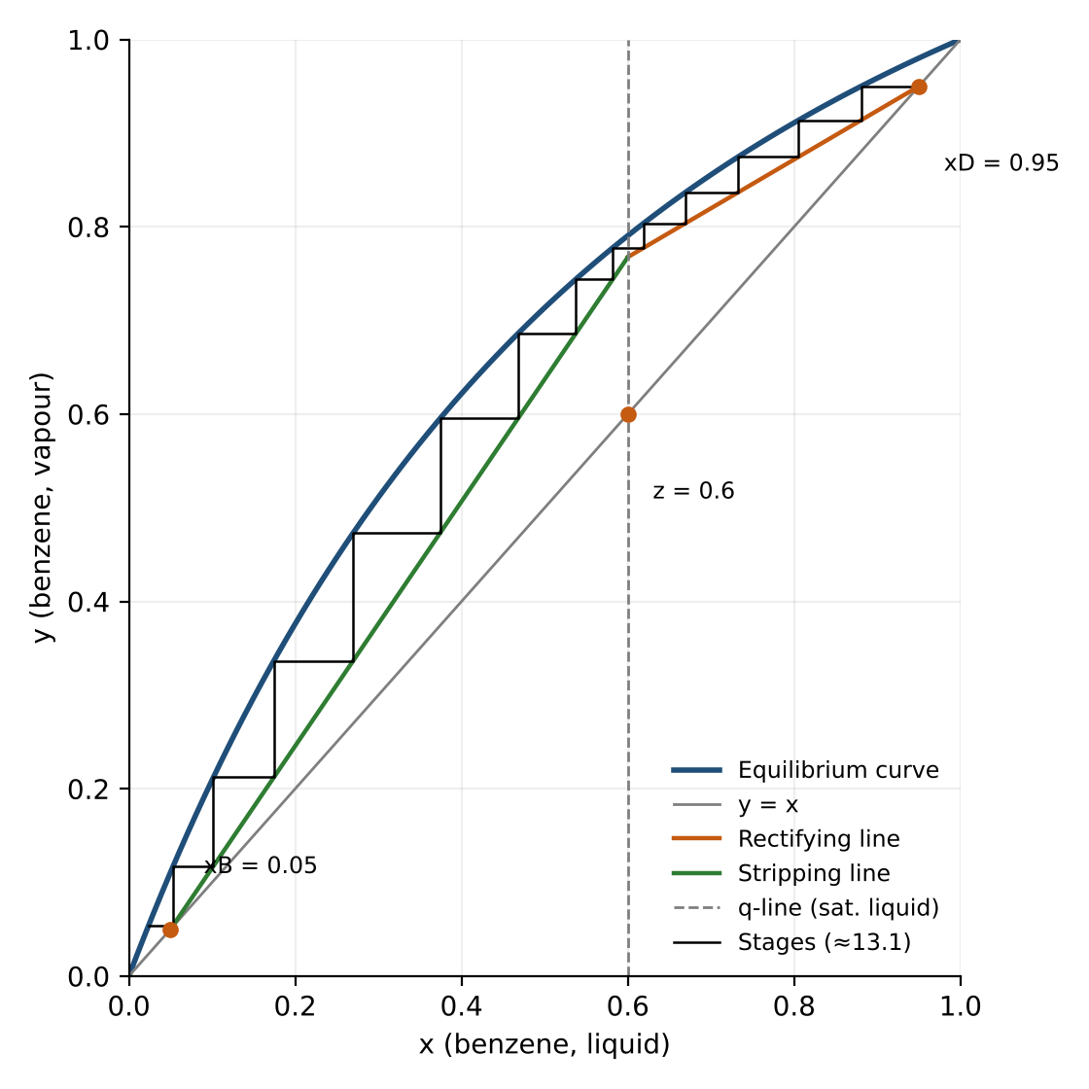
Figure 2. McCabe–Thiele diagram for the design basis (xD = 0.95, xB = 0.05, z = 0.60, saturated-liquid feed, R = 1.3 Rmin).
The diagram shows the equilibrium curve, the 45° line, the rectifying and stripping operating lines meeting on the vertical q-line at x = 0.60, and the stage steps between the distillate and bottoms compositions. The steps are widest around the feed and narrow towards both ends, a typical sign of a pinch-free design with comfortable driving force.

10. Energy Balance
The internal flows for the design reflux ratio R = 1.111 are: reflux L = 138.5 kmol/h, vapour boil-up V = 263.2 kmol/h, stripping-section liquid L′ = 342.5 kmol/h and V′ = 263.2 kmol/h (equal to V because the feed is a saturated liquid).
Table 8. Temperatures and heat duties (design basis)
Quantity | Value
Distillate (bubble point) temperature | 81.1 °C
Feed (bubble point) temperature | 89.3 °C
Bottoms (bubble point) temperature | 108.3 °C
Condenser duty Q_{C} = V λ_{D} | 2260 kW
Reboiler duty Q_{R} = V′ λ_{B} (direct estimate) | 2418 kW
Sensible-heat difference of products relative to feed | 26 kW
Reboiler duty from overall balance Q_{C} + sensible term | 2287 kW
Cooling water at 10 K rise (25 to 35 °C) | 54.1 kg/s (about 195 t/h)
Saturated steam at 3 bar abs (about 2163 kJ/kg) | 1.12 kg/s (about 4.0 t/h)

The two reboiler estimates differ by about 132 kW (5.4%). The direct estimate uses the latent heat at the bottoms composition, whereas the overall balance is anchored on the condenser duty, which uses the latent heat at the distillate composition. The difference arises because the constant-molar-overflow assumption ignores the variation of latent heat with composition, heat of mixing and the small sensible-heat effects. DWSIM solves a rigorous enthalpy balance on every stage, so its reboiler duty will close the overall balance exactly. It is expected to fall between about 2.29 MW and 2.42 MW, and the higher value is a conservative design figure.
The calculated duties correspond to roughly 2.3 to 2.4 MW for a 204 kmol/h feed, or about 43 MJ per kmol of feed. This energy intensity is the main operating cost of the column and the reason that the reflux ratio is the most important operating variable.

11. Effect of Reflux Ratio on Separation and Product Purity
The reflux ratio is the principal handle for trading energy for separation. Two complementary views were calculated: the stages required to reach the fixed 95/5 purity at different reflux ratios (design view), and the purities obtained from a fixed column at different reflux ratios (operating view, which is what a DWSIM sensitivity run of the base column reproduces).

11.1 Design view: stages required
Table 9. Gilliland stage requirement and boil-up versus reflux ratio (x_{D} = 0.95, x_{B} = 0.05)
R / R_{min} | Reflux ratio R | Theoretical stages N | Vapour boil-up V (kmol/h)
1.05 | 0.897 | 20.6 | 236.5
1.10 | 0.940 | 18.4 | 241.9
1.20 | 1.025 | 16.3 | 252.5
1.30 | 1.111 | 14.9 | 263.2
1.50 | 1.282 | 13.1 | 284.5
1.80 | 1.538 | 11.5 | 316.4
2.00 | 1.709 | 10.8 | 337.7
2.50 | 2.136 | 9.7 | 391.0
3.00 | 2.564 | 9.1 | 444.3

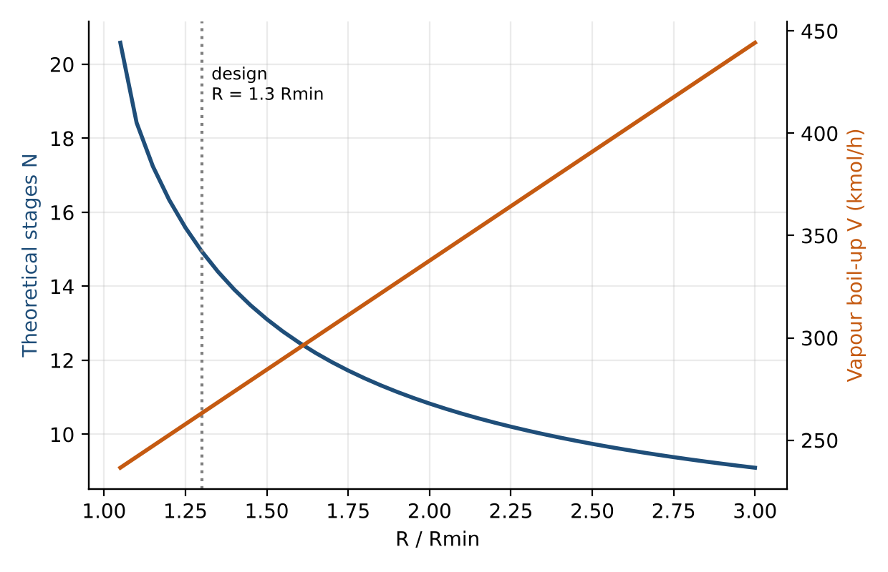
Figure 3. Required number of theoretical stages and vapour boil-up as functions of R / Rmin.
As the reflux ratio approaches the minimum, the number of stages rises steeply, from about 15 at 1.3 times the minimum to more than 20 at 1.05 times. At the other extreme, increasing the reflux ratio beyond about twice the minimum saves only a few stages while the boil-up, and thus the energy use, keeps climbing in direct proportion to (R + 1). The sensible operating region lies in between.

11.2 Operating view: purity of a fixed column
Table 10. Product purity and recovery for a fixed column (N = 15, feed stage 7, D = 124.67 kmol/h)
Reflux ratio R | Distillate benzene xD | Bottoms benzene xB | Benzene recovery (%) | Toluene recovery (%) | Boil-up V (kmol/h)
0.900 | 0.9425 | 0.0618 | 95.99 | 91.21 | 236.9
1.000 | 0.9522 | 0.0466 | 96.98 | 92.70 | 249.3
1.111 | 0.9603 | 0.0338 | 97.81 | 93.94 | 263.2
1.250 | 0.9672 | 0.0229 | 98.52 | 94.99 | 280.5
1.500 | 0.9739 | 0.0125 | 99.19 | 96.01 | 311.7
1.750 | 0.9769 | 0.0077 | 99.50 | 96.47 | 342.8
2.000 | 0.9784 | 0.0053 | 99.66 | 96.71 | 374.0
2.500 | 0.9799 | 0.0030 | 99.80 | 96.93 | 436.3
3.000 | 0.9805 | 0.0020 | 99.87 | 97.02 | 498.7
4.000 | 0.9811 | 0.0012 | 99.92 | 97.11 | 623.3

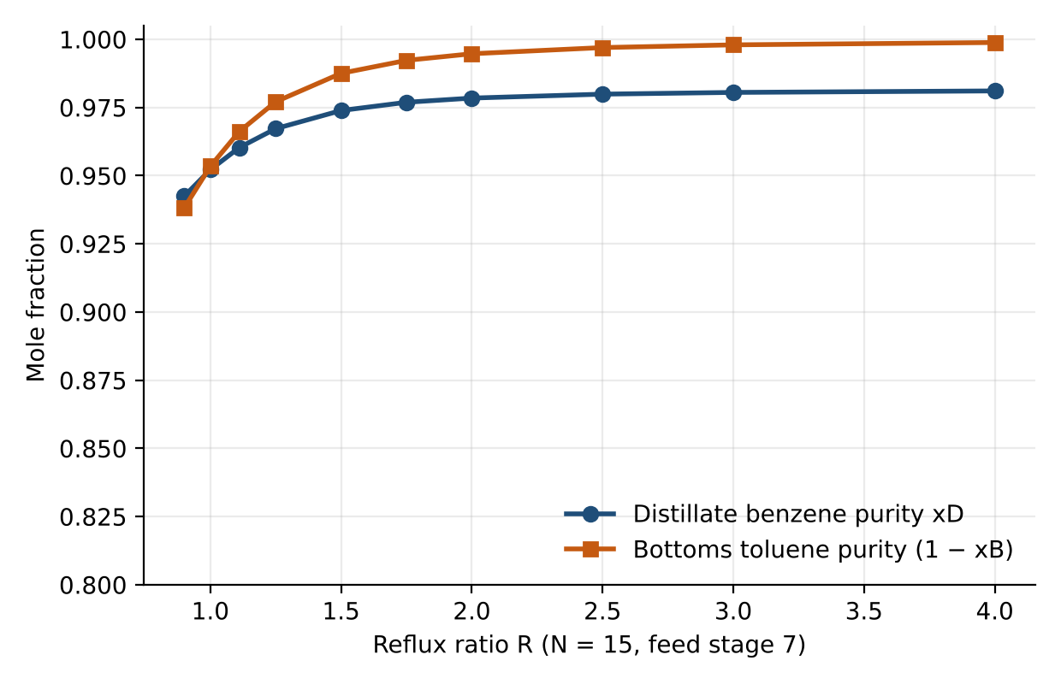
Figure 4. Distillate and bottoms purity versus reflux ratio for a column with 15 stages and fixed distillate rate.
With the distillate rate fixed, increasing R from 0.9 to 1.5 raises the distillate purity from 94.2% to 97.4% benzene and cuts the benzene in the bottoms from 6.2% to 1.2%. Beyond R ≈ 2 the purities level off, because the separation is then limited by the fixed distillate rate (which cannot exceed the benzene available in the feed) and by the number of stages. At R = 4 the distillate purity is only 98.1%, less than one percentage point above the value at R = 1.5, even though the boil-up has doubled. This demonstrates the law of diminishing returns in reflux and justifies operating at a modest multiple of the minimum reflux.
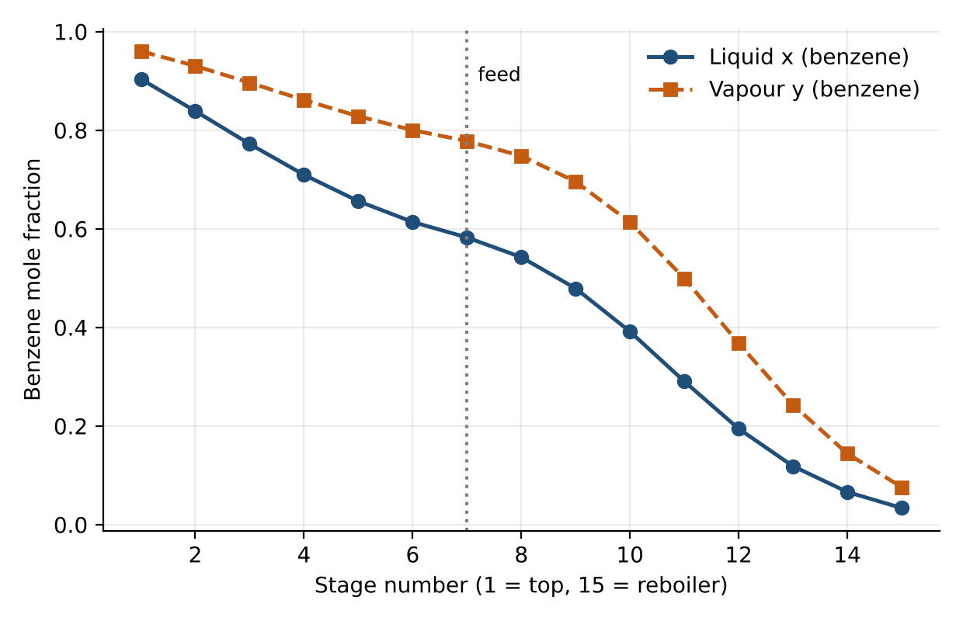
Figure 5. Composition profile of benzene in the liquid and vapour on each stage for the base case (R = 1.111).
The composition profile shows a gradual enrichment of benzene towards the top, with the steepest change in composition in the stripping section near the reboiler where the benzene concentration is lowest and the driving force is smallest. This profile is the one that should be compared with the stage-by-stage output of DWSIM.

12. Effect of Feed Stage Location and Number of Stages
For the fixed base column (15 stages, R = 1.111), the feed stage was moved from stage 3 to stage 12. The best result is obtained at stage 7, which agrees with the Kirkbride estimate. Feeding too high or too low leaves one section with too few stages for its separation duty and noticeably reduces product purity.
Table 11. Feed stage sensitivity (N = 15, R = 1.111, D = 124.67 kmol/h)
Feed stage (from top) | Distillate benzene xD | Bottoms benzene xB | Benzene recovery (%)
3 | 0.9276 | 0.0853 | 94.47
4 | 0.9434 | 0.0603 | 96.09
5 | 0.9535 | 0.0445 | 97.12
6 | 0.9590 | 0.0359 | 97.68
7 (optimum) | 0.9603 | 0.0338 | 97.81
8 | 0.9581 | 0.0373 | 97.58
9 | 0.9524 | 0.0462 | 97.00
10 | 0.9429 | 0.0612 | 96.04
11 | 0.9286 | 0.0836 | 94.58
12 | 0.9081 | 0.1158 | 92.49

The sensitivity is moderate for small deviations: moving the feed one stage away from the optimum changes the distillate purity by about 0.1 to 0.2 percentage points, but moving it four or five stages away costs three to five percentage points. In DWSIM this study is a direct way of locating the optimum feed stage.
Table 12. Effect of the number of stages (R = 1.111, feed stage near 47% of stages, D = 124.67 kmol/h)
Stages N | Feed stage | Distillate benzene xD | Bottoms benzene xB | Benzene recovery (%)
9 | 4 | 0.9204 | 0.0966 | 93.74
11 | 5 | 0.9382 | 0.0686 | 95.56
13 | 6 | 0.9510 | 0.0485 | 96.86
15 | 7 | 0.9603 | 0.0338 | 97.81
17 | 8 | 0.9673 | 0.0228 | 98.52
19 | 9 | 0.9725 | 0.0147 | 99.05
21 | 10 | 0.9762 | 0.0088 | 99.43

Adding stages improves the separation at fixed reflux, but the gain per added stage becomes smaller as the number of stages grows. Each stage adds to the column height and cost, so the number of stages is balanced against the reflux ratio in the optimisation below.

13. Process Optimisation
Optimisation of a distillation column is a trade-off between capital cost, which rises with the number of stages and with the column diameter, and operating cost, which is dominated by reboiler steam and condenser cooling and rises with the reflux ratio. The shortcut results provide both quantities for each reflux ratio. A simple relative cost index was constructed for the fixed 95/5 purity target:
Index = 0.5 · [N √V] / [N √V]_{min} + 0.5 · V / V_{min} (17)
The first term is a capital proxy (the number of stages times a diameter proxy proportional to the square root of the vapour rate), and the second is an energy proxy proportional to the vapour boil-up. Both are normalised by their minimum values over the range studied, and equal weights are used. The weights are illustrative assumptions and not actual cost data, and they can be changed to reflect local steam, cooling water and equipment prices.
Table 13. Relative cost index versus reflux ratio
R / R_{min} | R | Stages N | Boil-up V (kmol/h) | Relative cost index
1.05 | 0.897 | 20.6 | 236.5 | 1.326
1.10 | 0.940 | 18.4 | 241.9 | 1.259
1.20 | 1.025 | 16.3 | 252.5 | 1.211
1.30 | 1.111 | 14.9 | 263.2 | 1.189
1.50 | 1.282 | 13.1 | 284.5 | 1.178
1.80 | 1.538 | 11.5 | 316.4 | 1.203
2.00 | 1.709 | 10.8 | 337.7 | 1.233
2.50 | 2.136 | 9.7 | 391.0 | 1.329
3.00 | 2.564 | 9.1 | 444.3 | 1.439

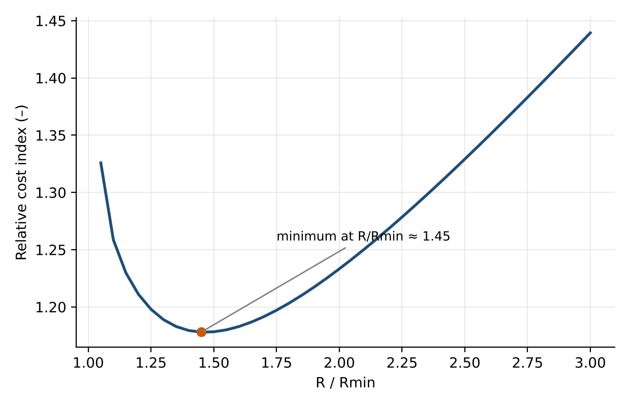
Figure 6. Relative cost index as a function of R / Rmin for the 95/5 purity target.
The index has a shallow minimum at R / R_{min} ≈ 1.45 (R ≈ 1.24, about 13.5 stages). The curve is flat between about 1.2 and 1.5 times the minimum, so any value in this range is close to optimal and the choice can be made on practical grounds. The design value of 1.3 times the minimum lies inside this region, and R = 1.1 to 1.25 is recommended as the working range for DWSIM runs. If energy is expensive, a reflux closer to 1.2 times the minimum with a few more stages is favoured, and if equipment is expensive, a higher reflux with fewer stages is favoured.
Further optimisation in DWSIM can be done by varying the reflux ratio, feed stage and number of stages together in a sensitivity or optimisation study, with an objective function that combines product value, utility costs and an equipment cost estimate. Heat integration is also possible, for example using the hot bottoms product to preheat the feed, which would reduce the reboiler duty.

14. Summary of Results and Comparison with the DWSIM Run
Table 14. Summary of key reference results
Parameter | Result
Distillate rate / bottoms rate (95/5 basis) | 124.67 kmol/h / 79.33 kmol/h
Benzene recovery (95/5 basis) | 96.76 %
Average relative volatility | 2.489
Minimum reflux ratio (constant α / full VLE) | 0.855 / 0.837
Minimum number of stages | 6.46
Operating reflux ratio | 1.111
Theoretical stages / feed stage (shortcut) | 15 / 7 from the top
Distillate / bottoms purity of as-built case (benzene mol%) | 96.03 % / 3.38 %
Condenser duty | 2260 kW
Reboiler duty (range) | 2287 to 2418 kW
Optimum reflux region | 1.2 to 1.5 × minimum

The table below is provided for the values read from the converged DWSIM simulation. The reference column gives the expected value from this report, and the last column gives the suggested acceptance tolerance. Large deviations point to a problem with the setup, such as the wrong feed stage numbering, a wrong specification or a different property package.
Table 15. Comparison of reference values with DWSIM output (to be completed from the simulation)
Quantity | Reference value | DWSIM value | Tolerance
Feed temperature (°C) | 89.3 |  | ± 0.5 °C
Distillate flow (kmol/h) | 124.67 |  | ± 0.1
Distillate benzene mole fraction | 0.9603 |  | ± 0.01
Bottoms flow (kmol/h) | 79.33 |  | ± 0.1
Bottoms benzene mole fraction | 0.0338 |  | ± 0.01
Benzene recovery (%) | 97.81 |  | ± 1.0
Condenser duty (kW) | 2260 |  | ± 5 %
Reboiler duty (kW) | 2287 to 2418 |  | within range
Distillate temperature (°C) | 81.1 (approx.) |  | ± 1 °C
Bottoms temperature (°C) | 108.3 (approx.) |  | ± 1 °C

The reference values come from stage-by-stage calculations with ideal VLE (Raoult’s law and Antoine vapour pressures). Peng–Robinson results are expected to be within the tolerances shown, because benzene and toluene deviate very little from ideal behaviour at atmospheric pressure. The calculated temperatures in the distillate and bottoms are the bubble points at the product compositions of the 95/5 basis; the as-built case will give slightly different values.

15. Discussion
Thermodynamics. The benzene–toluene system is well described by an ideal-solution model. The relative volatility changes only modestly across the composition range, and the bubble-point and dew-point curves are smooth with no azeotrope. This explains why distillation is so effective for this pair and why the choice of property package (Peng–Robinson or Raoult’s law) has little effect on the results. In more complex systems, the choice of the model must be validated against experimental data.
Reflux ratio. The reflux ratio is the most important operating variable. A reflux ratio near the minimum requires a very tall column, while a high reflux ratio wastes energy. The results show that the useful range is narrow: from about 1.1 to 1.5 times the minimum reflux ratio, the number of stages falls from 18 to 13 while the boil-up rises by only about 18%. Beyond this, the savings in stages are small compared with the added energy.
Product purity. Purity responds quickly to reflux ratio at low values and saturates at high values. In the operating view the distillate purity rises from about 94% to about 97% when R moves from 0.9 to 1.5, and then improves by less than 1 percentage point more when R is raised to 4. The final choice therefore depends on how valuable the extra purity is relative to the energy it costs.
Energy. The condenser and reboiler duties are nearly equal because the latent heats of benzene and toluene are similar and the feed is a saturated liquid, so that nearly all the energy supplied at the reboiler is removed at the condenser. Of the order of 2.3 to 2.4 MW is needed for this feed, and the energy demand is almost exactly proportional to the boil-up V = (R + 1)D. Heat integration offers the largest opportunity for savings.
Feed stage. The simulation shows a clear optimum for feed location. A feed stage that is too high or too low degrades the separation, because one section of the column does less work than it could. This is easy to explore in DWSIM and should always be checked after changing the number of stages or the specification.
Use of the simulator. The main benefit of DWSIM here is speed and consistency. Once the flowsheet is built, any change in feed, specification or property package takes a few seconds to evaluate, and the rigorous energy balance removes the constant-molar-overflow approximation used in hand calculations.

16. Assumptions and Limitations
- The column operates at steady state at 101.325 kPa with no pressure drop across the trays; in a real column the pressure rises towards the bottom and the bottoms temperature is slightly higher.
- The reference calculations use ideal VLE (Raoult’s law). The real mixture is very close to ideal, but small deviations exist.
- Constant molar overflow is assumed for the hand calculations and the McCabe–Thiele construction. The DWSIM solution is not restricted by this assumption.
- Theoretical equilibrium stages with 100% efficiency are used. Real columns need more trays: with an overall efficiency of 60 to 70%, the 15 theoretical stages correspond to roughly 21 to 25 actual trays.
- The purity targets of 95 mol% benzene in the distillate and 5 mol% benzene in the bottoms are assumed design targets, because they were not specified in the problem.
- The latent heats and heat capacities in the energy balance are approximate average values, and the cost index in the optimisation uses illustrative weights.
- Column hydraulics (diameter, flooding, pressure drop), tray or packing design, and control are outside the scope of this study.
- The DWSIM results have to be entered in the comparison table by the user, because the reference values were produced by equation-based calculations that follow the same physics but are not the output of the application itself.

17. Conclusions
- Benzene and toluene form a near-ideal binary system with an average relative volatility of 2.49, and the Peng–Robinson or Raoult’s law property package is suitable for modelling their VLE in DWSIM.
- For a 204 kmol/h feed with 60 mol% benzene, a 95/5 separation gives 124.7 kmol/h of distillate and 79.3 kmol/h of bottoms, with 96.8% benzene recovery and exact closure of the overall and component balances.
- Shortcut methods give R_{min} = 0.85, N_{min} = 6.5, and about 15 theoretical stages with the feed on stage 7 at an operating reflux ratio of 1.11.
- A column with 15 stages and R = 1.11 is predicted to give 96.0 mol% benzene in the distillate and 3.4 mol% benzene in the bottoms, meeting the target with margin.
- The condenser duty is about 2.26 MW and the reboiler duty is about 2.29 to 2.42 MW.
- Raising the reflux ratio improves purity with strongly diminishing returns while the energy demand increases in proportion to the boil-up; the cost optimum lies at about 1.2 to 1.5 times the minimum reflux ratio.
- The feed stage has a clear optimum near stage 7, and shifting it by several stages markedly reduces purity.
- The method and parameter set are fully documented so that the simulation can be reproduced and compared against the reference values.

18. Recommendations and Future Work
- Run the DWSIM base case and the Raoult’s law and NRTL cross-checks, record the results in Table 15, and examine any differences.
- Add pressure drop per stage and a column-sizing calculation to estimate the diameter and number of real trays.
- Carry out a rigorous economic optimisation using actual equipment and utility prices, including heat integration of feed and bottoms.
- Examine the effect of feed composition and flow disturbances, and of a feed that is partly vaporised, on column performance.
- Study operation at other pressures, for example under vacuum to reduce the reboiler temperature.
- Develop a simple control scheme, for example temperature control on a sensitive stage with reflux or boil-up as the manipulated variable, using DWSIM’s dynamic capabilities.

References
- Seader, J. D., Henley, E. J., Roper, D. K. Separation Process Principles, 3rd or later edition, John Wiley & Sons.
- McCabe, W. L., Smith, J. C., Harriott, P. Unit Operations of Chemical Engineering, McGraw-Hill.
- Treybal, R. E. Mass-Transfer Operations, McGraw-Hill.
- Smith, J. M., Van Ness, H. C., Abbott, M. M. Introduction to Chemical Engineering Thermodynamics, McGraw-Hill.
- Green, D. W., Southard, M. Z. (eds.) Perry’s Chemical Engineers’ Handbook, McGraw-Hill.
- Fenske, M. R. (1932). Fractionation of straight-run Pennsylvania gasoline. Industrial & Engineering Chemistry, 24, 482–485.
- Underwood, A. J. V. (1948). Fractional distillation of multicomponent mixtures. Chemical Engineering Progress, 44, 603–614.
- Gilliland, E. R. (1940). Multicomponent rectification: estimation of the number of theoretical plates as a function of the reflux ratio. Industrial & Engineering Chemistry, 32, 1220–1223.
- Kirkbride, C. G. (1944). Process design procedure for multicomponent fractionators. Petroleum Refiner, 23, 321–336.
- Peng, D.-Y., Robinson, D. B. (1976). A new two-constant equation of state. Industrial & Engineering Chemistry Fundamentals, 15, 59–64.
- DWSIM – Open Source Chemical Process Simulator, project documentation and user guide, dwsim.org.

Appendix A. Nomenclature
Table 16. Symbols and abbreviations
Symbol | Meaning | Unit
F, D, B | Feed, distillate and bottoms molar flow rates | kmol/h
z, x_{D}, x_{B} | Mole fraction of benzene in feed, distillate and bottoms | –
x, y | Mole fraction of benzene in liquid and vapour | –
R | Reflux ratio, L/D | –
R_{min}, N_{min} | Minimum reflux ratio, minimum number of stages | –
L, V | Liquid and vapour flow in rectifying section | kmol/h
L′, V′ | Liquid and vapour flow in stripping section | kmol/h
q | Thermal condition of feed (1 = saturated liquid) | –
α | Relative volatility of benzene to toluene | –
P_{i}^{sat} | Vapour pressure of component i | mmHg
Q_{C}, Q_{R} | Condenser and reboiler duty | kW
λ | Molar latent heat of vaporisation | kJ/kmol
N_{r}, N_{s} | Stages above and below the feed | –
MESH | Material, equilibrium, summation, heat equations | –
VLE | Vapour–liquid equilibrium | –

Appendix B. DWSIM Run Checklist
- Compounds are Benzene and Toluene only, and the property package is selected before any stream is defined.
- The unit system is consistent (°C, kPa, kmol/h, kW).
- The feed has vapour fraction 0, 204 kmol/h and mole fractions 0.60 / 0.40, and the calculated feed temperature is close to 89.3 °C.
- The number of stages includes the condenser, and the feed stage uses the same numbering (stage 8 of 16 for the base case).
- The condenser is total and both pressures are 101.325 kPa.
- The two specifications are the reflux ratio (1.111) and the distillate flow (124.67 kmol/h), and no third specification is imposed.
- The solver reports convergence, and feed flow equals distillate plus bottoms flow.
- The condenser and reboiler duties are recorded, and the overall energy balance closes.
- The sensitivity studies on reflux ratio, feed stage and number of stages are repeated, and the results are tabulated.
- The values are entered in the comparison table and any deviation beyond the tolerance is investigated.

