Predicting pain based on Physiological data using Random Forests and Score-Level Fusion

Dakshin Rathan

*Abstract*—Brief overview of what you did, why it’s important, and the results

# Introduction

In this paper, we are discussing a pain recognition system based on physiological data using score level fusion with random forest classifiers. This is an important development and accurately predicting whether someone is in pain is useful for soldiers in combat, children who cannot clearly communicate, and for patients in a hospital.

Below are some short discussions on related papers discussing pain recognition and different methods to achieve accurate pain recognition.

Paper 1: Improving Pain Recognition Through Better Utilisation of Temporal Information

This paper explores the most accurate method of detecting pain through a video. Since videos have large file sizes, compression is done for temporal signal scanning. However, by using the spatial signals, a more accurate result is found.

Paper 2: Automatic Pain Recognition from Video and Biomedical Signals

This paper explores a automatic and continuous system of pain monitoring. It combines video analysis of facial expression and physiological data to make predictions using the BioVid Heat Pain Database.

Paper 3: Deep Multimodal Pain Recognition: A Database and Comparison of Spatio-Temporal Visual Modalities

This paper presents a pain recognition system using deep learning with multimodal data. It uses thermal data, video data pixel by pixel, and depth data for spatial analysis.

Paper 4: Automatic Recognition Methods Supporting Pain Assessment: A Survey

This paper shines light on various pain recognition systems and evaluates them via a survey. This paper also discusses the challenge of validating pain recognition results, as it is subjective and difficult to know if someone is actually in pain or not unless they answer themselves.

Paper 5: Spatio-temporal Pain Recognition in CNN-Based Super-Resolved Facial Images

This paper discusses a deep learning CNN model that takes spatial and temporal data from videos as well as facial resolution manipulation to improve accuracy of pain detection. This paper presents a super resolution algorithm to manipulate facial video frames with different resolutions.

# Method

Discuss random forest here. Cite Brieman's work - can find reference in Google Scholar.

A decision tree is an algorithm that is able to classify input data based on a series of decisions. A basic structure of a decision tree is below. The tree starts at the root node, and makes splits, or decisions, where the data will move further down the tree. When a pure classification is achieved (ex. Pain or No Pain), the a decision is made.

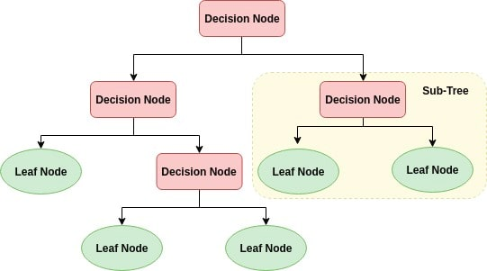

However, a single decision tree is vulnerable to overfitting to the training data and bias of a single data set. To comband this in this paper, we use random forest.

A random forest randomly samples a portion of the input data with replacement and creates many different and unique decision trees. Because of this, different splits occur and different decisions occur in each of the trees. After all the trees have made a decision, the random forest will make a classification in line with the majority decision among the trees.

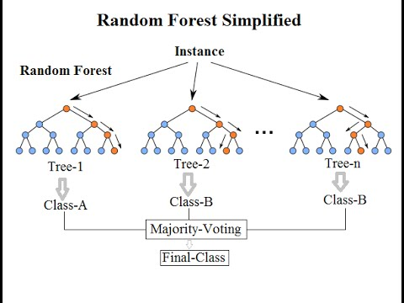

In this project, we classify whether a subject is in pain or not based entries of signal data for four types of physiological signals: Respiration Rate (RES), Systolic Blood Pressure (SYS), Diastolic Blood Pressure (DIA), and electrodermal activity (EDA).

Training and Testing Random Forest

We used training and testing data of 30 subjects with 8 sets of physiological signal readings: 4 sets corresponding to each type of physiological signal when “pain” was reported and 4 sets when “no pain” was reported. To accomplish classification in this project, we trained four different random forests for each type of physiological signal. However, physiological signal entries are variable and random forests require each set of readings to contain the same number of features. To combat this, we downsampled the physiological readings of all entries to 5000 to create a uniform number of features. Then, we normalized each entry so values range between 0 and 1.

Because we are using one random forest for each type of physiological data, we filtered all of the signal readings for each type of physiological data for each random forest. For example, all of the RES training data will be filtered out to be trained on the RES random forest. This same process is done for the 3 other type of physiological data. The testing data is filtered out in the same way and is used as an input in the testing phase of the random forest. We generate a set of predictions for each subject in the testing data.

Score Level Fusion

After we get predictions from each random forest, we use a method called score level fusion to generate the final result for each subject. For each subject, we have a prediction from each of the 4 random forests corresponding to a type of physiological signal. Whichever choice (pain or no pain) has the majority vote among the 4 trees, is chosen as the final decision for a test subject.

Talk about the fusion approach you used. If you did the extra credit detail both of them.

# Experimental design and results

We used two different csv files as splits for training and testing. We also printed the confusiong matrix, accuracy, recall and precision for each individual random forest and the combined prediction results after score level fusion for each alternative. The results of the experiment is below.

Data1.csv: testing

Data2.csv: training

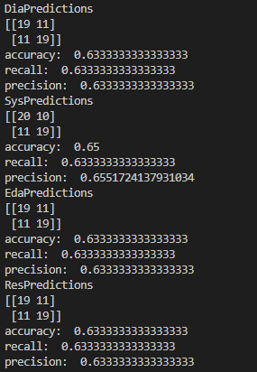



Data1.csv: training

Data2.csv: testing

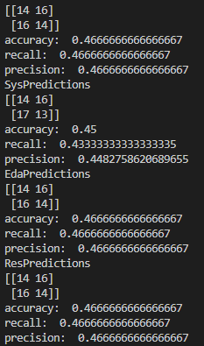



We can sese that the accuracy, prescision and recall was generally higher when data1.csv was the testing data than vice versa.

# Discussion and conclusion

I think physiological data is good for pain recognition. However, some physiological responses are shown to contribute to pain more so than others.

Do you think phsyiological data is good for pain recognition? What about fusion? Is there a better approach?

According to the data, the majority voting fusion approach did not improve the accuracy, recall or precision by very much. We think that fusion method from project 1, where the data was fused in the before random forest classification worked better. Though we cannot conclude anything definitively, we can see that by the results below from our project 1 algorithm using the project 1 fusion method with hand crafted features, that the method results in higher accuracy, recall, and precision.

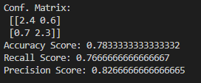

We think that contributing multipole modalities can improve the accuracy of the machine learning models. In the papers we referenced in the jintroduction section, using data from thermal readings, fiacial photos, videos of different resolutions, and temporal and spatial analysis of those videos allowed for more reliable and accurate predictions. This allows the model to get a more full picture of the different variables that contribute to pain.

##### References

**IEEE References are required.**

Werner, P., Al-Hamadi, A., Niese, R., Walter, S., Gruss, S., & Traue, H. C. (2014, August). Automatic pain recognition from video and biomedical signals. In *2014 22nd International Conference on Pattern Recognition* (pp. 4582-4587). IEEE.

@inproceedings{werner2014automatic,

title={Automatic pain recognition from video and biomedical signals},

author={Werner, Philipp and Al-Hamadi, Ayoub and Niese, Robert and Walter, Steffen and Gruss, Sascha and Traue, Harald C},

booktitle={2014 22nd International Conference on Pattern Recognition},

pages={4582--4587},

year={2014},

organization={IEEE}

}

Lucey, P., Howlett, J., Cohn, J., Lucey, S., Sridharan, S., & Ambadar, Z. (2008). Improving pain recognition through better utilisation of temporal information. In *International conference on auditory-visual speech processing* (Vol. 2008, p. 167). NIH Public Access.

@inproceedings{lucey2008improving,

title={Improving pain recognition through better utilisation of temporal information},

author={Lucey, Patrick and Howlett, Jessica and Cohn, Jeff and Lucey, Simon and Sridharan, Sridha and Ambadar, Zara},

booktitle={International conference on auditory-visual speech processing},

volume={2008},

pages={167},

year={2008},

organization={NIH Public Access}

}

Haque, M. A., Bautista, R. B., Noroozi, F., Kulkarni, K., Laursen, C. B., Irani, R., ... & Moeslund, T. B. (2018, May). Deep multimodal pain recognition: a database and comparison of spatio-temporal visual modalities. In *2018 13th IEEE International Conference on Automatic Face & Gesture Recognition (FG 2018)* (pp. 250-257). IEEE.

@inproceedings{haque2018deep,

title={Deep multimodal pain recognition: a database and comparison of spatio-temporal visual modalities},

author={Haque, Mohammad A and Bautista, Ruben B and Noroozi, Fatemeh and Kulkarni, Kaustubh and Laursen, Christian B and Irani, Ramin and Bellantonio, Marco and Escalera, Sergio and Anbarjafari, Golamreza and Nasrollahi, Kamal and others},

booktitle={2018 13th IEEE International Conference on Automatic Face \& Gesture Recognition (FG 2018)},

pages={250--257},

year={2018},

organization={IEEE}

}

Werner, P., Lopez-Martinez, D., Walter, S., Al-Hamadi, A., Gruss, S., & Picard, R. (2019). Automatic recognition methods supporting pain assessment: A survey. *IEEE Transactions on Affective Computing*.

@article{werner2019automatic,

title={Automatic recognition methods supporting pain assessment: A survey},

author={Werner, Philipp and Lopez-Martinez, Daniel and Walter, Steffen and Al-Hamadi, Ayoub and Gruss, Sascha and Picard, Rosalind},

journal={IEEE Transactions on Affective Computing},

year={2019},

publisher={IEEE}

}

Bellantonio, M., Haque, M. A., Rodriguez, P., Nasrollahi, K., Telve, T., Escalera, S., ... & Anbarjafari, G. (2016). Spatio-temporal pain recognition in cnn-based super-resolved facial images. In *Video Analytics. Face and Facial Expression Recognition and Audience Measurement* (pp. 151-162). Springer, Cham.

@incollection{bellantonio2016spatio,

title={Spatio-temporal pain recognition in cnn-based super-resolved facial images},

author={Bellantonio, Marco and Haque, Mohammad A and Rodriguez, Pau and Nasrollahi, Kamal and Telve, Taisi and Escalera, Sergio and Gonzalez, Jordi and Moeslund, Thomas B and Rasti, Pejman and Anbarjafari, Gholamreza},

booktitle={Video Analytics. Face and Facial Expression Recognition and Audience Measurement},

pages={151--162},

year={2016},

publisher={Springer}

}