Sew

DOCUMENTATION

Sew helps to organise all changes made to a repository into a single file. These changes can then be edited/translated removed etc. and applied it to a corresponding target repository.

Pre-requisites:

- Install Dotnet and Git

- Pull recent changes before running tool.

Basic Sew Workflow:

* Generate .sew file for Target repository.
* Make changes (translate) if necessary.
* Import .sew file and apply changes to Target repository.

# To Generate a .sew File:

- Choose Source and Target repositories from the file explorer.

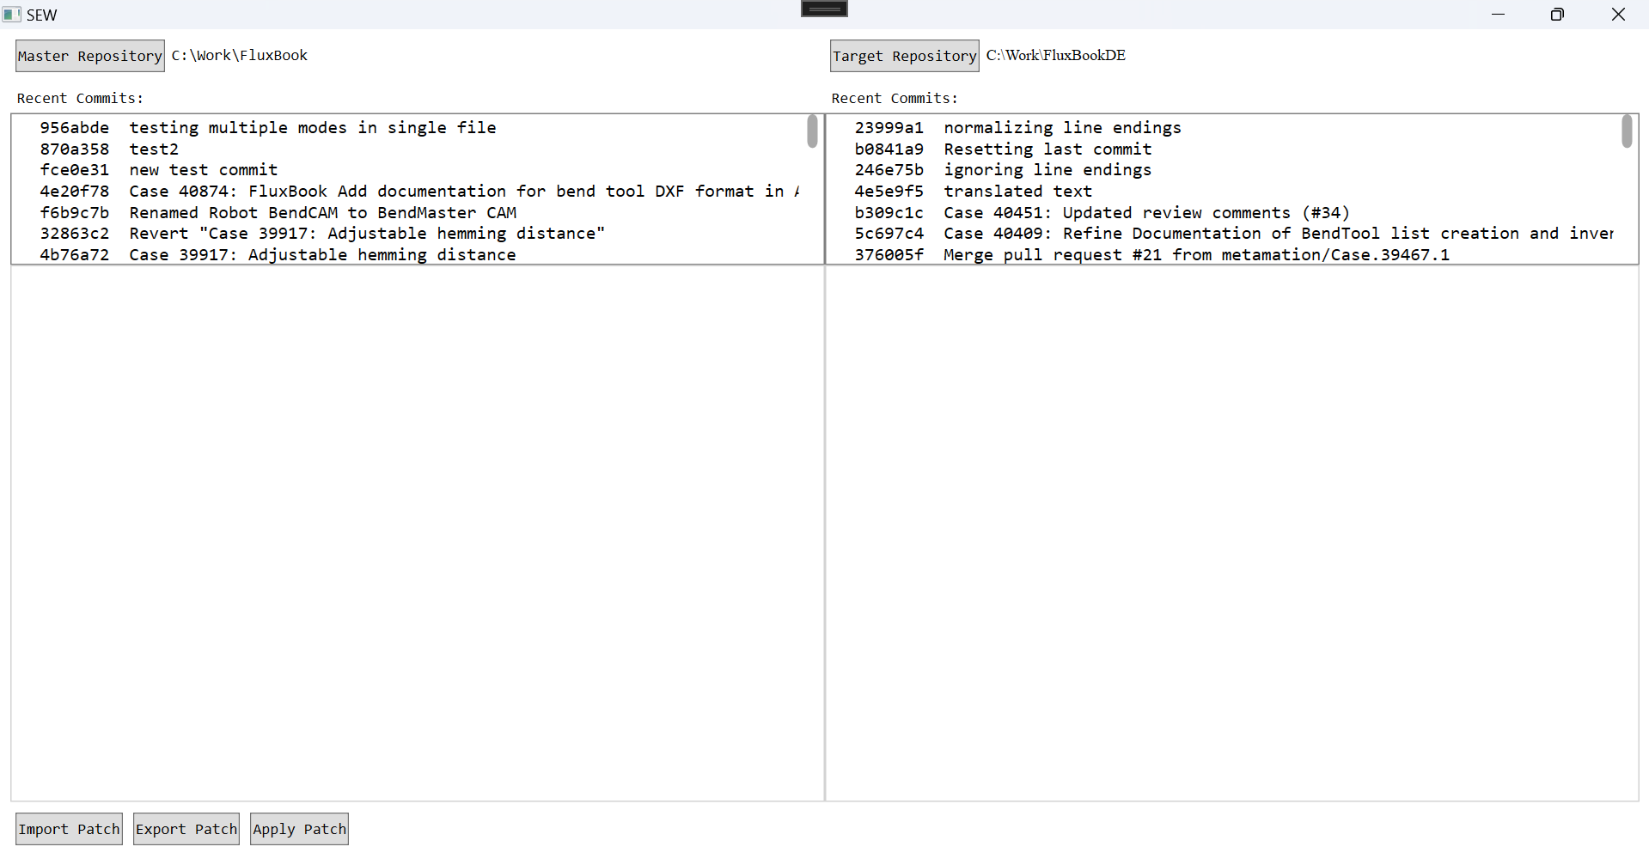

- Choose the LAST MERGED/TRANSLATED commit from recent commits (from the main branch); The generated diffs will be shown as below:

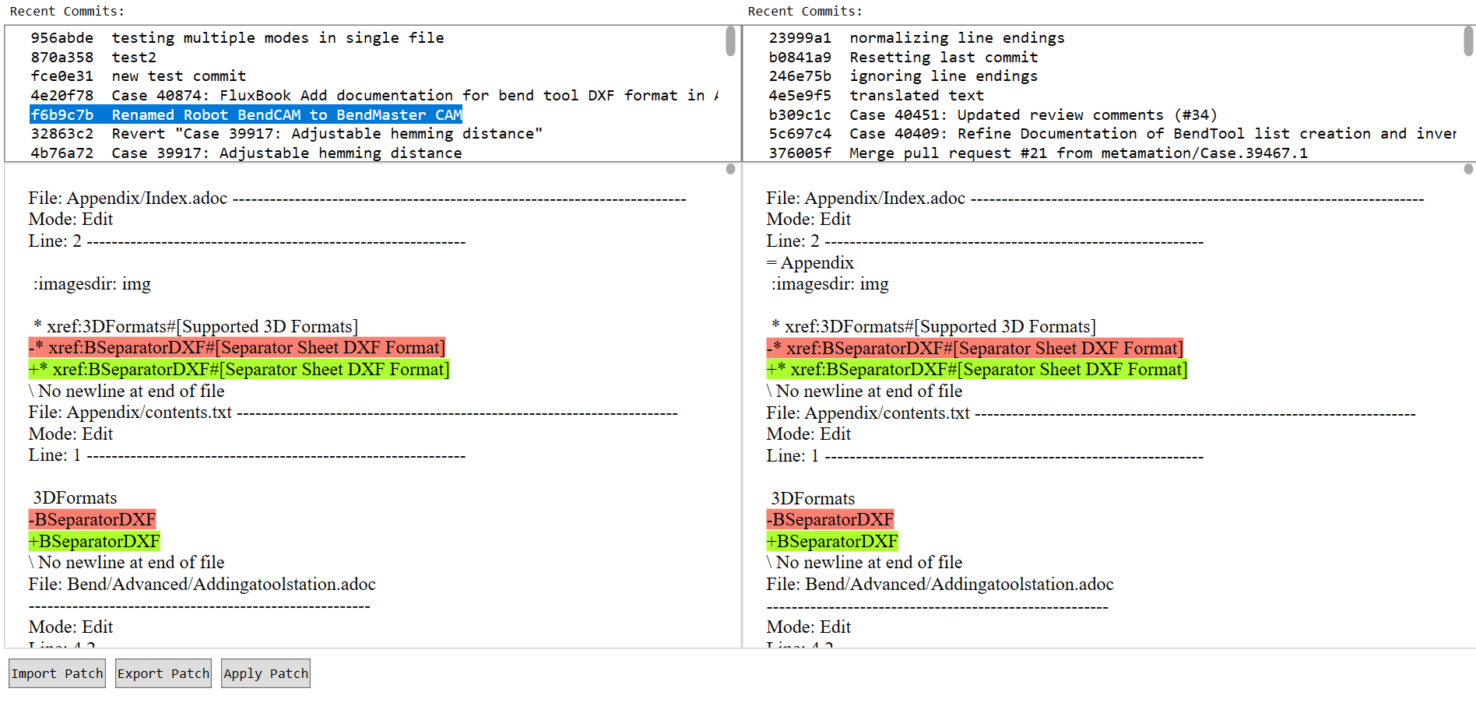

- The left diff corresponds to the source repository and the right diff to the Target.

- If target is not chosen, diff is generated for source repository changes.

- Click on 'Export Patch' to save CommitID.sew file in target repository.

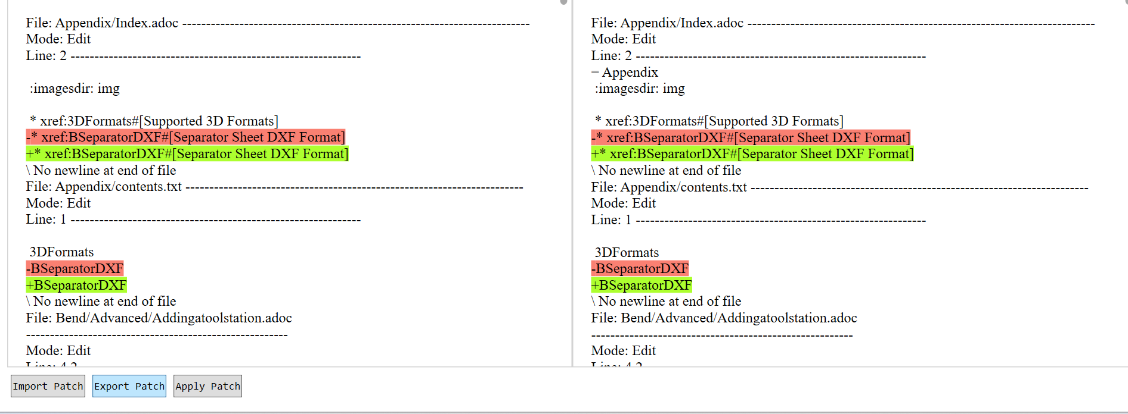

# To Edit a .Sew File:

- Open .sew file from the target repository (to which the changes are to be applied). It can be opened in any text editor (notepad, notepad++, word etc.)

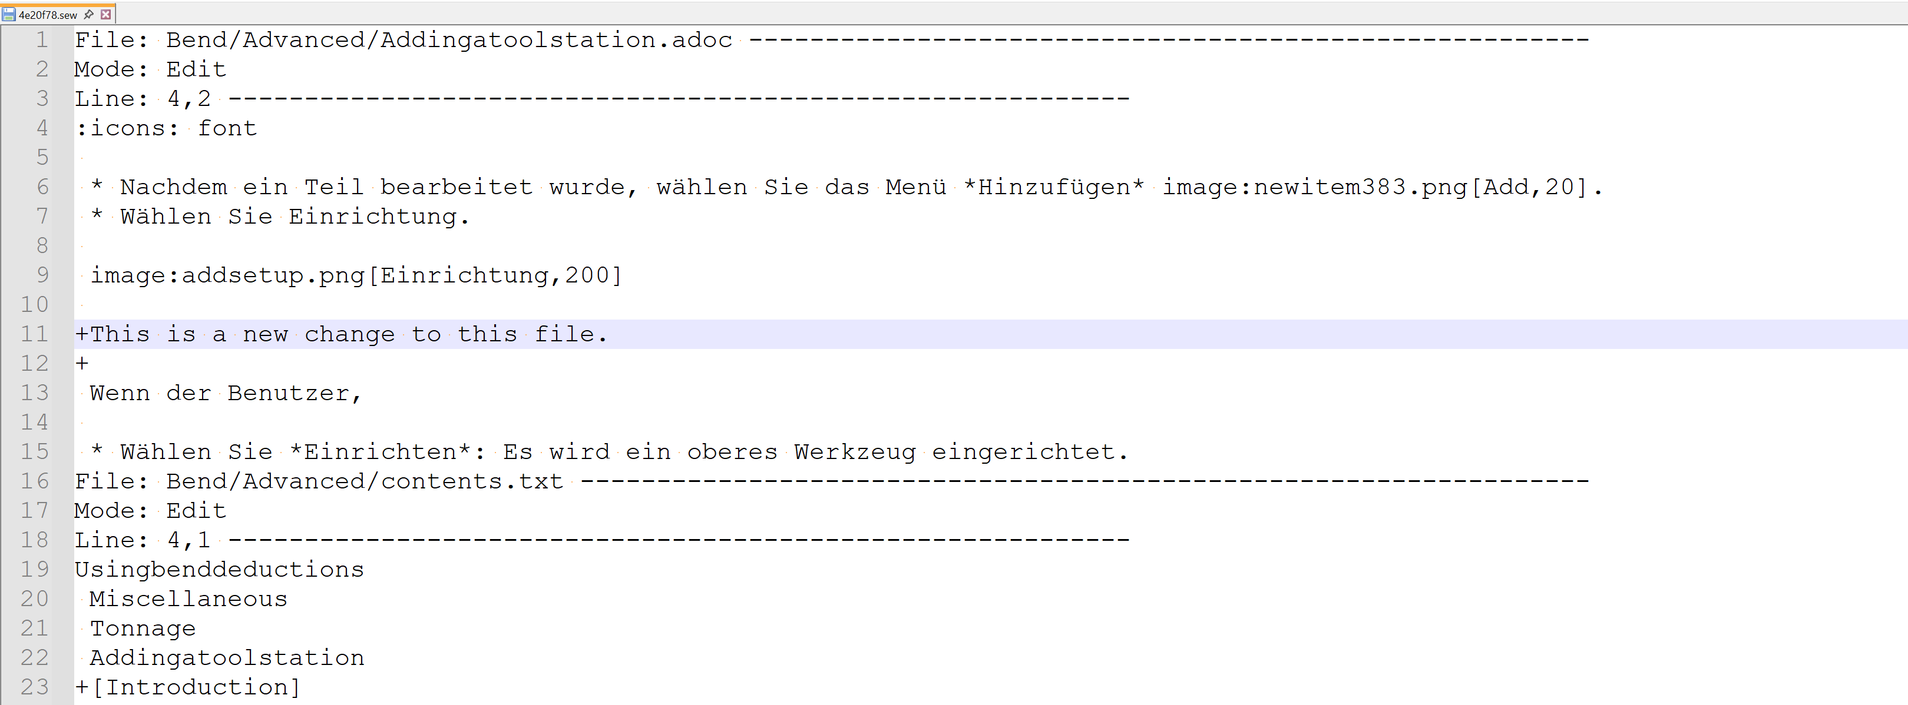

## File Structure:

- File = file path (Where is the file relative to the current folder?)

Mode = Edit | NewFile | Delete | Rename (What kind of changes were made?)

Line = StartLine (Where in the file is this change located?)

Lines = Number of lines (How many lines does a new file have?)

Below a newly added file is shown (Mode = New). It has 433 lines in total that have been added:

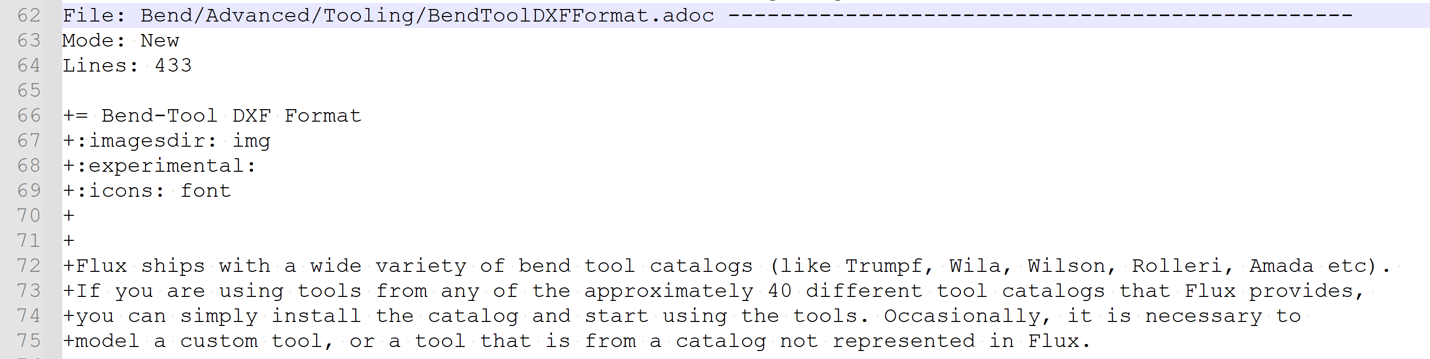

Files in Delete and Rename modes do not contain any information except that they were deleted/renamed.





- The changes are marked by a '+' or '-' sign to indicate if a line was added, removed, or changed.

- **Edits should ONLY be made in the lines starting with '+'.**

Line added:



Line Edited: ‘-‘ sign indicates the previous version of the line. ‘+’ sign indicates the new/changes version of the line. In this case, the changed version from the English document is sewn into the German document. **Only the line starting with ‘+’ must be changed.**

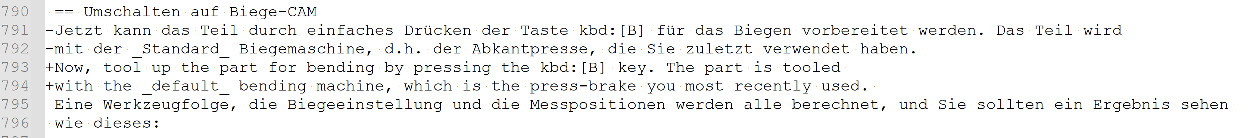

Any lines that have only been removed should not be edited.

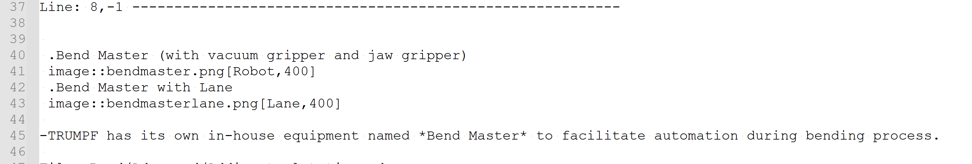

- A single File can have multiple "Line" sub-sections, one for each change made, but only one parent mode.

For example:

The following file has two changes made in two different places. Instead of writing the whole change along with context, it has been split into 2:

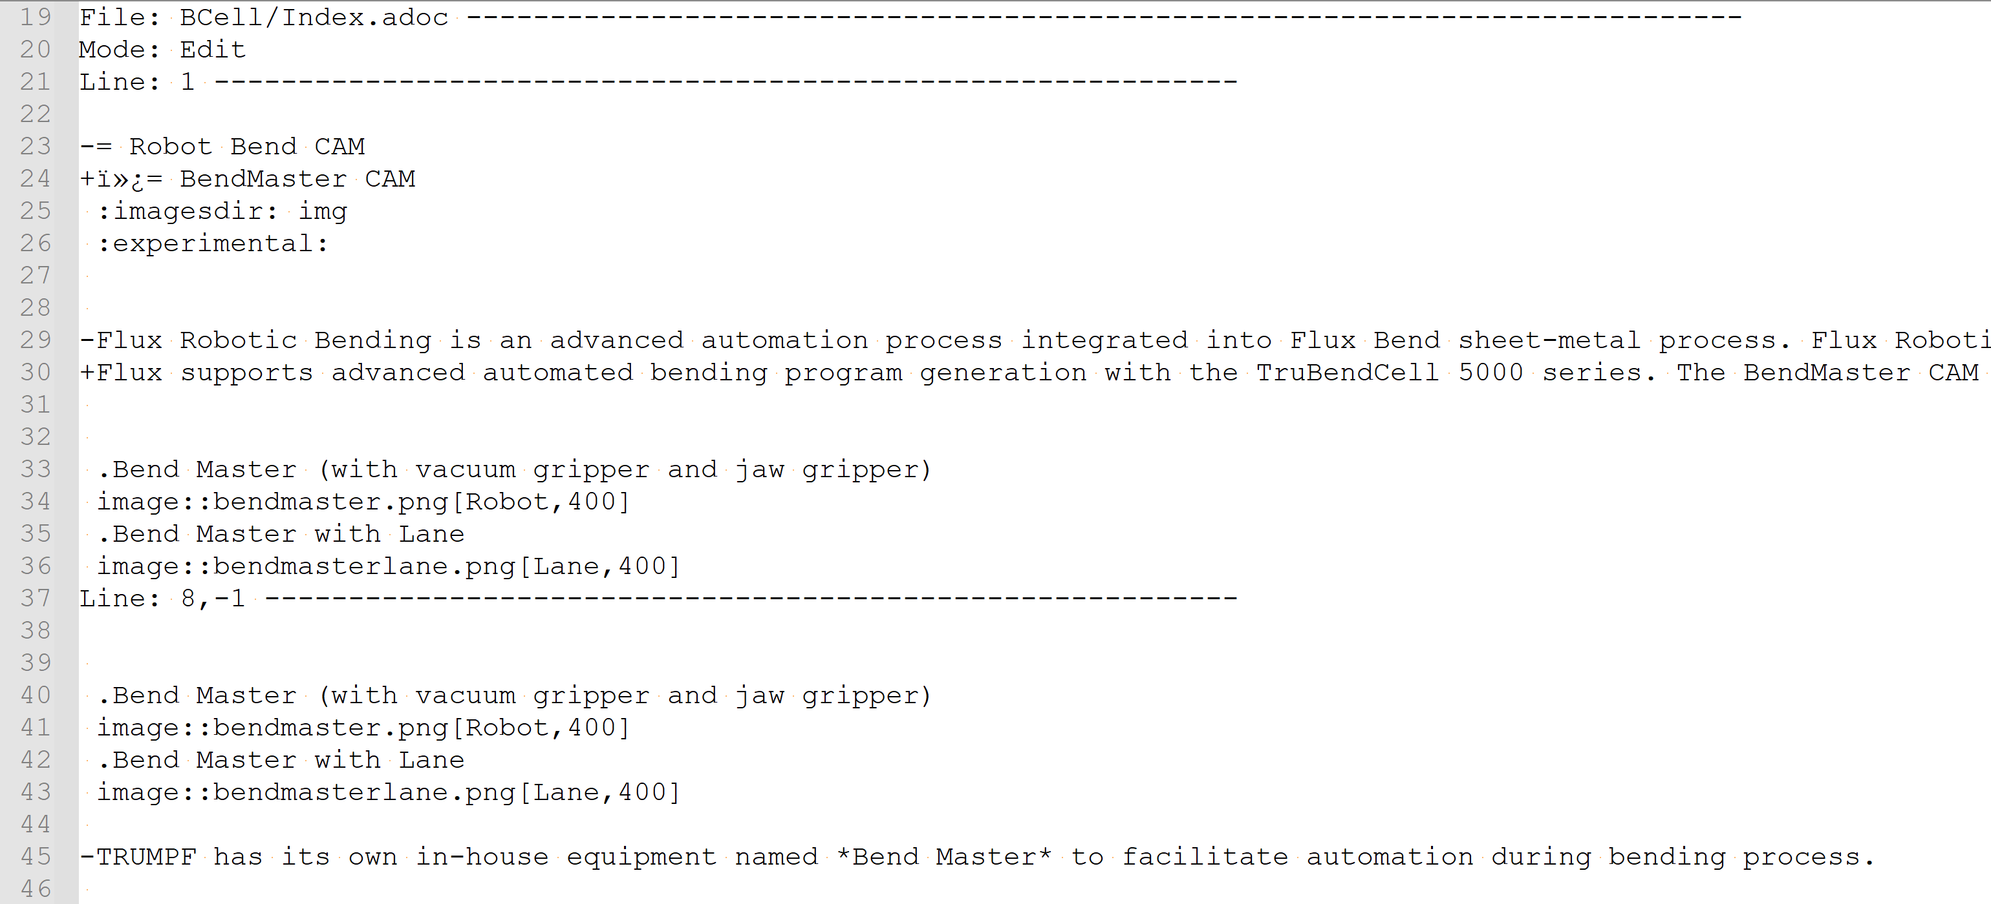

Renaming and then editing a file would require two entries like so:

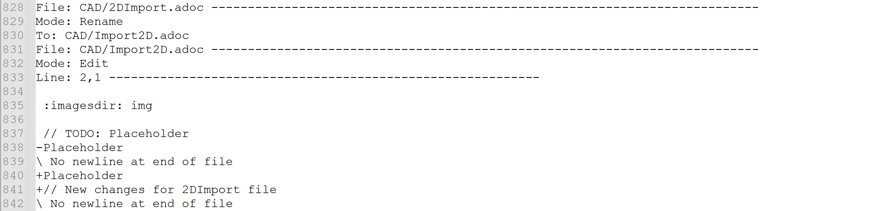

## To Apply changes to the Target repository:

- If .sew file already exists, click on 'Import Patch' button at the bottom of the screen and choose the file from the file explorer.

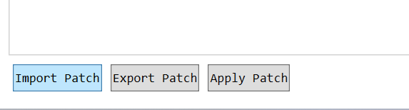

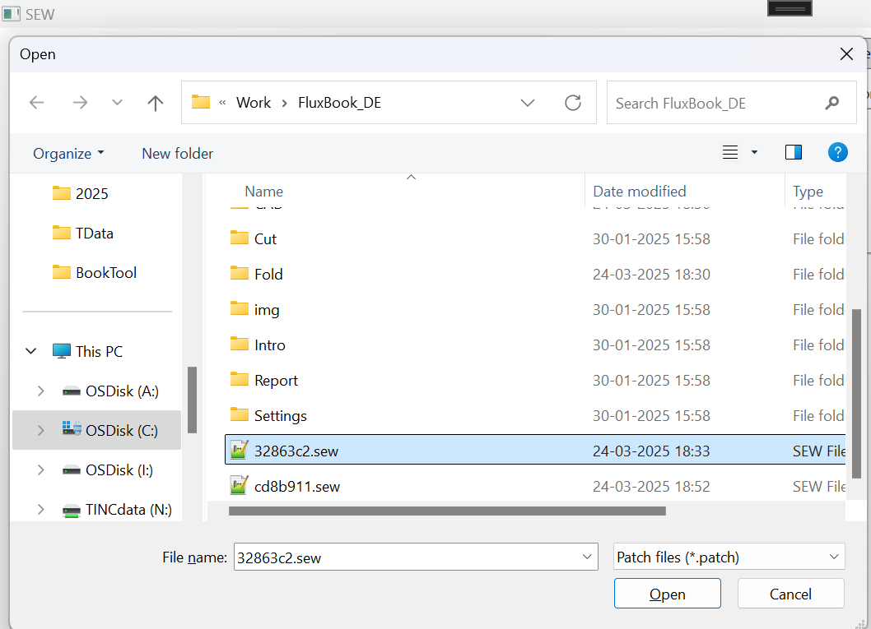

File will be loaded on the right side of the screen.

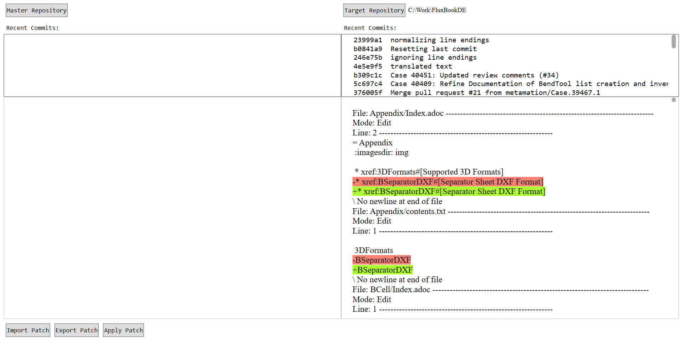

- Click on Apply patch. The right document will contain a detailed description if any error is encountered.

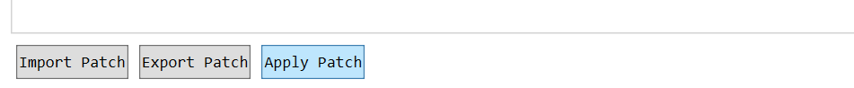

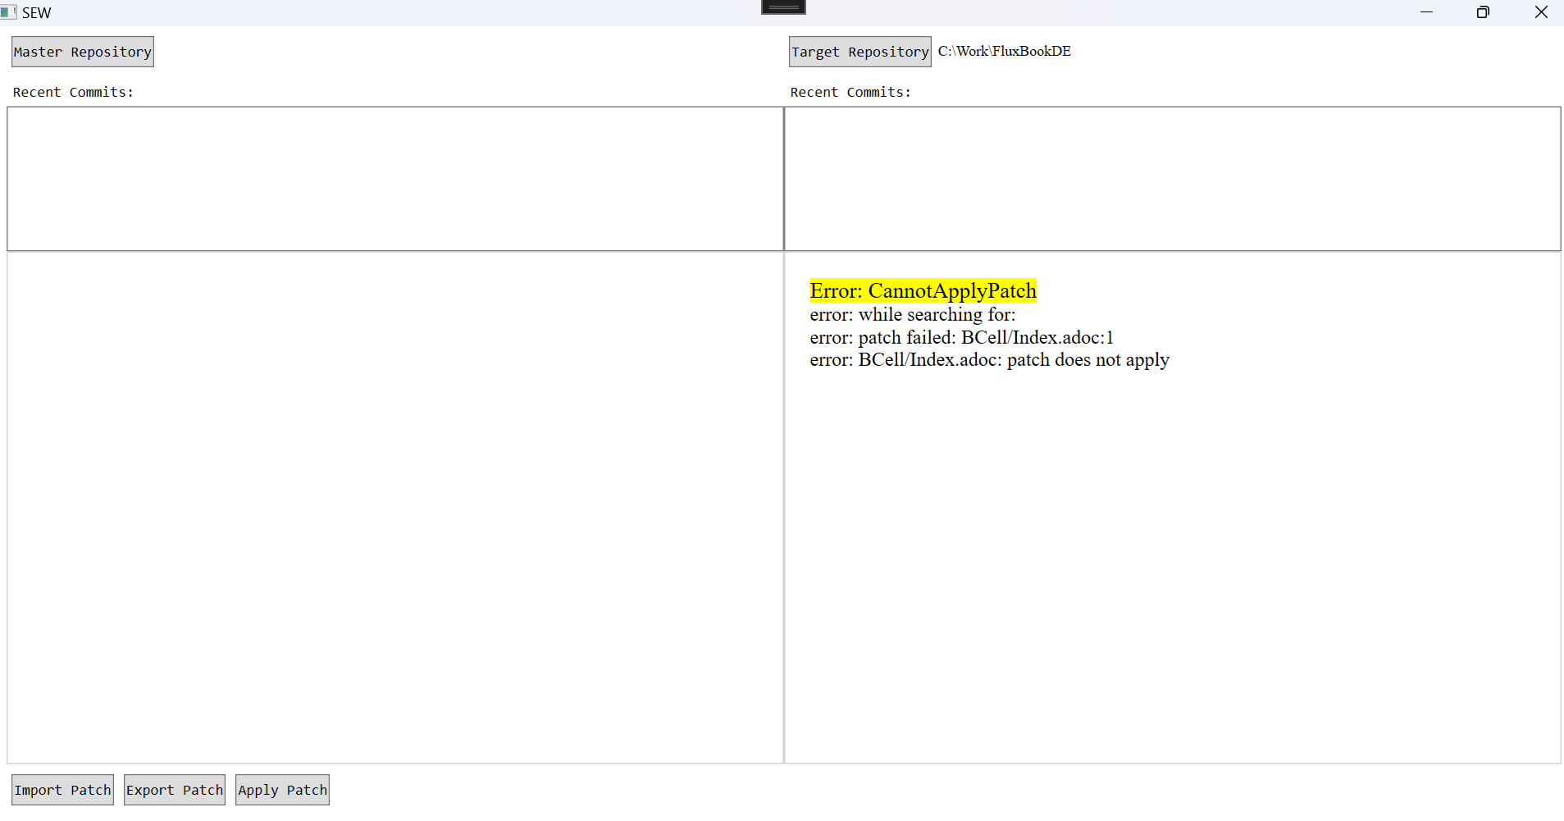

Generally, “Error: Cannot Apply Patch” messages are because you are trying to apply changes already there in the target repository.

Other messages like Error:

- If a patch is applicable, it is applied, and a diff is shown in winmerge/any difftool, if it is configured.

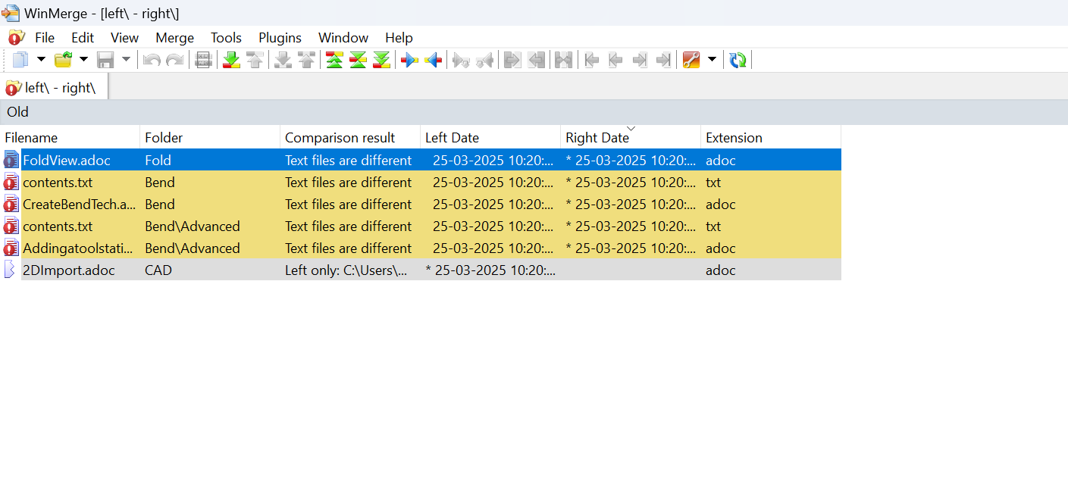

Otherwise changes can also be seen in the tool’s right window by choosing files from the treeview on the left.

Sew also supports applying changes made in other file formats such as .pngs.

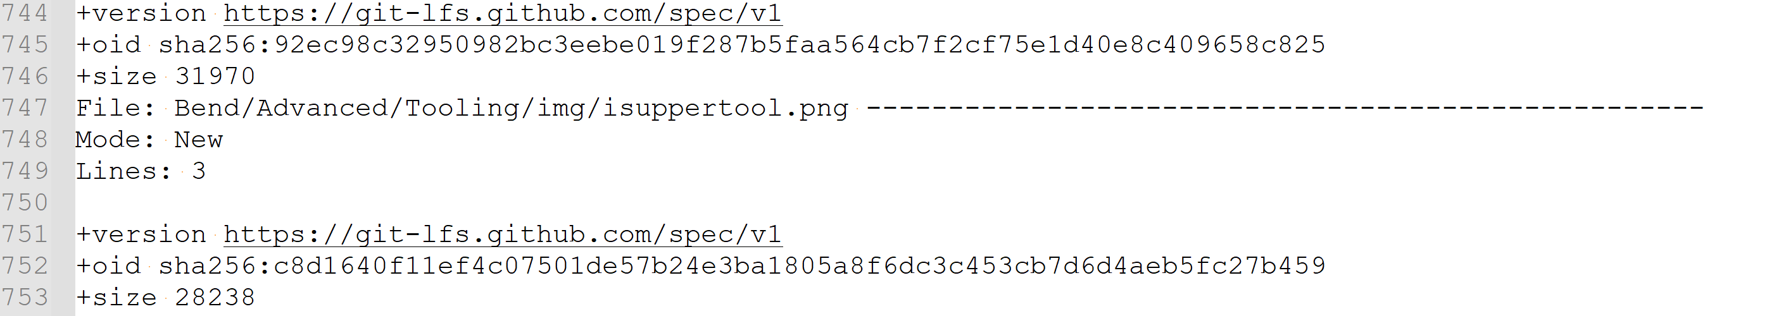

NOTE: Currently, only .png is supported for images.

Shortcuts:

Press [Ctrl+G] to go to a specific line in document after content has loaded.

Press [Ctrl+F] to find occurrences of words.