Game Design Document

Fill up the following document

1. Write the title of your project.

My DJ Game.

1. What is the goal of the game?

To overcome all the obstacles and to reach the required score.

1. Write a brief story of your game.

It is like mario game where obstacles come and we have to over come them and take the treasure to reach the required score.

1. Which are the playing characters of this game?

* Playing characters are the ones who respond to the user based on the input from the user.
* Cars, monkeys, dinos, wizards, etc., are the playing characters in the game.

|  |  |  |
| --- | --- | --- |
| Number | Character Name | What can this character do? |
| 1 | DJ | He can jump to avoid the obstacles |
| 2 |  |  |
| 3 |  |  |
| 4 |  |  |
| 5 |  |  |
| 6 |  |  |
| 7 |  |  |
| 8 |  |  |

1. Which are the Non-Playing Characters of this game?

* Non-Playing characters are the ones that don't have an action or behavior when the user interacts with the game.
* Hurdles, stones, bananas, coins, etc., are non-playing characters in the game.

|  |  |  |
| --- | --- | --- |
| Number | Character Name | What can this character do? |
| 1 | Grounds | It moves from right to left so as to hit the playing character |
| 2 | Treasures | It also moves right to left an the player have to collect them to increase there score |
| 3 |  |  |
| 4 |  |  |
| 5 |  |  |
| 6 |  |  |
| 7 |  |  |
| 8 |  |  |

Draw your imagination of this game. What does this game look like?

* Draw the game either on your computer or on paper.
* Add images of the game scenes to show each of the playing and non-playing characters at least once.

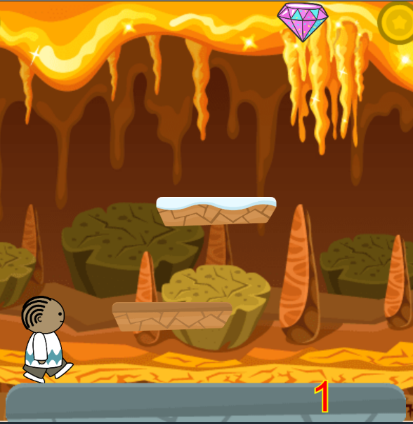

How do you plan to make your game engaging?

It is really fun to play this game because the carachter is not moving but the platforms are moving.