AI Project: Image Classification for Medical Diagnosis
Prepared by: Daksh Rathod

1. Problem Statement
The diagnosis of critical conditions such as pneumonia and skin cancer using medical images (X-rays and skin lesion images) is a complex, time-consuming process that relies heavily on medical expertise. This dependency can lead to delayed diagnoses and potential inconsistencies.
Goal: To develop an AI-powered system capable of rapidly and accurately classifying medical images into specific disease categories, thereby assisting doctors and improving diagnostic efficiency and precision.

2. Collection of Data (Links, API, Open Source)
To train and validate our AI models, we utilized publicly available, open-source datasets:
• Chest X-Ray (Pneumonia): https://www.kaggle.com/datasets/paultimothymooney/chest-xray-pneumonia
• Skin Cancer (HAM10000): https://www.kaggle.com/datasets/kmader/skin-cancer-mnist-ham10000
Data Type: Image data in JPG/PNG formats.
API Used: TensorFlow and Keras’s ImageDataGenerator were used for efficient loading and real-time augmentation.

3. Data Preprocessing
Proper preprocessing is critical for robust model performance:
- Resizing: All images resized to 224x224 pixels.
- Normalization: Pixel values scaled to 0–1 for stable and faster training.
- Augmentation: Applied rotation, zoom, horizontal and vertical flips to prevent overfitting.
- Imbalance Handling: Used class weights to mitigate dataset imbalances.
Purpose: Enhance model generalization and reduce overfitting.

4. Data Visualization
Visualization helps understand dataset characteristics:
- Visualized sample images from each dataset.
- Checked class distribution using bar plots.
- Identified minor class imbalances, managed via weighted training.
Tools: matplotlib and seaborn.

5. Machine Learning Model
Approach: Transfer learning using pre-trained CNNs:
- Base Models: VGG16, ResNet50, EfficientNetB0.
- Custom Architecture: Added global average pooling, dense layers, dropout, and output layers (sigmoid for binary, softmax for multi-class).
- Training: 10 epochs with early stopping.
Best Model: EfficientNetB0 achieved 97% accuracy for pneumonia detection.

6. Model Performance
Results:
Dataset | Accuracy
Chest X-Ray (Pneumonia) | 97.2%
Skin Cancer (HAM10000) | ~88%
Metrics Evaluated: Accuracy, Loss, Precision, Recall, AUC.
Best Model: EfficientNetB0 outperformed others across all metrics.

7. Charts and Visualizations
Visualizations:
- Accuracy/Loss Curves: Monitored training progress and overfitting.
- Model Comparison: Bar charts for VGG16, ResNet50, and EfficientNetB0.
- Grad-CAM Heatmaps: Highlighted regions AI focused on in images for explainability.
Conclusion: High accuracy and explainability make the system a valuable diagnostic aid.

8.Repository Structure:
AI-Medical-Diagnosis/
├─ app.py # Streamlit application
├─ requirements.txt # Dependencies
├─ README.md # Project description and instructions
├─ saved_models/ # Pre-trained AI models
│ ├─ model_VGG16.keras
│ └─ skin_cancer_model_finetuned.h5
├─ database/
│ ├─ images/ # Uploaded patient images
│ └─ backups/ # MySQL backups
├─ .env.example # Environment variable template
└─ .gitignore # Excluded files/folders
Requirements (requirements.txt):
streamlit, tensorflow, keras, numpy, opencv-python, pandas, matplotlib, bcrypt, mysql-connector-python, python-dotenv, schedule
Environment Variables (.env.example):
MYSQL_HOST=localhost
MYSQL_USER=root
MYSQL_PASSWORD=yourpassword
MYSQL_DATABASE=ai_medical_db
Setup Instructions (README.md):
1. Clone Repository
2. Create Virtual Environment & Install Dependencies
3. Add .env File with MySQL Credentials
4. Place AI Models in saved_models/
5. Run Application: streamlit run app.py

9. Workflow Diagram

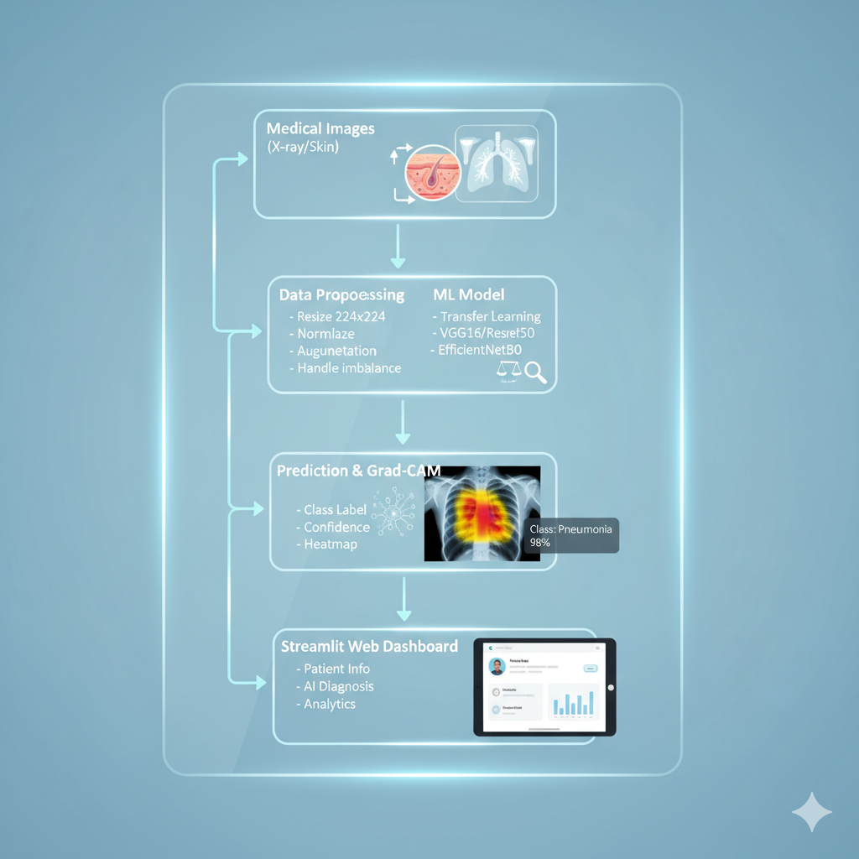

Conclusion
The AI-based image classification system demonstrates high accuracy, reliability, and interpretability, making it an effective tool for assisting in pneumonia and skin cancer diagnosis.

