VST Here: <https://asb2m10.github.io/dexed/>

Extra presets: <https://www.kvraudio.com/forum/viewtopic.php?t=277864>

[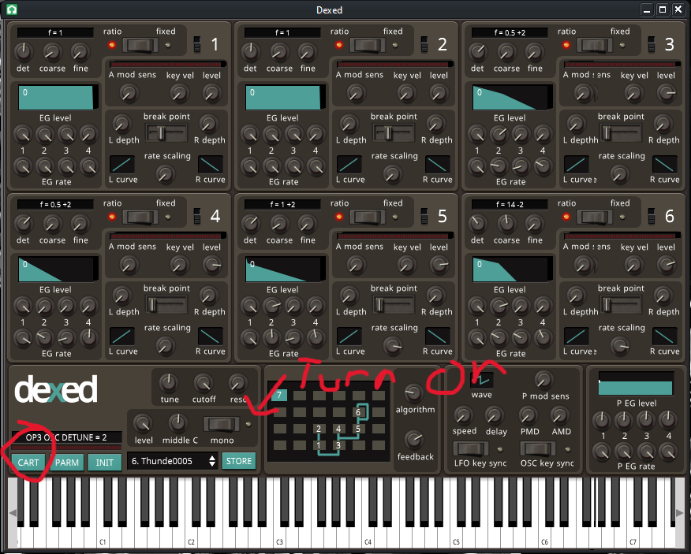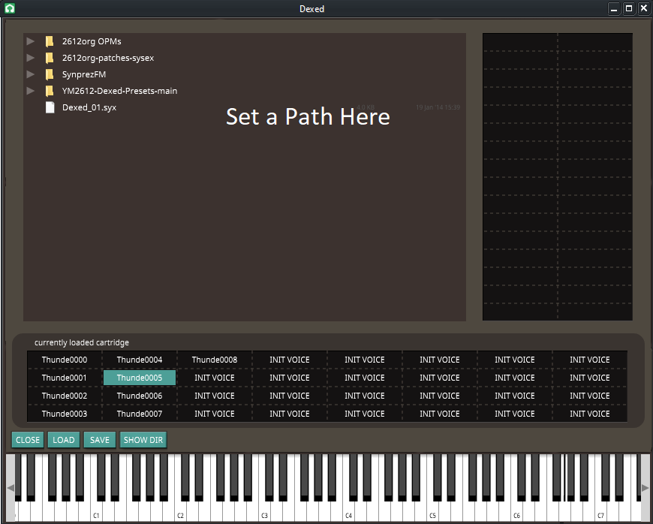](https://www.kvraudio.com/forum/viewtopic.php?t=277864)