Scope: To copy “.bak” file created on server to desktop via TASK Scheduler on Client.
The Server and Client are connected via Workgroup. Folder on server is mapped with Drive letter (Y:)
Part 1: Prepare a BATCH file to copy (The batch file is inset.)
When the Batch file ‘copyback.bat’ executed and the ‘db_back.bak’ is copied from SERVER to CLIENT pc. The file name changes to ‘db_back_dd-mm-yyyy.bak’ while copying.
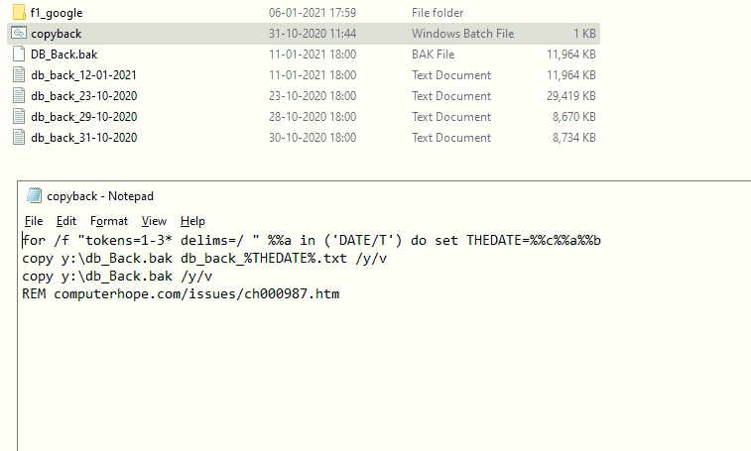
Figure 1 Files in Folder and BATCH file. The folder shows file db_back_12-01-2021.
Folder on Client PC. This shows ‘DB_Back.BAK’ and ‘db_back_12-01-2021’files.
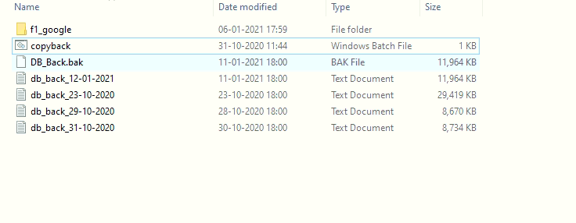
Figure 2 List of files after successful activity

Part 2: Setting Batch file in TaskScheduler on Client PC to copy ‘.BAK’ file from SERVER to CLIENT.
Schedule BATCH File. Properties. GENERAL.
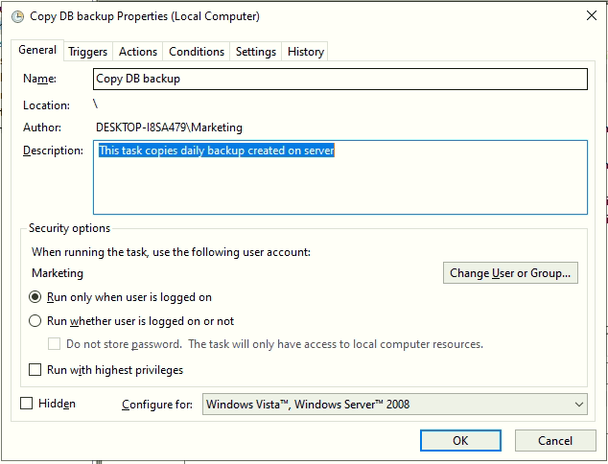
Figure 3

TRIGGER: On 1815Hrs everyday. Backup is completed on SERVER at 1800Hrs. everyday. (Takes seconds to complete the task)
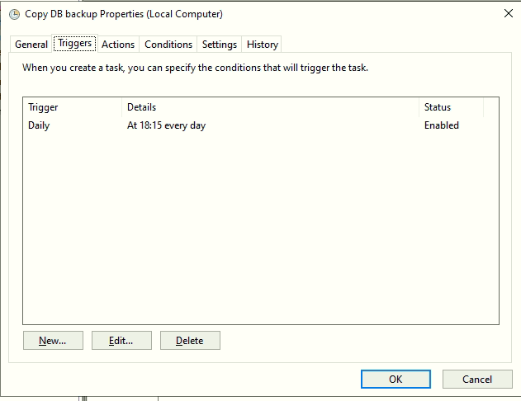
Figure 4
Batch file is selected in ACTION tab.
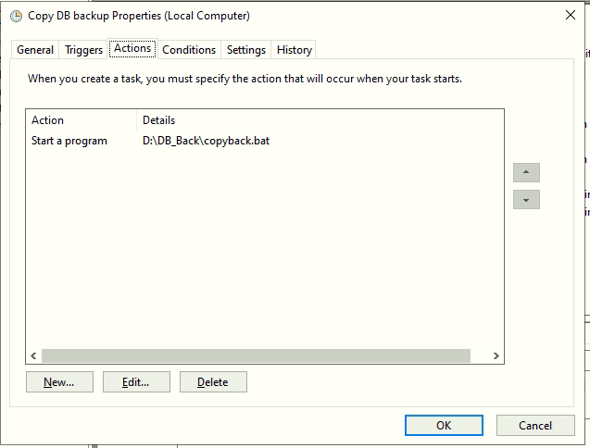
Figure 5
HISTORY: Shows the TASK is completed successfully. No errors are shown. But the expected result is not achieved.
COPY .BAK file from SERVER to CLIENT PC. Not Successful.
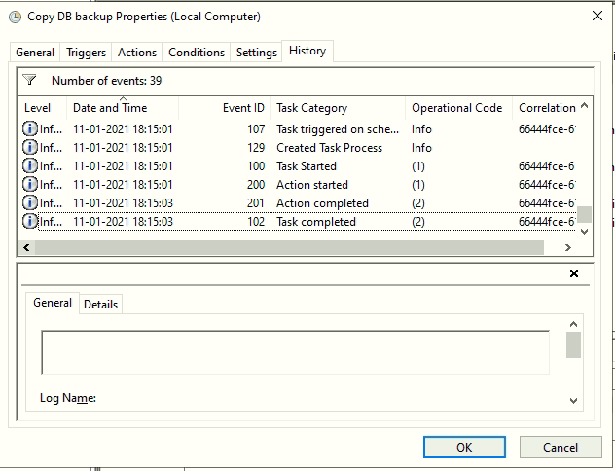
Figure 6

