Supplementary Bill
- The Bill will be generated ONLY when one DAILY BOOKING bill is generated.
- The DETAILS will be entered as a separate bill
- The Bill will be created for
- Electricity Charges
- Makeup Room
- Outdoor
- Bill Details will have charges, Rate, Amount. The Qty. will have break up in diff table.
- Separate Bills can be printed
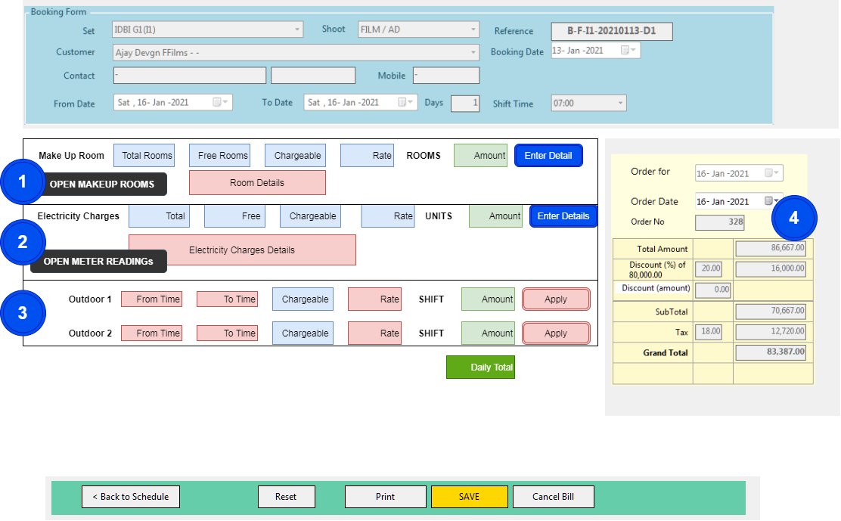
- Section 1: Makeup Room
- Section 2: Electricity Charges
- Section 3: Outdoor Bookings
- Section 4: Bill Valuation

- Section 1: Makeup Room
  - By Default the Makeup Rooms from the selected SET will be shown
  - Additional Makeup Room from Other SET can be Added
  - From the list of Makeup Rooms, mark occupied rooms
  - The Total Makeup Rooms will be calculated
  - After completion of marking, click on CLOSE.
  - The Total makeup rooms, free makeup room will be shown
  - The charges of makeup room will be calculated
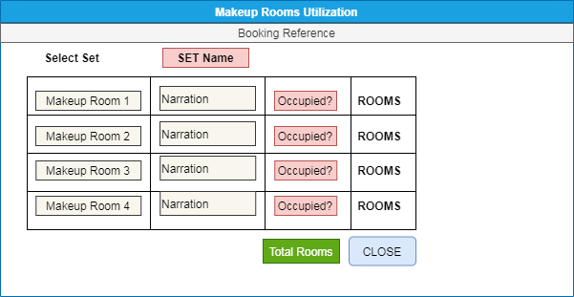

- Section 2: Electricity Charges
The METER Readings FORM will be opened. This FORM can be used for BILLING / FACILITY Activity.
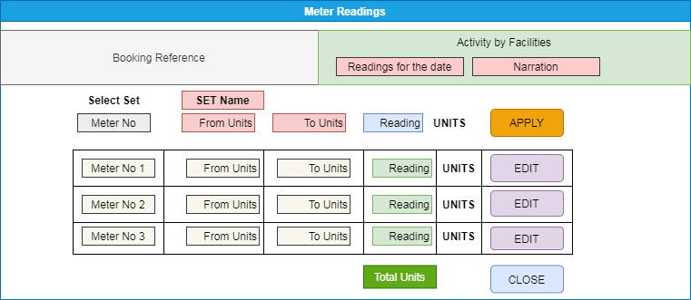
  - If the METER Readings are to be entered for Booking – The Booking Details will be shown
  - IF the METER Readings are to be entered for ACTIVITY of FACILITIES, the DETAILS will be entered.
  - Reading for the DATE will be entered.
  - The Meter No. of the SET will be selected.
  - In case of Booking – Meter of the SET will be selected. Additional Meter from other SET can be added.
  - FROM – TO units will be entered
  - The Total Units will be calculated.
  - Optional – Other Meter can be selected and UNITs details will be entered.
  - Total Units will be calculated. If FREE units are applicable will be applied to Total UNITs.
  - The Electricity charges will be calculated

- Section 3: Outdoor Entries (Optional)
  - In case of Outdoor shooting is carried out, the FROM – TO time will be entered.
  - Hours will be calculated
  - The RATE to calculate amount will be entered OR LUMPSUM Amount will be entered.
- Section 4: Bill Valuation
  - The Total Amount will be calculated.
  - DISCOUNTS will not be applicable
  - TAX will be applicable
  - BILL NO – This will be generated from the regular series

- SET-Electricity Meter and SET-Makeup Room Master
Entry of Set-wise Electricity Meter and Makeup Room.
  - The Set will be selected
  - Meter No 1, 2, 3,4 : Electricity Meter No will be entered
  - Alias: The conventional name / usage of the meter will be entered
  - Remarks: If any.
Makeup Rooms: The serial numbers of the makeup rooms will be generated and will be used in Billing
  - From No – To No: The makeup room numbers will be entered.
  - Generate – The series of Makeup Room numbers will be generated as per FROM and TO numbers
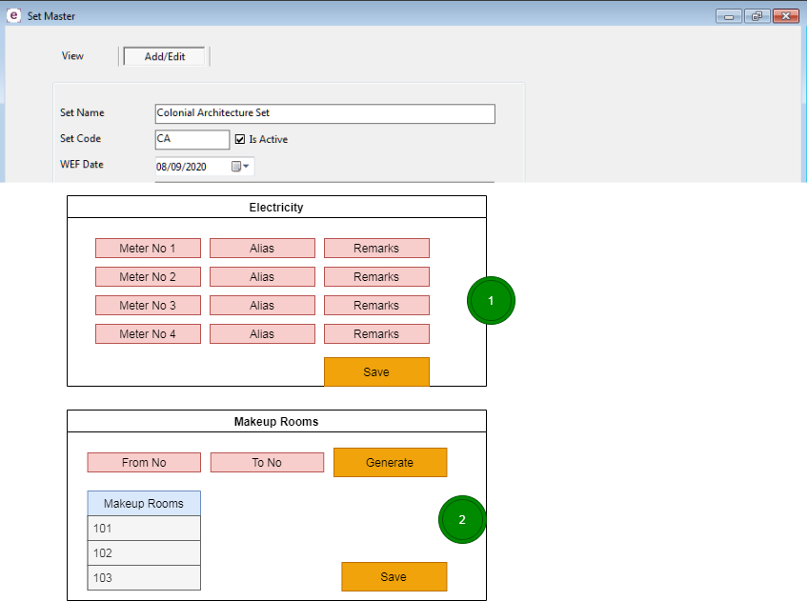

- Outdoor Set Master
  - The master will be created for the OUTDOOR. The Outdoor will be linked to the existing SET OR independent.
  - The UoM for the billing will be entered.
  - The charges can be used in ENQUIRY form entry.
  - The charges can be used during the Bill Entry.

End of doc

