Accounting
Debtor Report
- To maintain TDS deposited by customers. Balance of Customers and marking settlement of Booking.
- BATCH is created from multiple Bills of CUSTOMER from the System.
- The batch will be marked with TDS and Receipts.
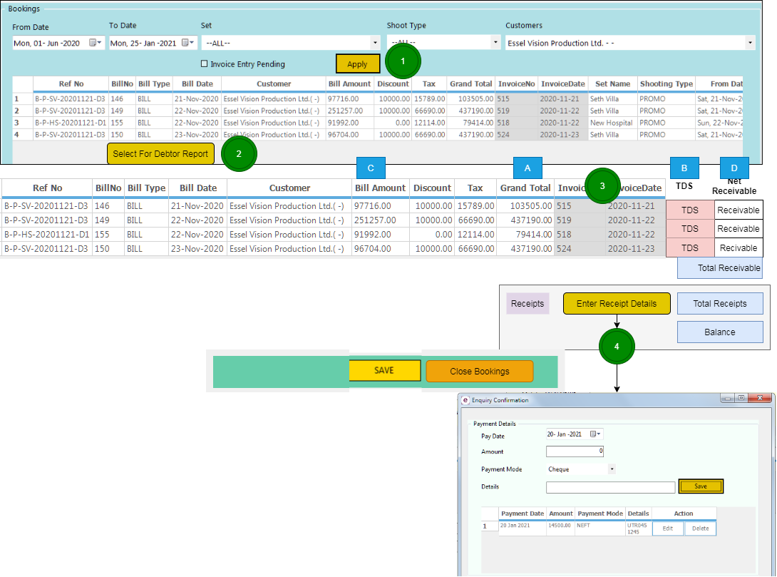
- The Receipts will be entered against Bookings
- The open BATCH will be shown for Receipts
- The BATCH will be closed by the user after entry of all the Receipts of customer.
- The Total amount of receipts can be MORE THAN Total Receivable (Excess received from the customer) or LESS THAN Total Receivable (balance with the customer)
- Reports – Customer wise Balance Report will be generated
- Customer Selection
  - All the Bookings not settled will be selected
- Booking Selection
  - Booking Schedule will be selected
  - A batch will be created for Booking Settlement
- TDS Entry
  - TDS amount will be entered for each booking
  - Total of Receivable will be generated
- Receipts Entry
  - The details of Receipts will be entered
  - The Advance received for the booking will be selected from the Enquiry ENTRY
  - Total receipts will be calculated
  - Balance Payable will be selected
- Save / Confirm Payment
  - The PARTIAL settlement can be saved.
  - The Partial settlement can be selected further for Complete Settlement
  - CONFIRM – to complete settlement

End of doc

