KDC Helpdesk System
The KDC Helpdesk System is a web-based application developed using PHP and MySQL to manage and track IT support tickets within an organization.

🚀 Features
- User login system (Admin / Technician / User)
- Ticket creation and tracking
- Status updates (Pending, In Progress, Resolved)
- Technician assignment
- Report generation

🛠️ Technologies Used
- PHP
- MySQL
- HTML, CSS, JavaScript
- XAMPP

📷 Screenshots
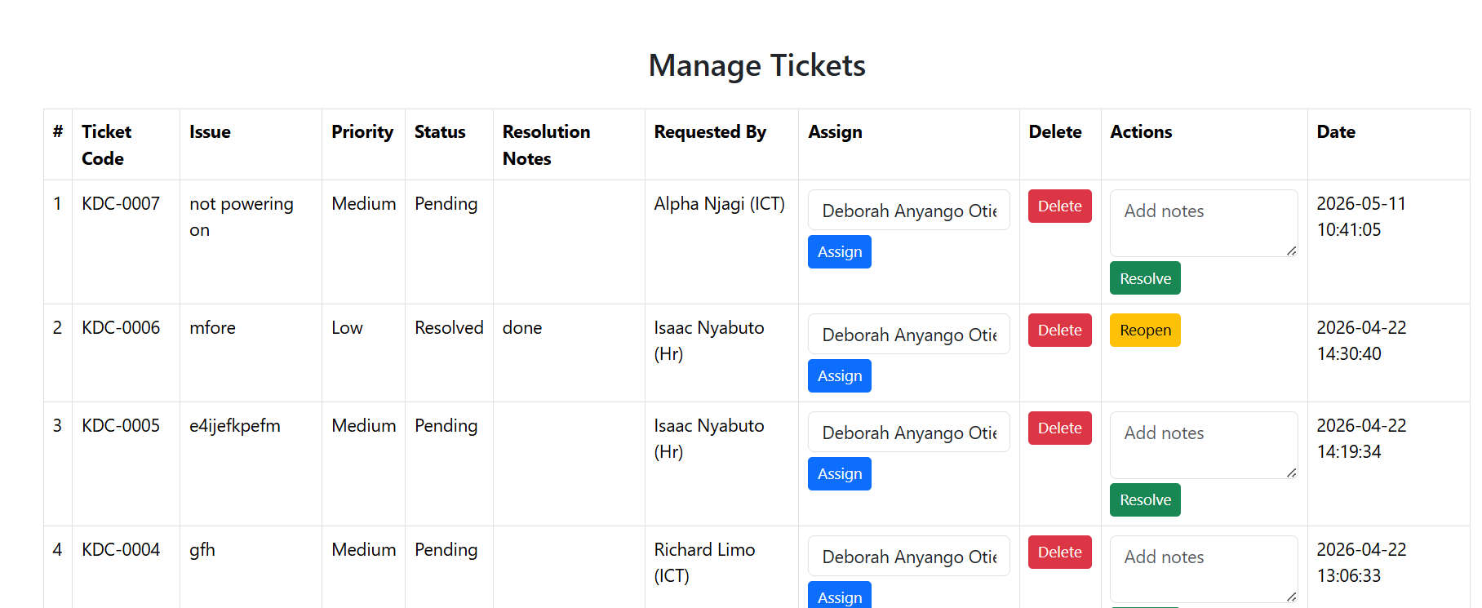a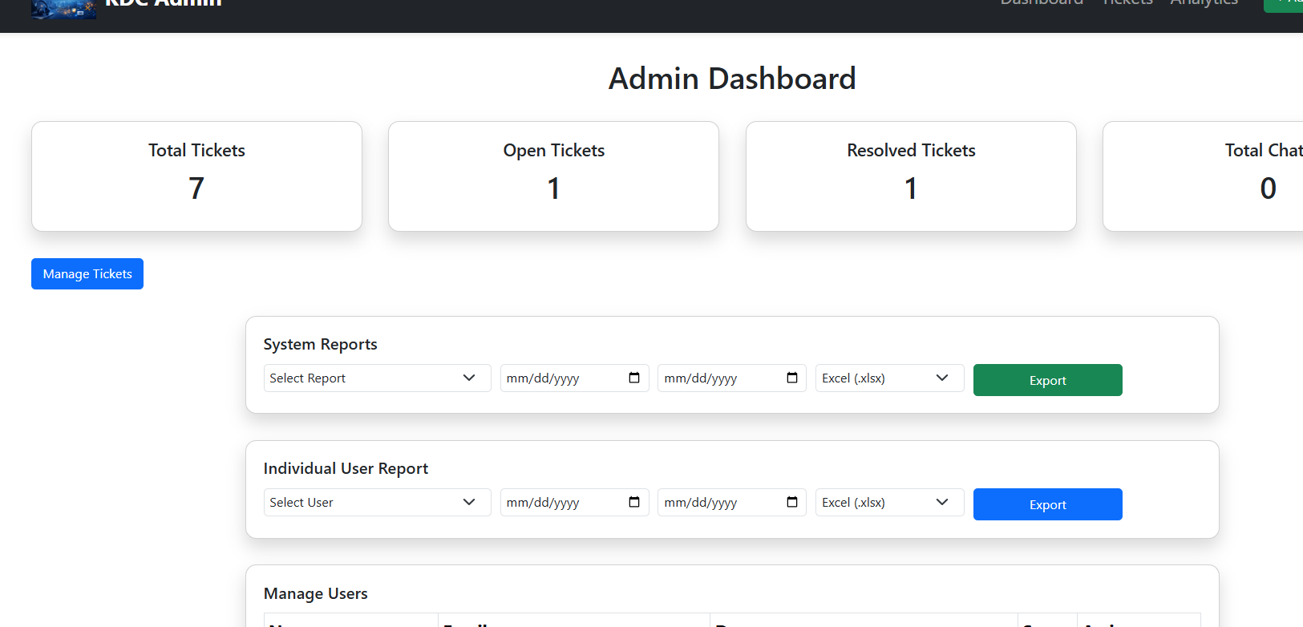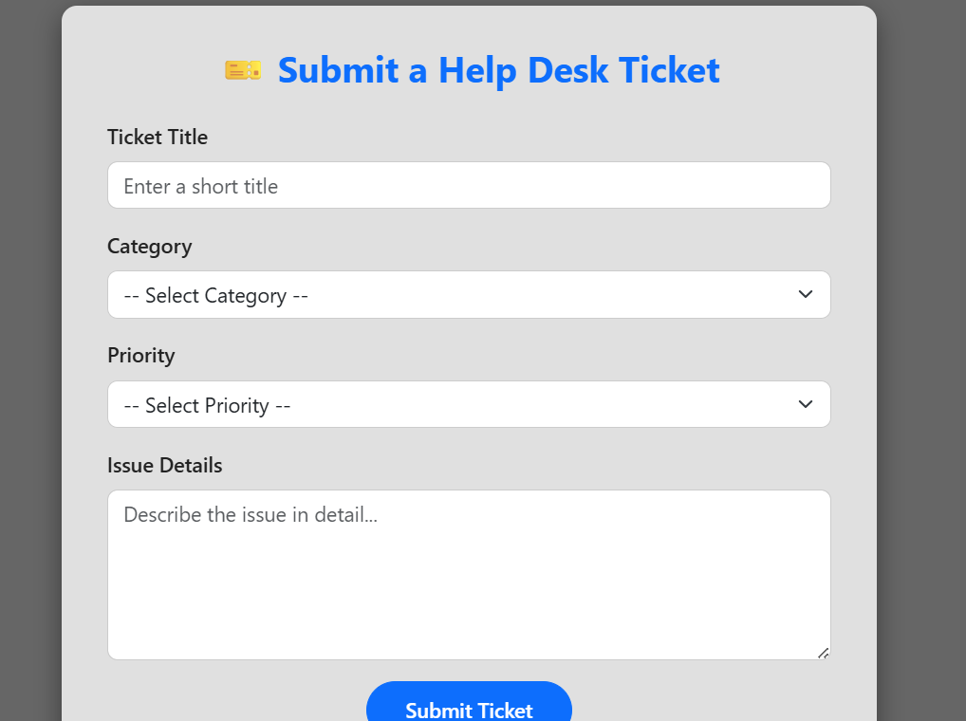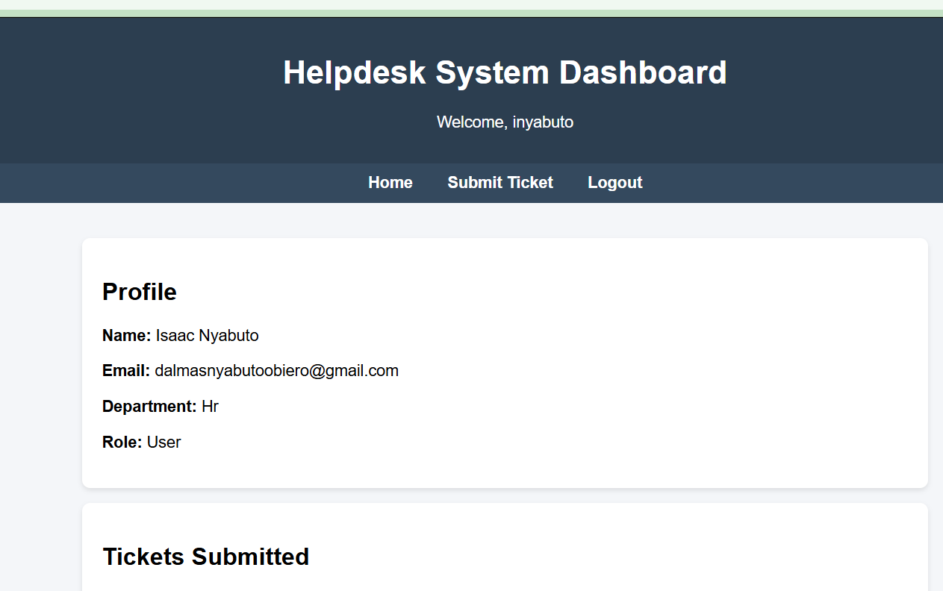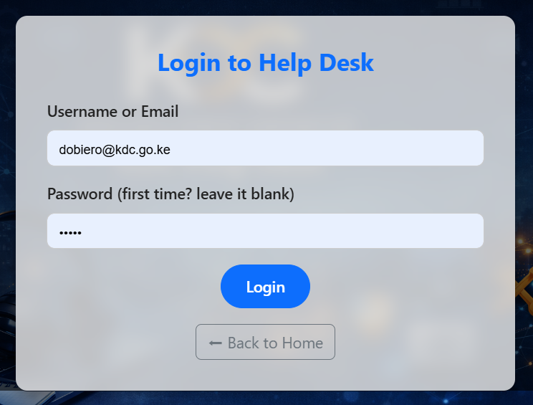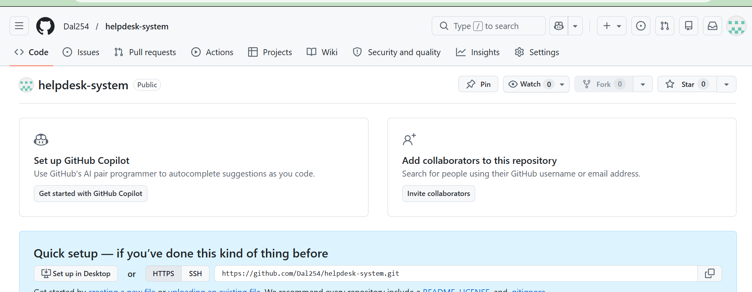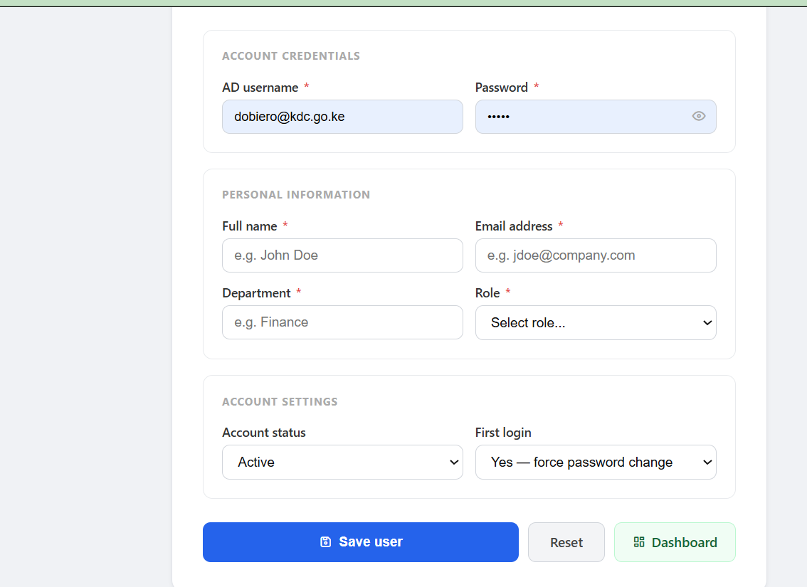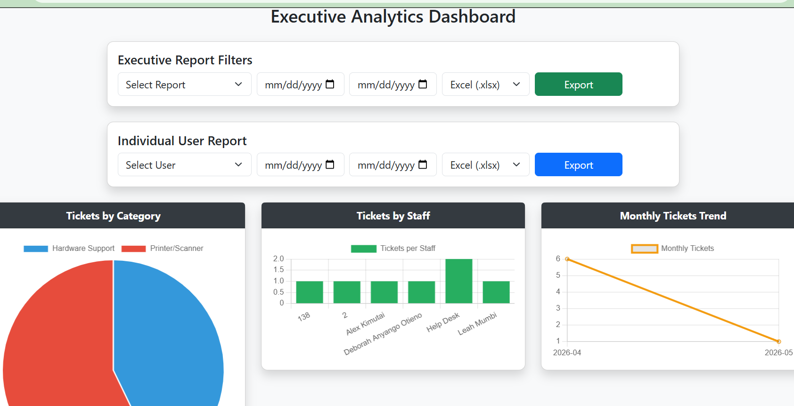

⚙️ Installation Guide
- Copy project to:
C:\xampp\htdocs\helpdesk
- Import database (helpdesk.sql) in phpMyAdmin
- Start Apache & MySQL
- Open:
http://localhost/helpdesk

🔐 Default Login
Admin:
username: admin
password: *****

Author
Dalmas Nyabuto obiero

💼 Projects
KDC Helpdesk System
- Developed a web-based IT support ticketing system using PHP and MySQL
- Implemented role-based access (Admin, Technician, User)
- Enabled real-time ticket tracking and reporting
- Deployed on Windows Server using XAMPP

