BUSINESS ANALYST CASE STUDY
University Fee Payment System
AS-IS / TO-BE Process Analysis, BPMN & UML Models
Project Name | University Fee Payment System (UFPS)
Document Type | BA Case Study & Process Models
Version | 1.0
Date | September 2026
Author | Dalali Shiva Kumar
Status | Draft — Self-Initiated Portfolio Case Study
This is a self-initiated case study prepared for portfolio and interview purposes.
It does not represent a real client engagement or implemented system. See the accompanying BRD for full requirements.

1. Project Overview
This case study analyses and redesigns the student fee payment process for a university. Today, students face difficulty tracking exact fee dues, payments pass through disconnected channels, and Finance staff spend significant time manually verifying and reconciling transactions. The objective of this project is to analyse the current (AS-IS) process, identify pain points, and propose an improved (TO-BE) process supported by a centralized University Fee Payment System (UFPS).
Full business and functional requirements for the proposed system are documented separately in the accompanying Business Requirements Document (BRD). This document focuses on process analysis and visual modelling using BPMN and UML.

2. Stakeholders
Stakeholder | Role
Student | Logs in, views fee details, and makes payment.
Parent / Guardian | May make payments on behalf of the student (assumption).
Finance Department | Views and reconciles payment transactions.
University Administration | Provides oversight of the fee collection process.
Payment Gateway | External system that processes online payments.

3. AS-IS Process
Currently, a student who wants to pay their fee must contact the Finance Office directly to confirm the exact amount due, since this information is not available to them online. The student then makes the payment through a bank deposit or at a cash counter, and submits proof of payment (such as a deposit slip or screenshot) back to the Finance Office. Finance staff manually verify this proof against bank statements and update the student's fee status in a spreadsheet or register. Because every step relies on manual coordination, the student is often informed of successful payment only after a delay of several days.
The diagram below illustrates this current process across the two involved parties.

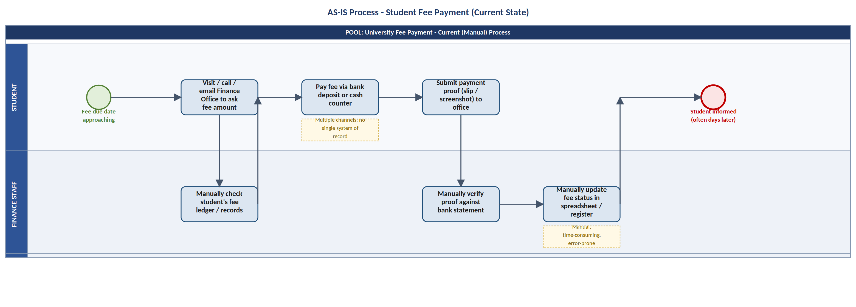
Figure 1: AS-IS Process — Student Fee Payment (Current Manual State)

4. Current Pain Points
- Students lack real-time visibility of the exact fee amount due and current payment status.
- Multiple, disconnected payment channels make transactions difficult to track consistently.
- Manual verification and status updates by Finance staff cause delays of several days.
- Students do not receive timely receipts or confirmation after making a payment.
- Finance staff find it difficult to quickly identify pending or failed payments.

5. TO-BE Process
In the proposed process, the student logs in to the University Fee Payment System and views their outstanding fee details directly, with no need to contact the Finance Office. After selecting the fee item and initiating payment, the request is forwarded to an integrated Payment Gateway, which processes the payment (via card, UPI, or net banking) and returns a result to the system.
If the payment is successful, the system automatically updates the fee status to “Paid” and generates a digital receipt for the student. If the payment fails, the system marks the payment as failed and notifies the student so that they can retry. In both cases, the Finance Department can view the transaction as part of its ongoing reconciliation, without needing to manually verify individual payments.
The BPMN diagram below models this proposed process across four participants: Student, University Fee Payment System, Payment Gateway, and Finance Department.

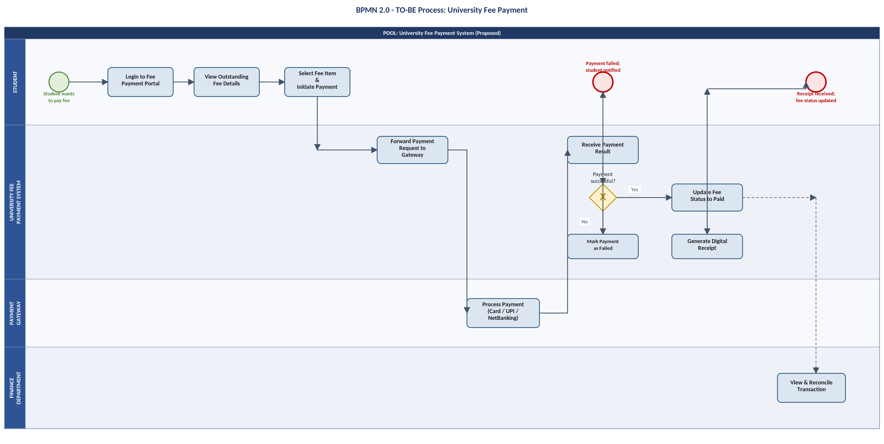
Figure 2: BPMN 2.0 — TO-BE Process for University Fee Payment

6. UML Use Case Diagram
The use case diagram below shows the major actors of the University Fee Payment System — Student, Finance Staff, and the external Payment Gateway — and the primary ways each interacts with the system. “Make Payment” includes “Process Payment (via Gateway)”, reflecting that every payment relies on the external gateway to complete.
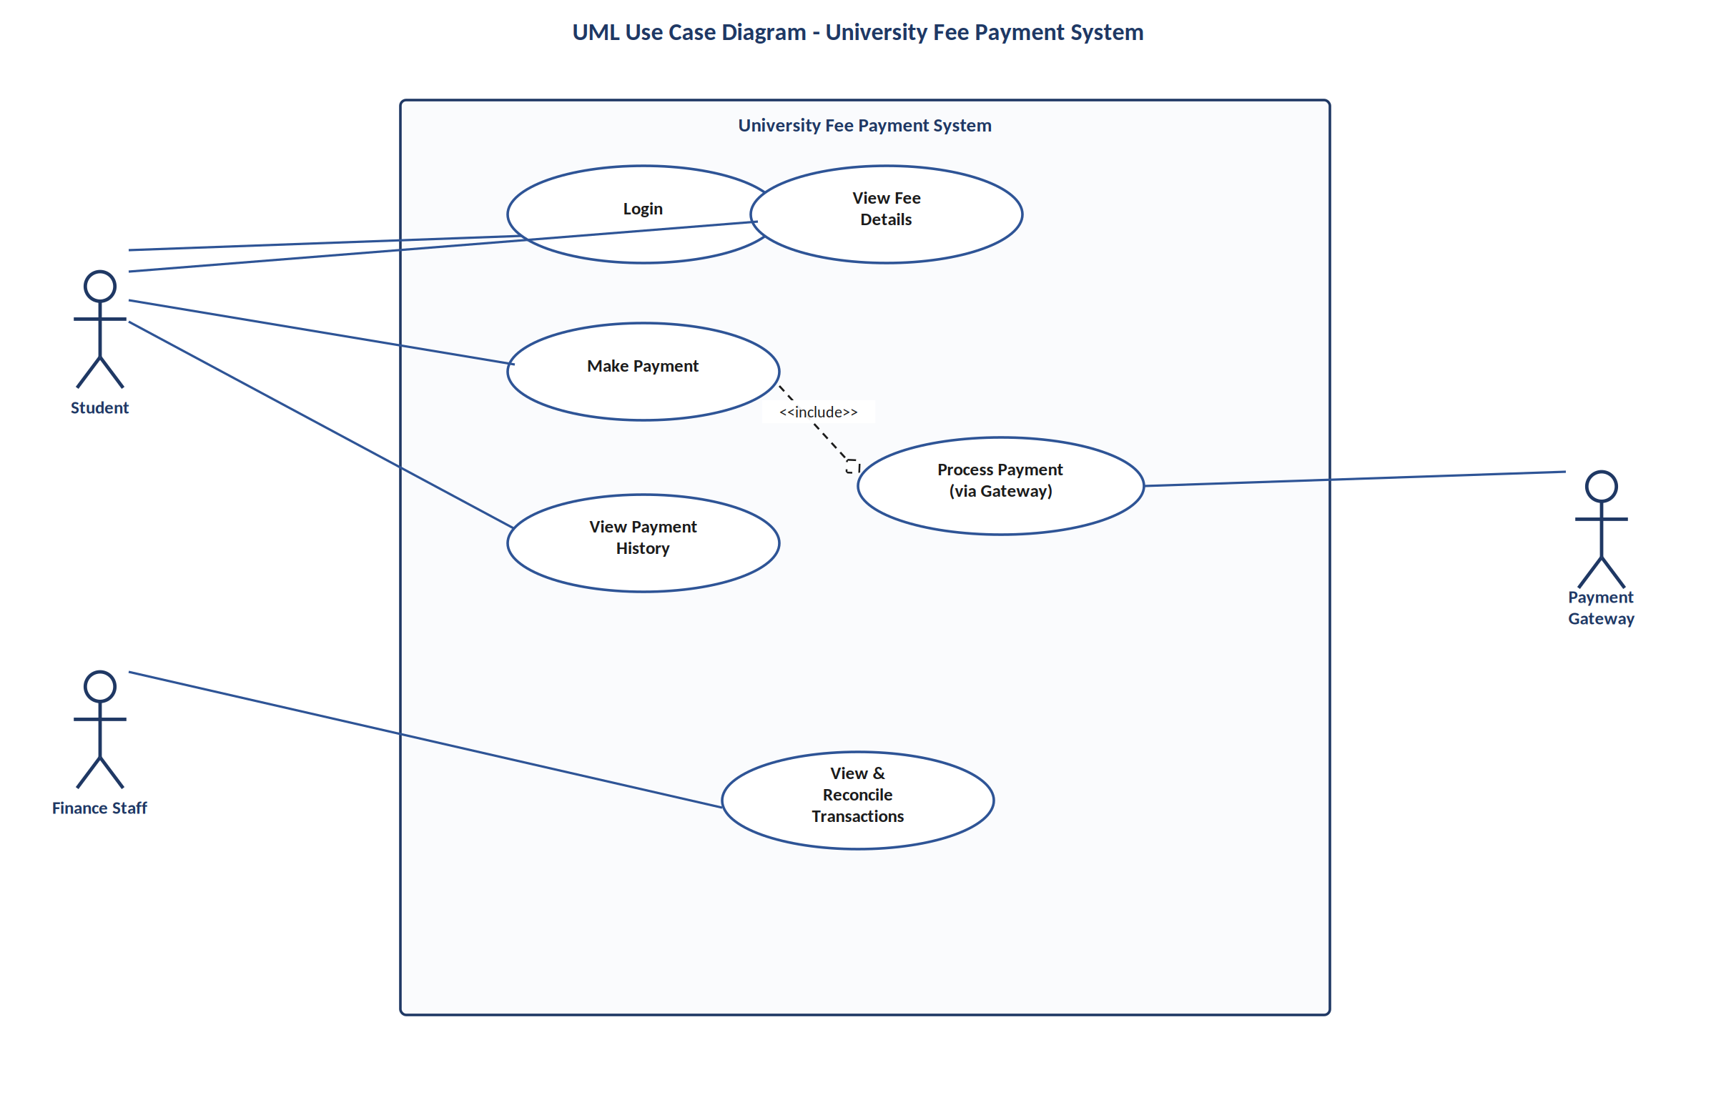
Figure 3: UML Use Case Diagram — University Fee Payment System

7. UML Activity Diagram
The activity diagram below details the internal workflow of a single use case — the student's fee payment — including the decision point after the payment gateway responds, and the two possible paths (successful payment vs. failed payment) before the flow converges to a single end point.
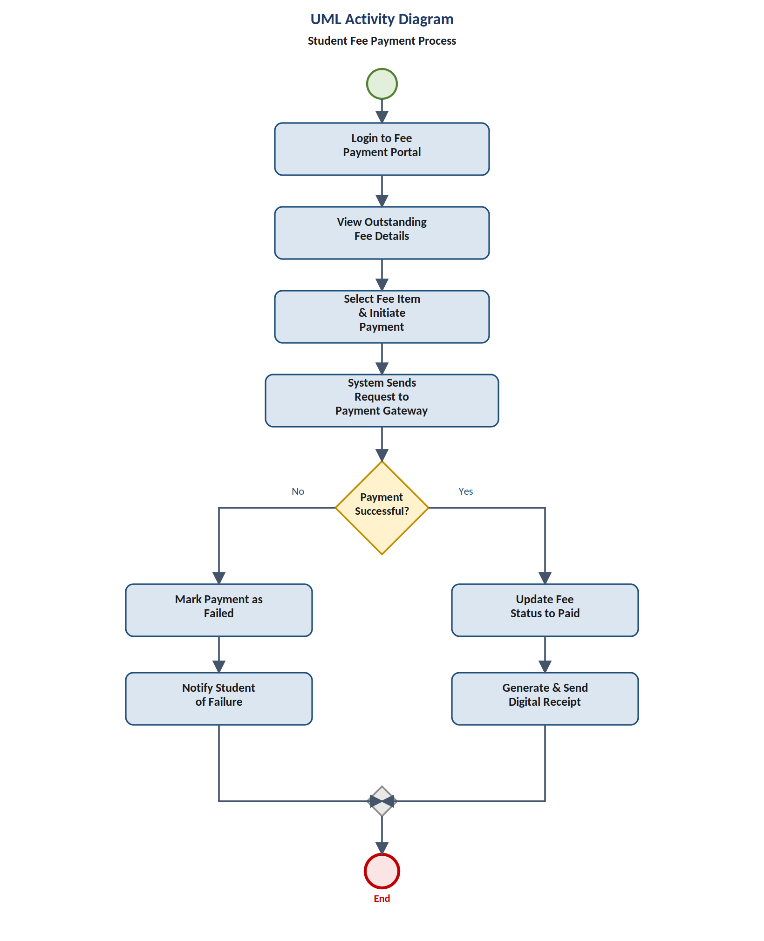
Figure 4: UML Activity Diagram — Student Fee Payment Process

8. UML Sequence Diagram
The sequence diagram below shows the time-ordered interactions between the Student, the University Fee Payment System, the Payment Gateway, and the Finance Department during a single payment attempt, including both the successful and failed outcomes (modelled with an alt frame).
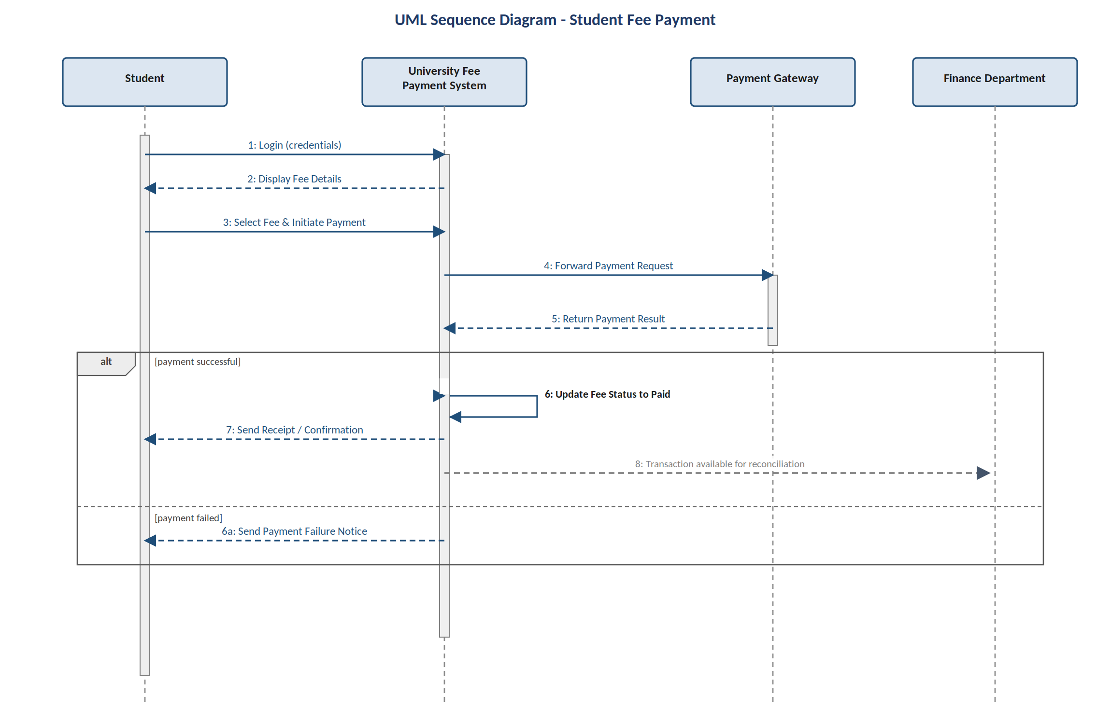
Figure 5: UML Sequence Diagram — Student Making a Payment

9. Diagram Interpretation
Each diagram in this document serves a distinct purpose in the analysis:
- The BPMN diagram models the end-to-end business process across organizational participants (Student, System, Payment Gateway, Finance) and is intended for business stakeholders reviewing how work moves between parties.
- The UML Use Case diagram summarizes what each actor can do with the system, at a high level, without describing step-by-step logic.
- The UML Activity diagram zooms into a single use case (the payment process) to show its detailed internal steps and decision logic — this is a system/design-level view rather than a cross-organizational process view.
- The UML Sequence diagram shows the same payment scenario from a time-ordered, message-passing perspective, useful for understanding the order of interactions between system components.
In short: BPMN explains “how the business process flows across people and systems”, while the UML Activity diagram explains “what happens step-by-step inside one use case” — both use similar decision-node notation, but at different levels of abstraction.

10. Proposed Benefits
- Students get real-time visibility of fee dues and payment status, removing the need to contact the Finance Office.
- Payment confirmation and receipts are near-instant instead of taking several days.
- Finance staff spend far less time manually verifying and reconciling payments.
- Failed or pending payments are clearly flagged, enabling faster follow-up.
- A single digital system of record replaces fragmented, channel-specific tracking.
— End of Document —

