

Comcast Video Software

OCATS Install Guide

Document Status
Document Control Number:
Document Title: | OCATS Install Guide
Revision History: | OCATS Install Guide 0_1 (initial draft)
Revision History: | Removed references to settops.catsrack and ROOT.war and renamed ocats-ui.war to OCATS.war  https://github.com/Comcast/cats/issues/13
Date: | September 16, 2015
Status: | Draft
Distribution:
Document Status Codes:
Work in Progress (WIP) An incomplete document designed to guide discussion and generate feedback that may include several alternative requirements for consideration.
Draft (D) A document in specification format considered largely complete, but lacking review. Drafts are susceptible to substantial change during the review process.
Issued (I) A stable document which has undergone rigorous review and is suitable for product design and development. It will serve as a /basis for testing requirements.
History Information
Date | Version | Updated | Section impacted | Comments
9/26/2013 | 0.1 |  | All | Initial Draft
10/10/2013 | 0.2 |  | All | Tested Install Guide

Author: Sajay Janardhana Kurup
Approved: __________________
Reviewed:
Douglas Sanders __________________
Chad Frederick __________________
Marcus Haebler __________________
Tahmina Husain __________________
Sreejith Sivasankar __________________

Sign-off for Issue:

Douglas Sanders __________________

Table of Contents
1 Introduction 1
1.1 Scope 1
2 Software Installation 2
2.1 Install and Configure MySQL 2
2.1.1 Datasource Setup 2
2.2 Install VLC Player 2
2.2.1 Install VLC from Repo 2
2.3 Install Java 3
2.3.1 Download Java 3
2.4 Create jboss user and CATS group 4
2.5 Install JBoss 4
2.5.1 Download JBoss 4
2.5.2 Unpack JBoss 4
2.5.3 Fix Permissions 4
2.5.4 Configure JBOSS_HOME 4
2.5.5 Configure JBoss Init Script 4
2.5.6 Register JBoss for Auto Start on Boot 8
2.5.7 Configure MySQL Driver 8
2.5.8 Configure CATS System Properties in JBoss 10
2.5.9 Enable WSDL Address Rewrite in standalone-full.xml 11
2.5.10 Enable AJP in JBoss 11
2.5.11 Set OCATS UI as Default Application 12
2.5.12 Java VM Tweaking 12
2.5.13 Add JBoss Console Admin User 12
2.6 Install Jenkins 13
2.6.1 Download Jenkins 13
2.6.2 Install Jenkins 13
2.6.3 Add jenkins user to cats Group 13
2.6.4 Configure Jenkins 13
2.7 Configure Apache 14
2.7.1 Apache Auto Start on System Boot 14
2.7.2 Configure Apache (AJP) Proxies 14
2.7.3 Set up OCATS Web Server Directories 15
2.7.4 Configure Apache for Video Storage 15
2.7.5 (Re)start Apache HTTPD 15
2.8 YAML Configuration Files 15
2.8.1 Download YAML Files 15
2.8.2 Install Files 16
2.9 Install the OCATS Application Modules 16
2.9.1 Unpack File 16
2.9.2 Deploy CATSvision WS Client 16
2.9.3 Deploy .war and .ear Files 16
2.9.4 Determine Deployment Status through JBoss CLI 17
2.10 Configure Stability Environment 17
2.10.1 CATS configuration files 17
2.10.2 Install the Stability JAR 17
2.10.3 Install Stability Template 18
2.10.4 Configuring Jenkins 18
2.10.5 CATS Stability Directory 19
2.10.6 Creating the Stability Template 20
2.10.7 Set up a Cron job to fix the permissions 21

Introduction
OCATS is comprehensive test automation framework that enables automated testing of customer premise equipment.

Scope
This document describes one possible configuration on how to setup the software components of OCATS. This document is not intended to describe the hardware installation procedure for the reference hardware implementation.
The document describes the process of installing the different OCATS components on a CentOS based system. The installation depends on
- JDK 1.7
- Maven 3.0
- Jboss 7.1.1 Final
- MySQL v5.0.77

Software Installation

Install and Configure MySQL
Automatically start mysqld on boot
chkconfig --level 345 mysqld on
chkconfig --list mysqld
mysqld 0:off 1:off 2:off 3:on 4:on 5:on 6:off
Start mysqld
service mysqld start
Create User account for OCATS
Set Password for OCATS User account
mysql -u root
UPDATE mysql.user SET Password=PASSWORD('<password>') WHERE User='root';
FLUSH PRIVILEGES;

Datasource Setup

Create Keymanager Database
Get the keymanager SQL script from here (checkout from SCM) - OCATS/services/ir/keymanager/src/main/resources/META-INF/key_manager.sql
Execute the following commands from MySQL command prompt
mysqladmin -u root -p create keymanager

[user@server]$ mysql -u root -p keymanager < <path to>/key_manager.sql;
Enter password:
[user@server]$

Create pvr_db
mysqladmin -u root -p create pvr_db

Install VLC Player

Install VLC from Repo
Add vlc via yum to get all the dependencies
Important: we require vlc version 2.0.0
cd /etc/yum.repos.d/
wget http://pkgrepo.linuxtech.net/el6/release/linuxtech.repo
yum install vlc

Install Java
Skip this step if Java is installed via RPM.

Download Java
Download jdk-7u<x>-linux-x64.bin to the Linux server.
Install via
mkdir -p /opt/ocats/software/java
cd /opt/ocats/software/java
sh /path/to/jdk-7u<x>-linux-x64.bin
ln -s jdk1.7.0_<x> current
/opt/ocats/software/java/current/bin/java -version
java version "1.7.0_<x>"
Java(TM) SE Runtime Environment (build 1.7.0_<x>-b02)
Java HotSpot(TM) 64-Bit Server VM (build 20.14-b01, mixed mode)
Configure JAVA_HOME
Export JAVA_HOME
/etc/profile.d/java.sh
JAVA_HOME=/opt/ocats/software/java/current
export JAVA_HOME
PATH=$PATH:$JAVA_HOME/bin
export PATH
Set default java
[root@web-cats ]# cd /usr/bin
[root@web-cats bin]# ll -l java
lrwxrwxrwx. 1 root root 22 Mar 20 01:06 java -> /etc/alternatives/java
[root@web-cats bin]# rm java
rm: remove symbolic link `java'? yes
[root@web-cats bin]# ln -s $JAVA_HOME/bin/java java
[root@web-cats bin]# ll -l java
lrwxrwxrwx. 1 root root 43 Sep 4 12:14 java -> /opt/ocats/software/java/current/bin/java

cat > /etc/profile.d/java.sh
JAVA_HOME=/opt/ocats/software/java/current
export JAVA_HOME
PATH=$PATH:$JAVA_HOME/bin
export PATH

Create jboss user and CATS group
Add JBoss user
useradd -m jboss
Create cats group and add jboss and jenkins to it:
groupadd -g 504 cats
usermod -aG cats jboss

Install JBoss

Download JBoss
Download JBoss (currently jboss-as-7.1.1.Final.zip) from: http://www.jboss.org/jbossas/downloads.html and upload it to the server.

Unpack JBoss
Install JBoss 7.1.x:
mkdir -p /opt/ocats/software/jboss
cd /opt/ocats/software/jboss
unzip /path/to/jboss-as-7.1.1.Final.zip
ln -s jboss-as-7.1.1.Final current

Fix Permissions
Fix the permission on the JBoss installation directory:
chown \-R jboss:cats /opt/ocats/software/jboss/current

Configure JBOSS_HOME
Configure JBOSS_HOME
cat > /etc/profile.d/jboss.sh
JBOSS_HOME=/opt/ocats/software/jboss/current
export JBOSS_HOME
PATH=$PATH:$JBOSS_HOME/bin
export PATH

cd /etc/profile.d
chmod 744 jboss.sh

Configure JBoss Init Script
cd /etc/init.d/
chmod 744 jboss

cat > /etc/init.d/jboss
# chkconfig: 345 90 20
# description: JBoss AS Standalone
# processname: jboss standalone
# pidfile: /var/run/jboss-as/jboss-as-standalone.pid
# config: /etc/jboss-as/jboss-as.conf

# Source function library.
. /etc/rc.d/init.d/functions

# Load Java configuration.
[ -r /etc/java/java.conf ] && . /etc/java/java.conf
export JAVA_HOME

JBOSS_USER=jboss
export JBOSS_USER

# Load JBoss AS init.d configuration.
if [ -z "$JBOSS_CONF" ]; then
JBOSS_CONF="/etc/jboss-as/jboss-as.conf"
fi

[ -r "$JBOSS_CONF" ] && . "${JBOSS_CONF}"

# Set defaults.

if [ -z "$JBOSS_HOME" ]; then
JBOSS_HOME=/opt/ocats/software/jboss/current
fi
export JBOSS_HOME

if [ -z "$JBOSS_PIDFILE" ]; then
JBOSS_PIDFILE=/var/run/jboss-as/jboss-as-standalone.pid
fi
export JBOSS_PIDFILE

if [ -z "$JBOSS_CONSOLE_LOG" ]; then
JBOSS_CONSOLE_LOG=/var/log/jboss-as/console.log
fi

if [ -z "$STARTUP_WAIT" ]; then
STARTUP_WAIT=30
fi

if [ -z "$SHUTDOWN_WAIT" ]; then
SHUTDOWN_WAIT=30
fi

if [ -z "$JBOSS_CONFIG" ]; then
JBOSS_CONFIG=standalone-full.xml
fi

JBOSS_SCRIPT=$JBOSS_HOME/bin/standalone.sh

prog='jboss-as'

CMD_PREFIX=''

if [ ! -z "$JBOSS_USER" ]; then
if [ -x /etc/rc.d/init.d/functions ]; then
CMD_PREFIX="daemon --user $JBOSS_USER"
else
CMD_PREFIX="su - $JBOSS_USER -c"
fi
fi

start() {
echo -n "Starting $prog: "
if [ -f $JBOSS_PIDFILE ]; then
read ppid < $JBOSS_PIDFILE
if [ `ps --pid $ppid 2> /dev/null | grep -c $ppid 2> /dev/null` -eq '1' ]; then
echo -n "$prog is already running"
failure
echo
return 1
else
rm -f $JBOSS_PIDFILE
fi
fi
mkdir -p $(dirname $JBOSS_CONSOLE_LOG)
cat /dev/null > $JBOSS_CONSOLE_LOG

mkdir -p $(dirname $JBOSS_PIDFILE)
chown $JBOSS_USER $(dirname $JBOSS_PIDFILE) || true
#$CMD_PREFIX JBOSS_PIDFILE=$JBOSS_PIDFILE $JBOSS_SCRIPT 2>&1 > $JBOSS_CONSOLE_LOG &
#$CMD_PREFIX JBOSS_PIDFILE=$JBOSS_PIDFILE $JBOSS_SCRIPT &

if [ ! -z "$JBOSS_USER" ]; then
if [ -x /etc/rc.d/init.d/functions ]; then
daemon --user $JBOSS_USER LAUNCH_JBOSS_IN_BACKGROUND=1 JBOSS_PIDFILE=$JBOSS_PIDFILE $JBOSS_SCRIPT -c $JBOSS_CONFIG 2>&1 > $JBOSS_CONSOLE_LOG &
else
su - $JBOSS_USER -c "LAUNCH_JBOSS_IN_BACKGROUND=1 JBOSS_PIDFILE=$JBOSS_PIDFILE $JBOSS_SCRIPT -c $JBOSS_CONFIG" 2>&1 > $JBOSS_CONSOLE_LOG &
fi
fi

count=0
launched=false

until [ $count -gt $STARTUP_WAIT ]
do
grep 'JBoss AS.*started in' $JBOSS_CONSOLE_LOG > /dev/null
if [ $? -eq 0 ] ; then
launched=true
break
fi
sleep 1
let count=$count+1;
done

success
echo
return 0
}

stop() {
echo -n $"Stopping $prog: "
count=0;

if [ -f $JBOSS_PIDFILE ]; then
read kpid < $JBOSS_PIDFILE
let kwait=$SHUTDOWN_WAIT

# Try issuing SIGTERM

kill -15 $kpid
until [ `ps --pid $kpid 2> /dev/null | grep -c $kpid 2> /dev/null` -eq '0' ] || [ $count -gt $kwait ]
do
sleep 1
let count=$count+1;
done

if [ $count -gt $kwait ]; then
kill -9 $kpid
fi
fi
rm -f $JBOSS_PIDFILE
success
echo
}

status() {
if [ -f $JBOSS_PIDFILE ]; then
read ppid < $JBOSS_PIDFILE
if [ `ps --pid $ppid 2> /dev/null | grep -c $ppid 2> /dev/null` -eq '1' ]; then
echo "$prog is running (pid $ppid)"
return 0
else
echo "$prog dead but pid file exists"
return 1
fi
fi
echo "$prog is not running"
return 3
}

case "$1" in
start)
start
;;
stop)
stop
;;
restart)
$0 stop
$0 start
;;
status)
status
;;
*)
## If no parameters are given, print which are available.
echo "Usage: $0 {start|stop|status|restart|reload}"
exit 1
;;
esac

Register JBoss for Auto Start on Boot
chkconfig --add jboss
chkconfig --level 345 jboss on

Configure MySQL Driver

Installing a MySQL driver in AS 7
Copy the following file in to AS7_HOME\modules\com\mysql\main (Create folders if not exists)
- module.xml
<!--

~ JBoss, Home of Professional Open Source.
~ Copyright 2010, Red Hat, Inc., and individual contributors
~ as indicated by the @author tags. See the copyright.txt file in the
~ distribution for a full listing of individual contributors.
~
~ This is free software; you can redistribute it and/or modify it
~ under the terms of the GNU Lesser General Public License as
~ published by the Free Software Foundation; either version 2.1 of
~ the License, or (at your option) any later version.
~
~ This software is distributed in the hope that it will be useful,
~ but WITHOUT ANY WARRANTY; without even the implied warranty of
~ MERCHANTABILITY or FITNESS FOR A PARTICULAR PURPOSE. See the GNU
~ Lesser General Public License for more details.
~
~ You should have received a copy of the GNU Lesser General Public
~ License along with this software; if not, write to the Free
~ Software Foundation, Inc., 51 Franklin St, Fifth Floor, Boston, MA
~ 02110-1301 USA, or see the FSF site: http://www.fsf.org.

-->
<module xmlns="urn:jboss:module:1.0" name="com.mysql">
<resources>
<resource-root path="mysql-connector-java-<version>.jar"/>
</resources>
<dependencies>
<module name="javax.api"/>
</dependencies>
</module>

- Download an appropriate mysql connector to the AS7_HOME\modules\com\mysql\main folder: ex mysql-connector-java-5.1.15.jar from
http://dev.mysql.com/downloads/connector/j/
[Specific url to mysql connector ] : https://downloads.mysql.com/archives/get/file/mysql-connector-java-5.1.15.zip
Edit AS7_HOME\standalone\configuration\standalone-full.xml
<subsystem xmlns="urn:jboss:domain:datasources:1.0">
<datasources>
...
...
<drivers>
...
...
<driver name="com.mysql" module="com.mysql">
<xa-datasource-class>com.mysql.jdbc.jdbc2.optional.MysqlXADataSource</xa-datasource-class>
</driver>
</drivers>
</datasources>
</subsystem>
Restart AS7

Configuring MySQL Datasource in AS 7

Must configure the datasource for standalone-full server at $JBOSS_HOME/standalone/configuration/standalone-full.xml.

NOTE that JNDI name needed to be altered to include java:jboss in order to be successfully used.
Configure DataSources and make sure you replace dbuser & dbpasswd with the correct MySQL user and password.
<subsystem xmlns="urn:jboss:domain:datasources:1.0">
<datasources>
...
<datasource jta="true" jndi-name="java:jboss/cats/datasources/pvr" pool-name="pvr-ds" enabled="true" use-ccm="false">
<connection-url>jdbc:mysql://localhost:3306/pvr_db</connection-url>
<driver-class>com.mysql.jdbc.Driver</driver-class>
<driver>com.mysql</driver>
<transaction-isolation>TRANSACTION_READ_COMMITTED</transaction-isolation>
<pool>
<min-pool-size>10</min-pool-size>
<max-pool-size>100</max-pool-size>
<prefill>true</prefill>
</pool>
<security>
<user-name>dbuser</user-name>
<password>dbpasswd</password>
</security>
<validation>
<validate-on-match>false</validate-on-match>
<background-validation>false</background-validation>
</validation>
<statement>
<share-prepared-statements>false</share-prepared-statements>
</statement>
</datasource>
<datasource jndi-name="java:jboss/datasources/keymanager" pool-name="keymanager" enabled="true">
<connection-url>jdbc:mysql://localhost:3306/keymanager</connection-url>
<driver>com.mysql</driver>
<transaction-isolation>TRANSACTION_READ_COMMITTED</transaction-isolation>
<pool>
<min-pool-size>10</min-pool-size>
<max-pool-size>100</max-pool-size>
<prefill>true</prefill>
</pool>
<security>
<user-name>dbuser</user-name>
<password>dbpasswd</password>
</security>
<statement>
<prepared-statement-cache-size>32</prepared-statement-cache-size>
<share-prepared-statements>true</share-prepared-statements>
</statement>
</datasource>
...

Configure CATS System Properties in JBoss
Configure JBoss System Properties in /opt/ocats/software/jboss/current/standalone/configuration/standalone-full.xml. Make sure you replace dbuser, dbpasswd and telnetpasswd (VLC telnet password) with the appropriate values.
</extensions>
<system-properties>
<property name="cats.ir.proxy.ip" value="127.0.0.1"/>
<property name="cats.config.path" value="/var/www/html/cats/config"/>
<property name="cats.pvr.file.server.base.path" value="/opt/video/"/>
<property name="cats.pvr.http.server.base.path" value="http://127.0.0.1/video-storage/"/>
<property name="cats.pvr.rest.api.base.url" value="http://127.0.0.1/video-recorder-service/rest"/>
<property name="cats.pvr.db.user.id" value="dbuser"/>
<property name="cats.pvr.db.password" value="dbpasswd"/>
<property name="cats.pvr.db.driver.class.name" value="com.mysql.jdbc.Driver"/>
<property name="cats.pvr.vlc.executable.path" value="/usr/bin/"/>
<property name="cats.pvr.db.connection.url" value="jdbc:mysql://127.0.0.1:3306/pvr_db"/>
<property name="cats.pvr.vlc.telnet.host" value="127.0.0.1"/>
<property name="cats.pvr.vlc.telnet.password" value="telnetpasswd"/>
<property name="cats.pvr.vlc.telnet.port.range.start" value="9000"/>
<property name="cats.pvr.vlc.telnet.port.range.end" value="9090"/>
<property name="keymanager.jndi.name" value="java:global/ocats-master-ear-1.0.1/keymanager-service/KeyManagerProxyImpl!com.comcast.cats.service.KeyManagerProxy"/>
</system-properties>
<management>

Enable WSDL Address Rewrite in standalone-full.xml
Set JBoss to correct the "soap:address" location in generated WSDL
...
<subsystem xmlns="urn:jboss:domain:webservices:1.1">
<modify-wsdl-address>true</modify-wsdl-address>
<wsdl-host>jbossws.undefined.host</wsdl-host>
<wsdl-port>80</wsdl-port>
<endpoint-config name="Standard-Endpoint-Config"/>
<endpoint-config name="Recording-Endpoint-Config">
<pre-handler-chain name="recording-handlers" protocol-bindings="##SOAP11_HTTP ##SOAP11_HTTP_MTOM ##SOAP12_HTTP ##SOAP12_HTTP_MTOM">
<handler name="RecordingHandler" class="org.jboss.ws.common.invocation.RecordingServerHandler"/>
</pre-handler-chain>
</endpoint-config>
</subsystem>
...

Enable AJP in JBoss
Add the AJP connector in /opt/ocats/software/jboss/current/standalone/configuration/standalone-full.xml
...
<subsystem xmlns="urn:jboss:domain:web:1.1" default-virtual-server="default-host" native="false">
<connector name="http" protocol="HTTP/1.1" scheme="http" socket-binding="http"/>
<connector name="ajp" protocol="AJP/1.3" scheme="http" socket-binding="ajp"/>
<virtual-server name="default-host" enable-welcome-root="true">
...

Set OCATS UI AS Default Application
Set OCATS UI as default application. Set enable-welcome-root to false:
...
<connector name="ajp" protocol="AJP/1.3" scheme="http" socket-binding="ajp"/>
<virtual-server name="default-host" enable-welcome-root="false">
<alias name="localhost"/>
<alias name="example.com"/>
</virtual-server>
</subsystem>
...

Java VM Tweaking
Increase the JVM heap space for JBoss by changing the JAVA_OPTS in /opt/ocats/software/jboss/current/bin/standalone.conf to the following:
JAVA_OPTS="-Xms1024m -Xmx1280m -XX:MaxPermSize=512m -Djava.net.preferIPv4Stack=true -Dorg.jboss.resolver.warning=true -Dsun.rmi.dgc.client.gcInterval=3600000 -Dsun.rmi.dgc.server.gcInterval=3600000"

Add JBoss Console Admin User
Add a user "admin" to the ManagementRealm:
/opt/comcast/software/jboss/current/bin/add-user.sh -?

What type of user do you wish to add?
a) Management User (mgmt-users.properties)
b) Application User (application-users.properties)
(a): ^C[root@rhel ~]#
[root@rhel ~]#
[root@rhel ~]# /opt/ocats/software/jboss/current/bin/add-user.sh

What type of user do you wish to add?
a) Management User (mgmt-users.properties)
b) Application User (application-users.properties)
(a):

Enter the details of the new user to add.
Realm (ManagementRealm) :
Username : admin
Password :
Re-enter Password :
The username 'admin' is easy to guess
Are you sure you want to add user 'admin' yes/no? yes
About to add user 'admin' for realm 'ManagementRealm'
Is this correct yes/no? yes
Added user 'admin' to file '/opt/comcast/software/jboss/jboss-as-7.1.1.Final/standalone/configuration/mgmt-users.properties'
Added user 'admin' to file '/opt/comcast/software/jboss/jboss-as-7.1.1.Final/domain/configuration/mgmt-users.properties'

Start Jboss
service jboss start

Install Jenkins

Download Jenkins
Download Jenkins stable for RedHat from http://pkg.jenkins-ci.org/redhat-stable/

Install Jenkins
Install jenkins via RPM:
# rpm -ivh jenkins-1.480.3-1.1.noarch.rpm
warning: jenkins-1.480.3-1.1.noarch.rpm: Header V4 DSA/SHA1 Signature, key ID d50582e6: NOKEY
Preparing... ########################################### [100%]
1:jenkins ########################################### [100%]

Add jenkins user to cats Group
Make the "jenkins" user part of the CATS group
usermod -aG cats jenkins

Configure Jenkins
Configure Jenkins in /etc/sysconfig/jenkins as follows:
...
# Make sure we use the Oracle Java VM installed above
JENKINS_JAVA_CMD="/opt/ocats/software/java/current/bin/java"

...
# Change ports to avoid conflict with JBoss on 8080
JENKINS_PORT="8081"
...
JENKINS_AJP_PORT="8010"
...
# Change prefix via JENKINS_ARGS - also needs to have a matching change on ajp_mod_prox to pass the prefix
# limit HTTP listener to localhost
# limit AJP listener to localhost (FIXME!)
#JENKINS_ARGS="--prefix=/jenkins --httpListenAddress=127.0.0.1 --ajp13ListenAddress=127.0.0.1"
JENKINS_ARGS="--prefix=/jenkins --httpListenAddress=127.0.0.1"
...

Configure Apache
Disable selinux if required by editing /etc/selinux/config
SELINUX=disabled
Installation Location:
/etc/httpd
Start-up script:
/etc/rc.d/init.d/httpd

Apache Auto Start on System Boot
Enable Apache httpd on startup
chkconfig --level 345 httpd on

Configure Apache (AJP) Proxies
Front JBoss, Jenkins etc. with Apache by configuring mod_proxy_ajp in /etc/httpd/conf.d/proxy_ajp.conf
#For CATSVision
ProxyPass /webstart !

#For exposing ocats configuration files
ProxyPass /ocats !

#For Fronting Jenkins
ProxyPass /jenkins ajp://0.0.0.0:8010/jenkins timeout=600
ProxyPassReverse /jenkins ajp://0.0.0.0:8010/jenkins

#For exposing video starage
ProxyPass /video-storage !

#For exposing cats config files
ProxyPass /cats !

#for exposing stability
ProxyPass /stability !

#ProxyPass /console http://127.0.0.1:9990/console

ProxyPass / ajp://127.0.0.1:8009/ timeout=600
ProxyPassReverse / ajp://127.0.0.1:8009/

<Location /console>
Order deny,allow
Allow from all
Options -Indexes FollowSymLinks
ProxyPass http://127.0.0.1:9990/console
ProxyPassReverse http://127.0.0.1:9990/console
</Location>

Set up OCATS Web Server Directories
As user root run:
mkdir -p /var/www/html/cats/config
mkdir -p /var/www/html/stability
mkdir -p /var/www/html/webstart

chown jenkins:cats /var/www/html/stability
chmod ug+ws /var/www/html/stability
chown –R jboss:cats /var/www/html/cats
chmod –R 774 /var/www/html/cats

Configure Apache for Video Storage
Edit /etc/httpd/conf.d/video-storage.conf. Modify/Add the following content
Alias /video-storage "/opt/video"

<Directory "/opt/video">
#Options FollowSymLinks
Options +Indexes +FollowSymLinks
AllowOverride None
Order allow,deny
Allow from all
</Directory>

Add the /opt/video and adjust permissions:

mkdir -p /opt/video
chgrp cats /opt/video
chmod g+ws /opt/video

(Re)start Apache HTTPD
(Re)start the Apache HTTPD:
service httpd restart

YAML Configuration Files

Download YAML Files
Get the following three YAML files from /ocats-release/sampleConfigFiles
- rackconfig.catsrack
- settopTypes.catsrack

Install Files
Upload and copy the files in /var/www/html/prod-cats/config
cp *.catsrack /var/www/html/cats/config/
chown jboss:jboss –R /var/www/html/cats/config/
chmod 664 –R /var/www/html/cats/config/
Edit rackconfig.catsrack to reflect the rack configuration.

Install the OCATS Application Modules
Obtain the OCATS release bundle or build the OCATS Zip file by building the ocats-release folder.
Please Note: if building from source please build and install catsvision and stability jar before building ocats-release project
cd ocats-vision
mvn clean install –P webstart
cd ../ocats-stability
mvn clean install –P stability
cd ../ocats-release
mvn clean install

Unpack File
unzip <OCATS zip file>

Deploy CATSvision WS Client
The catsvision-<version>.zip file is contained in the OCATS zip file.
cd /var/www/html/webstart
unzip /path/to/catsvision-<version>.zip

Deploy .war and .ear Files
Use the JBoss CLI to deploy the .war and .ear components of the application. .war and .ear files in this case are in /home/red/ocats_sw/.
/opt/ocats/software/jboss/current/bin/jboss-cli.sh
You are disconnected at the moment. Type 'connect' to connect to the server or 'help' for the list of supported commands.
[disconnected /] connect

[standalone@localhost:9999 /] deploy <pathTO>/ocats-master-ear-<version>.ear
[standalone@localhost:9999 /] deploy <pathTO> /video-recorder-service.war [standalone@localhost:9999 /] deploy <pathTO>/ocats-ui.war
quit

Determine Deployment Status through JBoss CLI
[standalone@localhost:9999 /] deployment-info --name=OCATS.war
NAME RUNTIME-NAME PERSISTENT ENABLED STATUS
OCATS.war OCATS.war true true OK

[standalone@localhost:9999 /] deployment-info --name=prod-cats-master-ear-1.2.1.ear
NAME RUNTIME-NAME PERSISTENT ENABLED STATUS
ocats-master-ear-1.2.1.ear ocats-master-ear-1.2.1.ear true true OK

[standalone@localhost:9999 /] deployment-info --name=video-recorder-service.war
NAME RUNTIME-NAME PERSISTENT ENABLED STATUS
video-recorder-service.war video-recorder-service.war true true OK

Configure Stability Environment

CATS configuration files
Copy the following configuration to /var/www/html/cats/config:
/ocats-release/sampleConfigFiles/
- reboot-config.properties
- settop-type-mapping.properties
- REDRAT_KEYMANAGER.xml

Install the Stability JAR
Create /opt/ocats/data/stability:
mkdir -p /opt/ocats/data/stability

Copy the following files to /opt/ocats/data/stability:
- testng.xml
- ocats-stability-<x>.<y>.<z>-test-jar.jar

chown –R jenkins:cats stability
chmod 744 –R stability
To build stability jar from source from ocats-stability project using
mvn clean install -P stability
This will build the stability jar ocats-stability-client-test-jar.jar with all dependencies and the StabilityClient TestNG client included in it.

Install Stability Template
Create /var/www/html/stability/sampleTest:
mkdir -p /var/www/html/stability/sampleTest
Copy the following files to /var/www/html/stability/sampleTest:
- cats.props
- SampleStability.catscript
Edit cats.props to change:
- the cats.server.url property - IMPORTANT: Make sure you include the "/" at the end!!!
- the cats.settop.list property to contain STB/DTA MACs you want to run the sample test against in the new rack.

Configuring Jenkins
Follow the security setup procedure as explained here.
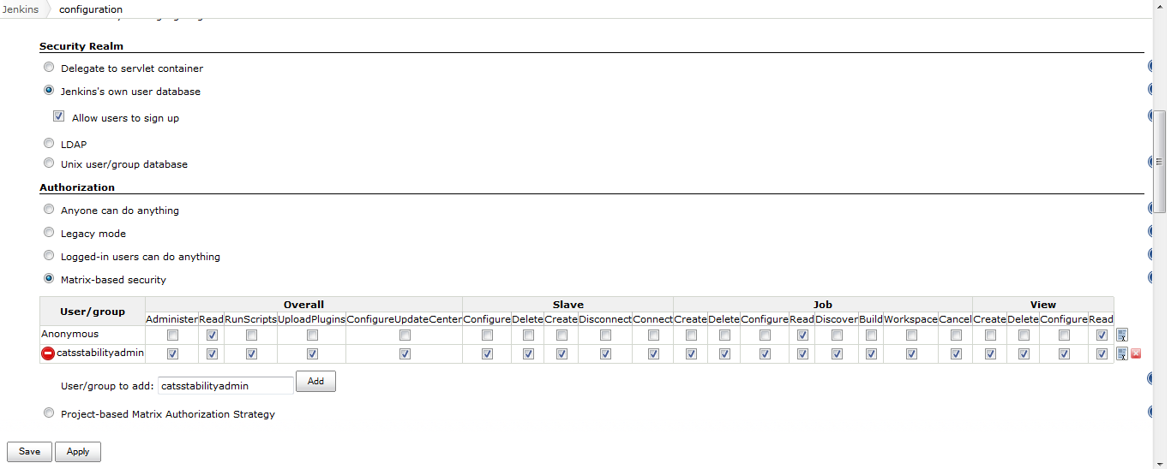

Role Permissions

CATS Stability Directory
For the stability template create a diretcory /var/www/html/stability/sampleTest
copy the sample cats.props and a sample .catsscript stability script here (check attachments). Make sure that jenkins is the owner and group for this directory structure and they have necessary read/write/delete permissions. 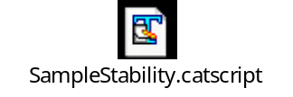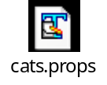

Creating the Stability Template
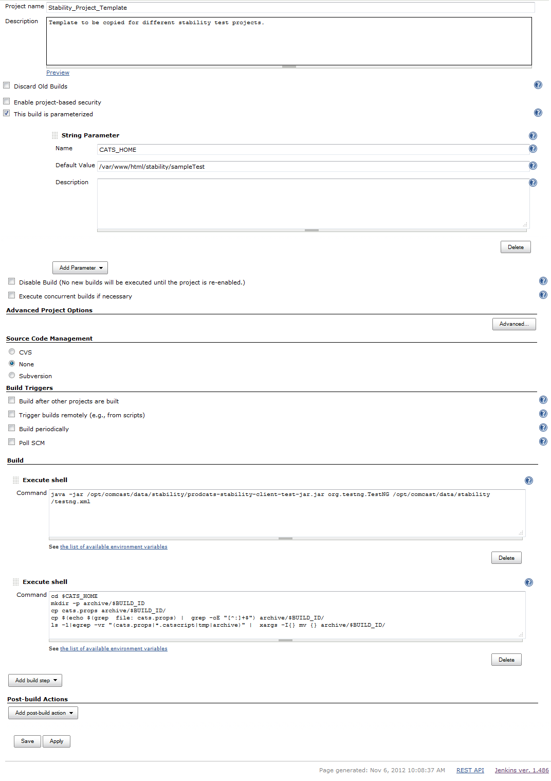
To aid in copy paste
Property | Value
Project Name | Stability_Project_Template
Description | Template to be copied for different stability test projects.
Execute Shell | java -jar /opt/ocats/data/stability/cats-stability-client-test-jar.jar org.testng.TestNG /opt/ocats/data/stability/testng.xml
Execute Shell  (please note: this  is different from  what is in the screen  shot. This is the latest). | cd $CATS_HOME  mkdir -p archive/$BUILD_ID  cp cats.props archive/$BUILD_ID/  cp $(echo $(grep file: cats.props) | grep -oE "[^:]+$") archive/$BUILD_ID/  ls -1|egrep -vr "(cats.props|.catscript|.jpg|.xml|.JPG|.jpeg|.groovy|tmp|archive)" | xargs -I{} mv {} archive/$BUILD_ID/

Set up a Cron job to fix the permissions
Add the following lines to root's crontab (use crontab -e as root to edit root's crontab):
#Adjust ownership and permissions for /var/www/html/stability on a regular basis
#change the owner to jenkins, make sure every file has group write permissions, make sure all directories have g+s
*/5 * * * * chown -R jenkins:cats /var/www/html/stability;chmod -R g+w /var/www/html/stability;find /var/www/html/stability/ -type d -exec chmod g+s {} \;

