Jorai keyboard

# Background and overview

The Jorai Windows keyboard was designed for the Jorai (or Jarai) language of Vietnam.

This implementation of the Jorai keyboard has been built using Microsoft Keyboard Layout Creator 1.4.

# Software requirements

* Windows XP or later.
* In that the keyboard generates NFD Unicode data, a Unicode font capable of correctly positioning the combining marks (diacritics) over their base characters is required. Suitable fonts are included with Windows Vista or Windows 7. Suitable fonts can also be downloaded from <http://scripts.sil.org/FontDownloads>.

# Installing and uninstalling the keyboard

To install the keyboard, go to the Jorai folder, and double-click on Setup.exe.

Repeat this procedure to **uninstall** the keyboard.

*Note: While one can remove the keyboard from within the “Text Services and Input Languages” control panel, the Setup program does a more thorough job of removing all components of the keyboard from the system.*

# Activating the keyboard

The software used to create the keyboard (Microsoft Keyboard Layout Creator) requires that the keyboard be associated with some language. Unfortunately, Windows does not yet offer Jorai as an option, so a different language had to be chosen. Vietnamese was used.

Installing the keyboard should have activated the Language Toolbar. This will usually be located near the right end of the Taskbar, but it may be free floating. It will display a two-letter language code which indicates what the current input language is. (EN will be displayed if the input language is English.)



Click on the existing language code to change it.

A menu will pop up showing the input language options. To select Jorai, click on   
“VI – Vietnamese (Vietnam)”.

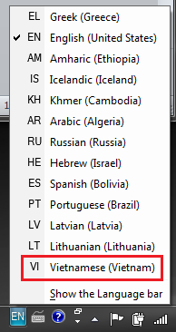

Now click on the little keyboard icon.



Finally, you can select the Jorai keyboard.

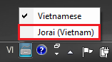

You can now use the keyboard in your document. The layout of the keyboard is on the next pages.

# Modifying the keyboard layout

Microsoft Keyboard Layout Creator is required to edit and rebuild the keyboard. All source files should be included with this distribution. The source files include:

* Jorai.klc
* JoraiKeyboardLayout.docx

# Jorai Keyboard Layout Chart

## Unshifted

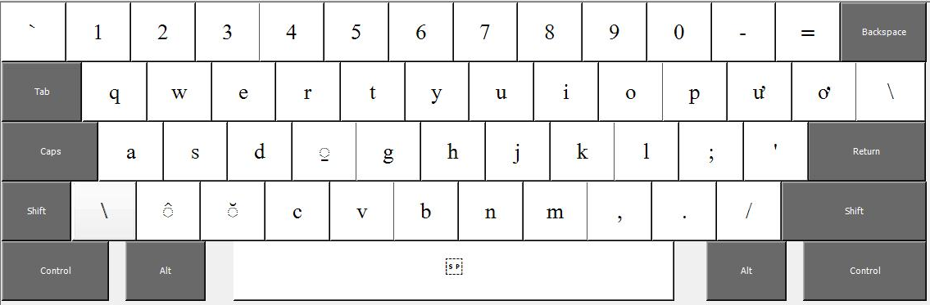

## Shifted

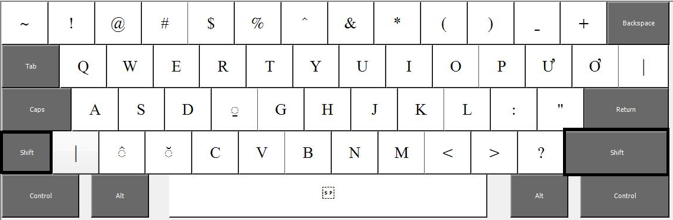

## Right Alt

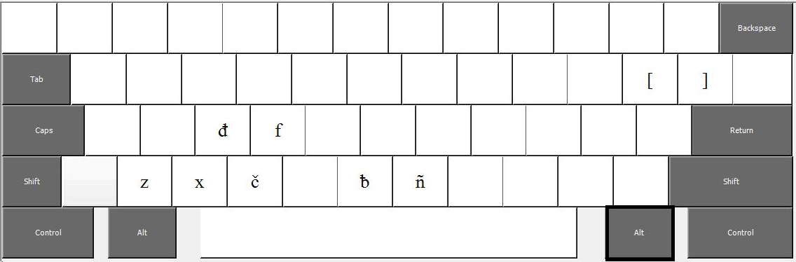

## Right Alt plus Shift

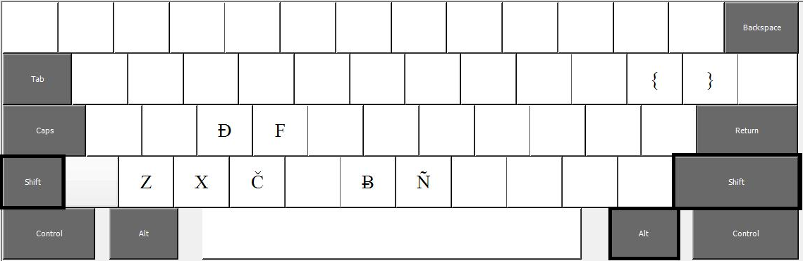

# License

The Jorai keyboard (MSKLC implementation) is copyright 2012 by Grace Montagnard Fellowship. It is distributed under the X-11 free software license.

X11-style License

Permission is hereby granted, free of charge, to any person obtaining a copy of this software and associated documentation files (the "Software"), to deal in the Software without restriction, including without limitation the rights to use, copy, modify, merge, publish, distribute, sublicense, and/or sell copies of the Software, and to permit persons to whom the Software is furnished to do so, subject to the following conditions:

The above copyright notice and this permission notice shall be included in all copies or substantial portions of the Software.

THE SOFTWARE IS PROVIDED "AS IS", WITHOUT WARRANTY OF ANY KIND, EXPRESS OR IMPLIED, INCLUDING BUT NOT LIMITED TO THE WARRANTIES OF MERCHANTABILITY, FITNESS FOR A PARTICULAR PURPOSE AND NONINFRINGEMENT. IN NO EVENT SHALL SIL INTERNATIONAL BE LIABLE FOR ANY CLAIM, DAMAGES OR OTHER LIABILITY, WHETHER IN AN ACTION OF CONTRACT, TORT OR OTHERWISE, ARISING FROM, OUT OF OR IN CONNECTION WITH THE SOFTWARE OR THE USE OR OTHER DEALINGS IN THE SOFTWARE.

Except as contained in this notice, the name of Grace Montagnard Fellowship shall not be used in advertising or otherwise to promote the sale, use or other dealings in this Software without prior written authorization from Grace Montagnard Fellowship.