**PART I**

**Q1:**

*docker pull sebp/lighttpd*

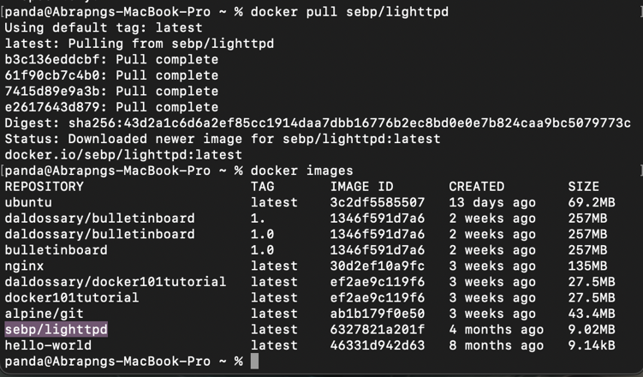

*Docker image with name “Dalal-201255”*

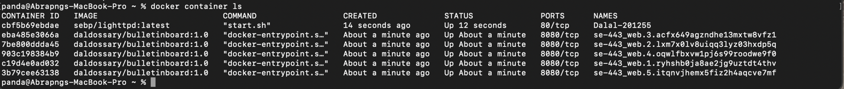

**Q2:**

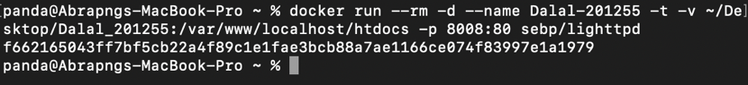



**Q3:**

**Q4:**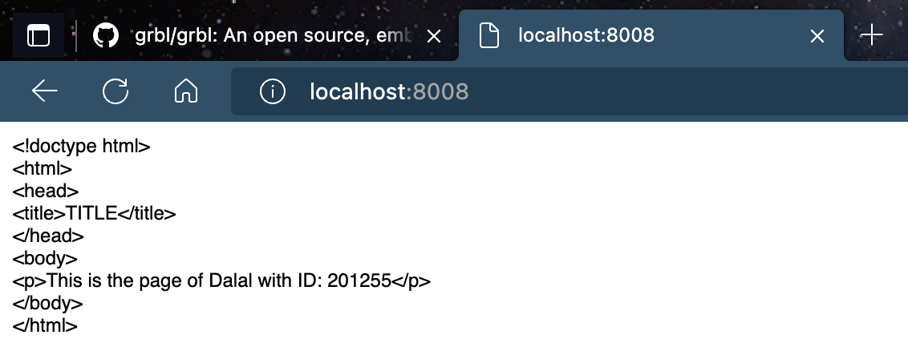



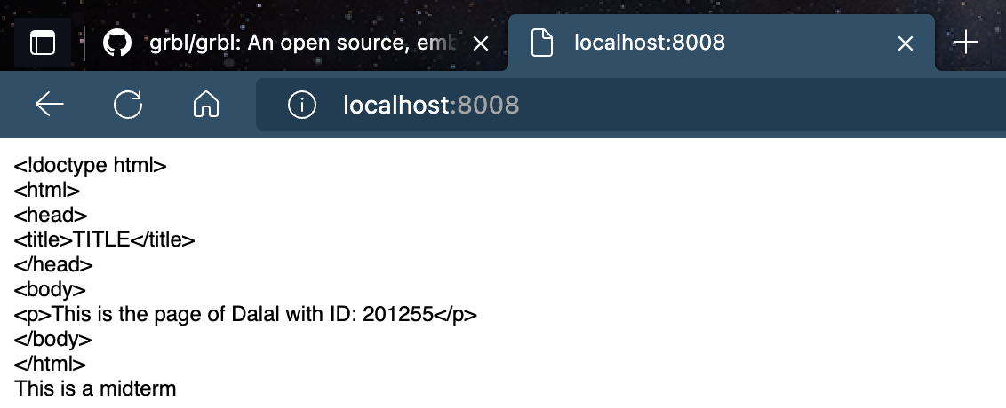

**Q5:**

**A - b)**

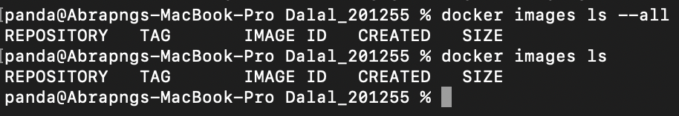

**c)**

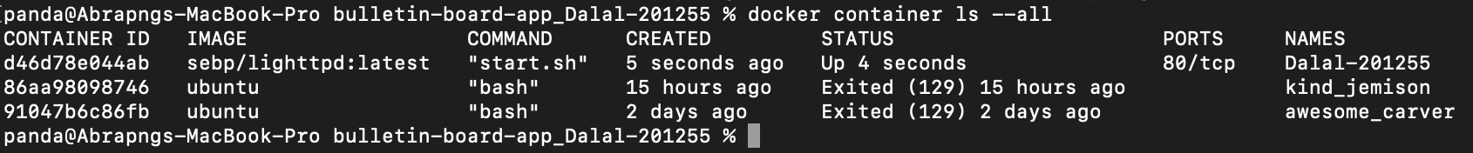

**Q6)**

**Q7)**

**Q8)**

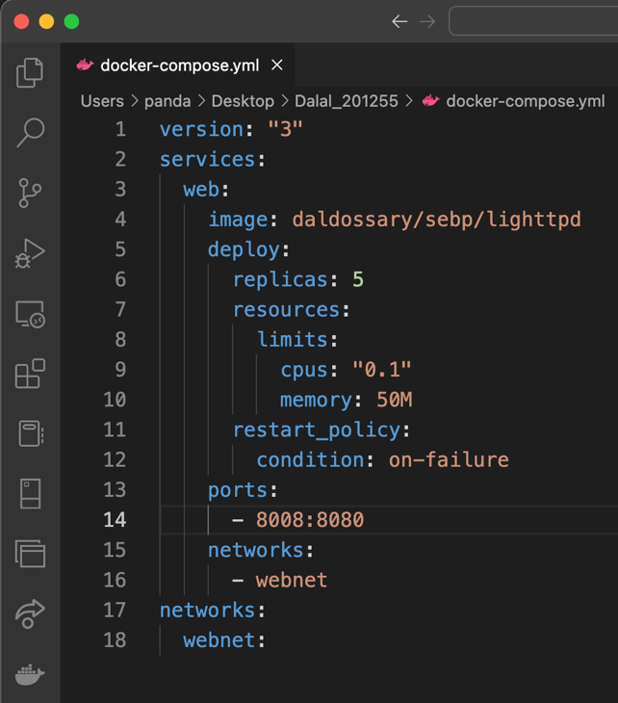

**PART II**

**Q9:**

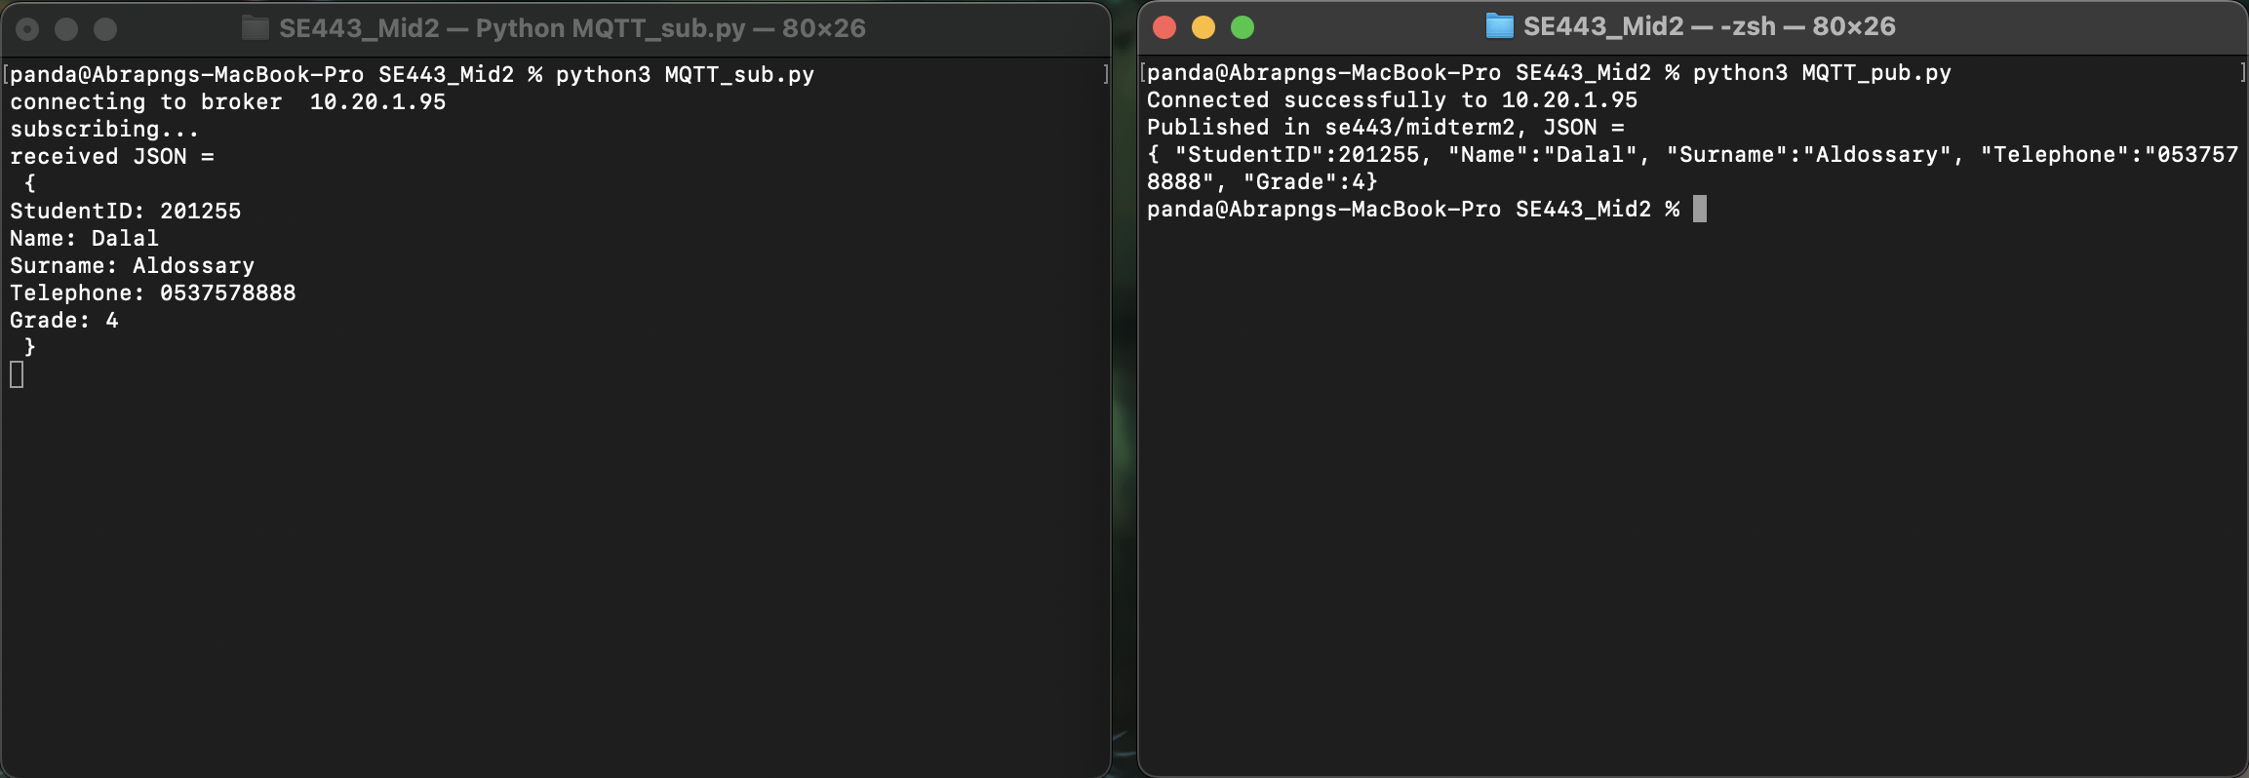

**Commands used after going to directory with python files:**

*python3 MQTT_sub.py*

*python3 MQTT_pub.py*