Installing Eclipse
To use this tutorial, users should not "sudo apt-get install eclipse". Instead:
- Go to eclipse web site
- Click on "download now" from the top-right corner
- Download eclipse for C/C++ developers
- Extract eclipse into a folder of your choice. E.g. tar -xvf eclipse-xxx.tar.gz -C /opt
- To make a nice launcher for Ubuntu, google for instructions or check e.g. http://www.blogs.digitalworlds.net/softwarenotes/?p=54
*reference: http://wiki.ros.org/IDEs#Eclipse

Setup Eclipse Project from ROS catkin workspace
- Open a terminal ( STRG+ALT+T ) and go to the catkin workspace directory and execute the commands from the script “gen_eclipse_project.sh”.
- Open a terminal ( STRG+ALT+T ) and run /opt/eclipse/eclipse to start Eclipse.
- go to File -> Import…. Select the import wizard General -> Existing Projects into Workspace
- Set the Select root directory and select the build directory of the catkin workspace – in this example: …/SYS_ROS/build.
- To check if the setup is correct, try to build the project.

Debugging Single Node
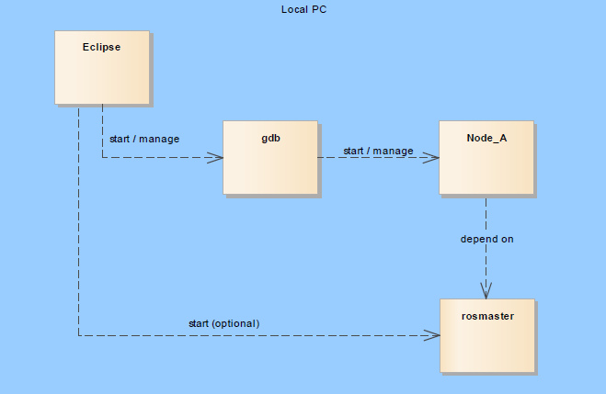

Debugging Multiple Nodes
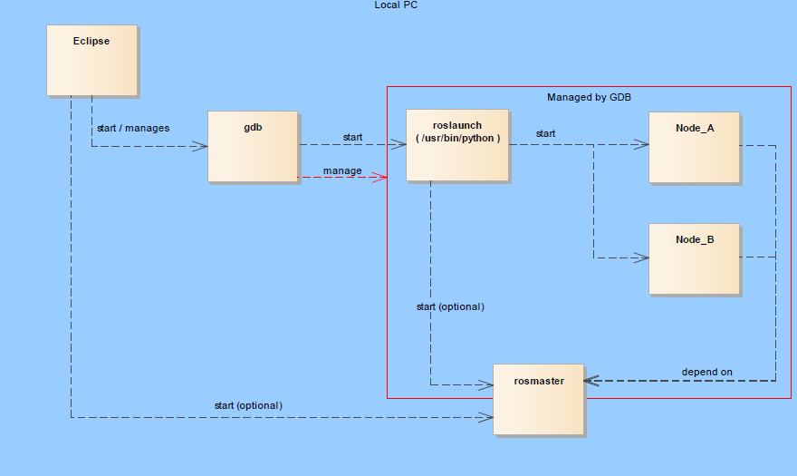
- Open the Debug Configuration window using Run -> Debug Configurations.
In the Main section of the Debug Configurations window the following setting is necessary:
As C/C++ Application we have to select /usr/bin/python instead of roslaunch.
- In the Arguments section of the Debug Configurations window:
/opt/ros/kinetic/roslaunch
package_name
launch_file_name
- in the Debugger section:
- [x] Stop at startup at main
- [v] Non-stop mode
- [v] Automatically debug forked processes
- Prepare breakpoints, then start debug

