Final Year Project Technical Report
BSc (Hons) Computing with Computer Games Development



How effectively can Bluetooth and GPS work together to provide seamless location tagging?

Student Name: Dale Nesbitt
Student ID: L00106269

Declaration

- I have accurately identified and included the sources of all facts, ideas, opinions, and viewpoints from others in the assignment references. All direct quotations, paraphrasing, and discussions of ideas from books, journal articles, internet sources, course materials, or any other sources used are properly acknowledged and cited in the assignment references.
- I have not used unauthorised artificial intelligence tools or aids.
- I understand and am compliant with ATU's policy and procedures regarding Academic Integrity and I am aware of the consequences of any violations.
- I have followed the referencing guidelines recommended in the assignment instructions and / or programme documentation.
- I understand that not adhering to the word limits on each section will result in penalties.
- By signing this form or by submitting material online I confirm that this assignment, or any part of it, has not been previously submitted by me or any other person for assessment on this or any other programme of study.
- By signing this form or by submitting material for assessment online I confirm that I have read and understood AQAE022 Academic Integrity Policy.

I confirm I agree to this declaration. ☒

Print Signature: Dale Nesbitt

Date: 21/04/2026

Acknowledgements
I would like to thank…

Table of Contents
1. Project Overview 1
1.1. Purpose 1
1.2. Objectives 1
1.2.1 BLE Proximity Detection 1
1.2.2 GPS Location Detection/Acquisition 1
1.2.3 BLE/GPS Handshake 1
1.2.4 Event Logging 2
1.2.5 System Feedback 2
1.2.6 Performance Evaluation 2
1.3. Project Scope 2
2. Requirements 4
2.1. Functional Requirements 4
2.2. Non-Functional Requirements 5
3. System Architecture & Design 7
3.1. High-Level Architecture Overview 7
3.2. Component Descriptions 7
3.3. BLE/GPS Handshake Process 8
3.4. Workflow Descriptions 8
3.5. Design Constraints 9
3.6. Security Considerations 9
4. Data Requirements 10
4.1. Data Types Stored 10
4.2. Data Format 10
4.3. Data Flow Summary 10
5. Implementation 11
5.1. Development Approach 11
5.2. ESP32 Setup and Upload Issues 11
5.3. ESP32 Hardware Validation (LED Test) 13
5.4. ESP32 Serial Communication Setup 14
5.5. GPS Integration Attempt 14
5.6. GPS Debugging Process 16
5.6.1 Library and Software Configuration 16
5.6.2 Baud Rate Testing 17
5.6.3 Wiring Verification 17
5.6.4 System Isolation and Minimal Testing 17
5.6.5 Serial Monitor Configuration 18
5.7. BLE Integration Attempt 18
5.8. BLE Data Handling 18
6. Testing & Evaluation 20
6.1. GPS Testing Results 20
6.2. GPS Evaluation 20
6.3. BLE Testing Results 20
6.4. BLE Evaluation 21
6.5. BLE Workaround and Validation 22
7. Project Conclusion 23
7.1. Limitations 24
7.2. Future Work 24
References: i
Appendix A: Report Structure Example v
Appendix B: Code Listing / GitHub Project Link vii

Table of Figures
Figure 1 Serial exception error 12
Figure 2 Correct serial port selected & upload log successfully uploaded 13
Figure 3 LED light toggling off/on 14
Figure 4 Format of expected NMEA sentence output 15
Figure 5 Received garbled output from GPS module 16
Figure 6 Blue flashing light indicating GPS data is being received. 17
Figure 7 Garbled output from BLE module 19
Figure 8 Output being converted to HEX (left) and then into readable characters 21
Figure 9 BLE's MAC address changing between scans 21
Figure 10 Proximity detection working as designed 22

Glossary of Terms
Term | Definition
BLE (Bluetooth Low Energy) | A type of wireless communication designed for short-range, low-power data exchange that operates in the 2.4 GHz band. Commonly used for proximity sensing, wearables, and IoT devices where battery efficiency is important. (Fürst et al., 2018)
GPS (Global Positioning System) | A satellite-based navigation system that provides absolute location and accurate time information anywhere on Earth. Alternative versions such as GLONASS (Russian Federation), BeiDou (China) and Galileo (European Union) also exist, but they all perform the same function. (Rutkowski, 2022)
RSSI (Received Signal Strength Indicator) | A measurement of how strong a received radio signal is. In BLE systems, RSSI is used to estimate how near or far a device is. (Chai, An and Du, 2016)
ESP32 | A microcontroller unit with integrated Wi-Fi and  Bluetooth connectivity for a wide-range of applications. (ESP32 Wi-Fi & Bluetooth SoC | Espressif Systems, no date)
NEO-8M | A small GPS receiver module that outputs location data using standard protocols like NMEA. It connects to microcontrollers via UART and provides reliable GPS fixes. It is a specific type of GNSS module. (NEO-M8 series, 2015)
GNSS | A Global Navigation Satellite System (GNSS) module is an electronic device that receives signals from satellite constellations such as GPS, GLONASS, Galileo, or BeiDou to calculate its geographic position in real time. (Rutkowski, 2022)
NMEA (National Marine Electronics Association Format) | A standardised text-based format used by GPS modules to transmit location, time, and status data. Messages are structured as comma-separated sentences starting with a “$” symbol. (Gakstatter, 2015)
ms (milliseconds) | A unit of time equal to one-thousandth of a second (0.001 s). (Merriam-Webster, 2025)
Hz (Hertz) | A unit of frequency meaning equal to one cycle per second. (Merriam-Webster, 2025)
GGA | An NMEA sentence that provides key GPS fix information, including latitude, longitude, fix quality, and number of satellites. Used in this project to validate the reliability of each GPS reading.
UART (Universal Asynchronous Receiver-Transmitter) | A commonly used asynchronous serial communication protocol. It is the protocol used by Arduino boards and computers in order to communicate.

Project Overview

Purpose
I will investigate how Bluetooth Low Energy (BLE) and Global Positioning System (GPS) technologies can be combined to create a hybrid ‘sensing’ model capable of supporting context-aware IoT applications to determine location. My primary goal will be to design and evaluate a BLE/GPS ‘handshake mechanism’, where BLE proximity events and GPS location updates interact to determine meaningful system states. I will focus on the technical synchronisation between BLE’s short-range RSSI-based detection and GPS’s global positional data, examining how these two sensing modalities can be used together to deliver reliable location tagging on a low-power microcontroller platform. I am hoping to provide a clear understanding of the limitations, timing behaviours, and accuracy characteristics involved in hybrid BLE/GPS sensing.

Objectives

1.2.1 BLE Proximity Detection
Implement a BLE 4.2 scanning system on the ESP32 that detects a predefined BLE tag, retrieves its RSSI values, and classifies proximity states (e.g., near, far, lost). I chose BLE 4.2 because it is already integrated into the ESP32 hardware (Espressif, 2025). This means no additional antennas, modules, or power overhead are required. It is more than capable of delivering the short-range proximity readings I need, and it maintains low power consumption while still offering stable scanning performance. The system must identify ‘tag-loss’ events within a scanning interval of <500 ms (Bluetooth SIG, 2014) and operate reliably across typical indoor and outdoor environments.

1.2.2 GPS Location Detection/Acquisition
Integrate the NEO-8M GPS module to obtain real-time coordinates. GPS fix-quality and satellite-count data will be used to validate readings and prevent false classifications. (NEO-M8 series, 2015)

1.2.3 BLE/GPS Handshake
Design a deterministic “handshake” workflow where BLE proximity loss triggers GPS location verification, and GPS updates influence BLE scanning behaviour. The handshake must define clear timing rules, thresholds, and decision logic for transitions between contextual system states (e.g., departure detected, geofence entry, false BLE loss).

1.2.4 Event Logging
Develop a local logging system using internal flash of the ESP32 or MicroSD storage to record BLE RSSI readings, GPS coordinates, fix quality, handshake outcomes, and system states.

1.2.5 System Feedback
Implement a visual or auditory output mechanism that reflects handshake-determined system states such as “BLE tag lost”, “geofence entered”, or “GPS invalid”. Feedback must be driven solely by validated BLE/GPS transitions.

1.2.6 Performance Evaluation
Evaluate the hybrid sensing system by analysing BLE range variability, GPS lock time, handshake timing behaviour, and false-positive/false-negative rates using the collected log data. This evaluation will determine the reliability and limitations of the coordinated BLE/GPS sensing model.

Project Scope
In Scope:
- Development of a hybrid BLE/GPS sensing system on the ESP32 platform.
- Implementation of BLE scanning, GPS location/data acquisitions, handshake logic and event logging
- Technical evaluation of synchronisation timing, accuracy, and system reliability.
Out of Scope:
- Cloud integration, remote databases, or mobile app development.
- Behavioural user testing or human-factor evaluation.
- AI-based modelling, multi-user capabilities, or commercial product design.
- Environmental/social impact analysis.
Assumptions:
- Adequate GPS satellite visibility during operation.
- BLE tags comply with Bluetooth 4.2 advertising behaviour. Components are often branded as being compliant when they, in fact, are not.
- Local power (vehicle or battery) is available.
- Environmental conditions permit stable BLE and GPS communication.
Dependencies:
- ESP32 BLE and GPS software libraries.
- ESP32’s BLE version correctly branded.
- Reliable NEO-8M GPS operation and NMEA sentence output.

Requirements

Functional Requirements
BLE Scanning
- The system shall scan for a specific BLE tag at an interval of <500 ms.
- The system shall retrieve RSSI values and classify proximity states.

Proximity Loss Detection
- The system shall determine tag loss after X consecutive missed scan cycles. (X shall be determined at a later date).

GPS Coordinate Acquisition
- The system shall retrieve GPS coordinates at a minimum of 1 Hz. (NEO-M8 series, 2015)
- The system shall validate readings using fix quality and satellite count. (Active Research Ltd., 2015)

Geofence Detection
- The system shall detect when coordinates enter or exit predefined geofences.

BLE/GPS Handshake
- The system shall trigger GPS checks when BLE proximity loss occurs.
- The handshake shall classify transitions such as departure, arrival, and false loss.

Event Logging
- Logs shall include timestamps, RSSI, GPS data, handshake results, and state transitions.

Feedback Output
- The system shall output visual/auditory indicators for state changes.

Non-Functional Requirements

Performance
- The system shall maintain a BLE scan interval of <500 ms and retrieve GPS coordinates at a minimum frequency of 1 Hz to ensure a responsive BLE/GPS handshake execution.

Accuracy
- The system shall achieve a typical GPS positional accuracy of 2.5 - 5 metres in open-sky conditions (NEO-M8 series, 2015).

Reliability
- The system shall operate continuously without unexpected interruptions to BLE scanning or GPS data acquisition, and it shall recover quickly from temporary GPS signal loss.

Robustness to Environmental Factors (Ireland)
- The system shall remain functional under moderate environmental interference such as BLE multipath effects, signal attenuation, and varying satellite visibility due to adverse weather conditions.

Power Efficiency
- The system should be capable of operating on portable power for at least 2 hours, with BLE scan intervals and GPS polling rates chosen to balance responsiveness and power usage.

Security
- The system should avoid the storage of personal or identifying data and should use BLE advertising mode without pairing to reduce security risks.

System Architecture & Design

High-Level Architecture Overview
My system will be built around a hybrid sensing approach that combines BLE for short-range proximity detection with GPS for absolute, accurate positional awareness. The ESP32 microcontroller acts as the central controller, coordinating the built-in BLE 4.2 and GPS subsystems and executing the handshake logic that determines the system’s context. The overall architecture is deliberately simple at this stage, as the detailed implementation will be carried out next semester.

The key components of the architecture are:
- BLE subsystem, which handles scanning for a specific tag and reading RSSI values; BLE scans occur at <500 ms intervals
- The GPS subsystem receives positional data from the NEO-8M module using NMEA sentences (Active Research Ltd., 2015) and updates at approximately 1 Hz.
- Handshake engine, which evaluates BLE and GPS data together to determine system state transitions.
- Dual sensor layer, which compares proximity information with location information.
- Event logger, which records system events and environmental data to either SD card or internal flash.

This high-level structure outlines how the major parts of the system are intended to work together, without going into implementation detail. This will be investigated and fine-tuned next semester.

Component Descriptions

Bluetooth Low Energy Module
BLE is used to detect the presence or absence of a designated tag by scanning for its advertising packets and reading the associated RSSI values. The ESP32’s built-in BLE 4.2 support makes it suitable for short-range proximity detection without requiring additional hardware. BLE range and signal strength vary depending on the environment, and RSSI readings may fluctuate due to interference or obstacles. The scan interval determines how quickly the system can detect proximity changes and affects overall power usage.

GPS Module (NEO-8M)
The NEO-8M GPS module provides global position data at an update rate of approximately one hertz, with typical accuracy of around 2.5 metres under good satellite visibility. Cold-start times range from roughly twenty to thirty seconds. The module outputs NMEA sentences such as GGA, which provide coordinates, fix quality, and satellite count. GPS performance reduces significantly indoors or in areas with obstructed sky view.

BLE/GPS Handshake Process
The handshake between BLE and GPS is the central behaviour that I will investigate. When the BLE subsystem detects that the tag’s RSSI has fallen below a threshold or that the tag has not appeared for a predefined number of scans, it flags a potential loss event. This triggers the handshake engine to request an updated GPS reading.

The GPS subsystem returns positional data along with fix quality and satellite count, allowing the system to assess whether the reading is reliable. Based on the combined BLE and GPS information, the handshake engine classifies the situation.
Examples include:
- the tag has genuinely moved out of range and the GPS position indicates that the user has left the area
- the BLE signal dropped due to interference, but the GPS position indicates the user is still within the expected area
- the GPS data is unreliable due to poor fix, in which case the event is ignored or deferred.

The handshake outcome leads to an internal state transition and the creation of a log entry

Workflow Descriptions
In a departure scenario, the BLE signal is initially strong. As the user moves away, RSSI decreases until the tag is no longer detected. This will initiate an internal state transition, which will then trigger the handshake. If GPS confirms the user has left the defined geofence, the system records this as a departure event. In an arrival scenario, the device receives periodic GPS updates and detects that the coordinates fall within a predefined location. The system updates its state accordingly. If the BLE tag is still missing at this point, the system may classify this as an arrival without the tagged item.

Design Constraints
Several constraints are expected at this stage. BLE RSSI is inherently noisy (Lee et al., 2025) meaning proximity readings may fluctuate even when the tag has not moved. GPS accuracy varies with weather conditions, satellite geometry, and environmental obstructions. The ESP32 must balance BLE scanning and GPS parsing within its available processing resources. Power consumption may increase if the scan interval or GPS polling frequency is set too aggressively. These are variables that will become evident when I begin building the artefact.

Security Considerations
The system does not collect personal information and does not use any cloud or network components. BLE operates in unpaired advertising mode, which limits potential security concerns. Logged data consists only of device identifiers and environmental readings taken from the NMEA sentence.

Data Requirements

Data Types Stored

The system will store the following data to support analysis and evaluation:

- GPS latitude and longitude, representing the device’s absolute position
- GPS fix quality and satellite count, used to assess the reliability of each coordinate reading
- BLE RSSI values, representing the detected proximity of the tagged device
- Presence or absence of the BLE tag, derived from the BLE scan results
- Internal state transitions, generated by the BLE/GPS handshake logic

Data Format
The data will be stored in a simple, structured format suitable for later analysis. The following is both appropriate and readable:

lat, lon, fixQuality, satCount, rssi, eventType

This approach is human readable and allows the data to be imported easily into spreadsheets or analysis tools if it’s saved as a CSV file.

Data Flow Summary
- BLE scanning produces RSSI values and presence information.
- GPS outputs positional data through NMEA sentences.
- The handshake engine evaluates both data sources and determines a classification.
- The logger records all relevant information to local storage.

5. Implementation

5.1. Development Approach
The system was built incrementally using the ESP32-2432S028R development board, the AT-09 Bluetooth 4.0 module, and the u-blox NEO-8M GPS module. Development was carried out using the Arduino IDE.
Rather than attempting to implement the entire system at once, each component was built and tested as independently as possible. This allowed potential problems to be isolated early and reduced complexity during debugging.
The implementation process followed a structured sequence:
- Verifying basic hardware functionality
- Establishing communication with the ESP32
- Implementing serial communication for debugging
- Attempting GPS communication via UART
- Integrating BLE communication
- Developing core system logic
This iterative/prototyping development model ensured that issues could be traced back to specific components rather than the system as a whole.

5.2. ESP32 Setup and Upload Issues
The ESP32 was configured using the “ESP32 Dev Module” profile within the Arduino IDE. Scripts of code in Arduino IDE are called sketches, and initial sketch uploads failed with repeated connection errors, specifically a serial timeout during upload.
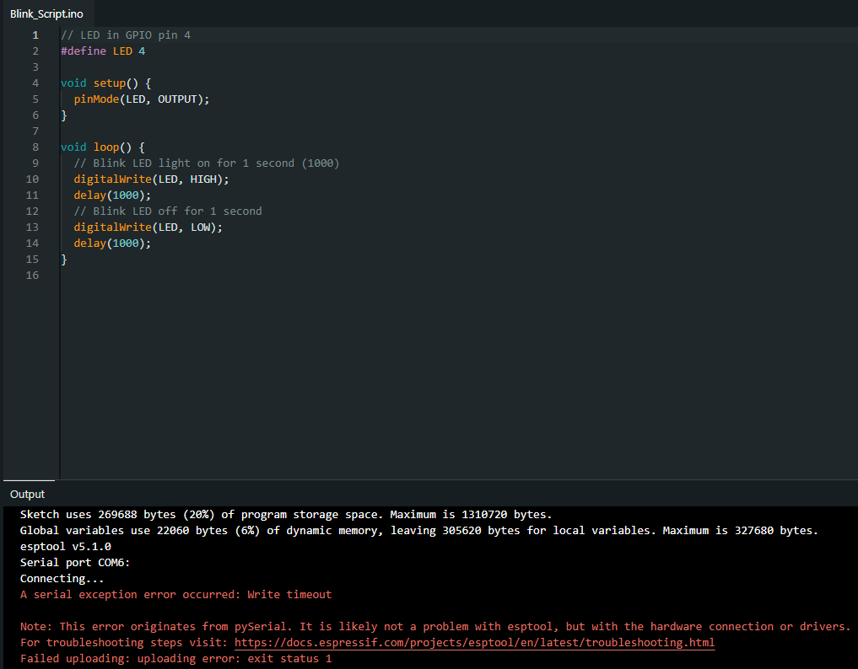
Figure 1: Serial exception error

This issue was traced to incorrect port selection and the ESP32 not entering bootloader mode. The correct port was identified by observing changes in available COM ports when the device was connected. The board was then manually placed into bootloader mode using the “BOOT” button during upload. After correcting these issues, sketches uploaded successfully and it worked as expected.
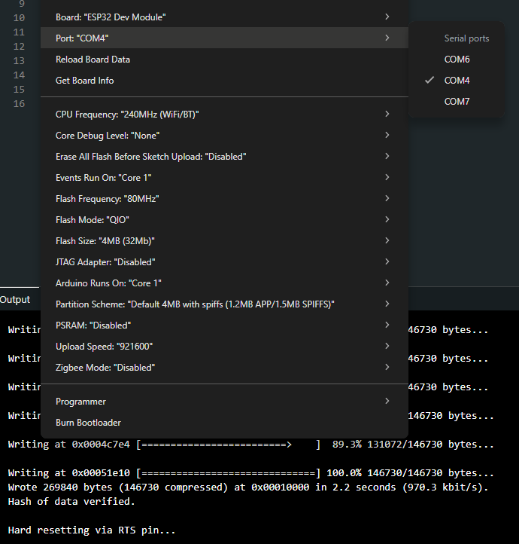
Figure 2: Correct serial port selected & upload log successfully uploaded

5.3. ESP32 Hardware Validation (LED Test)
A simple LED blink test was used to confirm that the ESP32 was functioning correctly. The LED connected to GPIO4 successfully toggled on and off using the built-in “blink” sketch in the IDE.
This confirmed that:
- Communication between the ESP32 and the computer was successful
- Code was being uploaded, executed and was compatible with the ESP32 microcontroller
- The GPIO pins on the board were functioning as expected
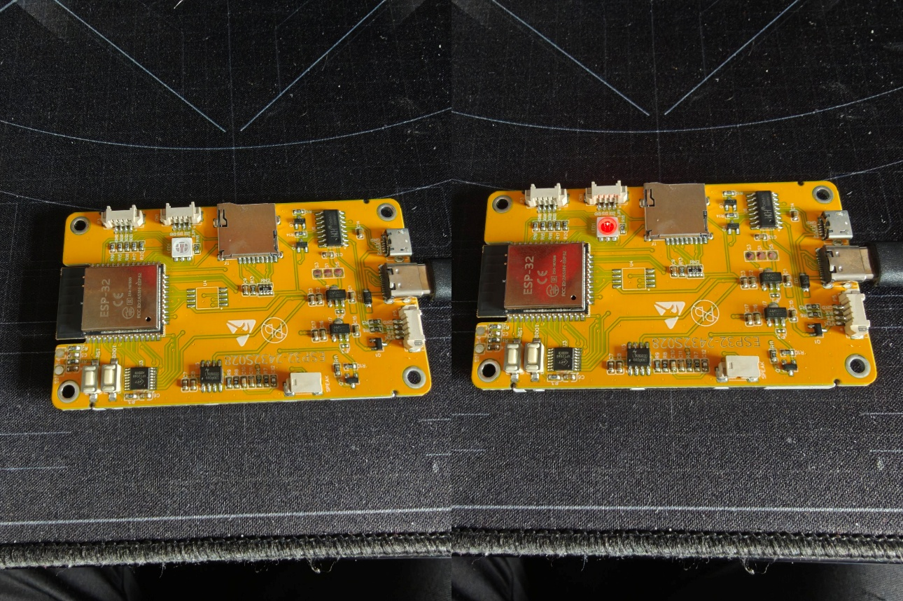
Figure 3:LED light toggling off/on

5.4. ESP32 Serial Communication Setup
Serial communication was then implemented to allow debugging in real time. Messages were printed from the ESP32 to the Serial Monitor, and the output appeared correctly. This confirmed that USB communication between the ESP32 and development environment was functioning as expected and that the Serial Monitor within Arduino IDE could be used for further diagnostics if required.

5.5. GPS Integration Attempt
The GPS module was connected to the ESP32 via UART using the TX and RX pins. A minimal test program was written to read incoming data from the GPS module and print it directly to the Serial Monitor.
The expected output was standard NMEA sentences, which include information such as latitude, longitude, GPS fix quality, and the number of connected satellites.
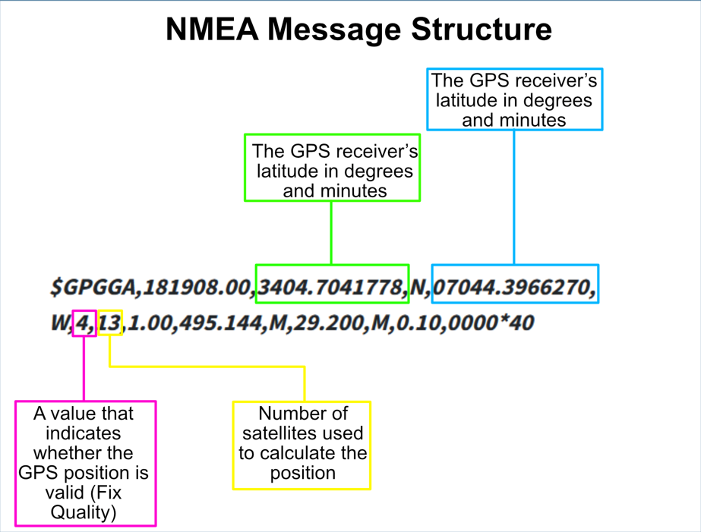
Figure 4:Format of expected NMEA sentence output

However, when the test was carried out, the output appeared as unreadable or garbled characters instead of valid NMEA sentences.
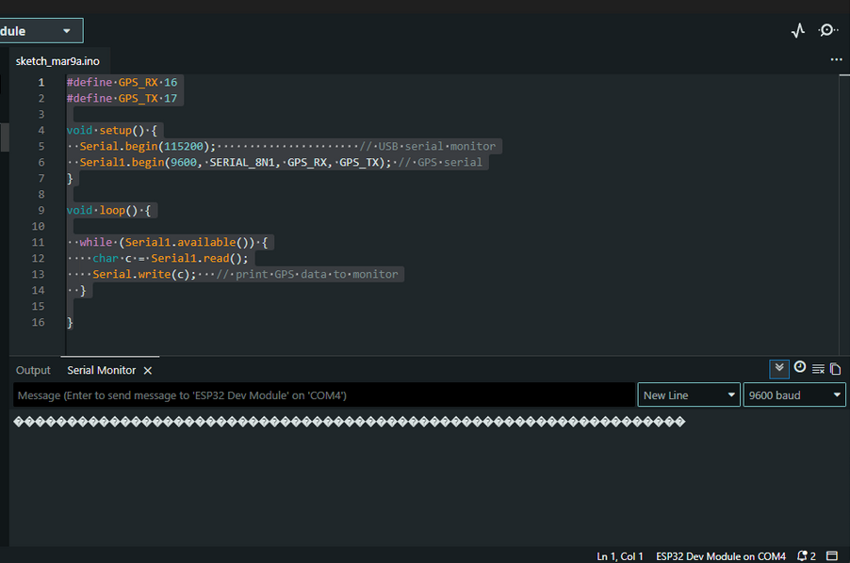
Figure 5:Received garbled output from GPS module

5.6. GPS Debugging Process
A structured and iterative debugging process was carried out to identify the cause of the incorrect GPS output. Since some form of data was consistently being received, the issue was treated as a communication or configuration problem rather than a complete hardware failure, therefore, multiple potential causes needed to be investigated.

5.6.1 Library and Software Configuration
Multiple Arduino libraries were tested to determine whether the issue was related to how the software was interpreting the data. Display related libraries such as Adafruit GFX, Adafruit SSD1306, and TFT_eSPI, were initially used to test whether the issue was limited to the Serial Monitor output. The IDE was still receiving the same garbled output, and the libraries were unable to display anything on the ESP32 OLED screen as anticipated. These libraries did not resolve the issue, indicating that the problem was not related to display handling.
GPS specific libraries, including TinyGPS, TinyGPSPlus, NeoGPS, and the SparkFun u-blox GNSS library, were then tested. These libraries are designed to parse NMEA data into usable values. However, all of them require valid input data. Since the incoming data was already corrupted and/or in an unknown format, none of the libraries were able to produce meaningful output. This confirmed that the issue existed before the parsing stage and was likely related to the data being received rather than how it was processed.

5.6.2 Baud Rate Testing
Since UART communication depends on matching baud rates between devices, multiple standard GPS baud rates were tested, including 4800, 9600, 38400, and 115200.
Each configuration was uploaded to the ESP32, and the Serial Monitor was checked for valid output. Despite testing these common baud rates, the output remained uninterpretable.

5.6.3 Wiring Verification
All wiring connections were rechecked to ensure correct configuration. The TX and RX connections were verified, and power and ground connections were confirmed to be stable and working. The GPS RX pin was considered non-essential and was temporarily disconnected to reduce possible interference. Multiple GPS modules were also tested to rule out a faulty unit.
A flashing blue LED on the GPS module indicated that it was powered and actively receiving satellite data.
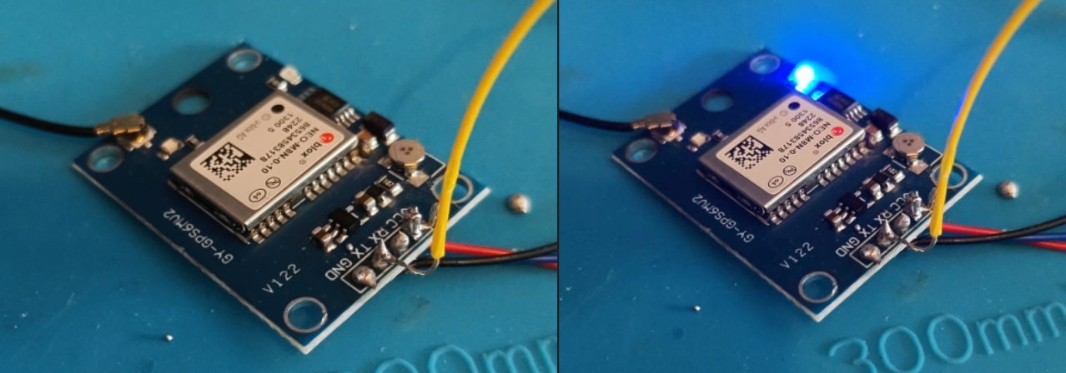
Figure 6: Blue flashing light indicating GPS data is being received.

5.6.4 System Isolation and Minimal Testing
To eliminate interference from other components or software complexity, all non-essential hardware connections were removed and a minimal test sketch was used, which only read raw serial data from the GPS module.
This ensured that the ESP32 was performing only a single task, with no additional libraries or processes that could affect device timing or communication. Despite this controlled setup, the output remained unchanged.

5.6.5 Serial Monitor Configuration
The Serial Monitor configuration was checked and verified to ensure correct interpretation of incoming data. The baud rate was matched to the code, and alternative baud rates were also briefly tested. No changes in output were observed, confirming that the issue was not caused by Serial Monitor settings.

5.7. BLE Integration Attempt
An external AT-09 Bluetooth 4.0 module was used to simulate a BLE tag device. Although the ESP32 itself includes built-in BLE functionality, the external module allowed for separation between scanning and broadcasting devices. The module was connected via UART and configured using AT commands within the IDE serial monitor. Communication between the ESP32 and the module was successful, with the module working as expected. The module was able to broadcast and be detected by other devices, confirming that BLE functionality was operational.

5.8. BLE Data Handling
When attempting to read data from the BLE module, the output appeared as garbled characters (similar to the results of the GPS module). After further investigation, it was determined that the module was outputting raw binary data rather than ASCII text.
To resolve this, the data was read byte-by-byte and converted into hexadecimal format before being printed to the Serial Monitor. This allowed the data to be visualised in a structured and readable way.
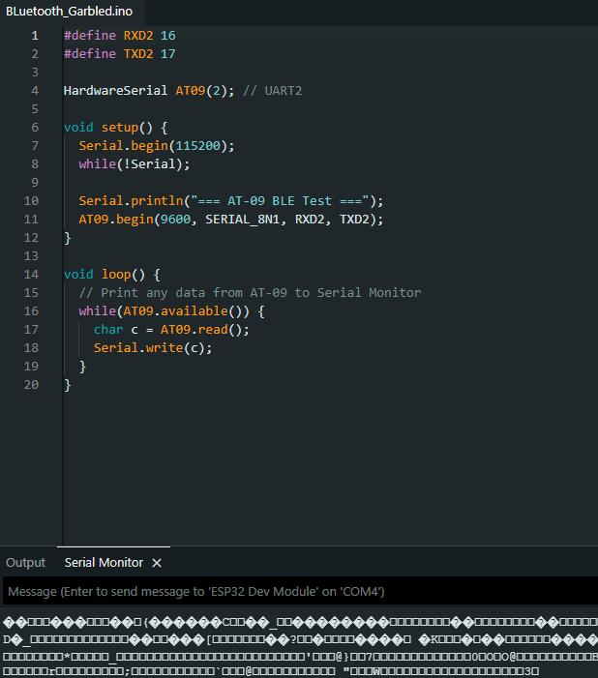
Figure 7: Garbled output from BLE module

6. Testing & Evaluation

6.1. GPS Testing Results
The GPS module was tested using a minimal serial read program. The expected result was the output of valid NMEA sentences (Figure 4). However, the actual output consisted entirely of unreadable characters (Figure 5).
After successfully converting the garbled output from the BLE to hexadecimal format and then into standard characters, the same process was carried out with the GPS, however, the results were ultimately unsuccessful.

6.2. GPS Evaluation
Although valid NMEA data was not obtained, consistent data transmission was observed from the GPS module. This confirms that the GPS module was powered and actively sending and receiving data, and that a communication channel existed between the module and the ESP32.
The failure to produce readable output suggested a low-level communication issue, such as unknown or incorrect baud rate configuration, incompatible signal levels, or non-standard data formatting.
All standard debugging procedures were followed, including library testing, wiring verification, baud rate adjustment, and system isolation. Since none of these resolved the issue, the problem is likely due to hardware compatibility or signal-level mismatch rather than software implementation.
This type of issue occurs below the level of standard software debugging and would not have been easily predicted during the design phase as it is not mentioned in any standard device documentation.

6.3. BLE Testing Results
The BLE module responded correctly to AT commands and was able to broadcast as expected. However, when reading data directly, the output initially appeared as garbled characters (Figure 7).

6.4. BLE Evaluation
Further investigation showed that it was not an encoding issues, but that the BLE module was outputting raw binary data. Once converted into hexadecimal format, the data became readable, confirming that communication was functioning correctly.
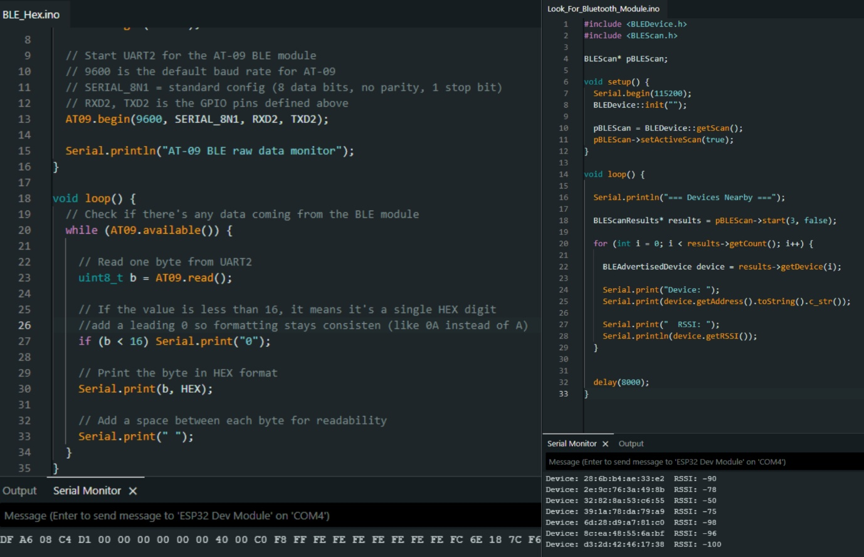
Figure 8: Output being converted to HEX (left) and then into readable characters (right)

During the process of extended testing of the BLE module, a further more significant issue was discovered. The MAC address of the BLE module would change every few minutes which would lead to a lost signal. The module would then reappear under a different MAC address.
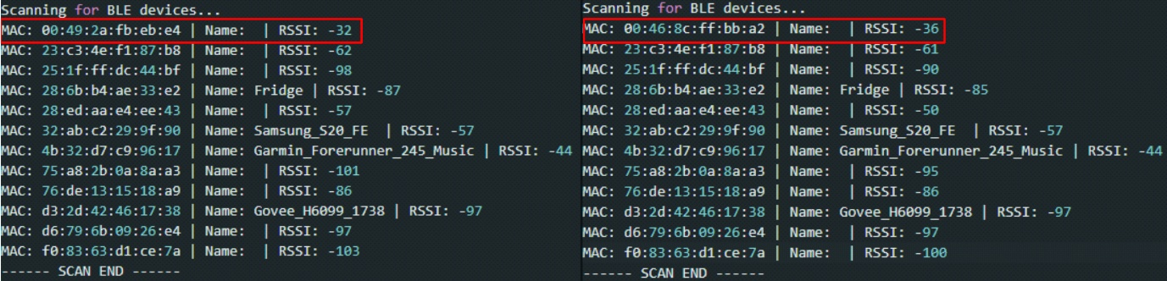
Figure 9: BLE's MAC address changing between scans

This behaviour prevented reliable identification of the device, making it unsuitable for consistent proximity tracking. While the BLE communication itself was successful, the instability of the module limited its practical use.

6.5. BLE Workaround and Validation
Therefore, to determine whether the issue was being caused by the ESP32 or the BLE module, a controlled test was implemented using a predefined identifier. The ESP32 was programmed to detect a known device and process its RSSI values. Under these conditions, the system functioned correctly, detecting the device and calculating proximity as expected.
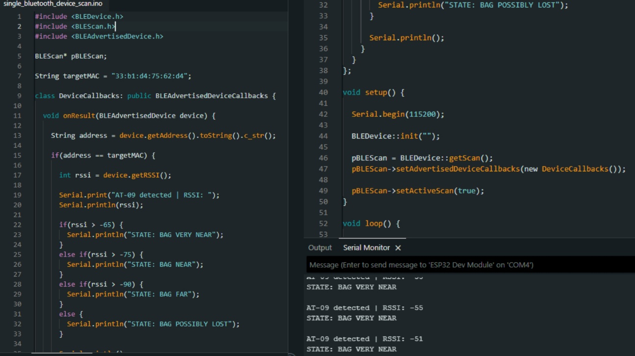
Figure 10: Proximity detection working as designed

This confirmed that BLE scanning functionality was working correctly, RSSI-based proximity detection was valid, and the issue of the changing MAC address was isolated to the BLE module hardware itself. This represents a partial success, as the system logic was validated despite hardware limitations.
Due to the nature of the cheap component, hard-coding a MAC address onto it was not possible. After further investigation into the device, it was assumed that the changing MAC address was a preconfigured security feature built into the firmware of the BLE module that could not be altered or removed.

7. Project Conclusion
The idea was to use BLE as a fast, low-power proximity trigger and GPS as a secondary verification layer, linked together through a deterministic handshake mechanism on a central microcontroller. From a design standpoint, this approach is sound and it directly addresses known weaknesses in each individual technology by using each one to compensate for the limitations of the other.
In implementation, the system as a whole produced a mixed outcome. The BLE subsystem performed reliably, consistently detecting proximity changes using RSSI-based measurements with a responsive scan interval suitable for real time updates. This provided a stable foundation for event detection and demonstrated that BLE can effectively act as the initial trigger in a layered sensing model. However, some variability was observed in device identification due to MAC address randomisation, but this did not significantly impact proximity classification within the scope of the project.
Despite this limitation, the system logic itself was still validated. By substituting live GPS readings with controlled or hardcoded input values from the user, the handshake mechanism was tested in full and behaved as intended. This confirms that the decision-making framework is correct and capable of differentiating between contextual states such as arrival, departure, and transient signal loss when valid inputs are available. The main constraint therefore lies in data acquisition rather than system design.
The GPS subsystem did not achieve the same level of success. Although the module was powered correctly and satellite activity was observed to be connected and relaying information, no usable NMEA data was successfully extracted. Multiple debugging approaches were applied, including changes to baud rate, parsing libraries, hardware configurations and multiple new GPS modules, but the issue remained unresolved. This seems to point toward a low-level communication or module compatibility problem rather than a software parsing error, particularly given that repeated testing produced consistent results across multiple configurations and modules.
When evaluated against the original objectives, BLE-based proximity detection was fully achieved and met the required performance expectations. GPS integration was not successfully completed, preventing full real-world deployment of the hybrid system, however, the handshake logic was partially validated through simulated figures, meaning the conceptual model remains intact and operational in principle.
Overall, the project demonstrates that a hybrid BLE/GPS architecture is conceptually effective and structurally sound, but its real-world viability is heavily dependent on hardware reliability and integration quality. While full system deployment was not achieved, the BLE subsystem and decision logic provided a strong foundation for future development. With improved GPS integration and enhanced signal processing, the model has clear potential to evolve into a practical low-power location tagging system suitable for real-world IoT applications.

7.1. Limitations
A key limitation of this work is the reliance on low-cost, inconsistently and incorrectly documented hardware. The unpredictability observed in both BLE behaviour and GPS output highlighted the challenges of developing reliable IoT systems using cheap, unreliable modules. Environmental sensitivity in RSSI-based measurements further added to this complexity, as signal strength can fluctuate significantly due to interference, obstruction, and device orientation. These factors collectively reduce the predictability of real-world performance, even when system the logic is sound.
The GPS subsystem did not achieve the same level of success. Although the module was powered correctly and satellite activity was observed to be connected and relaying information, no usable NMEA data was successfully extracted. Multiple debugging approaches were applied, including changes to baud rate, parsing libraries, hardware configurations and multiple new GPS modules, but the issue remained unresolved. This seems to point toward a low-level communication or module compatibility problem rather than a software parsing error, particularly given that repeated testing produced consistent results across multiple configurations and modules.

7.2. Future Work
Future work should focus primarily on resolving the GPS integration issue to enable full end-to-end system validation. This would involve replacing the current GPS module with a better-documented alternative and verifying UART communication at both electrical and protocol levels. Once stable positional data can be reliably acquired, the handshake mechanism can be tested under real-world movement scenarios to evaluate timing accuracy, false positive rates, and state classification reliability.
Beyond replacing the hardware, the BLE system could also be improved to make it more stable in real-world conditions. RSSI values tend to fluctuate quite a bit depending on movement and environmental interference, so applying simple filtering methods (such as averaging recent readings or ignoring sudden spikes) could make the distance estimates more consistent. Another option for future development would be to look at additional positioning methods alongside BLE, such as Wi-Fi-based location detection or combining multiple sensors together. This would make the system more reliable in situations where BLE signals alone are unstable or inaccurate.

References:
6 Different Bluetooth Versions Made Simple (Which One Do You Need?). 8 October 2025. https://soundhub.io/blog/different-bluetooth-versions/.
‘Accuracy and Precision of GNSS in the Field’. In GPS and GNSS Technology in Geosciences. Elsevier, 2021. https://doi.org/10.1016/B978-0-12-818617-6.00002-0.
Active Research Ltd., (Actisense). NMEA 0183 Information Sheet: Everything You Wanted to Know about NMEA 0183 (but Were Afraid to Ask). Poole, Dorset, UK, 2015. https://actisense.com/wp-content/uploads/2020/01/NMEA-0183-Information-sheet-issue-4-1-1.pdf.
Aftab, Muhammad Usama bin. Building Bluetooth Low Energy Systems. Packt Publishing Ltd, 2017.
Ahmad, Khadija Sania, Nazia Ahmad, Hina Tahir, and Shaista Khan. ‘Fuzzy_MoSCoW: A Fuzzy Based MoSCoW Method for the Prioritization of Software Requirements’. 2017 International Conference on Intelligent Computing, Instrumentation and Control Technologies (ICICICT), July 2017, 433–37. https://doi.org/10.1109/ICICICT1.2017.8342602.
Andersen. ‘Eleven Additional Governments Commit to New Plastics Economy’. 2 November 2022. https://www.unep.org/news-and-stories/story/eleven-additional-governments-commit-new-plastics-economy.
Baldauf, Matthias, Schahram Dustdar, and Florian Rosenberg. ‘A Survey on Context-Aware Systems’. International Journal of Ad Hoc and Ubiquitous Computing, 18 June 2007. World. https://www.inderscienceonline.com/doi/10.1504/IJAHUC.2007.014070.
Bisdikian, C. ‘An Overview of the Bluetooth Wireless Technology’. IEEE Communications Magazine 39, no. 12 (2001): 86–94. https://doi.org/10.1109/35.968817.
‘BLE | Bluetooth Low Energy – Why Everyone Is Using It?’ 30 April 2021. https://avsystem.com/blog/linkyfi/bluetooth-low-energy-ble.
Bluetooth SIG Proprietary. ‘Specification of the Bluetooth System’. Version BLUETOOTH SPECIFICATION Version 4.2. 2 December 2014. https://www.bluetooth.com/specifications/specs/core-specification-4-2/.
Chai, Song, Renbo An, and Zhengzhong Du. ‘An Indoor Positioning Algorithm Using Bluetooth Low Energy RSSI’. April 2016, 274–76. https://doi.org/10.2991/amsee-16.2016.72.
Climate, Tim Dodd, and Science Reporter. ‘Plastic Bags: Have Bans and Fees Curbed Shoreline Litter?’ BBC News, 19 June 2025. https://www.bbc.co.uk/news/articles/cdeznkxyek0o.
Crystal, Jonathon D. ‘Prospective Memory’. Current Biology 23, no. 17 (2013): R750–51. https://doi.org/10.1016/j.cub.2013.07.081.
Currey. HM-10 Bluetooth 4 BLE Modules – Martyn Currey. 14 August 2024. https://www.martyncurrey.com/hm-10-bluetooth-4ble-modules/.
‘Definition of HERTZ’. 2 December 2025. https://www.merriam-webster.com/dictionary/hertz.
‘Definition of MILLISECOND’. 8 December 2025. https://www.merriam-webster.com/dictionary/millisecond.
Einstein, Gilles O., and Mark A. McDaniel. ‘Prospective Memory: Multiple Retrieval Processes’. Current Directions in Psychological Science 14, no. 6 (2005): 286–90. https://doi.org/10.1111/j.0963-7214.2005.00382.x.
‘ESP32 Wi-Fi & Bluetooth SoC | Espressif Systems’. Accessed 10 December 2025. https://www.espressif.com/en/products/socs/esp32.
Espressif. ‘ESPRESSIF’. Product. ESP Product Selector, 2025. https://products.espressif.com/#/product-selector?language=en&names=ESP32-WROOM-32E-N16.
Federation, British Plastics. ‘A History of Plastics’. British Plastics Federation. Accessed 17 October 2025. https://www.bpf.co.uk/plastipedia/plastics_history/Default.aspx.
Fürst, Jonathan, Kaifei Chen, Hyung-Sin Kim, and Philippe Bonnet. ‘Evaluating Bluetooth Low Energy for IoT’. 2018 IEEE Workshop on Benchmarking Cyber-Physical Networks and Systems (CPSBench), April 2018, 1–6. https://doi.org/10.1109/CPSBench.2018.00007.
Gabriel, Alex, and Fabio Cruz. ‘Open Source IoT-Based Collection Bin Applied to Local Plastic Recycling’. HardwareX 13 (March 2023): e00389. https://doi.org/10.1016/j.ohx.2022.e00389.
Gakstatter, Eric. What Exactly Is GPS NMEA Data? - GPS World. Opinions. 4 February 2015. https://www.gpsworld.com/what-exactly-is-gps-nmea-data/.
‘Global Plastic Waste Pollution Challenges and Management’. Accessed 21 October 2025. https://ieeexplore.ieee.org/abstract/document/9078268.
Harrison, Tyler L., and Gilles O. Einstein. ‘Prospective Memory: Are Preparatory Attentional Processes Necessary for a Single Focal Cue?’ Memory & Cognition 38, no. 7 (2010): 860–67. https://doi.org/10.3758/MC.38.7.860.
Harrison, Tyler L., Hillary G. Mullet, Katie N. Whiffen, Hunter Ousterhout, and Gilles O. Einstein. ‘Prospective Memory: Effects of Divided Attention on Spontaneous Retrieval’. Memory & Cognition 42, no. 2 (2013): 212–24. https://doi.org/10.3758/s13421-013-0357-y.
Lee, Yi-Shiun, Yong-Yi Fanjiang, Chi-Huang Hung, and Yung-Shiang Huang. BLE Signal Processing and Machine Learning for Indoor Behavior Classification. 25, no. 14 (2025): 4496. https://doi.org/10.3390/s25144496.
Lyatuu, Cornel Andrew. ‘An Analysis of Bluetooth 5 in Comparison to Bluetooth 4.2’. Europub Journal of Education Research 3, no. 1 (2022): 112–20. https://doi.org/10.54745/ejerv3n1-008.
Macintosh, Andrew, Amelia Simpson, Teresa Neeman, and Kirilly Dickson. ‘Plastic Bag Bans: Lessons from the Australian Capital Territory’. Resources, Conservation and Recycling 154 (March 2020): 104638. https://doi.org/10.1016/j.resconrec.2019.104638.
Mackensen, Elke, Matthias Lai, and Thomas M. Wendt. ‘Bluetooth Low Energy (BLE) Based Wireless Sensors’. 2012 IEEE SENSORS, October 2012, 1–4. https://doi.org/10.1109/ICSENS.2012.6411303.
McDaniel, Mark A., and Gilles O. Einstein. ‘Strategic and Automatic Processes in Prospective Memory Retrieval: A Multiprocess Framework’. Applied Cognitive Psychology 14, no. 7 (2000): S127–44. https://doi.org/10.1002/acp.775.
McDermott-Wells, P. ‘What Is Bluetooth?’ IEEE Potentials 23, no. 5 (2005): 33–35. https://doi.org/10.1109/MP.2005.1368913.
Milner, Greg. ‘What Is GPS?’ Journal of Technology in Human Services 34, no. 1 (2016): 9–12. https://doi.org/10.1080/15228835.2016.1140110.
Norman, Don. The Design of Everyday Things. Revised and Expanded. Basic Books, 2013.
OpenAI. ChatGPT (GPT-5.1). V. GPT-5.1. OpenAI, released 2025. Web-based AI model. https://chat.openai.com/.
Paul, Wahinya M. K. Effectiveness of the Implementation of Plastic Bags Ban: Empirical Evidence from Kenya. n.d.
Perera, Charith, Arkady Zaslavsky, Peter Christen, and Dimitrios Georgakopoulos. ‘Sensing as a Service Model for Smart Cities Supported by Internet of Things’. Transactions on Emerging Telecommunications Technologies 25, no. 1 (2014): 81–93. https://doi.org/10.1002/ett.2704.
Pratama, Agung Rizky Putra. ‘IMPLEMENTASI SISTEM LORA UNTUK DETEKSI DAN PELACAKAN PENDAKI GUNUNG’. Jurnal Media Akademik (JMA) 3, no. 7 (2025). https://doi.org/10.62281/v3i7.2655.
Rhodes, Christopher J. ‘Plastic Pollution and Potential Solutions’. Science Progress 101, no. 3 (2018): 207–60. https://doi.org/10.3184/003685018X15294876706211.
Rutkowski, Rob. ‘What’s The Differences Between the 5 GNSS Constellations?’ What’s The Differences Between the 5 GNSS Constellations?, 25 January 2022. https://blog.bliley.com/the-differences-between-the-5-gnss-satellite-network-constellations.
Smith, Steven M., and Edward Vela. ‘Environmental Context-Dependent Memory: A Review and Meta-Analysis’. Psychonomic Bulletin & Review 8, no. 2 (2001): 203–20. https://doi.org/10.3758/BF03196157.
Sophia, S., B. Maruthi Shankar, K. Akshya, AR. C. Arunachalam, V. T. Y. Avanthika, and S. Deepak. ‘Bluetooth Low Energy Based Indoor Positioning System Using ESP32’. 2021 Third International Conference on Inventive Research in Computing Applications (ICIRCA), September 2021, 1698–702. https://doi.org/10.1109/ICIRCA51532.2021.9544975.
Taghipour, Hassan, Asghar Mohammadpoorasl, Mahdihe Tarfiei, and Nasrin Jafari. ‘Single-Use Plastic Bags: Challenges, Consumer’s Behavior, and Potential Intervention Policies’. Journal of Material Cycles and Waste Management 25, no. 6 (2023): 3404–13. https://doi.org/10.1007/s10163-023-01763-z.
Thomas, Gregory Owen, Wouter Poortinga, and Elena Sautkina. ‘The Welsh Single-Use Carrier Bag Charge and Behavioural Spillover’. Journal of Environmental Psychology 47 (September 2016): 126–35. https://doi.org/10.1016/j.jenvp.2016.05.008.
‘Tips to Reduce Your Plastic Waste | WWF’. Accessed 17 October 2025. https://www.wwf.org.uk/updates/top-tips-reduce-your-plastic-footprint.
U-Blox. ‘NEO-M8 Series’. 25 June 2015. https://www.u-blox.com/en/product/neo-m8-series.
UN Environment Programme. ‘Plastic Pollution’. Environmental Organization. Plastic Pollution, 1 July 2025. https://www.unep.org/plastic-pollution.
UNEP. ‘Drowning in Plastics – Marine Litter and Plastic Waste Vital Graphics | UNEP - UN Environment Programme’. 21 October 2021. https://www.unep.org/resources/report/drowning-plastics-marine-litter-and-plastic-waste-vital-graphics.
‘Universal Asynchronous Receiver-Transmitter (UART) | Arduino Documentation’. Accessed 11 April 2026. https://docs.arduino.cc/learn/communication/uart/.
Wabnitz, Colette, and Wallace J. Nichols. Editorial: Plastic Pollution: An Ocean Emergency. 2010.
Wilcox, Chris, Erik Van Sebille, and Britta Denise Hardesty. ‘Threat of Plastic Pollution to Seabirds Is Global, Pervasive, and Increasing’. Proceedings of the National Academy of Sciences 112, no. 38 (2015): 11899–904. https://doi.org/10.1073/pnas.1502108112.
Wolf, Jean. ‘Defining GPS and Its Capabilities’. In Handbook of Transport Geography and Spatial Systems, vol. 5, edited by David A. Hensher, Kenneth J. Button, Kingsley E. Haynes, and Peter R. Stopher. Emerald Group Publishing Limited, 2004. https://doi.org/10.1108/9781615832538-023.
Xanthos, Dirk, and Tony R. Walker. ‘International Policies to Reduce Plastic Marine Pollution from Single-Use Plastics (Plastic Bags and Microbeads): A Review’. Marine Pollution Bulletin 118, no. 1 (2017): 17–26. https://doi.org/10.1016/j.marpolbul.2017.02.048.
Ystgaard, Kaja Fjørtoft, Luigi Atzori, David Palma, et al. ‘Review of the Theory, Principles, and Design Requirements of Human-Centric Internet of Things (IoT)’. Journal of Ambient Intelligence and Humanized Computing 14, no. 3 (2023): 2827–59. https://doi.org/10.1007/s12652-023-04539-3.

Appendix A: Report Structure Example

Project Technical Report
1) Project Overview
- Purpose and objectives of the software
- Scope of the project
- Assumptions, constraints and dependencies
- Definitions and acronyms

2) Requirements
Functional Requirements
- Detailed description of system functions and capabilities
- Input and output specifications
- Data processing operations
- Use cases, user stories (if applicable)
Non-Functional Requirements
- Performance requirements (e.g., response time, throughput)
- Security requirements
- Usability and accessibility standards
- Reliability and availability metrics
- Scalability considerations (if applicable)

3) System Architecture & Design
- Hardware and software requirements (including development and runtime environment)
- High-level system architecture
- Key components/functions/objects and their interactions
- Detailed description of system features, including workflow descriptions.
- Design and implementation constraints
- System qualities (e.g., maintainability, extensibility)
- Security protocols / considerations
- Testing strategy

4) Data Requirements
- Data models and schemas
- Data flow diagrams, class diagram or similar

5) Implementation
- Document the development process
- Code management, version control, etc. (evidence of following best practice)
- Discuss challenges, errors and limitations

6) Testing & Evaluation
- Testing overview / discussing testing requirements
- Functional Testing / Analysis (following testing strategy)
- Results/Evaluation Discussion

7) Conclusion
- Project conclusion/findings
- Limitations
- Future Work

Appendix B: Code Listing / GitHub Project Link

https://github.com/DaleNesbitt/FinalYearProject

