Final Year Project Technical Report
BSc (Hons) Computing with Computer Games Development



How effectively can Bluetooth and GPS work together to provide seamless location tagging?

Student Name: Dale Nesbitt
Student ID: L00106269

Declaration

- I have accurately identified and included the sources of all facts, ideas, opinions, and viewpoints from others in the assignment references. All direct quotations, paraphrasing, and discussions of ideas from books, journal articles, internet sources, course materials, or any other sources used are properly acknowledged and cited in the assignment references.
- I have not used unauthorised artificial intelligence tools or aids.
- I understand and am compliant with ATU's policy and procedures regarding Academic Integrity and I am aware of the consequences of any violations.
- I have followed the referencing guidelines recommended in the assignment instructions and / or programme documentation.
- I understand that not adhering to the word limits on each section will result in penalties.
- By signing this form or by submitting material online I confirm that this assignment, or any part of it, has not been previously submitted by me or any other person for assessment on this or any other programme of study.
- By signing this form or by submitting material for assessment online I confirm that I have read and understood AQAE022 Academic Integrity Policy.

I confirm I agree to this declaration. ☒

Print Signature: Dale Nesbitt

Date: 21/04/2026

Acknowledgements
I would like to thank…

Table of Contents
1. Project Overview 1
1.1. Purpose 1
1.2. Objectives 1
1.2.1. One liner 1
1.2.2. Sub-Item 1
1.3. Project Scope 1
1.4. Definitions and Acronyms 2
2. Requirements 3
2.1. Functional Requirements 3
2.2. Non-Functional Requirements 3
2.3. Table Section 3
2.4. Code and Formulae 4
References i
Appendix A: Report Structure Example ii
Appendix B: Code Listing / GitHub Project Link iv

Table of Figures
Figure 1 Atlantic Technological University Donegal Logo 2
Figure 2 ATU Donegal, Letterkenny 2

Glossary of Terms
Term | Definition
BLE (Bluetooth Low Energy) | A type of wireless communication designed for short-range, low-power data exchange that operates in the 2.4 GHz band. Commonly used for proximity sensing, wearables, and IoT devices where battery efficiency is important. (Fürst et al., 2018)
GPS (Global Positioning System) | A satellite-based navigation system that provides absolute location and accurate time information anywhere on Earth. Alternative versions such as GLONASS (Russian Federation), BeiDou (China) and Galileo (European Union) also exist, but they all perform the same function. (Rutkowski, 2022)
RSSI (Received Signal Strength Indicator) | A measurement of how strong a received radio signal is. In BLE systems, RSSI is used to estimate how near or far a device is. (Chai, An and Du, 2016)
ESP32 | A microcontroller unit with integrated Wi-Fi and  Bluetooth connectivity for a wide-range of applications. (ESP32 Wi-Fi & Bluetooth SoC | Espressif Systems, no date)
NEO-8M | A small GPS receiver module that outputs location data using standard protocols like NMEA. It connects to microcontrollers via UART and provides reliable GPS fixes. It is a specific type of GNSS module. (NEO-M8 series, 2015)
GNSS | A Global Navigation Satellite System (GNSS) module is an electronic device that receives signals from satellite constellations such as GPS, GLONASS, Galileo, or BeiDou to calculate its geographic position in real time. (Rutkowski, 2022)
NMEA (National Marine Electronics Association Format) | A standardized text-based format used by GPS modules to transmit location, time, and status data. Messages are structured as comma-separated sentences starting with a “$” symbol. (Gakstatter, 2015)
ms (milliseconds) | A unit of time equal to one-thousandth of a second (0.001 s). (Merriam-Webster, 2025)
Hz (Hertz) | A unit of frequency meaning equal to one cycle per second. (Merriam-Webster, 2025)
GGA | An NMEA sentence that provides key GPS fix information, including latitude, longitude, fix quality, and number of satellites. Used in this project to validate the reliability of each GPS reading.
UART (Universal Asynchronous Receiver-Transmitter) | A commonly used asynchronous serial communication protocol. It is the protocol used by Arduino boards and computers in order to communicate.

Project Overview

Purpose
I will investigate how Bluetooth Low Energy (BLE) and Global Positioning System (GPS) technologies can be combined to create a hybrid ‘sensing’ model capable of supporting context-aware IoT applications to determine location. My primary goal will be to design and evaluate a BLE/GPS ‘handshake mechanism’, where BLE proximity events and GPS location updates interact to determine meaningful system states. I will focus on the technical synchronisation between BLE’s short-range RSSI-based detection and GPS’s global positional data, examining how these two sensing modalities can be used together to deliver reliable location tagging on a low-power microcontroller platform. I am hoping to provide a clear understanding of the limitations, timing behaviours, and accuracy characteristics involved in hybrid BLE/GPS sensing.

Objectives

1.2.1 BLE Proximity Detection
Implement a BLE 4.2 scanning system on the ESP32 that detects a predefined BLE tag, retrieves its RSSI values, and classifies proximity states (e.g., near, far, lost). I chose BLE 4.2 because it is already integrated into the ESP32 hardware (Espressif, 2025). This means no additional antennas, modules, or power overhead are required. It is more than capable of delivering the short-range proximity readings I need, and it maintains low power consumption while still offering stable scanning performance. The system must identify ‘tag-loss’ events within a scanning interval of <500 ms (Bluetooth SIG, 2014) and operate reliably across typical indoor and outdoor environments.

1.2.2 GPS Location Detection/Acquisition
Integrate the NEO-8M GPS module to obtain real-time coordinates. GPS fix-quality and satellite-count data will be used to validate readings and prevent false classifications. (NEO-M8 series, 2015)

1.2.3 BLE/GPS Handshake
Design a deterministic “handshake” workflow where BLE proximity loss triggers GPS location verification, and GPS updates influence BLE scanning behaviour. The handshake must define clear timing rules, thresholds, and decision logic for transitions between contextual system states (e.g., departure detected, geofence entry, false BLE loss).

1.2.4 Event Logging
Develop a local logging system using internal flash of the ESP32 or MicroSD storage to record BLE RSSI readings, GPS coordinates, fix quality, handshake outcomes, and system states.

1.2.5 System Feedback
Implement a visual or auditory output mechanism that reflects handshake-determined system states such as “BLE tag lost”, “geofence entered”, or “GPS invalid”. Feedback must be driven solely by validated BLE/GPS transitions.

1.2.6 Performance Evaluation
Evaluate the hybrid sensing system by analysing BLE range variability, GPS lock time, handshake timing behaviour, and false-positive/false-negative rates using the collected log data. This evaluation will determine the reliability and limitations of the coordinated BLE/GPS sensing model.

Project Scope
In Scope:
- Development of a hybrid BLE/GPS sensing system on the ESP32 platform.
- Implementation of BLE scanning, GPS location/data acquisitions, handshake logic and event logging
- Technical evaluation of synchronisation timing, accuracy, and system reliability.
Out of Scope:
- Cloud integration, remote databases, or mobile app development.
- Behavioural user testing or human-factor evaluation.
- AI-based modelling, multi-user capabilities, or commercial product design.
- Environmental/social impact analysis.
Assumptions:
- Adequate GPS satellite visibility during operation.
- BLE tags comply with Bluetooth 4.2 advertising behaviour. Components are often branded as being compliant when they, in fact, are not.
- Local power (vehicle or battery) is available.
- Environmental conditions permit stable BLE and GPS communication.
Dependencies:
- ESP32 BLE and GPS software libraries.
- ESP32’s BLE version correctly branded.
- Reliable NEO-8M GPS operation and NMEA sentence output.

Requirements

Functional Requirements
BLE Scanning
- The system shall scan for a specific BLE tag at an interval of <500 ms.
- The system shall retrieve RSSI values and classify proximity states.

Proximity Loss Detection
- The system shall determine tag loss after X consecutive missed scan cycles. (X shall be determined at a later date).

GPS Coordinate Acquisition
- The system shall retrieve GPS coordinates at a minimum of 1 Hz. (NEO-M8 series, 2015)
- The system shall validate readings using fix quality and satellite count. (Active Research Ltd., 2015)

Geofence Detection
- The system shall detect when coordinates enter or exit predefined geofences.

BLE/GPS Handshake
- The system shall trigger GPS checks when BLE proximity loss occurs.
- The handshake shall classify transitions such as departure, arrival, and false loss.

Event Logging
- Logs shall include timestamps, RSSI, GPS data, handshake results, and state transitions.

Feedback Output
- The system shall output visual/auditory indicators for state changes.

Non-Functional Requirements

Performance
- The system shall maintain a BLE scan interval of <500 ms and retrieve GPS coordinates at a minimum frequency of 1 Hz to ensure a responsive BLE/GPS handshake execution.

Accuracy
- The system shall achieve a typical GPS positional accuracy of 2.5 - 5 metres in open-sky conditions (NEO-M8 series, 2015).

Reliability
- The system shall operate continuously without unexpected interruptions to BLE scanning or GPS data acquisition, and it shall recover quickly from temporary GPS signal loss.

Robustness to Environmental Factors (Ireland)
- The system shall remain functional under moderate environmental interference such as BLE multipath effects, signal attenuation, and varying satellite visibility due to adverse weather conditions.

Power Efficiency
- The system should be capable of operating on portable power for at least 2 hours, with BLE scan intervals and GPS polling rates chosen to balance responsiveness and power usage.

Security
- The system should avoid the storage of personal or identifying data and should use BLE advertising mode without pairing to reduce security risks.

System Architecture & Design

High-Level Architecture Overview
My system will be built around a hybrid sensing approach that combines BLE for short-range proximity detection with GPS for absolute, accurate positional awareness. The ESP32 microcontroller acts as the central controller, coordinating the built-in BLE 4.2 and GPS subsystems and executing the handshake logic that determines the system’s context. The overall architecture is deliberately simple at this stage, as the detailed implementation will be carried out next semester.

The key components of the architecture are:
- BLE subsystem, which handles scanning for a specific tag and reading RSSI values; BLE scans occur at <500 ms intervals
- The GPS subsystem receives positional data from the NEO-8M module using NMEA sentences (Active Research Ltd., 2015) and updates at approximately 1 Hz.
- Handshake engine, which evaluates BLE and GPS data together to determine system state transitions.
- Dual sensor layer, which compares proximity information with location information.
- Event logger, which records system events and environmental data to either SD card or internal flash.

This high-level structure outlines how the major parts of the system are intended to work together, without going into implementation detail. This will be investigated and fine-tuned next semester.

Component Descriptions

Bluetooth Low Energy Module
BLE is used to detect the presence or absence of a designated tag by scanning for its advertising packets and reading the associated RSSI values. The ESP32’s built-in BLE 4.2 support makes it suitable for short-range proximity detection without requiring additional hardware. BLE range and signal strength vary depending on the environment, and RSSI readings may fluctuate due to interference or obstacles. The scan interval determines how quickly the system can detect proximity changes and affects overall power usage.

GPS Module (NEO-8M)
The NEO-8M GPS module provides global position data at an update rate of approximately one hertz, with typical accuracy of around 2.5 metres under good satellite visibility. Cold-start times range from roughly twenty to thirty seconds. The module outputs NMEA sentences such as GGA, which provide coordinates, fix quality, and satellite count. GPS performance reduces significantly indoors or in areas with obstructed sky view.

BLE/GPS Handshake Process
The handshake between BLE and GPS is the central behaviour that I will investigate. When the BLE subsystem detects that the tag’s RSSI has fallen below a threshold or that the tag has not appeared for a predefined number of scans, it flags a potential loss event. This triggers the handshake engine to request an updated GPS reading.

The GPS subsystem returns positional data along with fix quality and satellite count, allowing the system to assess whether the reading is reliable. Based on the combined BLE and GPS information, the handshake engine classifies the situation.
Examples include:
- the tag has genuinely moved out of range and the GPS position indicates that the user has left the area
- the BLE signal dropped due to interference, but the GPS position indicates the user is still within the expected area
- the GPS data is unreliable due to poor fix, in which case the event is ignored or deferred.

The handshake outcome leads to an internal state transition and the creation of a log entry

Workflow Descriptions
In a departure scenario, the BLE signal is initially strong. As the user moves away, RSSI decreases until the tag is no longer detected. This will initiate an internal state transition, which will then trigger the handshake. If GPS confirms the user has left the defined geofence, the system records this as a departure event. In an arrival scenario, the device receives periodic GPS updates and detects that the coordinates fall within a predefined location. The system updates its state accordingly. If the BLE tag is still missing at this point, the system may classify this as an arrival without the tagged item.

Design Constraints
Several constraints are expected at this stage. BLE RSSI is inherently noisy (Lee et al., 2025) meaning proximity readings may fluctuate even when the tag has not moved. GPS accuracy varies with weather conditions, satellite geometry, and environmental obstructions. The ESP32 must balance BLE scanning and GPS parsing within its available processing resources. Power consumption may increase if the scan interval or GPS polling frequency is set too aggressively. These are variables that will become evident when I begin building the artefact.

Security Considerations
The system does not collect personal information and does not use any cloud or network components. BLE operates in unpaired advertising mode, which limits potential security concerns. Logged data consists only of device identifiers and environmental readings taken from the NMEA sentence.

Data Requirements

Data Types Stored

The system will store the following data to support analysis and evaluation:

- GPS latitude and longitude, representing the device’s absolute position
- GPS fix quality and satellite count, used to assess the reliability of each coordinate reading
- BLE RSSI values, representing the detected proximity of the tagged device
- Presence or absence of the BLE tag, derived from the BLE scan results
- Internal state transitions, generated by the BLE/GPS handshake logic

Data Format
The data will be stored in a simple, structured format suitable for later analysis. The following is both appropriate and readable:

lat, lon, fixQuality, satCount, rssi, eventType

This approach is human readable and allows the data to be imported easily into spreadsheets or analysis tools if it’s saved as a CSV file.

Data Flow Summary
- BLE scanning produces RSSI values and presence information.
- GPS outputs positional data through NMEA sentences.
- The handshake engine evaluates both data sources and determines a classification.
- The logger records all relevant information to local storage.

Implementation

Development Approach
In the implementation phase I focused on building the system incrementally using the ESP32-2432S028R development board, the AT-09 Android IOS HM-10 BLE Bluetooth 4.0 Serial Wireless Module and the u-blox NEO-8M GPS module. Development was carried out in the Arduino IDE.
Rather than attempting to build the full system all at once, each part was developed and tested in isolation. This made it easier to identify issues in the beginning and avoid any confusion during debugging. The process followed these stages:
- Setting up and connecting to the ESP32
- Verifying basic hardware functionality
- Establishing serial communication for debugging
- Attempting GPS communication via UART
- Designing the BLE/GPS handshake logic in code
This approach allowed potential faults to be isolated to specific components rather than trying to debug the entire system as a whole.

ESP32 Setup and Upload Issues
I configured the ESP32 using the “ESP32 Dev Module” board profile within Arduino IDE. Initial attempts to upload code failed, producing repeated connection errors such as “A serial exception error occurred: Write timeout.
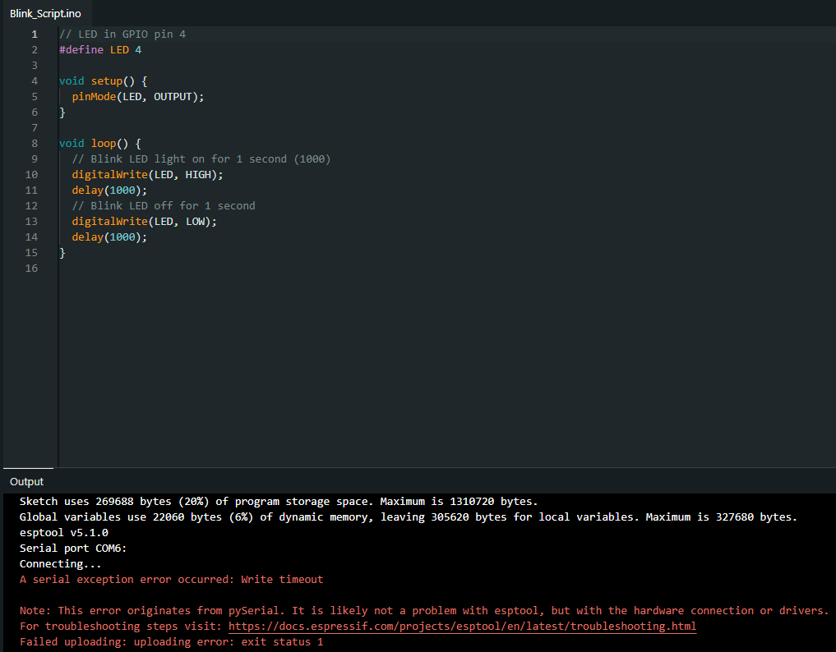
Figure 1: Serial exception error

This was traced back to selecting the wrong serial port and the ESP32 not entering bootloader mode.
The issue was resolved by:
- Identifying the correct serial port by testing other available ports
- Manually triggering boot mode using the BOOT button on the ESP32
- Reattempting the upload process
Once corrected, uploads completed successfully.

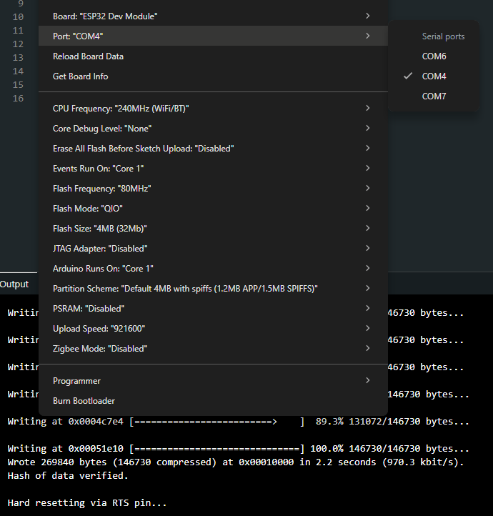
Figure 2: Correct serial port selected + upload log successfully uploaded

ESP32 Hardware Validation (LED Test)
A simple LED blink test was used to confirm that the board was functioning correctly. The LED connected to GPIO4 successfully toggled on and off as expected.
This confirmed:
- Communication with the ESP32 was successful
- Code was running as expected on the device
- GPIO pins were functioning
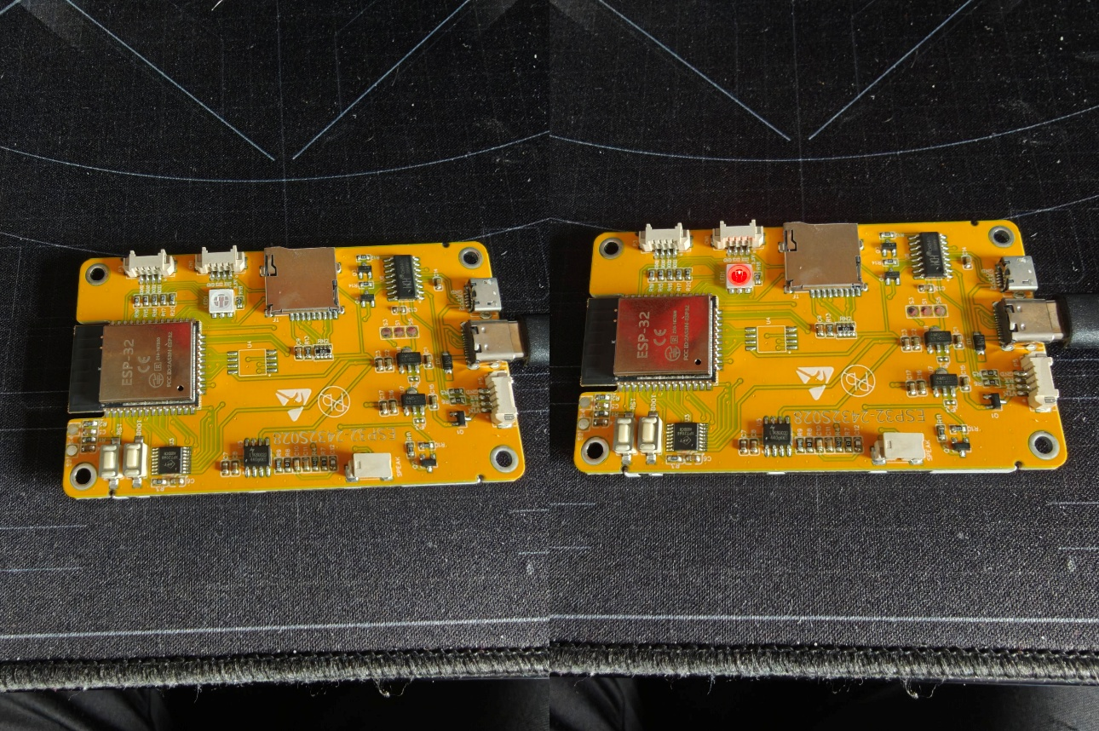
Figure 3: LED light blinking which confirms code works

ESP32 Serial Communication Setup
Serial communication was then implemented to allow real-time debugging. Messages were printed from the ESP32 to the Serial Monitor The output appeared correctly, confirming USB communication was working and the Serial Monitor could be used for debugging.

GPS Integration Attempt
The GPS module was connected via UART using the TX/RX pins. A minimal test program was written to read incoming data from the GPS and print it to the Serial Monitor.
The expected output was standard NMEA sentences which shows important information such as longitude, latitude, GPS fix quality and number of satellites connected to. However, the actual output appeared as unreadable characters; leading me to believe that the output was either coming through as raw data or else the IDE did not have the necessary library of characters in order to read the data.
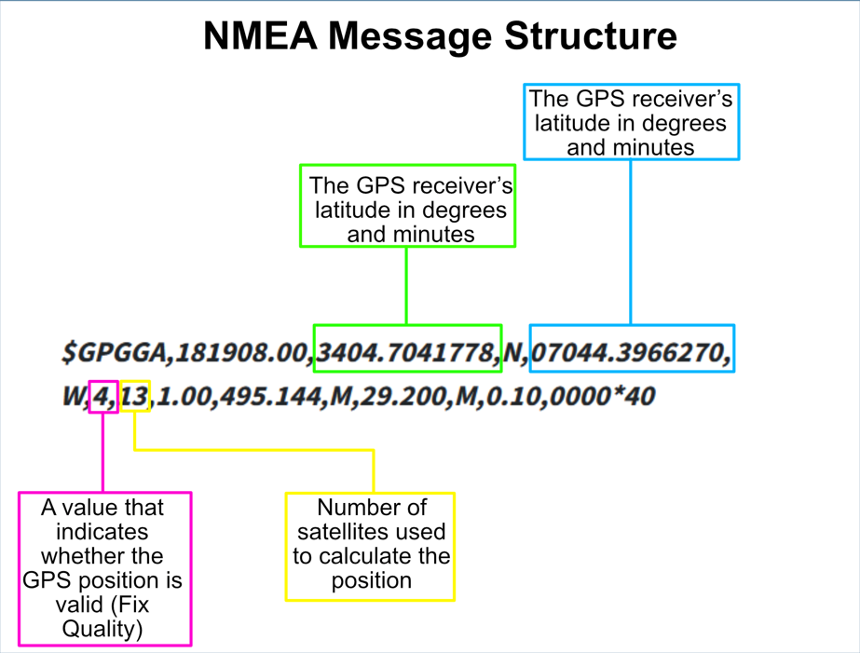
Figure 4: Format of expected NMEA sentence output
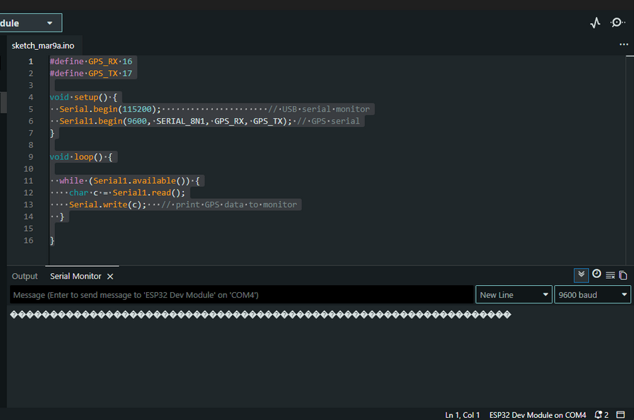
Figure 5: Actual garbled output from GPS

GPS Module Debugging Process
I performed a structured and iterative debugging process to attempt to identify the cause of the incorrect GPS output. Given that some form of data was consistently being received, the issue was treated as a communication or configuration problem rather than a complete hardware failure. Multiple potential causes were investigated systematically.

5.6.1. Library and Software Configuration
As part of the troubleshooting process, a range of Arduino libraries were installed and tested to determine whether the issue with unreadable GPS output was related to software rather than hardware. The problem being investigated was that the Serial Monitor displayed garbled characters instead of standard NMEA sentences (e.g. $GPGGA, $GPRMC), which are expected from a functioning GPS module.
Initially, several display related libraries were installed, including Adafruit GFX, Adafruit SSD1306, and TFT_eSPI. These libraries are commonly used for rendering text and graphics on OLED and TFT displays. Adafruit GFX provides core drawing functions, while SSD1306 and TFT_eSPI act as drivers for specific display hardware. The purpose of testing these libraries was to explore whether the issue was specific to the Serial Monitor by attempting to output GPS data to the external OLED display that’s built into the ESP32. However, this approach did not resolve the issue, indicating that the problem was not related to how the data was being displayed on the micro-controller side.
Following this, I tried multiple GPS parsing libraries, including NeoGPS, TinyGPS, TinyGPSPlus, and the SparkFun u-blox GNSS Arduino Library. These libraries are designed to process raw NMEA sentences received from a GPS module and extract useful information such as latitude, longitude, time, and speed. TinyGPS and TinyGPSPlus offer relatively simple interfaces for basic parsing, while NeoGPS provides a more configurable and supposedly memory efficient solution. The SparkFun u-blox library is more specialised, offering direct communication with u-blox modules (such as the NEO-M8N used in this project), including support for NMEA.
Each of these libraries was tested to determine whether they could correctly interpret the incoming data stream. However, all of them rely on receiving valid, correctly formatted serial data as input. Since the data being received was already corrupted and/or not in NMEA format, (as evidenced by the unreadable characters in the Serial Monitor), none of the libraries were able to function as intended. This demonstrated that the issue was occurring at a lower level, before any parsing or processing could take place. After speaking to some experienced hobbyists in this field, it was proposed that the output may be in a RAW data format.
From this process, it was concluded that the problem was not related to the choice of library, but rather to the underlying serial communication between the ESP32 and the GPS module. To rule out any hardware issues, two more GPS modules were purchased and wired correctly using GPIO jumper cables rather than soldering, but the result of garbled output was the same.

Baud Rate Testing
Since UART communication is highly dependent on matching baud rates between devices, multiple standard GPS baud rates were tested within Arduino IDE: 4800, 9600, 8400 and 115200; 9600 and 115200 being the two most common. Each configuration was uploaded to the ESP32, and the Serial Monitor was observed for valid NMEA output.
Despite testing all common configurations, the output remained consistently garbled. This indicated that the ESP32 was receiving data, however, the baud rate was likely incorrect or non-standard or alternatively, the data being output was on a low-level and and/or unknown format.

Wiring Verification
All physical connections were rechecked to ensure correct hardware configuration. As part of troubleshooting, the GPS RX line was considered optional (since only incoming data was required) and was temporarily disconnected to reduce potential interference. Multiple GPS Modules were tested to rule out a faulty module. A blue flashing light indicated that the GPS was receiving data from connected satellites and was outputting information. No wiring faults were identified, and the issue persisted.
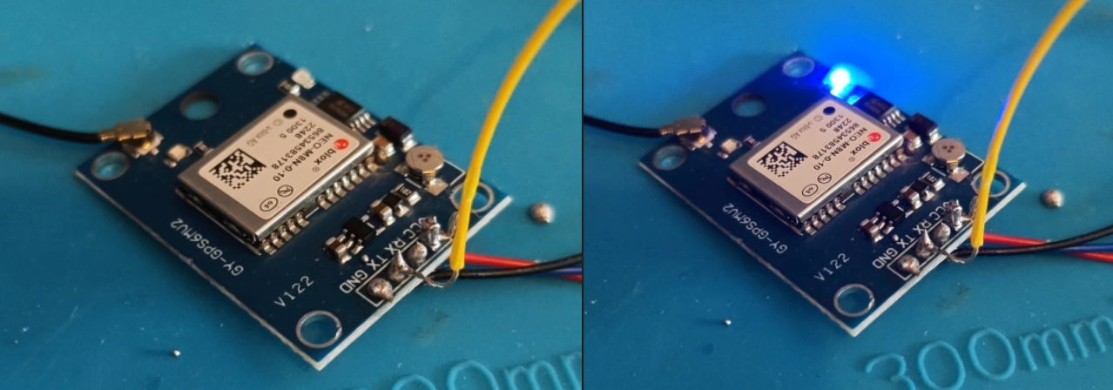
Figure 6: Blue flashing light indicating GPS module was on and working

System Isolation and Minimal Testing
To eliminate interference from other components or software complexity I removed all non-essential hardware connections. I created and uploaded a minimal test sketch which allowed the module to output raw serial read-only data. No other additional libraries or logic were included. This ensured that the ESP32 was performing only one task – reading UART data from the GPS module. There were no timing conflicts or resource contention, but despite this controlled setup, the output remained the same, indicating the problem was not caused by software complexity or resource conflicts.

Serial Monitor Configuration
The Serial Monitor configuration was also verified to ensure correct interpretation of incoming data. Baud rate was matched to Serial.begin(115200). Different baud rates were briefly tested to rule out display mismatches. This confirmed that the issue was not due to incorrect Serial Monitor settings.

Analysis of Observed Behaviour
The consistent output of unreadable characters suggested that the data transmission between the GPS module and ESP32 were active, however, the data format or timing was incorrect. This points to several likely causes like a non-standard or unknown baud rate used by the GPS module. However, it is not uncommon to purchase cheap components which turn out to be incompatible or wrongly labelled. A potential mismatch in voltage levels or UART configuration was also a key consideration but could not be fully investigated as the appropriate hardware to test this was not available.

Debugging Outcome
After testing different software setups, baud rates, wiring configurations, and isolating parts of the system, valid NMEA sentences were still not produced at any point. With that being said, the ESP32 was consistently receiving data which indicated that the GPS module was powered and actively transmitting, and that a communication link between the devices were in place.
Given this, the problem is more likely related to how the data is being interpreted or a mismatch in signal compatibility, rather than a complete hardware failure. It’s also worth mentioning that this kind of low-level communication issue wouldn’t have been easy to predict during the planning stage, especially since the components used are generally considered compatible and well-documented under normal conditions.

BLE Integration Attempt
In addition to the GPS subsystem, a Bluetooth Low Energy (BLE) component was implemented using an external AT-09 Bluetooth 4.0 module. Although the ESP32 has built-in BLE capability, the AT-09 module was used during development to simulate a separate BLE tag device for proximity detection.
The module was connected to the ESP32 via UART and configured using AT commands within Arduino IDE. Initial communication with the module was successful, confirming that the ESP32 could both send and receive data over a serial interface. This validated the feasibility of integrating an external BLE device into the system.
The expected behaviour was that the BLE module would continuously broadcast a consistent MAC address, allowing the ESP32 to identify and track it. This would enable stable proximity classification based on received RSSI values and allow the BLE/GPS handshake system to determine the approximate location of the BLE tag (near, far, lost).
During early testing, the BLE module was able to broadcast as expected and could be detected by scanning devices. This confirmed that the module was powered and functioning correctly, BLE advertising was active and the ESP32 could interact with the module via serial communication.
However, when attempting to read data from the module, the output appeared as garbled characters, similar, but not identical to the issue encountered with the GPS module. At first, this suggested another baud rate or communication mismatch. After multiple attempts at fixing it, it was deduced that the module was actually outputting raw binary data. This is common in BLE communication, where data packets are transmitted in byte format rather than ASCII strings.

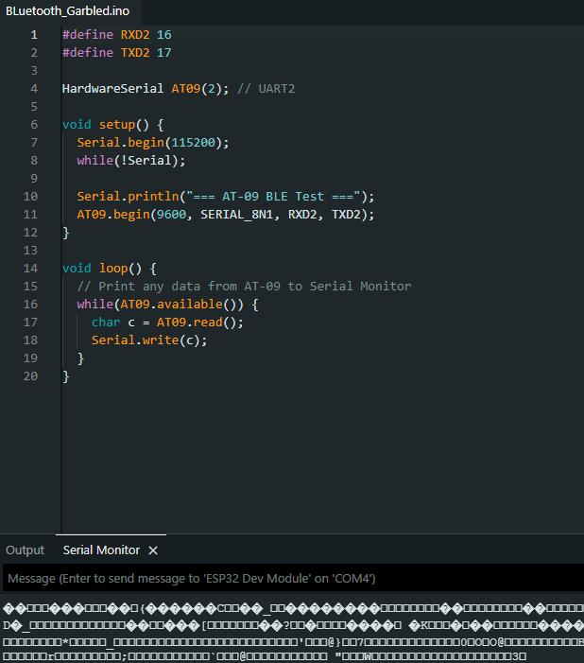
Figure 7: Garbled output from BLE module

BLE Debugging Process

5.8.1. Output Interpretation Fix
Instead of printing incoming data directly as characters, the data was read byte-by-byte and converted into a more readable format. The process involved reading raw bytes from the serial buffer, converting each byte into hexadecimal representation and then interpreting the resulting values to understand the underlying data
This allowed the previously unreadable output to be visualised in a structured way, making it clear that valid data was being transmitted rather than noise.
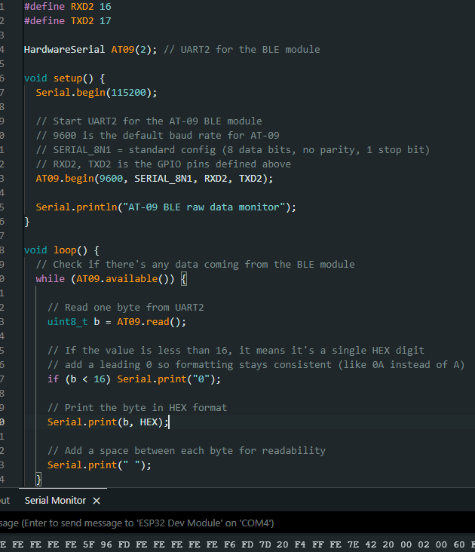
Figure 8: BLE output being converted to HEX

5.8.2. MAC Address Instability
A key issue identified during testing was that the MAC address associated with the AT-09 module did not remain constant. Even when a device was successfully detected and tracked temporarily, it would later disappear or reappear under a different MAC address.
This behaviour is not typical of higher-quality BLE devices and is likely due to the low-cost nature of the AT-09 module. Some inexpensive BLE modules either randomise their MAC address periodically or don’t implement consistent advertising behaviour. This instability prevented the ESP32 from reliably filtering and locking onto the correct device indefinitely, which is required for the proximity detection portion of the system.
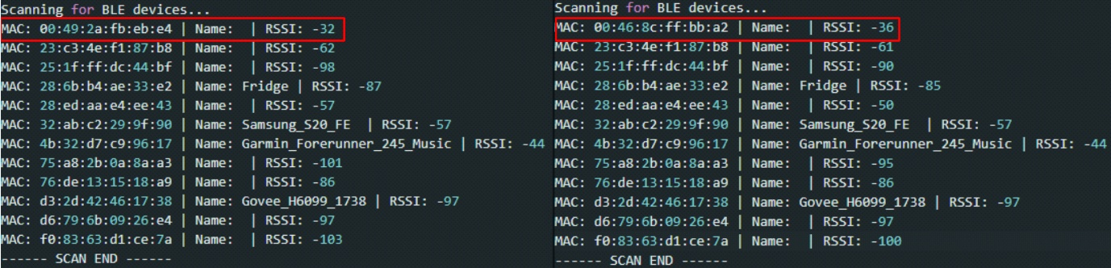
Figure 9 : BLE’s MAC address changing between scans

5.8.3. Controlled Testing via Hardcoded Identifiers
To confirm that the ESP32 BLE scanning and filtering logic was functioning correctly, a controlled test was implemented. A known MAC address was hardcoded into the ESP32 program, and the system was configured to filter specifically for that identifier.
During this test, the ESP32 successfully detected the device, read it’s RSSI values, and processed proximity states as intended. This demonstrated that the ESP32’s BLE scanning functionality was working correctly, the RSSI-based proximity logic was working as designed and the MAC randomisation issue was isolated to the AT-09 module itself rather than the ESP32 or software implementation. This was considered a partial success, as it validated the core BLE detection pipeline under controlled conditions.
A PHOTO OF SINGLE BLUETOOTH DEVICE SCAN HERE!!!

5.8.4. Conclusion and Workaround
Based on the debugging process, it was concluded that the AT-09 BLE module was not reliable enough for use in a deterministic proximity detection system. The inconsistent MAC address and unreliable broadcasting behaviour made it unsuitable for continuous tracking.
To compensate for this limitation, a software-based simulation was developed. This simulation replicated BLE scanning, RSSI fluctuation, device loss, and recovery scenarios. By doing so, it allowed the BLE–GPS handshake logic to be fully implemented and tested without dependence on unreliable hardware.
This approach ensured that:
- The system logic could still be validated
- Edge cases (e.g. false BLE loss, GPS confirmation) could be tested
- The overall project objectives could still be achieved despite hardware limitations

References:

Appendix A: Report Structure Example

Project Technical Report
1) Project Overview
- Purpose and objectives of the software
- Scope of the project
- Assumptions, constraints and dependencies
- Definitions and acronyms

2) Requirements
Functional Requirements
- Detailed description of system functions and capabilities
- Input and output specifications
- Data processing operations
- Use cases, user stories (if applicable)
Non-Functional Requirements
- Performance requirements (e.g., response time, throughput)
- Security requirements
- Usability and accessibility standards
- Reliability and availability metrics
- Scalability considerations (if applicable)

3) System Architecture & Design
- Hardware and software requirements (including development and runtime environment)
- High-level system architecture
- Key components/functions/objects and their interactions
- Detailed description of system features, including workflow descriptions.
- Design and implementation constraints
- System qualities (e.g., maintainability, extensibility)
- Security protocols / considerations
- Testing strategy

4) Data Requirements
- Data models and schemas
- Data flow diagrams, class diagram or similar

5) Implementation
- Document the development process
- Code management, version control, etc. (evidence of following best practice)
- Discuss challenges, errors and limitations

6) Testing & Evaluation
- Testing overview / discussing testing requirements
- Functional Testing / Analysis (following testing strategy)
- Results/Evaluation Discussion

7) Conclusion
- Project conclusion/findings
- Limitations
- Future Work

Appendix B: Code Listing / GitHub Project Link

