**Objective**

Understand how electronic and steric factors control energy barriers for oxidative additions of Pd to C-X bonds (CH4, CH3Cl, C2H6) by analyzing the potential energy surface using the activation strain model of chemical reactivity.[1]

**Introduction**

In 2010, the Nobel Prize in Chemistry was awarded to Heck, Negishi, and Suzuki for developing “palladium-catalyzed cross couplings”. Cross-coupling reactions provide a method to efficiently create bonds between carbon atoms, and are therefore of paramount importance to chemists working in a variety of fields, including: academic, medicinal, pharmaceutical, and materials industries. The cross-coupling reaction requires a transition-metal-based catalyst and traditionally, palladium catalysts have been employed due to the efficient and selective nature of the reaction.[2] The first, and generally rate-determining, step in the catalytic cycle (Scheme 1) of a typical cross-coupling reaction is the activation of a bond by oxidative addition to a transition-metal complex (Scheme 2). Our group has performed a number of studies to systematically investigate the electronic and steric effects that govern trends in selectivity and reactivity of various catalysts. For example, we have assessed how the reaction barrier varies depending on the activation of various bonds by palladium, the effect of different metal ligands, and also how different metal centers perform compared to palladium.[3,4]

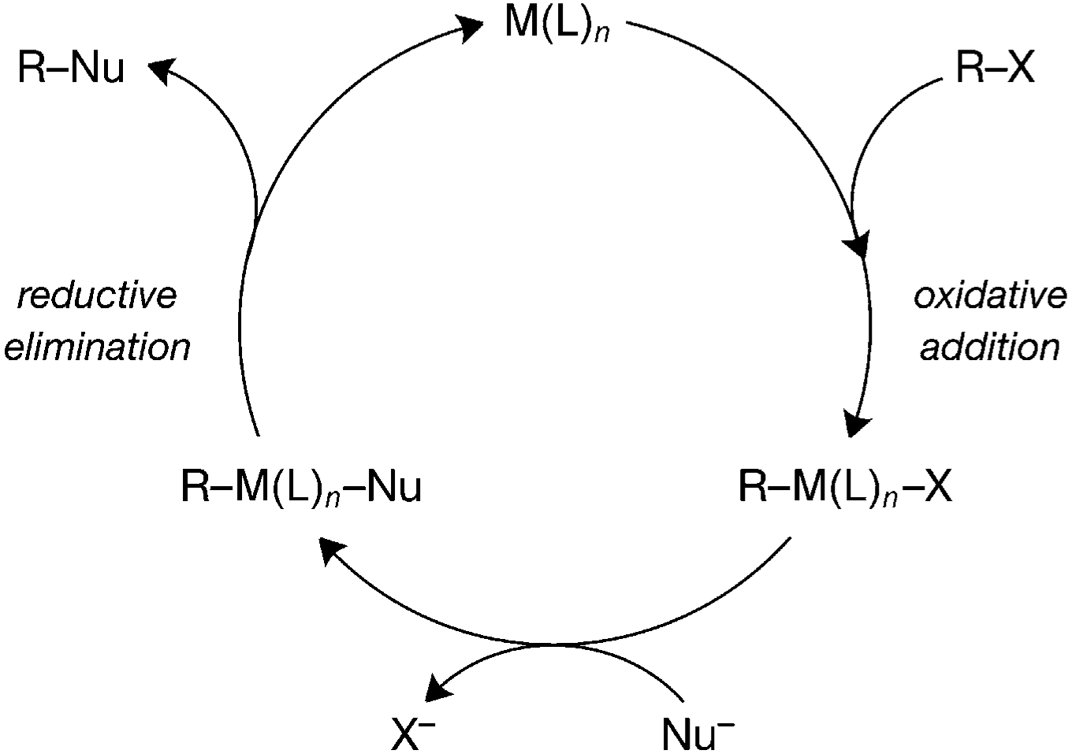

Scheme 1. General mechanism for cross-coupling reactions.

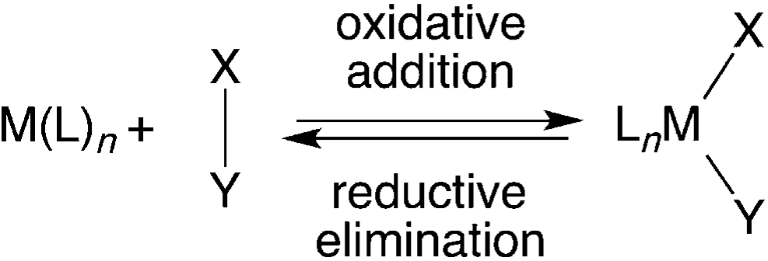

Scheme 2. Oxidative addition and reductive elimination.

**Computational Methods**

**General Procedure**

In this exercise, computations on bond activation of C-Cl, C-H and C-C by palladium will be carried out using the Amsterdam Density Functional (ADF2016) suite. Relativistic density functional theory at ZORA-BLYP/TZ2P with the frozen core approximation will be used for all calculations. We will analyze the oxidative addition of Pd + CH3X with substituent X = H, Cl, and CH3 in the gas phase (see Scheme 3). Firstly, a geometry optimization will be performed to obtain the structures of reactant (R), reactant complex (RC) and product (P) (Figure 1). A linear transit calculation (LT) can be used to obtain an initial structure for the input of a TSRC calculation, used in the calculation the transition state (TS). Following the geometry optimizations, a vibrational analysis will confirm all stationary points to be equilibrium structures (no imaginary frequencies) or transition states (a single imaginary frequency). The character of the normal mode associated with the imaginary frequency can be analyzed to ensure that the correct transition state has been located. With transition state structures on hand, intrinsic reaction coordinate (IRC) calculations will be performed to obtain the potential energy surfaces (PES) of the reactions. The PyFrag program can be used to facilitate the analyses of the potential energy surfaces (PESs). PyFrag performs a series of energy decomposition analysis (EDA) calculations at each point along the IRC, which can be analyzed by the ASM to give critical insights of the electronic and geometrical factors that influence the energy profile of the whole reaction process. Further details about ASM can be found in following section and reference.[5,6] When PyFrag program is unavailable, one can perform EDA calculations on the RC, TS, P, and a handful of other points along the IRC to obtain similar results. A general sequence for the calculations in the exercise is shown in Scheme 4.



R RC TS P

Scheme 3. Model reaction systems (X = H, Cl, CH3)

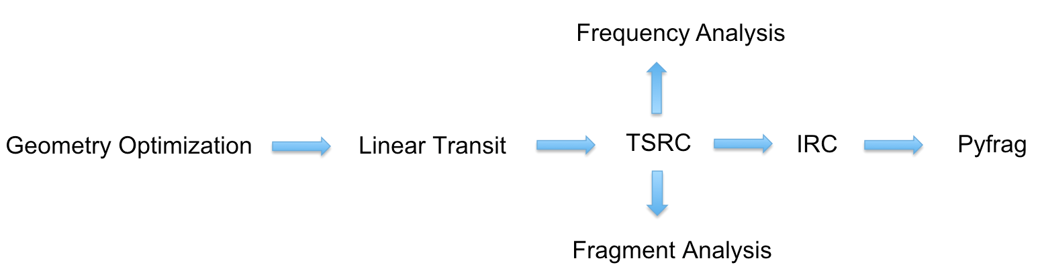

Scheme 4. Basic calculation process in this exercise

**Activation Strain Analyses**

Insight into the overall reaction energies is obtained through activation strain analyses. The activation strain model of chemical reactivity is a fragment-based approach to understand the energy profile of a chemical process and to explain it in terms of the original reactants. This provides a critical assessment of the influence of geometrical deformation and electronic structure of catalyst and substrate. Obviously, in current work, our main interest is the interplay between one fragment, the catalyst, and another fragment, the substrate. Subsequently, the division of the reacting catalyst is used in the PyFrag computation to generate the activation strain profile. Thus, the bonding energy Δ*E* is decomposed along the reaction coordinate into the strain energy ∆*E*strain that is associated with the geometrical deformation of the individual reactants as the process takes place, plus the actual interaction energy ∆*E*int between the deformed reactants. We project the reaction coordinate on the stretch of the activated C-X bond, which has been shown to be a suitable choice.[4] Furthermore, the strain energy ∆*E*strain can be readily split in contributions from the deformation of the catalyst and substrate (see Eq. 1).

Δ*E* = ∆*E*strain + ∆*E*int = ∆*E*strain[substrate] + ∆*E*strain[cat] + ∆*E*int (1)

The interaction energy ∆*E*int between the deformed reactants is further analyzed in the conceptual framework provided by the Kohn–Sham molecular orbital method, using a quantitative energy decomposition scheme (see Eq. 2).

Δ*E*int = Δ*V*elst + Δ*E*Pauli + Δ*E*oi (2)

The term Δ*V*elst corresponds to the classical Coulomb interaction between the unperturbed charge distributions of the deformed reactants and is usually attractive. The Pauli repulsion energy Δ*E*Pauli comprises the destabilizing interactions between occupied orbitals on the reactants and is responsible for steric repulsion. The orbital interaction energy Δ*E*oi accounts for charge transfer (interaction between occupied orbitals on one fragment with unoccupied orbitals on the other fragment, including the HOMO–LUMO interactions) and polarization (empty-occupied orbital mixing on one fragment due to the presence of another fragment). Scheme 5 illustrates the components of the interaction energy.

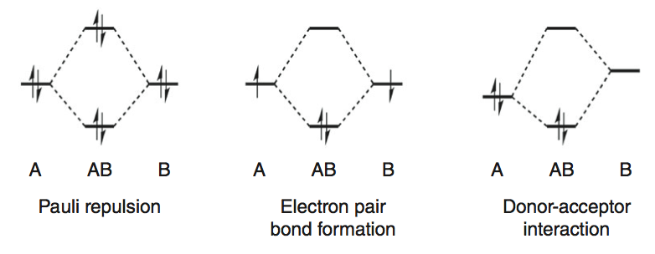

Scheme 5 Orbital interaction diagrams for the most commonly appearing interactions

**Calculation process**

**1. Geometry optimization**

The reaction of Pd + CH4 will be used as an example to show how to perform the various calculations in this exercise. This procedure will then be applied for the oxidative addition to the other two substrates (CH3Cl and C2H6). If time permits, a systematic study into the effect of the ligand, as well as the steric effect of catalyst will be carried out by exploring the Pd(PH3)2 + CH4 and Pd[P2P] + CH4 systems.[7]

In general, the reactions start from a reactant complex (RC), obtained after the separated reactants coordinate. For CH4 and CH3Cl these complexes are stable, while for C2H6 they are weakly coordinated or essentially unbound. Moving onwards from the reactant complex, the catalyst migrates towards the C-H, C-Cl or C-C bonds, which begins to elongate until it is, via a transition state, effectively broken in the product complex (see Figure 1, 2, 3 for the oxidative addition for the different substrates).

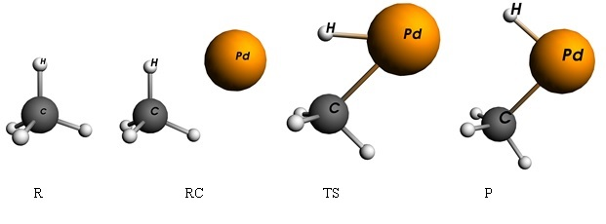

**Figure 1.** Structures of the stationary points along the reaction coordinate for the oxidative insertion of Pd into the methane (C-H).

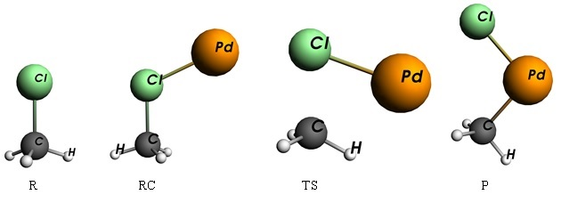

**Figure 2.** Structures of the stationary points along the reaction coordinate for the oxidative insertion of Pd into the chloromethane (C-Cl).

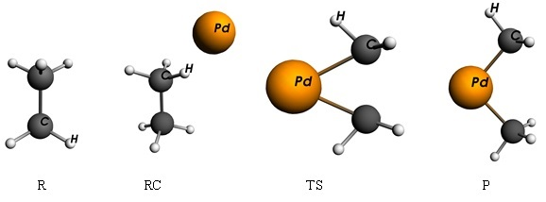

**Figure 3.** Structures of the stationary points along the reaction coordinate for the oxidative insertion of Pd into the ethane (C-C).

The Tutorial Videos on the SCM website are useful for beginning to understand the workings of the graphical user interface and can be found at: (<http://www.scm.com/Videos/>.) Watch Tutorial 1 (geometry optimization of ethanol). The next step is to follow (<http://www.scm.com/Doc/Doc/GUI/GUI_tutorial/page1.html>), and complete Tutorial 1 on your own. If have prior experience with the ADF program, feel free to skip this step.

Draw a reactant molecule (substrate) in ADFinput and set parameters as shown by figure below to perform a geometry optimization this system at the ZORA-BLYP/TZ2P level. You can use the “wheel” button at the bottom right of the pane to pre-optimize the molecule. Please be aware that this tool does not work in every case and note if the geometry changes too much from your educated guess, you should revert the structure. Additionally, understand that the closer your molecule is to the “real geometry”, the calculation will be faster and has a better chance to converge. The structures in Figure 1-3 serve as helpful reminders for what these molecules look like. The coordinates of already optimized structures can be found in Supporting Information as reference.

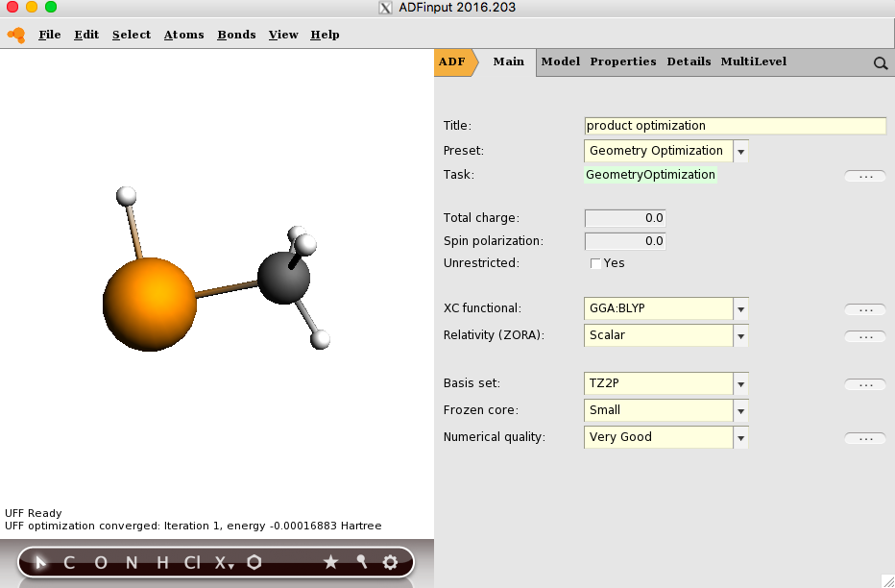

**2. Linear Transit**

Next, perform a linear transit at the same level of theory to obtain a reaction path between the reactant complex and product to obtain an approximate transition state structure. This can be done either starting from reactant complex or product, as long as the path spans the possible transition state along the reaction coordinate. Open ADFinput and import the optimized structure from step 1. Select Linear transit in the main menu. Select ‘Geometry Constraints and Scan’ from the Model menu. Select two atoms to add a distance constraint. The bond you choose should reflect the characteristic of the reaction process, for instance, the activated C-X bond is a good choice. Sometimes two or three constraints are also needed, but be careful they should not contradict with each other. Write the initial and the final atomic distances of the linear transit, for example, the C-H bond length in reactant and product, as shown in figure. Run the job and then, use ADFmovie to look at the results and plot the energy graph. Click on the View tab and select ‘converged geometries only’, you should see a highest energy point, which is supposed to have a geometry that is similar to real transition state structure. Select this structure and export its coordinates to be used for a transition state search.

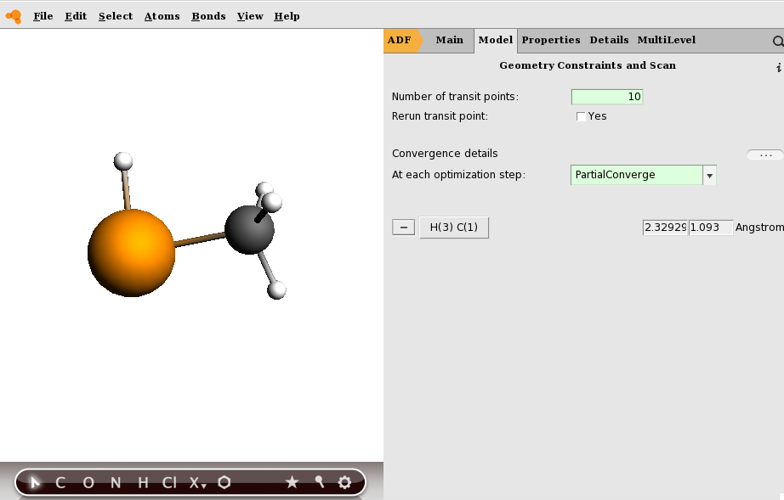

**3. Transition state search**

Use the approximate structure found in Step 2 to perform a transition state search calculation at the same level of theory, as shown in the figure below. The transition state search may prove difficult in some cases, as the calculation is quite sensitive to initial input structure. Sometimes instead of obtaining transition state, the transition state search may actually be geometry optimization, leading to structures of reactant or product, if the initial structure is not accurate enough. In this situation, it is better to check again the result in LT step. If the resultant structure from LT deviates far from the potential transition state structure according to one’s chemical intuition, consider recalculating the LT using a more judicious choise of constraints.

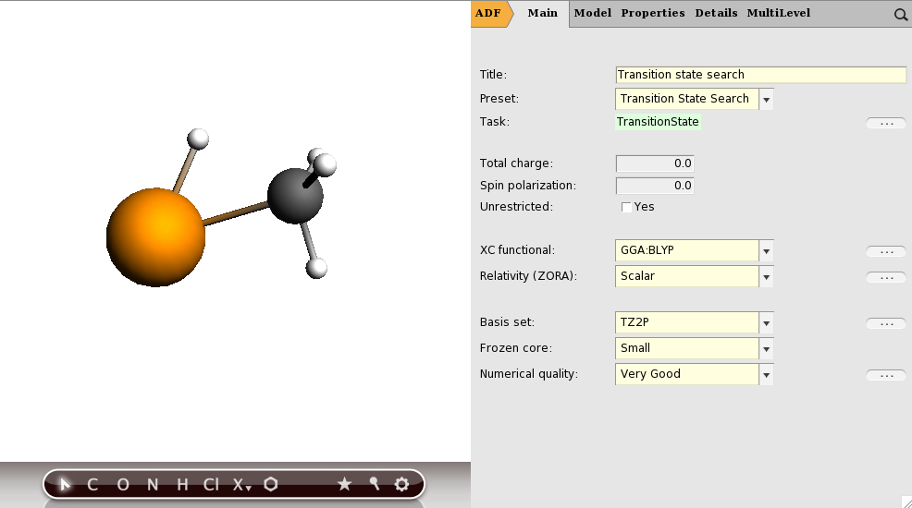

**4. Frequency Analysis**

Perform a frequency analysis on the transition state structure you found in step 3. Start with importing the geometry in ADFinput, and set ‘Preset’ to ‘Frequencies’. When the calculation has finished you can look at the results with ADFspectra. By clicking on a certain peak in the IR spectrum, you can visualize the corresponding vibrational mode. If you look at the imaginary frequency vibration of the TS structures, the vibrational mode should correspond to critical reaction parameter, namely the oxidative insertion into the C-X bond. In the current case, you will see the imaginary frequency vibration is the stretch of the C-H bond.

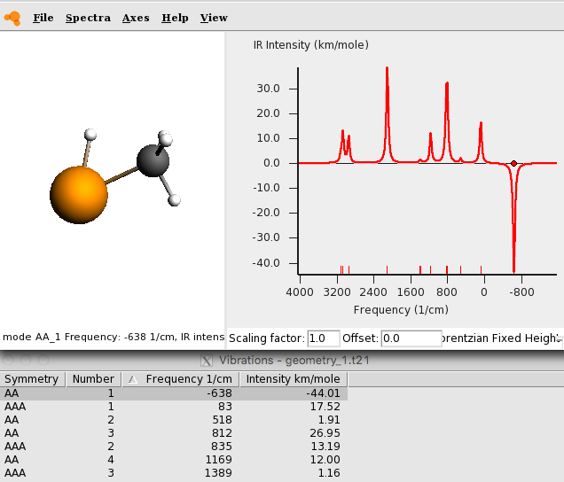

**5. IRC**

With TS structure in hand, the next step is to perform an IRC calculation to obtain the reaction profile that connects the TS to both the reactant complex and the product. Running the IRC is similar to previous type of calculations like Geometry Optimization, except changing from “Geometry Optimization” to “IRC” in Preset option in the menu. In order to provide the hessian matrix, obtained from the previously calculated frequencies, to IRC calculation, choose Details––>Files(Restart) and set the right path of your Tape21 file obtained from Frequency Analysis This is an optional choice which can accelerate the computation.

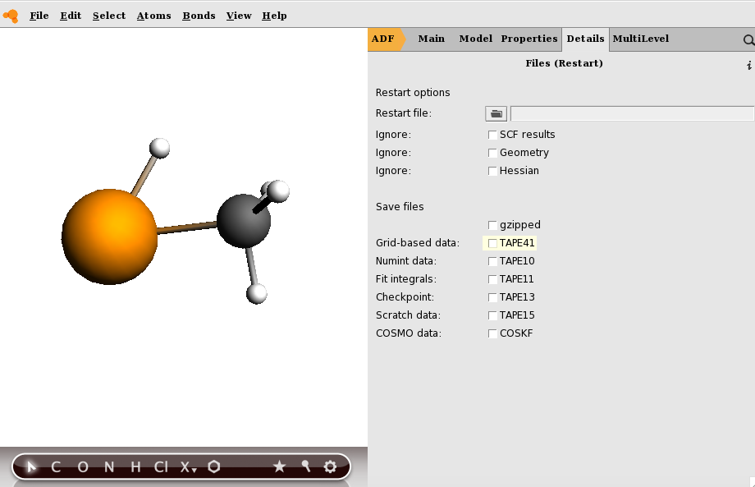

**6. Energy decomposition analysis**

Energy decomposition analysis can provide a graphic and intuitive way to interpret orbital interaction such as HOMO-LUMO interactions under the framework of Kohn-Sham molecular orbital method. In order to accomplish EDA, fragment analysis is necessary. First choose the “Fragment Analysis” in Preset option, then change to Model––>Region part to define fragment. The choice of fragments is a bit arbitrary and often depends on the research focus. For example, if one want to study the activation of C-H bond activation by Pd, selecting Pd as one fragment and the substrate as the other fragment is good choice, as it can reveal how the Pd and C-H bond interact with each other and how the orbitals constituting C-H bond changes with the approach of Pd . This type of analysis will provide insights for the oxidative insertion reaction process. Select Pd in the pane, then click the “+” button to add this fragment. Do the same to the other fragment. You can also change the default name of each fragment and total complex, that is “All”, “Region_1”, “Region_2” to any name simply by clicking it and rewriting it.

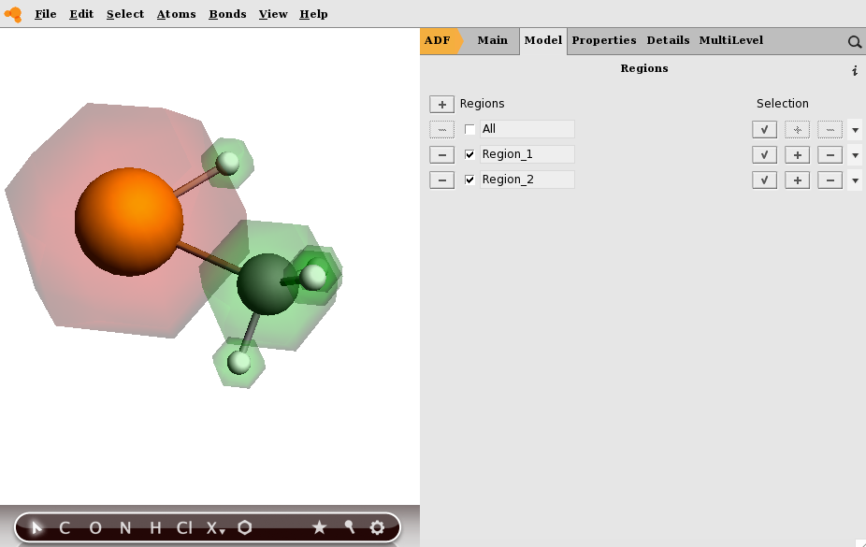

**7. Activation strain analysis**

PyFrag was designed as a “wrap-around” for ADF to facilitate fragment analysis calculations along a set of geometry points obtained from an IRC calculation. Since it is a program written in the highly transferable Python programming language, running it on any given system should pose no problems giving there is are working copies of [Python](http://www.python.org/) and the [ADF package](http://www.scm.com/) present. The principal idea behind is to use an ADF input script as a basis and constructs the necessary ADF jobs from it by reading additional PyFrag input statements.The program has been used in our group to employ the “extended activation strain” model of chemical reactivity. The purpose is to make analyses of reaction paths and other (in principle also multidimensional) potential energy surfaces easier and more transparent. PyFrag also enables a user-friendly analysis of reaction paths in terms of the Extended Activation Strain model of chemical reactivity.

PyFrag input can be divided into two parts, as shown by an example below, one part is to set up basic parameters such as how to define two fragments and specify which data should be printed later, etc. Second part is just normal ADF input for single point calculation. More information can be found in http://few.vu.nl/~lws260/pyfrag/PyFrag/Home.html.

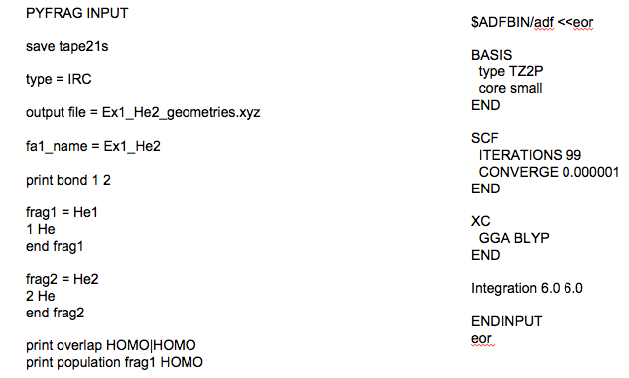

After computation finish, PyFrag will generated a txt file, summerizing all the import data for each points covering the whole reaction process, such as Bondlength which is the bond length change between the current geometry and reactant. Another example is StrainFrag1, the difference between the singlepoint energy of current geometry and reference structure, which usually is reactant or reactant complex. Plotting these data against one reaction coordinate, like the stretch of the activated C-H bond, will give rise to figures like below which shows a whole picture of the reaction process. Activation strain analysis of these figures can reveal different factors that determine the reaction barrier, which can translate into the reaction activity and selectivity. With these insights on mind, one can try to rationally design different reactions or different catalysts by changing the ligand to tune the orbital interaction or to control the bite angle to reduce strain energy.

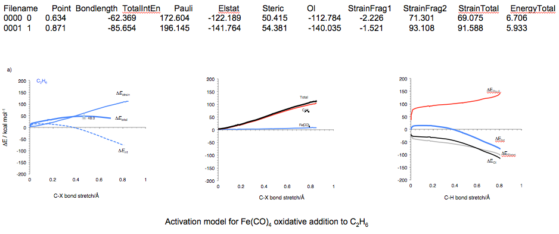The problem with PyFrag is that it is a python script which can not be run by ADFinput like other types of calculations. In order to use PyFrag, one should use terminal to run it. Therefore, some basic knowledge about unix and bash is needed. However, one can also do this similar type of calculation by hand, simply by doing a series of Fragment Analysis for some special points of IRC, such as R, RC, TS, P. It may need more effort, but in principle the results are the same.

**8. Extension of calculation**

Steps 1-7 serve as the basic calculation procedure for laboratory exercise. After the model reaction Pd + CH4 is completed, perform the same process for the reactions of Pd + CH3Cl and C2H6. Use the data obtained to analyze the effect of changing substrates for Pd-catalyzed oxidative insertion. If additional time is available, we can alter the catalyst from bare Pd to dicoordinated Pd(PH3)2 and chelated Pd[P2P] and study the ligand effect and bite angle effect.

**Reference**

1. G. Th. de Jong, F. M. Bickelhaupt,  [*ChemPhysChem*](http://www3.interscience.wiley.com/cgi-bin/abstract/114229111/ABSTRACT) [**2007**,*8*, 1170-1181](http://www3.interscience.wiley.com/cgi-bin/abstract/114229111/ABSTRACT).

2. [Árpád Molnár](http://pubs.acs.org/author/Moln%C3%A1r%2C+%C3%81rp%C3%A1d), *Chem. Rev.*, **2011**, *111* (3), 2251–2320.

3. L. P. Wolters, F. M. Bickelhaupt,  [*WIRES Comput. Mol. Sci.* **2015**, *5*, 324-343](http://dx.doi.org/10.1002/wcms.1221).

4. L. P. Wolters, W. J. van Zeist, F. M. Bickelhaupt, [*Chem. Eur. J.* **2014**,](http://dx.doi.org/10.1002/chem.201403237) [*20*, 11370-11381](http://dx.doi.org/10.1002/chem.201403237).

5. I. Fernandez, F. M. Bickelhaupt, *Chem. Soc. Rev.* **2014**, *43*, 4953-4967.

6. W .J. van Zeist, C. Fonseca Guerra, F.M. Bickelhaupt, *J. Comput. Chem.* **2008**, *29*, 312-315.

7.W.J. van Zeist, R. Visser, F. M. Bickelhaupt [*Chem. Eur. J.* **2009**, *15*, 6112-6115](http://dx.doi.org/10.1002/chem.200900367) .

**Supporting information**

**Table 1.** Cartesian coordinates (in Å) and ADF total bonding energies (in kcal mol–1) of all molecular species in this exercise, computed at ZORA-BLYP/TZ2P.

|  |  |  |  |  |  |  |
| --- | --- | --- | --- | --- | --- | --- |
| RC: Pd+CH4 | -541.51 | TS: Pd+CH4 | -530.92 | P: Pd+CH4 | | -538.19 |
| C -2.06885297 -2.79029497 0.08427909  Pd -2.74279319 -0.52043641 0.42866570  H -3.02305366 -2.37077961 -0.33468318  H -2.33226362 -3.61801785 0.74649037  H -1.45861012 -3.13063016 -0.75524098  H -1.45630181 -2.05926642 0.67790228 | | C -2.06525454 -2.54566335 0.16844807  Pd -2.73653576 -0.55702011 0.42014471  H -3.37426454 -1.75521047 -0.35538769  H -2.65540815 -3.32922424 0.64833760  H -1.76693405 -2.84180508 -0.83944813  H -1.17400671 -2.32098092 0.77417736 | | C -2.08070257 -2.46433448 0.18397769  Pd -2.73330026 -0.56500119 0.41934265  H -3.97488900 -0.97182202 -0.39497938  H -2.78585131 -3.15975389 0.64664377  H -1.94208626 -2.68080614 -0.87848684  H -1.11920976 -2.45347012 0.71933387 | | |
|  | | | | | | |
| RC: Pd+CH3Cl | -504.14 | TS: Pd+CH3Cl | -491.84 | | P: Pd+CH3Cl | -524.31 |
| C -1.51113075 -3.59549282 0.21442385  Pd -2.83938341 -0.33402034 0.44955520  H -1.63228777 -3.50499983 -0.86419767  H -2.42465222 -3.93975814 0.69738054  H -0.65158452 -4.21350809 0.47850929  Cl -1.15062570 -1.89144414 0.87177822 | | C -2.17175966 -2.89139372 -0.02514243  Pd -2.81242376 -0.48941028 0.39674759  H -3.09037949 -2.45244129 -0.44723300  H -2.38842881 -3.67814304 0.68976607  H -1.46204062 -3.16935357 -0.79717929  Cl -0.94123310 -1.73043329 1.13888515 | | | C -2.29695096 -2.77024951 -0.02032526  Pd -2.22318207 -0.87310358 0.63173421  Cl -0.28649523 -1.01269794 1.78108450  H -1.43017098 -2.97102961 -0.65336189  H -3.23946900 -2.73587220 -0.59156361  H -2.34966521 -3.44673392 0.83521855 | |
|  | | | | | | |
| RC: Pd+C2H6 | -902.67 | TS: Pd+C2H6 | -877.66 | | P: Pd+C2H6 | -905.17 |
| C -0.90192958 -2.12984586 -0.13084628  H -2.55212272 -3.42446021 0.48911606  H -1.25191601 -2.06704891 -1.19876992  H -0.11880825 -2.89505504 -0.11797804  H -0.40864218 -1.18019934 0.21801460  H -1.75262183 -2.58402756 1.83218650  C -2.08553324 -2.47819865 0.79169296  H -2.85521479 -1.69891156 0.76222749  Pd -0.64300422 -0.16329464 -1.51612251 | | C -1.47184688 -1.78181252 -0.28209690  H -1.59782531 -3.87642517 0.90518098  H -1.64384582 -1.51787746 -1.36047526  H -0.49080183 -2.25185875 -0.22999957  H -1.50580285 -0.86616111 0.30682653  H -2.16675546 -2.43057781 1.81315056  C -2.30937311 -3.05212673 0.93028886  H -3.34602034 -3.47900842 1.00299457  Pd -3.37061530 -2.61652901 -0.90737977 | | | C -1.40233760 -1.26827218 -1.08594800  H -1.48849822 -3.71664792 0.93270620  H -1.61442374 -0.81684939 -2.06726050  H -0.49093452 -1.87177288 -1.12139211  H -1.34768210 -0.50296964 -0.30656869  H -2.34803967 -2.34917875 1.74683791  C -2.43139844 -3.17117147 1.03024210  H -3.25315877 -3.85060005 1.30377791  Pd -3.01127921 -2.45992352 -0.77603266 | |