Ghana Smart Waste-Management Optimizer
This document contains the essential benchmark comparisons generated directly from the project log files. Only the key performance metrics are included to keep the submission focused and readable.

Runtime
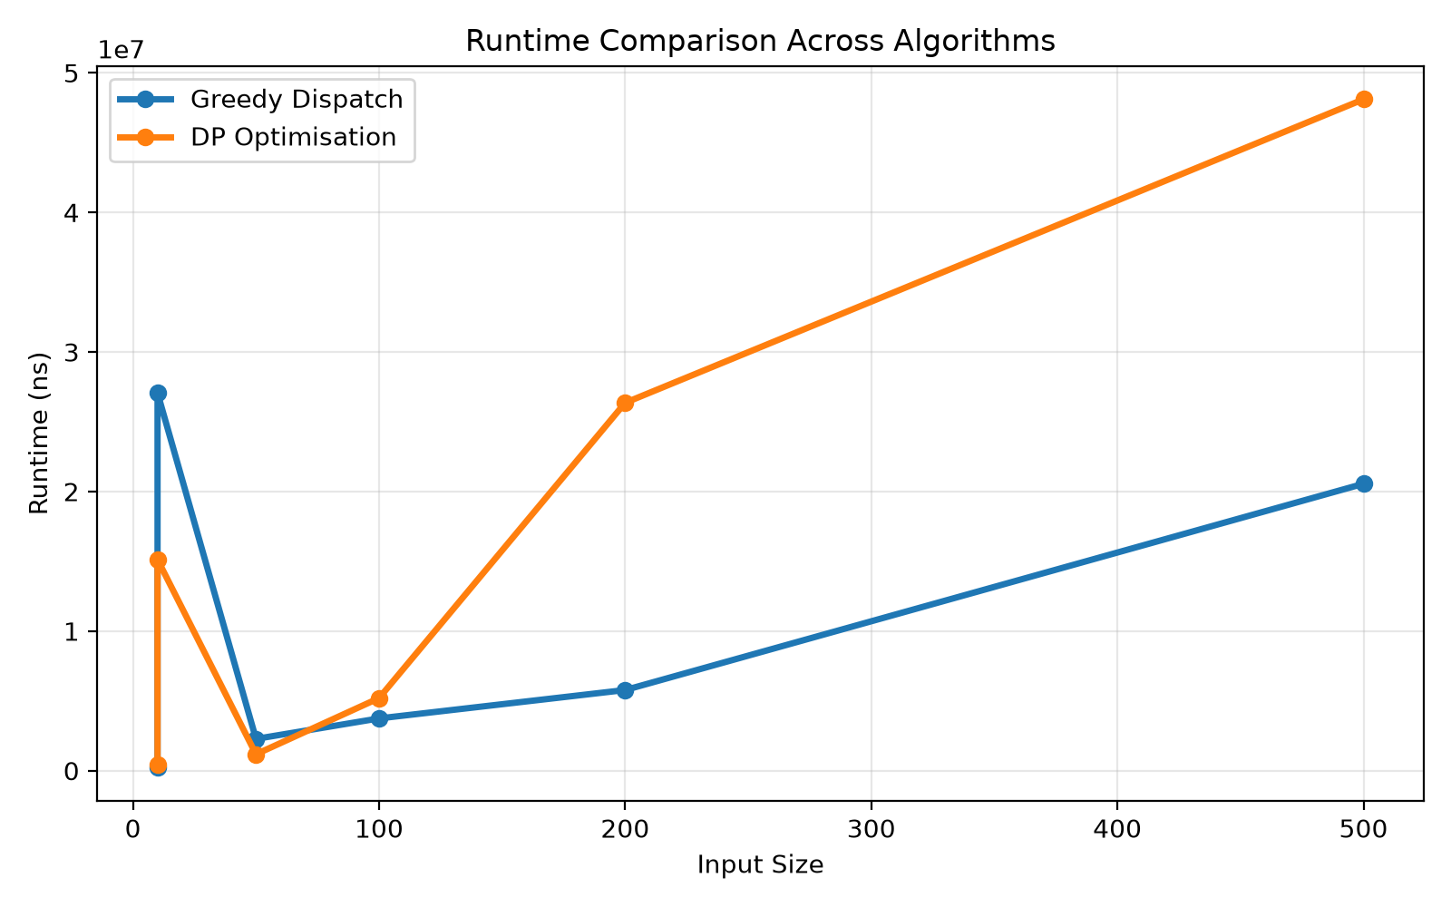
Figure: Runtime comparison between the main algorithms.

Memory
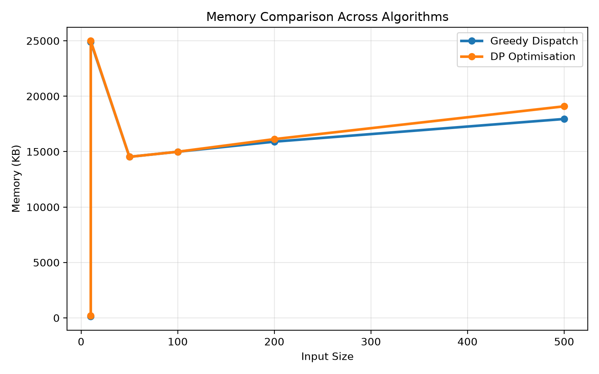
Figure: Memory comparison between the main algorithms.

Completion
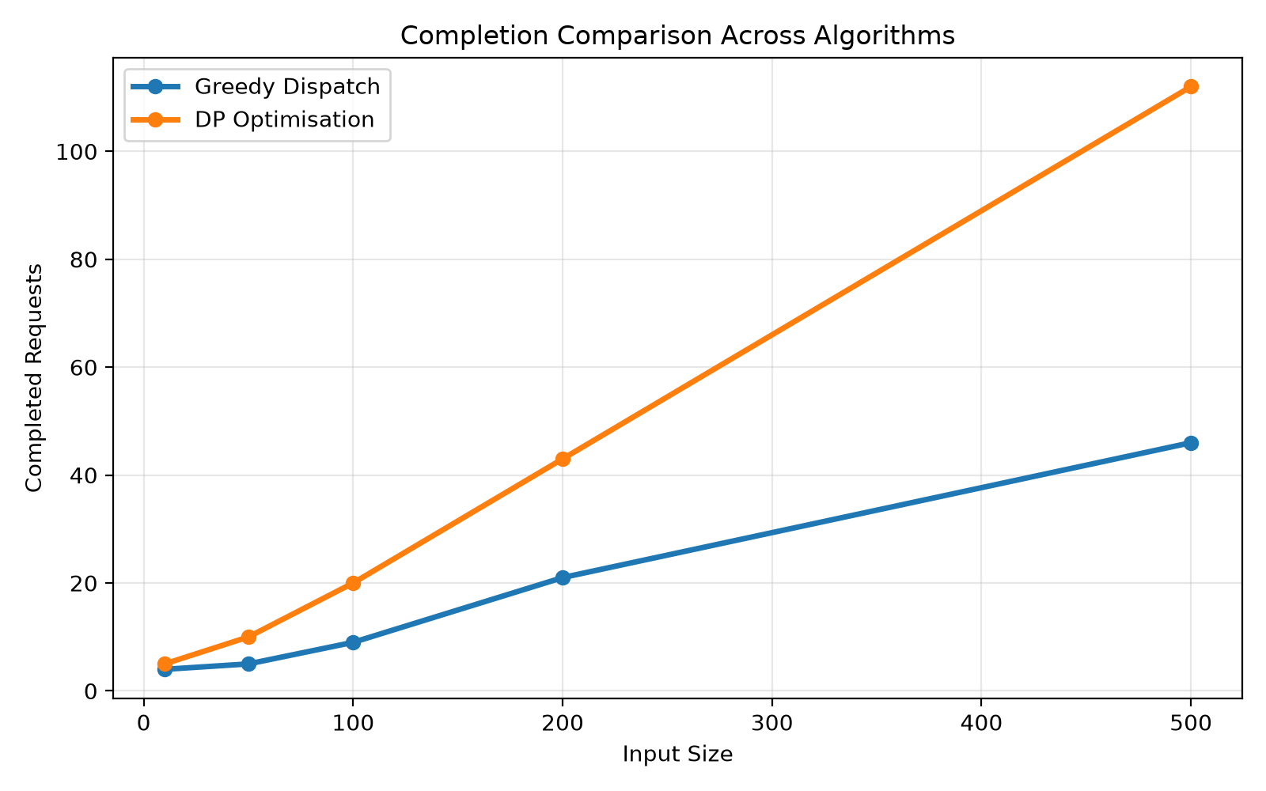
Figure: Completion comparison between the main algorithms.

