# App: Capnote Developer: Daler Asrorov

## App definition statement

Capnote is an iOS application that allows users to share notes of different formats, find and search for note takers for specific class, find classmates, and enjoy social experience through notes. The primary user will be able to subscribe to other people (from his contact list, username, or people from the same class) for notes. Furthermore, the user will see the feed of activities of note takers or note taker requests to create that social experience. Adding to that, each user will have a public profile and contact info for potential study sessions or note taking requests. Last but not least, each note taker will get points after getting “upvotes” for helping other students with notes. In this app people can become note takers and request for note takers; the organization of people is handled in the app.

## Key Features

* 3 – 5 core features
* Allows user to view public profile of the note taker and his statistics
  + Profile picture
  + Text info
    - Topics, courses
  + Location
  + Notes shared
  + Stats
    - How many people he/she helped
    - Notes value points
  + Other users will be able to request notes from the user
* Allows users to subscribe to note takers
* Allows users to see the “feed” of notes and documents uploaded by the note takers the user is subscribed to
* Allows each user to upload notes
  + Notes will be divided into different categories based on course or topic of the uploaded note or document
* Allows each user to edit/remove his or her notes
* Allows each user to increment the number of votes (“upvotes”) for a particular item
  + For social experience
  + Will be used as heuristic for sorting items for the selected category based on popularity
* Sharing features (social media --- optional if I have enough time)

## User Profile

* Students
* Teaching Assistants
* Teachers (can upload their notes)
* Disabled people (can request note takers)

## Technology Items (at least 2)

* Firebase
* Facebook Authentication
* ImagePicker
* Address Book
* Core Data
* Core location & Map Kit
* (Optional) USC Courses API
* (Optional) Facebook

## Wireframes

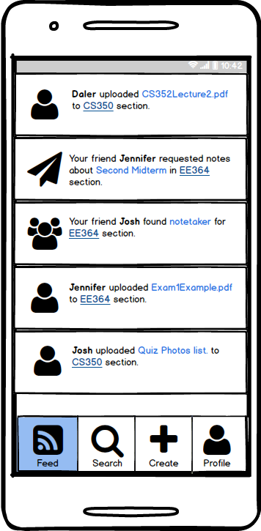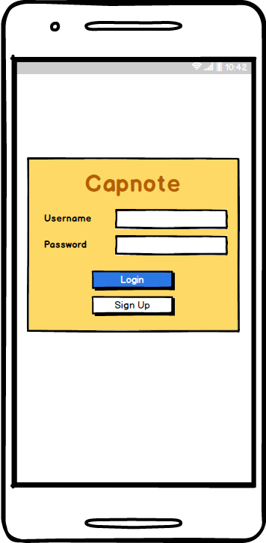

**Feed View 2**

**Login View 1**

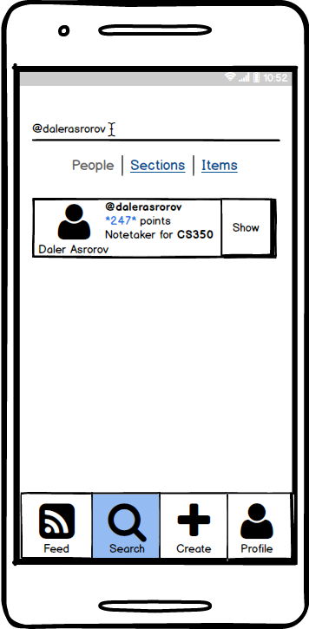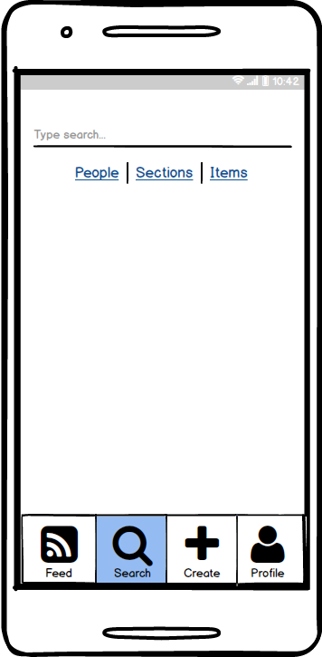

**Search View (People Tab) 4**

**Search View 3**

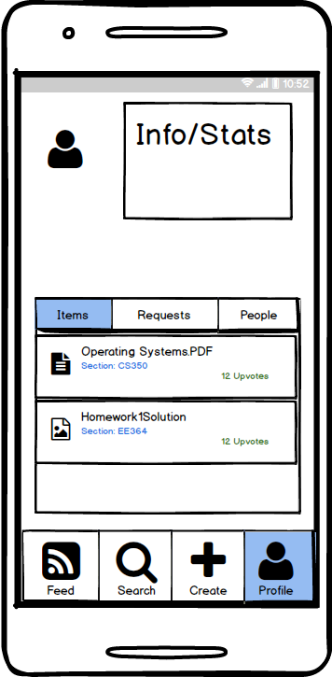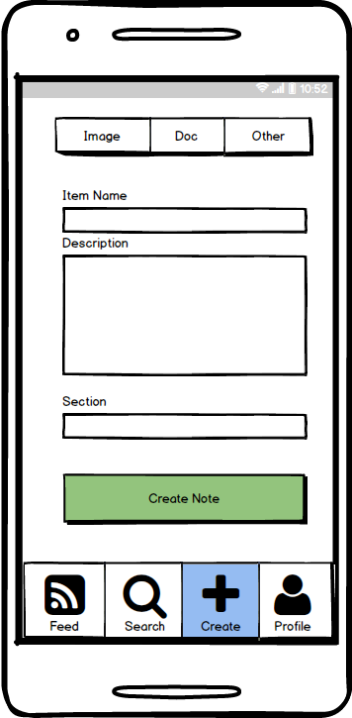

**Profile View (Items tab) 6**

**Create Note View 5**

## 

**Profile View (People tab) 8**

**Profile View (Requests tab) 7**