STATIC WEBSITE DEPLOYMENT ON AZURE USING GITHUB ACTIONS
Name: Temidayo Alex Atanda
Reg. No: AWS/2025/TC3/153
Instructor: Mr. Komolafe Temiloluwa
Date: 24th October, 2025

1. Project Overview
This project involves deploying a static website to Azure using Azure Static Web Apps and GitHub Actions. The website files were uploaded to a GitHub repository, linked to Azure for automated CI/CD deployment.

2. Architecture
The architecture consists of three main components:
1. GitHub Repository – hosts the website source files and workflow configuration.
2. Azure Static Web App – serves as the hosting service for the static site.
3. GitHub Actions – automates deployment to Azure whenever changes are pushed.

3. Deployment Steps
Step 1: Created a GitHub repository named 'temzz-azure-static-site'.
Step 2: Cloned the repository and added the static website files (HTML, CSS, JS).
Step 3: Logged into Azure Portal and created a Static Web App resource.
Step 4: Linked the app to the GitHub repository.
Step 5: Configured GitHub Actions to automate build and deployment.
Step 6: Verified deployment through the Azure-provided URL.

4. GitHub Actions Workflow
The workflow file '.github/workflows/azure-static-deploy.yml' was generated automatically by Azure. It contains the configuration that triggers deployment on each push to the main branch.

5. Challenges Faced
During implementation, one of the challenges faced was authentication and permissions issue between GitHub and Azure. Initially, deployment failed due to token misconfiguration. This was resolved by regenerating the Azure Static Web App deployment token and adding it as a GitHub repository secret.

6. Solutions Implemented
To solve the authentication issue, I configured a new deployment token in Azure and updated the GitHub secret with the correct key. I also ensured that the branch in the workflow file matched the main branch in the repository.

7. Screenshots
Below are screenshots illustrating the deployment process and results:
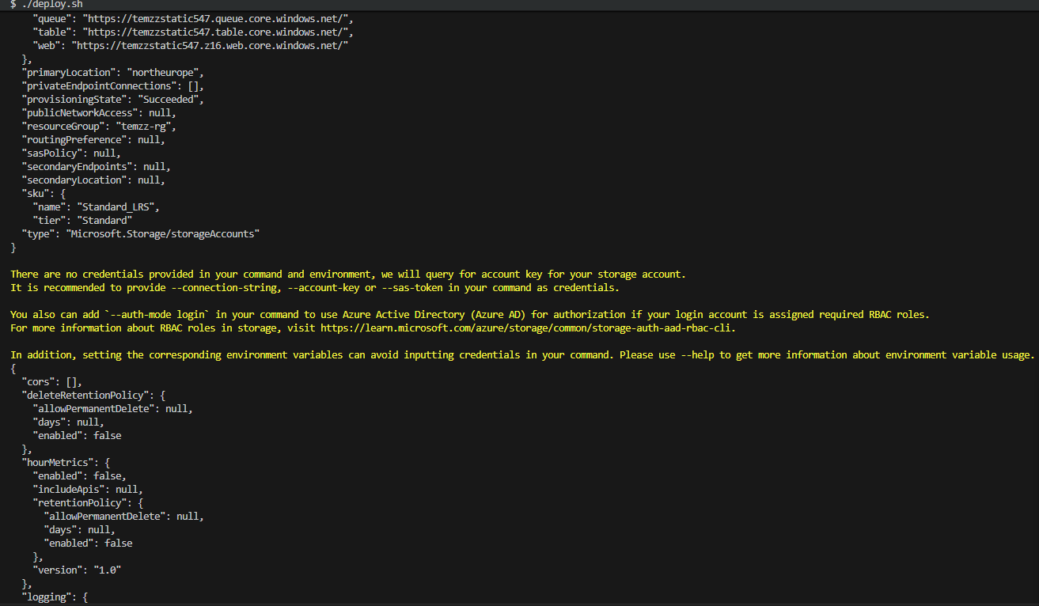
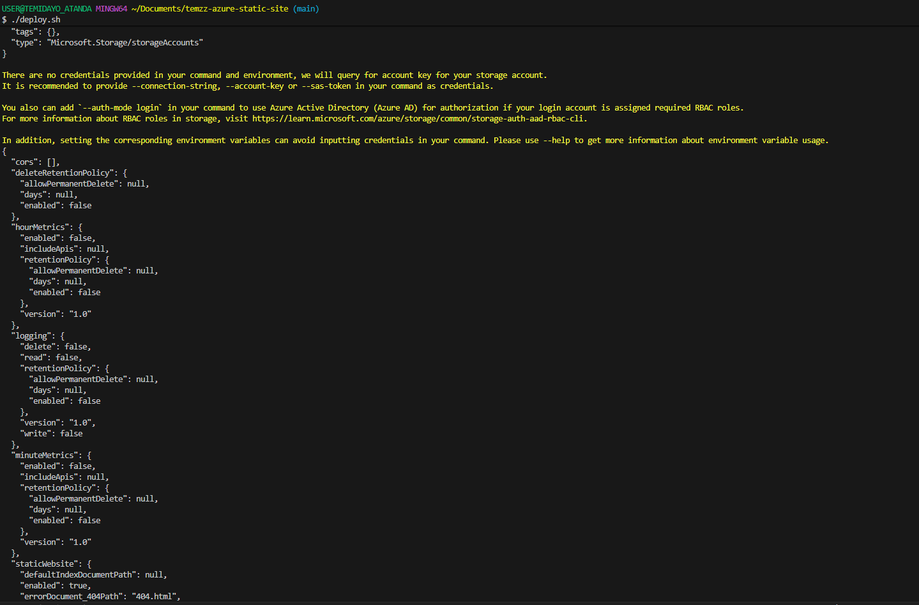
- Azure Portal Static Web App Resource

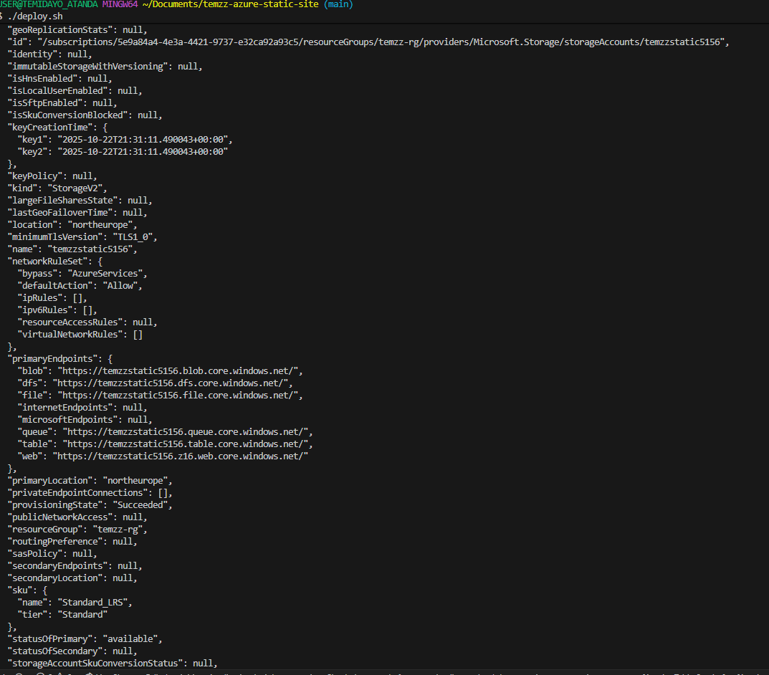
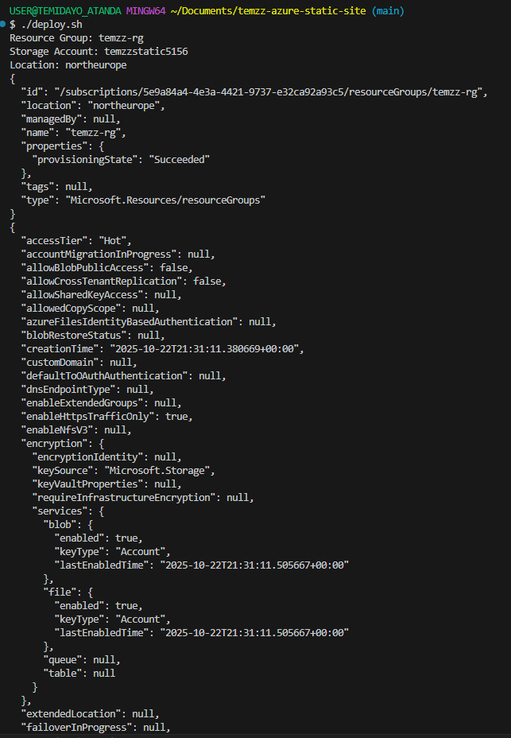
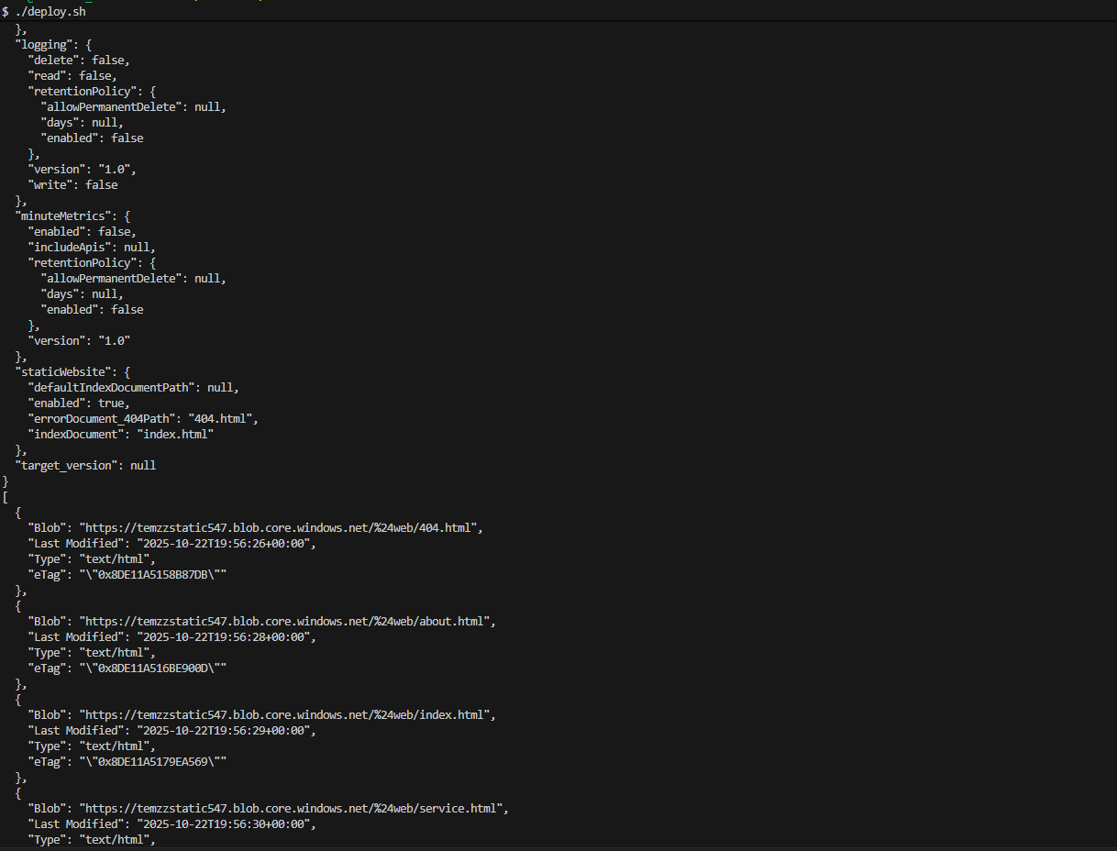
- GitHub Actions Workflow Run (Success)
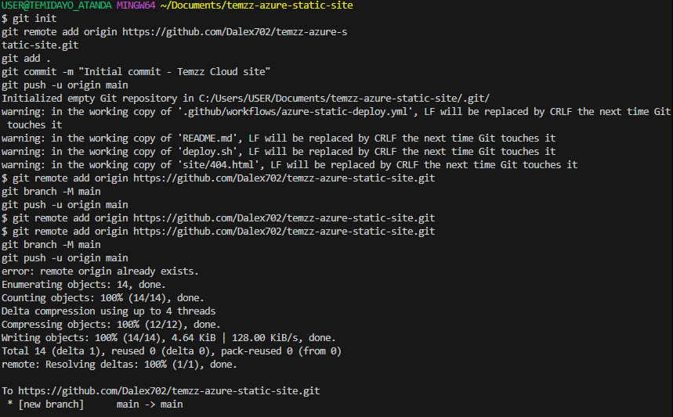
- Deployed Static Website via Public URL


8. Results and Verification
The static website was successfully deployed and accessible through the public URL:
https://temzzstatic5156.z16.web.core.windows.net/
GitHub Repository Link:
https://github.com/Dalex702/temzz-azure-static-site

9. Conclusion
This project demonstrates a seamless CI/CD pipeline for static website deployment using Azure and GitHub Actions. It also showcases proficiency in cloud hosting, automation, and version control practices.
The experience improved my understanding of cloud deployment and automation workflows, particularly the connection between GitHub Actions and Azure Static Web Apps.

