PrestaShop module: Planning Delivery By Carrier

Description
This module, specially developed for the CMS e-commerce Prestashop allows the end user to choose the date and time slot for delivery, depending on availability
merchant.
Features:
- Configure dates of deliveries and time slots for each carrier
- Ability to display a summary of deliveries within the next 7
days on the homepage of the BO.
- Manage the number of days to provide the final customer (between first and last
selectable date).
- Management of days of the week for which delivery is possible.
- Ability to enable or disable management slots.
- Management of independent slots for each day of the week.
- Management of the maximum number of deliveries for each time slot.
- Exception Managment
- Send an email to the customer to remind him of the date and time slot
he chose for delivery.
- Create a tab in the administration summarizing all deliveries
performed by the merchant.

1) Installing the 'Planning Delivery':

o Upload the module in the directory 'modules' on your PrestaShop store.
o Since the administration, install the module located from the 'Modules'.


2) Module Settings:

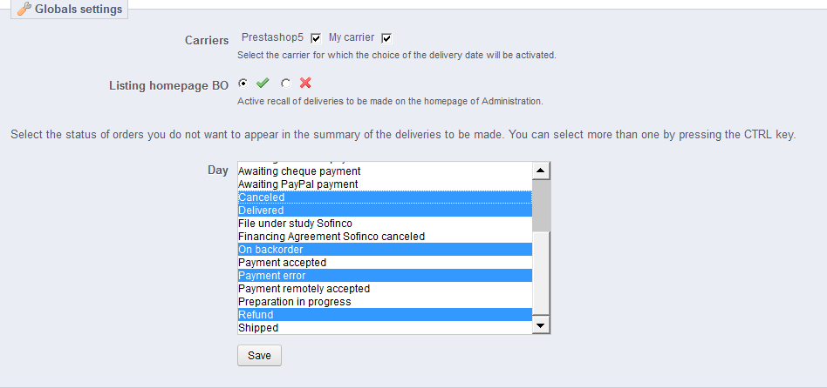
- Transporteurs :
Pour les transporteurs sélectionnés, le choix de la date de livraison sera proposé à l'intrernaute .
- Listing on the homepage of the B0:
If this option is selected, the list of delivery for the next 7 days
appear on the home page of the Back Office, and a link to a page summarizing all deliveries to be made.

Exceptions :
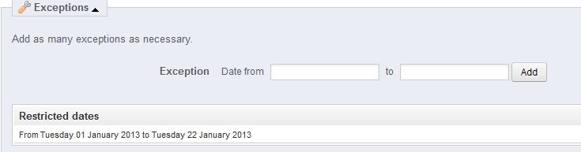
o Can choose the dates or delivery will not be possible (vacation, holiday, etc ...).
These dates are not selectable on the calendar displayed to the user.

3) Configuration for each carrier:

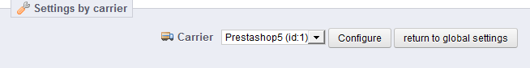

- Sélectionnez le transporteur à configurer. Une fois sur la page de configuration du transporteur, vous pouvez revenir à la configuration générale du module en cliquant
sur 'retour à la configuration générale'.
Parameters
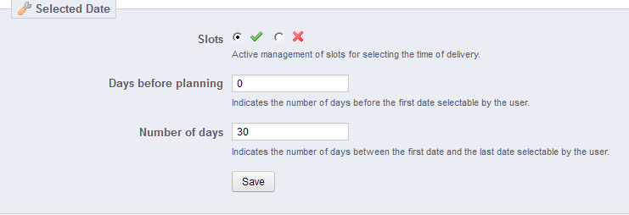
o Listing on the homepage of the B0:
If this option is selected, the list of delivery for the next 7 days
appear on the home page of the Back Office, and a link to a page summarizing all deliveries to be made.
o Number of days before the first date:
Indicates the number of days before the first date selectable by the user.
o Number of days before the last date:
Specifies the maximum number of days between the first and the last selectable date
by the user.

4) Available days:

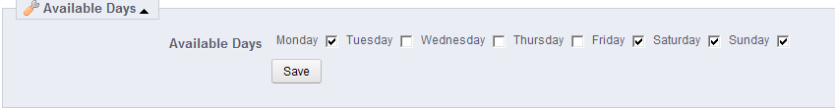
o Allows you to select the days for which delivery is possible.

5) Slots:

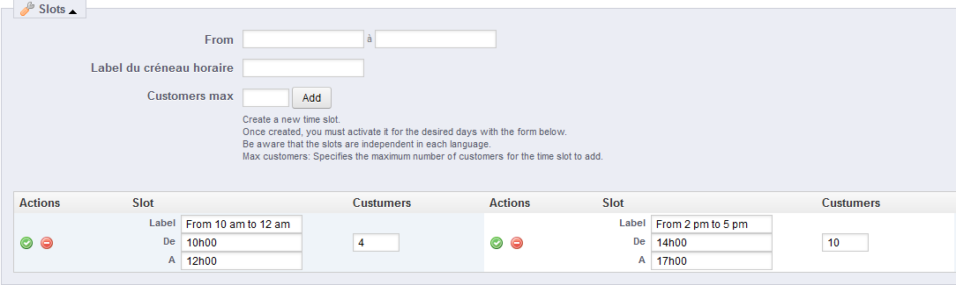
o Allows you to create different slots in their binding a maximum number of customer.
(Number of deliveries up to the time slot in question)
IMPORTANT: In order for the slots to be placed in the correct order when displaying the dropdown menu for choosing the user, you must precede the
name of the slot by "x" or "x" is the number corresponding to the position of the slot.
(The position number will of course not displayed to the end customer)
ex: 1.8am to 10am
appear like this: 8am-10am
and come out on top.

6) Days <=> Slots:

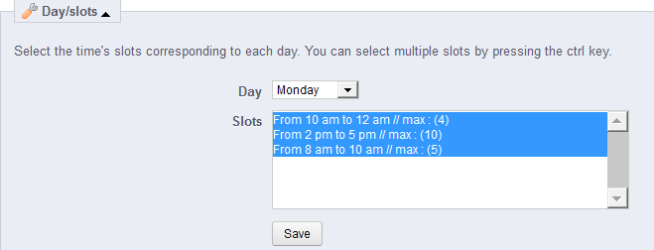
o Selects time slots for each day of the week.
As indicated, it is possible to select several by holding down the CTRL key.

