Network Automation Technical Report

By Dali Hoffman

BIT Semester 1 2024

Contents

**Introduction** 1

Benefits of SolarWinds 1

**References** 4

# **Introduction**

In an era defined by digital transformation, network automation is rapidly becoming an essential technology. It empowers organizations to achieve greater efficiency, reliability, and scalability in network management. With the ever-growing demands on Boogle.Inc.'s network currently consisting of several hundred network devices over multiple sites, network automation powered by a tool like SolarWinds presents a transformative opportunity. This report explores the potential benefits and challenges of implementing this network automation tool within our specific organizational context.

## Benefits of SolarWinds

**Reducing Human Error:**

Manual configuration changes, such as setting up new VLANs or applying firewall rules, are often complex and time-consuming. At Boogle.Inc., with hundreds of devices across multiple sites, even a minor human error during these tasks can lead to significant network downtime. Studies show that human error accounts for up to 80% of network outages (Bednarz, 2023). SolarWinds network automation can significantly reduce this risk by automating repetitive tasks, enforcing configuration consistency, and minimizing manual intervention. This can lead to a more stable and reliable network environment for Boogle.Inc.

**Improving Overall Efficiency:**

Automating network operations with SolarWinds eliminates manual intervention, significantly reducing the likelihood of delays. Studies have shown that network automation will improve efficiency by up to 30% by the year 2025 (Comeau, 2021). Boogle.Inc will not want to be left behind. Automated workflows ensure tasks are executed consistently and efficiently, freeing up valuable IT staff time. At Boogle.Inc., repetitive tasks like configuration changes, software updates, and security patch deployment can all be automated with SolarWinds. This allows our IT staff to focus on more strategic initiatives, such as network optimization and cloud migration, driving greater innovation and business value.

**Enhancing Security:**

Network automation with SolarWinds facilitates the implementation of consistent security policies across the entire network infrastructure, significantly reducing the risk of misconfigurations and security breaches. With Boogle.Inc having several hundred devices across multiple sites, this makes it especially vulnerable to security breaches. SolarWinds can automate tasks like enforcing firewall rules, whitelisting authorized devices, and rotating passwords on a regular basis. This guarantees uniform security standards throughout the network and minimizes the timeframe in which vulnerabilities may arise. Additionally, SolarWinds can automate vulnerability scanning and patch deployment, proactively identifying and addressing security weaknesses before they can be exploited (WJ England, 2017). To further enhance our Network Security, Solarwinds also allows for integration with other dedicated Security Policy companies such as Tufin for an extra layer of defence (Tufin).

**Comprehensive Network Monitoring:**

In addition to automation, SolarWinds offers network monitoring through its Network Performance Monitor (NPM) product. NPM could provide Boogle.Inc. with real-time visibility into network performance by automatically discovering and monitoring Boogle.Inc’s hundreds of devices across multiple sites (routers, switches, firewalls). NPM also offers network visualization tools to identify potential bottlenecks and troubleshoot issues faster, ensuring optimal network health.

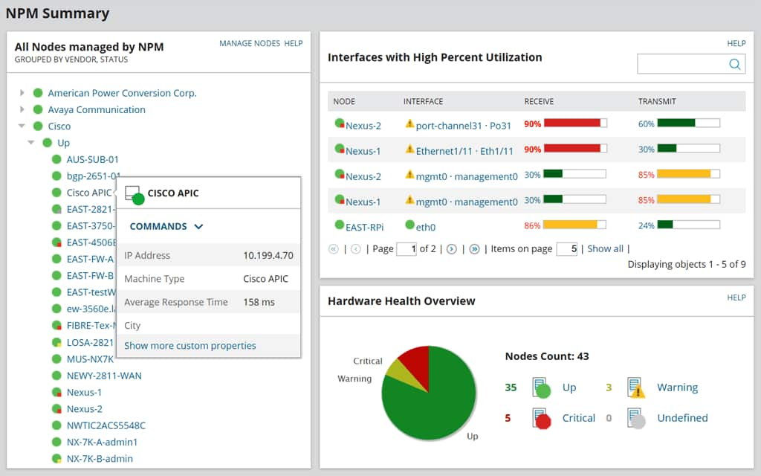

"This screenshot shows the NPM Summary interface, which provides a real-time overview of the health of a network."

**Increasing Scalability:**

SolarWinds has been designed to handle large and complex network infrastructures. This ensures that Boogle.Inc. will not need to worry about outgrowing the platform as its network expands. SolarWinds achieves this scalability through a modular system. Boogle.Inc. can start with core functionalities and then add pre-built modules offered by SolarWinds as its needs evolve (e.g., virtualization management, security event management). This modular approach allows for a scalable solution that can grow alongside your network infrastructure while maintaining optimal performance. While adding modules may involve some configuration and potentially cause minor downtime, SolarWinds is designed to minimize disruption during the process (Kirsch, 2020). As Boogle.Inc.'s network expands, a single server monitoring hundreds of additional devices could become a bottleneck, potentially leading to slower response times and delayed alerts. SolarWinds' Additional Polling Engine (APE) addresses this challenge by distributing the workload across multiple servers, ensuring optimal performance even with a growing network. This not only improves monitoring efficiency but also simplifies management by allowing Boogle.Inc. to scale its monitoring capabilities without needing to replace existing infrastructure. As Boogle.Inc scales and the amount of Network devices that we will be monitoring increases, there may be a strain on the server as it monitors huge amounts at one time. SolarWinds also offers an Additional Polling Engine (APE) and Additional web server which could offer load-balancing so we do not have to worry about scaling.

# **References**

**WJ England. (2017, October 12).** *SolarWinds - Vulnerability scanning -*  WJ England. https://www.wjengland.com/products/n-able-in-malta-and-gozo/data-security/vulnerability-scanning/

**Bednarz, A. (2023, April 3).** *10 things to know about data-center outages*. Network World. <https://www.networkworld.com/article/972102/10-things-to-know-about-data-center-outages.html>

**Comeau, Z. (2021, November 2).** *Gartner: Data center automation will advance significantly by 2025*. My TechDecisions. <https://mytechdecisions.com/it-infrastructure/gartner-data-center-automation-will-advance-significantly-by-2025/>

**(n.d.). Tufin** - Firewall Management & Network Security Policy Software. <https://www.tufin.com/supported-devices-and-platforms/solarwinds-ipam>

**SolarWinds, Inc.** "Screenshot of NPM Summary Interface." <https://www.solarwinds.com/network-performance-monitor>, 19 March 2024.

**Kirsch, B (2020, 18 May).** *How -- and why -- to add SolarWinds modules*. IT Operations. https://www.techtarget.com/searchitoperations/tip/How-and-why-to-add-SolarWinds-modules