LoRa is the abbreviation for “Long Range”. Today, I want to see if this is an earned name. I will attempt to break at least two world records:

1. Longest connection to a TTN gateway.
2. Longest LPWAN ground to ground connection with LoRa on 868 MHz

Maybe you want to accompany me in this attempt.

As in every sport, I have to do some training. For example, find the right antenna and extend my knowledge about propagation of these LoRa waves in air.

In video #118 I already started with the training and the understanding of propagation. In addition, I had to set some goals for the attempt. As far as I know, the longest distances measured with LoRa gateways in Switzerland is 62 km. And some crazy technicians from TI were able to get 100 km in South Africa, but with a slightly different technology. So, the goal is for sure more than 100km. But, as you know, we Swiss are ambitious…

This project became possible when I discovered in my last video about Lora, that there is a new Gateway on a hill in the middle of Switzerland, called “Weissenstein”.

But let’s start with the training first: Last Saturday I drove around 300 km with my car, and my LoRa node. The initial plan was, to go to the highest hill in our area, the “Grand Ballon” in France. There are websites available to map the profile between two points on the map. And here, you see, that I should have a line of sight. And that the distance is about 80 km. Which would be already goal one achieved. But unfortunately, it is still winter here and the road to the Grand Ballon is still closed. So, I had to change my plan and I just searched hills in the surrounding to get a connection. Without big success. The first connection I got was only about 25 km, which definitively was disappointing. Here, you see, that I had a line of sight from this place to the gateway.

But I was able to do some training. The first new thing was, that I discovered a very promising project: The TTNmapper. This is a webpage and an app for IOS and Android. And they work together in a very innovative way.

You have to have your smartphone and your Lora node with you. Then, the app on your smartphone connects to the MQTT server on the things network. As soon as your Node sends a message and it it arrives at one or more gateways, the TTN network sends a MQTT message to your smartphone. Because it knows the exact place of your node, it sends this position information, together with the information about the connection, the webpage and there, the connection is mapped. Very cool. And extremely simple. You just have to keep this app running during your tests. And your smartphone needs to have an internet connection, which is not always easy, as we will see later.

The other thing is, that I was able to test the different antennas.

Summarized, the antenna is less important than many people might think. The reason for that fact is, that LoRa has a very high link budget, as showed in video #112. And an antenna, even if it has a lot of gain, adds only 6 to maximum 10 db to this budget. This is, why I was able to connect also with the smallest antenna to the gateway without problems. But only, with line of sight. And without line of sight, there was no connection, also very close to a gateway.

So, I had to plan a new drive. The plan was to try the first connection at 50 km. So, the first stop was at Habsheim.

I promised to show you how I found the two castles, from where the connection was possible.

Fortunately, I found a great software from Roger Coudé, a ham radio operator with 40 years of experience in RF propagation. One of the functions is to simulate the coverage of a sender at a particulat place. I first simulated my own gateway and discovered, that the prediction of the software were very much in line with my experience from “Wardriving”. So, I simulated the Weissenstein gateway. I treated it as a sender, not as a receiver. But physics do not care too much about that. And here is the result: We see, that it covers a nice part of Switzerland. But it covers also a huge area in France and Germany: This is, where I found my points at 50, 100 and 150 km. The maximum was not so easy to find, because most of them are in a forest. And in the middle of a forest, you have a big loss and the chance to get a connection is smaller. But then, I discovered the two castles, in the middle of the forest. And the rest of the story is known to you.

Just a small remark: If you do not believe me that I established the two world records:

1: Here you see, that I really had a direct line of sight. And you see also, that the Earth curvature is clearly visible. This is, why you need a reasonable height for the sender and the receiver.

And you find a link in the comment, wher you see the logged connections.

I hope, this video was useful or at least interesting for you. If true, then like. Bye

I am just producing my video and wanted to show the connections. Unfortunately, they do not show up on ttnmapper.ord and also no more on

Summarized, I can say, that both world records

eu:sensorsiot_test1:sensorsiot_lora_shield:ttn-account-v2.ghe_hH52vCnUban49B7qfPkRRztT-g-EjmpjDfC71Rs

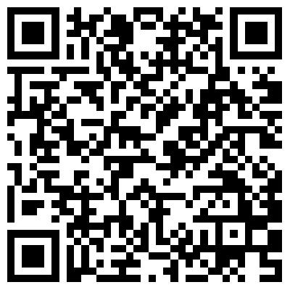

<http://www.ve2dbe.com/rmonline.html>

<https://www.youtube.com/watch?v=wgqtEu5PfAw>

<https://www.thethingsnetwork.org/community/Bern/post/hello-switzerland>