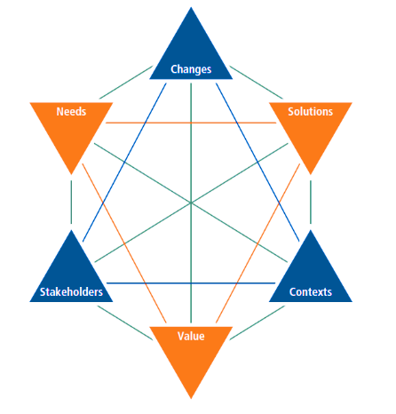

**BACCM**: A conceptual **framework** for BA outlined

Includes what business analysis is & it meaning for BA

All **concepts** hold

the same **importance**

All concepts are **equally** **important** and necessary

A problem or opportunity to be addressed by the business analyst

A group/individual with a relationship of the same need

A specific way of satisfying the needs in a context

Circumstances that influence the organization changing occurs within an environment

The worth/importance/usefulness of something to a stakeholder within a context

The transformation within the organization responding to the need

**Defining** the goals/objectives of the business at the organization (organization as a whole).

**Example:** A business rule which runs that process and that data

**Business Requirements**

**Describing** the **goals**/ objectives of a particular group within an organization.

**Example**: Suppliers(provide goods, material),Project Manager(managing

schedule, budget), User(real users of the project deliverables,require new featues)

**Stakeholder Requirements**

**Describing** various **points** of the solution (A process/system solution ) that must be met.

**Solution Requirements**

**Describing** any capabilities of the solution then do the transition of users/information from the current solution to the new solution has occurred.

**Example:** Updating the system or use new resources

**Transition Requirements**

**Describing** the **behavior** and information that the solution will manage.

**Example**: A prototype , A workflow diagram

**Functional Requirements**

**Describing** the **qualities** (Not describing what the solution must do) of the process/system.

**Example**: Performance, usability, compatibility

**Non-Functional Requirements**

The tasks ( describing meaningful requirements and designs and assessing) that BA perform on proposed changes to requirements and designs

**Techniques**: Glossary, Item tracking.

**Requirements Life Cycle Management**

The assessment of the available to select the most appropriate solution to implement the requirements

**Techniques** : Process Analysis, Acceptance & Evaluation

**Solution Evaluation**

Describing the BA work that must be performed in order to identify a need for strategic/tactical importance enabling the enterprise to address that need

**Techniques**: Business Case, Risk Analysis.

**Strategy Analysis**

Activities which a business analyst should follow to determine the efforts involved in the future.

**Techniques**: Functional Decomposition, Interface Analysis

**Business Analysis Planning and Monitoring**

It’s important to gather the requirements from the available sources and elicit from them.

**Techniques**: brain storming, interviewing, Experiment (prototyping),Research(Market Analysis).

**Elicitation and Collaboration**

Perform in order to manage/maintain the requirements and design information from inception to retirement.

**Techniques**: user (Use Case), Process (Process Modelling), Data (Data Modelling)

**Requirements Analysis and Design Definition**