**Task #1 - Basics  
Did you know everything in Google runs on containers, Containerization allows their development teams to move fast, deploy software efficiently, Each week, they start over two billion containers?  
The following task will help you to understand differences between Containers and virtual machines.  
  
1-Why using Container over VM?**

Virtual machines and containers differ in several ways, but the primary difference is that containers provide a way to virtualize an OS so that multiple workloads can run on a single OS instance. With VMs, the hardware is being virtualized to run multiple OS instances.[1]

**2- What is Docker and why is it So Popular?**

**Docker** is a tool designed to make it easier to create, deploy, and run applications by using containers.

* And importantly, Docker is open source. This means that anyone can contribute to Docker and extend it to meet their own needs if they need additional features that aren't available out of the box.

Docker is a tool that is designed to benefit both developers and system administrators, making it a part of many DevOps (developers + operations) toolchains. For developers, it means that they can focus on writing code without worrying about the system that it will ultimately be running on. It also allows them to get a head start by using one of thousands of programs already designed to run in a Docker container as a part of their application[1]

**3-List use cases for using Docker.**

* Portable deployment of applications as a single object versus process sandboxing;
* Application-centric versus machine/server-centric;
* Supports for automatic container builds;
* Built-in version tracking;
* Reusable components;
* Public registry for sharing containers; and
* A growing tools ecosystem from the published API.

**Task#2: Docker architecture.**

**1- before going to practicing with docker, understand the docker architecture.   
This task is to understand how to run Docker and the difference between image and container, how Create Image from container, and how to use Docker hub.**

**Install Docker on your virtual machine.  
Bring up a Docker container with Ubuntu 16.04  
Login to This container using bash.  
Create & share your image at Docker hub.**

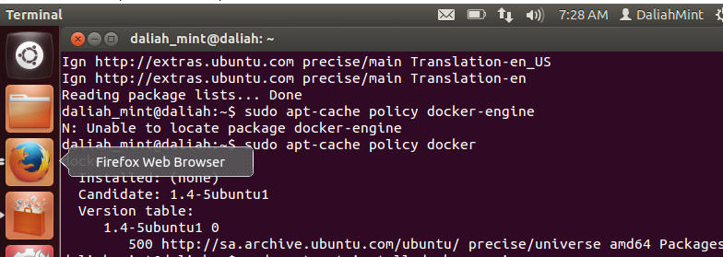

**[1] https://blog.netapp.com/blogs/containers-vs-vms/**