**TechKnights-CompanyAPI**

**this is an api for company information (JAVA,Springboot)**

to use this api: For Company API: 1- Clone Project folders from Github 2- Use Eclipse or intellij IDE 3- Make sure u are using JDK 8 version in your computer, if not then download it 4- Open project via chosen IDE (intellij recommended) 5- Wait for dependencies files to be installed (press “import changes” in bottom right screen in IDE) .

* if you want to make an new project an failed to import make a "Maven Project"

NOTE:

* you have to make sure that no other processes use port number 8080
* open your command line in PC
* run “findstr 8080” command
* if the response was empty then no processes use this port
* if any , use “taskkill /F /PID” and the process id which is shown to u in your terminal.

6- Run project as follows:

* Open DemoApplication file and Click right on it.
* Choose “run DemoApplication”.

7- After Running the project go to Postman to Make your requests

**To insert company >> use POST Request with**

**URL: http//127.0.0.1:8080/company/signup**

Put your parameters in parameter section of Postman parameters: Name, password, description, address, jobs.

Response : whole body info of the company

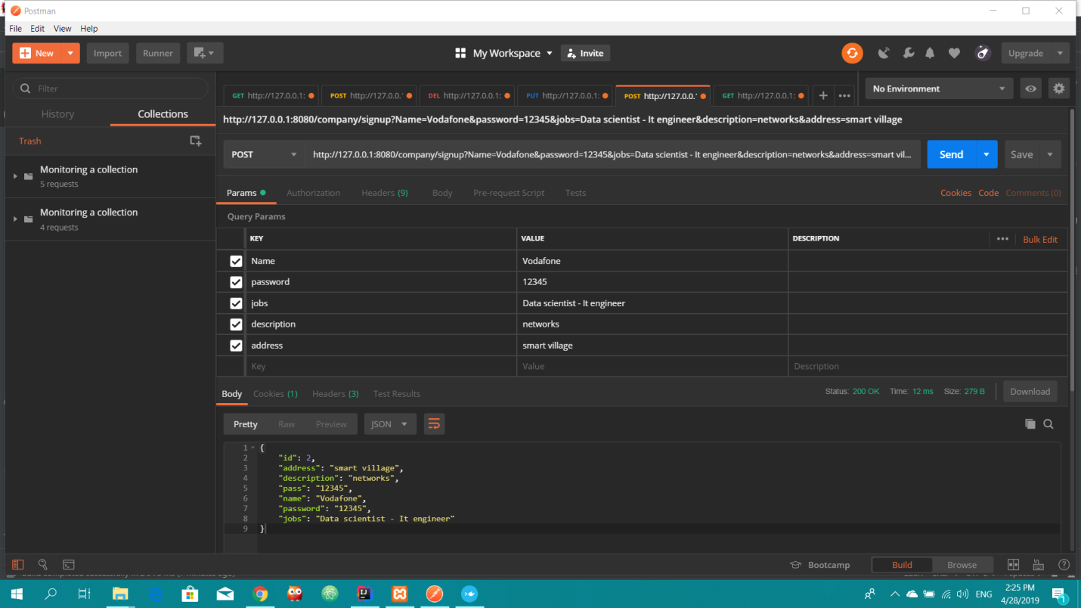

**To update company >> use PUT request with**

**URL: http//127.0.0.1:8080/company/update**

parameters: Name password, description, address, jobs.

Response : whole updated body info of the company

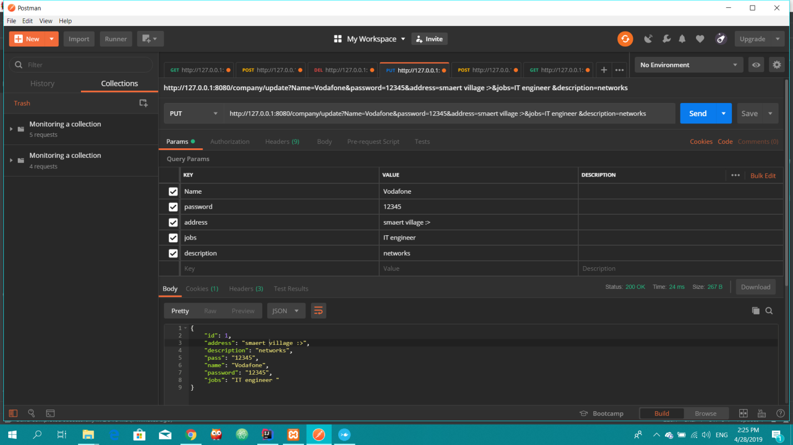

**To delete company >> DELETE Request**

**URL: http//127.0.0.1:8080/company/deleteaccount**

parameters: Name

Response: account deleted successfully

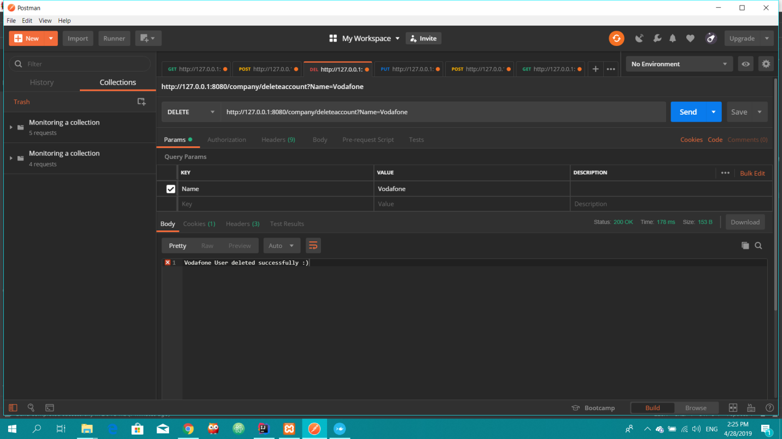

**To login USE >> GET request**

**URL: http//127.0.0.1:8080/company/login**

parameters: Name, password, description, address, jobs.

Response : whole updated body info of the company

**To Fill form as an applicant USE >> PUT request**

**URL: http//127.0.0.1:8080/form/fillform**

parameters: nameAns, phoneAns, emailAns, educationAns, fieldAns, skillsAns, whyAns, name (Company name)

Response: the whole body of the form with questions and answers

