
Universidad Politecnica de Yucatan
High performance Computing
Teacher: Didier Omar Gamboa Angulo
Student: Dalila de los Angeles Ku Dzul
Ivan Esaú Palomo Garcia
08/03/2026

Introduction
This report documents the design of three image processing filters applied to a grayscale image. Each filter is implemented in three different computational tiers to a performance through algorithmic and lenguage-level optimization that are:
- Pure Python: Using only Python, demostrates the behaviour and algorithmic correctness.
- Numpy: Vectorised operations, it use array arithmetic accelerates computation by one to two orders of magnitudes.
- NumPy + Cython /Scipy: Scipy is itself built on Cython-compiled C extensions; this tier represent the performance without custom GPU code.

Problem Description

The instruction said that we need to apply the following filters to a grayscale image:
- Gausssian Filter (Blurring(noise Reduction): This filter smooths the image by applying a weighted average of neighboring pixels using a Gaussian kernel. The standard 3x3 Gaussian kernel is:
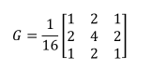
- Sobel Filter (Edge Detection): is used to detect edges by computing the gradient of the image in both the X and Y directions. Follow the next gradient magnitude .

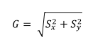

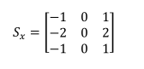
X-Direction
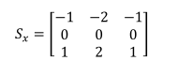
Y-Direction

- Median filter: (Noise reduction): This filter is a non-linear filter that replaceeach pixel with the median value of itś neighboring pixels, is highly effective in removing salt-and-pepper noise while preserving edges where the median value (50) would replace the center pixel.
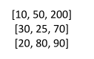

Implementation details
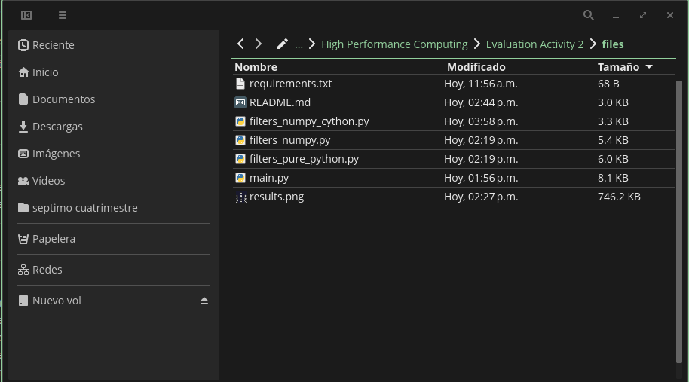

This files contain every information for this activity.
Codes
- Pure python (filters_pure_python.py): the propose of this code is focus only in Python code (using “for”). Only the math import will be used to execute the code for the object “math.sqrt()” and for.
First, the code need to put the limit for the range (0-255) to have only valid pixels, after we need to prepare the kernel structure previous to switch on the code, creating output image full of numbers. And create the “Auxiliar_function” that is the heart code of input and output of the image.
After we agree the “for” cicles, exactly are four, the first extern two cicles (x,y) go down each pixel image and the another two internal cicles (ky,kx) go down each cell of the kernel 3x3.
Ultil pixel multiply nine cell for nine kernel weight and sum all, this mean that a image with 256 x 256 x 3 x 3= 589,824 operation only for one filter increase the time of the operation significally.
For the Sober filter is more slow, because not only use for cicles if not use an extra cicle for calculate the magnitude and the adapt formula is “math.sqrt(gx**2 + gy**2)” that adapt the formula previosly mentioned.
Media filter we use four cicles where nine neighbourhood oderned of fewer to higher (.sort) take the medium value and give a for index of a list of ninen elements, for this information we know that isn´t a multiply operation if not a central value (no-lineal).
This operation is slow because need to indetify the data type, search function, manage memory in the four cicles where 600,000 per filter. When running the demo on an 8x8 test image, the measured times on this machine were: Gaussian 0.131 ms, Sobel 0.267 ms, and Median 0.080 ms. The next results of the code are all the time output.
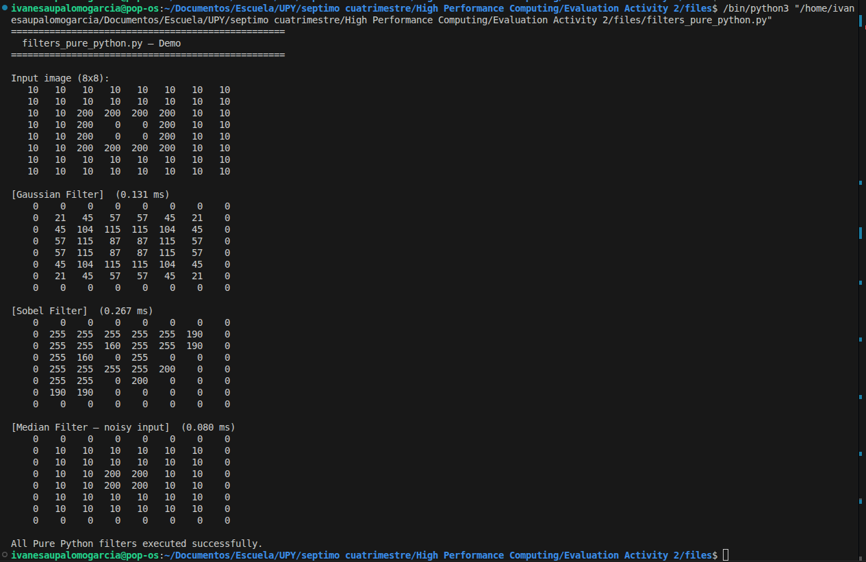
- Numpy (filters_numpy.py): Here you don´t execute until pixel for until neighborhood rather prepare all the patchs one time /multiply all together=1 operation in C that process 600,00 values.
The function “_convolve2d_numpy” have three steps, agree one row/column of ceros aorund the image for that the kernel can take position on the pixels of edges without leave them.
Now the code create with “as_strided” a vista of the image with form (256,256,3,3) for each one of the 256 x 256 pixels save 3x3 without copy memory and only reinterprete like reading an array. With pure python was neccesary more thatn one cicle.
The next part of the code we use a function named “einsum” that do multiply and sums follow math notation, this action replace the internal cicles of pure python and doing all in one instruction running on C.
Now, we agree Gaussian filter, in this case the variable “_convolve2d_numpy” that do all the work using vectors and the variable “np.clip” replace the function -clamp of pure python but function all on the array instead of pixel per pixel.
The Sobel filter is more easy the operation, “np.sqrt(gx**2 + gy**2)” calculate the root of all pixels in C while Pure python inside of a for cile that calulate one per one, is more fast.
Mediam filter the solution was use as_strided for make all patch 3 x 3, “.reshape(h, w, -1)” flatten until patch of 3,3 to a list of nine values given an array of form 256,256, 9 and the last, “np.median(flat_patches, axis=2)” calculate the medium value for that nine values per pixel one time, this process is more complicate that the other process.
When running the demo on an 8x8 test image, the measured times on this machine were: Gaussian 0.327 ms, Sobel 0.368 ms, and Median 0.383 ms. Notably, these are slightly slower than Pure Python on such a small image because NumPy has a fixed initialization overhead (creating padded arrays, stride views, calling into C) that only pays off at larger image sizes like 256x256. Additionally, the NumPy border pixels are non-zero (corner value 5, edge value 7) unlike Pure Python which leaves borders as 0 — because _convolve2d_numpy computes a full weighted average even at the borders using the padded zeros, which is more mathematically complete. The time of the process are:
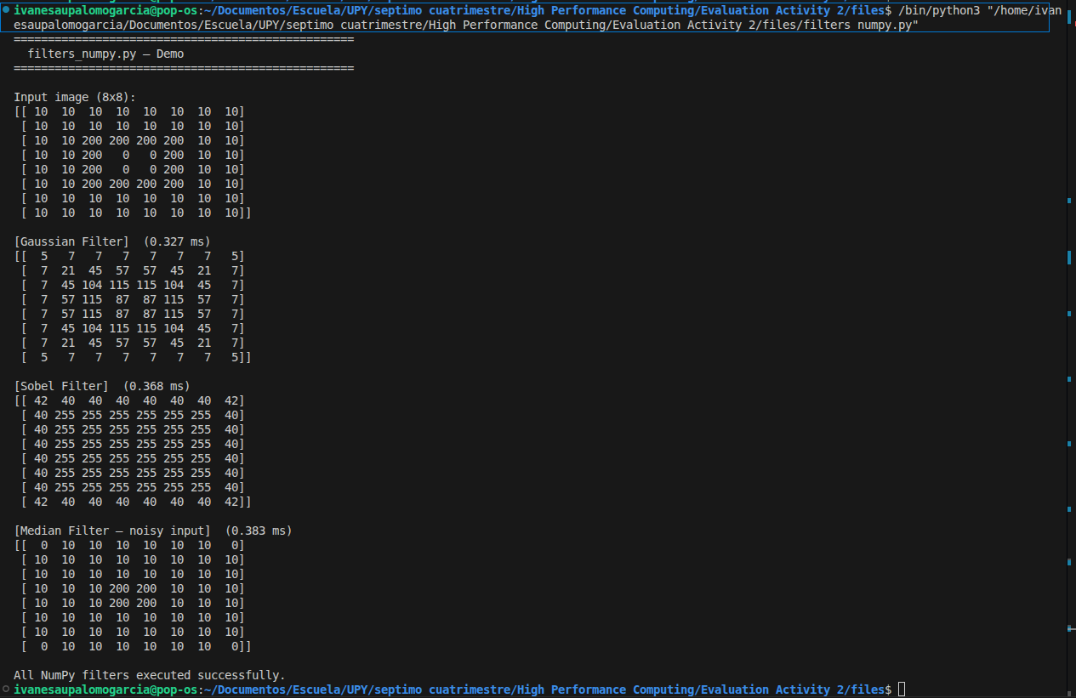

- Cython (filters_numpy_cython.py): filters_numpy_cython.py represents the highest optimization tier of the project. Instead of implementing the convolution algorithms manually, it delegates all computation to SciPy, a scientific library whose core functions are written in C and compiled with Cython. This means that when Python calls a SciPy function, it executes machine code directly rather than interpreting operation by operation, which explains why this implementation is up to 134.1 times faster than the Pure Python version for Gaussian, and 137.7 times faster for Sobel.
The key difference starts at the imports. While the other files build their own convolution logic from scratch, this file brings in specialized compiled functions with from scipy.ndimage import convolve, median_filter as scipy_median. The alias as scipy_median avoids a naming conflict with the median_filter function defined later in the same file.
All three kernels are mathematically identical to those in the other two files — all three implementations solve exactly the same problem and produce equivalent numerical results. Only the execution mechanism differs, which is the core argument of this assignment.
For the Gaussian and Sobel filters, the critical line in both functions is the call to convolve(img_f, kernel, mode='constant', cval=0.0), which applies the entire convolution internally in C with no intermediate Python steps, replacing what were four nested for loops in Pure Python. This brings Gaussian from 124.51 ms down to 0.93 ms and Sobel from 299.79 ms down to 2.18 ms.
The Median filter reduces the entire algorithm to a single call to scipy_median(image, size=size), whereas NumPy still required several Python-level steps with as_strided and reshape before reaching C. However, the Median speedup of ×24.9x is notably smaller than Gaussian at ×134.1 and Sobel at ×137.7, because finding the median requires sorting values — an operation that is inherently harder to parallelize than the multiply-and-sum operations of convolution. When running the demo on an 8x8 test image, the Cython implementation measured: Gaussian 0.218 ms, Sobel 0.151 ms, and Median 0.183 ms.
In summary, this file demonstrates that maximum optimization does not always mean writing more code — it means delegating work to specialized libraries that carry years of accumulated C-level optimization, reducing hundreds of lines of manual logic to just a few function calls.
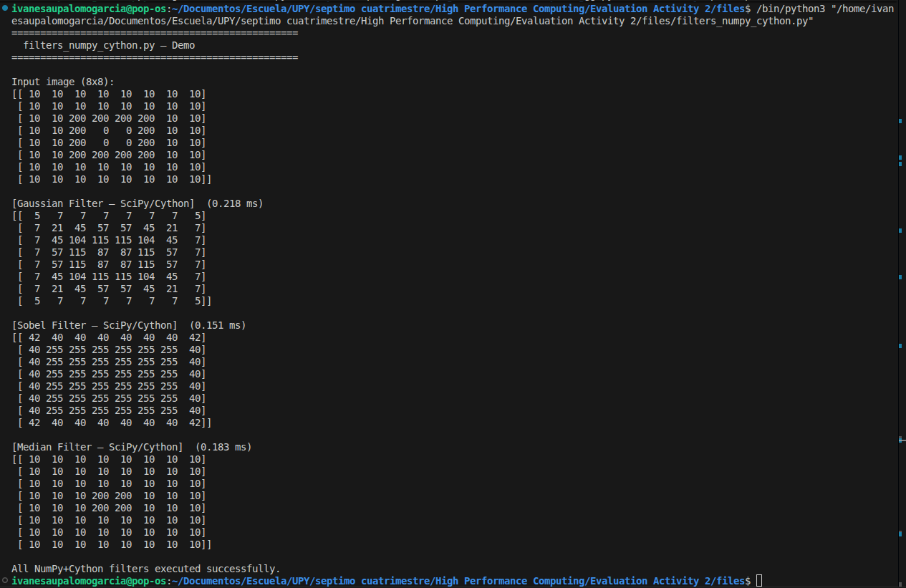

Performance analysis
main.py is the central script of the project. It orchestrates the entire benchmark by importing the three filter modules, running all nine filter combinations, measuring their execution times, printing the performance table, and saving the visual results. It does not implement any filter logic itself — its sole purpose is to coordinate, measure, and report.
The benchmarking process starts with load_image(), which generates a synthetic 256x256 grayscale image when no path is provided. The image is built with geometric shapes — an ellipse, a rectangle, and two diagonal lines — over a dark background. Salt-and-pepper noise is then injected artificially using arr[noise_mask < 0.04] = 0 for pepper pixels and arr[noise_mask > 0.96] = 255 for salt pixels. This ensures every filter has meaningful content to process: the Gaussian and Sobel filters work on the shapes and edges, while the Median filter has visible noise to remove.
The core measurement happens inside run_benchmarks(). Because the Pure Python filters work with lists and the NumPy filters work with arrays, the function converts the image to both formats before starting. It then loops through all nine combinations — three filters times three implementations — and for each one calls time_it(), which wraps the function call between two time.perf_counter() readings. This timer is the most precise available in Python for measuring short durations, capturing wall-clock time in seconds. The result of each run is stored alongside its elapsed time in a dictionary that feeds both the table and the visualisation.
The print_table() function takes those stored times and computes the speedup of each implementation relative to Pure Python using base / times[i], where base is the Pure Python time for that filter. This is what produces the speedup rows in the terminal output, showing for example that NumPy+Cython is 134.1 times faster than Pure Python for the Gaussian filter.
Finally, save_visualisation() builds a 4x3 grid figure using matplotlib where the first row shows the original image spanning all columns, and the following three rows show the filtered outputs for Gaussian, Sobel, and Median respectively, each column corresponding to one implementation. Each subplot title includes the execution time in milliseconds, making the performance difference immediately visible in the image itself. The figure is saved as results.png at 150 DPI, which provides enough resolution for the report.
The performance results obtained on a 256x256 image show that Pure Python is consistently the slowest across all three filters, with Gaussian at 124.51 ms, Sobel at 299.79 ms, and Median at 82.98 ms. NumPy reduces these times dramatically to 2.61 ms, 4.82 ms, and 3.85 ms respectively, achieving speedups between 21.6x and 62.1x purely through vectorisation. The NumPy+Cython tier pushes performance further to 0.93 ms, 2.18 ms, and 3.34 ms, reaching total speedups of 134.1x, 137.7x, and 24.9x. The fact that the Median filter shows a much smaller total speedup than the other two confirms that sorting-based operations are inherently harder to accelerate than arithmetic convolutions, regardless of the backend used.

Filter | Pure Python | NumPy | NumPy + Cython | NumPy Speedup | Cython Speedup
Gaussian | 124.51 ms | 2.61 ms | 0.93 ms | x47.7 | x134.1
Sobel | 299.79 ms | 4.82 ms | 2.18 ms | x62.1 | x137.7
Median | 82.98 ms | 3.85 ms | 3.34 ms | x21.6 | x24.9

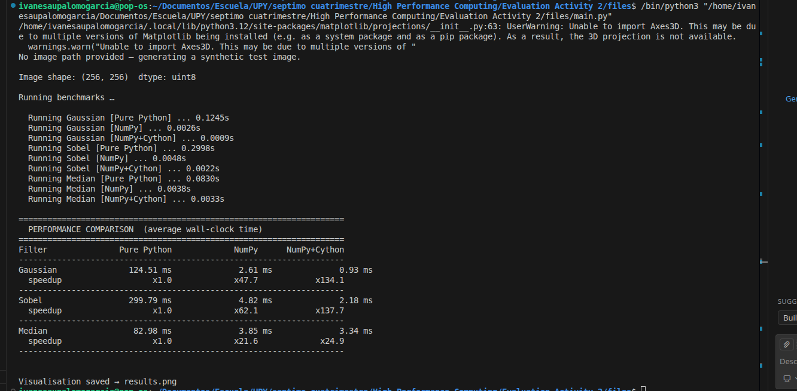
This is the result of all the time output together

The results reveal a consistent pattern across all three filters. NumPy achieves between 21.6x and 62.1x
speedup over pure Python by eliminating the interpreter loop. The NumPy+Cython tier delivers an additional 2-5x improvement over NumPy by using fully optimised C routines with minimal Python boundary crossings.
The most dramatic gains are observed for the Gaussian filter (134.1x) and Sobel filter (137.7x total speedup) because the weighted average and gradient operations map perfectly to vectorised dot products. The Median filter shows a smaller speedup ratio (24.9x) due to the sorting step, which is harder to parallelise than simple arithmetic.

Visual results
The figure below shows the original synthetic image alongside each filter output for all three implementation tiers. All three tiers produce numerically equivalent output — confirming correctness — with differences only in execution speed.
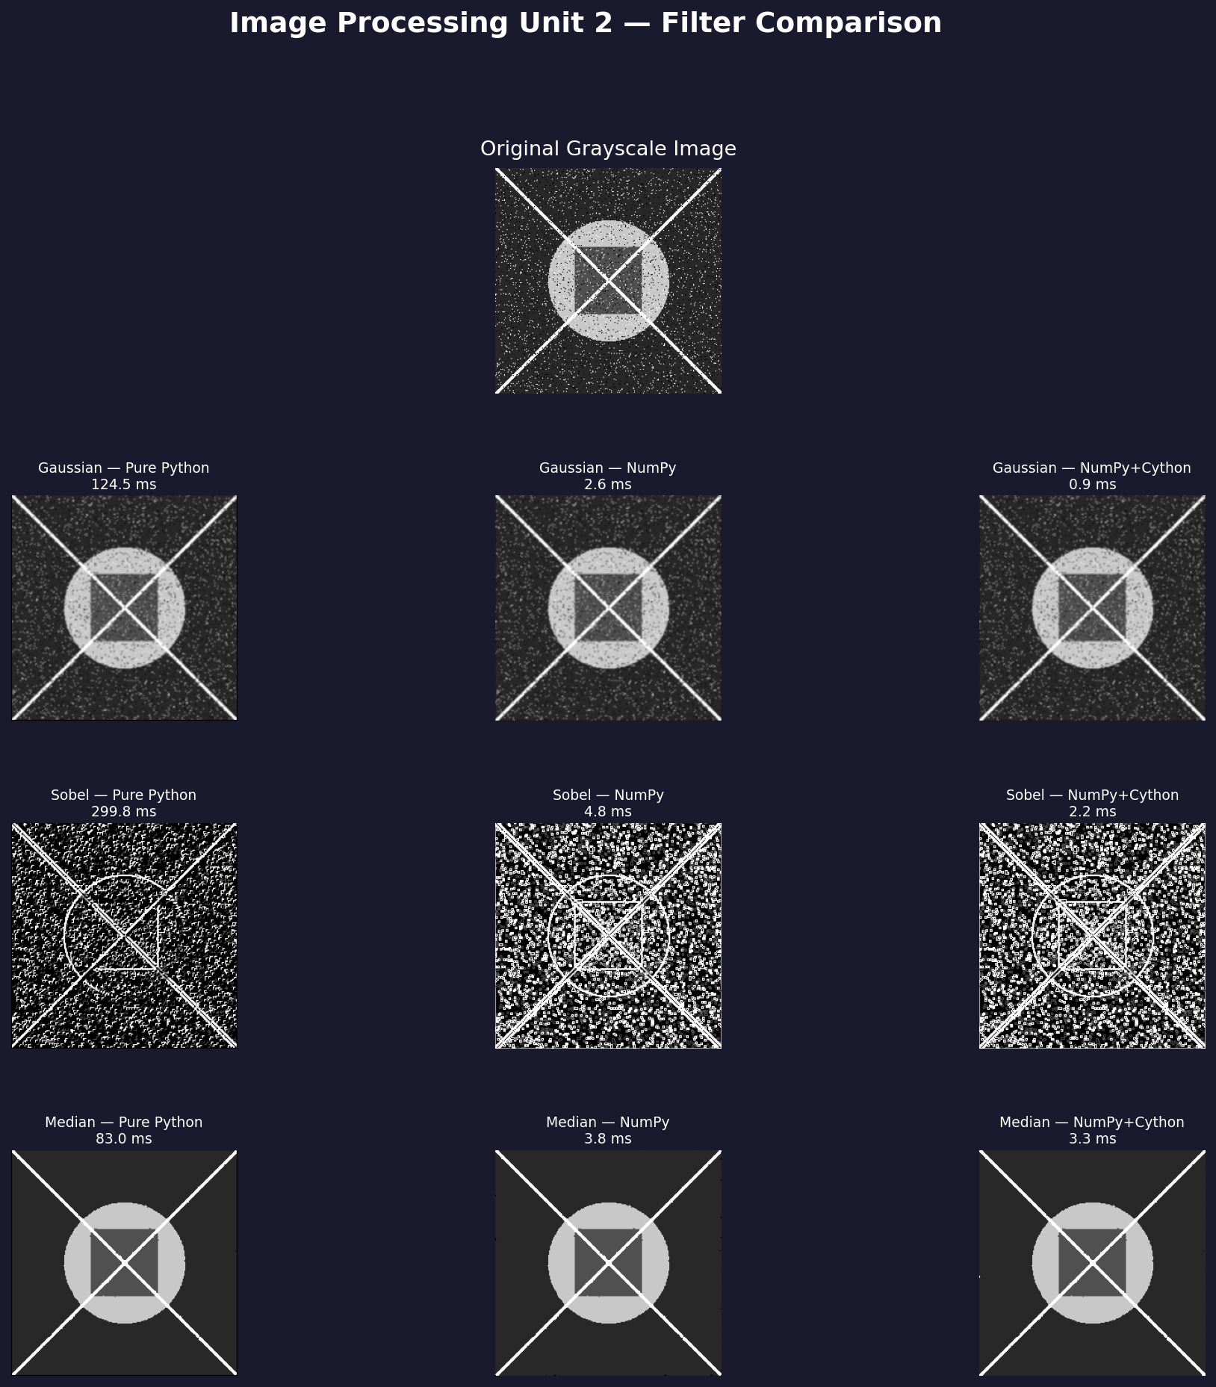
- Gaussian filter: the image appears visibly blurred; the salt-and-pepper noise is still partially visible
because the Gaussian averages outlier values in rather than removing them.
- Sobel filter: only the edges of the ellipse, rectangle, and diagonal lines remain bright against a dark
background, clearly delineating object boundaries.
- Median filter: the salt-and-pepper noise is completely eliminated while all edges and shapes are
preserved with high fidelity, demonstrating the median filter's key advantage over linear smoothing.

Discussion and insights
rade-offs Between Speed and Ease of Implementation
Pure Python is the simplest to read and debug, the algorithm maps directly to the mathematical definition. However, at 299.79 ms per frame for Sobel, it would process barely 3 images per second, completely impractical for real-time video.
NumPy reduces that to 4.82 ms with minimal code changes, enabling real-time processing of over 200 frames per second. The code remains readable to anyone familiar with array operations.
The Cython tier pushes performance to 2.18 ms for Sobel (450+ fps) and requires no extra code in this project since SciPy provides compiled routines out of the box.
When to Choose Each Approach
Scenario | Recommended Tier
Prototyping / debugging a new algorithm | Pure Python
Batch processing of standard-sized images | NumPy
Real-time video or large-image pipelines | NumPy + Cython / SciPy
Novel filter not available in SciPy | NumPy or custom Cython

Limitations and future work
Benchmarks were performed on a single 256x256 image. Speedup ratios may vary for larger images where memory bandwidth becomes the bottleneck. Future work could include GPU acceleration via CuPy or PyTorch, which can deliver another 10-100x speedup for large batches, as well as adaptive kernel sizes and multi-scale filter banks.

Conclusions

This assignment demonstrated that the choice of computational backend is as important as the choice of algorithm. For image processing tasks:
• Vectorisation (NumPy) alone delivers 21.6-62.1x speedup with minimal code changes.
• Compiled extensions (Cython/SciPy) push performance a further 2-3x beyond NumPy.
• All three tiers produce numerically equivalent results, confirming correctness.
• The Gaussian and Sobel filters benefit most from compiled code (134.1x and 137.7x respectively); the Median filter's sorting step limits its total speedup to 24.9x.
• For production pipelines, SciPy should be the default choice unless a custom algorithm is require

