DATA WAREHOUSE PROJECT
ADVENTUREWORKS COMPANY

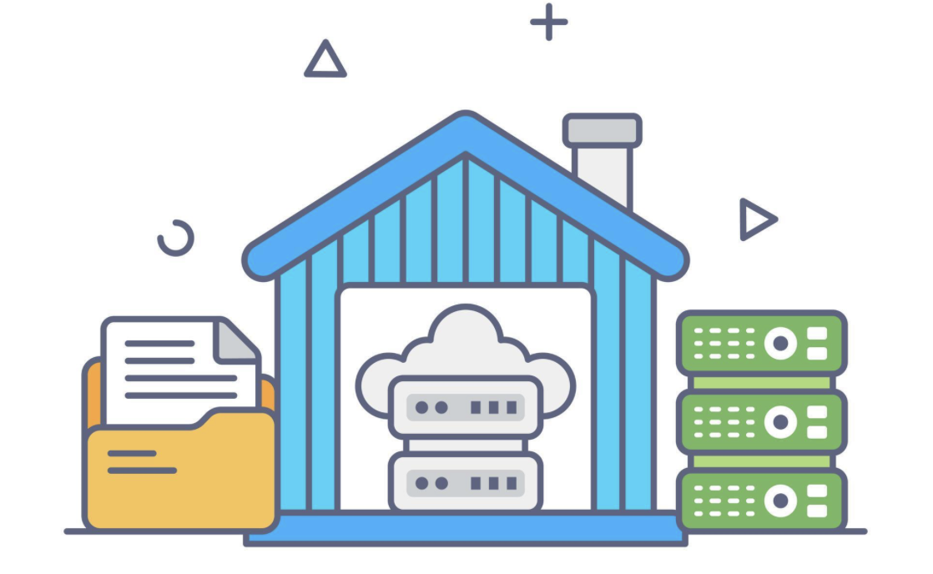

BY: CHORN CHEADALIN

BY: CHORN CHEADALIN
Problem Overview

The company currently relies on the AdventureWorks2022 transactional database for daily operations (products, customers, orders, sales), but it is not suited for analytics. The company faces challenges with scattered and unorganized data, which slows analytical queries and leads to decisions based on partial or outdated information. This causes difficulties for management in answering key strategic questions:
- Which products are most profitable over time?
- How are sales trending by region/channel?
- Which customers drive the most revenue growth?
To solve and answer all those questions, the company has to build a dedicated Data Warehouse (AdventureWorks_DWH) to consolidate and cleanse the data from multiple sources. Additionally, the data warehouse will enable fast and reliable analytical queries, which makes it easier to provide better decision-making.
Project Objectives
The project aims to design and implement the AdventureWorks_DWH, a dedicated Sales and Marketing Data Warehouse, to enable fast, accurate, and insightful analytics for strategic decision-making.
There are three key objectives to implement the AdventureWorks_DWH:
- Data Integration: extract, transform, and load (ETL) data from the AdventureWorks2022 transactional database into the AdventureWorks_DWH
- Data Modeling: design a Galaxy Schema model suitable for analytical queries. It is divided into dimension tables and fact tables.
- Technique Implementation: Implement an incremental load in the ETL process using SSIS to update only new or changed records, improving performance and efficiency.

Project Overview
Project Scope
The scope of this project is to cover the end-to-end design and implement the complete AdventureWorks_DWH for AdventureWorks Cycles. The priority objective is to transform the existing database into a structured analytical database, making it easier and faster to query.
Project Architecture Design and Workflow
Architecture Overview
The architectural design of AdventureWorks_DWH is engineered to ensure maximum efficiency, scalability, and reliability in data extraction, transformation, loading (ETL), and reporting. The solution adheres to a robust three-layer data warehouse architecture, a proven industry standard that separates concerns, enhances maintainability, and optimizes performance for analytical workloads.
This layered approach enables seamless data movement from operational systems to a centralized analytics platform, transforming raw transactional data into actionable business insights. The architecture supports full and incremental loads, data quality enforcement, and historical trend analysis, directly addressing the strategic questions posed by AdventureWorks.
- Source: contains the data from AdventureWorks2022, a transactional database. It stores day-to-day operational data, including customer information, products, and orders.
- Staging: acts as a temporary storage area used to extract data from the source (AdventureWorks2022). It performs data cleansing, transformation, and validation.
- Data Warehouse: a centralized analytical database that contains dimension tables and fact tables. Additionally, it stores historical and aggregated data optimized for analytical queries.
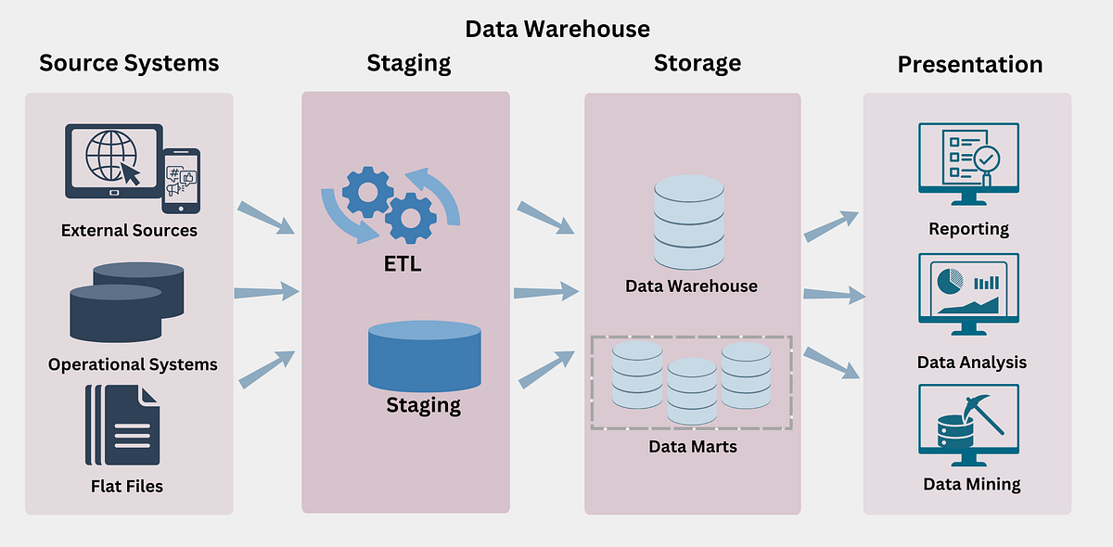
Data Model Design
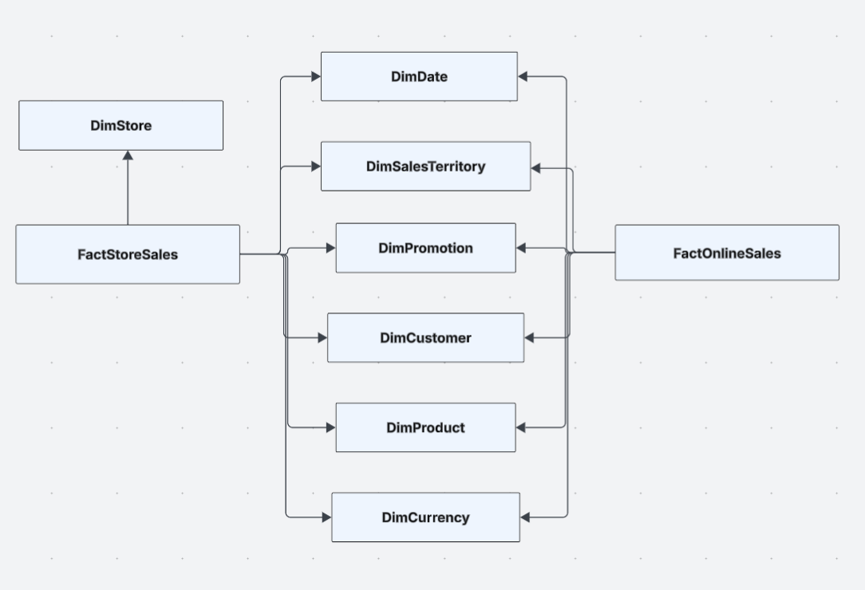
Project Task Breakdown(Environment)
To set up the environment, we need to have:
- Visual Studio
- Microsoft SQL Server
The Database needed:
- Source: AdventureWorks2022
- Staging: AdventureWorks_Staging
- Destination: AdventureWorks_DWH
Here is the breakdown of the ELT process to load data from source, staging, and warehouse
I built DimStore by loading store data from AdventureWorks2022 into staging, then into the warehouse using SCD Type 2. New stores are inserted, and if a store’s details change, the old record is closed and a new version is added. This keeps a full history of store changes for accurate reporting.
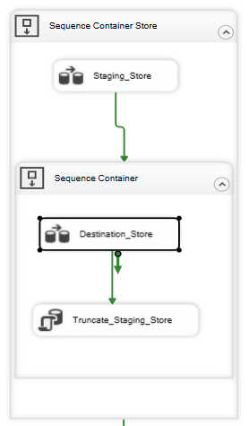
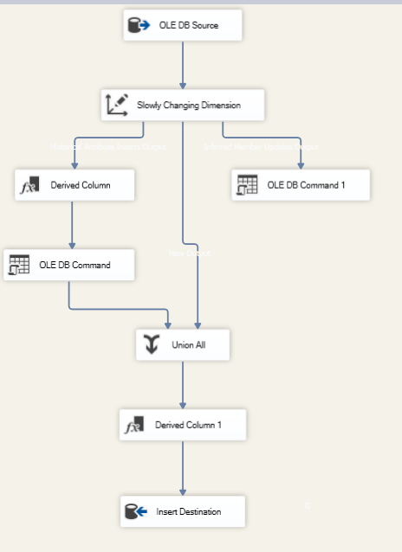

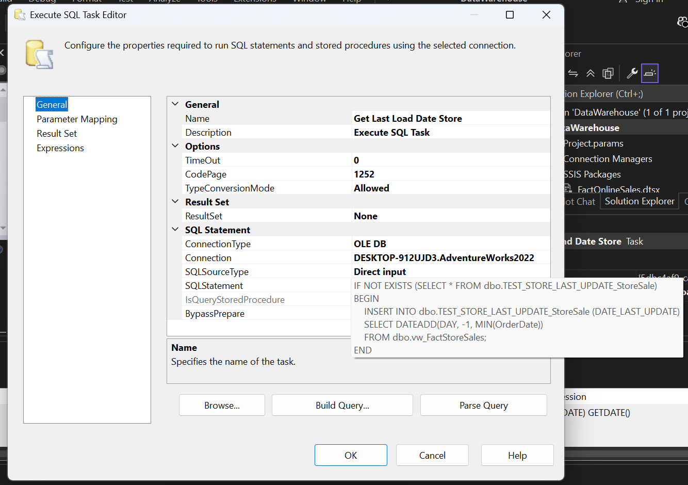
I implemented the fact table by loading source data into staging, then using incremental load logic to insert only new or updated records into the warehouse. A control table stores the last load timestamp, and each run loads rows with OrderDate greater than that value. This prevents full reloads, improves performance, and keeps the fact table updated with only the latest changes.
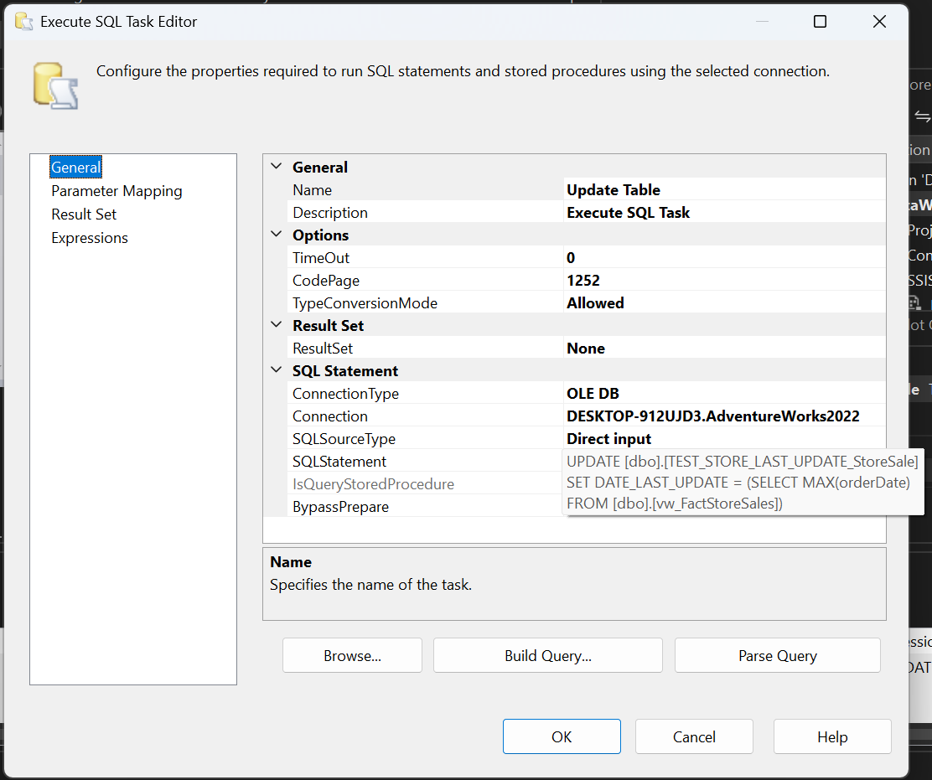
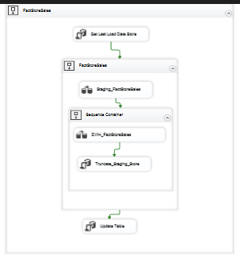
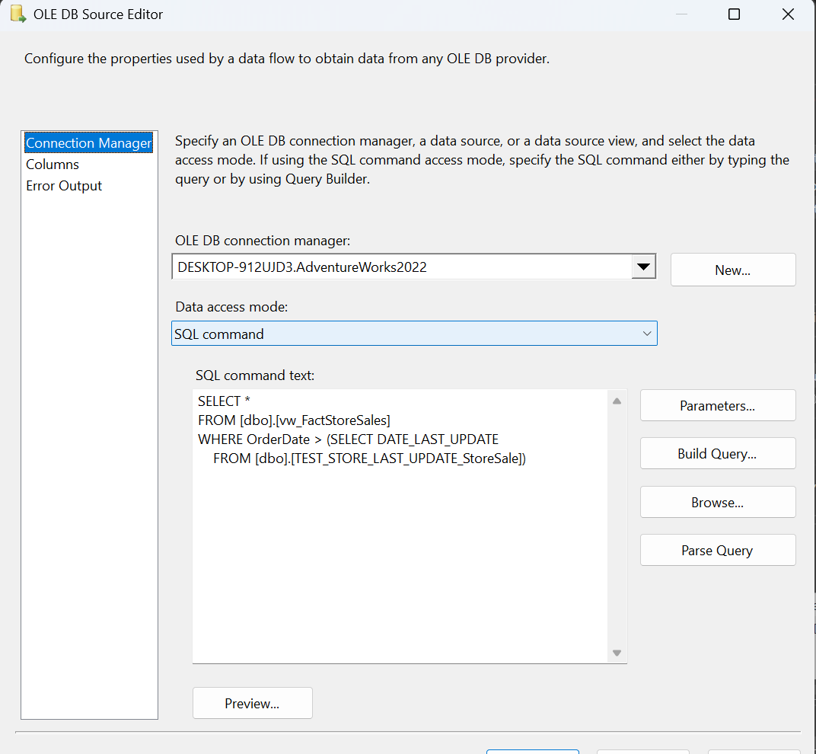

Conclusion
This project demonstrates a complete ELT pipeline from source to staging and finally to the data warehouse, including SCD Type 2 for dimensions and incremental loading for fact tables. The structure ensures accurate history tracking, efficient loading, and a scalable warehouse design.

