**MY TOP 4 HYPER CASUAL GAMES**

1. BLOCKY HIGHWAY

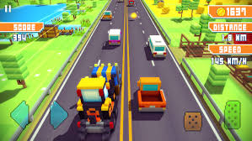

I love car games in general, even though I can’t drive. This game is fun and easy to play from the get go. I love the themes and the fact that you can change the game environment and earn new vehicles even a boat, fun fact you can onboard your vehicle onto another vehicle and have it bash other cars😂. The game play is easy, doesn’t require you to wrack your brain about what you’re supposed to do and it’s thrilling.

1. GEOMETRIC DASH

This game is a bit stressful because you might forget to tap when you’re supposed. But it’s fun once you get the hung of it. The gameplay is rhythmic making it fun and interesting. It creates a powerful "just one more try" loop keeping me feel like I can improve the next time I play. The game mechanics are easy all you need to do is just tap.

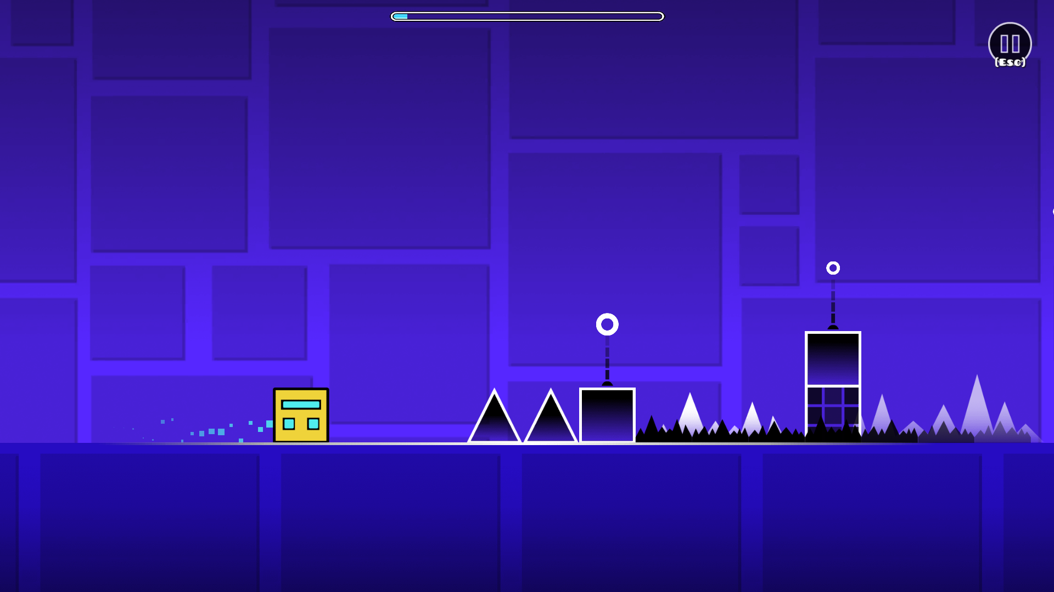

1. STICKMAN PARTY

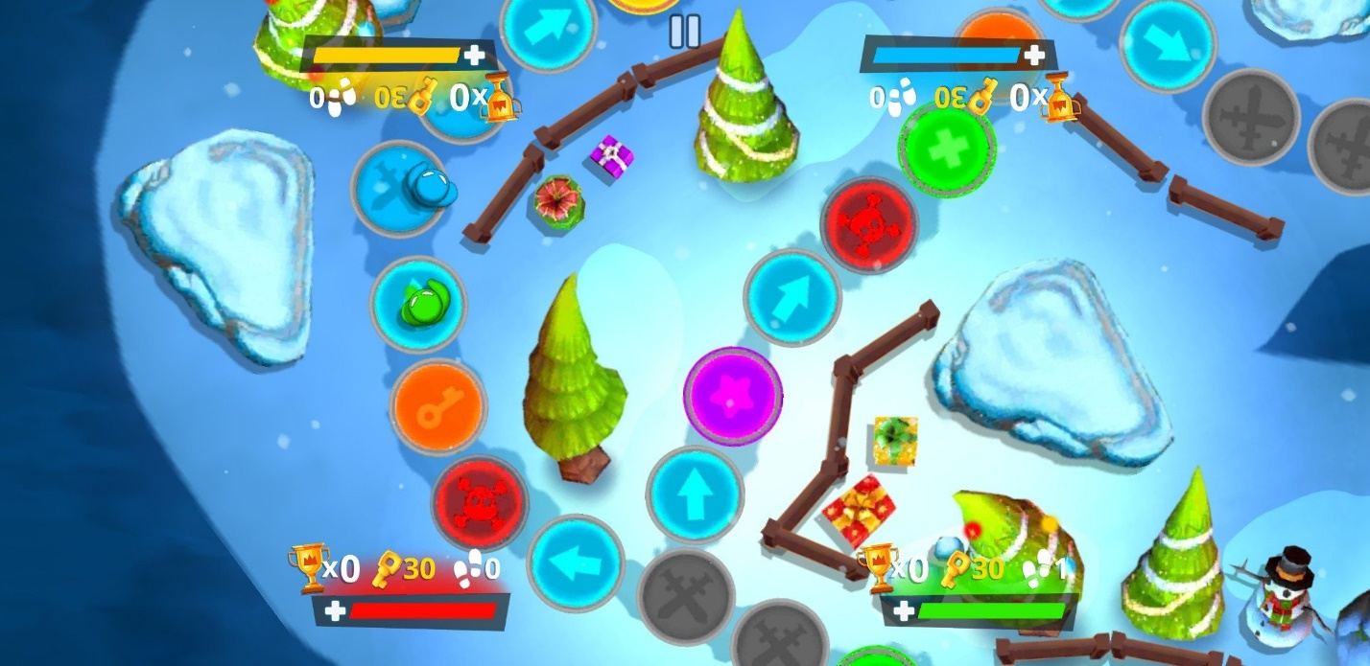

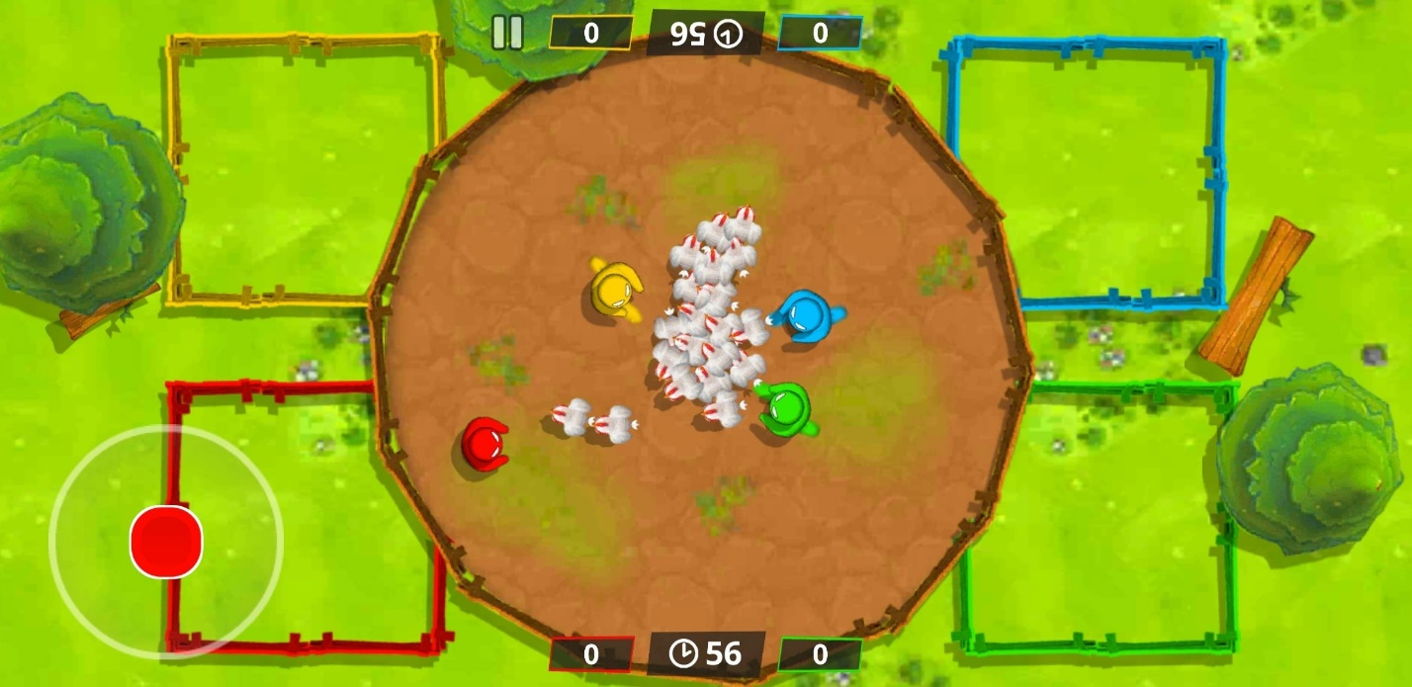

Stickman party is a fun game it contains mini games and allows you the pleasure of playing the game with other people, the mechanics are easy and does not have any learning curve that’s how easy it is. It has short play sessions making it perfect for short bursts of entertainment. It also encourages a competitive nature especially if played with friends.

1. CANDY CRUSH

Why not candy crush? It’s fun, engaging and just easy to pick up but has the levels increase so does your thinking capacity as it requires you to plan your moves strategically. It’s not a mindless game, it helps boost the dopamine levels with its reward system, you just want to keep winning to keep your earnings. The visuals are also stunning.

