Yes, all "Decora" style devices share the same cover plate opening, within a couple of thousandths of an inch (+/-.005" or so). GFCI receptacles also fit this description, as well as many dimmers, timers and "smart switches".

For instance the opening on a [Hubbell plate is 1.312"x2.625"](http://www.hubbellcatalog.com/canada/catalogpages/section-c.pdf), while these Leviton are slightly different, but all within a reasonable spec to be called the same.

[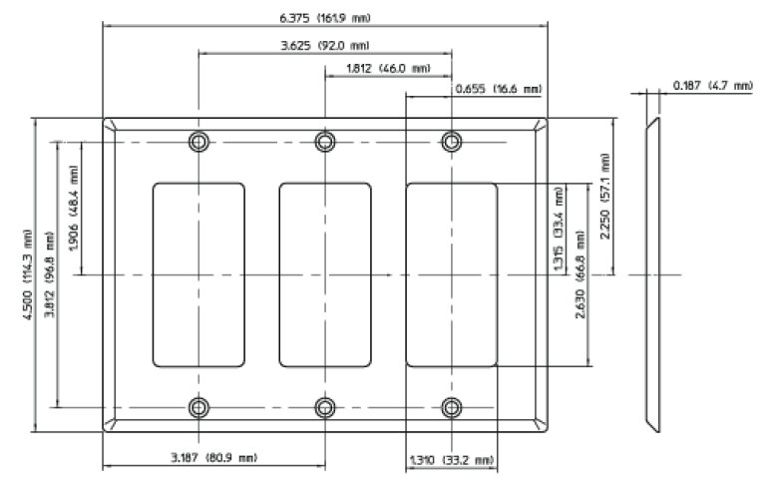](https://i.stack.imgur.com/aT4Ct.jpg)

W: 1.310 (min)

L: 2.630 (min)

R: 0.094 (0.079 347V)

C: 3.812 (4.062 347V) +/- 0.010 (counter-sunk for #6-32 UNC oval head machine screw)

Application (Face of device): 1.300 (max) W x 2.620 (max) L

[page iv](https://www.nema.org/Standards/view/Wiring-Devices-Dimensional-Specifications) notes: (#1) dimensions are in inches (#2) tolerances are +/- 0.005 (#10) dimensions are for interchangeability and do not preclude other designs.

[NEMA WD 6-2016](https://www.nema.org/Standards/view/Wiring-Devices-Dimensional-Specifications), page 5 says: [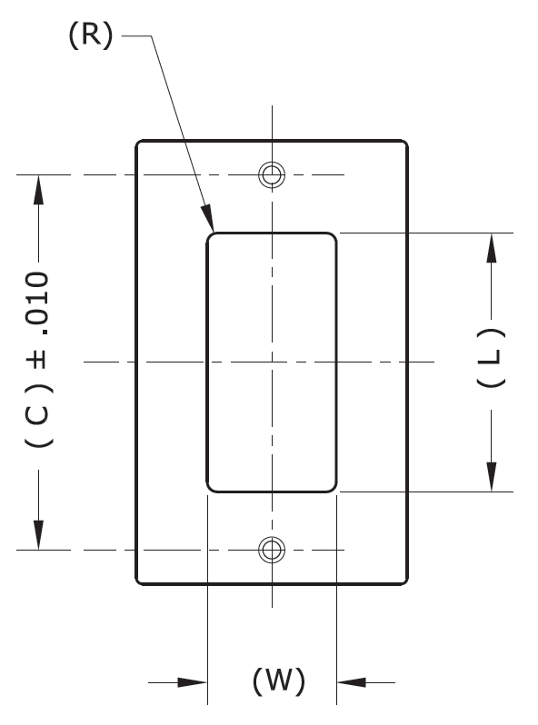](https://i.stack.imgur.com/zAvAe.png)