<<epic music>> MarioParty TriadStone <<epic music>>

Players will traverse a nonlinear board (example below). There are multiple paths players can choose and there may be advantages and disadvantages to choosing whichever path. I would like the boards to be fairly large (maybe a bit larger that this) with a variety of different squares and abilities (possibly including moving squares or paths, teleporting, a shop etc…).

Players will also hold a deck of cards, the details of which are up to you. Cards may have their own unique attack, defense, special effects, type advantages, and whatever else you can think of. Meaning that you do not have to follow any one game but may use ideas from any card related game. You will need to have at least 10 cards in your player’s decks and may create as many cards as you want.

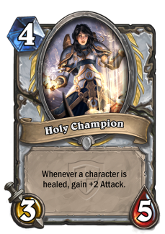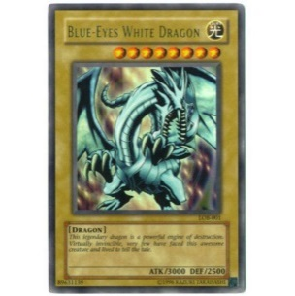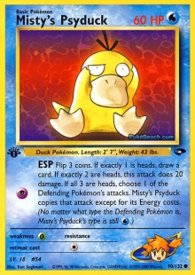 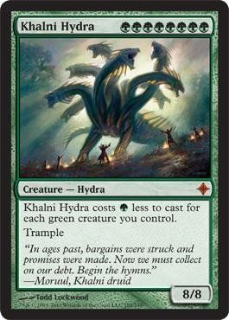 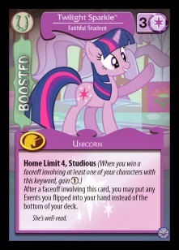 

There will multiple players in the game. Each will start with a generic deck with additional cards being found/purchased/gathered from the board during gameplay. When players meet on the board this starts a short card battle (rules are up to you) where the loser will relinquish one of their cards to the winner. The rules of the battles could change – like how there are different challenges in Mario Party. The board could also have types to their squares (Water, Fire, Ground…) which could impact the cards performance.

Actual win conditions may vary, and could depend on wins in battles, cards owned, damage dealt. In fact having multiple win conditions that could be set at game start might be an interesting mechanic.

The games needs to support single player games and have AI’s capable of playing the game with human players. The AI needs to have a difficulty scale with the lowest difficulty that is merely capable of playing valid moves, and the highest difficulty being able to “read” ahead when making moves (note that this is not cheating). We will discuss exactly how to “read” ahead in class. I will note that reading in the card game can be fairly difficult so keep in mind how the AI will play the card game as you write it - generally, we need some way of ranking cards and moves by strength as a number. If the card effects and skills are too abstract then it becomes difficult for the AI to decide how to play cards.

Multiplayer with humans may be supported by hotseat or by the unity networking system. Other mechanics such as player profiles maybe added to support deck building.

# Grading and Student Responsibility

There are many parts to this project. First a Board game with things like points/coins, squares to avoid and ones to go after. Maybe a store for buying and selling cards, dynamic squares that change, and even the option of additional boards (maybe needing a tool for creating boards more easily and quickly). Someone needs to be responsible for the board game side of this project (I’ll call him the BoardMaster). That doesn’t mean others can’t help and add input, but this person will focus on and take ownership of this part of the game. There then needs to be someone working with the BoardMaster to write the AI for the enemy players (call him the BoardWhisperer – no, that one maybe a bit lame – you come up with a title).

Next there is Card game, with all its rules and cards that make up playing that side of the game (call him maybe the CardMaster – am I good at these names or should I stop trying?). Like on the Board Game side there needs to be someone in charge of the Card Game’s AI (again, maybe a CardWhisperer – Like I said you come up with a title).

That leaves 2 additional members of the team. Someone will need to coordinate the project (I don’t mean a project leader but someone who will know what everyone is doing and if someone is absent they can take over and work on their part of the puzzle). This guy should also be responsible for all the parts working together. We’ll call him the Technical Director. The last guy will have a job that I won’t specify because it may be necessary for your project to have another main responsibility – such as if you decide to attempt networking maybe that person will be the Network Manager. Or if you decide to save player profiles to a database, then that person can be the DataBase Coordinator. Regardless, I’m sure you will find a task suitable for them.

Grading will be by a final demonstration of the projects by each team. Each person will have to describe their roll and responsibility throughout the project. Attendance and Participation will be considered in grading – (group email and coordination can make up for missing some time but those that are gone consistently will be penalized). I’m treating this like a game development studio and if you don’t show up to work then you don’t get paid (and they start to wonder why they hired you). The only difference here is that you are being paid with a grade and not cash. You also have the situation where you are responsible for a part of the project and will be graded on the success or failure in that area. I would highly advise you to do experiments (write some code to try to solve or encounter a problem) then ask your instructor for how to handle the issues you are having. By experimenting with smaller focused tests you can address the issues without having to keep track of all the code for the entire project.